Ex1

**import** java.util.Scanner;

**public** **class** Acasatema {

**public** **static** **void** main (String[]args) {

Scanner hw=**new** Scanner(System.***in***);

**int** n=hw.nextInt();

**int** x=2;

**int** i=1;

**do** {

System.***out***.println(+x);

i++;

x=2*i;

}**while**(i<=n);

}

}

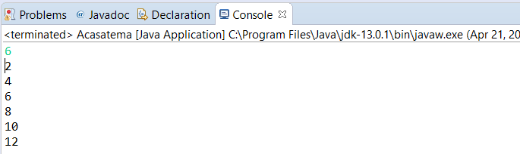

Ex2

**import** java.util.Scanner;

**public** **class** Acasatema {

**public** **static** **void** main (String[]args) {

Scanner hw=**new** Scanner(System.***in***);

**int** n=hw.nextInt();

**int** sum=0;

**int** i=1;

**do** {

sum =sum+(**int**) Math.*pow*(i,2);

i++;

}**while**(i<=n);

System.***out***.println("Suma numerelor la patrat este:"+sum);

}

}

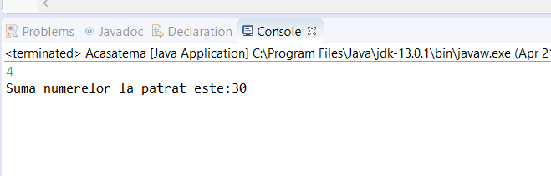

Ex3

**public** **class** Acasatema {

**public** **static** **void** main (String[]args) {

**int** x=0;

**int** i=1;

**do** {

x=x*10+i;

System.***out***.printf("%-5d",x);

System.***out***.println();

i++;

}**while**(i<=5);

}

}

