**Ex7 a)import** java.util.Scanner;

**public** **class** Acasa {

**public** **static** **void** main(String[]args) {

Scanner hw=**new** Scanner (System.***in***);

**int** n=hw.nextInt();

**int** sum=0;

**int** produs=1;

**for**(**int** i=1;i<=n;i++) {

sum=sum+(2*i-1);

produs=produs*(2*i-1);

}

System.***out***.println("suma="+sum+""+"produs="+produs);

}

}

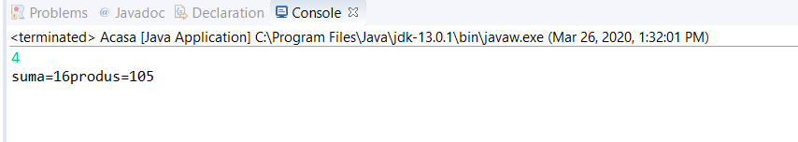

**import** java.util.Scanner;

**public** **class** Homexercitiu1 {

**public** **static** **void** main (String[]args) {

Scanner hw = **new** Scanner(System.***in***);

**int** n=hw.nextInt();

**int** sum=0;

**int** produs=1;

**int** i=1;

**while**(i<=n) {

sum=sum+(2*i-1);

produs=produs*(2*i-1);

i++;

}

System.***out***.println("suma="+sum+""+"produs="+produs);

}

}

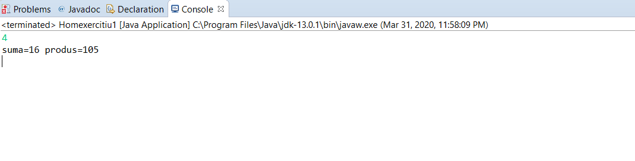

**b)import** java.util.Scanner;

**public** **class** Acasa {

**public** **static** **void** main(String[]args) {

Scanner hw=**new** Scanner (System.***in***);

**int** n=hw.nextInt();

**int** sum=0;

**int** produs=1;

**for**(**int** i=1;i<=n;i++) {

sum=sum+(2*i);

produs=produs*(2*i);

}

System.***out***.println("suma="+sum+""+"produs="+produs);

}

}

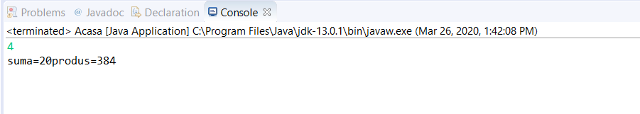

**import** java.util.Scanner;

**public** **class** Homexercitiu1 {

**public** **static** **void** main (String[]args) {

Scanner hw=**new** Scanner (System.***in***);

**int** n=hw.nextInt();

**int** sum=0;

**int** produs=1;

**int** i=1;

**while**(i<=n) {

sum=sum+(2*i);

produs=produs*(2*i);

i++;

}

System.***out***.println("suma="+sum+""+"produs="+produs);

}

}

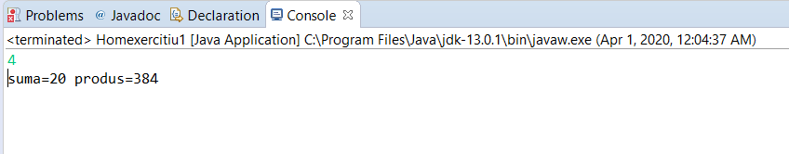

**c)import** java.util.Scanner;

**public** **class** Acasa {

**public** **static** **void** main(String[]args) {

Scanner hw=**new** Scanner (System.***in***);

**int** n=hw.nextInt();

**int** sum=0;

**int** produs=1;

**for**(**int** i=1;i<=n;i++) {

sum=sum+(3*i);

produs=produs*(3*i);

}

System.***out***.println("suma="+sum+""+"produs="+produs);

}

}

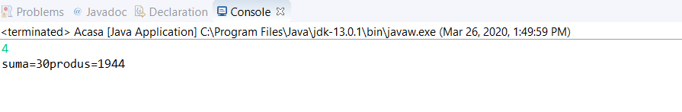

**import** java.util.Scanner;

**public** **class** Homexercitiu1 {

**public** **static** **void** main (String[]args) {

Scanner hw=**new** Scanner (System.***in***);

**int** n=hw.nextInt();

**int** sum=0;

**int** produs=1;

**int** i=1;

**while**(i<=n) {

sum=sum+(3*i);

produs=produs*(3*i);

i++;

}

System.***out***.println("suma="+sum+""+" produs="+produs);

}

}

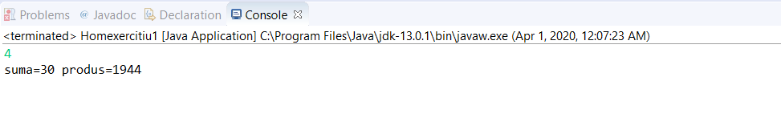

**d)import** java.util.Scanner;

**public** **class** Acasa {

**public** **static** **void** main(String[]args) {

Scanner hw=**new** Scanner (System.***in***);

**int** n=hw.nextInt();

**int** sum=0;

**int** produs=1;

**for**(**int** i=1;i<=n;i++) {

sum=sum+(4*i);

produs=produs*(4*i);

}

System.***out***.println("suma="+sum+""+"produs="+produs);

}

}

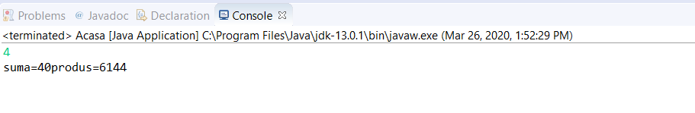

**import** java.util.Scanner;

**public** **class** Homexercitiu1 {

**public** **static** **void** main (String[]args) {

Scanner hw=**new** Scanner (System.***in***);

**int** n=hw.nextInt();

**int** sum=0;

**int** produs=1;

**int** i=1;

**while**(i<=n) {

sum=sum+(4*i);

produs=produs*(4*i);

i++;

}

System.***out***.println("suma="+sum+""+" produs="+produs);

}

}

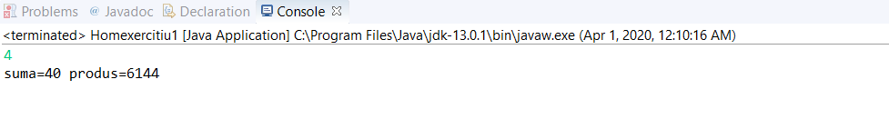

Ex8 pag 97

**import** java.util.Scanner;

**public** **class** Tema {

**public** **static** **void** main(String[]args){

Scanner hw=**new** Scanner(System.***in***);

**int** n=hw.nextInt();

**double** sum=0;

**int** i=1;

**while**(i<=n) {

**if**(i%2==0) {

sum=sum-(1d/i);

i++;

}

**else** {

sum=sum+(1d/i);

i++;

}

}

System.***out***.println("sum="+sum);

}

}

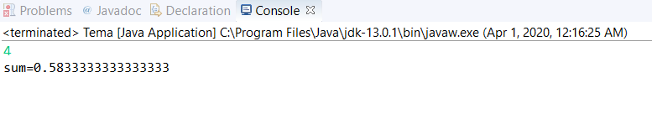

**import** java.util.Scanner;

**public** **class** Tema {

**public** **static** **void** main(String[]args){

Scanner hw=**new** Scanner(System.***in***);

**int** n=hw.nextInt();

**double** sum=0;

**for**(**int** i=1;i<=n;i++) {

**if**(i%2==0) {

sum=sum-(1d/i);

}

**else** {

sum=sum+(1d/i);

}

}

System.***out***.println("sum="+sum);

}

}

Ex.de pe fisa

**import** java. util.Scanner;

**public** **class** Ffhd {

**public** **static** **void** main(String[]args) {

Scanner hw=**new** Scanner(System.***in***);

**int** n=hw.nextInt();

**double** sum=0;

**double** prod=1;

**int** m=1;

**while**(m<=n) {

sum=sum+m/(m+1d);

prod=prod*m/(m+1d);

m++;

}

System.***out***.println("sum= "+sum +" prod= "+prod);

}

}

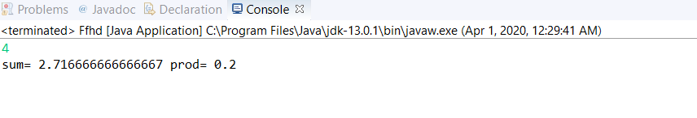

**import** java. util.Scanner;

**public** **class** Ffhd {

**public** **static** **void** main(String[]args) {

Scanner hw=**new** Scanner(System.***in***);

**int** n=hw.nextInt();

**double** sum=0;

**double** prod=1;

**for**(**int** m=1;m<=n;m++) {

sum=sum+m/(m+1d);

prod=prod*m/(m+1d);

}

System.***out***.println("sum= "+sum +" prod= "+prod);

}

}