# Converting or preparing a GUI

In order to create a GUI that works both with the coffee machine and the rasPI module, you need to use the updated rheaMedia2 that you can download from here: https://we.tl/t-nSTsYf8n2v

This version of RheaMedia2 works exactly like the previous one but, every time you save a GUI, it will also save a mobile version of the same GUI that will run on the rasPI and that you will see on your phone.

**Conversion of an existing GUI**

In order to convert an already existing GUI, you only need to open it in this new RheaMedia2 (using the button “Edit an existing GUI”) and save it again. There’s no special action to do, just:

1. open it in RheaMedia2,
2. click “Preview GUI and export” and
3. save it.

**Creation of a new GUI**

You can also create a new GUI on the fly as usual, by opening RheaMedia2 (of course, this new version) and clicking on “Create a new GUI”.

Once you have a GUI ready, you’ll need to upload it on the coffee machine, by saving the GUI onto a USB drive and performing a normal GUI update as always.

Follow the instruction in the following paragraph for a step by step installation.

# Step by step installation

Here’s a step by step list of what you should do in order to have the machine ready to work with the rasPI module:

1. Prepare a GUI and save it on a USB drive, you ‘ll need it later
2. Install the new **GPU_v.2.3.2_ESAPI_200708_3d59341.mh6**  that you can download from here: <https://we.tl/t-PkFHWUQ8hE>
3. Make sure your **CPU FW** is **2.3**
4. Switch the **machine** **off**
5. Connect the rasPI to the GPU via serial cable
6. Turn **ON** the **rasPI** by plugging the AC power into a socket. You will see a little red LED turning on, on the rasPI board, on the top right corner

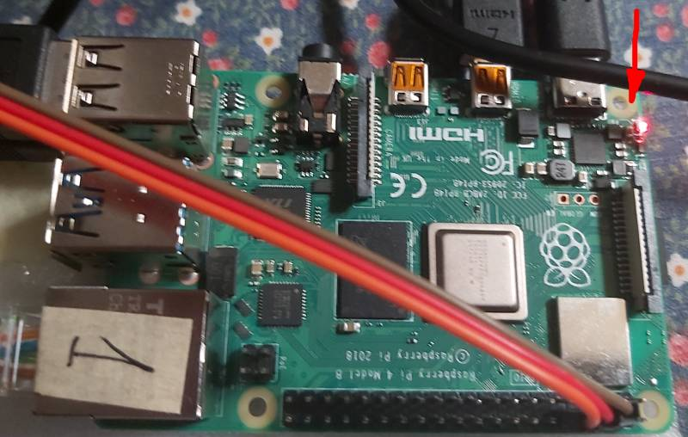

1. Insert the USB drive with the GUI into the coffee machine
2. Switch the coffee machine **ON**
3. You will notice some new information displayed on screen by the GPU, something that look like this: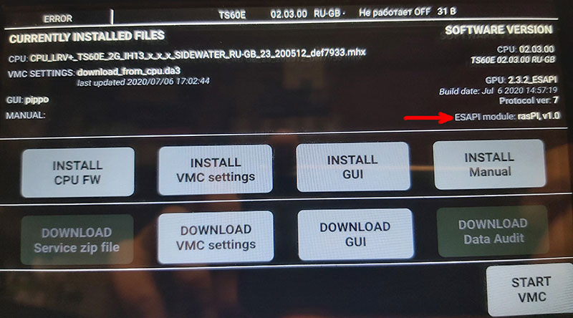

Notice that on the right side, there’s a new indication stating that an ESAPI module has been detected. If no module has been connected to the serial cable, you should see something like this:

ESAPI: API version 1.0 (i.e.: there’s no reference to a “module” at all).

1. Now proceed by installing the GUI as usual, by clicking on “INSTALL GUI” and choosing the GUI from step 1. After the GUI has been installed on the coffee machine, you will see that now it will also be installed on the rasPI module. You will see a progress indicator showing the status of the transfer. It’s going to take a while (around 4 minutes) to install the GUI on the rasPI. We are compressing the mobile GUI as much as possible but beverage images still can take quite some space in terms of kiloByte. An average compressed mobile GUI is a single file around 4MB in size (not that much for today standards), but we only have a serial cable connecting the coffee machine to the rasPI and, this serial cable, can transfer data at a maximum rate of 10KB per second. Having said that, the transfer of (circa) 4MB of data at (circa) 10KB per seconds, it’s going to take some minutes. Luckily this is not something you have to do every time, it’s something you do only when/if you need to change the GUI.
2. After the GUI upload is finished, you can click on START VMC as usual and everything should be working as expected, both the coffee machine and the rasPI module.

Whenever you turn the coffee machine **OFF**, you should remember also to turn the rasPI **OFF** by unplugging the AC power from its socket.

Also, much more **important**, this powering sequence must be followed: **1) switch the rasPI module ON, 2) switch the coffee machine ON**. In the future, the rasPI module will take power directly from the coffee machine, so the correct sequence shall be respected by design.