Development and Simulation of a 2-DOF Robotic Arm for Alphanumeric Character Rendering Using MATLAB and Simulink
Abstract
This study presents the design and simulation of a two-degree-of-freedom (2-DOF) robotic arm capable of generating alphanumeric characters through an interactive MATLAB-based graphical user interface (GUI). The primary objective is to develop a robotic drawing platform that converts user-selected characters into executable motion trajectories using image processing and simulation-driven path planning techniques. Upon selecting a letter or numeral, the system retrieves a corresponding image template from a predefined database and processes it through a contour extraction pipeline. The extracted contours are transformed into vectorized trajectories representing the desired drawing path.
The generated trajectories are formatted and stored in a MATLAB workspace variable, simin, which serves as the input to a Simulink-based robotic arm model. The Simulink environment performs inverse kinematics calculations and control operations to determine the required joint movements for accurately tracing the selected character. The proposed framework enables motion verification in a fully simulated environment, allowing real-time visualization, trajectory validation, and controller tuning without the need for physical hardware.
By employing a simple 2-DOF planar manipulator, the system achieves a balance between mechanical simplicity and functional capability, making it suitable for educational demonstrations, robotic sketching applications, and introductory handwriting automation. The work establishes a foundation for future developments in robotic drawing, educational robotics, and automated symbol generation systems.

1. Introduction
The integration of digital image processing with robotic control systems has become increasingly important in modern automation and human-machine interaction. Robotic manipulators rely on trajectory planning algorithms to transform desired end-effector motions into time-dependent joint commands, ensuring precise and stable operation. This capability is particularly significant in applications that require the reproduction of graphical patterns such as handwritten characters, symbols, and artistic sketches.
The primary objective of this project is to develop a robotic control framework capable of automatically generating and executing motion trajectories from user-defined visual inputs. Conventional robotic drawing systems often require manual trajectory specification, limiting their flexibility and accessibility. To address this limitation, the proposed system converts arbitrary two-dimensional alphanumeric images into executable Cartesian trajectories through an automated image-processing pipeline.
An interactive graphical user interface developed using MATLAB App Designer serves as the primary human-machine interface, enabling users to select desired characters intuitively. Once a character is chosen, the system performs a sequence of image-processing operations, including grayscale conversion, binarization, contour extraction, and path optimization. These operations transform the visual representation of the character into an efficient sequence of coordinate points suitable for robotic execution.
The resulting trajectory is formatted into a time-indexed matrix (simin) and transferred to a Simulink model of a planar 2-DOF robotic arm. The model computes the required inverse kinematics and control actions necessary for trajectory tracking. This integrated environment allows users to visualize robot motion in real time, evaluate controller performance, and verify trajectory execution without physical hardware.
The remainder of this report is organized as follows. Section 2 presents a review of related work in robotic drawing, image processing, and trajectory generation. Section 3 describes the proposed methodology, including user interaction, image processing, trajectory generation, inverse kinematics, and control design. Section 4 discusses the simulation results and performance evaluation, while Section 5 concludes the work and outlines future research directions.

2. Methodology
2.1 System Overview
The proposed system integrates user interaction, image processing, trajectory generation, inverse kinematics, and control simulation within the MATLAB-Simulink environment. The overall workflow begins with character selection through a graphical interface and concludes with trajectory execution by a simulated 2-DOF robotic manipulator.
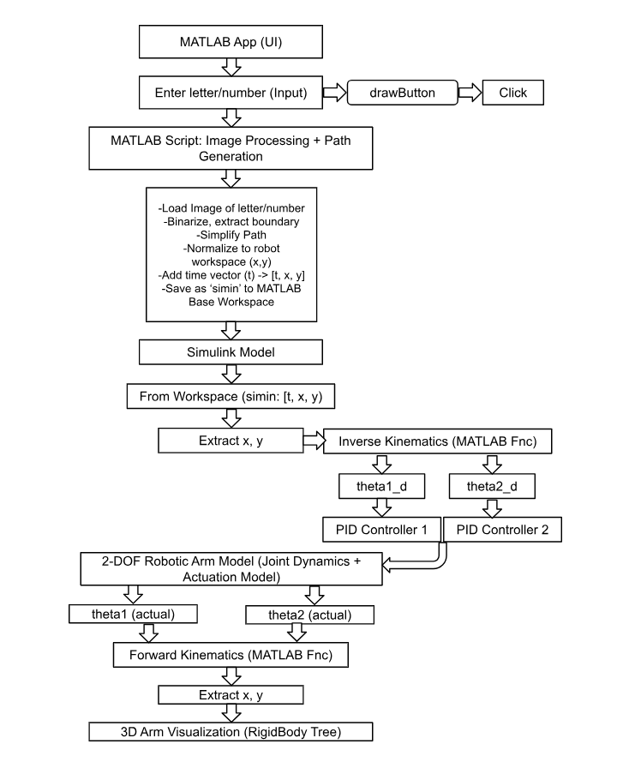
2.2 User Interface Design
A graphical application developed using MATLAB App Designer serves as the primary interface between the user and the robotic system. Users select an alphanumeric character from a predefined set of templates stored within a dedicated image repository.
Once the draw command is executed, the application retrieves the corresponding template image and initiates the trajectory generation process. The modular structure of the interface facilitates future expansion by allowing additional characters and graphical symbols to be incorporated with minimal modifications.
2.3 Image Processing and Boundary Extraction
Following image retrieval, the system performs a sequence of preprocessing operations using MATLAB's Image Processing Toolbox:
- Grayscale Conversion: RGB images are converted to grayscale to reduce computational complexity.
- Intensity Adjustment and Inversion: The image is automatically inverted when necessary to maximize foreground-background contrast.
- Binarization: Adaptive thresholding converts the grayscale image into a binary representation.
- Boundary Extraction: Character outlines are extracted using MATLAB's bwboundaries function.
- Path Optimization: Redundant contour points are removed through path simplification, reducing computational requirements while preserving geometric accuracy.
The output of this stage is a simplified set of two-dimensional coordinate points representing the character boundary.
2.4 Trajectory Generation and Formatting
The extracted boundary coordinates are normalized and scaled to fit within the reachable workspace of the robotic arm. This ensures that all generated trajectories remain physically feasible while preserving the original shape of the character.
A time vector is then generated according to the number of trajectory samples and the desired simulation duration. The time vector and coordinate data are combined to create the simin matrix in the format:
simin = [time, x, y]
This matrix serves as the primary input signal for the Simulink simulation model.
2.5 Inverse Kinematics
The robotic arm is modeled as a planar manipulator consisting of two revolute joints with link lengths (L_1) and (L_2). For each trajectory point, inverse kinematics calculations determine the corresponding joint angles required to position the end-effector at the desired coordinates.
The algorithm processes all trajectory points sequentially, generating synchronized joint trajectories for both actuators. These joint commands are subsequently transmitted to the Simulink control subsystem for execution.

2.6 Control System Design
Trajectory tracking is achieved using a Proportional-Derivative (PD) controller. The controller continuously computes control torques based on the difference between desired and actual joint positions and velocities.
Controller gains are tuned through simulation to minimize overshoot, reduce steady-state error, and ensure smooth trajectory tracking. Real-time monitoring of joint positions, velocities, and tracking errors is performed through Simulink visualization tools, allowing comprehensive evaluation of system performance.
3. Results and Discussion
The proposed robotic drawing framework was successfully implemented and evaluated within the MATLAB-Simulink environment. The system integrates five primary modules: user input acquisition, template retrieval, image processing, trajectory generation, and robotic motion control.
Experimental testing was conducted using fifteen alphanumeric characters. The system successfully reproduced ten characters, corresponding to a success rate of approximately 66.67%. Successfully rendered characters included:
A, B, D, L, O, P, 1, 4, 7, and 8
These characters primarily consisted of simple geometric structures, limited stroke complexity, and moderate curvature, making them well-suited for a planar 2-DOF manipulator.
The remaining characters failed to meet the desired accuracy requirements due to several limitations:
- High curvature regions and acute angular transitions.
- Segmentation inaccuracies caused by unclear contour boundaries.
- Tight loops and concave structures that introduced inverse kinematics constraints.
Characters such as C, V, E, G, and S exhibited trajectory deviations exceeding 5 mm and reduced path overlap accuracy. These findings highlight the limitations of low-degree-of-freedom manipulators when reproducing complex handwriting structures.
Compared with previously reported robotic drawing systems employing 3-DOF or higher-order manipulators, the proposed approach demonstrates lower trajectory fidelity but benefits from reduced mechanical complexity, simplified control implementation, and lower computational requirements. The results confirm that a 2-DOF architecture is effective for basic character reproduction while revealing the need for additional degrees of freedom when handling more complex handwriting patterns.
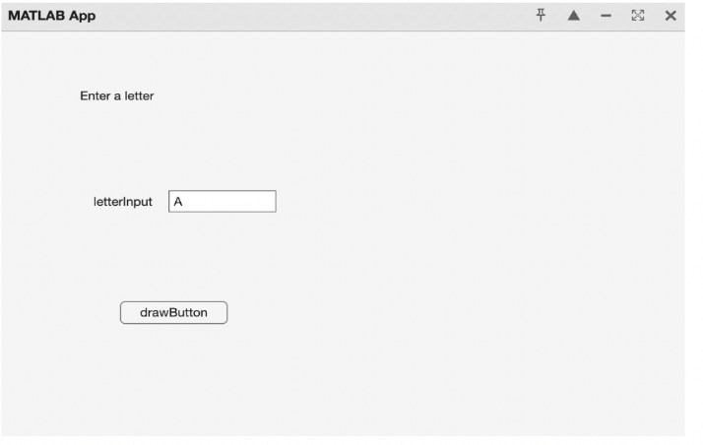
Fig. 2. MATLAB UI to take input from user (letter or number)

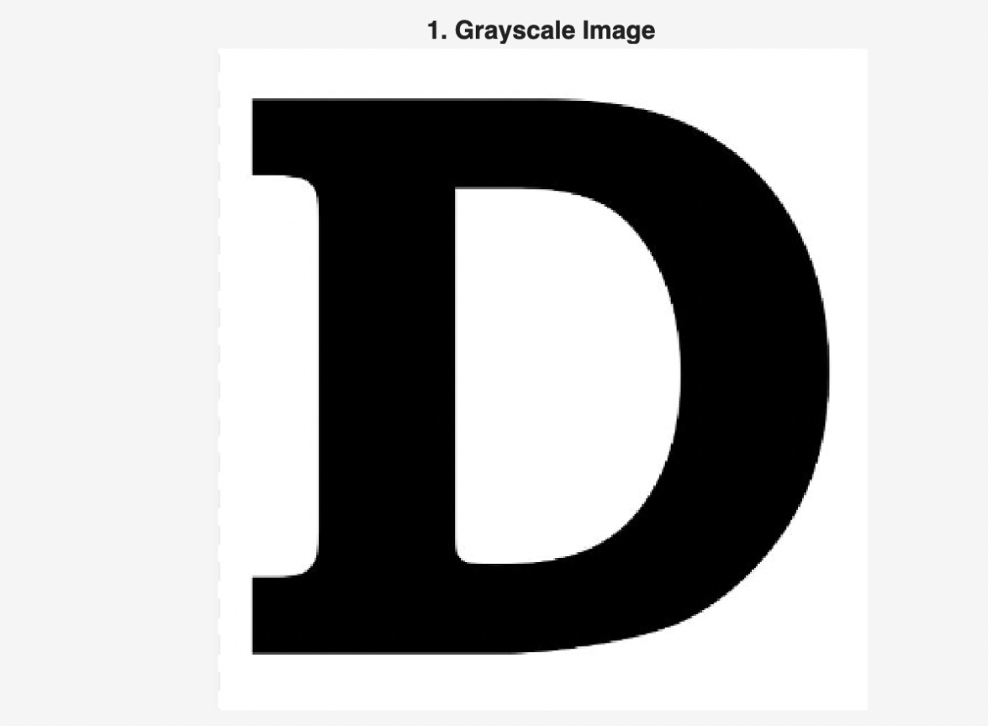
Fig. 3. Input image in grayscale
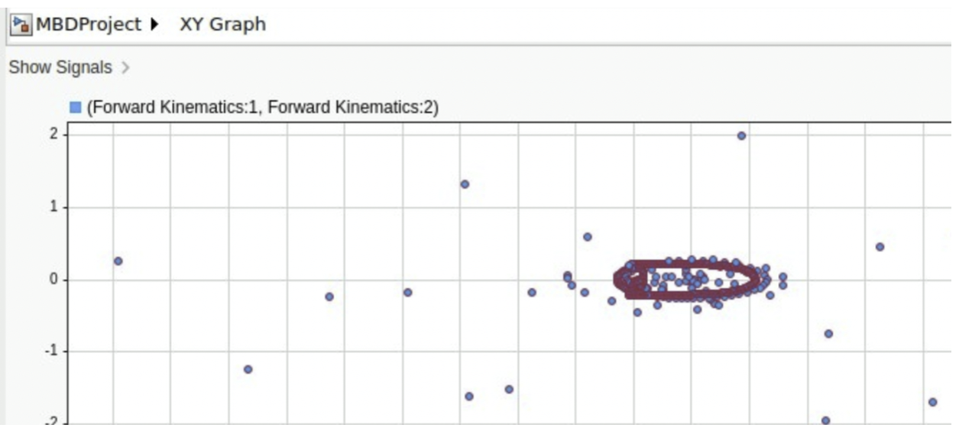
Fig. 4. Actual path traced by the robotic arm for the letter D
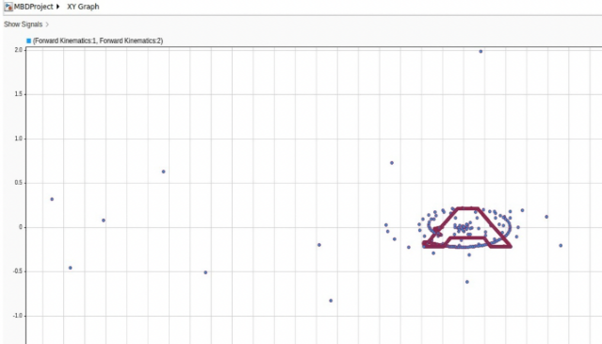
Fig. 5. Path traced by the robotic arm for the letter A

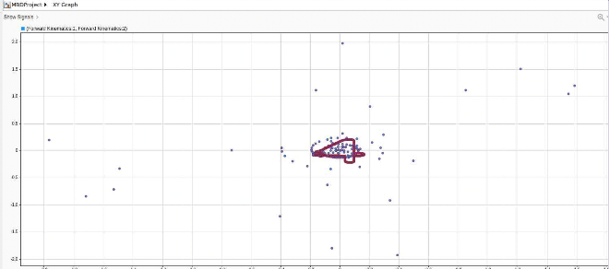
Fig. 6. Path traced by the robotic arm for the number 4
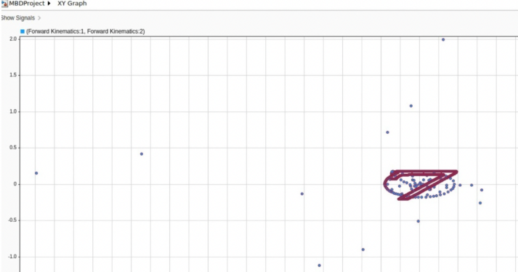
Fig. 7. Path traced for the number 7

4. Conclusion
This project presented the design and simulation of a 2-DOF robotic arm capable of reproducing alphanumeric characters using image-processing-based trajectory generation and MATLAB-Simulink simulation. The system successfully converts user-selected character templates into executable robotic trajectories through contour extraction, path optimization, inverse kinematics, and closed-loop control.
Simulation results demonstrated successful reproduction of characters characterized by simple geometric structures and moderate curvature. However, characters containing sharp turns, continuous loops, and complex concave features exceeded the kinematic capabilities of the 2-DOF configuration, highlighting inherent limitations in trajectory resolution and workspace flexibility.
The proposed framework demonstrates the feasibility of using simple robotic architectures for handwriting and drawing applications while providing a strong foundation for future developments in educational robotics, automated sketching, and intelligent robotic writing systems.

