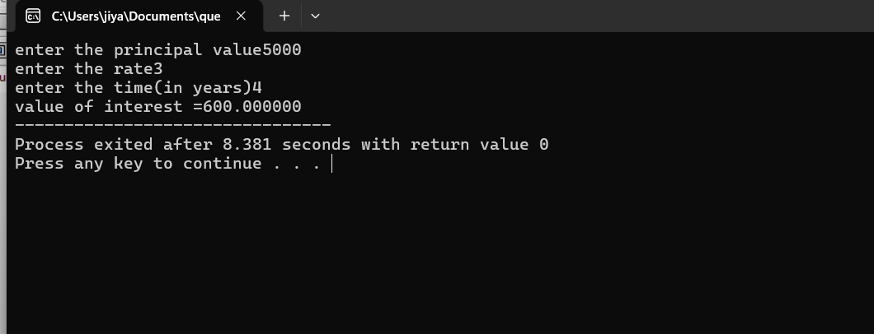

#include<stdio.h>
int main()
{
float interest,principalvalue,rate,time;
printf("enter the principal value");
scanf("%f",&principalvalue);
printf("enter the rate");
scanf("%f",&rate);
printf("enter the time(in years)");
scanf("%f",&time);
interest=(principalvalue*rate*time)/100;
printf("value of interest =%f",interest);
}

Question-2
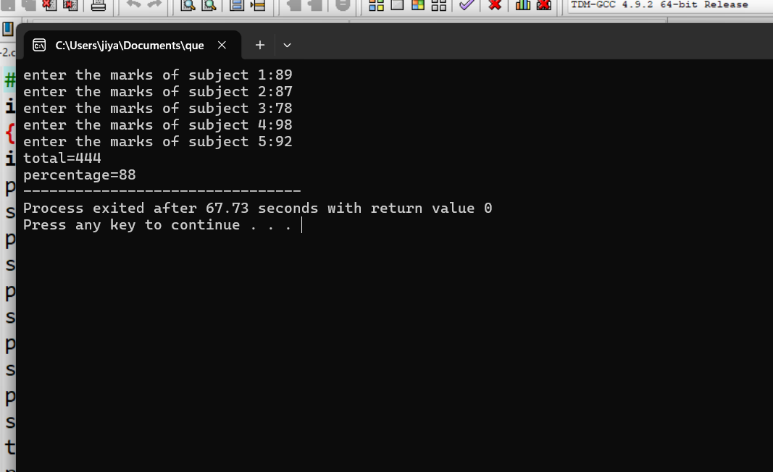

#include<stdio.h>
int main()
{
int subject1,subject2,subject3,subject4,subject5,total,percentage;
printf("enter the marks of subject 1:");
scanf("%d",&subject1);
printf("enter the marks of subject 2:");
scanf("%d",&subject2);
printf("enter the marks of subject 3:");
scanf("%d",&subject3);
printf("enter the marks of subject 4:");
scanf("%d",&subject4);
printf("enter the marks of subject 5:");
scanf("%d",&subject5);
total =(subject1+subject2+subject3+subject4+subject5);
printf("total=%d\n",total);
percentage=(total*100)/500;
printf("percentage=%d",percentage);

}

Question-3

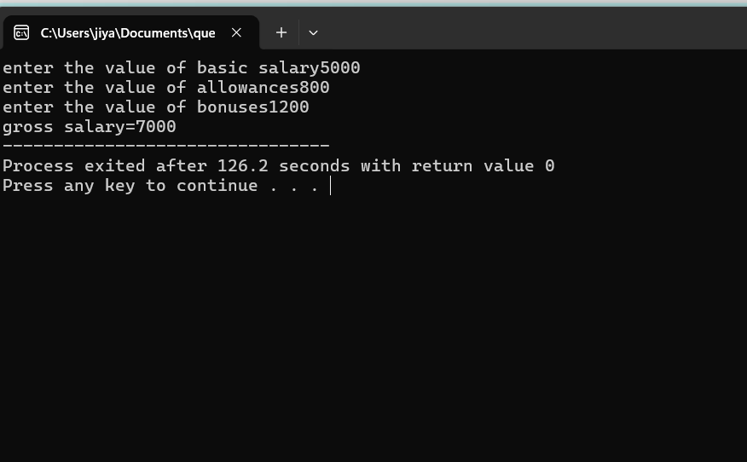

#include<stdio.h>
int main()
{
int basicsalary,allowances,bonuses,grosssalary;
printf("enter the value of basic salary");
scanf("%d",&basicsalary);
printf("enter the value of allowances");
scanf("%d",&allowances);
printf("enter the value of bonuses");
scanf("%d",&bonuses);
grosssalary=basicsalary+allowances+bonuses;
printf("gross salary=%d",grosssalary);
}

Question-4
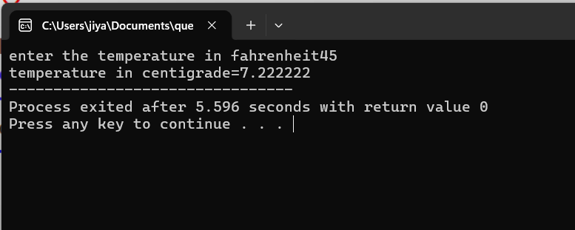

#include<stdio.h>
int main()
{
float fahrenheit,centigrade;
printf("enter the temperature in fahrenheit");
scanf("%f",&fahrenheit);
centigrade=(fahrenheit-32)*5/9;
printf("temperature in centigrade=%f",centigrade);
}
Question-5
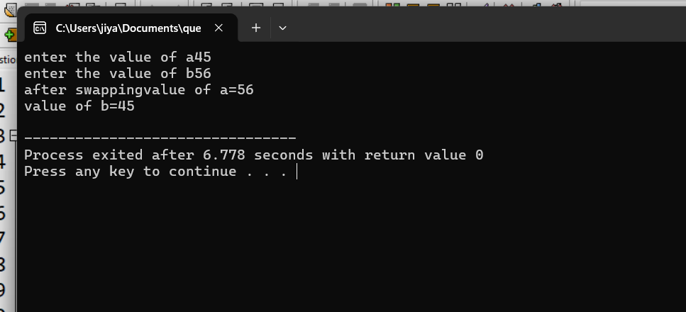

#include<stdio.h>
int main()
{
int a,b,c;
printf("enter the value of a");
scanf("%d",&a);
printf("enter the value of b");
scanf("%d",&b);
c=a;
a=b;
b=c;
printf("after swapping");
printf("value of a=%d\n",a);
printf("value of b=%d\n",b);
}

Question-6
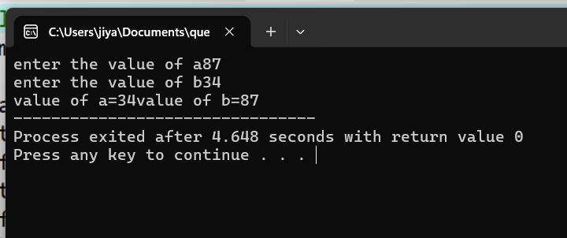
#include<stdio.h>
int main()
{
int a,b,c;
printf("enter the value of a");
scanf("%d",&a);
printf("enter the value of b");
scanf("%d",&b);
a=a+b;
b=a-b;
a=a-b;
printf("value of a=%d",a);
printf("value of b=%d",b);
}

Question-7
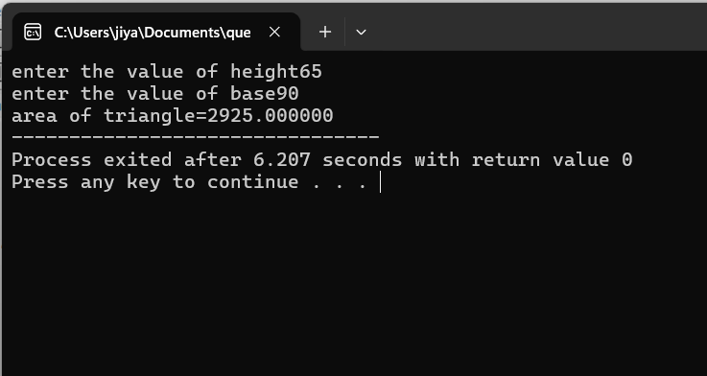
#include<stdio.h>
int main()
{
float height,base,areaoftriangle;
printf("enter the value of height");
scanf("%f",&height);
printf("enter the value of base");
scanf("%f",&base);
areaoftriangle=(height*base)/2;
printf("area of triangle=%f",areaoftriangle);
}

Question-8
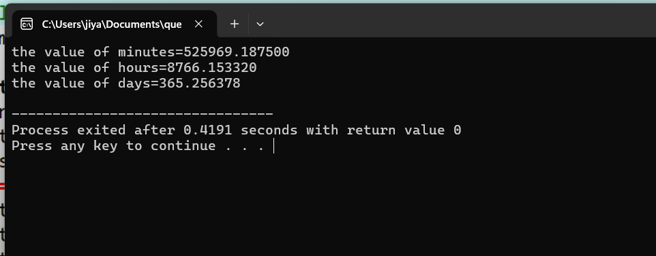

#include<stdio.h>
int main()
{
float seconds,minutes,hours,days;
seconds=31558150;
minutes=seconds/60;
hours=minutes/60;
days=hours/24;
printf("the value of minutes=%f\n",minutes);
printf("the value of hours=%f\n",hours);
printf("the value of days=%f\n",days);
}

Question-9

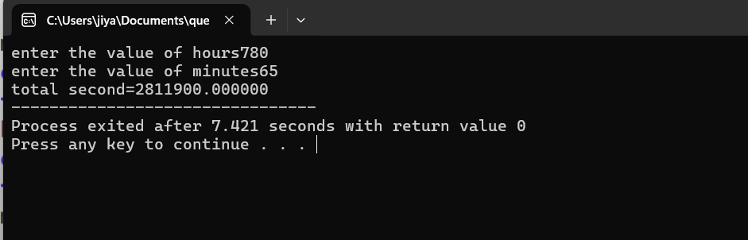

#include<stdio.h>
int main()
{
float time,second1,second2,minutes,hours,totalseconds;
printf("enter the value of hours");
scanf("%f",&hours);
second1=hours*3600;
printf("enter the value of minutes");
scanf("%f",&minutes);
second2=minutes*60;
printf("total second=%f",second1+second2);
}

Question-10
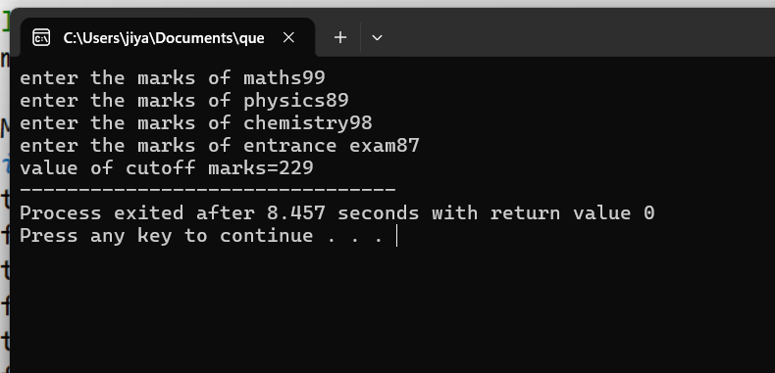
#include<stdio.h>
int main()
{
int M,P,C,E,cutoffmarks;
/*M is marks of maths out of 200,P is marks of physics out of 200,C is marks of chemistry out of 200,E is marks of entrance exam out of 100*/
printf("enter the marks of maths");
scanf("%d",&M);
printf("enter the marks of physics");
scanf("%d",&P);
printf("enter the marks of chemistry");
scanf("%d",&C);
printf("enter the marks of entrance exam");
scanf("%d",&E);
cutoffmarks=(M/2+P/2+C/2+E);
printf("value of cutoff marks=%d",cutoffmarks);
}

Question-11
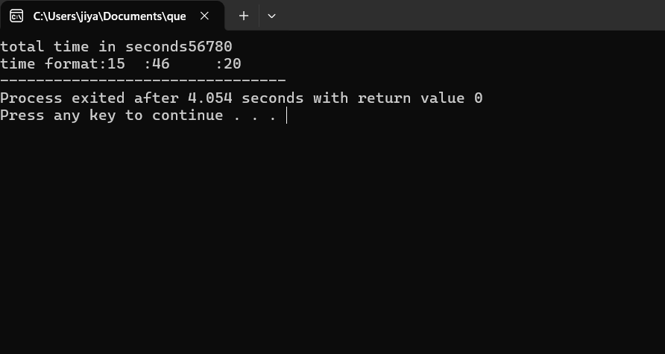
#include<stdio.h>
int main()
{
int total_sec,hours,minutes,seconds;
printf("total time in seconds");
scanf("%d",&total_sec);
hours=total_sec/3600;
total_sec=total_sec%3600;
minutes=total_sec/60;
seconds=total_sec%60;
printf("time format:%d:%d:%d",hours,minutes,seconds);
}

