Assignment -2
Question-36
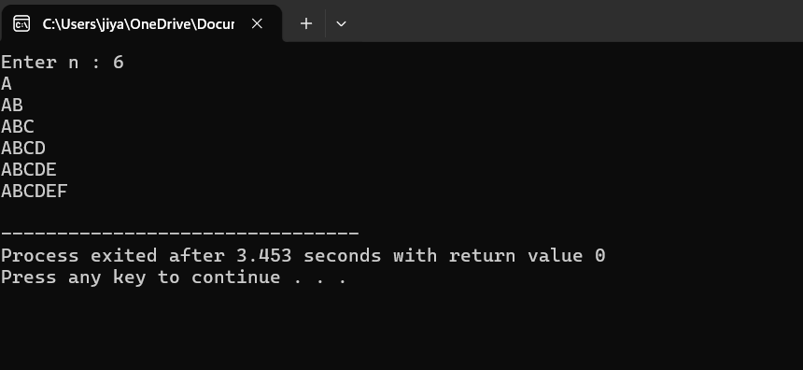

#include<stdio.h>
int main()
{
int i,j,n;
char c;
printf("Enter n : ");
scanf("%d",&n);
for(i=1;i<=n;i++)
{
for(j=1;j<=i;j++)
{
printf("%c",'A'+j-1);
}
printf("\n");
}
}

Question-37
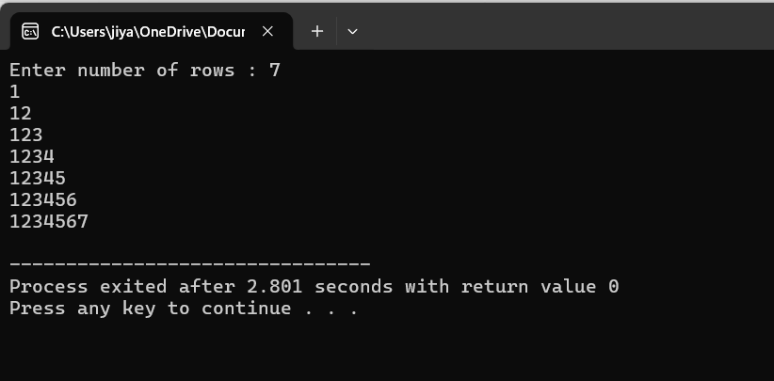
#include<stdio.h>
int main()
{
int n,i,j;
printf("Enter number of rows : ");
scanf("%d",&n);
for(i=1;i<=n;i++)
{
for(j=1;j<=i;j++)
{
printf("%d",j);
}
printf("\n");
}
}
Question-38
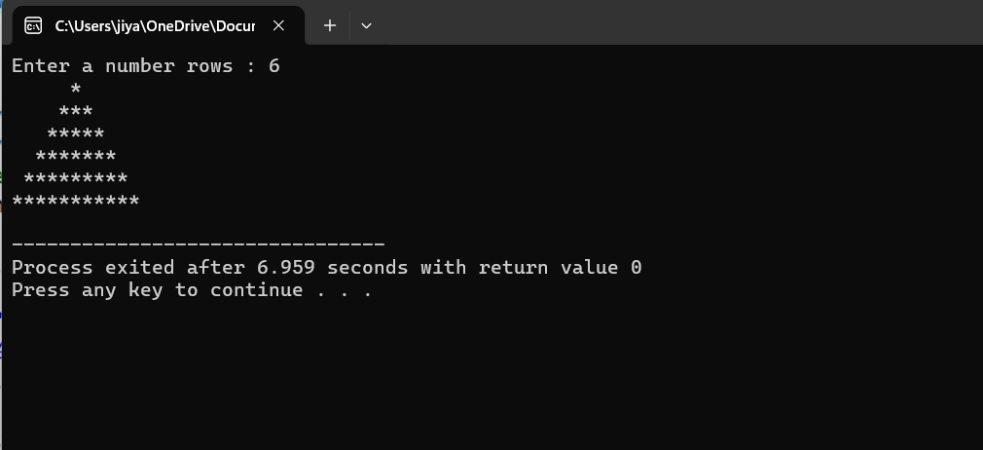
#include<stdio.h>
int main()
{
int n,i,j;
char c;
printf("Enter a number rows : ");
scanf("%d",&n);
for(i=1;i<=n;i++)
{
for(j=1;j<=n-i;j++)
{
printf(" ");
}
for(j=1;j<=i;j++)
{
printf("%c",'*');
}
for(j=i-1;j>=1;j--)
{
printf("%c",'*');
}
printf("\n");
}
}
Question-39
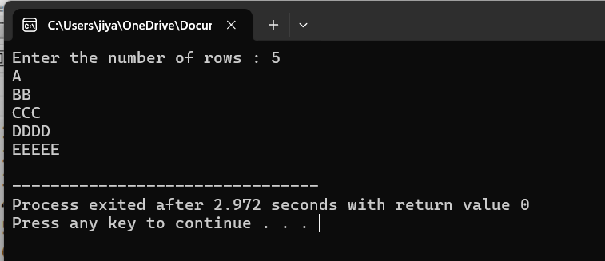
#include<stdio.h>
int main()
{
int n,i,j,x=0;
printf("Enter the number of rows : ");
scanf("%d",&n);
for(i=1;i<=n;i++)
{
x=i+64;
for (j=1;j<=i;j++)
{
printf("%c",x);
}
printf("\n");
}
}
Question-40
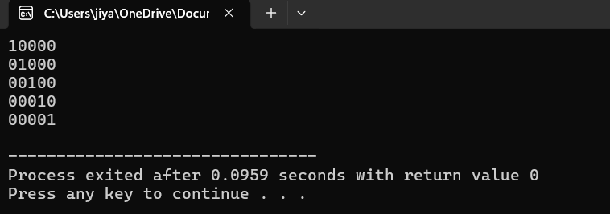
#include<stdio.h>
int main()
{
int i,j,count;
for(i=1;i<=5;i++)
{
for (j=1;j<=5;j++)
{
if (i==j)
count=1;
else
count=0;

if(count==1)
printf("1");
else
printf("0");
}

printf("\n");
}
}
Question-41
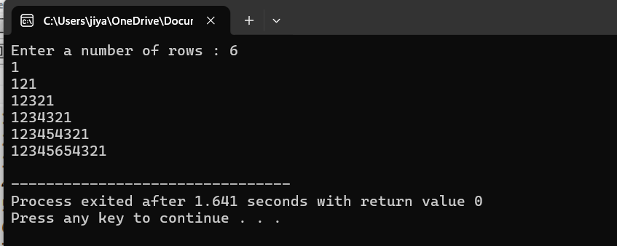
#include<stdio.h>
int main()
{
int i,j,n;
printf("Enter a number of rows : ");
scanf("%d",&n);

for(i=1;i<=n;i++)
{
for(j=1;j<=i;j++)
printf("%d",j);
for(j=i-1;j>=1;j--)
printf("%d",j);

printf("\n");
}
}
Question-42
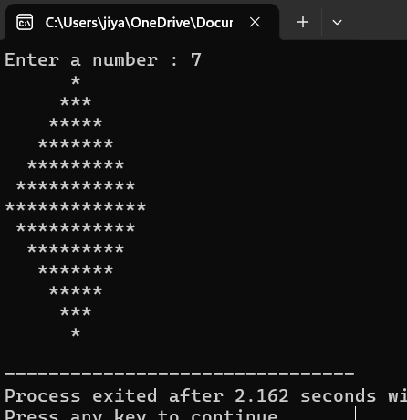
#include<stdio.h>
int main()
{
int n,i,j;
char c;
printf("Enter a number : ");
scanf("%d",&n);
for(i=1;i<=n;i++)
{
for(j=1;j<=n-i;j++)
{
printf(" ");
}
for(j=1;j<=i;j++)
{
printf("%c",'*');
}
for(j=i-1;j>=1;j--)
{
printf("%c",'*');
}
printf("\n");
}

for(i=1;i<=n-1;i++)
{
for(j=1;j<=i;j++)
{
printf(" ");
}
for(j=1;j<=n-i;j++)
{
printf("%c",'*');
}
for(j=1;j<=(n-i-1);j++)
{
printf("%c",'*');
}
printf("\n");
}
}
Question-43
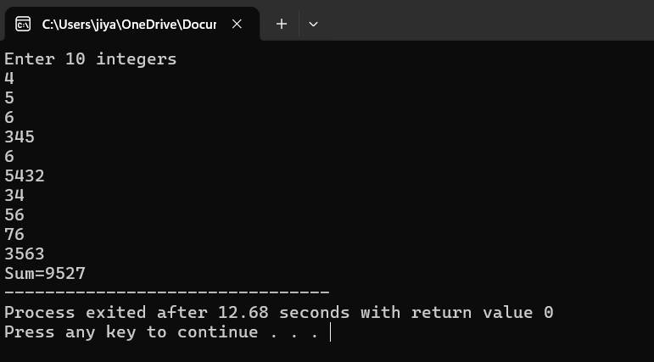
#include<stdio.h>
int main()
{
int a[10],sum=0,i;
printf("Enter 10 integers \n");
for(i=0;i<10;i++)
{scanf("%d",&a[i]);
sum=sum+a[i];
}
printf("Sum=%d",sum);
}
Question-44
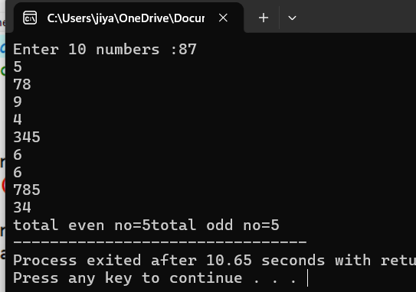
#include<stdio.h>
int main()
{
int a[10],countodd=0,counteven=0,i;
printf("Enter 10 numbers :");
for(i=0;i<10;i++)
{
scanf("%d",&a[i]);
if(a[i]%2==0)
{
counteven++;
}
else
{
countodd++;
}
}
printf("total even no=%d",counteven);
printf("total odd no=%d",countodd);

}

Question-45
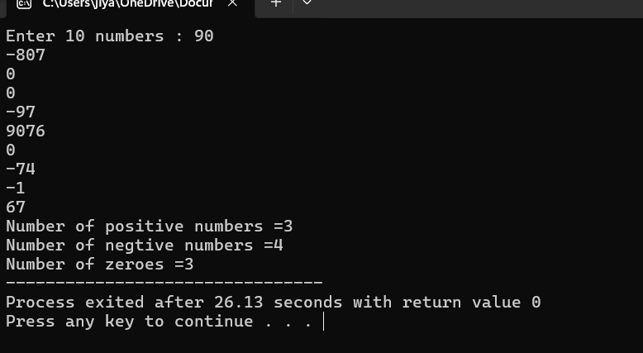
#include<stdio.h>
int main()
{
int a[10],i,countpos=0,countneg=0,countzero=0;
printf("Enter 10 numbers : ");
for(i=0;i<10;i++)
{
scanf("%d",&a[i]);

if(a[i]>0)
{
countpos++;
}
if(a[i]<0)
{
countneg++;
}
if(a[i]==0)
{
countzero++;
}
}

printf("Number of positive numbers =%d\n",countpos);
printf("Number of negtive numbers =%d\n",countneg);
printf("Number of zeroes =%d",countzero);
}
Question-46
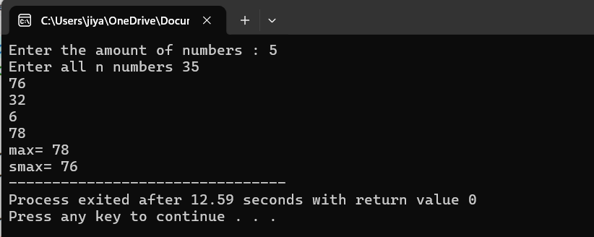
#include<stdio.h>
int main()
{
int max,smax,i,n;
printf("Enter the amount of numbers : ");
scanf("%d",&n);
int a[n];
printf("Enter all n numbers ");
for(i=0;i<n;i++)
{
scanf("%d",&a[i]);
}
max=a[0];
smax=a[0];
for(i=0;i<n;i++)
{
if(a[i]>max)
{
smax=max;
max=a[i];
}
if(a[i]>smax && a[i]<max)
{
smax=a[i];
}
}
printf("max= %d\n",max);
printf("smax= %d",smax);
}

Question-47
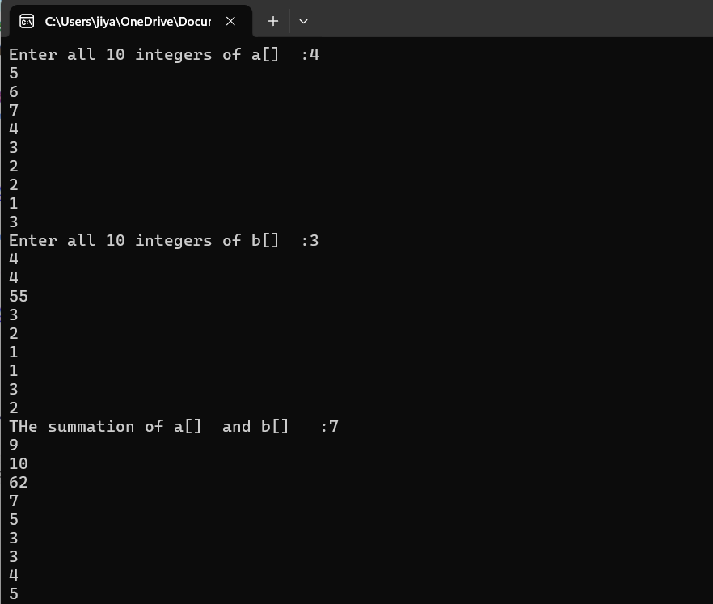
#include<stdio.h>
int main()
{
int a[10],b[10],c[10],i;
printf("Enter all 10 integers of a[] :");
for(i=0;i<10;i++)
{
scanf("%d",&a[i]);
}
printf("Enter all 10 integers of b[] :");
for(i=0;i<10;i++)
{
scanf("%d",&b[i]);
}
for(i=0;i<10;i++)
{
c[i]=a[i]+b[i];
}
printf("THe summation of a[] and b[] :");
for(i=0;i<10;i++)
{
printf("%d\n",c[i]);
}
}

Question-48
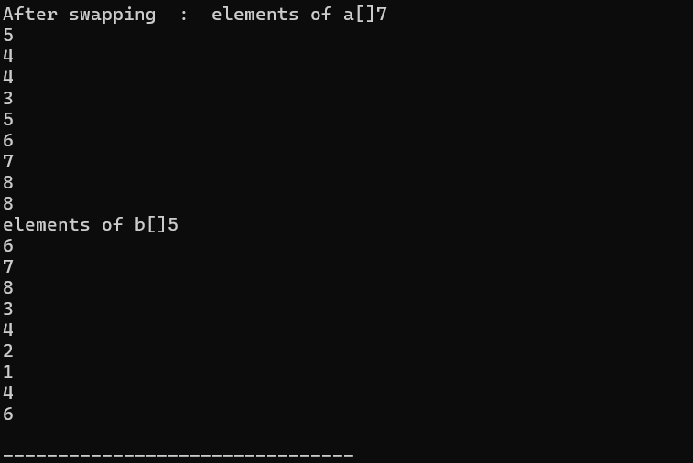
#include<stdio.h>
int main()
{
int a[10],b[10],tamp,i;
printf("Enter all elements of a[] : ");
for (i=0;i<10;i++)
{
scanf("%d",&a[i]);
}
printf("Enter all elements of b[] : ");
for(i=0;i<10;i++)
{
scanf("%d",&b[i]);
}
for(i=0;i<10;i++)
{
printf("%d\n",a[i]);
}
for(i=0;i<10;i++)
{
printf("%d\n",b[i]);
}
for(i=0;i<10;i++)
{
tamp=a[i];
a[i]=b[i];
b[i]=tamp;
}
printf("After swapping : ");
printf("elements of a[]");
for(i=0;i<10;i++)
{
printf("%d\n",a[i]);
}
printf("elements of b[]");
for(i=0;i<10;i++)
{
printf("%d\n",b[i]);
}
}

Question-49
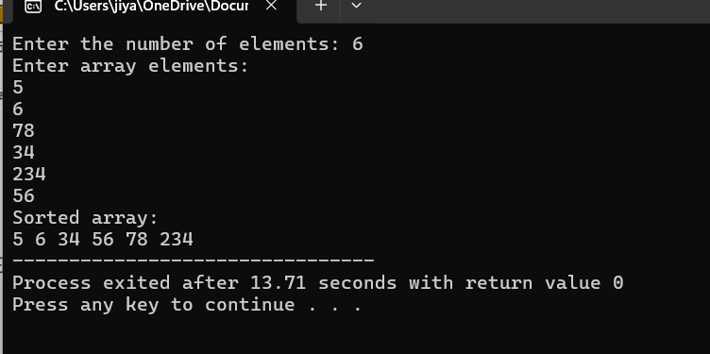
#include <stdio.h>

int main()
{
int a[100],n,i,j,min,temp;

printf("Enter the number of elements: ");
scanf("%d", &n);

printf("Enter array elements:\n");
for(i = 0; i < n; i++)
{
scanf("%d", &a[i]);
}

for(i = 0; i<n-1; i++)
{
min = i;

for(j =i+1;j<n;j++)
{
if(a[j] < a[min])
{
min = j;
}
}

temp = a[i];
a[i] = a[min];
a[min] = temp;
}

printf("Sorted array:\n");
for(i = 0; i < n; i++)
{
printf("%d ", a[i]);
}

return 0;
}
Question-50
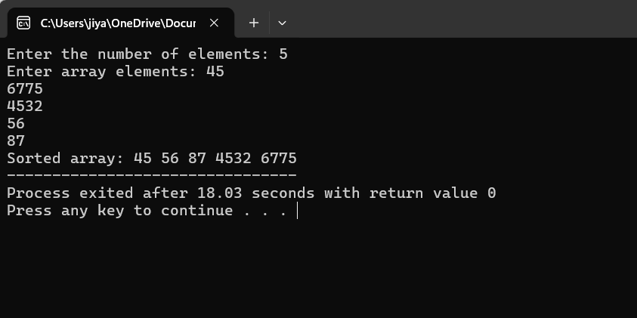
#include <stdio.h>

int main()
{
int a[100], n, i, j, temp;

printf("Enter the number of elements: ");
scanf("%d", &n);

printf("Enter array elements: ");
for(i = 0; i < n; i++)
{
scanf("%d", &a[i]);
}

// Bubble Sort
for(i = 0; i < n-1; i++)
{
for(j = 0; j < n-i-1; j++)
{
if(a[j] > a[j+1])
{
temp = a[j];
a[j] = a[j+1];
a[j+1] = temp;
}
}
}

printf("Sorted array: ");
for(i = 0; i < n; i++)
{
printf("%d ", a[i]);
}

return 0;
}
Question-51
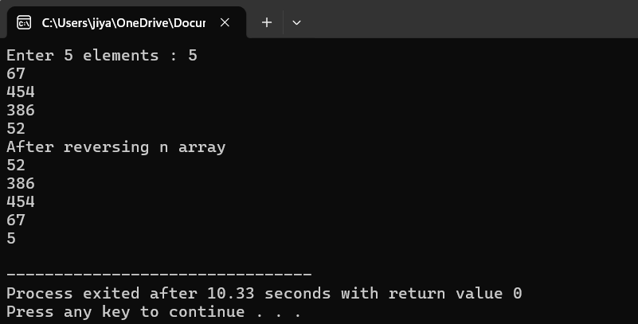
#include<stdio.h>
int main()
{
int a[5],i;
printf("Enter 5 elements : ");
for(i=0;i<5;i++)
{
scanf("%d",&a[i]);
}

printf("After reversing n array \n");
for(i=4;i>=0;i--)
{
printf("%d",a[i]);
printf("\n");
}
}
Question-52
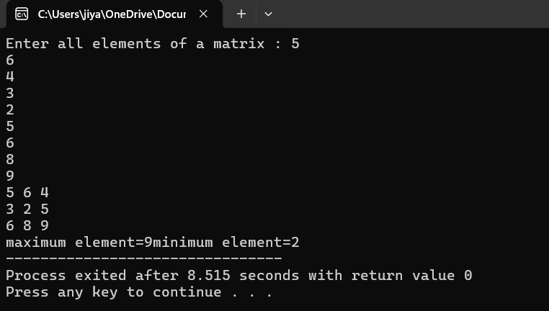
#include<stdio.h>
int main()
{
int a[3][3],i,j,max,min;
printf("Enter all elements of a matrix : ");
for(i=0;i<3;i++)
{
for(j=0;j<3;j++)
{
scanf("%d",&a[i][j]);
}
}

for(i=0;i<3;i++)
{
for(j=0;j<3;j++)
{
printf("%d",a[i][j]);
printf(" ");
}
printf("\n");
}
max=a[0][0];
for(i=0;i<3;i++)
{
for(j=0;j<3;j++)
{
if(a[i][j]>max)
{
max=a[i][j];
}
}
}
printf("maximum element=%d",max);

min=a[0][0];
for(i=0;i<3;i++)
{
for(j=0;j<3;j++)
{
if(a[i][j]<min)
{
min=a[i][j];
}
}
}
printf("minimum element=%d",min);
}
Question-53
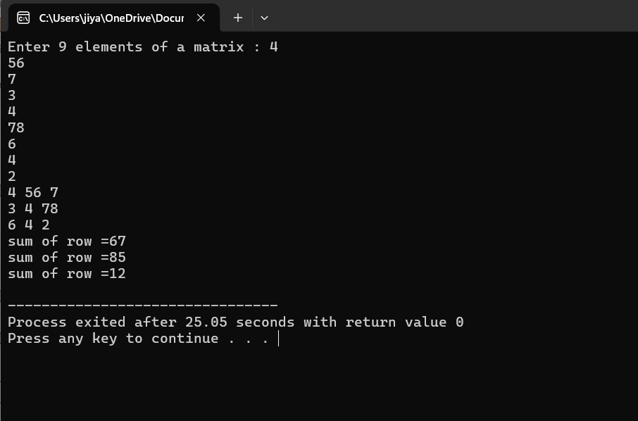
#include<stdio.h>
int main()
{
int a[3][3],i,j,sum=0;
printf("Enter 9 elements of a matrix : ");

for(i=0;i<3;i++)
{
for(j=0;j<3;j++)
{
scanf("%d",&a[i][j]);
}
}

for(i=0;i<3;i++)
{
for(j=0;j<3;j++)
{
printf("%d",a[i][j]);
printf(" ");
}
printf("\n");
}

for(i=0;i<3;i++)
{
for(j=0;j<3;j++)
{
sum=sum+a[i][j];
}
printf("sum of row =%d",sum);
printf("\n");
sum=0;
}
}

Question-54
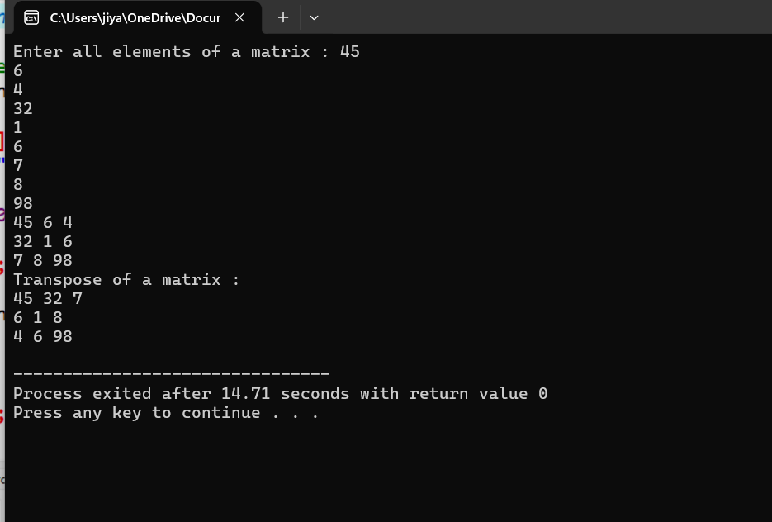
#include<stdio.h>
int main()
{
int a[3][3],i,j;
printf("Enter all elements of a matrix : ");

for (i=0;i<3;i++)
{
for(j=0;j<3;j++)
{
scanf("%d",&a[i][j]);
}
}

for(i=0;i<3;i++)
{
for(j=0;j<3;j++)
{
printf("%d",a[i][j]);
printf(" ");

}
printf("\n");
}
printf("Transpose of a matrix : \n");

for(j=0;j<3;j++)
{
for(i=0;i<3;i++)
{
printf("%d",a[i][j]);
printf(" ");
}
printf("\n");
}
}
Question-55
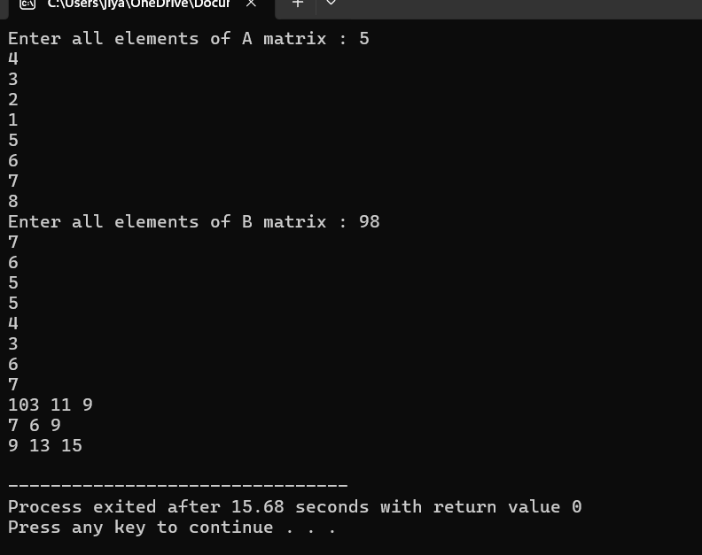
#include<stdio.h>
int main ()
{
int a[3][3],b[3][3],c[3][3],i,j;
printf("Enter all elements of A matrix : ");
for(i=0;i<3;i++)
{
for(j=0;j<3;j++)
{
scanf("%d",&a[i][j]);
}
}

printf("Enter all elements of B matrix : ");
for(i=0;i<3;i++)
{
for(j=0;j<3;j++)
{
scanf("%d",&b[i][j]);
}
}

for(i=0;i<3;i++)
{
for(j=0;j<3;j++)
{
c[i][j]=a[i][j]+b[i][j];
}
}

for(i=0;i<3;i++)
{
for(j=0;j<3;j++)
{
printf("%d",c[i][j]);
printf(" ");
}
printf("\n");
}
}
Question-56
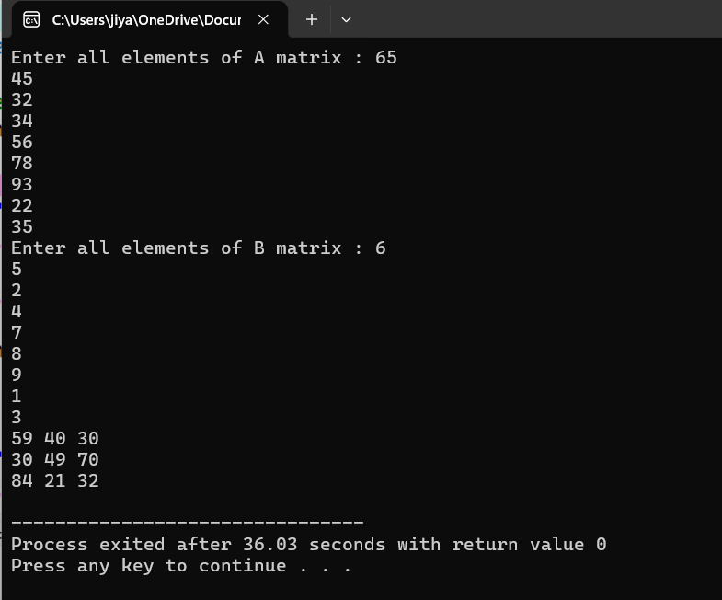
#include<stdio.h>
int main ()
{
int a[3][3],b[3][3],c[3][3],i,j;
printf("Enter all elements of A matrix : ");
for(i=0;i<3;i++)
{
for(j=0;j<3;j++)
{
scanf("%d",&a[i][j]);
}
}

printf("Enter all elements of B matrix : ");
for(i=0;i<3;i++)
{
for(j=0;j<3;j++)
{
scanf("%d",&b[i][j]);
}
}

for(i=0;i<3;i++)
{
for(j=0;j<3;j++)
{
c[i][j]=a[i][j]-b[i][j];
}
}

for(i=0;i<3;i++)
{
for(j=0;j<3;j++)
{
printf("%d",c[i][j]);
printf(" ");
}
printf("\n");
}
}
Question-57
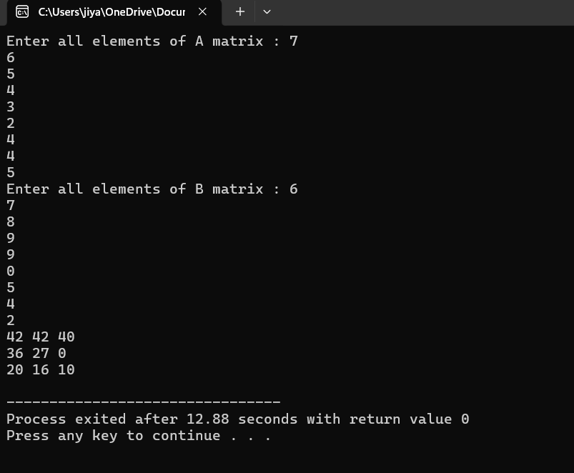
#include<stdio.h>
int main ()
{
int a[3][3],b[3][3],c[3][3],i,j;
printf("Enter all elements of A matrix : ");
for(i=0;i<3;i++)
{
for(j=0;j<3;j++)
{
scanf("%d",&a[i][j]);
}
}

printf("Enter all elements of B matrix : ");
for(i=0;i<3;i++)
{
for(j=0;j<3;j++)
{
scanf("%d",&b[i][j]);
}
}

for(i=0;i<3;i++)
{
for(j=0;j<3;j++)
{
c[i][j]=a[i][j]*b[i][j];
}
}

for(i=0;i<3;i++)
{
for(j=0;j<3;j++)
{
printf("%d",c[i][j]);
printf(" ");
}
printf("\n");
}
}
Question-58
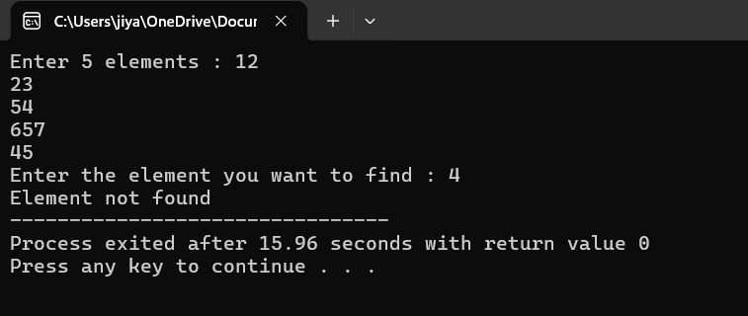
#include<stdio.h>
int main()
{
int a[5],i,j,key,found=0;
printf("Enter 5 elements : ");

for(i=0;i<5;i++)
{
scanf("%d",&a[i]);
}

printf("Enter the element you want to find : ");
scanf("%d",&key);

for(i=0;i<5;i++)
{
if(a[i]==key)
{

found=1;

}
}

if(found==1)
{
printf("Element found ");
}
if(found==0)
{
printf("Element not found ");
}
}
Question-59
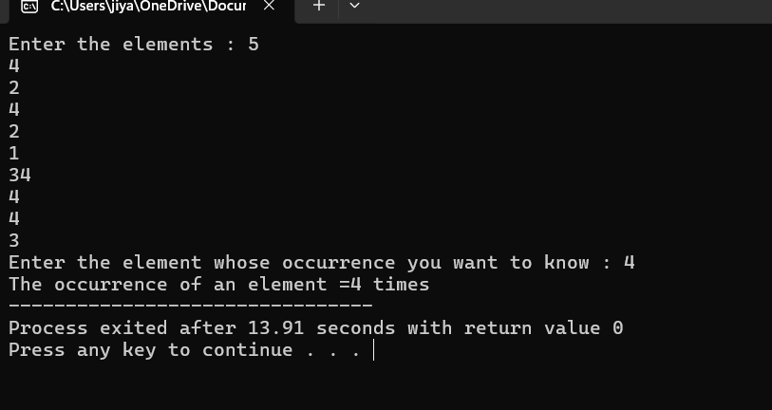
#include<stdio.h>
int main()
{
int a[10],i,j,n,count=0;
printf("Enter the elements : ");
for(i=0;i<10;i++)
{
scanf("%d",&a[i]);
}

printf("Enter the element whose occurrence you want to know : ");
scanf("%d",&n);

for(i=0;i<10;i++)
{
if(a[i]==n)
{
count++;
}
}
printf("The occurrence of an element =%d times ",count);
}

