Question-12
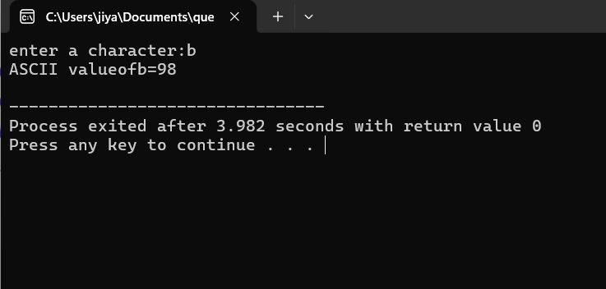

#include<stdio.h>
int main()
{
char ch;
printf("enter a character:");
scanf("%c",&ch);
printf("ASCII valueof%c=%d\n",ch,ch);
return 0;
}

Question-13
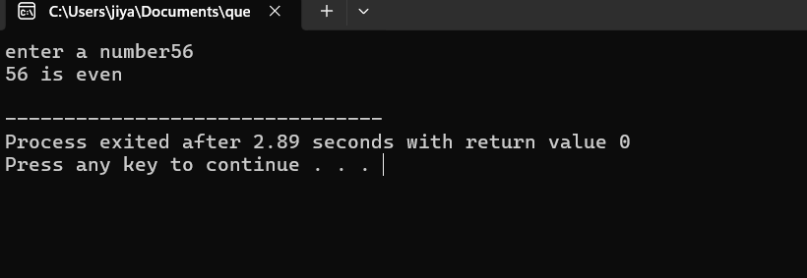
#include<stdio.h>
int main()
{
int number;
printf("enter a number");
scanf("%d",&number);
if (number%2==0)
printf("%d is even\n",number);
else
printf("%d is odd\n",number);
}

Question-14
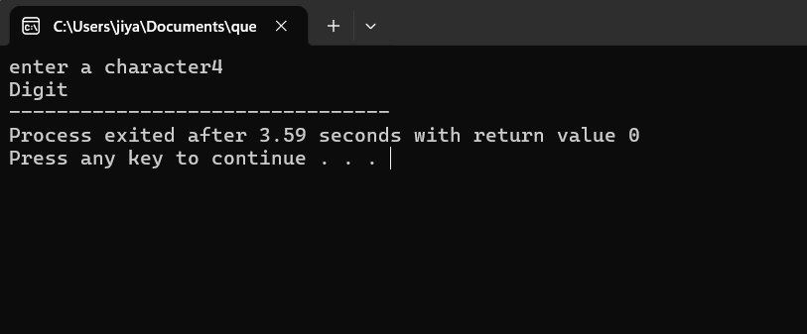
#include<stdio.h>
int main()
{
char ch;
printf("enter a character");
scanf("%c",&ch);
if(ch>='A'&&ch<='Z')
printf("Capital letter");
else if (ch>='a'&&ch<='z')
printf("small letter");
else if(ch>='0'&&ch<='9')
printf("Digit");
else
printf("specific symbol");
}
Question-15
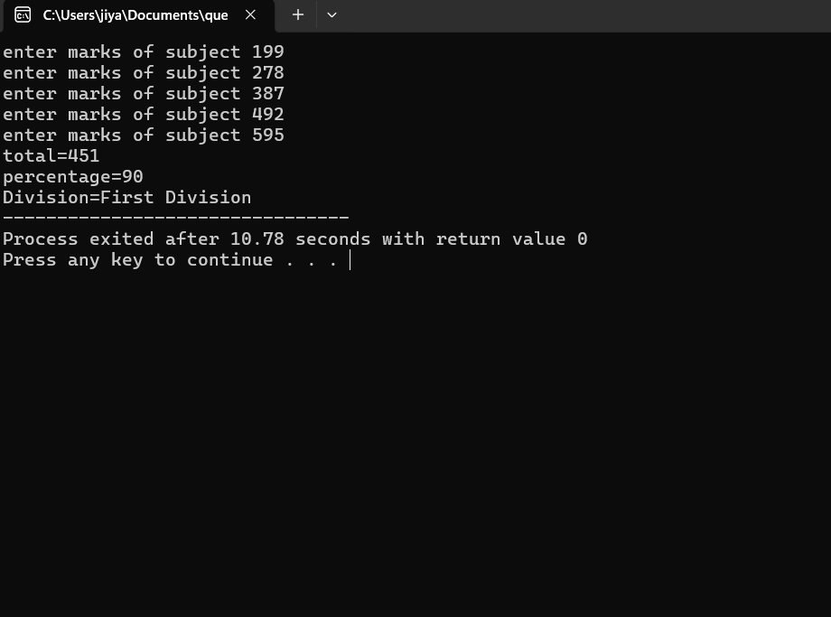
#include<stdio.h>
int main()
{
int m1,m2,m3,m4,m5,total,percentage;
printf("enter marks of subject 1");
scanf("%d",&m1);
printf("enter marks of subject 2");
scanf("%d",&m2);
printf("enter marks of subject 3");
scanf("%d",&m3);
printf("enter marks of subject 4");
scanf("%d",&m4);
printf("enter marks of subject 5");
scanf("%d",&m5);
total=m1+m2+m3+m4+m5;
printf("total=%d\n",total);
percentage=(total*100)/500;
printf("percentage=%d\n",percentage);
if(percentage>=80)
printf("Division=First Division");
else if(percentage>=60)
printf("Division=Second Division");
else if(percentage>=40)
printf("Division=Third Division");
else
printf("Fail");
}
Question-16
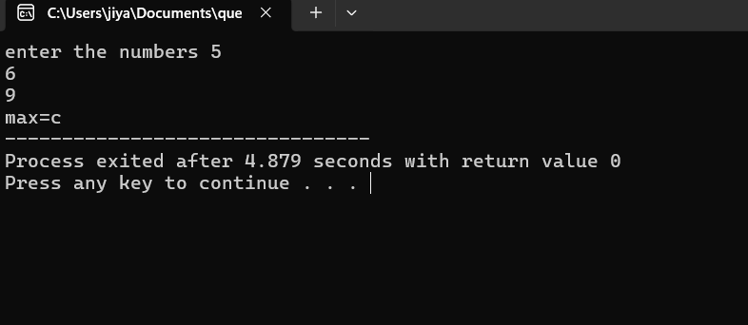
#include<stdio.h>
int main()
{
int a,b,c;
printf("enter the numbers ",a,b,c);
scanf("%d%d%d",&a,&b,&c);
if(a>b)
printf("max=a");
else if (c>a)
printf("max=c");
else
printf("max=b");
}

Question-17
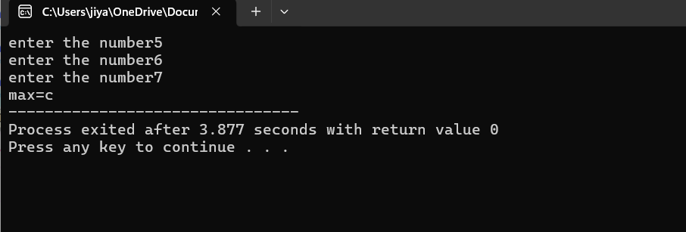
#include<stdio.h>
int main()
{
int a,b,c;
printf("enter the number",a);
scanf("%d,%d,%d",&a);
printf("enter the number",b);
scanf("%d,%d,%d",&b);
printf("enter the number",c);
scanf("%d,%d,%d",&c);
if(a>b&&a>c)
{printf("max=a");}
else if (b>a&&b>c)
{printf("max=b");}
else
{printf("max=c");}
}

Question-18
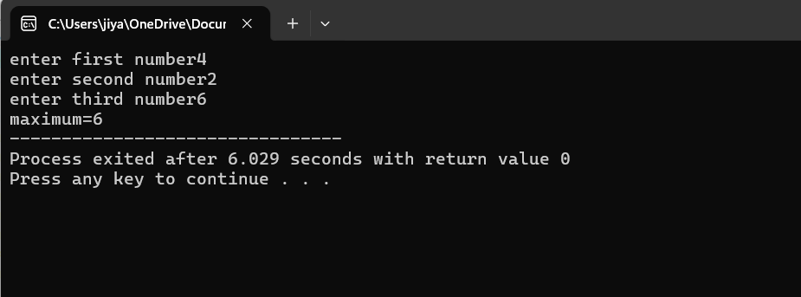
#include<stdio.h>
int main()
{
int a,b,c,max;
printf("enter first number");
scanf("%d",&a);
printf("enter second number");
scanf("%d",&b);
printf("enter third number");
scanf("%d",&c);
max=(a>b)?((a>c)?a:c):((b>c)?b:c);
printf("maximum=%d",max);

}
Question-19
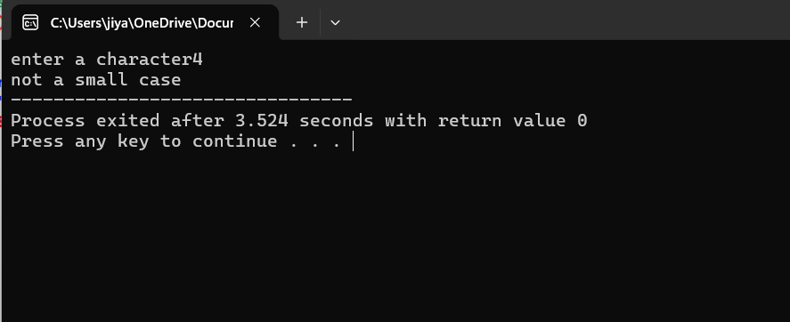
#include<stdio.h>
int main()
{
char ch;
printf("enter a character");
scanf("%c",&ch);
(ch>='a'&&ch<='z')?printf("small case"):printf("not a small case");
}

Question-20
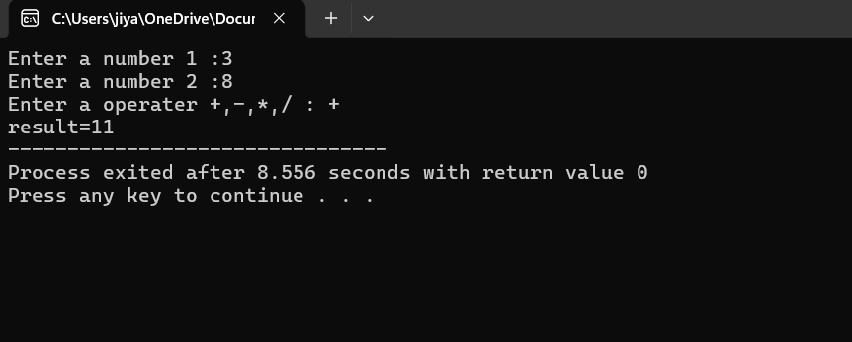
#include<stdio.h>
int main()
{
char op;
float a,b,result;
printf("enter the operator(+,-,*,/) : ",op);
scanf("%c",&op);

printf("enter a and b : ",a,b);
scanf("%d%d",&a,&b);
switch (op)
{
case'+':
printf("result=%d",a+b);
break;
case'-':
printf("result=%d",a-b);
break;
case'*':
printf("result=%d",a*b);
break;
case'/':
if(b!=0)
{
printf("result=%d",a/b);
}

else
{
printf("Cannot divide by zero");
}
break;
default :
{
printf("Invalid operator");
}
}

}

Question-21
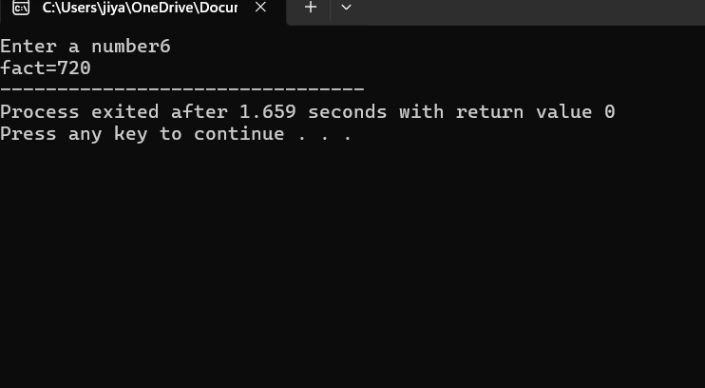
#include<stdio.h>
int main()
{
int n1,n2,result;
char op;
printf("Enter a number 1 :");
scanf("%d",&n1);
printf("Enter a number 2 :");
scanf("%d",&n2);
printf("Enter a operater +,-,*,/ : ");
scanf(" %c",&op);
switch(op)
{
case'+':
result=n1+n2;
printf("result=%d",result);
break;
case'-':
result=n1-n2;
printf("result=%d",result);
break;
case'*':
result=n1*n2;
printf("result=%d",result);
break;
case'/':
result=n1/n2;
printf("result=%d",result);

}
return 0;
}
Question-22
#include<stdio.h>
int main()
{
int n,i;
int fact=1;
printf("Enter a number",n);
scanf("%d",&n);
for(i=1;i<=n;i++)
(fact=fact*i);
printf("fact=%d",fact);
}

Question-23
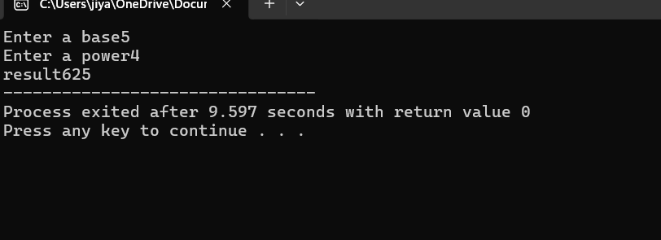
#include<stdio.h>
int main()
{
int b,p,result=1,i;
printf("Enter a base");
scanf("%d",&b);
printf("Enter a power");
scanf("%d",&p);
for(int i=1;i<=p;i++)
{
result=result*b;
}
printf("result%d",result);
}

