CCZG506 - API-driven Cloud Native Solutions
Assignment I
Cloud-based Data Science / Machine Learning Application
Telecom Customer Churn Prediction
(Data Pipeline + ML Pipeline + API Access using Prefect)

Group No: __________
S.No | BITS ID | Name | Contribution %
1
2
3

Index
1. Project Overview 3
2. Sub-Objective 1 - Data Pipeline (8 marks) 3
1.1 Business Understanding 3
1.2 Data Ingestion 3
1.3 Data Pre-processing 4
1.4 Exploratory Data Analysis (EDA) 6
1.5 DataOps - Automation, Scheduling & Dashboard 8
3. Sub-Objective 2 - Machine Learning Pipeline (5 marks) 13
2.1 Model Preparation 13
2.2 Model Training 13
2.3 Model Evaluation 13
2.4 MLOps - Monitoring & Metric Logging 14
4. Sub-Objective 3 - API Access (2 marks) 15
5. How to Run (Appendix) 17

1. Project Overview
This project implements an end-to-end, cloud-native Data Science / Machine Learning application for predicting telecom customer churn. The solution is orchestrated with Prefect, which provides the flows, scheduled deployments, a web dashboard (the cloud dashboard), and a built-in REST API used for the API-access sub-objective.
Technology stack:
- Orchestration / dashboard / API: Prefect 3.8
- Data & ML: pandas, NumPy, scikit-learn
- Visualisation: matplotlib, seaborn
- Dataset: IBM Telco Customer Churn (7,043 records, 21 columns)

2. Sub-Objective 1 - Data Pipeline (8 marks)

1.1 Business Understanding
Customer churn - customers discontinuing their subscription - is a major revenue risk for telecom operators, since acquiring a new customer costs far more than retaining an existing one. The business problem is: given a customer's demographics, account, and service usage attributes, predict whether the customer will churn, so the retention team can target high-risk customers proactively. This is a binary classification problem.

1.2 Data Ingestion
The dataset is the public IBM Telco Customer Churn dataset (also distributed on Kaggle), with 7,043 records and 21 columns covering demographics (gender, SeniorCitizen, Partner, Dependents), account information (tenure, Contract, PaymentMethod, charges), and subscribed services. The target column is 'Churn' (Yes/No). The data pipeline's ingest task loads this CSV, with retries configured for resilience.
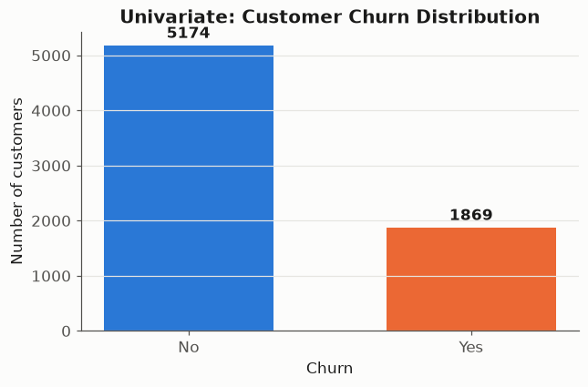
Target class balance: 5,174 'No' vs 1,869 'Yes' (ingested data).

1.3 Data Pre-processing
The following pre-processing activities are automated as Prefect tasks:
- Summary statistics via describe() on numeric features.
- Data types captured for every column.
- Missing-value check before and after processing.
- Inducing missing data: 5% of values in each numeric column (tenure, MonthlyCharges, TotalCharges) are randomly set to NaN to simulate dirty data.
- Imputation of numeric NaNs with the column median.
- Normalisation: Min-Max scaling of numeric columns to [0, 1].
Summary statistics (numeric features):
feature | count | mean | std | min | 25% | 50% | 75% | max
SeniorCitizen | 7043.0000 | 0.1600 | 0.3700 | 0.0000 | 0.0000 | 0.0000 | 0.0000 | 1.0000
tenure | 7043.0000 | 32.3700 | 24.5600 | 0.0000 | 9.0000 | 29.0000 | 55.0000 | 72.0000
MonthlyCharges | 7043.0000 | 64.7600 | 30.0900 | 18.2500 | 35.5000 | 70.3500 | 89.8500 | 118.7500
TotalCharges | 7032.0000 | 2283.3000 | 2266.7700 | 18.8000 | 401.4500 | 1397.4800 | 3794.7400 | 8684.8000
Normalisation preview (original vs _norm columns):
tenure | MonthlyCharges | TotalCharges | tenure_norm | MonthlyCharges_norm | TotalCharges_norm
1.0000 | 29.8500 | 29.8500 | 0.0139 | 0.1141 | 0.0013
34.0000 | 56.9500 | 1889.5000 | 0.4722 | 0.3842 | 0.2159
2.0000 | 53.8500 | 108.1500 | 0.0278 | 0.3533 | 0.0103
45.0000 | 42.3000 | 1840.7500 | 0.6250 | 0.2382 | 0.2102
2.0000 | 70.7000 | 151.6500 | 0.0278 | 0.5212 | 0.0153
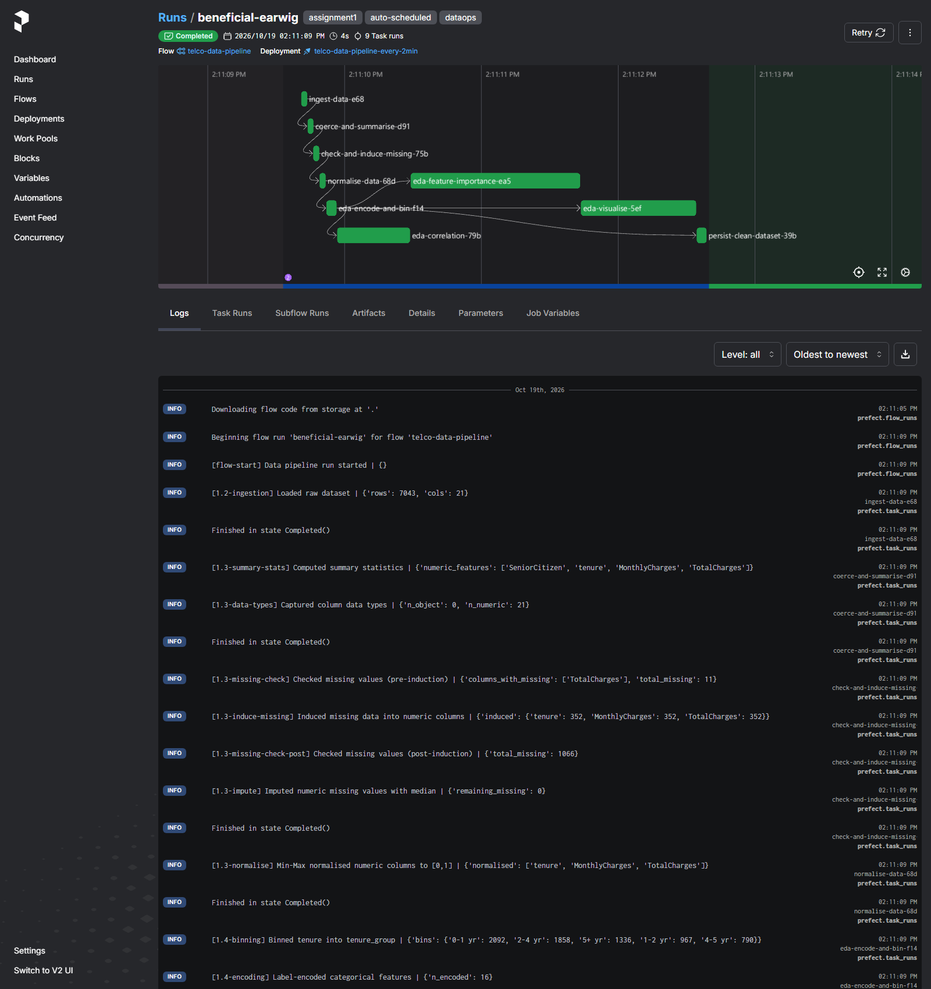
Data-pipeline run on the dashboard - the [1.3-*] log lines show summary stats, data types, the missing-value check, the induced missing data (352 cells per numeric column), median imputation and Min-Max normalisation.

1.4 Exploratory Data Analysis (EDA)
EDA activities, all automated inside the data pipeline:
- Correlation coefficients across all (encoded) features.
- Correlation of numeric & categorical features with churn.
- Binning: 'tenure' grouped into bands (0-1 yr ... 5+ yr).
- Encoding: label-encoding of categorical features.
- Feature importance via a Random Forest.
- Univariate & bivariate visualisations.
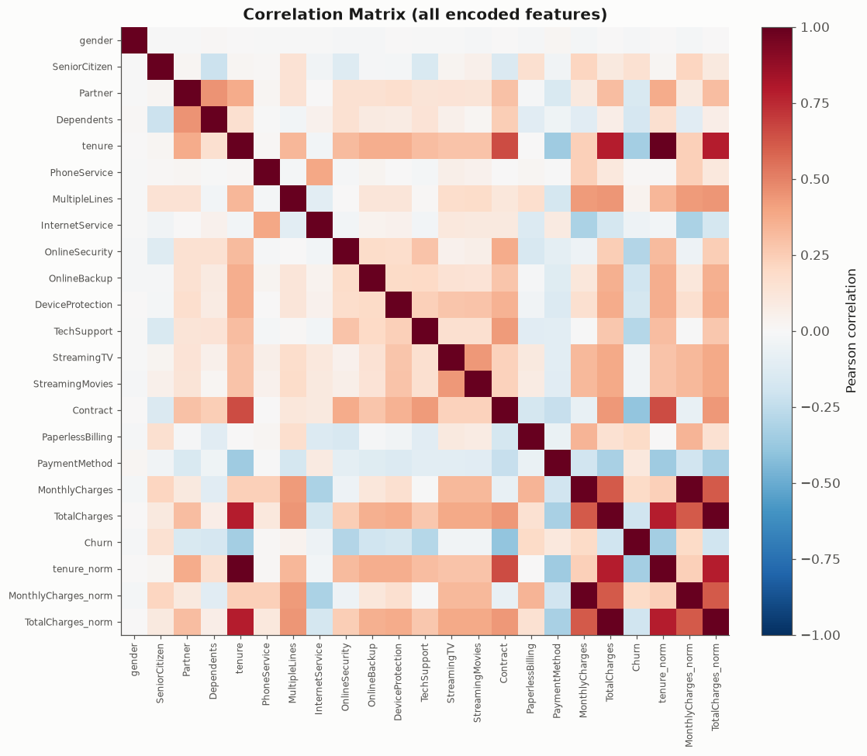
Correlation matrix across all encoded features (diverging palette).
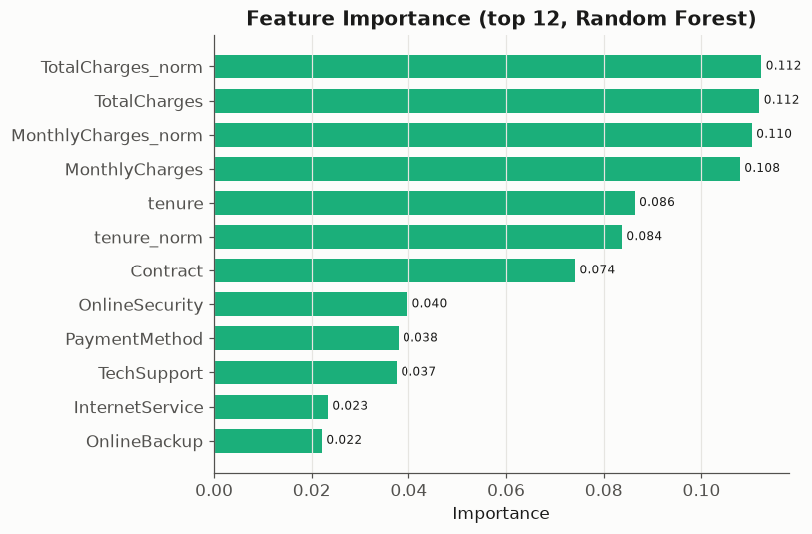
Random-Forest feature importance (top features w.r.t. churn).
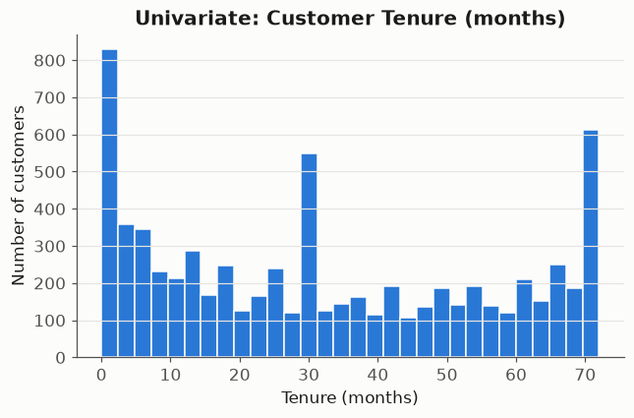
Univariate analysis: distribution of customer tenure.
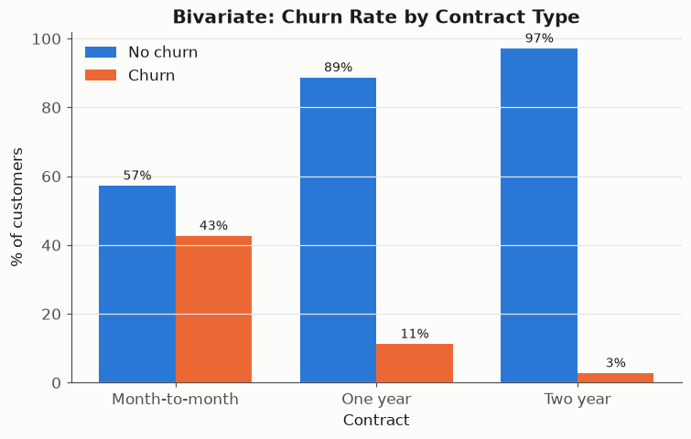
Bivariate analysis: churn rate by contract type (month-to-month customers churn far more).
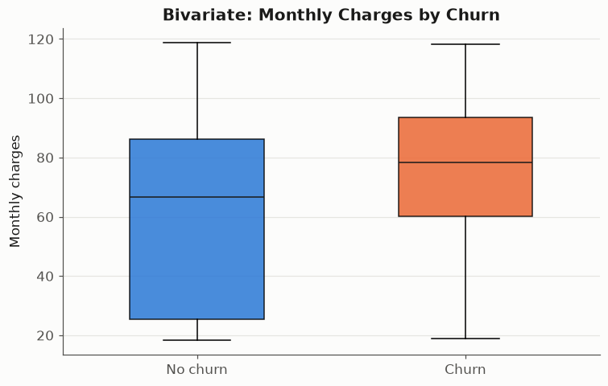
Bivariate analysis: monthly charges by churn outcome.

1.5 DataOps - Automation, Scheduling & Dashboard
Steps 1.3 and 1.4 are implemented as tasks inside a single Prefect flow (telco-data-pipeline). The flow is served as a deployment with an interval schedule of 2 minutes, so it runs automatically every 2 minutes. Every task logs its activity both to the Prefect dashboard and to a JSON-lines activity log. The screenshots below show the scheduled runs on the Prefect cloud dashboard.
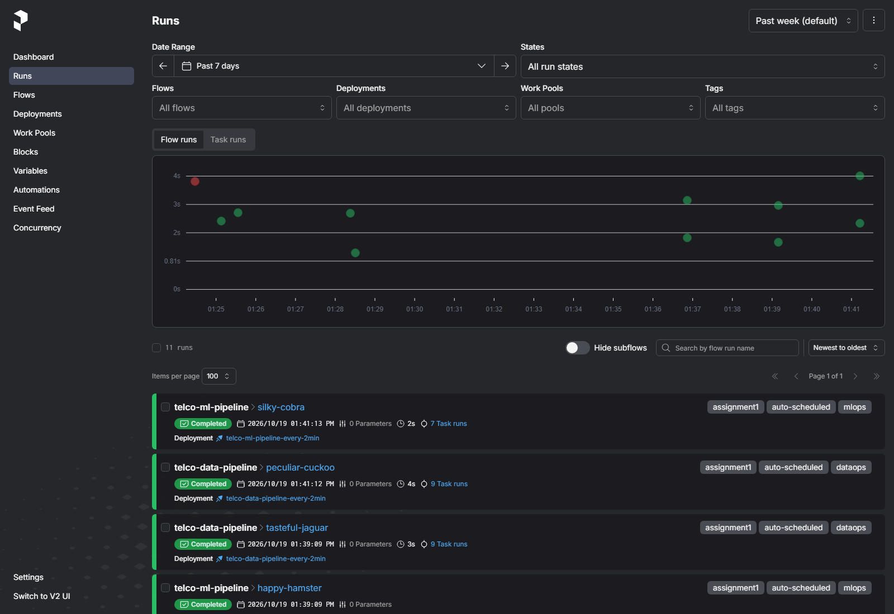
Prefect dashboard - flow runs auto-scheduled every 2 minutes (note the 'auto-scheduled' tag and 2-minute spacing).
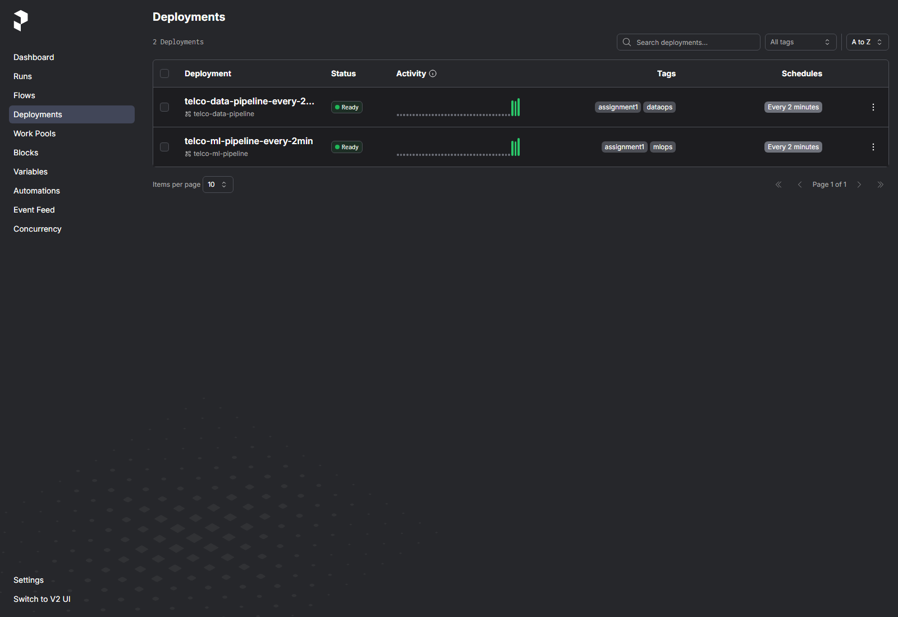
Prefect dashboard - the two deployments with their schedules.
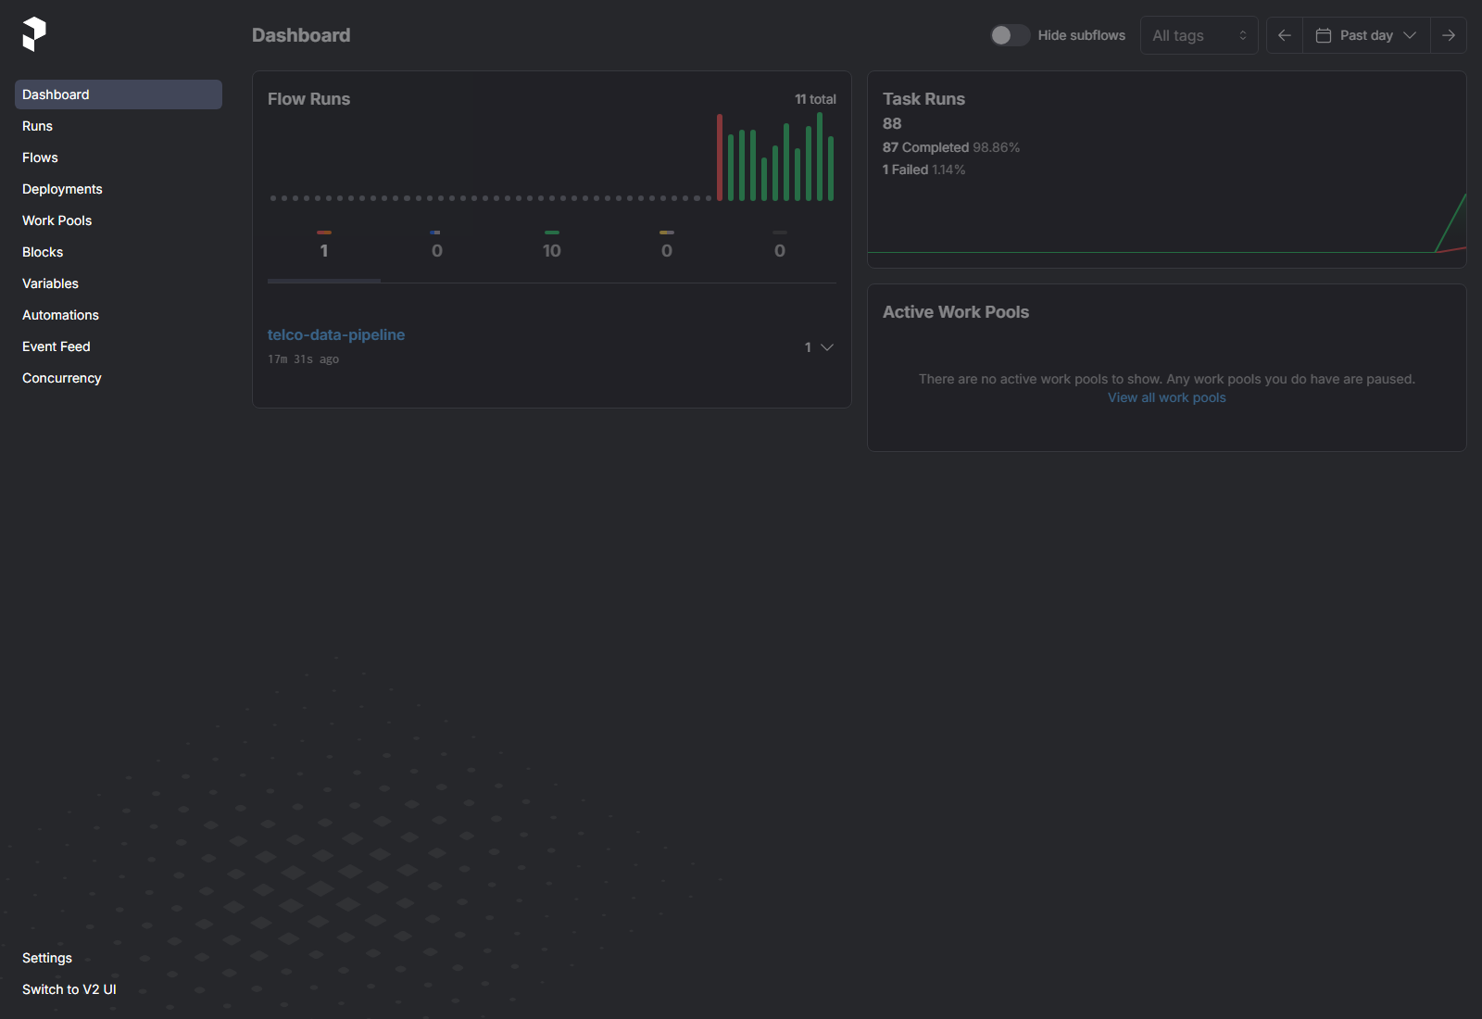
Prefect main dashboard overview.
A single telco-data-pipeline run opened on the dashboard - the task run graph and the per-task activity logs for steps 1.3 and 1.4.

3. Sub-Objective 2 - Machine Learning Pipeline (5 marks)

2.1 Model Preparation
Churn prediction is a binary classification task. Two complementary algorithms were selected: (1) Logistic Regression - a fast, interpretable linear baseline, and (2) Random Forest - a non-linear ensemble that captures feature interactions. Features are label-encoded; Logistic Regression additionally standardises features in a scikit-learn pipeline.

2.2 Model Training
The cleaned dataset is split 70% train / 30% test using a stratified split (preserving the churn ratio) with a fixed random seed for reproducibility. Both models are trained on the training set.

2.3 Model Evaluation
Evaluation on the 30% hold-out test set:
model | accuracy | precision | recall | f1_score | roc_auc
LogisticRegression | 0.7956 | 0.6381 | 0.5312 | 0.5798 | 0.8351
RandomForest | 0.7894 | 0.6368 | 0.4813 | 0.5482 | 0.8208
Best model by F1-score: LogisticRegression (F1 = 0.5798, accuracy = 0.7956).
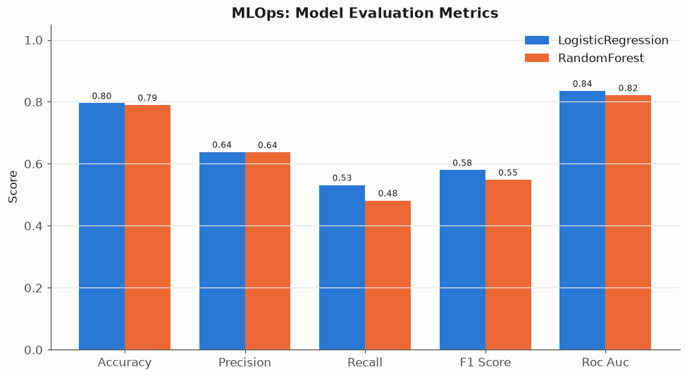
Model evaluation metrics for both algorithms.
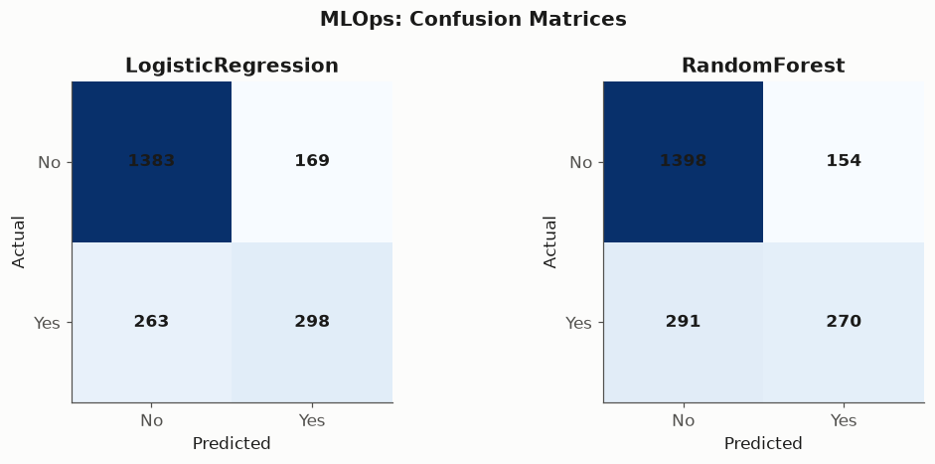
Confusion matrices on the hold-out test set.

2.4 MLOps - Monitoring & Metric Logging
The ML pipeline (telco-ml-pipeline) is also a scheduled Prefect deployment running every 2 minutes. For every run it logs at least four metrics - accuracy, precision, recall, F1-score and ROC-AUC - to the dashboard and appends them to a metrics-history CSV so model performance can be monitored for drift over time.
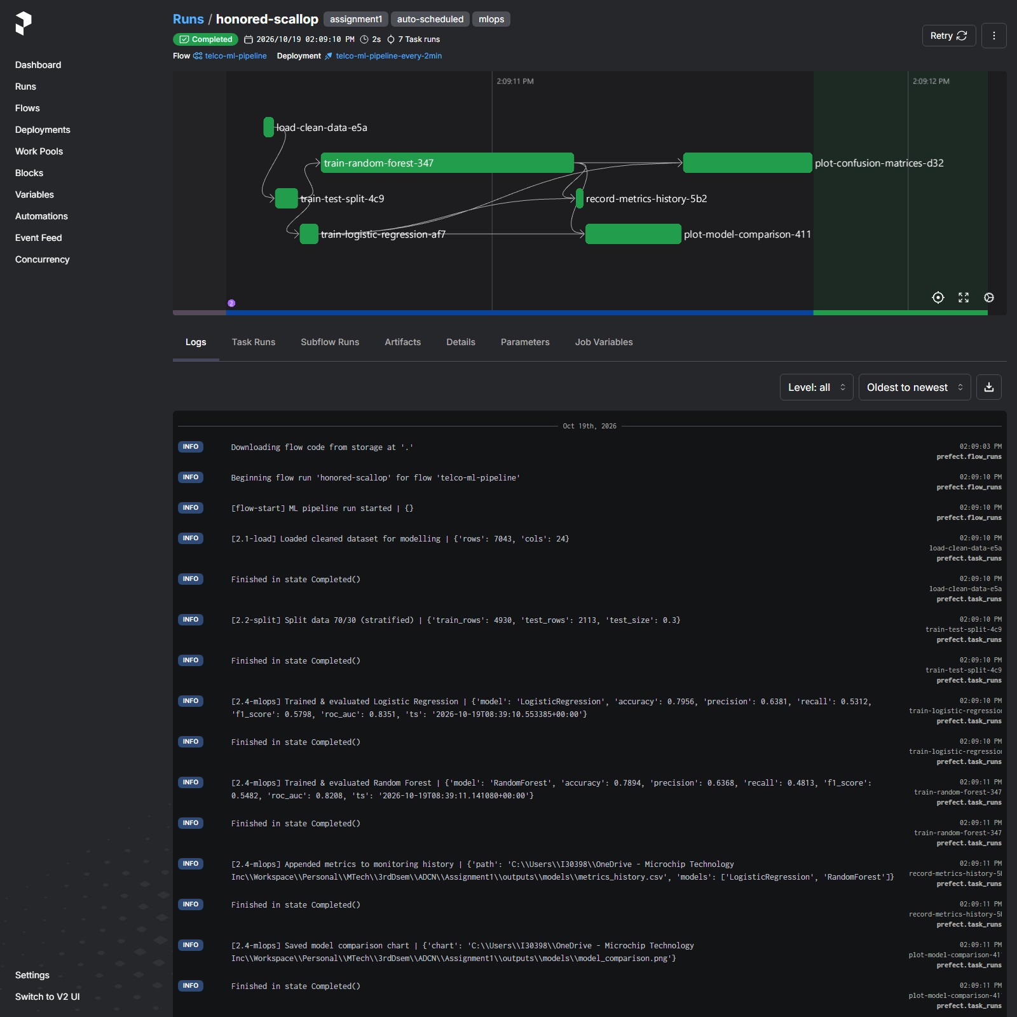
A completed telco-ml-pipeline run on the dashboard - the task graph plus the [2.4-mlops] log lines recording accuracy, precision, recall, F1-score and ROC-AUC for both models.

4. Sub-Objective 3 - API Access (2 marks)
Key application details are retrieved programmatically using Prefect's built-in REST API (via the official Python client). The script src/api_access.py retrieves and displays the following application details:
- Flows registered: 2
- Deployments (with schedules): 2
- Recent flow runs and their states: 10 shown
- Run statistics: {'total_flow_runs_sampled': 73, 'runs_by_state': {'Completed': 12, 'Failed': 1, 'Scheduled': 60}, 'n_flows': 2, 'n_deployments': 2}
Deployments retrieved via API:
name | paused | schedule | tags
telco-data-pipeline-every-2min | False | every 120s | dataops, assignment1
telco-ml-pipeline-every-2min | False | every 120s | mlops, assignment1
Recent flow runs retrieved via API:
name | state | start_time | total_run_time_s
amiable-skua | Completed | 2026-10-19T08:13:10.414282+00:00 | 1.6357
awesome-pony | Completed | 2026-10-19T08:13:09.419204+00:00 | 2.7247
silky-cobra | Completed | 2026-10-19T08:11:13.092513+00:00 | 1.8920
peculiar-cuckoo | Completed | 2026-10-19T08:11:12.900182+00:00 | 3.2513
tasteful-jaguar | Completed | 2026-10-19T08:09:09.963634+00:00 | 2.4001
happy-hamster | Completed | 2026-10-19T08:09:09.912476+00:00 | 1.3449
smiling-lorikeet | Completed | 2026-10-19T08:06:52.089940+00:00 | 2.5527
amazing-tortoise | Completed | 2026-10-19T08:06:52.059657+00:00 | 1.4758
black-impala | Completed | 2026-10-19T07:58:30.858827+00:00 | 1.0425
marble-pudu | Completed | 2026-10-19T07:58:23.221204+00:00 | 2.1854
Console output of src/api_access.py:
======================================================================
PREFECT BUILT-IN API - KEY APPLICATION DETAILS
Retrieved at: 2026-10-19T08:13:20.122023+00:00
======================================================================
[1] FLOWS (2)
- telco-data-pipeline (id=492f87ce...)
- telco-ml-pipeline (id=feb5c52d...)
[2] DEPLOYMENTS (2)
- telco-data-pipeline-every-2min | every 120s [active] | tags=['dataops', 'assignment1']
- telco-ml-pipeline-every-2min | every 120s [active] | tags=['mlops', 'assignment1']
[3] RECENT FLOW RUNS (10)
- amiable-skua state=Completed start=2026-10-19T08:13:10.414282+00:00
- awesome-pony state=Completed start=2026-10-19T08:13:09.419204+00:00
- silky-cobra state=Completed start=2026-10-19T08:11:13.092513+00:00
- peculiar-cuckoo state=Completed start=2026-10-19T08:11:12.900182+00:00
- tasteful-jaguar state=Completed start=2026-10-19T08:09:09.963634+00:00
- happy-hamster state=Completed start=2026-10-19T08:09:09.912476+00:00
- smiling-lorikeet state=Completed start=2026-10-19T08:06:52.089940+00:00
- amazing-tortoise state=Completed start=2026-10-19T08:06:52.059657+00:00
- black-impala state=Completed start=2026-10-19T07:58:30.858827+00:00
- marble-pudu state=Completed start=2026-10-19T07:58:23.221204+00:00
[4] WORK POOLS
[5] RUN STATISTICS
flows=2 deployments=2 runs_sampled=73
runs_by_state={'Completed': 12, 'Failed': 1, 'Scheduled': 60}
======================================================================
Saved full API response to: C:\Users\I30398\OneDrive - Microchip Technology Inc\Workspace\Personal\MTech\3rdDsem\ADCN\Assignment1\outputs\api_details.json
(The full console output above is the live result of running python -m src.api_access against the Prefect API.)

5. How to Run (Appendix)
- pip install -r requirements.txt
- Terminal 1: prefect server start (dashboard at http://127.0.0.1:4200)
- Terminal 2: set PREFECT_API_URL=http://127.0.0.1:4200/api
- python -m src.data_pipeline (run data pipeline once)
- python -m src.ml_pipeline (run ML pipeline once)
- python -m src.deploy (schedule both every 2 min)
- python -m src.api_access (retrieve API details)

