Telecom Customer Churn Prediction
  - CCZG506 API driven Cloud Native Solutions
Assignment I review copy
This project identifies customers at risk of leaving a telecom service. A scheduled Prefect workflow performs data preparation and exploration, then trains and evaluates two classifiers. Prefect APIs expose the application's flows, deployments and execution details.
Group number: ________________
BITS ID | Name | Contribution | %

Execution and evidence
Execution environment: local. Latest completed cycle: 2026-10-25T09:00:20.043240+00:00. The original repository outputs are retained separately from these results.
The evidence in this review demonstrates local execution. Cloud hosting has not yet been demonstrated.

1 Data pipeline

1.1 Business understanding and data ingestion
The business objective is to support retention decisions by predicting customer churn from account, service and demographic attributes. The public IBM Telco Customer Churn dataset contains 7043 records and 21 columns. Churn is a binary Yes or No target; customerID is excluded from model features.
Dataset source: https://raw.githubusercontent.com/IBM/telco-customer-churn-on-icp4d/master/data/Telco-Customer-Churn.csv
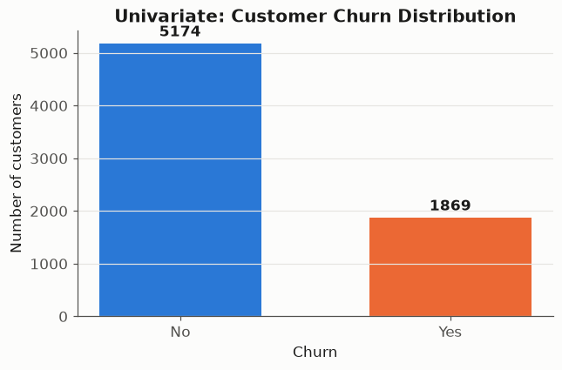
Figure 1 Customer churn class balance

1.2 Preprocessing
The workflow coerces TotalCharges to numeric, identifies missing values, and induces 352 missing entries in each of tenure, MonthlyCharges and TotalCharges using a fixed random seed. Full-data EDA uses median imputation and Min-Max normalisation. The pre-imputation snapshot is passed separately to ML so that test records cannot influence training preprocessing.
Feature | Count | Mean | Std | Min | Max
SeniorCitizen | 7043 | 0.16 | 0.37 | 0.00 | 1.00
tenure | 7043 | 32.37 | 24.56 | 0.00 | 72.00
MonthlyCharges | 7043 | 64.76 | 30.09 | 18.25 | 118.75
TotalCharges | 7032 | 2283.30 | 2266.77 | 18.80 | 8684.80

Column | Data type
customerID | object
gender | object
SeniorCitizen | int64
Partner | object
Dependents | object
tenure | int64
PhoneService | object
MultipleLines | object
InternetService | object
OnlineSecurity | object
OnlineBackup | object
DeviceProtection | object
TechSupport | object
StreamingTV | object
StreamingMovies | object
Contract | object
PaperlessBilling | object
PaymentMethod | object
MonthlyCharges | float64
TotalCharges | float64
Churn | object

Numeric feature | Original example | Normalised example
tenure | 1.00 | 0.0139
MonthlyCharges | 29.85 | 0.1141
TotalCharges | 29.85 | 0.0013

1.3 Exploratory data analysis
Tenure is binned into five bands. Encoding mappings and bin counts are saved. Pearson coefficients are calculated for numeric features and the binary target. Cramer's V measures categorical association without assuming an ordering between category codes. Random Forest exploratory importance is aggregated from one-hot category levels, using each original numeric feature once.
Categorical feature | Association with churn
Contract | 0.410
OnlineSecurity | 0.347
TechSupport | 0.343
tenure_group | 0.341
InternetService | 0.322
PaymentMethod | 0.303

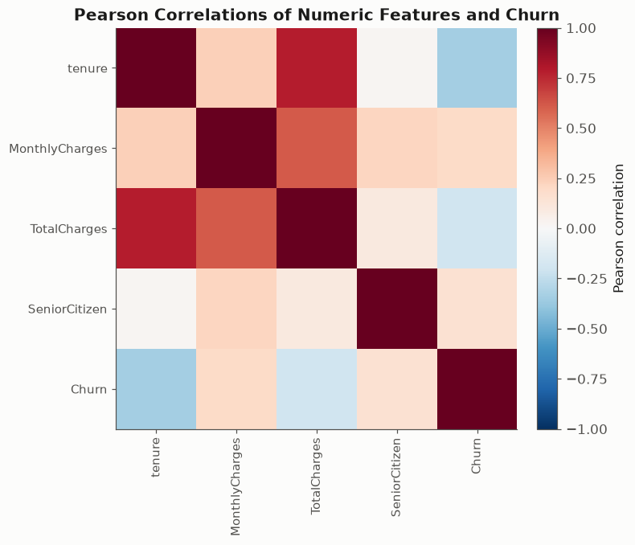
Figure 2 Numeric correlations
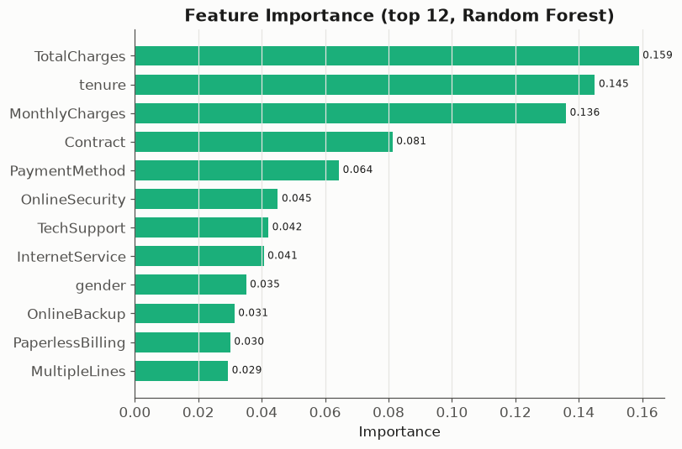
Figure 3 Exploratory feature importance
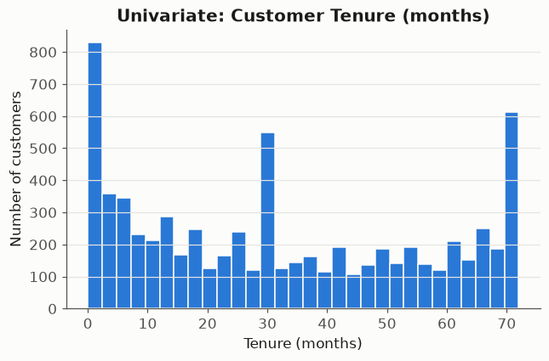
Figure 4 Univariate tenure distribution
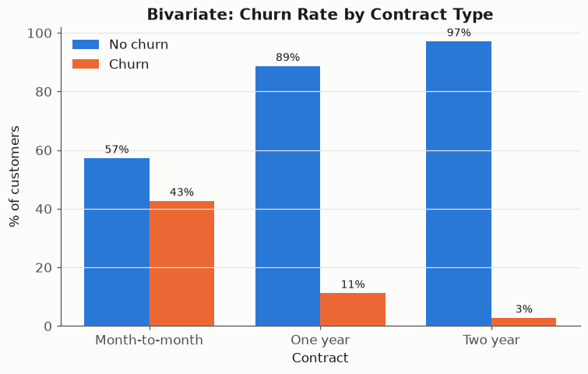
Figure 5 Churn rate by contract
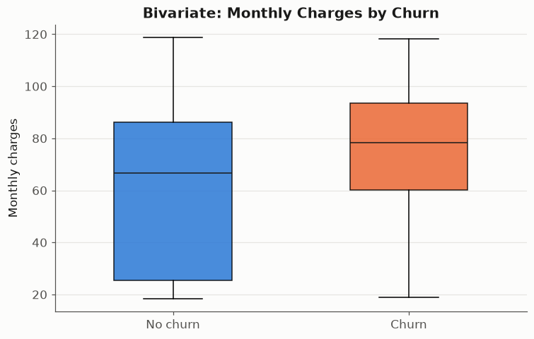
Figure 6 Charges by churn outcome

1.4 DataOps scheduling and monitoring
One deployment runs every 120 seconds with concurrency limited to one cycle. DataOps completes before MLOps starts. Complete files are published by atomic replacement, and cross-process locks protect appended logs. Every task records its activity in the Prefect dashboard and JSONL logs; result tables are also available as Prefect artifacts.
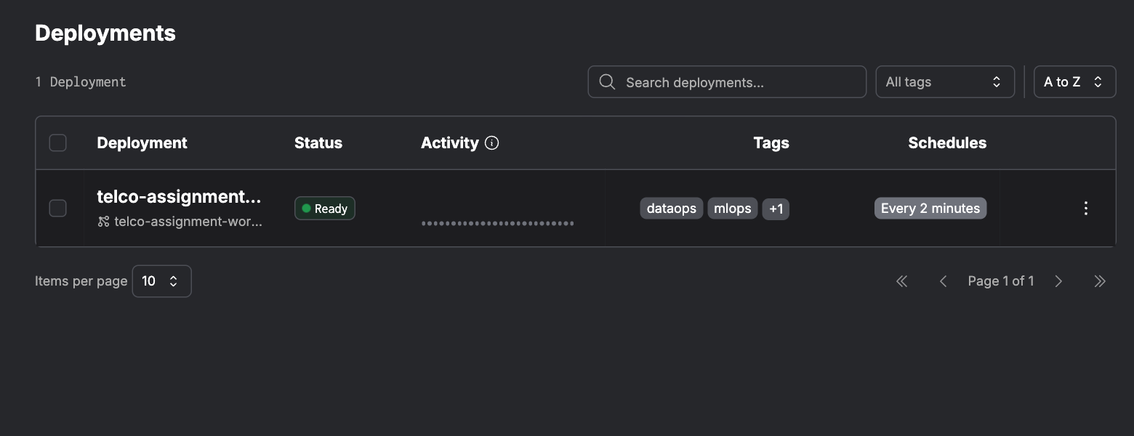
Figure 7 Deployment interval and status
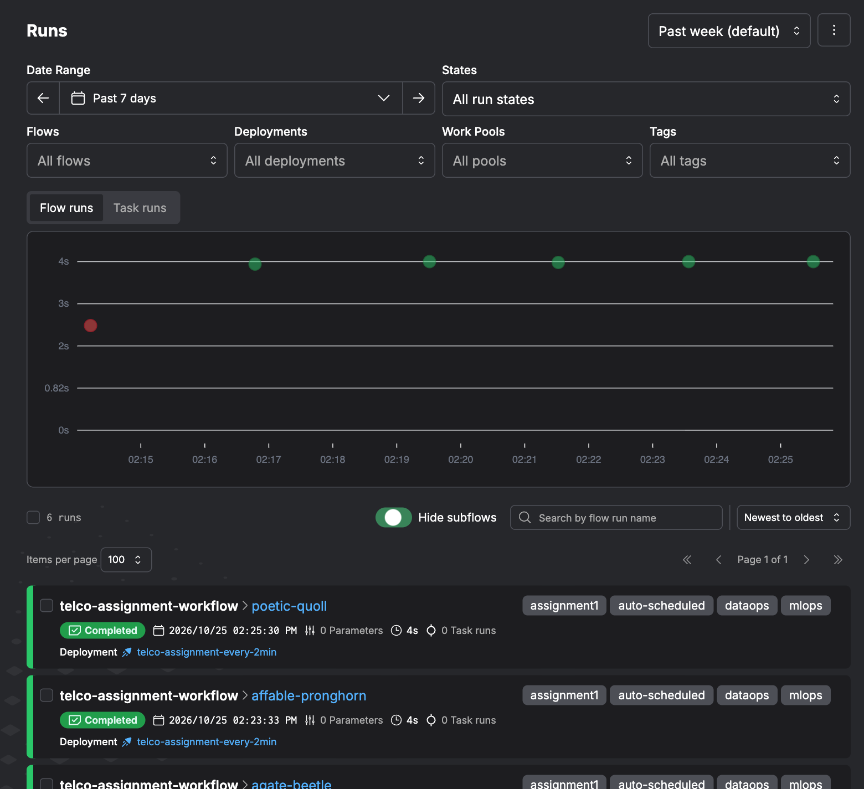
Figure 8 Scheduled execution history
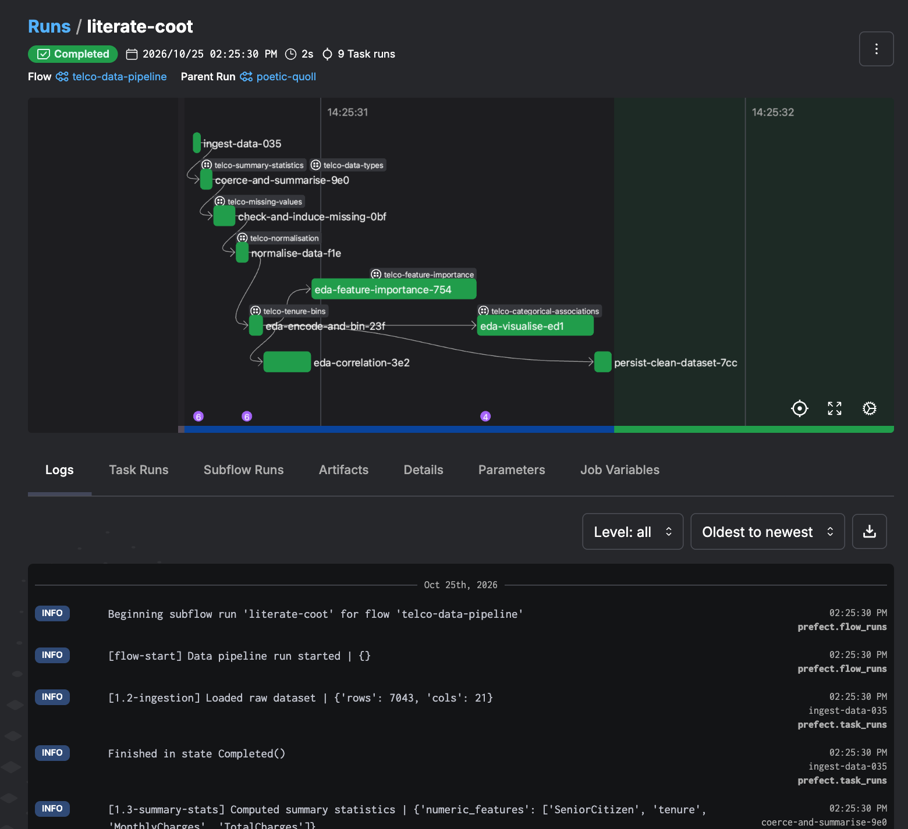
Figure 9 Data preparation activity logs

2 Machine learning pipeline

2.1 Preparation training and evaluation
Logistic Regression provides a linear baseline; Random Forest captures non-linear relationships. A stratified 70/30 split produces 4930 training records and 2113 test records. Each model contains its own fitted preprocessing pipeline: numeric median imputation and standardisation, plus categorical imputation and one-hot encoding. All fitted parameters are learned from training records. Test records are transformed without refitting.
Model | Accuracy | Precision | Recall | F1 | ROC AUC
LogisticRegression | 0.7970 | 0.6435 | 0.5276 | 0.5798 | 0.8403
RandomForest | 0.7851 | 0.6230 | 0.4831 | 0.5442 | 0.8182

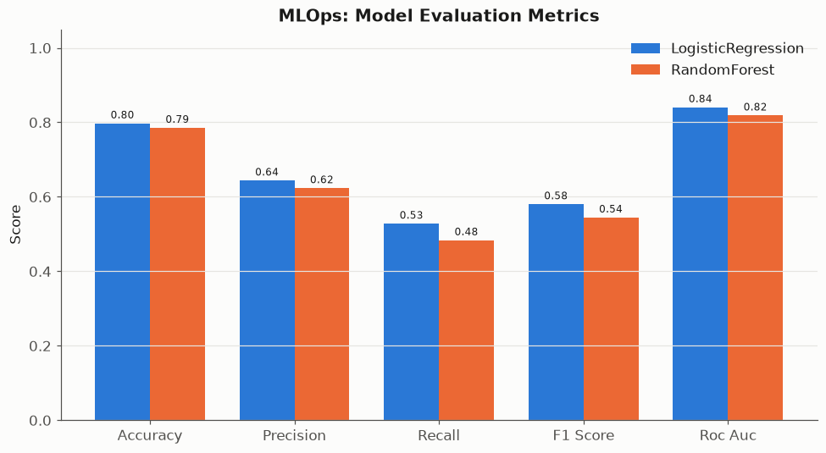
Figure 10 Five metrics for each model
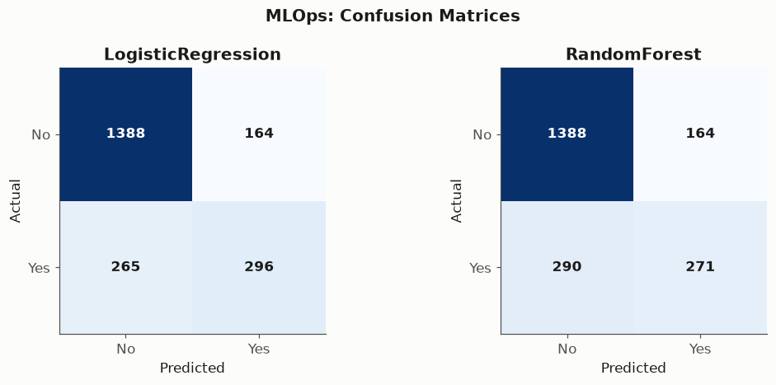
Figure 11 Holdout confusion matrices

2.2 MLOps and interpretation
Every cycle records accuracy, precision, recall, F1 and ROC AUC for both models. The metrics history records timestamps, pipeline version and source fingerprint. Repeating evaluation on this fixed dataset demonstrates monitoring and logging; it does not establish drift detection or performance on a changing production population. Recall measures the proportion of actual churners identified, while precision measures how many flagged customers churn.
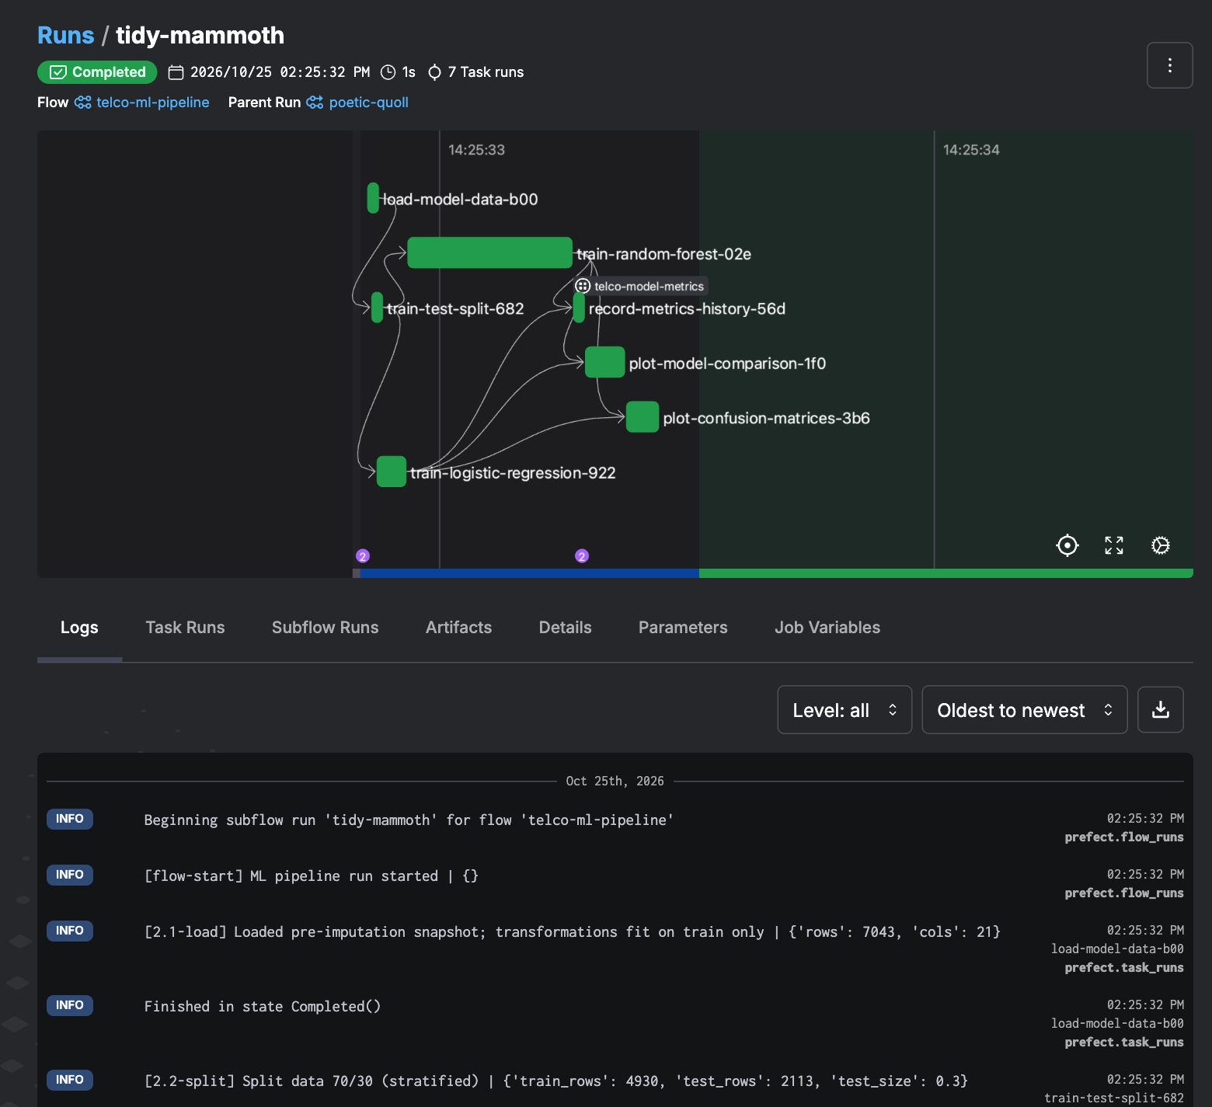
Figure 12 ML task logs and metrics

3 API access
The official Prefect client retrieves details through built-in APIs. Project filters keep unrelated flows out of the evidence. The saved response contains registered flows, deployment schedules and concurrency, recent run states, start times and durations. Aggregate statistics describe a bounded sample of up to 200 project runs and include child flows.
Detail | Retrieved value
Retrieved at | 2026-10-25T08:57:37.903292+00:00
Project flows | telco-assignment-workflow, telco-data-pipeline, telco-ml-pipeline
Deployments | telco-assignment-every-2min
Recent executed runs | 20
Sampled run states | {'Completed': 18, 'Failed': 2, 'Scheduled': 30}

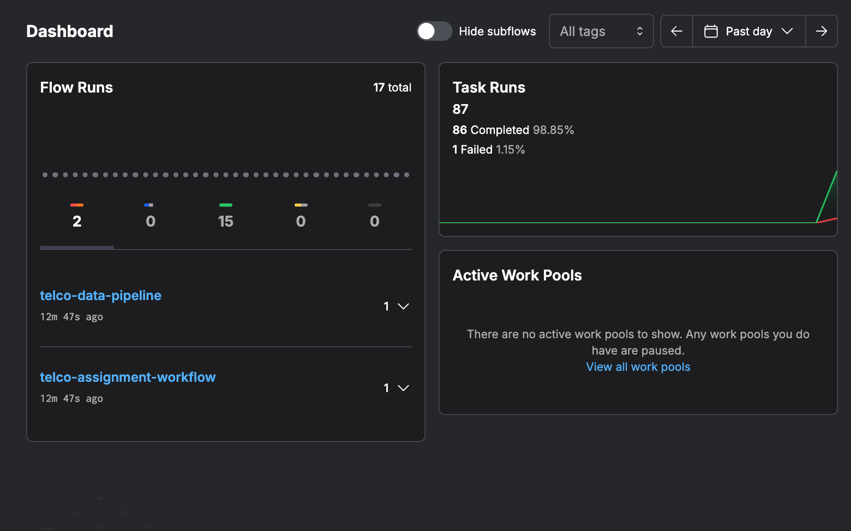
Figure 13 Dashboard overview

4 Reproduction and demonstration
Follow README.md for the tested Python 3.12 setup, local server and scheduled workflow. The local dashboard is at http://127.0.0.1:4207. Run python -m src.api_access to capture current API details. The Docker Compose package provides the same server and runner arrangement for local or cloud VM execution; selecting cloud configuration alone is not proof of deployment.
Dataset SHA256: 16320c9c1ec72448db59aa0a26a0b95401046bef5d02fd3aeb906448e3055e91

