Telecom Customer Churn Prediction
  - CCZG506 API driven Cloud Native Solutions
Assignment I
This project identifies customers at risk of leaving a telecom service. A scheduled Prefect workflow performs data preparation and exploration, then trains and evaluates two classifiers. Prefect APIs expose the application's flows, deployments and execution details.
Group number: 15
BITS ID | Name | Contribution | %
2025MT03009 | Moulik Patra | Workflow architecture, cloud runtime configuration, and Prefect deployment with the 120-second schedule and concurrency controls. | 20
2025MT03071 | Soumyajyoti Biswas | Dataset ingestion and data preparation: missing values, duplicate records, column types, cleaned outputs, and preprocessing logs. | 20
2025MT03141 | Yuvraj Vijay Vedpathak | Exploratory data analysis: descriptive statistics, numeric and categorical distributions, association analysis, and interpretation of visualizations. | 20
2025NT03083 | Ajeet Kumar Yadav | Machine learning: stratified 70/30 split, train-fitted preprocessing, Logistic Regression and Random Forest training, and comparison of five evaluation metrics. | 20
2024MT03582 | Yakkanti Sivaiah | Operational API access, dashboard monitoring, scheduled-run verification, and consolidation of execution evidence and report results. | 20

Execution and evidence
Execution environment: cloud. Latest completed cycle: 2026-10-25T20:52:55.717005+00:00. The original repository outputs are retained separately from these results.
The application ran on the BITS Prayogshala CCZG506 virtual lab, host ip-10-3-21-151.ap-south-1.compute.internal. The frozen output set was captured at 2026-10-25T20:54:12.999641+00:00. Its inventory hashes were verified after transfer.
All 14 functional checks passed. The API recorded 5 completed scheduled parent cycles with a 120-second interval and concurrency of one. Provider and dashboard screenshots were captured later, on 26 October 2026, after services resumed on replacement host ip-10-3-17-92.ap-south-1.compute.internal. The screenshots and frozen results retain their separate capture times.
The verification manifest retains its default local environment label and does not independently certify hosting. Cloud execution is supported by the VM metadata, provider status and application captures together. The dashboard is private and session-bound; the lab's inactivity limits apply.

1 Data pipeline

1.1 Business understanding and data ingestion
The business objective is to support retention decisions by predicting customer churn from account, service and demographic attributes. The public IBM Telco Customer Churn dataset contains 7043 records and 21 columns. Churn is a binary Yes or No target; customerID is excluded from model features.
Dataset source: IBM Telco Customer Churn public dataset.
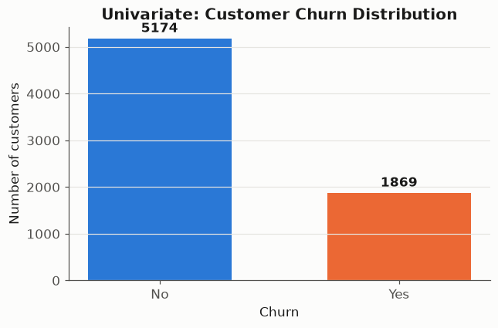
Figure 1 Customer churn class balance

1.2 Preprocessing
The workflow coerces TotalCharges to numeric, identifies missing values, and induces 352 missing entries in each of tenure, MonthlyCharges and TotalCharges using a fixed random seed. Full-data EDA uses median imputation and Min-Max normalisation. The pre-imputation snapshot is passed separately to ML so that test records cannot influence training preprocessing.
Feature | Count | Mean | Std | Min | Max
SeniorCitizen | 7043 | 0.16 | 0.37 | 0.00 | 1.00
tenure | 7043 | 32.37 | 24.56 | 0.00 | 72.00
MonthlyCharges | 7043 | 64.76 | 30.09 | 18.25 | 118.75
TotalCharges | 7032 | 2283.30 | 2266.77 | 18.80 | 8684.80

Column | Data type
customerID | object
gender | object
SeniorCitizen | int64
Partner | object
Dependents | object
tenure | int64
PhoneService | object
MultipleLines | object
InternetService | object
OnlineSecurity | object
OnlineBackup | object
DeviceProtection | object
TechSupport | object
StreamingTV | object
StreamingMovies | object
Contract | object
PaperlessBilling | object
PaymentMethod | object
MonthlyCharges | float64
TotalCharges | float64
Churn | object

Numeric feature | Original example | Normalised example
tenure | 1.00 | 0.0139
MonthlyCharges | 29.85 | 0.1141
TotalCharges | 29.85 | 0.0013

1.3 Exploratory data analysis
Tenure is binned into five bands. Encoding mappings and bin counts are saved. Pearson coefficients are calculated for numeric features and the binary target. Cramer's V measures categorical association without assuming an ordering between category codes. Random Forest exploratory importance is aggregated from one-hot category levels, using each original numeric feature once.
Categorical feature | Association with churn
Contract | 0.410
OnlineSecurity | 0.347
TechSupport | 0.343
tenure_group | 0.341
InternetService | 0.322
PaymentMethod | 0.303

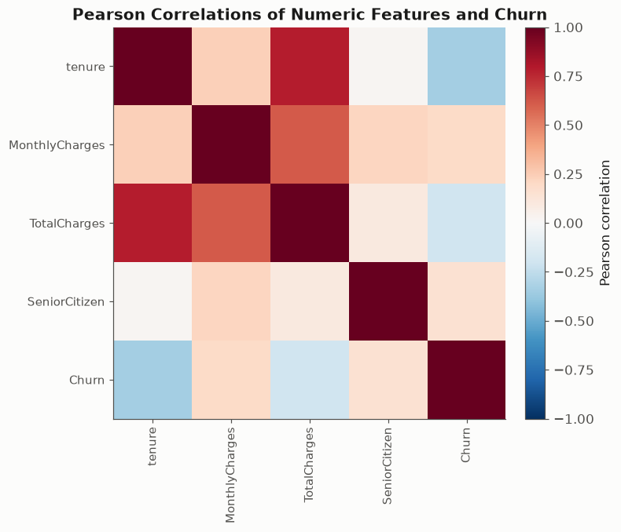
Figure 2 Numeric correlations
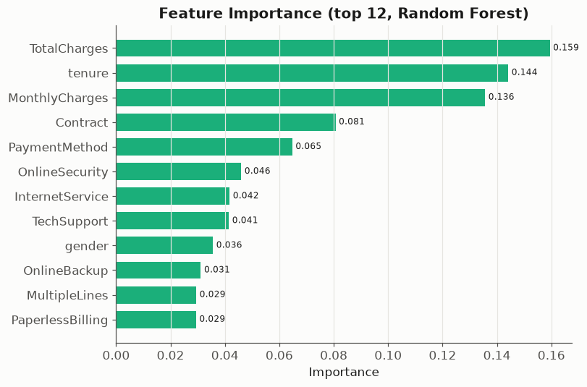
Figure 3 Exploratory feature importance
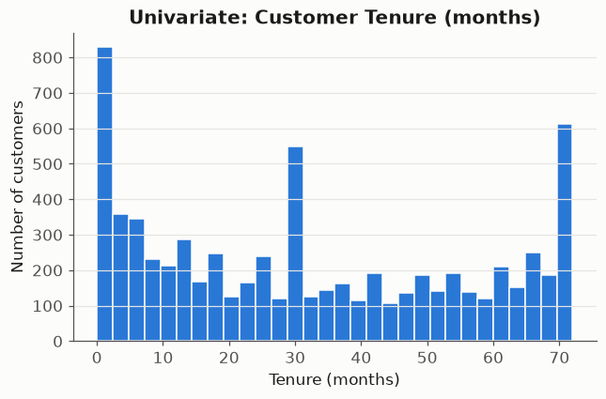
Figure 4 Univariate tenure distribution
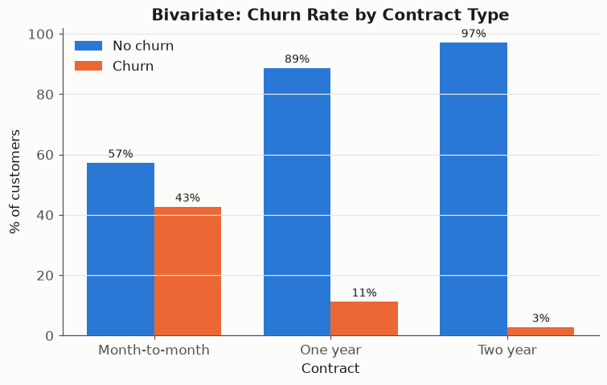
Figure 5 Churn rate by contract
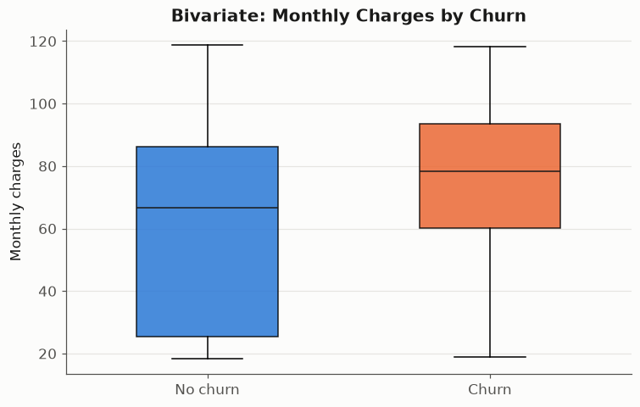
Figure 6 Charges by churn outcome

1.4 DataOps scheduling and monitoring
One deployment runs every 120 seconds with concurrency limited to one cycle. DataOps completes before MLOps starts. Complete files are published by atomic replacement, and cross-process locks protect appended logs. Every task records its activity in the Prefect dashboard and JSONL logs; result tables are also available as Prefect artifacts.
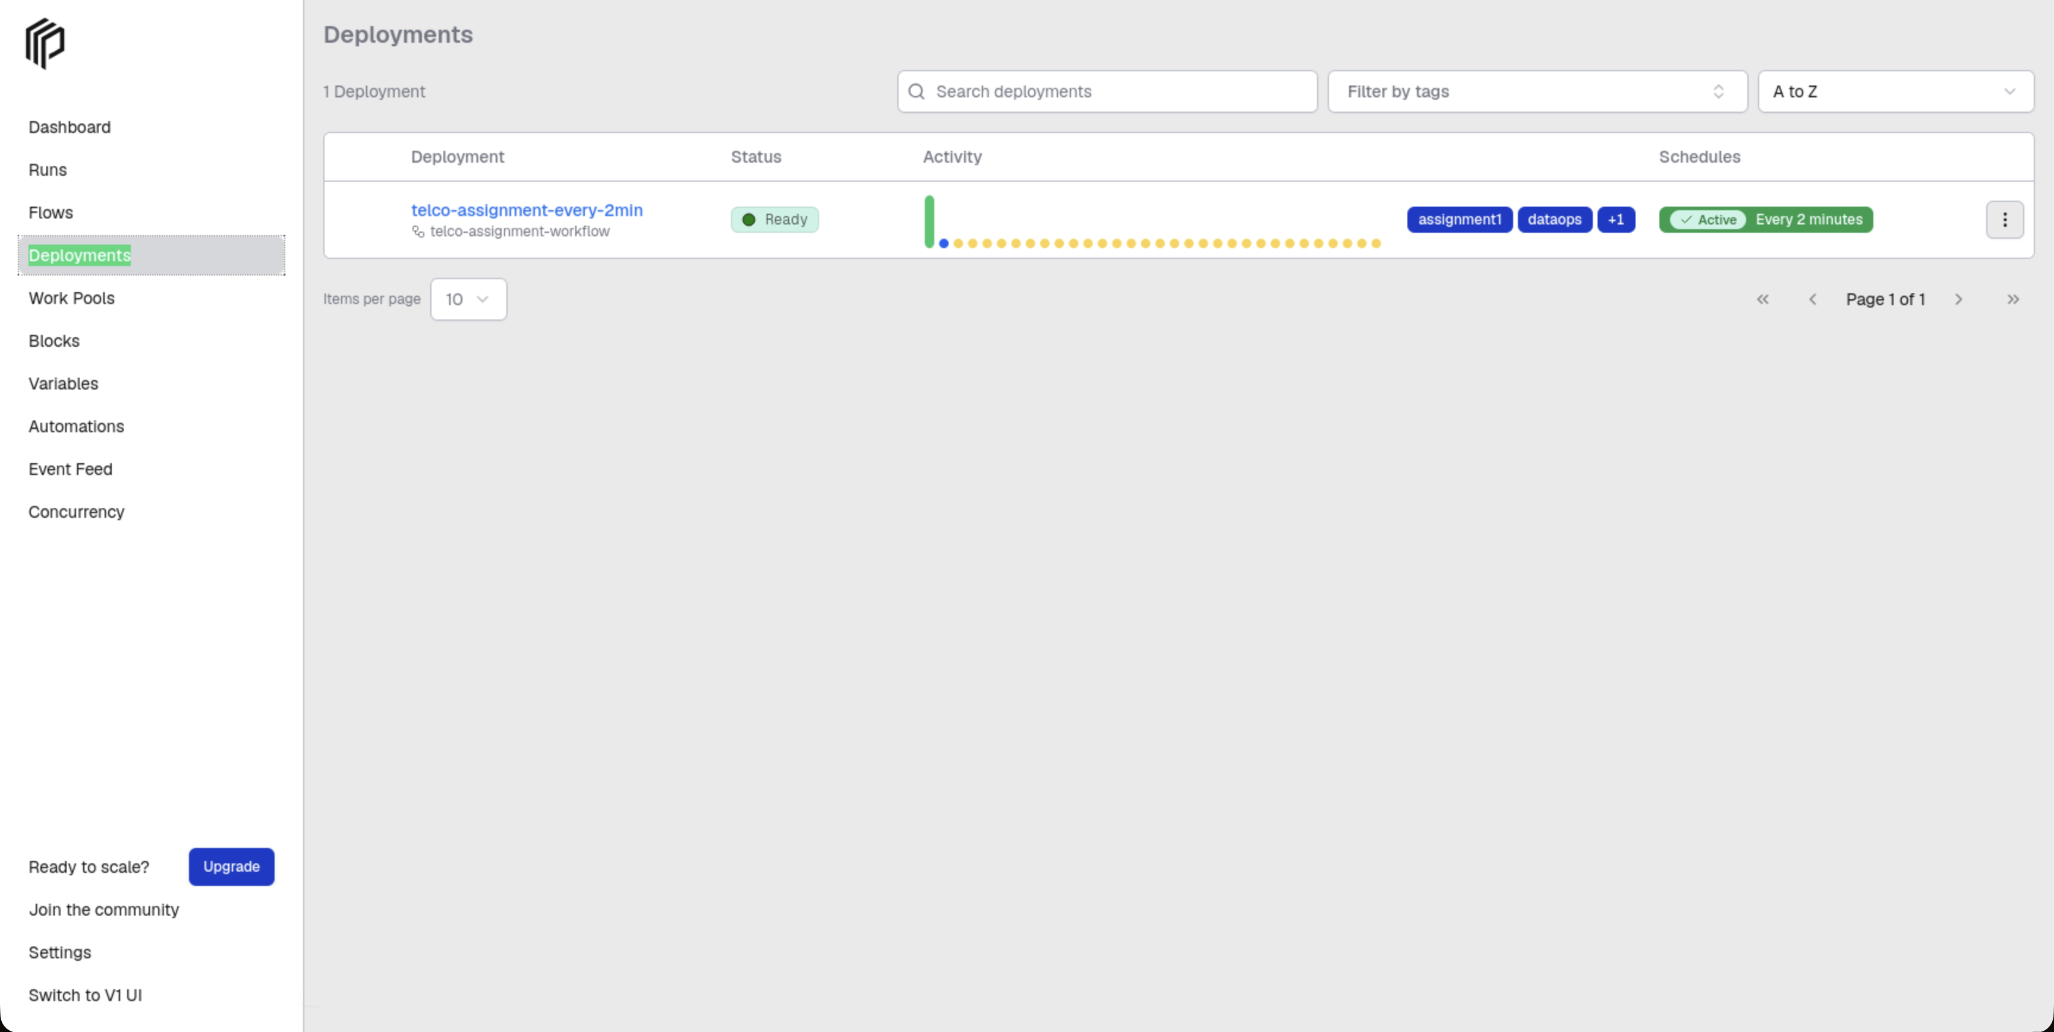
Figure 7 Deployment interval and status
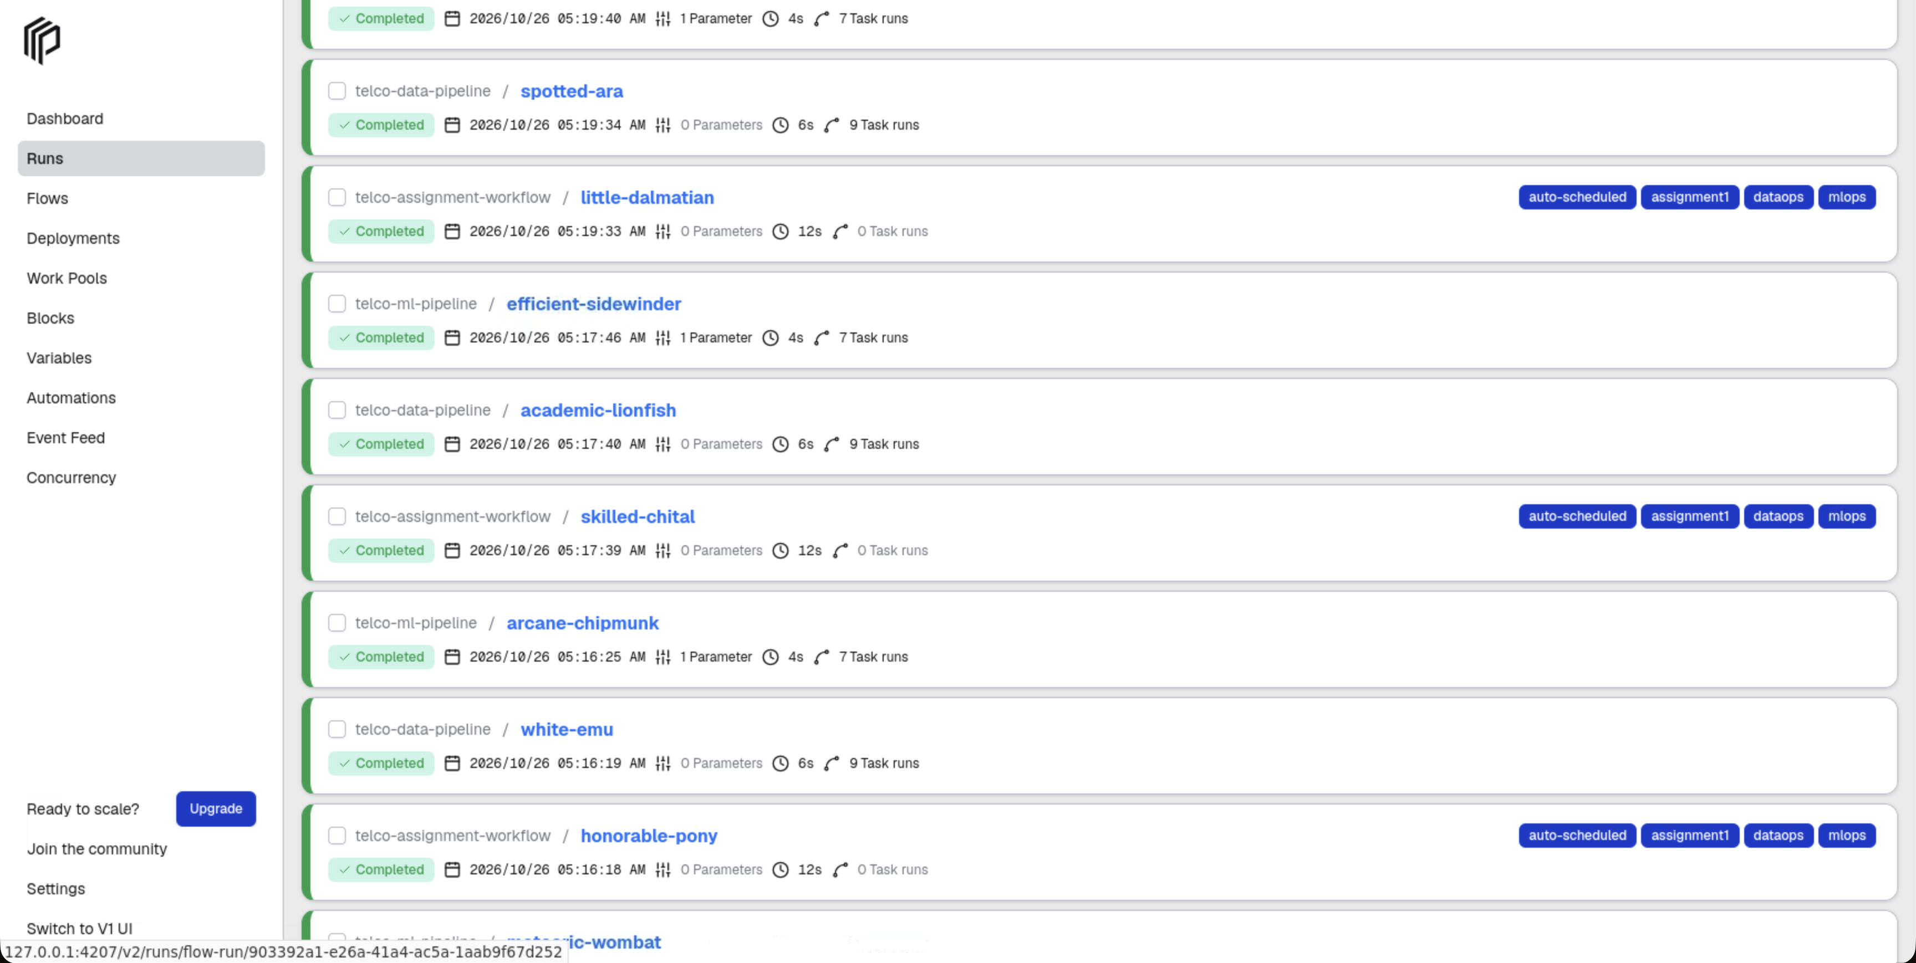
Figure 8 Scheduled execution history
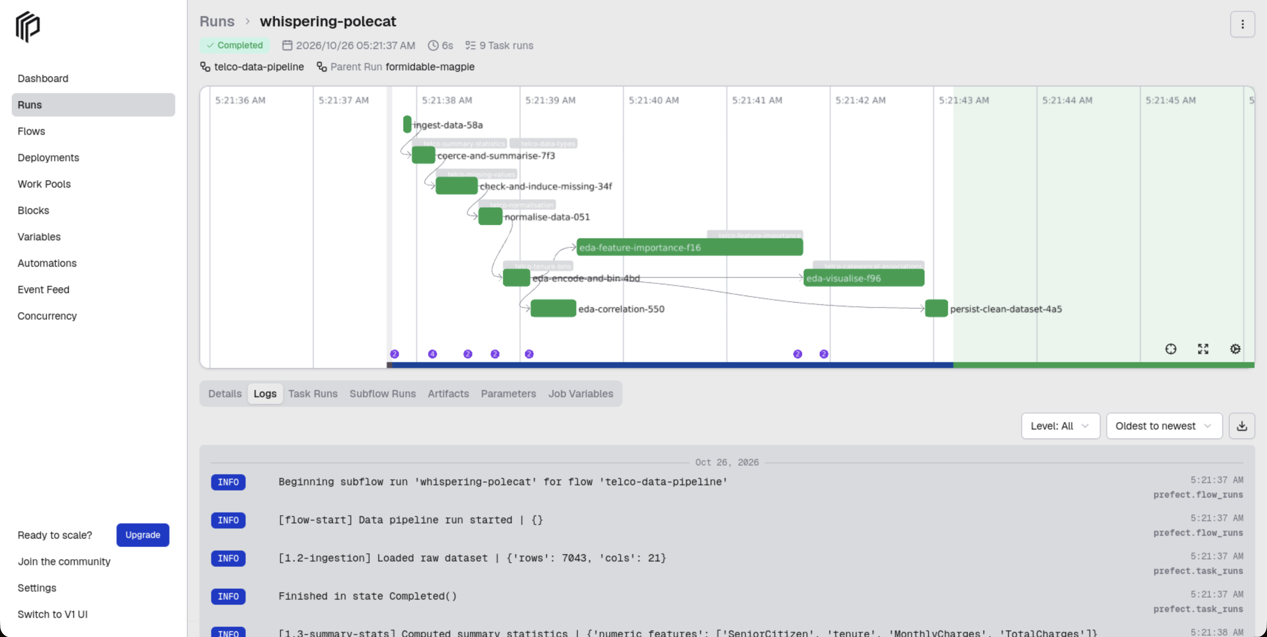
Figure 9 Data preparation activity logs

2 Machine learning pipeline

2.1 Preparation training and evaluation
Logistic Regression provides a linear baseline; Random Forest captures non-linear relationships. A stratified 70/30 split produces 4930 training records and 2113 test records. Each model contains its own fitted preprocessing pipeline: numeric median imputation and standardisation, plus categorical imputation and one-hot encoding. All fitted parameters are learned from training records. Test records are transformed without refitting.
Model | Accuracy | Precision | Recall | F1 | ROC AUC
LogisticRegression | 0.7970 | 0.6435 | 0.5276 | 0.5798 | 0.8403
RandomForest | 0.7847 | 0.6205 | 0.4866 | 0.5455 | 0.8173

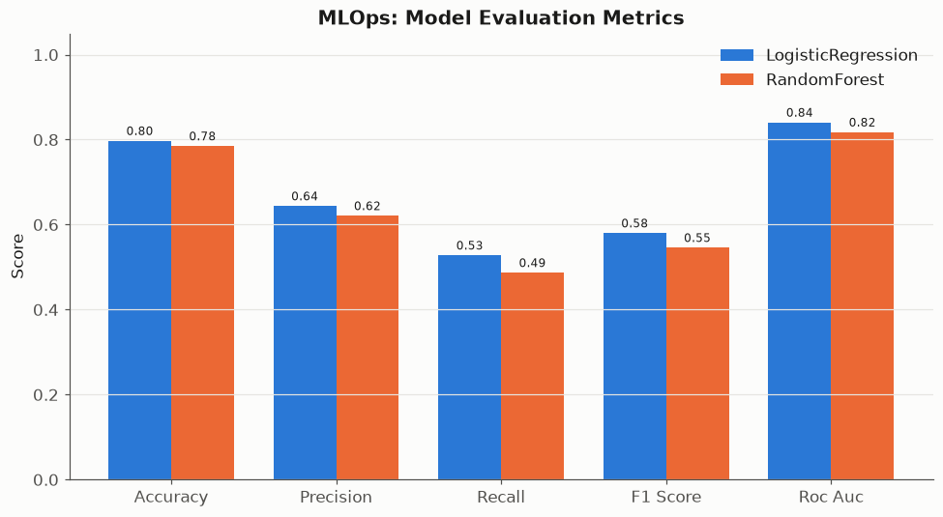
Figure 10 Five metrics for each model
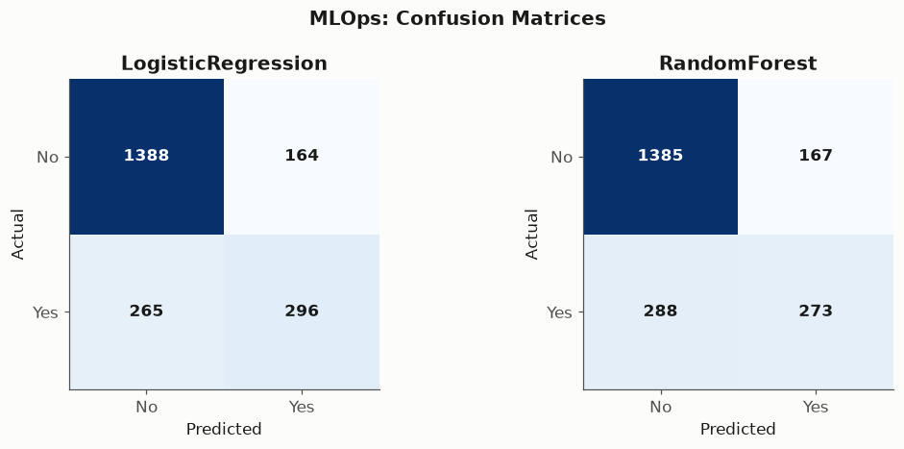
Figure 11 Holdout confusion matrices

2.2 MLOps and interpretation
Every cycle records accuracy, precision, recall, F1 and ROC AUC for both models. The metrics history records timestamps, pipeline version and source fingerprint. Repeating evaluation on this fixed dataset demonstrates monitoring and logging; it does not establish drift detection or performance on a changing production population. Recall measures the proportion of actual churners identified, while precision measures how many flagged customers churn.
LogisticRegression performed better in this holdout comparison, with ROC AUC 0.8403 and recall 0.5276. At the default decision threshold, 47.2% of actual churners were missed. Retention use would require threshold selection and validation on later data.
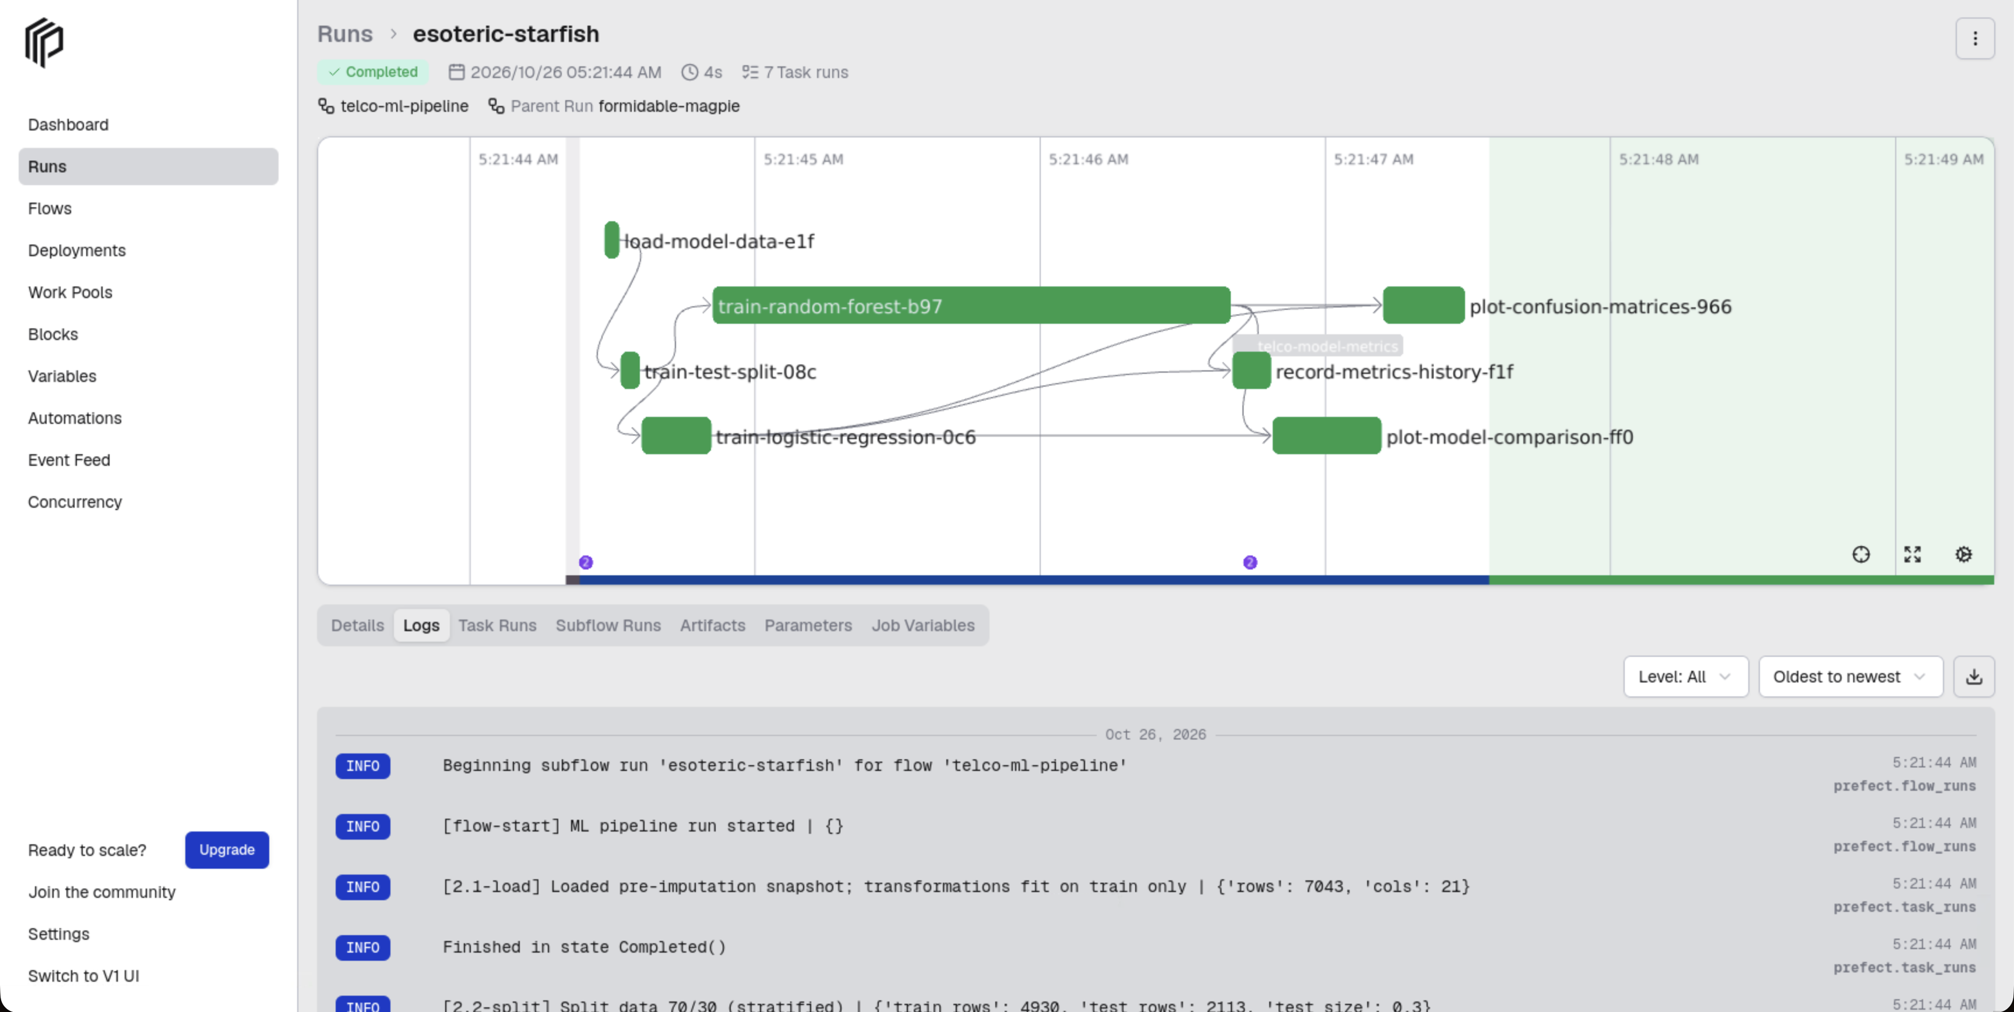
Figure 12 ML task logs and metrics

3 API access
The official Prefect client retrieves details through built-in APIs. Project filters keep unrelated flows out of the evidence. The saved response contains registered flows, deployment schedules and concurrency, recent run states, start times and durations. Aggregate statistics describe a bounded sample of up to 200 project runs and include child flows.
Detail | Retrieved value
Retrieved at | 2026-10-25T20:53:00.182337+00:00
Project flows | telco-assignment-workflow, telco-data-pipeline, telco-ml-pipeline
Deployments | telco-assignment-every-2min
Recent executed runs | 15
Sampled run states | {'Completed': 15, 'Scheduled': 31}

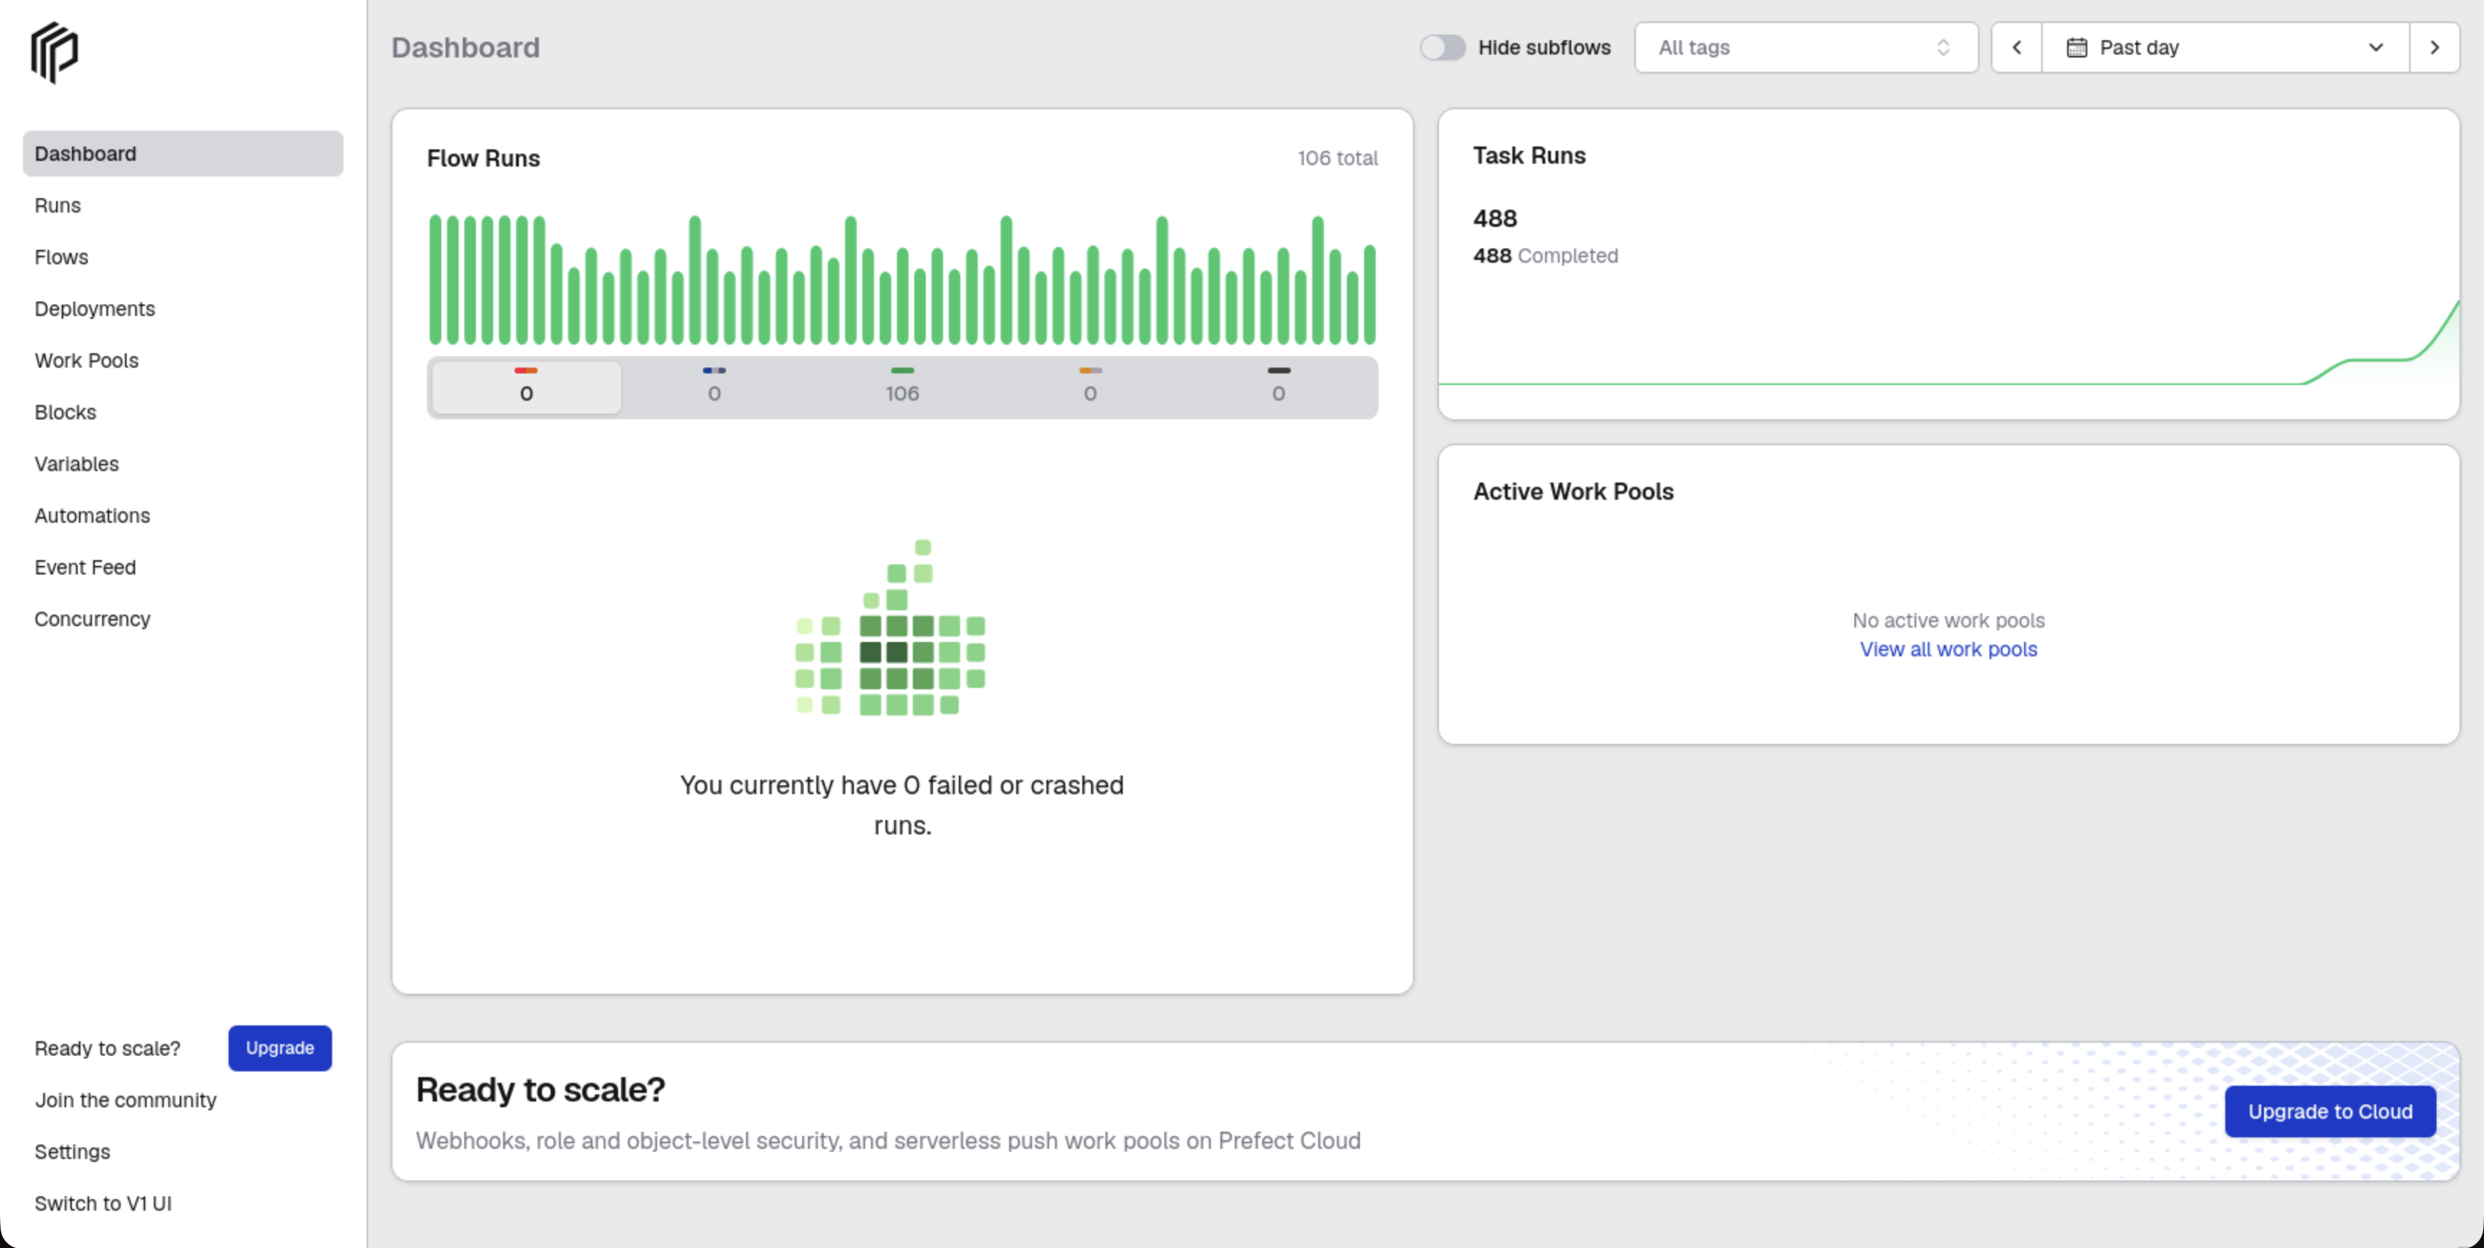
Figure 13 Dashboard overview

4 Reproduction and demonstration
On the provisioned BITS VM, run .venv/bin/python scripts/lab_start.py from ~/workspace/BITS_API_Assignment1. The launcher restores the dedicated hard NFS mount, checks the persistent PostgreSQL database, then starts Prefect on 127.0.0.1:4207 and the two-minute schedule. All runtime and project files are under ~/workspace. Stop the launcher with Ctrl+C. See docs/DEPLOYMENT.md for setup, storage and private-access details.
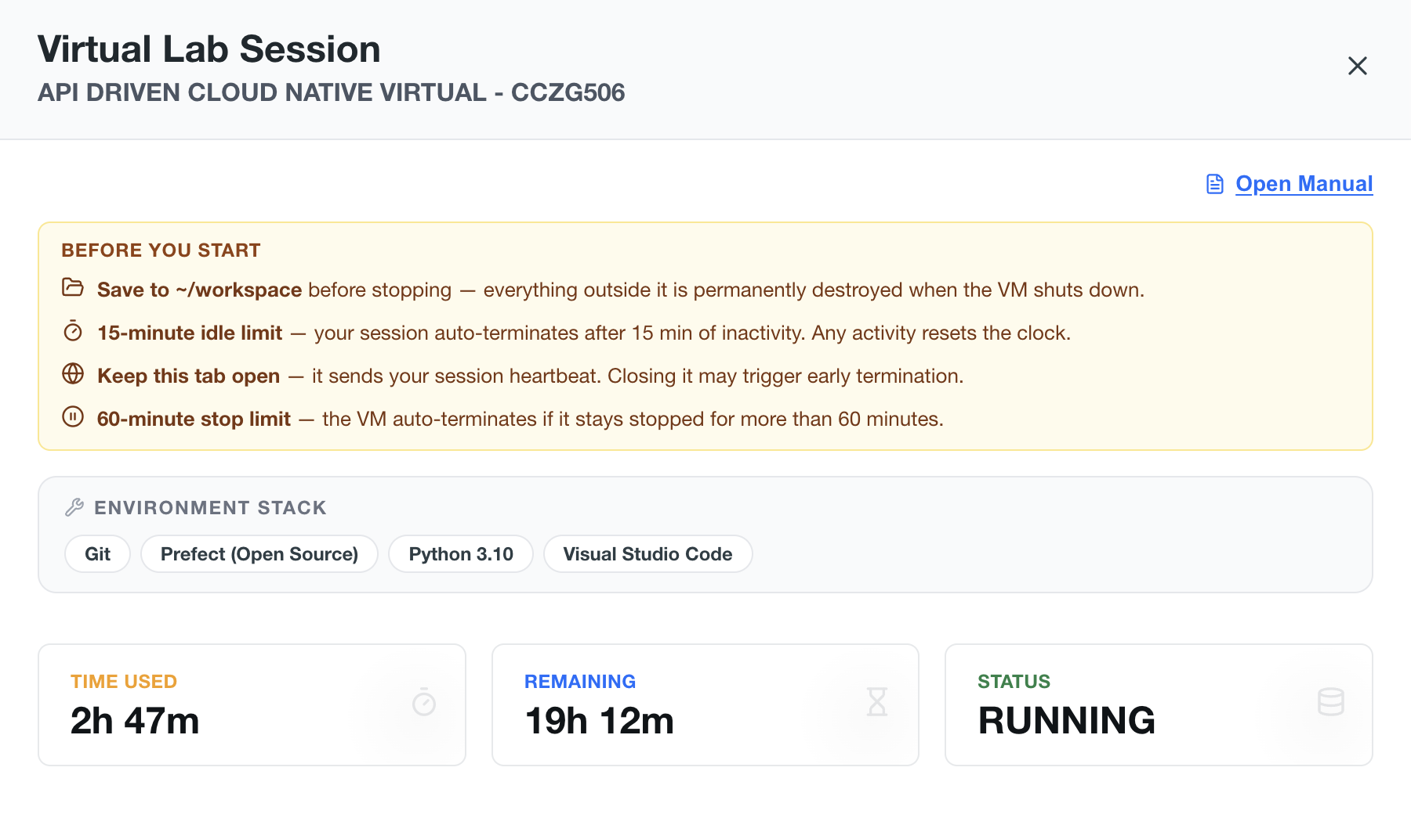
Figure 14 BITS virtual lab hosting status
Demonstration video: https://drive.google.com/file/d/1-yIpgDq7lpkkwypf6Lnp9yAZhWEdek3l/view?usp=drive_link
Assignment artifacts: https://drive.google.com/drive/folders/1J8KbmClrJWQzPwq248O7B81_3NRtQGIK?usp=drive_link
Dataset SHA256: 16320c9c1ec72448db59aa0a26a0b95401046bef5d02fd3aeb906448e3055e91

