FoodExpress — Microservices-based Online Food Ordering Application
Field | Details
Student | Ajeet Kumar Yadav
BITS ID | 2025MT03083
Course | Scalable Services — Assignment
Application | FoodExpress (online food ordering & delivery)
Implemented services | Restaurant Service, Order Service
Deployment target | Docker containers on a local Minikube Kubernetes cluster

Contents
Right-click and choose "Update Field" to build the table of contents.

1. Application description
FoodExpress is an online food ordering platform similar to Swiggy or Zomato. It brings together customers, partner restaurants and delivery agents:
- Customers browse restaurants by city or cuisine, view menus, place orders, track order status and see their order history.
- Restaurant partners register their restaurant, manage the menu (add items, change prices, mark items unavailable), open or close the restaurant, and accept and prepare incoming orders.
- Delivery agents pick up prepared orders and mark them delivered.
- The platform takes payments and notifies every party as the order moves forward.
The core functional use case is "Customer places a food order with a restaurant and tracks it until it is delivered."
Traffic is very uneven. Lunch and dinner peaks can be 10–20× the off-peak load, and browsing menus (reads) far outnumbers placing orders (writes). A microservices architecture lets the read-heavy restaurant catalogue and the write-heavy order pipeline scale independently.

2. Part 1 — Design

2.1 System operations (commands and queries)
System operations come from the core use case. Commands change state; queries only read it.
# | Operation | Type | Actor | Description
1 | registerCustomer() | Command | Customer | Create a customer profile and delivery addresses
2 | registerRestaurant() | Command | Restaurant partner | Register a new restaurant (name, cuisine, city, address)
3 | openOrCloseRestaurant() | Command | Restaurant partner | Toggle whether the restaurant accepts orders
4 | addMenuItem() | Command | Restaurant partner | Add a dish with price, category and veg flag
5 | updateMenuItem() | Command | Restaurant partner | Change price or availability of a dish
6 | searchRestaurants() | Query | Customer | List restaurants filtered by city, cuisine or open status
7 | getRestaurantDetails() | Query | Customer | Fetch one restaurant
8 | browseMenu() | Query | Customer | Fetch a restaurant's menu
9 | validateOrderItems() | Query (internal) | Order Service | Check that items belong to the restaurant and are available; return authoritative prices
10 | placeOrder() | Command | Customer | Create an order for a restaurant's menu items
11 | acceptOrder() / updateOrderStatus() | Command | Restaurant / Delivery agent | Move the order through ACCEPTED → PREPARING → OUT_FOR_DELIVERY → DELIVERED
12 | cancelOrder() | Command | Customer | Cancel an order that is not yet being prepared
13 | trackOrder() | Query | Customer | Current status plus status history of an order
14 | getOrderHistory() | Query | Customer / Restaurant | List orders by customer, restaurant or status
15 | authorizePayment() / refundPayment() | Command | Payment gateway | Charge the customer; refund on cancellation
16 | assignDeliveryAgent() | Command | System | Assign a nearby agent once the order is being prepared
17 | updateAgentLocation() / getDeliveryStatus() | Command / Query | Delivery agent / Customer | Live delivery tracking
18 | sendNotification() | Command | System | SMS, email or push on every order event

2.2 Business capabilities → services
Services are decomposed by business capability. Each capability becomes one service that owns its data.
Business capability | Service | Owns (data)
Customer management | Customer Service | customers, addresses
Restaurant & menu management | Restaurant Service ★ | restaurants, menu items
Order management | Order Service ★ | orders, order items, status history
Payment processing | Payment Service | payments, refunds
Delivery management | Delivery Service | agents, delivery assignments, locations
Customer & partner notification | Notification Service | templates, notification log

★ = implemented in Part 2.

2.3 Assignment of operations to services and collaboration
Service | Operations owned | Collaborators
Customer Service | registerCustomer, getCustomer | —
Restaurant Service | registerRestaurant, openOrCloseRestaurant, addMenuItem, updateMenuItem, searchRestaurants, getRestaurantDetails, browseMenu, validateOrderItems | Called by Order Service (sync)
Order Service | placeOrder, updateOrderStatus / acceptOrder, cancelOrder, trackOrder, getOrderHistory | Restaurant Service (sync REST, implemented); Customer Service (verify customer); publishes events to Payment, Delivery, Notification (async, designed)
Payment Service | authorizePayment, refundPayment | Consumes OrderPlaced, OrderCancelled; publishes PaymentAuthorized / PaymentFailed
Delivery Service | assignDeliveryAgent, updateAgentLocation, getDeliveryStatus | Consumes OrderAccepted; publishes DeliveryAssigned, OrderDelivered
Notification Service | sendNotification | Consumes every order, payment and delivery event

Collaboration for the `placeOrder` command (implemented):
- The customer calls POST /api/orders on the Order Service.
- The Order Service calls the Restaurant Service synchronously: POST /api/restaurants/{id}/menu/validate.
- The Restaurant Service checks that the restaurant exists and is open, and that each item belongs to it and is available. It returns the authoritative name and unit price of each item, so the Order Service never trusts a price sent by the client.
- If validation passes, the Order Service stores the order, its items and a PLACED history entry in its own database in one local transaction, then returns 201 Created.
- (Designed) The Order Service publishes OrderPlaced. Payment authorizes the charge, the restaurant accepts, Delivery assigns an agent, and Notification informs the customer. This choreography is a Saga; the compensating action is cancelOrder → refundPayment.
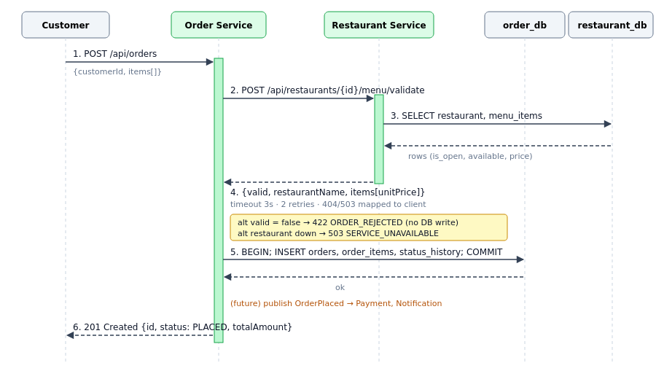
placeOrder sequence

2.4 Scalable architecture
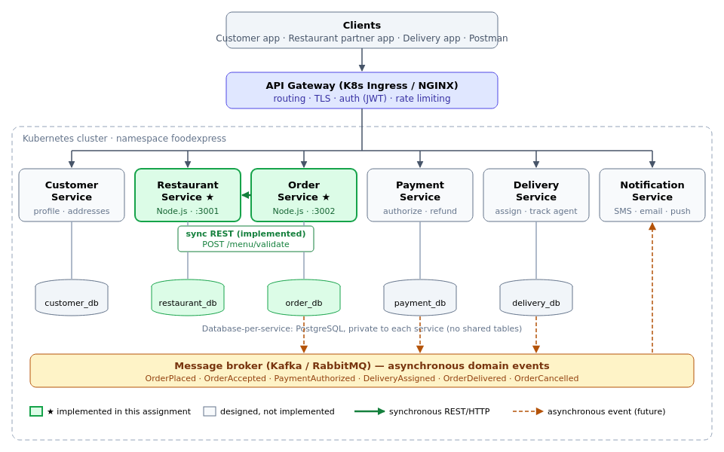
FoodExpress architecture
Key design decisions:
Concern | Decision
Decomposition | By business capability; one bounded context per service
Data | Database-per-service. Each service has its own private PostgreSQL instance; no tables are shared. The Order Service keeps a snapshot of item name and price (no cross-DB joins).
Entry point | API Gateway (Kubernetes Ingress / NGINX) for routing, TLS, auth and rate limiting
Sync communication | REST/JSON over HTTP when an immediate answer is needed (order validation). Calls go through a timeout, retries and error mapping (404 / 422 / 503).
Async communication | Domain events over a message broker (Kafka/RabbitMQ) for the long-running order Saga, so a failure in Payment or Notification does not block ordering
Service discovery | Kubernetes DNS (http://restaurant-service:3001) plus ClusterIP/NodePort Services that load-balance across pods
Scalability | Stateless services → horizontal scaling with replicas: 2 and an HPA (2–5 pods at 70 % CPU). The read-heavy Restaurant Service can scale separately from the Order Service.
Availability | Readiness and liveness probes on /health (checks the DB too); rolling updates; DB connection retry on start-up
Configuration | ConfigMaps for settings; Secrets for DB credentials

3. Part 2 — Implementation

3.1 Selected services
- Restaurant Service: restaurant and menu management, including the internal validateOrderItems query.
- Order Service: order placement and its lifecycle. It collaborates with the Restaurant Service on every new order.

3.2 Technology stack
Layer | Technology | Reason
Language / runtime | Node.js 18 (JavaScript) | Lightweight, fast start-up, good fit for I/O-bound REST services
Web framework | Express 4 | Minimal, widely used REST framework
Database | PostgreSQL 15, one per service | ACID transactions for orders; relational menu model
DB driver | pg (node-postgres) with connection pool
Inter-service communication | Synchronous REST/JSON over HTTP using axios (3 s timeout, 2 retries) | Order placement needs an immediate, consistent answer about item availability and price
Testing | Jest + Supertest + pg-mem (in-memory PostgreSQL) | Each service is tested independently with no external DB; the Order Service tests stub the Restaurant Service
Containerization | Docker (node:18-alpine), non-root user, HEALTHCHECK
Orchestration | Kubernetes on Minikube: Deployments, Services, ConfigMaps, Secrets, PVCs, HPA, Ingress
API testing | Postman collection

3.3 Why synchronous REST between these two services
placeOrder cannot continue until it knows the items are valid and what they cost, so the call is a request/response query by nature. To limit the coupling a synchronous call brings:
- the Order Service calls through a client with a timeout and retries (restaurantClient.js);
- failures are mapped to clear status codes: restaurant not found → 404, items rejected → 422, Restaurant Service unreachable → 503. The Order Service itself stays up;
- the Order Service stores a snapshot of names and prices, so later queries (trackOrder, getOrderHistory) never call the Restaurant Service.
Downstream steps (payment, delivery, notification) are designed to be asynchronous events, as described in §2.3.

3.4 Project structure (each service is a separate repository)
Each of restaurant-service/ and order-service/ is a self-contained repository: its own package.json, source, tests, Dockerfile, docker-compose file and Kubernetes manifests. Each can be built, tested and deployed alone.
2025MT03083_FoodExpress/
├── restaurant-service/ ← repository 1
│ ├── src/
│ │ ├── server.js # bootstrap: wait for DB, create schema, seed, listen
│ │ ├── app.js # express app, /health, error handling
│ │ ├── db.js # pg pool, schema, connection retry
│ │ ├── mappers.js # row → API object
│ │ ├── seed.js # demo restaurants & menus
│ │ └── routes/restaurants.js # REST endpoints (commands & queries)
│ ├── tests/restaurant.test.js # 8 tests (Jest + pg-mem)
│ ├── k8s/
│ │ ├── restaurant-db.yaml # Secret, PVC, Postgres Deployment, Service
│ │ └── restaurant-service.yaml# ConfigMap, Deployment, NodePort Service, HPA
│ ├── Dockerfile
│ ├── docker-compose.yml # run standalone with its own DB
│ └── package.json
├── order-service/ ← repository 2
│ ├── src/
│ │ ├── server.js
│ │ ├── app.js
│ │ ├── db.js # orders, order_items, order_status_history
│ │ ├── orderStatus.js # order state machine
│ │ ├── restaurantClient.js # REST client → Restaurant Service (timeout/retry)
│ │ └── routes/orders.js # REST endpoints (commands & queries)
│ ├── tests/order.test.js # 9 tests (Restaurant Service stubbed)
│ ├── k8s/
│ │ ├── order-db.yaml
│ │ └── order-service.yaml
│ ├── Dockerfile
│ ├── docker-compose.yml
│ └── package.json
├── deployment/
│ ├── k8s/00-namespace.yaml # namespace foodexpress
│ ├── k8s/10-ingress.yaml # optional API gateway
│ ├── deploy-minikube.sh # one-shot build + deploy
│ ├── smoke-test.sh # end-to-end calls for the demo
│ └── cleanup.sh
├── postman/2025MT03083_Ajeet_Kumar_Yadav_FoodExpress.postman_collection.json
├── docs/ # this document + diagrams
├── screenshots/ # Postman, kubectl, dashboard snapshots
└── video/ # demo screen recording

3.5 Data model
restaurant_db (Restaurant Service)
Table | Columns
restaurants | id (PK), name, cuisine, city, address, rating, is_open, created_at
menu_items | id (PK), restaurant_id (FK), name, description, category, price, is_veg, available, created_at

order_db (Order Service)
Table | Columns
orders | id (PK), customer_id, restaurant_id, restaurant_name (snapshot), delivery_address, status, total_amount, created_at, updated_at
order_items | id (PK), order_id (FK), menu_item_id, name (snapshot), unit_price (snapshot), quantity
order_status_history | id (PK), order_id (FK), status, changed_at

restaurant_id and menu_item_id in order_db are logical references only. There is no foreign key across databases.

3.6 REST API
Restaurant Service (port 3001)
Method | Endpoint | Operation | Success
GET | /health | health/readiness | 200
POST | /api/restaurants | registerRestaurant | 201
GET | /api/restaurants?city=&cuisine=&open= | searchRestaurants | 200
GET | /api/restaurants/{id} | getRestaurantDetails | 200 / 404
PATCH | /api/restaurants/{id}/status | openOrCloseRestaurant | 200
POST | /api/restaurants/{id}/menu | addMenuItem | 201
GET | /api/restaurants/{id}/menu | browseMenu | 200
PATCH | /api/restaurants/{id}/menu/{itemId} | updateMenuItem | 200
POST | /api/restaurants/{id}/menu/validate | validateOrderItems (internal) | 200

Order Service (port 3002)
Method | Endpoint | Operation | Success / errors
GET | /health | health/readiness | 200
POST | /api/orders | placeOrder → calls Restaurant Service | 201 / 400 / 404 / 422 / 503
GET | /api/orders?customerId=&restaurantId=&status= | getOrderHistory | 200
GET | /api/orders/{id} | trackOrder | 200 / 404
PATCH | /api/orders/{id}/status | updateOrderStatus / acceptOrder | 200 / 409 invalid transition
POST | /api/orders/{id}/cancel | cancelOrder | 200 / 409

Order state machine: PLACED → ACCEPTED → PREPARING → OUT_FOR_DELIVERY → DELIVERED. CANCELLED is allowed only from PLACED or ACCEPTED.
Sample placeOrder request and response:
POST /api/orders
{
"customerId": "cust-2025MT03083",
"restaurantId": "rest-001",
"deliveryAddress": "BITS Pilani WILP, Bengaluru",
"items": [ { "menuItemId": "item-101", "quantity": 2 },
{ "menuItemId": "item-102", "quantity": 4 } ]
}
201 Created
{
"id": "ord-6375787f",
"customerId": "cust-2025MT03083",
"restaurantId": "rest-001",
"restaurantName": "Spice Garden",
"status": "PLACED",
"totalAmount": 678,
"items": [
{ "menuItemId": "item-101", "name": "Paneer Butter Masala", "unitPrice": 249, "quantity": 2, "lineTotal": 498 },
{ "menuItemId": "item-102", "name": "Butter Naan", "unitPrice": 45, "quantity": 4, "lineTotal": 180 }
],
"statusHistory": [ { "status": "PLACED", "changedAt": "..." } ]
}

3.7 Implementation steps
- Domain analysis. Identified the actors, the core use case, the system operations (§2.1) and the business capabilities (§2.2).
- Service scaffolding. Created two independent Node.js projects (restaurant-service, order-service), each with its own dependencies.
- Persistence. Wrote a PostgreSQL schema per service, created at start-up (CREATE TABLE IF NOT EXISTS). The service retries the DB connection so it tolerates the DB pod starting late. The Restaurant Service seeds demo restaurants and menus.
- REST endpoints. Implemented the commands and queries from §3.6, with input validation and consistent JSON errors.
- Inter-service communication. Built restaurantClient.js in the Order Service (axios, timeout, retries, error mapping) and the matching /menu/validate endpoint in the Restaurant Service.
- Order lifecycle. Implemented the state machine (orderStatus.js) and transactional status changes with history.
- Testing. Wrote unit and integration tests per service using an in-memory PostgreSQL; the Order Service tests stub the Restaurant Service. 17/17 tests pass. An end-to-end run with both services over real HTTP was also checked.
- Containerization. Wrote a Dockerfile per service (Alpine, production deps only, non-root, HEALTHCHECK) and a docker-compose.yml per service for standalone runs.
- Kubernetes manifests. Wrote a Namespace, plus per service: Secret, PVC, Postgres Deployment and Service, ConfigMap, app Deployment (2 replicas, probes, resource limits), NodePort Service and HPA. An Ingress acts as the gateway.
- Deployment. Started Minikube, built the images inside Minikube's Docker daemon, applied the manifests and waited for the rollouts.
- Verification. Exercised every endpoint through Postman and smoke-test.sh, then inspected the workloads in the Kubernetes Dashboard.

3.8 Test results
restaurant-service$ npm test
PASS tests/restaurant.test.js
✓ GET /health reports UP
✓ lists seeded restaurants and filters by cuisine
✓ registers a restaurant and adds a menu item
✓ rejects invalid restaurant payload
✓ returns 404 for unknown restaurant
✓ validate returns authoritative prices
✓ validate flags items from another restaurant and unavailable items
✓ validate rejects orders when restaurant is closed
Tests: 8 passed, 8 total
order-service$ npm test
PASS tests/order.test.js
✓ places an order with prices from restaurant service
✓ rejects missing fields
✓ returns 422 when restaurant rejects items
✓ returns 404 for unknown restaurant
✓ returns 503 when restaurant service is down
✓ tracks order through full lifecycle
✓ rejects invalid status transition
✓ cancels a placed order but not a delivered one
✓ lists order history by customer
Tests: 9 passed, 9 total

4. Part 3 — Deployment

4.1 Deployment plan
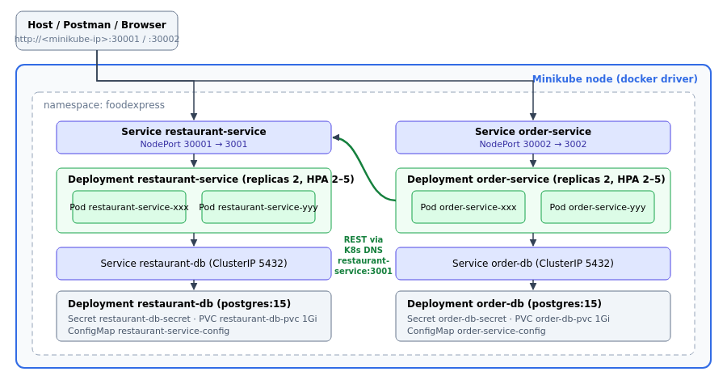
Kubernetes deployment
K8s object | restaurant-service | order-service
Namespace | foodexpress | foodexpress
Database Deployment + ClusterIP Service | restaurant-db :5432 | order-db :5432
Secret (DB credentials) | restaurant-db-secret | order-db-secret
PersistentVolumeClaim | restaurant-db-pvc (1 Gi) | order-db-pvc (1 Gi)
ConfigMap | restaurant-service-config | order-service-config (includes RESTAURANT_SERVICE_URL=http://restaurant-service:3001)
App Deployment | restaurant-service, 2 replicas | order-service, 2 replicas
App Service | NodePort 30001 → 3001 | NodePort 30002 → 3002
HPA | 2–5 pods @ 70 % CPU | 2–5 pods @ 70 % CPU
Probes | readiness + liveness on /health | readiness + liveness on /health

Docker containers: each microservice runs in its own Docker container (restaurant-service:1.0, order-service:1.0), and each database runs in its own postgres:15-alpine container.

4.2 Prerequisites
- Docker (with your user in the docker group)
- minikube ≥ 1.30 and kubectl
- Postman

4.3 Step-by-step deployment
# 1. Start Minikube and enable the addons
minikube start --driver=docker --cpus=2 --memory=4096
minikube addons enable metrics-server
minikube addons enable dashboard
# 2. Build the images inside Minikube's Docker daemon (no registry needed)
eval $(minikube docker-env)
docker build -t restaurant-service:1.0 ./restaurant-service
docker build -t order-service:1.0 ./order-service
# 3. Deploy
kubectl apply -f deployment/k8s/00-namespace.yaml
kubectl apply -f restaurant-service/k8s/
kubectl apply -f order-service/k8s/
# 4. Verify
kubectl -n foodexpress get deployments,pods,svc,hpa -o wide
kubectl -n foodexpress logs deploy/order-service
# 5. Get the service URLs
minikube ip # → e.g. 192.168.49.2 → :30001 / :30002
minikube service restaurant-service order-service -n foodexpress --url
# 6. Smoke test and dashboard
./deployment/smoke-test.sh
minikube dashboard
The same steps are scripted in deployment/deploy-minikube.sh.
Independent deployment of one service. For example, to roll out a new Order Service build without touching the Restaurant Service:
eval $(minikube docker-env)
docker build -t order-service:1.1 ./order-service
kubectl -n foodexpress set image deployment/order-service order-service=order-service:1.1
kubectl -n foodexpress rollout status deployment/order-service
Scaling demo:
kubectl -n foodexpress scale deployment/restaurant-service --replicas=3
kubectl -n foodexpress get pods -l app=restaurant-service

4.4 Kubernetes Dashboard analysis
The dashboard was opened with minikube dashboard and namespace foodexpress was selected. Everything below was observed on the running cluster (Kubernetes v1.37.0, single minikube node, containerd runtime). The screenshots are in §5.4.
Dashboard view | What was observed | What it shows
Workloads overview | Deployments: Running 4 · Pods: Running 6 · Replica Sets: Running 4. All status rings green. | The whole application is healthy, with no failed or pending workloads
Deployments | restaurant-service 2/2, order-service 2/2, restaurant-db 1/1, order-db 1/1. Images restaurant-service:1.0, order-service:1.0, postgres:15-alpine. Labels tier: backend / tier: database. | Each microservice runs in its own container image with 2 replicas; each DB is a single instance
Deployment detail (order-service) | Strategy RollingUpdate (max surge 25 %, max unavailable 25 %); Pods status 2 updated / 2 total / 2 available; conditions Available = True (MinimumReplicasAvailable) and Progressing = True (NewReplicaSetAvailable) | New versions roll out with no downtime; the deployment reached its desired state
Pods | 6 pods Running, 0 restarts, all on node minikube. Live CPU/memory per pod: about 1 m CPU and 29–32 Mi for each service pod, about 4 m CPU and 33 Mi for each Postgres pod. | Far below the declared requests (100 m / 64 Mi) and limits; zero restarts means the liveness and readiness probes pass
Replica Sets | One ReplicaSet per deployment (e.g. order-service-7b78f775d6, 2/2) | Revision 1 of every deployment; a new image would create a new ReplicaSet
Services | restaurant-service NodePort 3001:30001, order-service NodePort 3002:30002, restaurant-db / order-db ClusterIP 5432 | The APIs are exposed outside the cluster; the databases are reachable only inside it. The service endpoints list both pod IPs (e.g. 10.244.0.6:3001, 10.244.0.7:3001), so requests are load-balanced.
Horizontal Pod Autoscalers | order-service-hpa and restaurant-service-hpa: target CPU 70 %, current 1 %, min 2 / max 5, replicas 2 | metrics-server is feeding the HPA; each service can scale to 5 pods on its own under load
Persistent Volume Claims | order-db-pvc and restaurant-db-pvc: Bound, 1 Gi, RWO, storage class standard | Each database has its own volume (database per service), so data survives pod restarts
Config Maps / Secrets | order-service-config (5 keys, including RESTAURANT_SERVICE_URL=http://restaurant-service:3001), restaurant-service-config (4 keys); order-db-secret and restaurant-db-secret (3 keys each) | Configuration and credentials are kept out of the images
Pod logs | The order-service pod logs show the start-up lines (listening on port 3002, restaurant service at http://restaurant-service:3001), then the kubelet's GET /health probes and the API calls POST /api/orders, PATCH /api/orders/{id}/status, GET /api/orders/{id}. Each POST /api/orders is matched by a POST /api/restaurants/rest-001/menu/validate in the restaurant-service pod logs. | Shows the synchronous call from the Order Service to the Restaurant Service inside the cluster

Observations
- Independent deployment and scaling. The two services have separate Deployments, ReplicaSets, Services, HPAs, ConfigMaps and databases, so either one can be redeployed or scaled without touching the other.
- Service discovery works through Kubernetes DNS. The Order Service reaches the Restaurant Service at http://restaurant-service:3001, which is load-balanced across both restaurant pods.
- Resource headroom is large. Measured usage (about 1 m CPU, about 30 Mi per service pod) is roughly 1 % of the CPU request, so the 2-replica minimum easily handles the demo load. The HPA would add pods under a real lunch-time spike.
- Resilience. No pod restarted during about 3 hours of running and testing. Probes and the Recreate strategy for the databases keep each Postgres volume attached to exactly one pod.

5. Snapshots
All snapshots were taken on the running Minikube deployment on 21 Oct 2026. Every file is named with the prefix 2025MT03083_Ajeet_Kumar_Yadav_ and stored in screenshots/.
- Terminal snapshots (§5.1, §5.5) show the real command output.
- Service-call snapshots (§5.2, §5.3) come from running the project's Postman collection (postman/2025MT03083_Ajeet_Kumar_Yadav_FoodExpress.postman_collection.json) with Newman, the Postman command-line runner, against the cluster NodePorts http://192.168.49.2:30001 and :30002. Each panel shows the request (method, URL and body) and the real response (status, time and body) recorded by that run.
- Dashboard snapshots (§5.4) are screenshots of the live Kubernetes Dashboard.

5.1 Minikube cluster, workloads and images
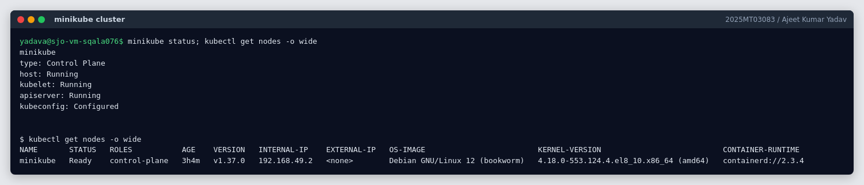
minikube status and kubectl get nodes: single Ready control-plane node, Kubernetes v1.37.0, containerd
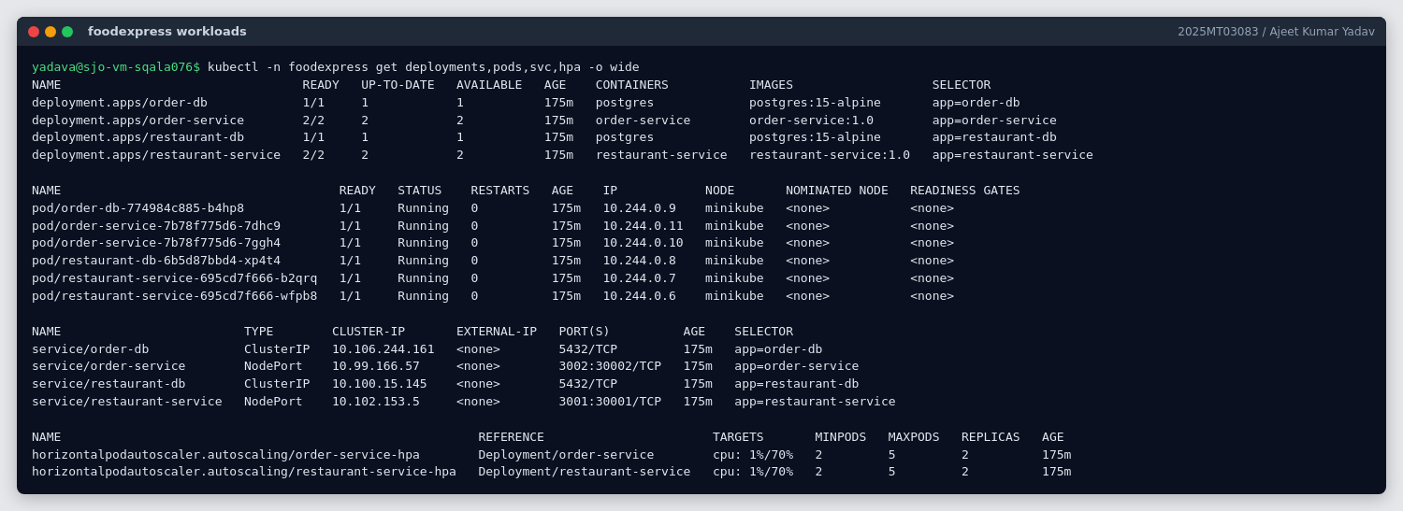
kubectl get deployments,pods,svc,hpa: 4 deployments, 6 Running pods, NodePorts 30001/30002, 2 HPAs
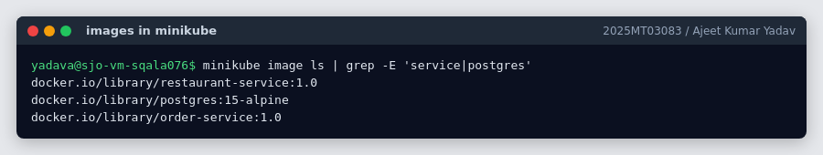
Container images built inside Minikube (minikube image build): restaurant-service:1.0, order-service:1.0, postgres:15-alpine

5.2 Service calls: Restaurant Service
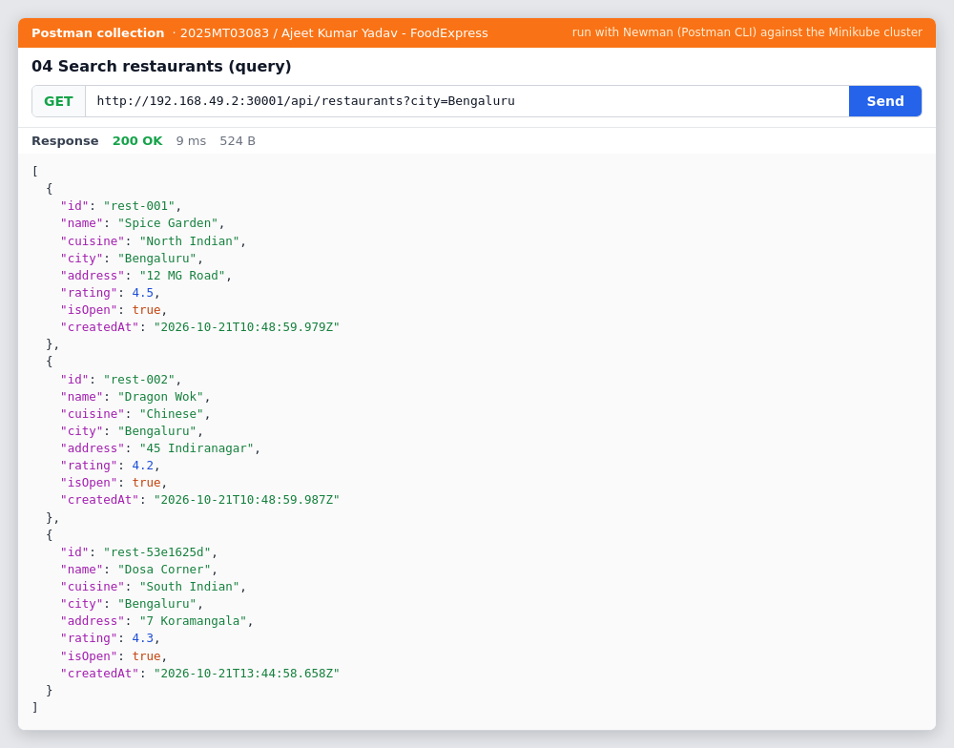
Query searchRestaurants: GET /api/restaurants?city=Bengaluru returns 200 OK
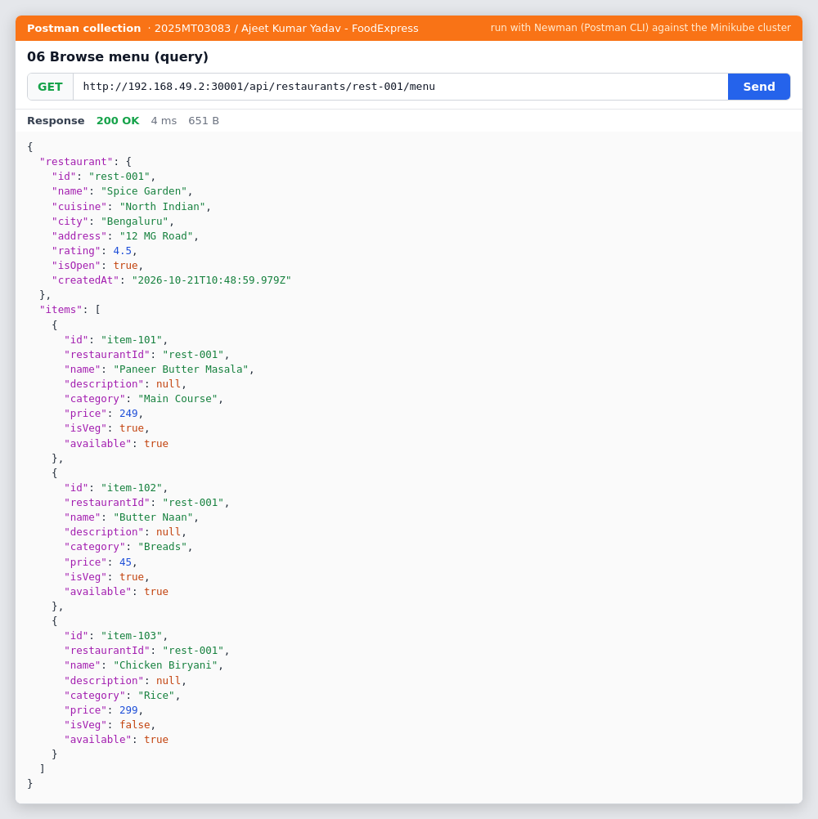
Query browseMenu: GET /api/restaurants/rest-001/menu returns 200 OK
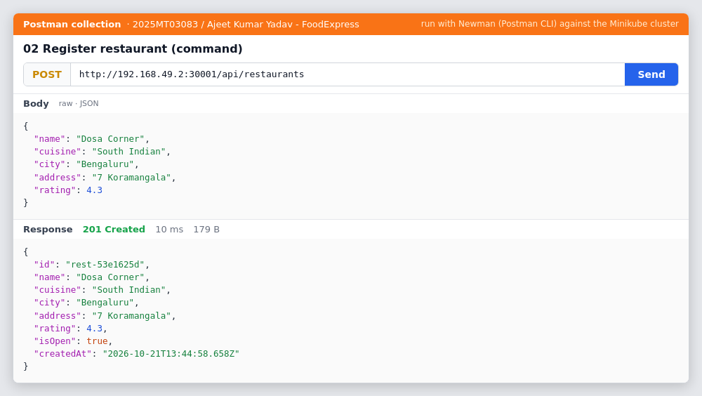
Command registerRestaurant: POST /api/restaurants returns 201 Created
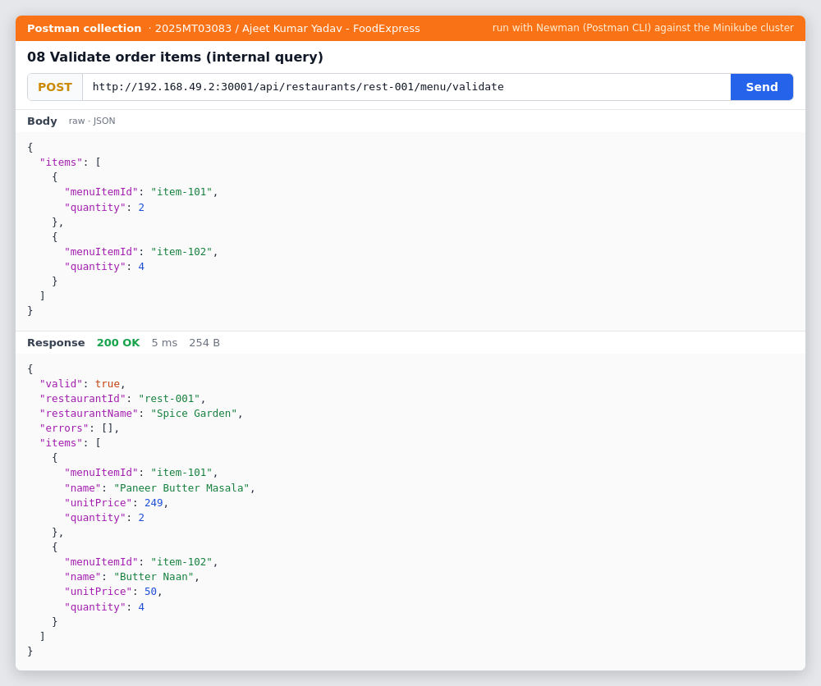
Internal query validateOrderItems: POST /api/restaurants/rest-001/menu/validate returns authoritative prices

5.3 Service calls: Order Service (including the call to the Restaurant Service)
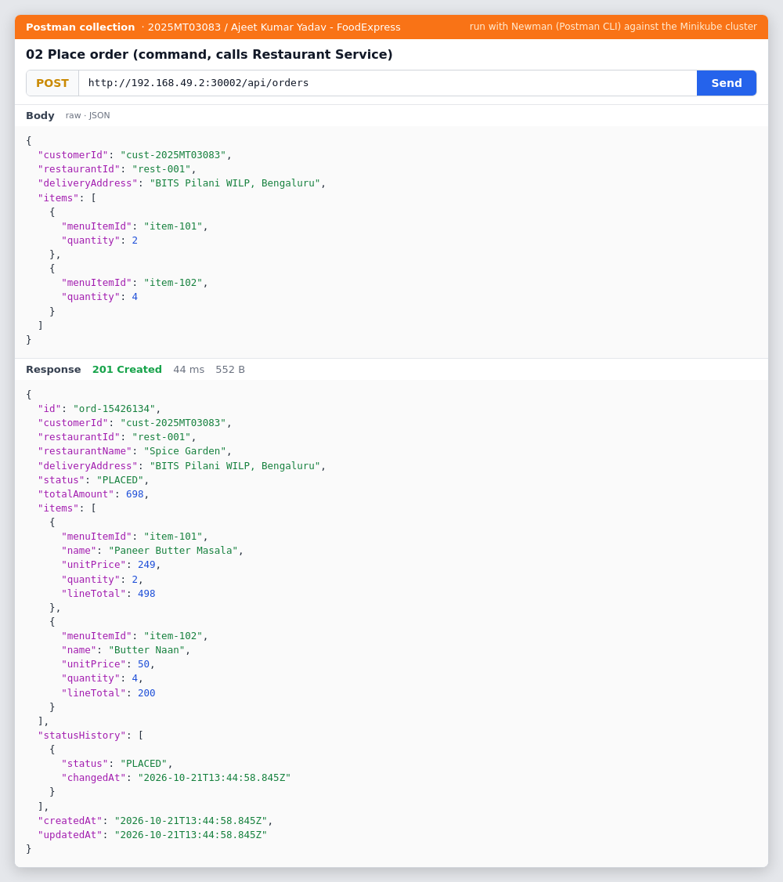
Command placeOrder: POST /api/orders returns 201 Created; names and prices come from the Restaurant Service
Butter Naan is priced at 50 here, not the seeded 45. That's because the collection's earlier request 07 Update menu item price changed it in the Restaurant Service. The Order Service picked up the new price through the call between the services, and the total of 698 (2 × 249 + 4 × 50) reflects it.
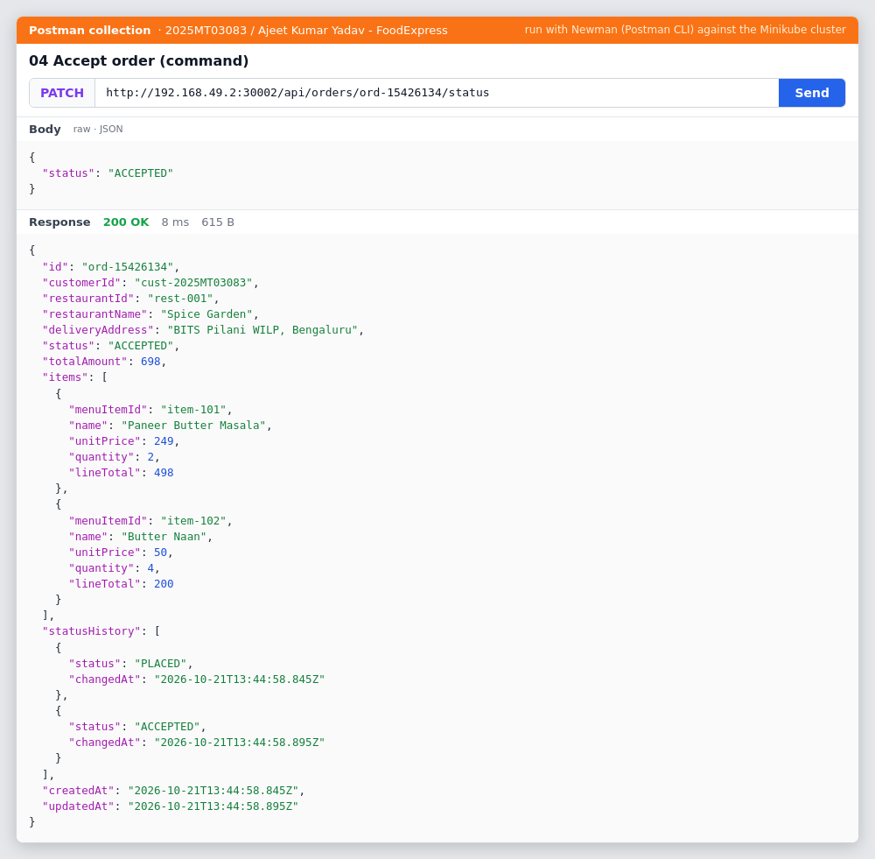
Command updateOrderStatus: PATCH /api/orders/{id}/status to ACCEPTED returns 200 OK with status history
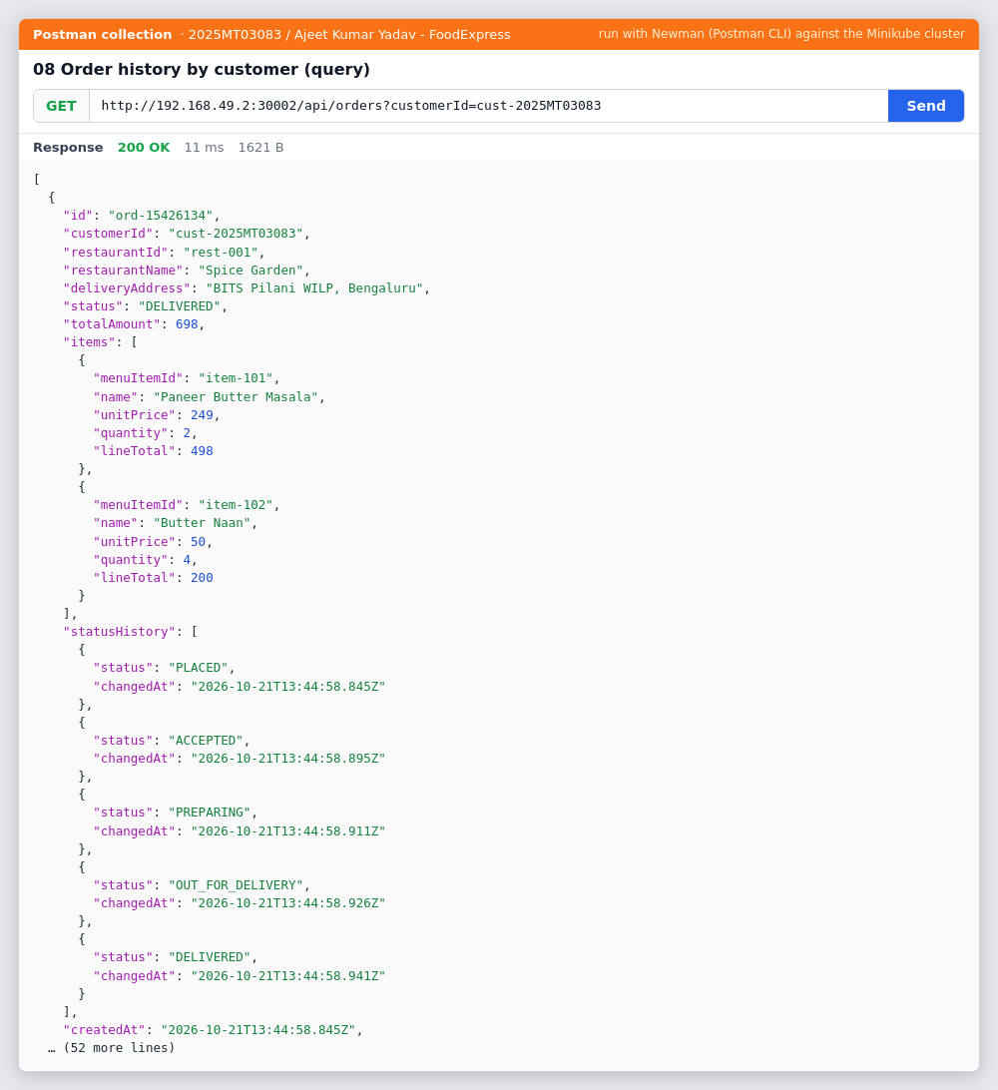
Query getOrderHistory: GET /api/orders?customerId=cust-2025MT03083, delivered order with full status history
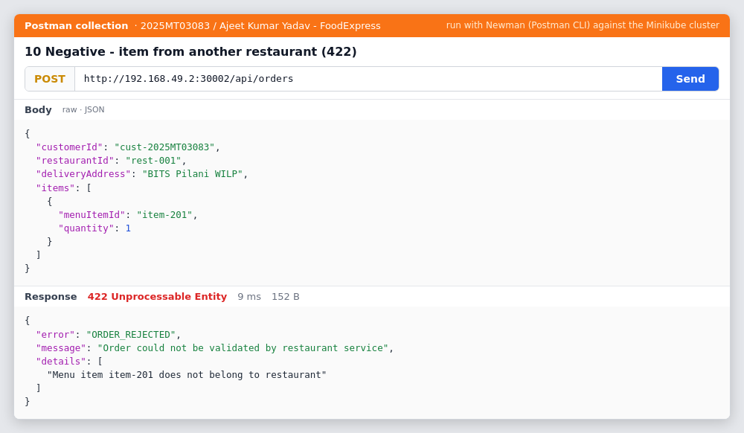
Negative case: item from another restaurant returns 422 ORDER_REJECTED from Restaurant Service validation
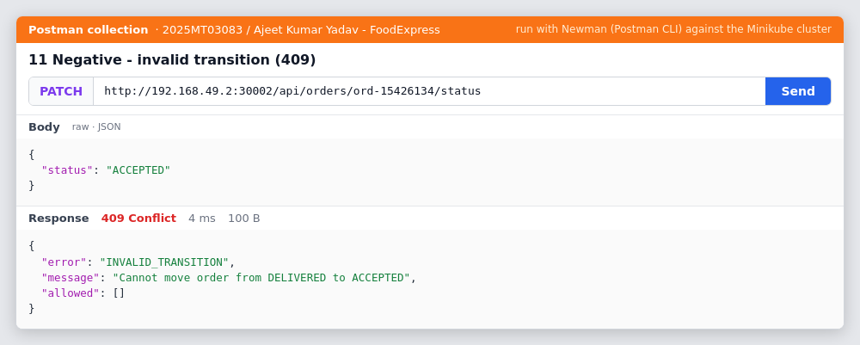
Negative case: DELIVERED to ACCEPTED returns 409 INVALID_TRANSITION from the order state machine
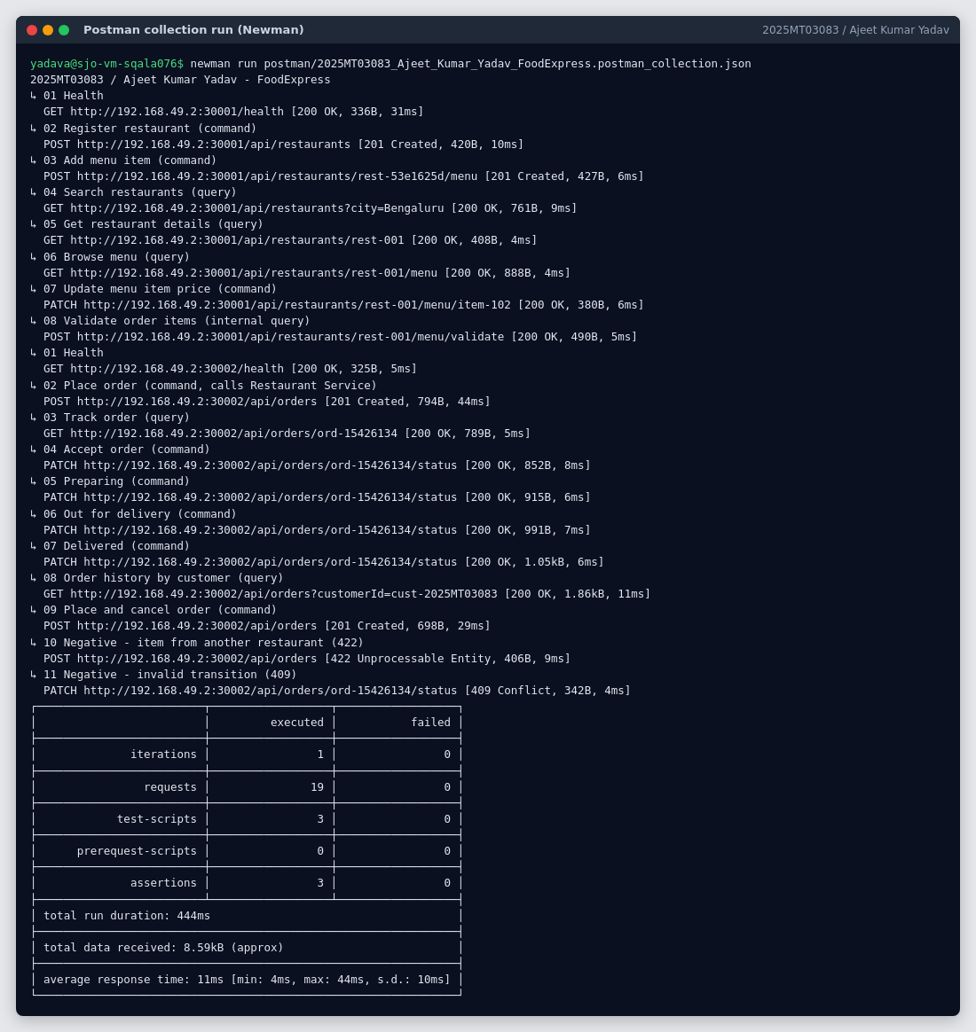
Complete Postman collection run: 19 requests, 3 assertions, 0 failures

5.4 Kubernetes Dashboard
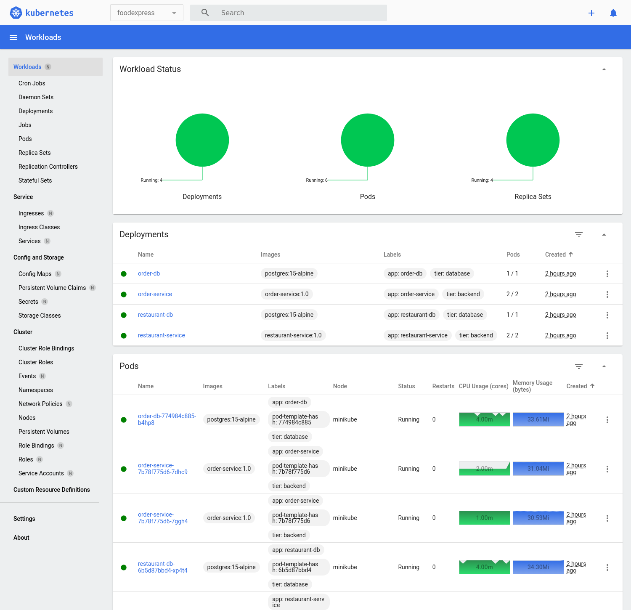
Dashboard Workloads overview, namespace foodexpress: 4 Deployments, 6 Pods, 4 Replica Sets all Running
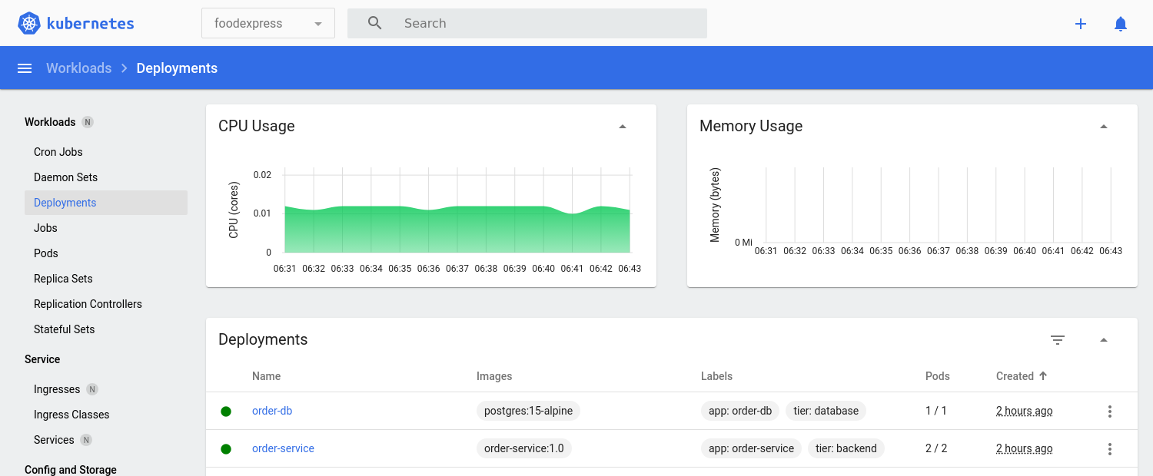
Dashboard Deployments: restaurant-service 2/2, order-service 2/2, restaurant-db 1/1, order-db 1/1
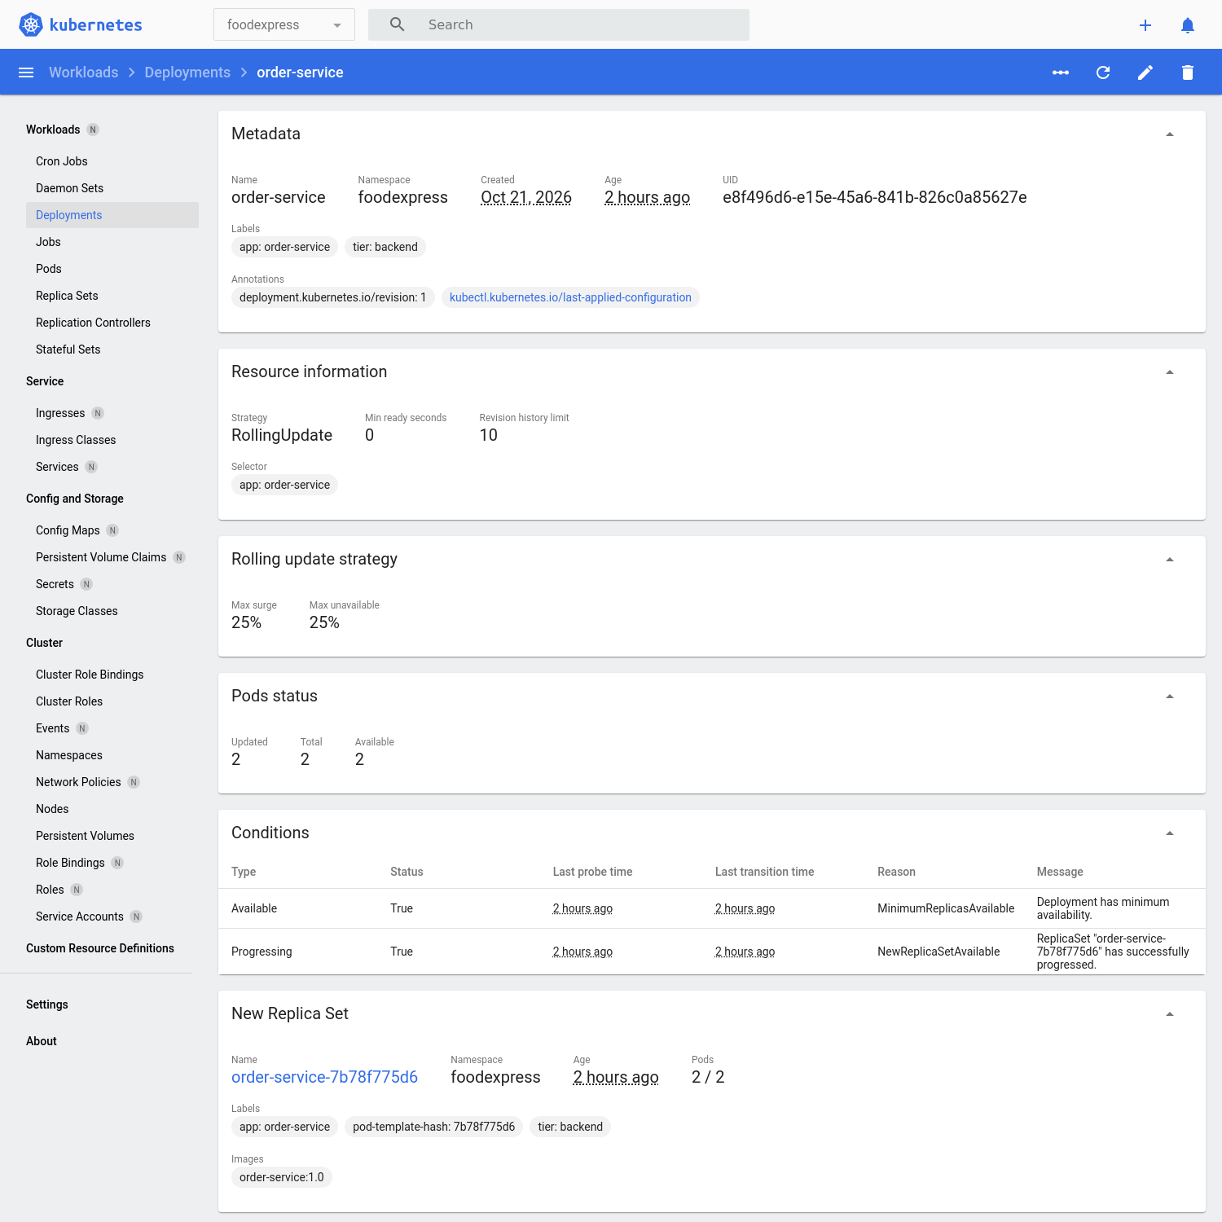
Dashboard order-service deployment detail: RollingUpdate strategy, 2/2 available, conditions True
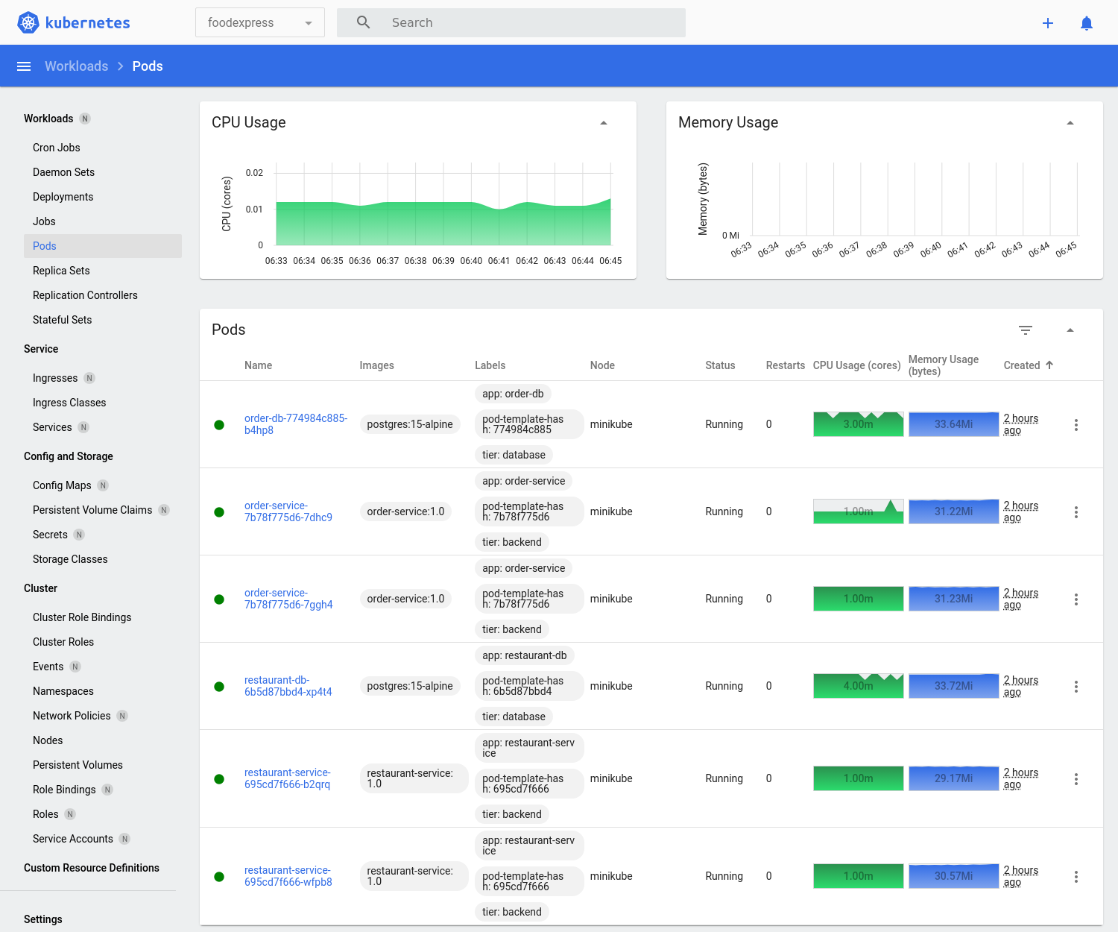
Dashboard Pods: 6 Running, 0 restarts, live CPU and memory per pod from metrics-server
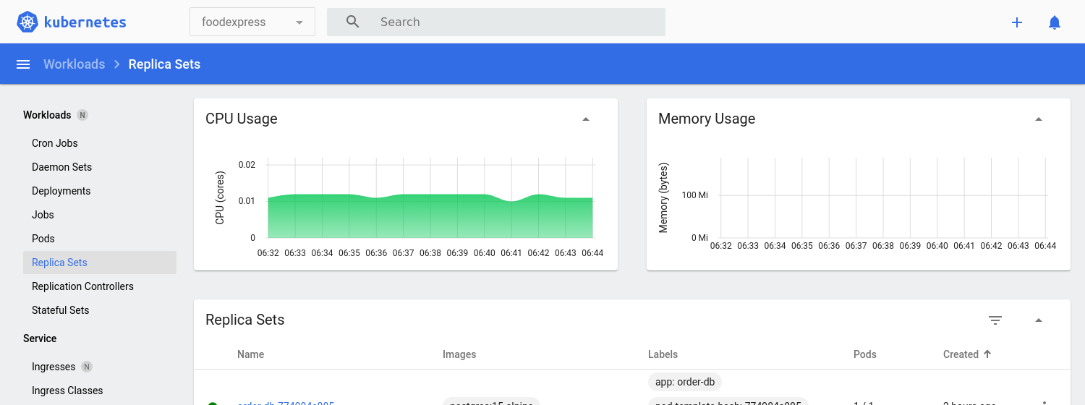
Dashboard Replica Sets: one per deployment
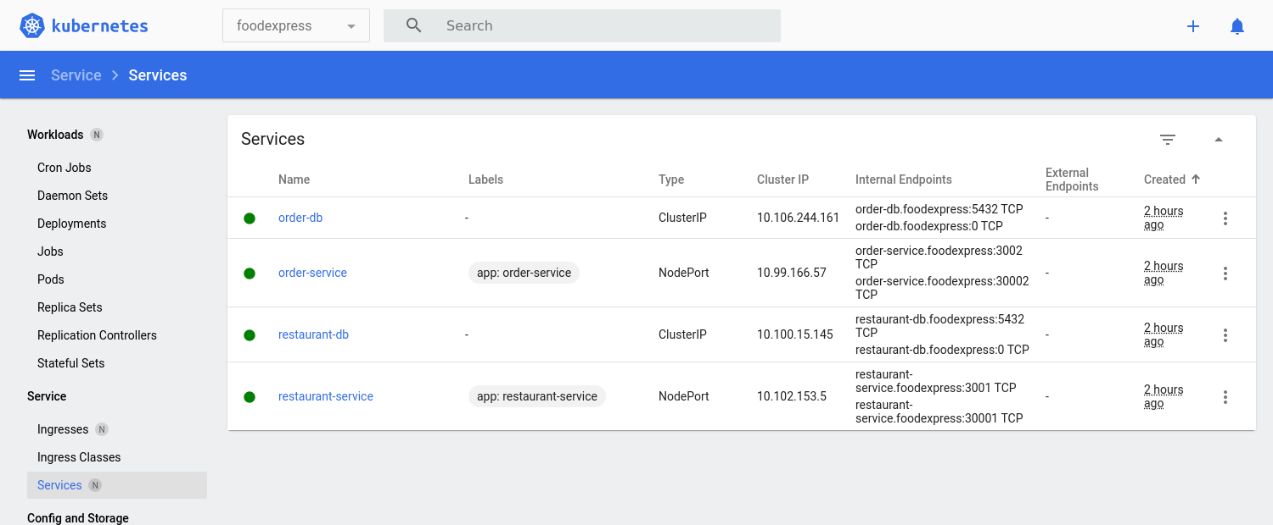
Dashboard Services: NodePort 30001/30002 for the APIs, ClusterIP 5432 for the databases
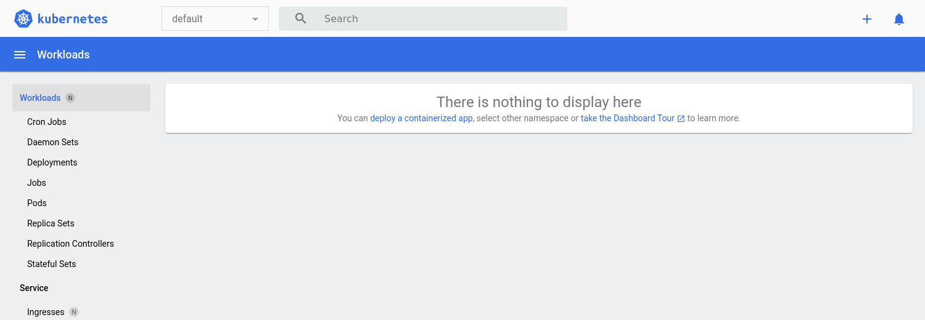
Dashboard Horizontal Pod Autoscalers: CPU target 70 %, 2 to 5 replicas
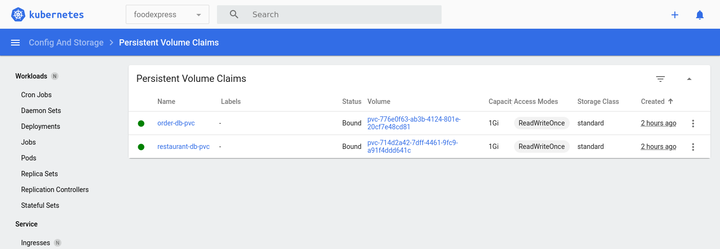
Dashboard Persistent Volume Claims: one Bound 1 Gi volume per database
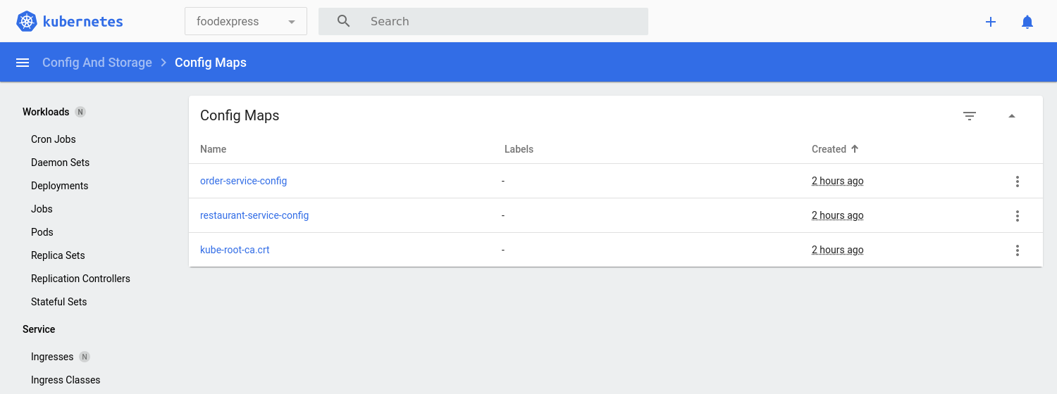
Dashboard Config Maps: per-service configuration, including RESTAURANT_SERVICE_URL
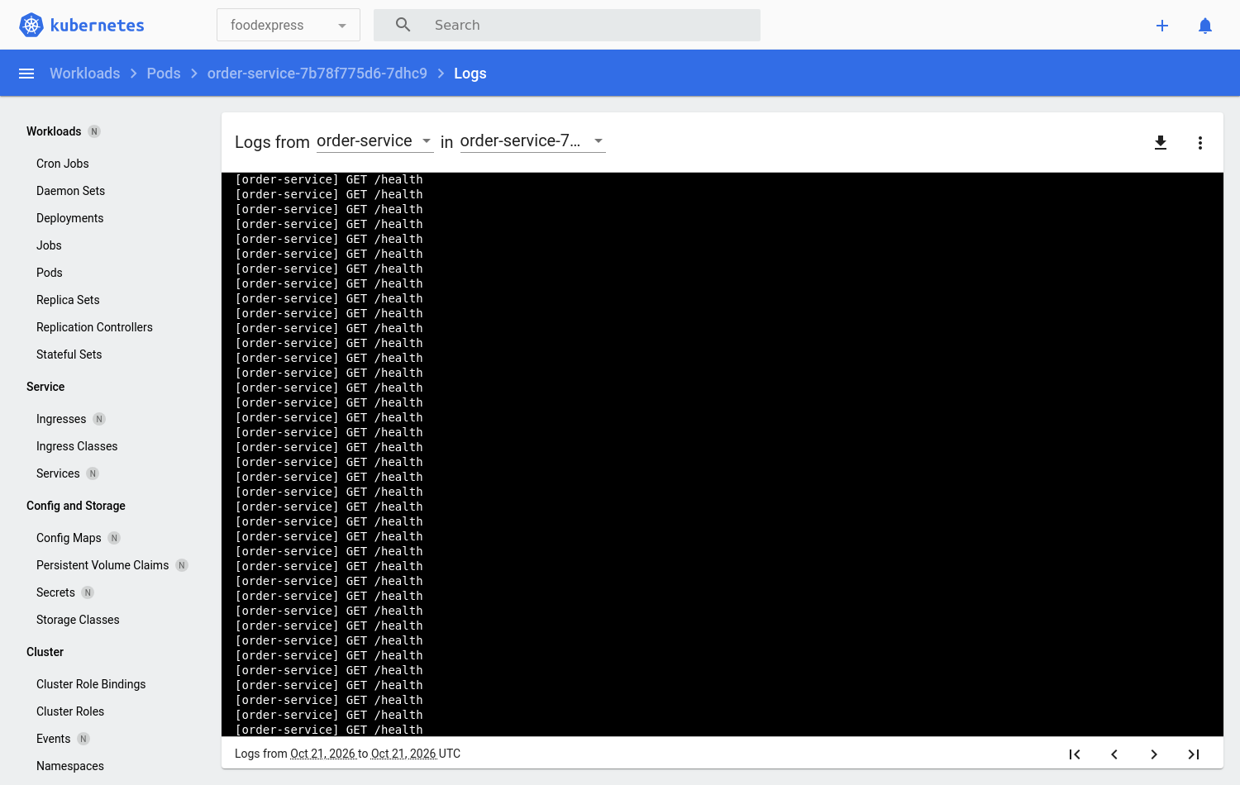
Dashboard pod logs for order-service: start-up lines and kubelet /health readiness and liveness probes

5.5 Pod logs: the call between the services
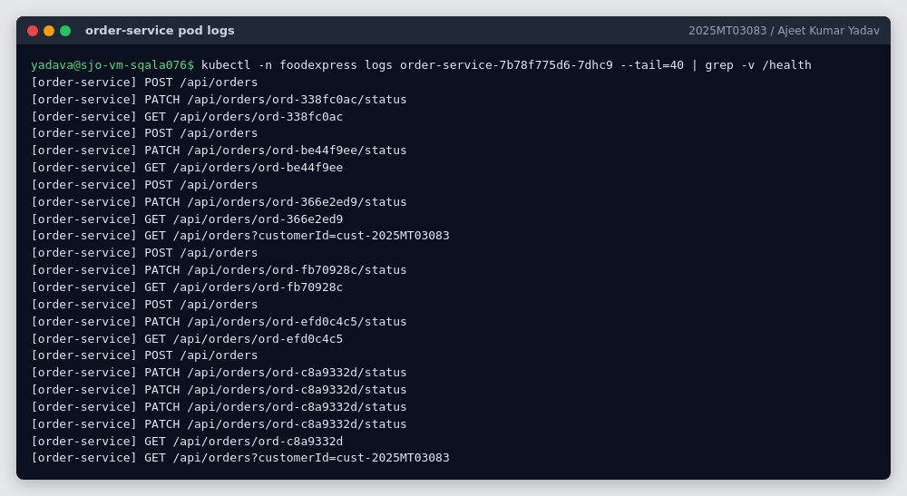
order-service pod logs: POST /api/orders, PATCH .../status and GET calls (health probes filtered out)
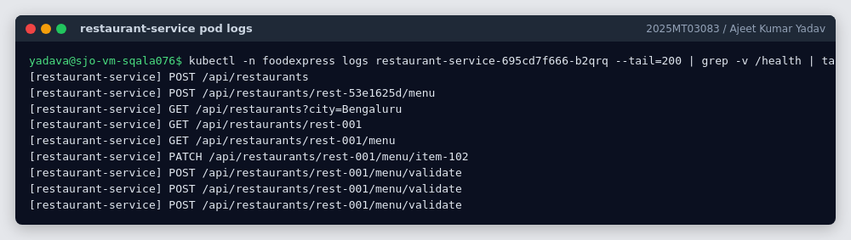
restaurant-service pod logs: each order triggers POST /api/restaurants/rest-001/menu/validate from the Order Service

6. Demonstration video
video/2025MT03083_Ajeet_Kumar_Yadav_FoodExpress_Demo.mp4 shows:
- The project structure and the two separate service repositories
- minikube start and minikube status
- Building both Docker images inside Minikube
- kubectl apply of all manifests and kubectl get all -n foodexpress
- The Postman calls: search restaurants → browse menu → place order (Order Service → Restaurant Service) → status updates → track order → negative cases
- The Kubernetes Dashboard: deployments, pods, logs, services, HPA
- Scaling a deployment and watching new pods appear

7. Conclusion
FoodExpress is decomposed by business capability into six microservices, each owning its own database. The Restaurant and Order services are implemented as independent Node.js repositories with PostgreSQL. They talk over resilient synchronous REST, are packaged as separate Docker containers, and are deployed to a local Minikube cluster with replicas, health probes, configuration, secrets, persistent storage and autoscaling. The remaining services and the event-driven Saga are designed to plug into the same platform.
— 2025MT03083 / Ajeet Kumar Yadav
2025MT03083 / Ajeet Kumar Yadav

