Report

**組別:** 第二組

**使用軟體:** NetBeans IDE 8.1

**作業系統:** Windows 7

**檔案:**

* 程式碼
  + course
* 輸出結果
  + output/one
  + output/two
  + output/three

**結果:**

* + 題目:

Given a list of user's comments, determine the first and last time a user commented and the total number of comments from that user.

* + 指令:

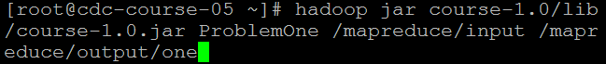

* + 輸出:

見檔案檔案

* + 題目:

Given a list of user's comments, deteramine the averge comment length per hour of days.

* + 指令:

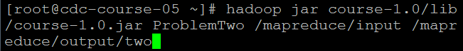

* + 輸出: 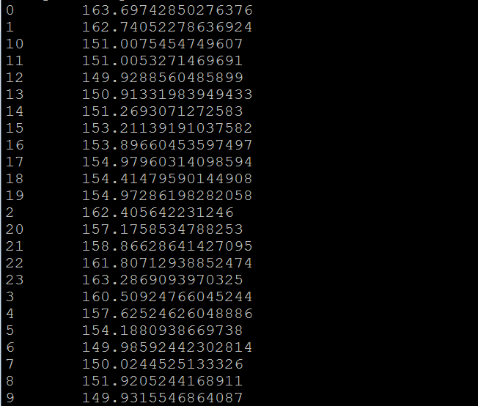
  + 題目:

Given a list of user's comments, determine the median and standard deviation of comment lengths per hour of days.

* + 指令: 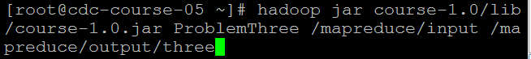
  + 輸出: 