Report

**組別:** 第二組

**使用軟體:** NetBeansIDE 8.1

**作業系統:** Windows 7

**檔案:**

* 程式碼

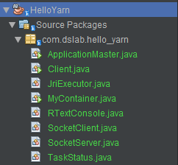

* 輸出結果
  + output/output.txt

**結果:**

* + 題目:

Every container will get specify task name (e.g.node1.R, node2.R), and client connects to AM socketServer to get the job report of all tasks

* + 指令:



* + 輸出: 