## Description

PxWeb is used for publishing statistics in a data base or in px-file format at the web and is since 1 January 2016 free of charge for Swedish government agencies and municipalities, international NSI:s and international organisations of statistics. PX-Web offers all the datasets in the database as open data through an API in many formats.

## History

The software is used in 40 countries 63 international organisations 21 Swedish organisations.

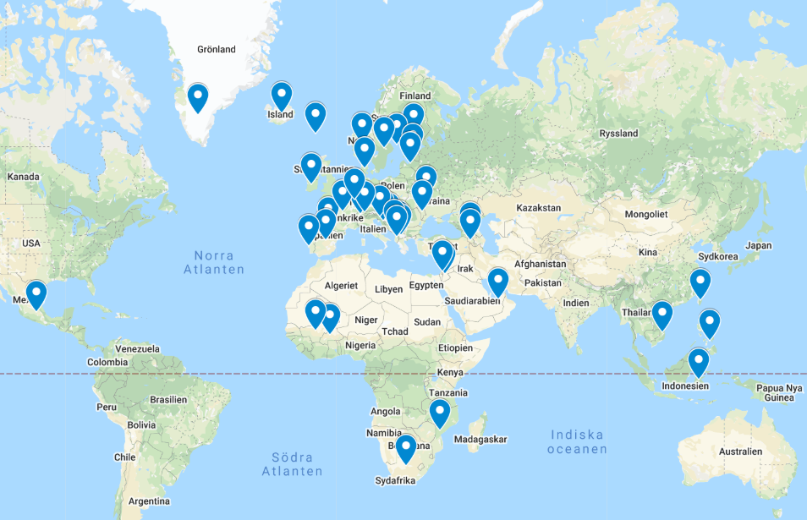

## Main features

The PX-Web application consists of two parts:

**Administration interface -** The Administration interface is used by PX-Web administrators to manage and maintain their PX-Web installation.

**User interface -** The User interface is the part of the application that is exposed to the end users, the actual dissemination application. The statistical data that should be disseminated could either be stored in PX file located locally on the Web server or remote in a SQL server in a database having the Common Nordic Meta Model. PX-Web is also able to combine the two types of data sources.

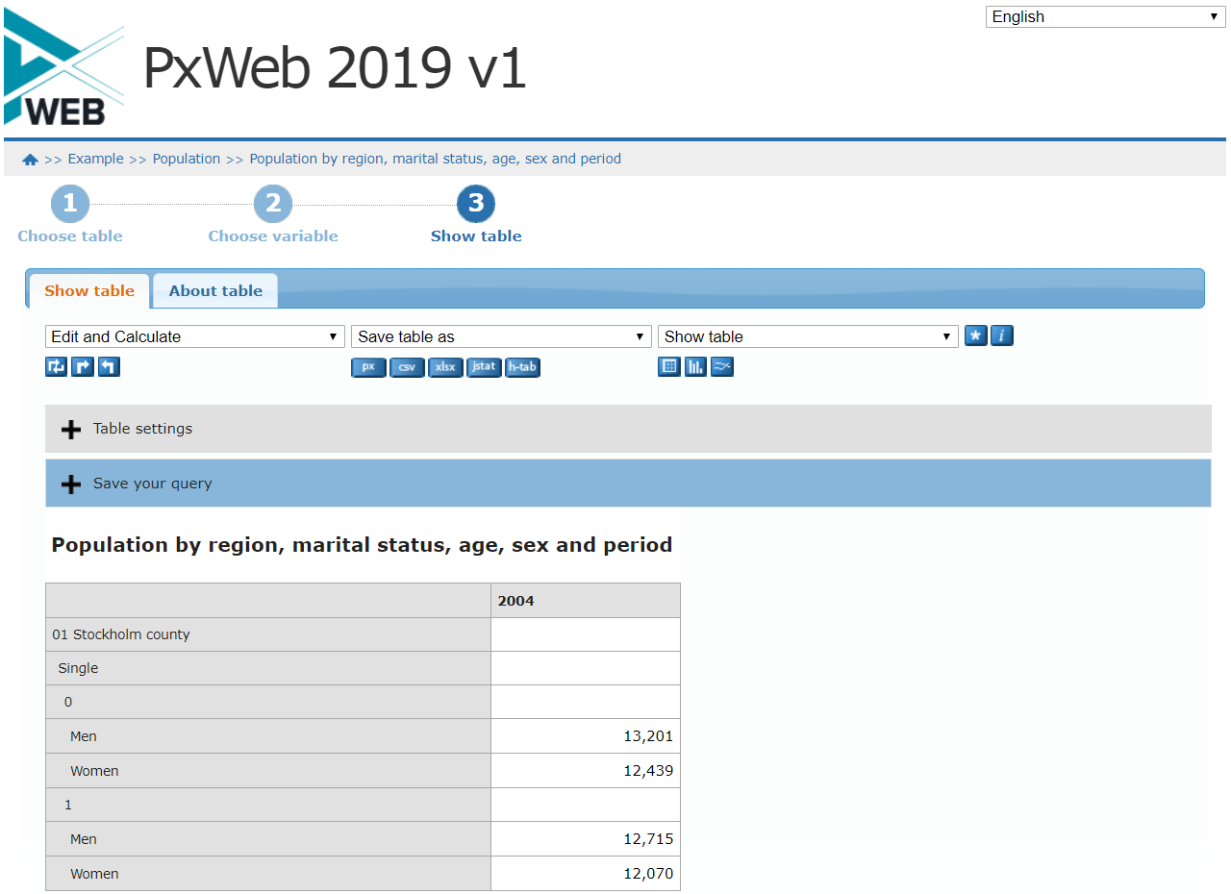

## Conditions regarding use of PxWeb

The receiving authority / organisation are responsible for handling the tool on their own using the instructions supplied with the tool. The access to PxWeb does not include ongoing support, any promises of further development or any guarantee against errors in the program and any use shall be at the users own risk.

## Documentation & Additional resources

SCPA Katalog: <https://www.statistical-services.org/>

PX-Web information page: <https://www.scb.se/en/services/statistical-programs-for-px-files/px-web/>

Statistics Sweden Github: <https://github.com/statisticssweden/PxWeb>

Demosite: <https://www.h6.scb.se/pxwebtest/pxweb/en/>

## License

OpenSource MIT

## Contacts

e-mail to [pc-axis@scb.se](mailto:pc-axis@scb.se)