|  |
| --- |
| Istat |
| Relais service architecture |
| AS-IS and TO-BE |

|  |
| --- |
| Francesco Amato, Mauro Bruno, Laura Tosco, Giuseppina Ruocco |

Summary

1. Introduction 3

2. Current architecture 4

2.1 Business layer 6

2.2 Application layer 10

3. Statistical Service Generalized Architecture (IS2) 14

4. Reengineering Relais in IS2 15

Annex 1. Example of inputs and outputs of the business steps implemented in Relais-IS2. 17

Annex 2. Data base schema 21

# Introduction

The Essnet Serv2 is a project launched in 2018 to develop new statistical services, either from scratch or from existing tool. The software Relais (Record Linkage At IStat) was selected for the relevance of data integration in the statistical process.

The first version of Relais dates back to 2007. The toolkit was designed as a software running on desktop computer. It is developed in Java and runs R programs to perform different methods for record linkage. Data are stored in a MySQL database for which the user needs to have administrator grants.

This document provides: i) the description of Relais current version (AS-IS) that is already composed by self-contained modules; an overview of the software re-engineering, adopting a generalized architectural pattern (Relais in IS2).

The following analysis is focused on the business and application layers. The assessment of the technology layer is still in progress.

# Current architecture[1]

Relais (Record Linkag At IStat) is a software designed and developed with the aim of providing an integrated environment to solve record linkage problems based on the belief that a record linkage process is structured in sub-phases that can be combined together in order to obtain the best process for the data being processed. Figure 1 shows an overview of the AS-IS architecture from the business layer point of view.

As shown in Figure 1, the current realization of Relais offers, for each process step, many business services that realize different techniques to solve the steps. From the application layer point of view, Relais implements each business service with a specific Java module that, in two cases, calls an R program. Currently, Relais is a desktop module with a graphic user interface that, step-by-step, guides the user in the realization of the record linkage process. Figure 1 shows in blue the application modules callable to run the chosen solution step while in dark blue are shown the most important data structures (mySql tables) used by the software.

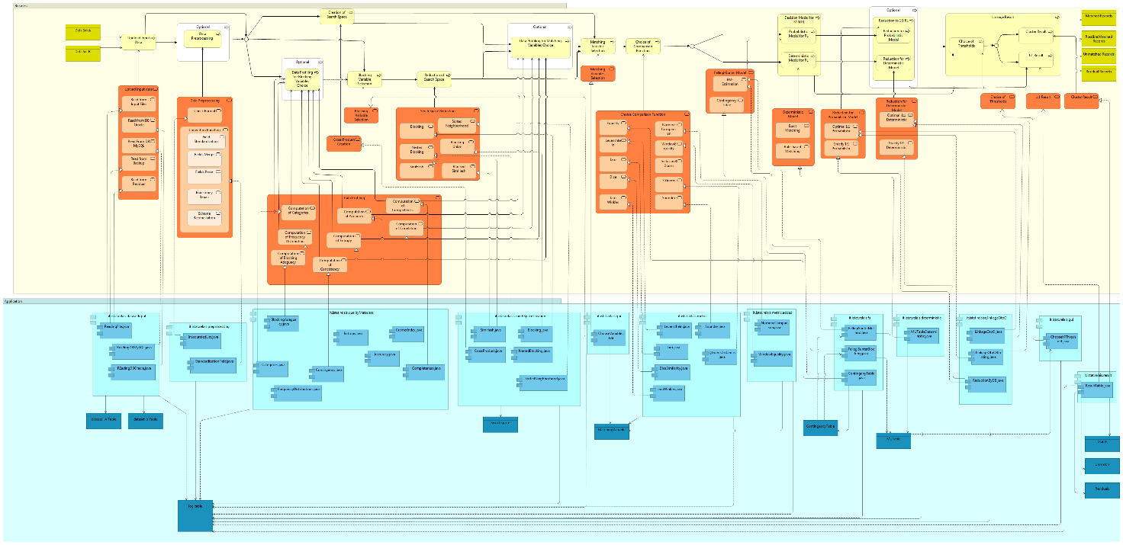

Figure 1. Relais AS-IS architecture

## Business layer

The designed business layer shows that a record linkage process can be realized by different workflows composed by different steps, depending from the data to be linked. Different pattern can be composed allowing mainly a deterministic, or a probabilistic record linkage approach. Some process steps are mandatory while other steps are optional.

The core steps for realizing a record linkage process are:

1. Upload input data: different input data format are admitted (csv file, mySql Tables, Oracle Tables);

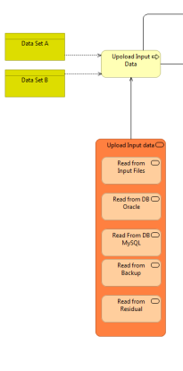

Figure 2. Upload input data business process and service

1. Search Space creation: it can be realized simply via a cross product or a search space reduction step can be performed. In this second case, different methods can be performed, namely: Blocking, Nested Blocking, Sorted Neighborhood, Blocking Union, Simhash and Blocked Simhash. If a space reduction step is performed, a previous step of blocking variable selection must be performed.

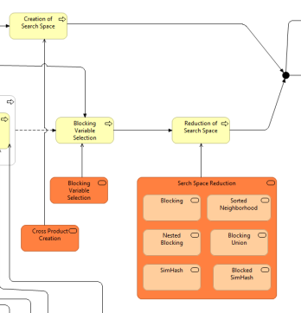

Figure 3. Search Space Creation business process and service

1. Matching variable and comparison function selection: In this step, the best matching variable must be selected and for each of theme a comparison function must be associated. These variables and functions are used to perform the following step.

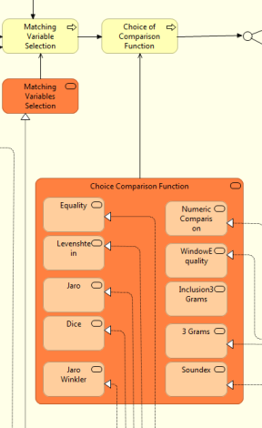

Figure 4. Matching variable and comparison function selection business process and service

1. Decision Model: In this step, a determinist or probabilistic record linkage model can be applied. In the first case, a further choice can be made between rule based or exact matching. The result of this step is a M:N record linkage, that is a record of the first data source is linked to N records of the second data source and a record of the second data source is linked to M records of the first data source.

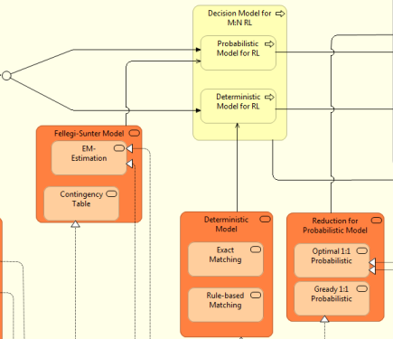

Figure 5. Decision model business process and service

1. Linkage Result: this step is composed of two sub-steps namely choice of thresholds and results creation. Firstly, two thresholds must be chosen: the match threshold and the un-match threshold. These thresholds discriminates couples of records defining three sets: Match, Unmatch and Possible Match records. The first set contains couple of records that surely relates to the same real world entity; the second set contains couple of records that surely do not refer to the same real world entity. The third set contains couple of records for which a human revision is needed to discriminate whether a couple refer to the same entity or not.

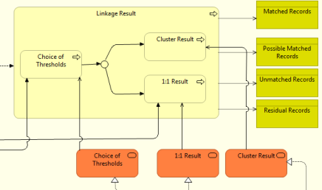

Figure 6. Linkage result business process and service

In the process creation, are available four optional process steps:

1. Preprocessing: different “data manipulation” are realizable to clean and better format data to perform a better record linkage process.

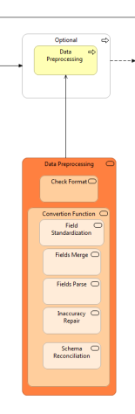

Figure 7. Preprocessing business process and service

1. Data profiling for blocking variable choice. In this phase different indicators are available that help user to analyze variables and make better choice for blocking phase.

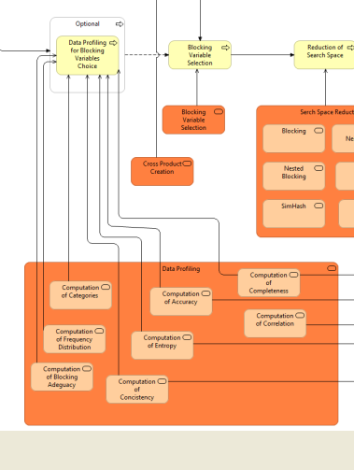

Figure 8. Data profiling for blocking variable choice business process and service

1. Data profiling for matching variable choice. In this phase different indicators are available that help user to analyze variables and make better choice for matching records.

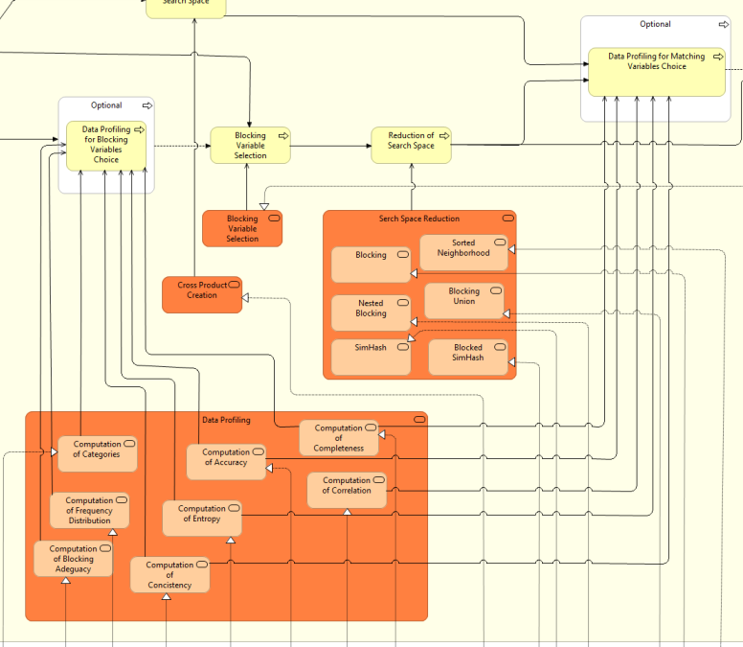

Figure 9. Data profiling for matching variable choice business process and service

1. Reduction to 1:1 record linkage: as previously seen, the decision models give as result a N:M linkage. This result is not always the best one; a unique correspondence between records can be desired. In this case, the user can choose between two different methods: optimal solution or greedy solution.

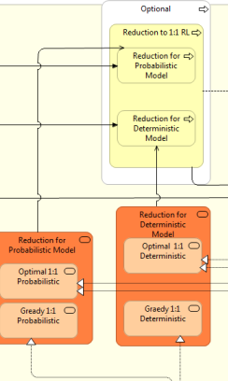

Figure 10. Reduction to 1:1 record linkage business process and service

## Application layer

Currently, the application layer consist of java modules realizing the business services. Figure 1 shows the main modules that realize the services. A graphical interface helps the user to interact with data and helps him to design and to run the record linkage process.

Referring to the core business steps, described in the previous section, in the following we report the main java module called from the graphical interface to execute the business service.

1. Upload input data: as shown in the following excerpt of Figure 1, the main java modules executing the upload business service are ReadingFile.java, ReadingDBMySQL.java and ReadingDBOracle.java, depending from the input format.

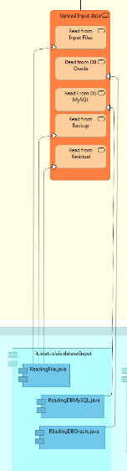

Figure 11. Upload input data application module

1. Search Space creation: as shown in the following excerpt of Figure 1, the Cross Product Creation service is realized by the CrossProduct.java java module. The SimHash.java, Blocking.java, NestedBlocking.java and SortedNeighborhood.java java modules realize the corresponding business service of the Search Space Reduction business service.

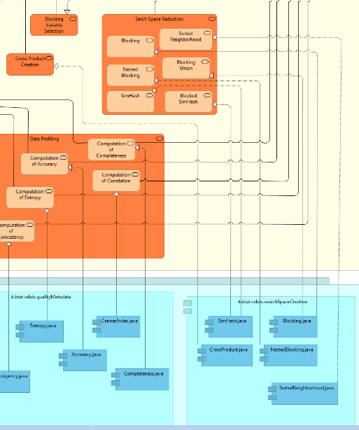

Figure 12. Search Space creation application module

1. Matching variable and comparison function selection: as shown in the following excerpt of Figure 1, the Matching Variable Selection service is realized by the java module ChooseVariable.java, while each comparison function is realized by the corresponding java module, specifically: Levenstein.java implements Levenstein service, Jaro.java implents Jaro service, and so on.

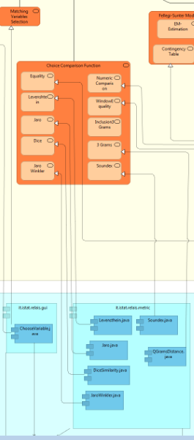

Figure 13. Matching variable and comparison function selection apllication module

1. Decision Model: two java modules implement the probabilistic method, realized by the Fellegi-Sunter Method business service namely: Contingencytable.java and FellegiSunterMethod.java (that invoke an R program). The MUTableDeterminist.java java module implements the deterministic method business service.

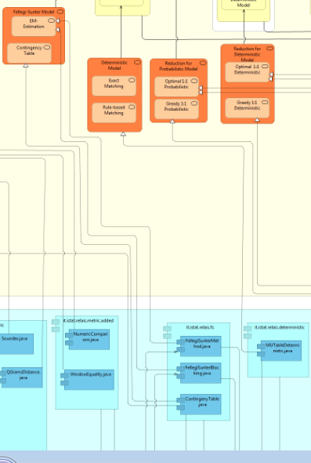

Figure 14. Decision Model application module

1. Linkage Result: the Choice Of Thresholds business service is implemented by the ChooseMThreshold.java java module. The cluster result business service is implemented by the ResultTable.java java module.

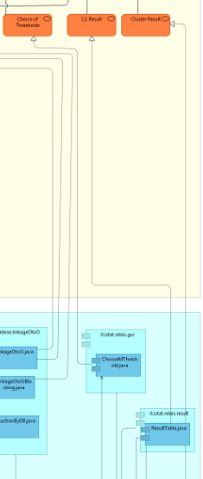

Figure 15. Linkage result application module

# Statistical Service Generalized Architecture (IS2)[2]

In the long-term, in order to implement shareable statistical services for different GSBPM phases, Istat realized a generalized architecture (Istat Statistical Service - IS2) that allows users to select statistical services in a catalogue and execute them through a web application (IS2 workbench).

The service specifications (e.g: input, output, method, rules) are described by using GSIM concepts. Starting from these concepts (e.g: business function, business process, process steps), a set of process metadata has been modelled. This metadata model allows to describe, launch and manage the single steps of each process corresponding to a specific service.

The IS2 Workbench, as shown in Figure 16, allows to manage different workflows, to visualize and analyze input and output data. Available services use different engines, currently: R, Java and SQL. Data and metadata are stored in a repository.

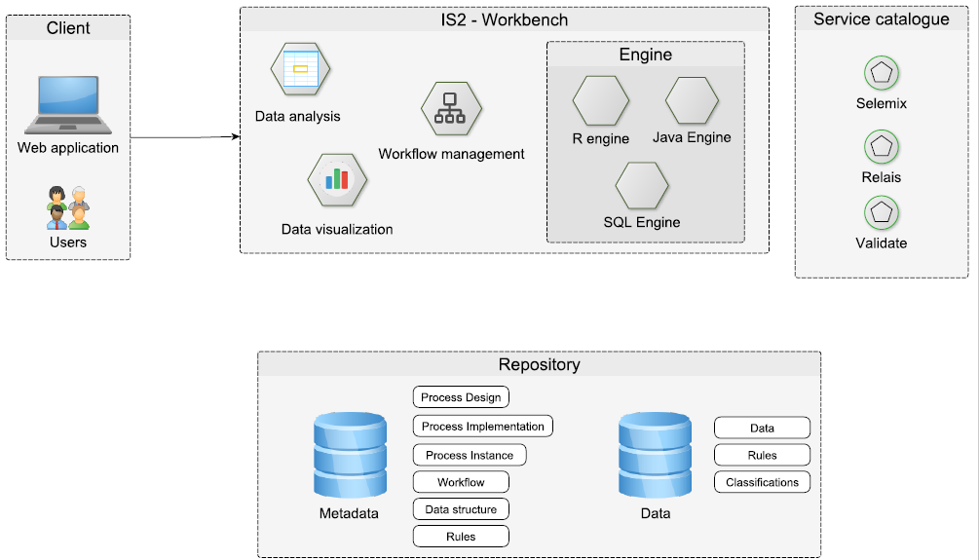

Figure 16. IS2 Workbench

**Mettere una breve descrizione di ogni componente** (prendere ispirazione dal documento architetturale di SINTESI)

* **Repository** (Metadata mandatory, Data fallo come te piace a te). Una descrizione dettagliata del metadata repository is provided in annex
* **Service catalogue**
* **Engines** (bridge di paoline)
* **Workflow management**
* **Components (data analysis, data visualization, etc)**

**Process flow…**

A statistical service, regardless of the implemented method, is supposed to execute the following tasks:

1. Upload and manage input data, to provide initial data to process;
2. Parameters and variables settings;
3. Run method;
4. Analyze output.

In a generalized architecture of a statistical service, these tasks correspond to the following business steps, as shown in Figure 17:

1. **Create Working Session:** this step includes data upload and preprocessing. In addition to the information to process, input data may include auxiliary information split in different datasets. Before setting a method parameters, a statistician may need to perform basic statistics, or create new variables by transforming the existing ones, or select a subset of records and/or variables.
2. **Create Processing Session:** by mapping initial data with standardized metadata, input data are transformed in working data. In this step, the user can classify and manage the information to processby: i) assigning specific roles to some variables (e.g. identification variable, classification, core variables); ii) selecting auxiliary information (if needed); iii) setting the model parameters.
3. **Run method**: working data, with their standardized data structures, can be processed by one or more iterations of the statistical method. The result of each iteration is stored in standardized data structures (output data).
4. **Analyze output**: this process step can be used to perform quality checks and/or to calculate statistical indicators to assess the outcome of each iteration.

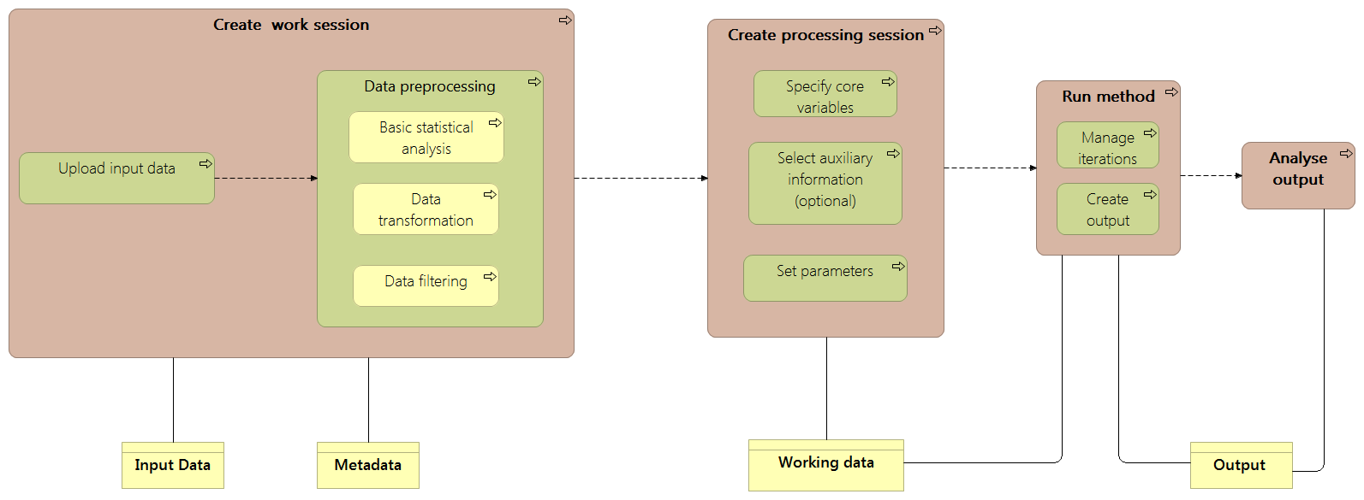

Figure 17. Statistical Service Business Process (che schifo bleah)

# Reengineering Relais in IS2

We decided to reengineer Relais starting from the business process, shown in Figure 18, that realizes a probabilistic record linkage workflow applying the Fellegi-Sunter method. It is composed of the following steps:

1. Upload input data.
2. Creation of search space using the cross-product method.
3. Matching variable and comparison function selection.
4. Application of the decision model that implements the Fellegi-Sunter probabilistic method.
5. Creation of the resulting datasets.

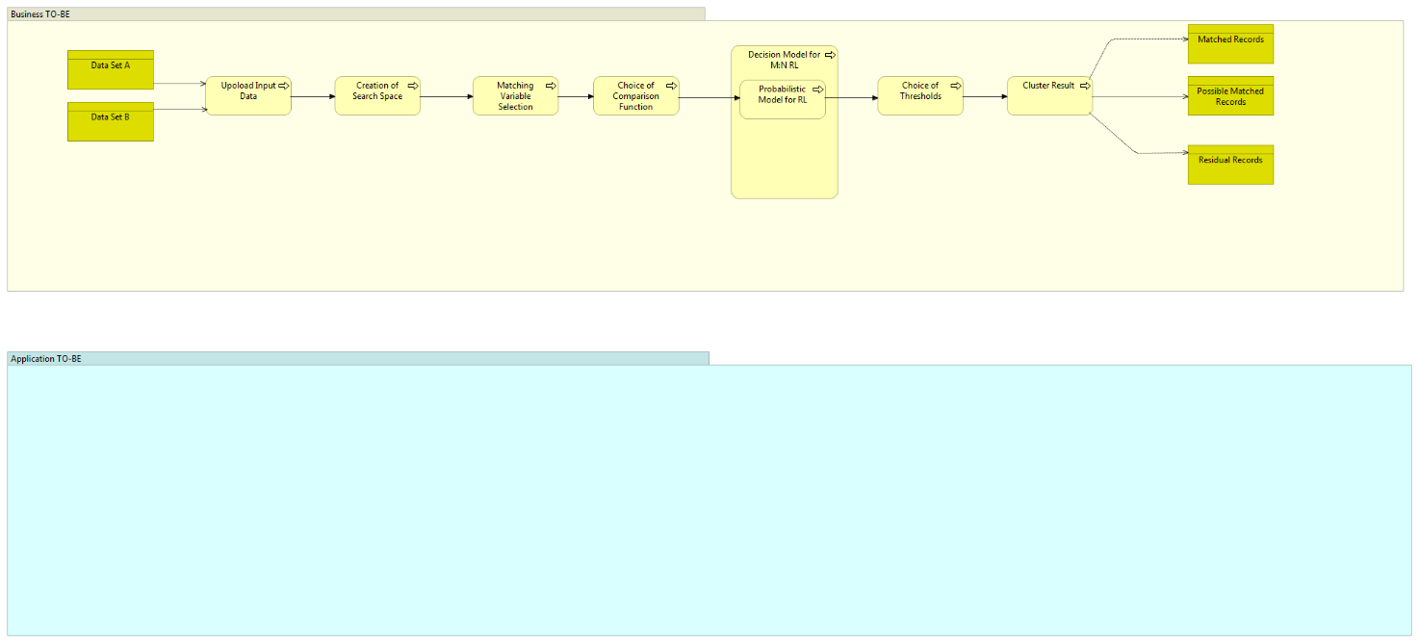

Figure 18. Relais business process implemented first

To implement Relais as a business service following the IS2 architecture, previously described and summarized in Figure 17, we reviewed the previously shown (Figure 18) business process. The following Figure shows the Relais business workflow revised, based on the IS2 business architecture.

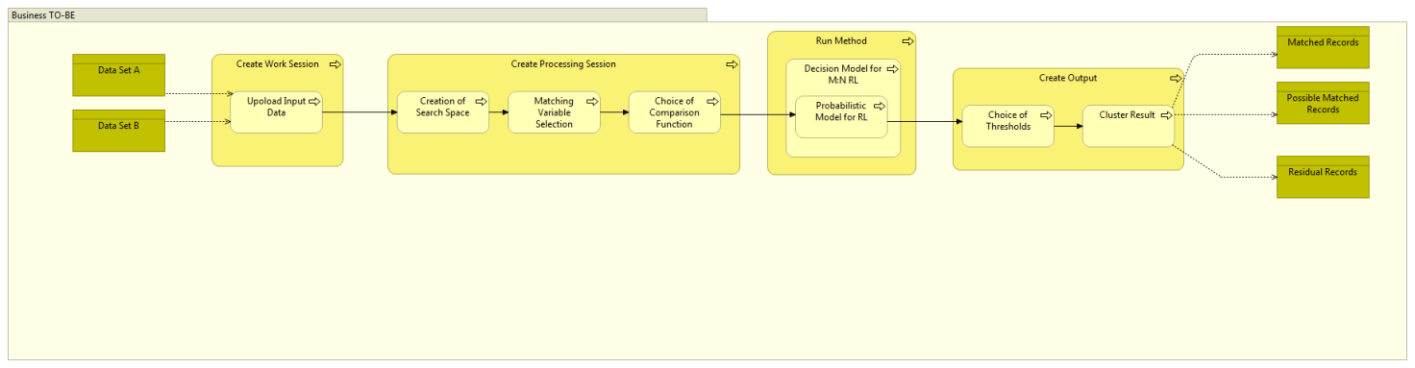

Figure 19. Relais business workflow implemented first, compliant to the IS2 business architecture

The following Table shows the correspondence between the old-Relais business steps and the new-Relais IS2 compliant ones.

|  |  |
| --- | --- |
| **Old-Relais business step** | **New-Relais business step** |
| Upload Input Data | Create Working Session – upload input data |
| Creation of Search Space | Create Working Session |
| Matching variable Selection | Create Processing Session – specify core variables |
| Choice of Comparison Function | Create Processing Session – set parameters |
| Probabilistic model for RL | Run method |
| Choice of thresholds | Create Processing Session – set parameters |
| Cluster result | Run Method – create output  Analyse output |

Table 1. Correspondence between old and new business steps

# Annex 1. Example of inputs and outputs of the business steps implemented in Relais-IS2.[3]

The following example aims to clarify the contents of the inputs and outputs of the business steps composing the business function of Relais currently implemented in IS2 (as detailed in Section 4) .

First input file (Data set A):

|  |  |  |  |  |
| --- | --- | --- | --- | --- |
| Id_DSA | Name | Surname | Address | Phone Number |
| 1 | Alessandro | Gassmann | v. Roma,11 | 333333333 |
| 2 | Marcello | Mastroianni | Viale Europa 16 | 333222222 |
| 3 | Pasquale | Banfi | Via Mar Tirreno 1 | 333111111 |
| 4 | Francesco | Zalone | Viale Adriatico 11 | 333000000 |

Second input file (Data set B):

|  |  |  |  |  |  |
| --- | --- | --- | --- | --- | --- |
| Id_DSB | Name | Surname | Address | Place of Birth | Date of Birth |
| 1 | Lino | Banfi | Via Mar Tirreno 1 | Andria | 09/07/1936 |
| 2 | Diego | Abatantuono | Via Roma 128 | Milano | 20/05/1955 |
| 3 | Alessandro | Gassman | v. Roma,11 | Roma | 24/02/1965 |
| 4 | Pierfrancesco | Favino | Via torino 16 | Roma | 24/08/1969 |
| 5 | Pasquale | Zalone | Viale Adriatico 114 | Bari | 03/06/1977 |
| 6 | Marcello | Mastroianni | Viale Europa | Fontana Liri | 28/09/1924 |

Starting from the input files, the search space business step, evaluated applying the cross-product method gives the following the resulting table:

|  |  |
| --- | --- |
| ID_DSA | ID_DSB |
| A_1 | B_1 |
| A_1 | B_2 |
| A_1 | B_3 |
| A_1 | B_4 |
| A_1 | B_5 |
| A_1 | B_6 |
| A_2 | B_1 |
| A_2 | B_2 |
| A_2 | B_3 |
| A_2 | B_4 |
| A_2 | B_5 |
| A_2 | B_6 |
| A_3 | B_1 |
| A_3 | B_2 |
| A_3 | B_3 |
| A_3 | B_4 |
| A_3 | B_5 |
| A_3 | B_6 |
| A_4 | B_1 |
| A_4 | B_2 |
| A_4 | B_3 |
| A_4 | B_4 |
| A_4 | B_5 |
| A_4 | B_6 |

Choosing Name, Surname and Address as matching variables and choosing for all of them Jaro as comparison function with a threshold equal to 0.8, we obtain the following contingency table:

|  |  |  |  |
| --- | --- | --- | --- |
| Name | Surname | Address | Frequency |
| 0 | 0 | 0 | 19 |
| 0 | 0 | 0 | 0 |
| 0 | 1 | 0 | 0 |
| 0 | 1 | 1 | 2 |
| 1 | 0 | 0 | 1 |
| 1 | 0 | 1 | 0 |
| 1 | 1 | 0 | 0 |
| 1 | 1 | 1 | 2 |

Assuming that applying the Fellegi-Sunter probabilistic model, we obtain the following result:

|  |  |  |  |  |
| --- | --- | --- | --- | --- |
| Name | Surname | Address | Frequency | Probability |
| 0 | 0 | 0 | 19 | 0.1 |
| 0 | 0 | 1 | 0 | 0.2 |
| 0 | 1 | 0 | 0 | 0.2 |
| 0 | 1 | 1 | 2 | 0.9 |
| 1 | 0 | 0 | 1 | 0.5 |
| 1 | 0 | 1 | 0 | 0.2 |
| 1 | 1 | 0 | 0 | 0.2 |
| 1 | 1 | 1 | 2 | 1 |

To each couple of records of the search space table corresponds a probability, as shown the following table:

|  |  |  |  |  |  |  |  |  |  |
| --- | --- | --- | --- | --- | --- | --- | --- | --- | --- |
| ID_DSA | Name_DSA | Surname_DSA | Address_DSA | ID_DSB | Name_DSB | Surname_DSB | Address_DSB | Pattern | Prob |
| A_1 | Alessandro | Gassmann | v. Roma,11 | B_1 | Lino | Banfi | Via Mar Tirreno 1 | 000 | 0.1 |
| A_1 | Alessandro | Gassmann | v. Roma,11 | B_2 | Diego | Abatantuono | Via Roma 128 | 000 | 0.1 |
| A_1 | Alessandro | Gassmann | v. Roma,11 | B_3 | Alessandro | Gassman | v. Roma,11 | 111 | 1 |
| A_1 | Alessandro | Gassmann | v. Roma,11 | B_4 | Pierfrancesco | Favino | Via torino 16 | 000 | 0.1 |
| A_1 | Alessandro | Gassmann | v. Roma,11 | B_5 | Pasquale | Zalone | Viale Adriatico 114 | 000 | 0.1 |
| A_1 | Alessandro | Gassmann | v. Roma,11 | B_6 | Marcello | Mastroianni | Viale Europa | 000 | 0.1 |
| A_2 | Marcello | Mastroianni | Viale Europa 16 | B_1 | Lino | Banfi | Via Mar Tirreno 1 | 000 | 0.1 |
| A_2 | Marcello | Mastroianni | Viale Europa 16 | B_2 | Diego | Abatantuono | Via Roma 128 | 000 | 0.1 |
| A_2 | Marcello | Mastroianni | Viale Europa 16 | B_3 | Alessandro | Gassman | v. Roma,11 | 000 | 0.1 |
| A_2 | Marcello | Mastroianni | Viale Europa 16 | B_4 | Pierfrancesco | Favino | Via torino 16 | 000 | 0.1 |
| A_2 | Marcello | Mastroianni | Viale Europa 16 | B_5 | Pasquale | Zalone | Viale Adriatico 114 | 000 | 0.1 |
| A_2 | Marcello | Mastroianni | Viale Europa 16 | B_6 | Marcello | Mastroianni | Viale Europa | 111 | 1 |
| A_3 | Pasquale | Banfi | Via Mar Tirreno 1 | B_1 | Lino | Banfi | Via Mar Tirreno 1 | 011 | 0.9 |
| A_3 | Pasquale | Banfi | Via Mar Tirreno 1 | B_2 | Diego | Abatantuono | Via Roma 128 | 000 | 0.1 |
| A_3 | Pasquale | Banfi | Via Mar Tirreno 1 | B_3 | Alessandro | Gassman | v. Roma,11 | 000 | 0.1 |
| A_3 | Pasquale | Banfi | Via Mar Tirreno 1 | B_4 | Pierfrancesco | Favino | Via torino 16 | 000 | 0.1 |
| A_3 | Pasquale | Banfi | Via Mar Tirreno 1 | B_5 | Pasquale | Zalone | Viale Adriatico 114 | 100 | 0.5 |
| A_3 | Pasquale | Banfi | Via Mar Tirreno 1 | B_6 | Marcello | Mastroianni | Viale Europa | 000 | 0.1 |
| A_4 | Francesco | Zalone | Viale Adriatico 11 | B_1 | Lino | Banfi | Via Mar Tirreno 1 | 000 | 0.1 |
| A_4 | Francesco | Zalone | Viale Adriatico 11 | B_2 | Diego | Abatantuono | Via Roma 128 | 000 | 0.1 |
| A_4 | Francesco | Zalone | Viale Adriatico 11 | B_3 | Alessandro | Gassman | v. Roma,11 | 000 | 0.1 |
| A_4 | Francesco | Zalone | Viale Adriatico 11 | B_4 | Pierfrancesco | Favino | Via torino 16 | 000 | 0.1 |
| A_4 | Francesco | Zalone | Viale Adriatico 11 | B_5 | Pasquale | Zalone | Viale Adriatico 114 | 011 | 0.9 |
| A_4 | Francesco | Zalone | Viale Adriatico 11 | B_6 | Marcello | Mastroianni | Viale Europa | 000 | 0.1 |

Choosing 0.8 as match threshold and 0.4 as unmatch threshold, we obtain the following results.

File of Match record:

|  |  |  |  |  |  |  |  |  |  |  |
| --- | --- | --- | --- | --- | --- | --- | --- | --- | --- | --- |
| Id_DSA | Name | Surname | Address | Phone Number | Id_DSB | Name | Surname | Address | Place of Birth | Date of Birth |
| A_1 | Alessandro | Gassmann | v. Roma,11 | 333333333 | B_3 | Alessandro | Gassman | v. Roma,11 | Roma | 24/02/1965 |
| A_2 | Marcello | Mastroianni | Viale Europa 16 | 333222222 | B_6 | Marcello | Mastroianni | Viale Europa | Fontana Liri | 28/09/1924 |
| A_3 | Pasquale | Banfi | Via Mar Tirreno 1 | 333111111 | B_1 | Lino | Banfi | Via Mar Tirreno 1 | Andria | 09/07/1936 |
| A_4 | Francesco | Zalone | Viale Adriatico 11 | 333000000 | B_5 | Pasquale | Zalone | Viale Adriatico 114 | Bari | 03/06/1977 |

File of Possible Match record:

|  |  |  |  |  |  |  |  |  |  |  |
| --- | --- | --- | --- | --- | --- | --- | --- | --- | --- | --- |
| Id_DSA | Name | Surname | Address | Phone Number | Id_DSB | Name | Surname | Address | Place of Birth | Date of Birth |
| A_3 | Pasquale | Banfi | Via Mar Tirreno 1 | 333111111 | B_5 | Pasquale | Zalone | Viale Adriatico 114 | Bari | 03/06/1977 |

File of first file residuals:

|  |  |  |  |  |
| --- | --- | --- | --- | --- |
| Id_DSA | Name | Surname | Address | Phone Number |

File of second file residuals:

|  |  |  |  |  |  |
| --- | --- | --- | --- | --- | --- |
| Id_DSB | Name | Surname | Address | Place of Birth | Date of Birth |
| 2 | Diego | Abatantuono | Via Roma 128 | Milano | 20/05/1955 |
| 4 | Pierfrancesco | Favino | Via torino 16 | Roma | 24/08/1969 |
|  |  |  |  |  |  |

# Annex 2. Data base schema

1. Laura Tosco and Luca Valentino.
2. By Francesco Amato, Mauro Bruno, Paolo Francescangeli, Giuseppina Ruocco
3. By Laura Tosco