

**MARMARA UNIVERSITY**

**FACULTY OF ENGINEERING**

CSE2025

Data Structures

Project #1

Submitted to: Res. Asst. Birol GENCYILMAZ

Due Date: 11/05/2021

|  |  |  |  |
| --- | --- | --- | --- |
|  | Dept | Student Id | Name Surname |
| 1 | CSE | 150119807 | Yasin Enes Şişik |

1. PURPOSE

The purpose of this experiment is to learn the principle of the linked list and some methods like recursion etc. .

2.PROBLEM

Assume an (theoretically) infinitely large positive natural number specified in decimal number system. How can we multiply it in our computer? We look for a solution that is capable of multiplying such a number. The infinitely large numbers concerning the multiplication (i.e., the multiplicand and the result) should be shown in the original number system presented to your program.

metin içeren bir resim

Açıklama otomatik olarak oluşturuldu

Picture 2.1

The requirement that the numbers may be infinitely large implies that you cannot use standard data types to represent these numbers. Therefore, you will need a data structure that appropriately represents such large natural numbers and you will redefine the multiplication operation in terms of these data structures. A typical data structure to exploit in this case is linked lists (LLs). You may hold each number (including the result) in a LL each digit stored in a node and, while multiplying each pair of digits of multiplicand and multiplier, you may accordingly update the relevant digits in the result. We provide below how the second example is implemented.

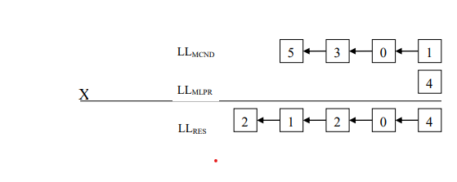

Picture 2.2

In this project you are expected to develop an algorithm that is capable of finding a solution to the above problem and implement this algorithm in C that runs under.

3.SKETCH

Before start coding, I thought on multiplication. What i know and what things can be helpful about coding. These are the first thing that come to my mind.

1. In multiplication, order does not efffect on result.

metin, beyaz tahta içeren bir resim

Açıklama otomatik olarak oluşturuldu

Picture 3.1

1. The number of digits of the product of two numbers is at most equal to the sum of the digits of the two number.

Japon sürgülü kapısı içeren bir resim

Açıklama otomatik olarak oluşturuldu

Picture 3.2

1. I saw that multiplication of two digits can be write at the their index sum. So result and multipliers can be stored in a linked list and help of the nested loop. It was possible

metin, beyaz tahta içeren bir resim

Açıklama otomatik olarak oluşturuldu

Picture 3.3

4.CODING

a)Libraries

I use extra one library that append bool variable.( **#include <stdbool.h>)**

metin içeren bir resim

Açıklama otomatik olarak oluşturuldu

Picture 4.1

**b)Structs**

I define 3 struct two of them actually equal but i want to see them clearly. Two of them are normal linked list and they have 2 variable that hold number and index. Third one has a prev pointer as an extra. So it is an double linked list

metin içeren bir resim

Açıklama otomatik olarak oluşturuldu

Picture 4.2

After that I wrote functions. These functions are creating linked lists and there is a boolean function which is check linked lists emptity. **insertProduct** function hold previous as different the others.

**metin içeren bir resim

Açıklama otomatik olarak oluşturuldu**

Picture 4.3

c)Int main

In in main firstly, it reads each line as a character. And assigned this character in its linked list with its index and digit value. I use **(int)(holder - '0')** notation for char to int conversion. Then it write number what it read from txt in output file. After that insert empty node accodirng to index in product linked list. Afterwards, when it reach end of the line while loop breaks and second while loop starts. Its similiar. Finally, I closed the files. Now we have double linked list of the size of the sum of the digits of the multiplied number. And all of them have value of zero. Write read jons finish and enter the function.

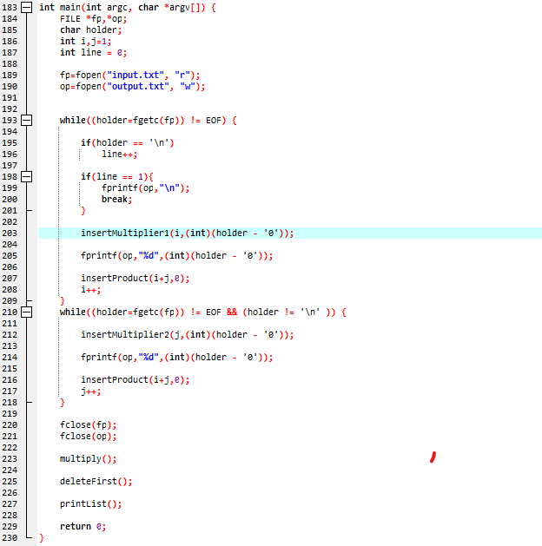

Picture 4.4

**d)Functions**

**Multiply function** emulates multiplication and juxtaposes the necssary numbers then enter the add function.

metin içeren bir resim

Açıklama otomatik olarak oluşturuldu

Picture 4.5

**Add function** iterates through linked list and assigns data to specific index. Then it checks that if there is elde it enters the recursion till there is no elde.

metin içeren bir resim

Açıklama otomatik olarak oluşturuldu

Picture 4.6

**DeleteFirst function**, if there is zero at the head of the linked list, it will delete them.

metin içeren bir resim

Açıklama otomatik olarak oluşturuldu

Picture 4.7

**PrintList function,** writes to product linked list in text file.

metin içeren bir resim

Açıklama otomatik olarak oluşturuldu

Picture 4.8

5.DISCUSSION

In this Project, I had the opportunity to reinforce what we learned in the lesson and I tried to use most of the things we learned. In terms of the subject of the Project, I would be interested and I could concentrate more.

6.REFERANCES

# <https://www.tutorialspoint.com/cprogramming/c_file_io.htm>

<https://www.youtube.com/watch?v=e-srF6c3TJ8&ab_channel=ProgrammingKnowledge>

<https://www.javatpoint.com/doubly-linked-list>

<https://stackoverflow.com/questions/7828393/c-programming-casting-a-void-pointer-to-an-int>

<https://stackoverflow.com/questions/40699389/comparing-int-to-null-in-c-is-this-tutorial-incorrect>

<https://stackoverflow.com/questions/33129639/reading-file-line-by-line-character-by-character-in-c>

https://www.geeksforgeeks.org/data-structures/linked-list/