Upgrade Oracle Database 10.2.x to 11.2.0.4

Windows x64 environment

Table of Contents

Task overview 3

Installing oracle patch 10.2.0.5 4

Installation Media 4

Install the Oracle 10.2.0.5 patch 5

Procedure after upgrade 7

Installing oracle release 11.2.0.4 10

Installation Media 10

Install Oracle 11 software 10

SKIPPED #Installing additional orcle patches 11

Copying and Adapting the SQL*Net Files 12

Backup SAP database 12

Delete old LISTENER 12

Perform database upgrade 13

Post Upgrade scripts 15

Post Upgrade steps 15

Setting up new LISTENER 15

Upgrade SAP executables and BRTools 16

Performing Post Upgrade tasks 17

Performing Task in SAP system 17

Uninstall old oracle 19

SKIPPED #Uninstall software 19

List of Materials 20

# Task overview

Source version: Oracle 10.2.x

Target version: Oracle 11.2.0.4

OS: Windows 2003 Server EN x64

If the source database runs Oracle 10.2 with patch set lower than 10.2.0.5, you need to first upgrade the source database to at least patch set 10.2.0.5.

If the source database runs with patch set greater or equal than 10.2.0.5 then you can jump to step “Installing oracle release 11.2.0.4” on page 10

In my upgrade process, I have skipped two unmandatory steps:

- Installation of additional oracle patch

- uninstallation of old oracle software after upgrade

# Installing oracle patch 10.2.0.5

## Installation Media

Download SAP DISK 51040057_4 - ORACLE_Patch_10.2.0.5_LINUX__Windows

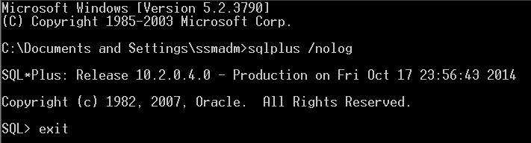

Shut down SAP and Oracle. Stop all Oracle services

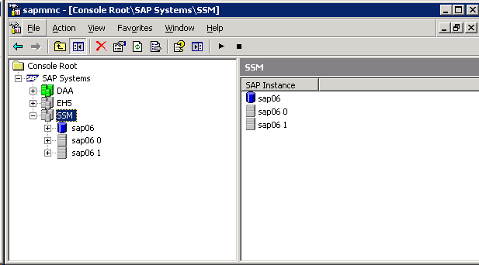

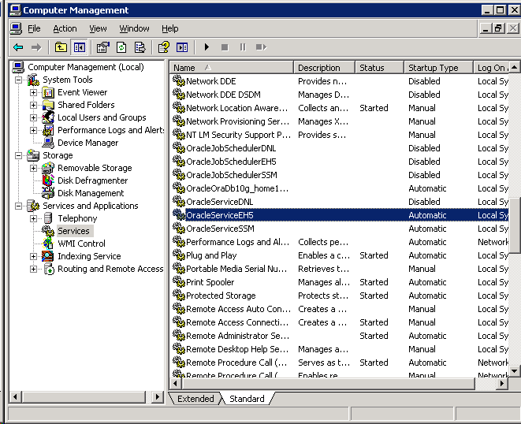

## Install the Oracle 10.2.0.5 patch

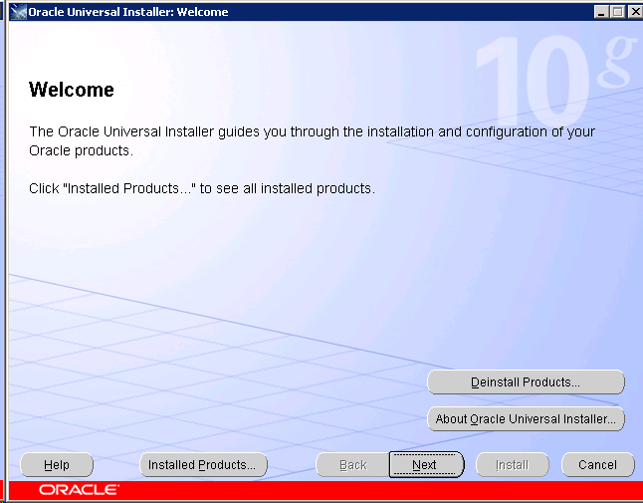

Check the Environment Variable

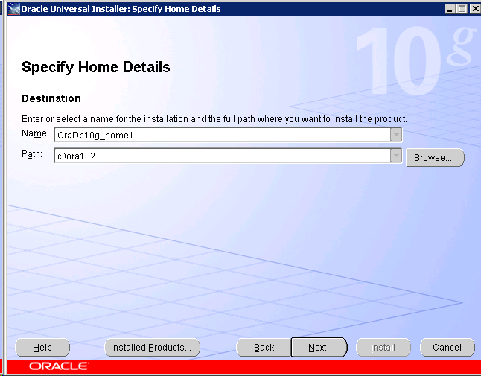

Start installation

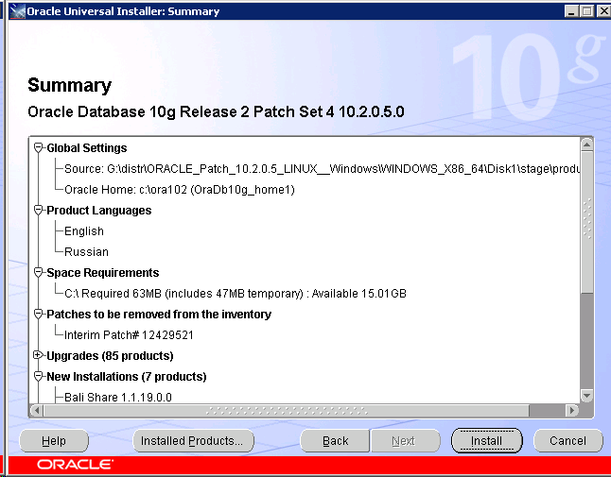

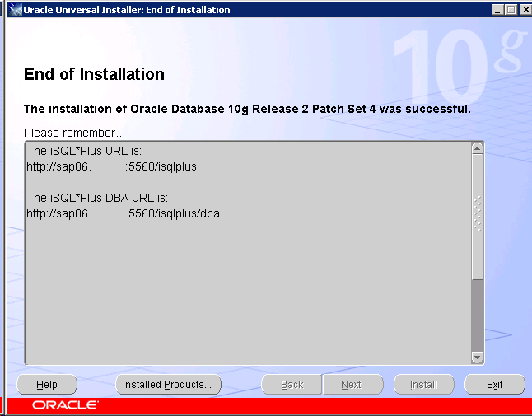

Start all Oracle services and check oracle version

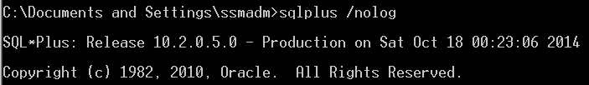

## Procedure after upgrade

Open CMD as <sid>adm

sqlplus /nolog

startup migrate;

@<path>\catupgrd.sql;

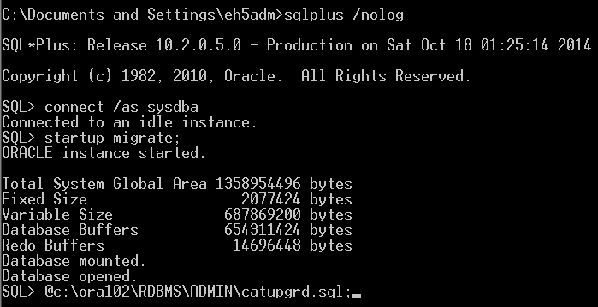

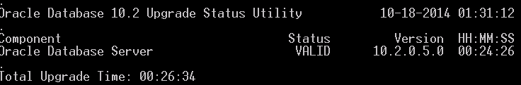

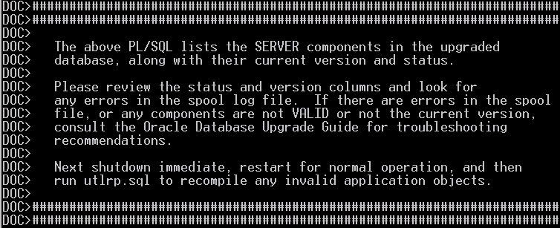

shutdown immediate

startup

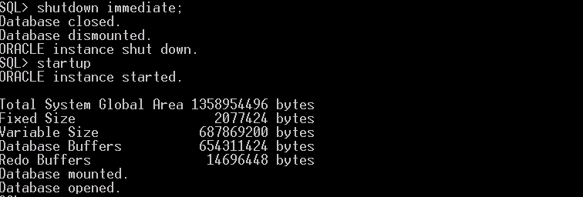

@<path>\utlrp.sql

Start SAP instance

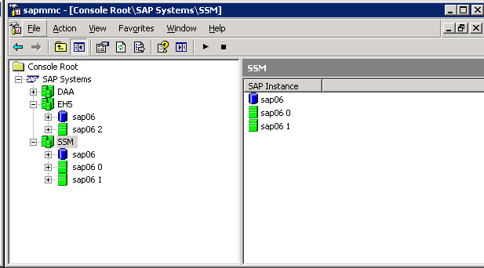

# Installing oracle release 11.2.0.4

## Installation Media

Download SAP DISK 51047948 - ORACLE 11.2.0.4 64-BIT RDBMS Windows Server on x64 64bit

Download Oracle 11.2.0.4 Patch 9584028 for Windows, P9584028GEN11204P_1-20010784.ZIP

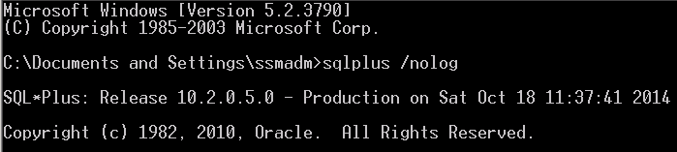

## Install Oracle 11 software

Change the ORACLE_HOME environment variable for <sid>adm user. Login off to changes take effect 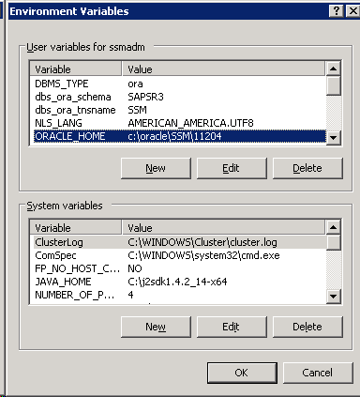

Stop all SAP instance without database. Start Oracle Universal Installer. Select install database software only

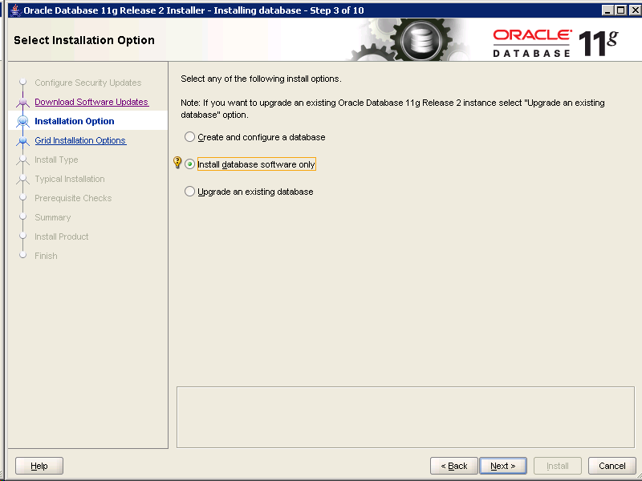

Select Enterprise Edition

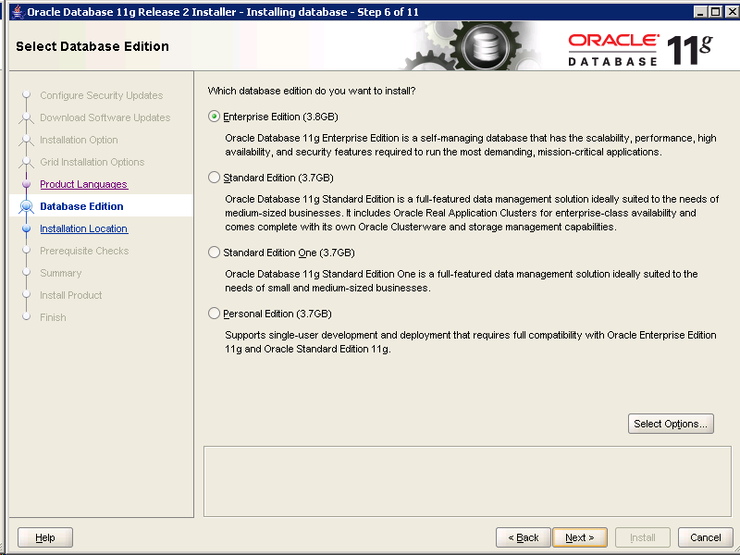

Set ORACLE_BASE AND new Oracle Home directory

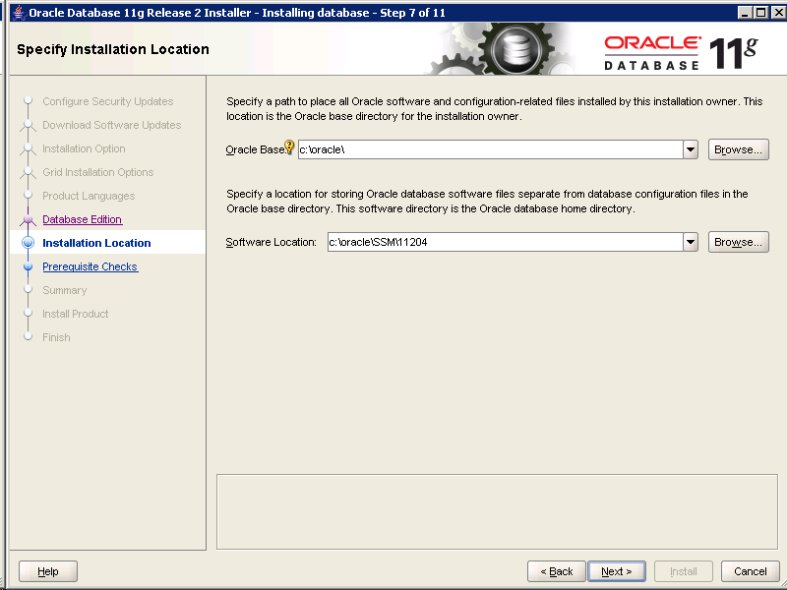

Check free space on disk

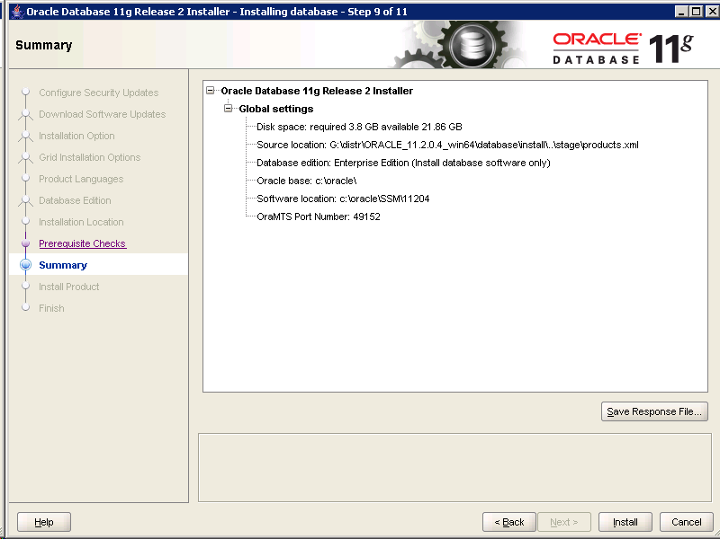

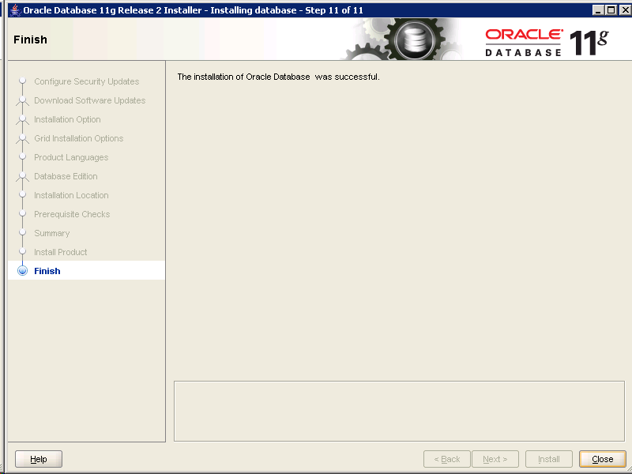



SKIPPED #Installing additional orcle patches

After the database software installation, you need to install all required Oracle database patches. Check SAP Note 1631931 for Oracle 11.2.0.3 and SAP Note 1949250 for Oracle 11.2.0.4 for the patches to be installed.

## Copying and Adapting the SQL*Net Files

Copy the profiles of SAP BR*Tools:

Copy <old_Oracle_home>\database\init<SID>.sap to <new_Oracle_home>\database\ init<SID>.sap

Copy <old_Oracle_home>\database\init<SID>.utl to <new_Oracle_home>\database\init<SID>.utl (if existing)

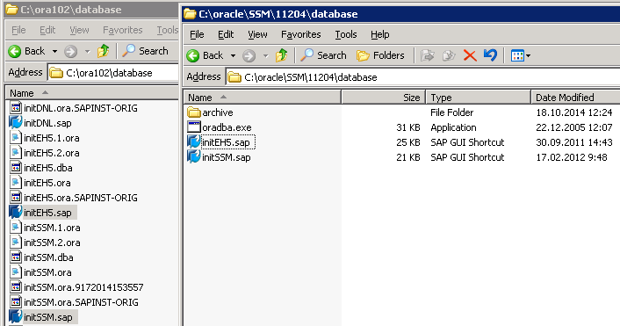

Copy the SQL*Net parameter files listener.ora, sqlnet.ora, and tnsnames.ora from the directory <old >\network\admin to the directory <new_ORACLE_HOME>\network\admin

Open listener.ora, edit ORACLE_HOME entry and add ADR_BASE_<listener_name> parameter

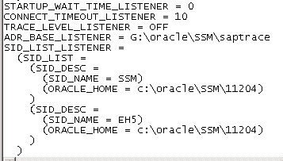

## Backup SAP database

Copy <old_Oracle_home>\database\init<SID>.ora to <new_Oracle_home>\database\init<SID>.ora

Start **BRTools** by <sid>adm and back up database

## Delete old LISTENER

Change ORACLE_HOME environment variable back to **old** value and start delete old LISTENER

Choose **Start -> All Programs -> <OLD_ORACLE_HOME> -> Configuration and Migration Tools -> Net Configuration Assistant**.

On the Welcome screen, choose Listener Configuration and then Next. When Delete LISTENER.

Change ORACLE_HOME environment variable back to **new** value. Login off to changes take effect.

## Perform database upgrade

If not yet stopped, stop the SAP system but do not stop the DB instance.

Choose **Start -> All Programs -> <NEW_ORACLE_HOME> -> Configuration and Migration Tools -> Database Upgrade Assistant**

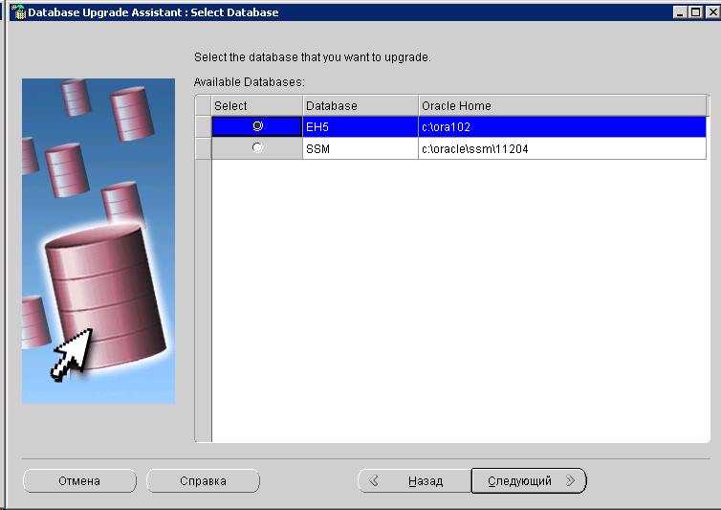

Set Upgrade Timezone checkbox

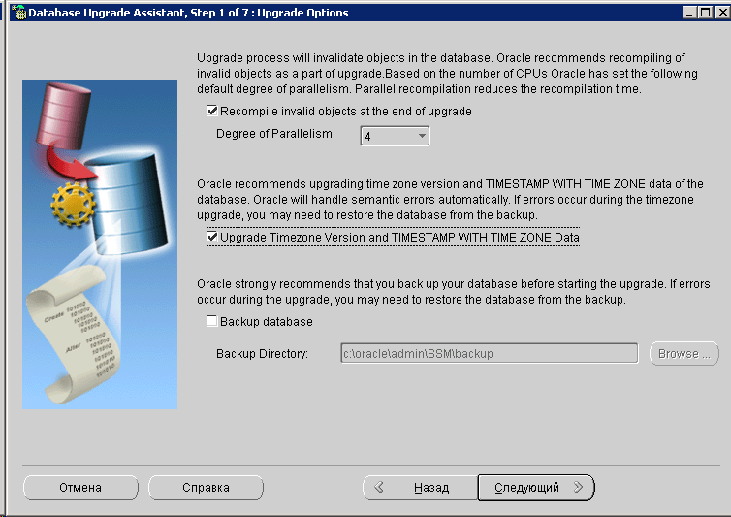

Do not Move Database Files

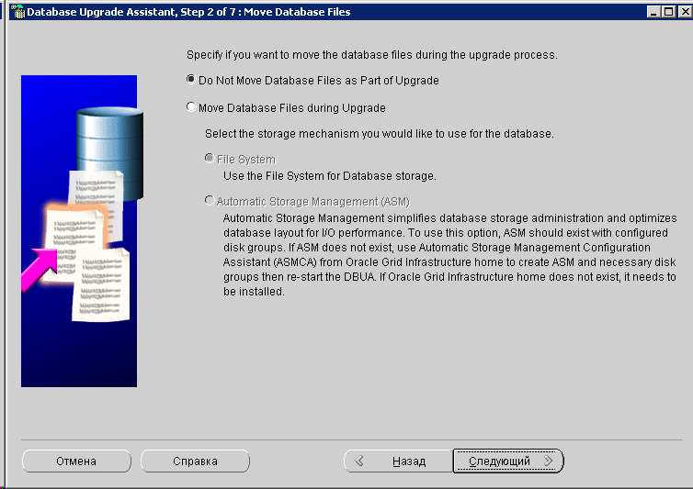

Select saptrace directory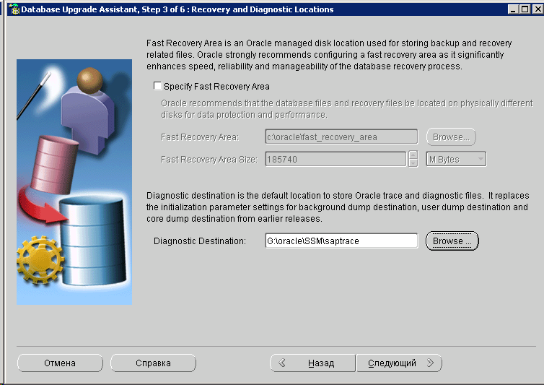

Deselect Configure the Database with Enterprise Manager, if selected, and choose Next. 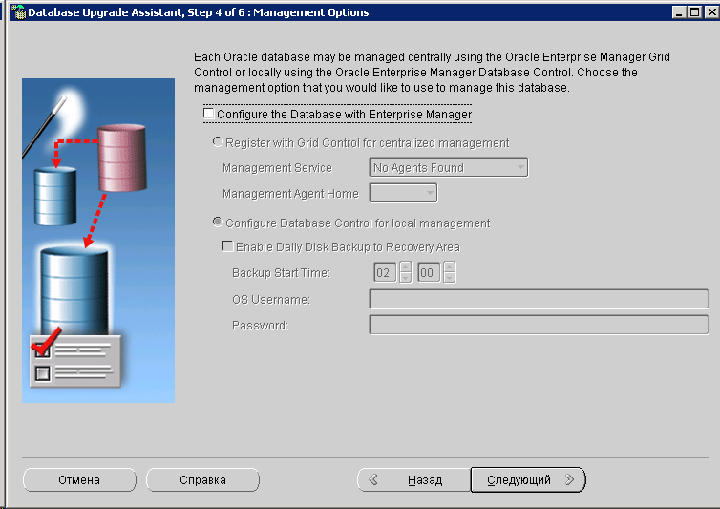

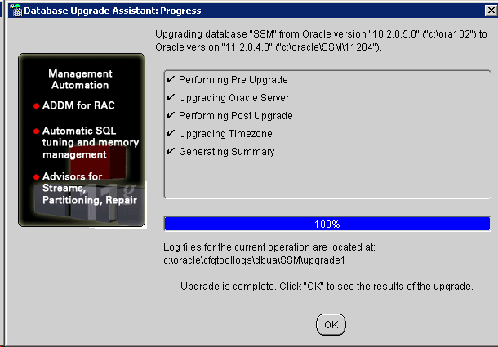

## Post Upgrade scripts

To run the required SAP- specific post-upgrade scripts, follow the instructions in SAP note 1431793.

Extract sap folder from 9584028 patch in <ORACLE_HOME>

Change the directory to '<ORACLE_HOME>/sap/ora_upgrade/post_upgrade' and run the scripts from SQL*Plus as SYSDBA.

|  |  |  |
| --- | --- | --- |
| Step description | Command(s) | Additional info |
| Perform Post-upgrade tasks | SQL> spool post_upgrade_tasks.log SQL> @post_upgrade_tasks.sql SQL> spool off |  |
| Perform post-upgrade checks | SQL> @post_upgrade_status.sql | Run this script after the upgradfe to check whether the database is configured correctly. The result of this check is logged in 'post_upgrade_status.log'. |
| Set database parameters | SQL> @set_remote_os_authent.sql | Description: sets parameter remote_os_authent=true run on Unix/Linux platforms for SAP installations with ABAP stack, if no Secure Store ([SSFS](http://service.sap.com/sap/support/notes/1622837)) is configured Reference for parameter remote_os_authent: [SAP note 1431798](http://service.sap.com/sap/support/notes/1431798) |
| Set database parameters | SQL> @set_compatible.sql | Description: sets parameter COMPATIBLE Must be run on Unix and Windows platforms after upgrade from release 10.2 to 11.2.0.x Can be run after upgrade from 11.2.0.x to 11.2.0.y. Reference for parameter COMPATIBLE: [SAP note 1431798](http://service.sap.com/sap/support/notes/1431798) |

## Post Upgrade steps

In the user environment and system environment <sid>adm, check the PATH variable and, if required, remove all parts referring to the old Oracle version

In the user environment of <sid>adm, set the ORACLE_HOME variable to the correct value for Oracle 11g, for example to: <DRIVE>:\ORACLE\<DBSID>\11204

Check the user environment variable TNS_ADMIN to point to the directory \\<sapglobalhost>\sapmnt \<DBSID>\SYS\profile\oracle

Log off and log on again to activate the environment changes in your user session

## Setting up new LISTENER

Open a command prompt and enter the following:

<Complete_Path_To_New_Oracle_Home>\bin\lsnrctl start <Listener_Name>

You will get the following error message: Failed to open service <Oracle<SID>11202TNSListener>, error 1060. Then the service will be created and started.

Change Startup Type of new LISTENER service to Automatic in Services Console

Change the registry value of ORA_<DBSID>_AUTOSTART. Open a command prompt and enter the following command: <new_Oracle_Home>\bin\oradim -edit -sid <dbsid> -startmode manual

Start the Oracle services (Database and Listener), if not yet started.

## Upgrade SAP executables and BRTools

Check current kernel version and patch level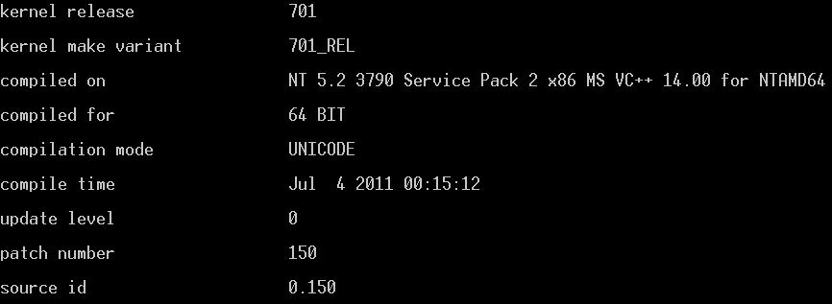

Download latest SAP KERNEL 7.21 64-BIT UNICODE Windows on x64 ORACLE 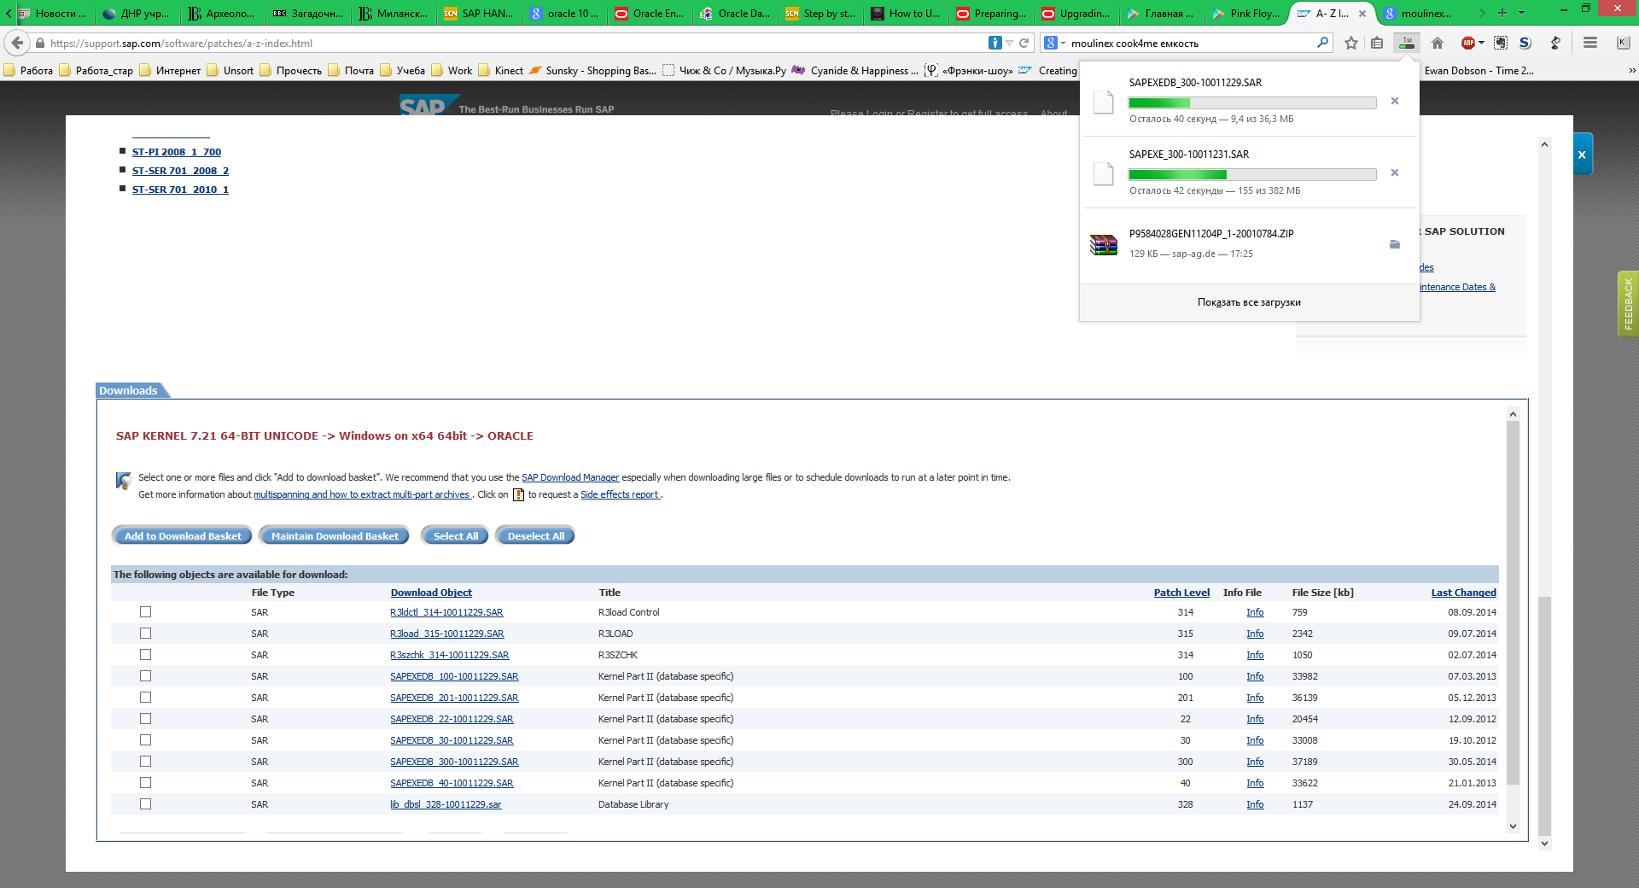

Back up old kernel \\<Server_name>\sapmnt\<SID>\SYS\exe\uc\NTAMD64

Unpack new kernel with SAPCAR

SAPCAR –xvf <archive_path>SAPEXE*.SAR –R <target_dir>

Replace kernel in \\<Server_name>\sapmnt\<SID>\SYS\exe\uc\NTAMD64 with a new one

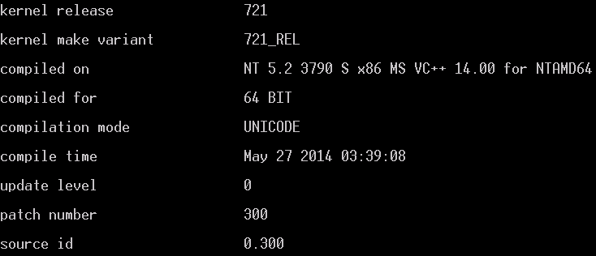

## Performing Post Upgrade tasks

brconnect -u / -c -f stats -t system_stats

brconnect -u / -c -f stats -t oradict_stats

brconnect -u / -c -f stats -t all -f collect -p 4

## Performing Task in SAP system

Start SAP instance

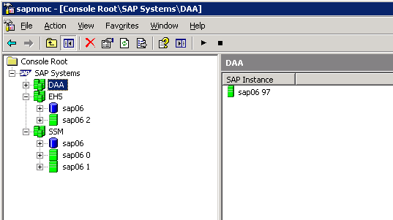

Check system with SICK transaction

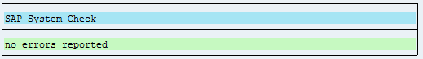

Check DB02

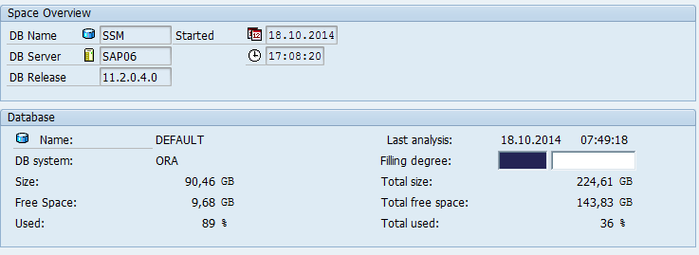

Check System - Status

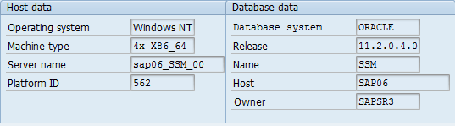

Check kernel

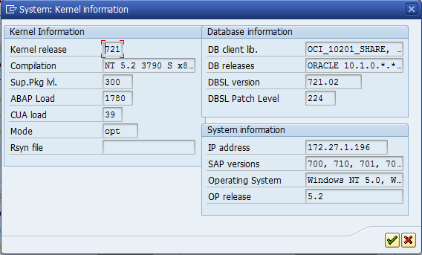

Start SGEN

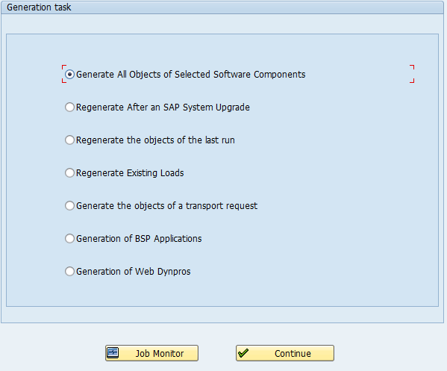

# Uninstall old oracle

SKIPPED #Uninstall software

Do not delete the old software, if it still has to be accessed by another database instance running with this version.

Stop the services of the old Oracle Home

To deinstall the Oracle 10.2 software, you use the Oracle Universal Installer (OUI). If you find the Universal Installer under Start All Programs <New_Oracle_Home_Name> Oracle Installation Products Universal Installer , you must start it from this path. Otherwise, start it from Start All Programs Oracle Installation Products Universal Installer .

On the Welcome screen, choose Deinstall Products.

On the Content tab of the Inventory dialog box, check the node representing your old Oracle Home and press the Remove button

If available, delete the services in which the name contains the old Oracle Home name. To delete a service, open a command prompt and enter:

sc delete <service_name>

Delete the entry Oracle – <OLD_ORACLE_HOME_NAME>, if it exists, in the Windows Start menu.

# List of Materials

Guide [Upgrade to Oracle Database 11 Release 2 (11.2): Windows Based on Oracle Patch Set Release 11.2.0.4 version 3.00 – 2014-03-10](https://websmp206.sap-ag.de/~sapidb/011000358700000608442010E/win_ora_upgrade.pdf)

SAP Note [1431793 - Oracle 11.2.0: Upgrade Scripts](http://service.sap.com/sap/support/notes/1431793) version 54