Yina Tang & Wyn Roberts
Task 6
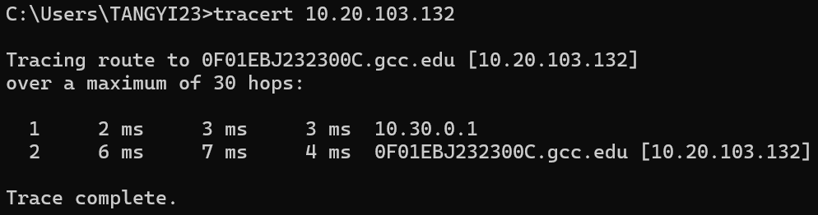
One intermediate node: 10.30.0.1
Latency for Stop-and-Wait ARQ: 245.497s
Given the mechanisms of Stop-and-Wait, the sender only sends out another packet after it has received ACK for the previous packet, waiting when we could be propagating other packets. Moreover, it doesn’t help that we have a lot of data/packets and an intermediate node which adds to transmission delay.

Task 7: Latency vs. winSize
