Operating Systems Course
CPU Scheduling Comparison Project — C1

Priority Scheduling vs SRTF
Field | Details
Algorithms | Priority Scheduling & SRTF
Language | HTML / CSS / JavaScript
Priority Rule | Lower value = Higher priority
Course | Operating Systems
Comparative Analysis Report

1. Introduction
CPU scheduling is one of the fundamental responsibilities of an operating system. The scheduler determines which process in the ready queue is allocated the CPU at any given moment, directly influencing system responsiveness, resource utilization, fairness, and overall throughput.

This report presents a detailed comparative study of two preemptive CPU scheduling algorithms:
- Priority Scheduling: assigns CPU time based on a predefined priority value associated with each process. The process with the highest priority (lowest numeric value in our convention) is selected first.
- Shortest Remaining Time First (SRTF): always selects the process with the least remaining burst time. It is the preemptive version of Shortest Job First (SJF).

The objective of this project is to implement both algorithms, execute them on identical workloads, and analyze the differences in terms of performance metrics (Waiting Time, Turnaround Time, Response Time), fairness, starvation risk, and practical suitability.

Key Question
How does a policy-driven scheduler (Priority) compare to an efficiency-driven scheduler (SRTF)
when faced with the same workload? Which is fairer? Which is faster?

2. Algorithm Descriptions

2.1 Priority Scheduling
Priority Scheduling selects the process with the highest priority from the ready queue. In this project, a lower numeric priority value indicates a higher priority (i.e., Priority 1 is served before Priority 3).

Rules applied in our implementation:
- At each time unit, the scheduler selects the process with the smallest priority number among all arrived processes.
- If two processes share the same priority, the tie is broken by Arrival Time (earlier arrival wins), then by Process ID.
- The scheduler is fully preemptive: if a newly arrived process has higher priority than the running process, it immediately preempts it.
- A process that is preempted returns to the ready queue and resumes later.

Starvation Risk: Low-priority processes may wait indefinitely if high-priority processes keep arriving.

2.2 Shortest Remaining Time First (SRTF)
SRTF is the preemptive counterpart of SJF. At every time unit, the process with the smallest remaining burst time is chosen. If a new process arrives whose burst time is less than the remaining time of the currently running process, the current process is preempted immediately.

Rules applied in our implementation:
- The scheduler compares remaining burst times at every time unit and at every new process arrival.
- Ties in remaining burst time are resolved by Arrival Time, then by Process ID.
- SRTF minimizes Average Waiting Time theoretically, but it ignores priority values entirely.

Starvation Risk: Long processes may be indefinitely postponed if short processes keep arriving.

3. Implementation Details

3.1 Technology Stack
- Frontend: HTML5, CSS, JavaScript
- Gantt charts rendered using structured HTML tables with dynamic coloring
- All calculations performed in real-time on process input

3.2 System Architecture
The simulator is organized into the following modules:
- Input Module: collects Process ID, Arrival Time, Burst Time, and Priority; validates all fields before simulation.
- Validation Engine: rejects negative arrival times, non-positive burst times, duplicate IDs, non-numeric values, and missing fields.
- Scheduling Engine: runs two separate simulation loops — one for Priority, one for SRTF — on identical input data.
- Gantt Chart Renderer: draws the execution timeline for each algorithm independently.
- Metrics Calculator: computes WT, TAT, RT per process and calculates averages.
- Comparison Module: displays side-by-side comparison and generates the conclusion.

3.3 Assumptions
- All time values are integers and simulation runs unit by unit.
- Priority rule: smaller value = higher priority.
- Tie-breaking for equal priority or equal remaining time: earlier arrival time, then lower Process ID.
- Context switch overhead is not modeled (zero-cost preemption assumed).
- All processes are independent with no I/O bursts.

3.4 Input Validation
Validation Rule | Error Behavior
Negative Arrival Time | Rejected with error message
Zero or Negative Burst Time | Rejected with error message
Duplicate Process ID | Rejected — all IDs must be unique
Non-numeric input in numeric field | Rejected with field-level error
Missing required field | Simulation blocked until corrected
Invalid priority value (e.g., 0 or negative) | Rejected with error message

4. Test Scenarios and Results
All four test scenarios were executed using identical process inputs for both algorithms. Results, Gantt charts, and metrics are presented separately for each algorithm.

Scenario A: Basic Mixed Workload
A standard workload with varied arrival times, burst times, and priorities to evaluate baseline behavior of both algorithms.
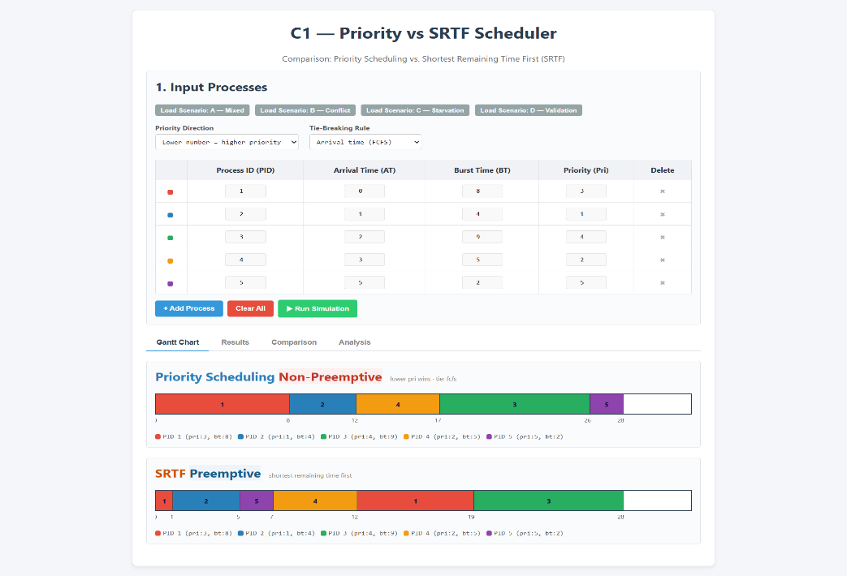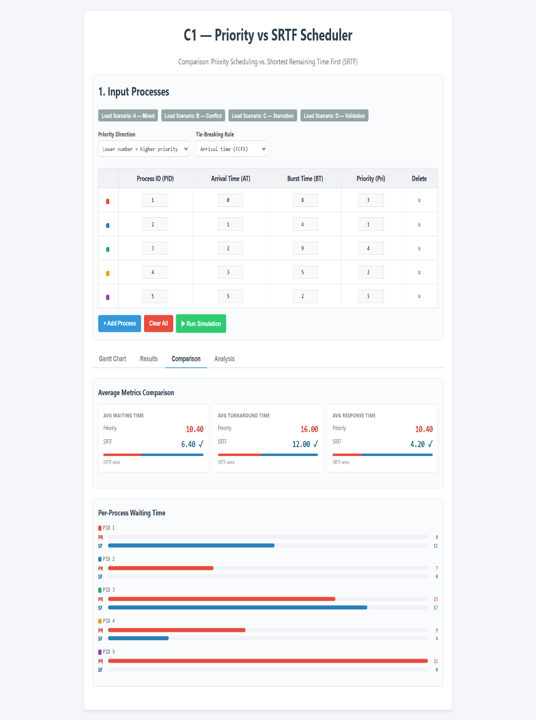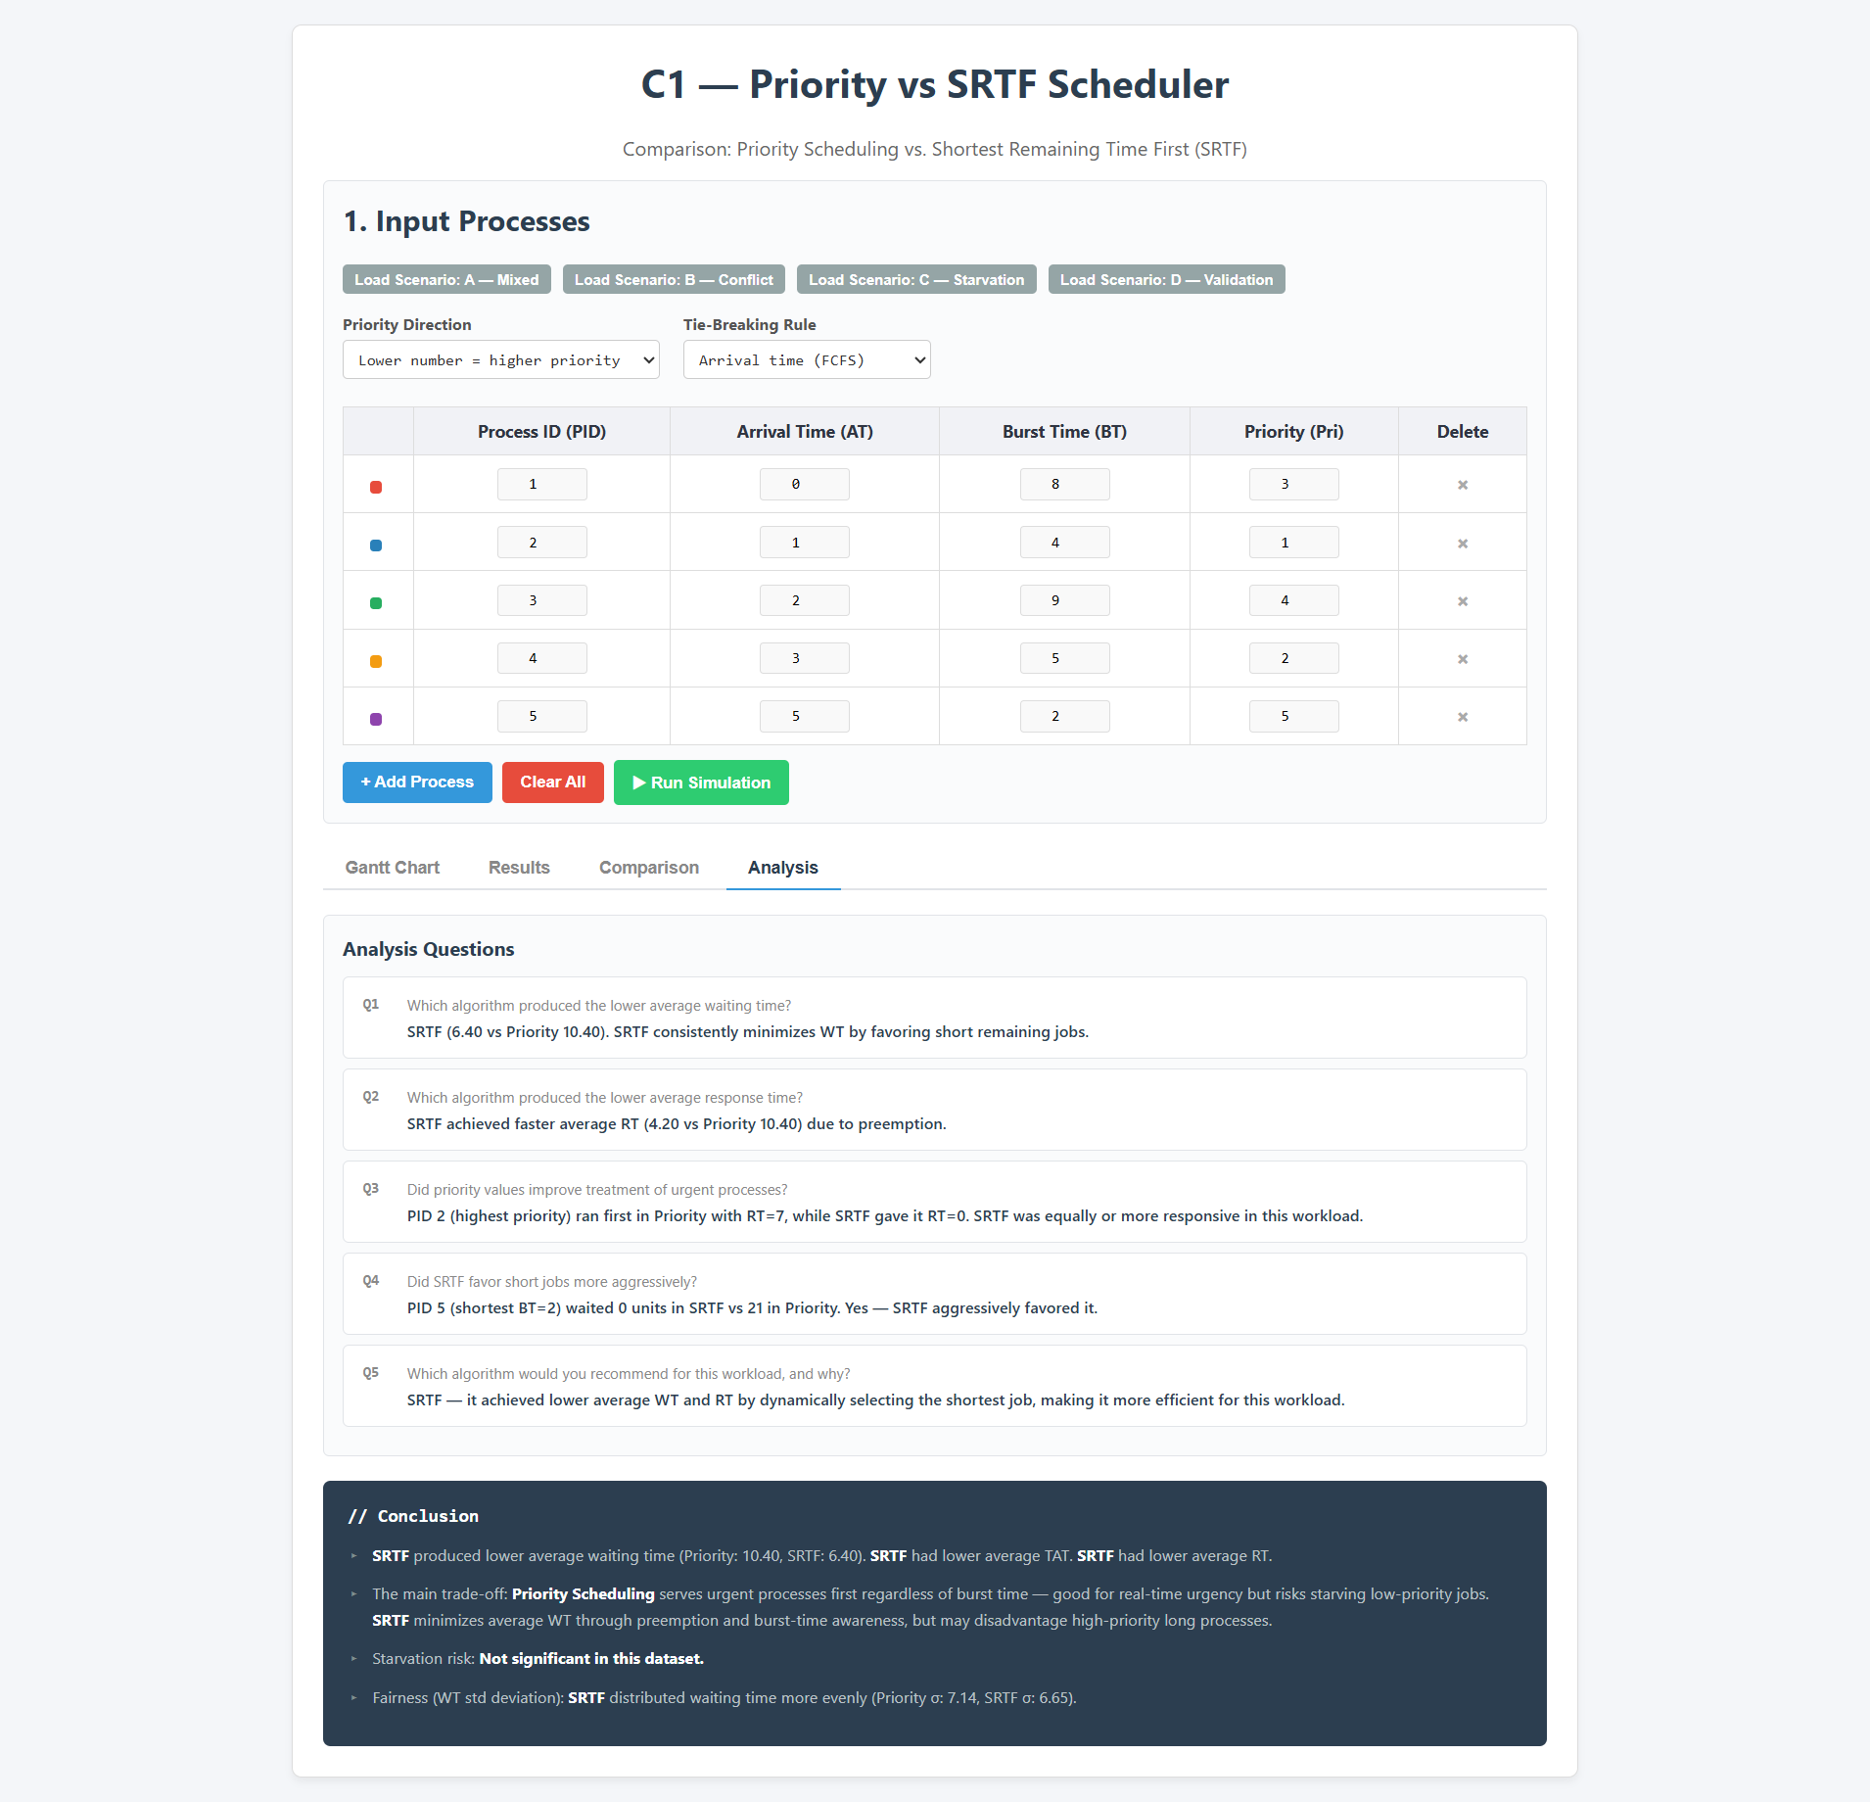

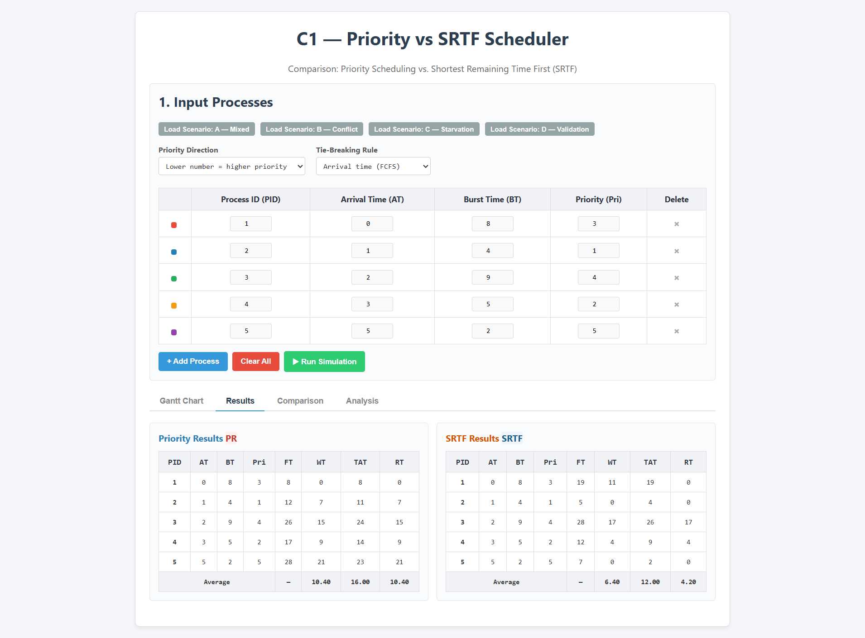

Scenario B: Conflict Between Priority and Burst Time
This scenario is designed to highlight the fundamental difference between the two algorithms. A high-priority process has a very long burst time, while a low-priority process has a very short burst time. The two schedulers make completely different decisions.

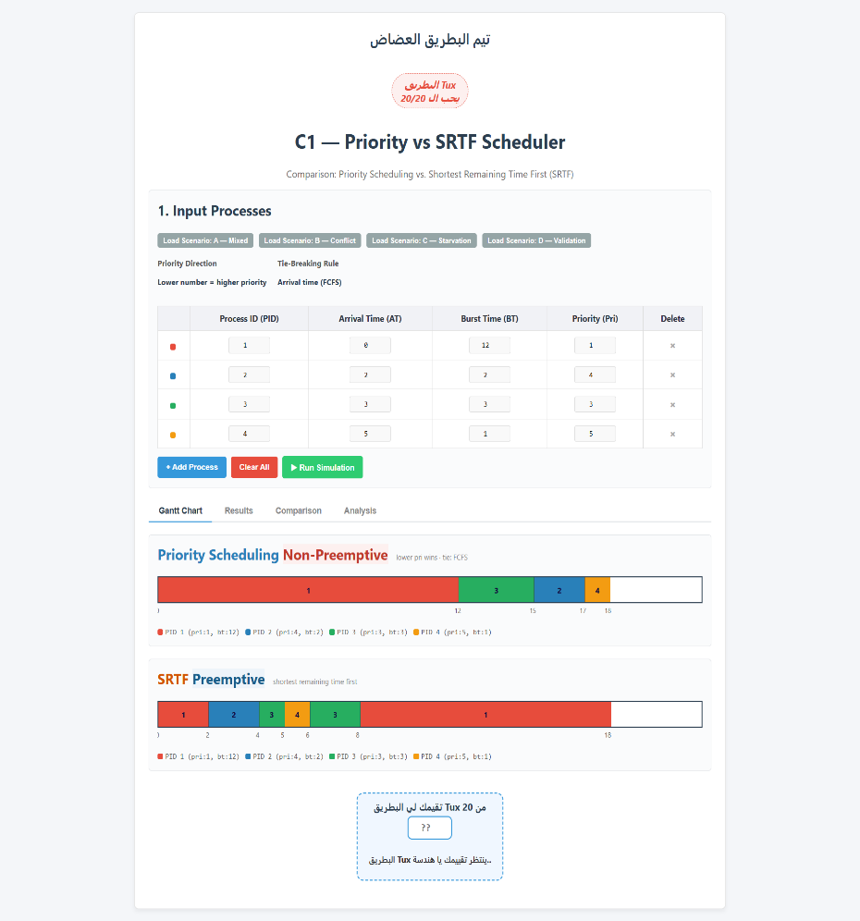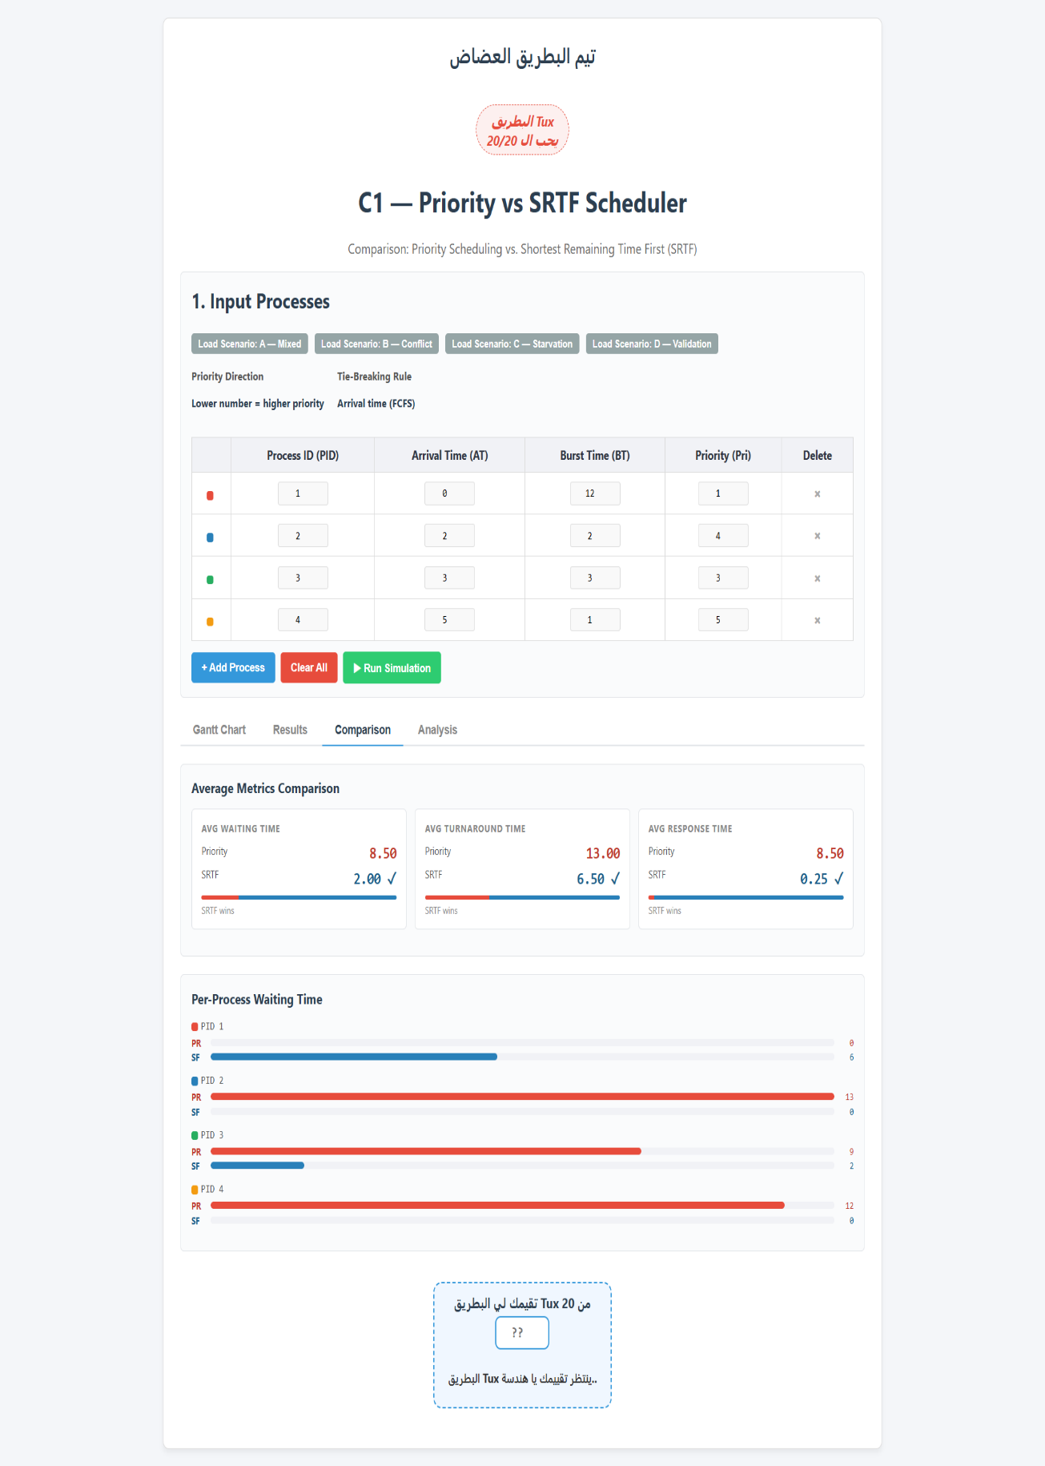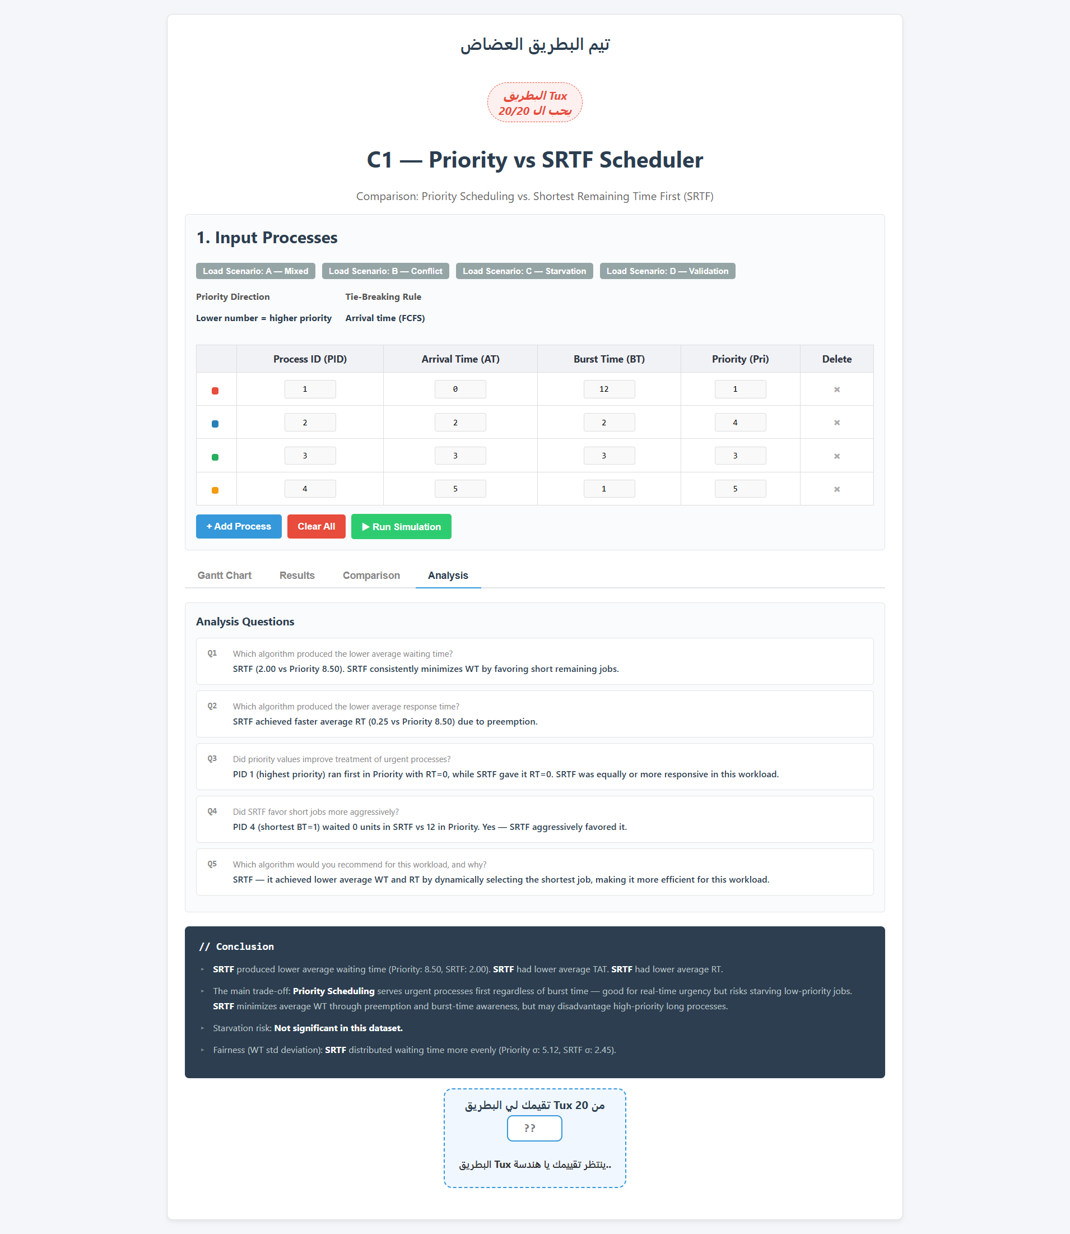

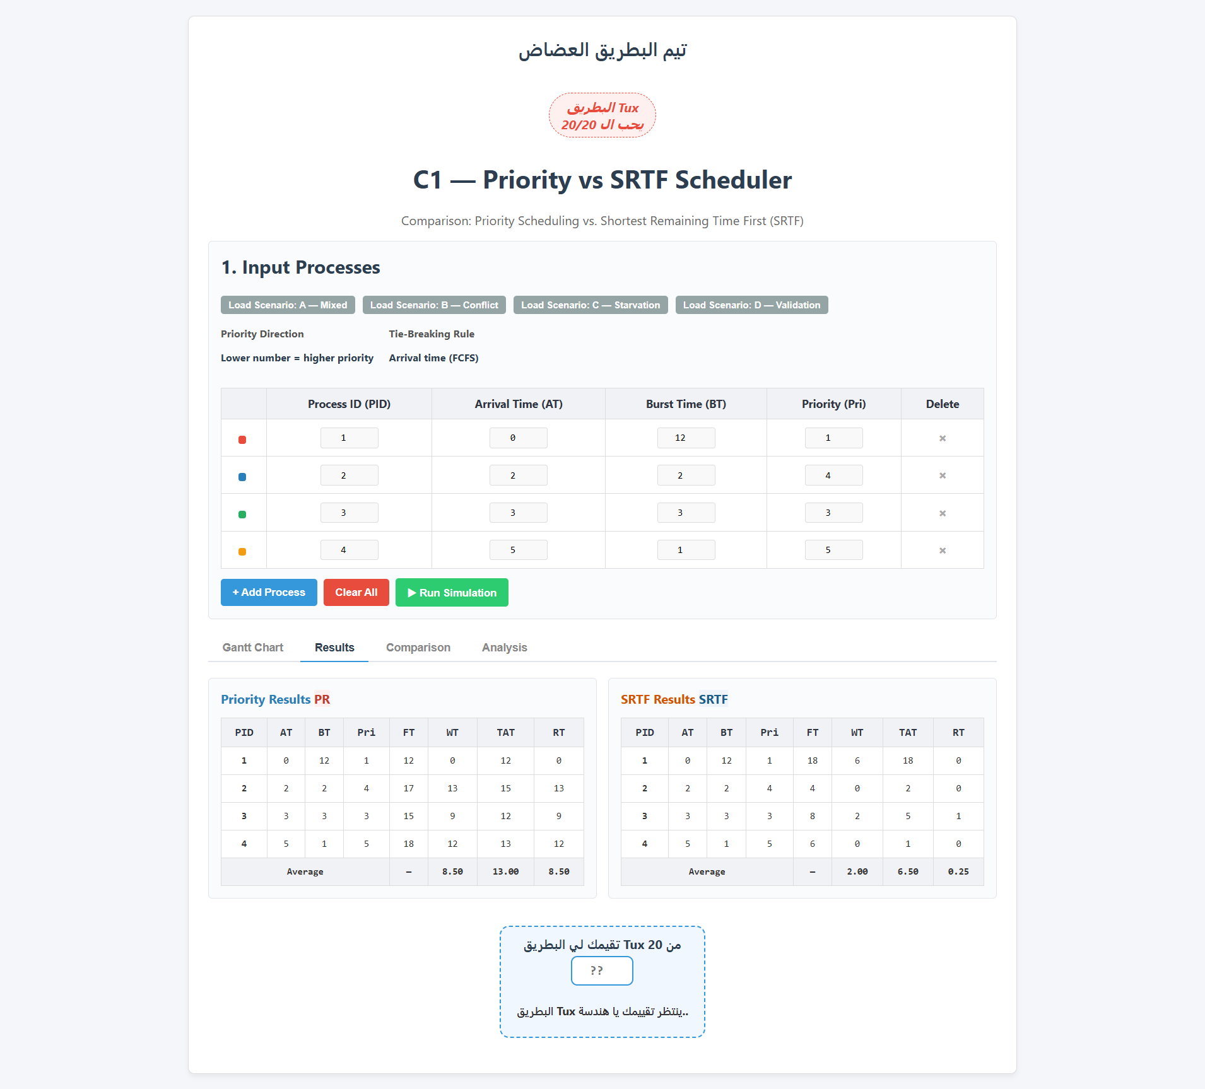

Scenario C: Starvation-Sensitive Case
This scenario tests starvation risk. A low-priority long process competes against a continuous stream of shorter or higher-priority arrivals. We observe how long the vulnerable process must wait under each algorithm.
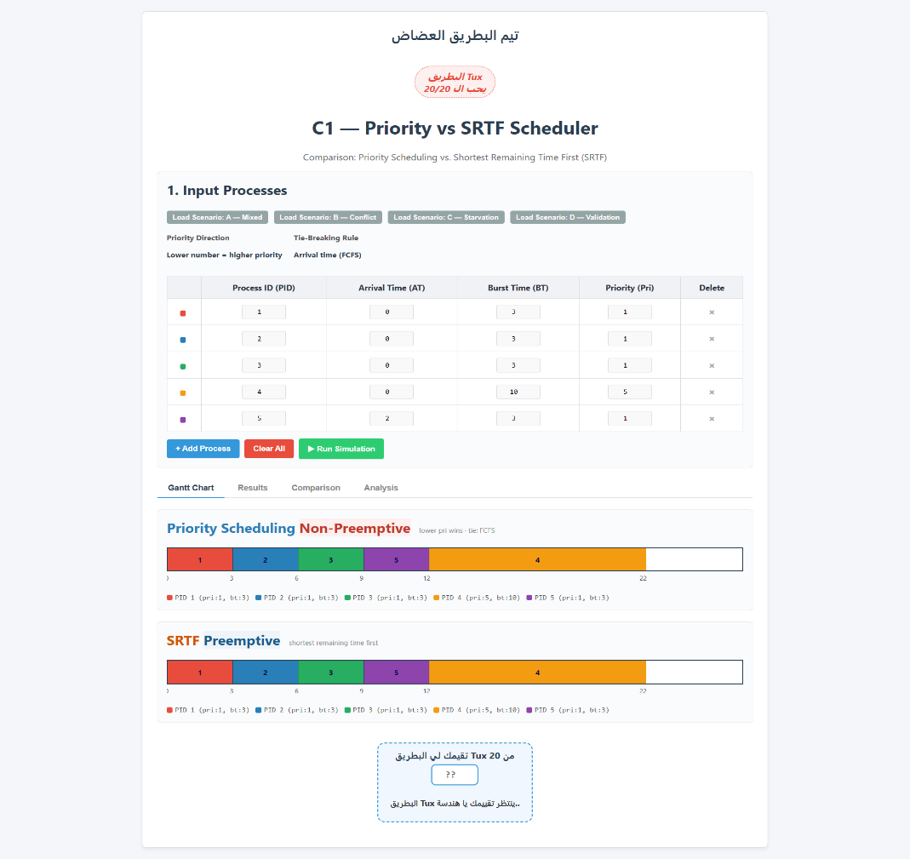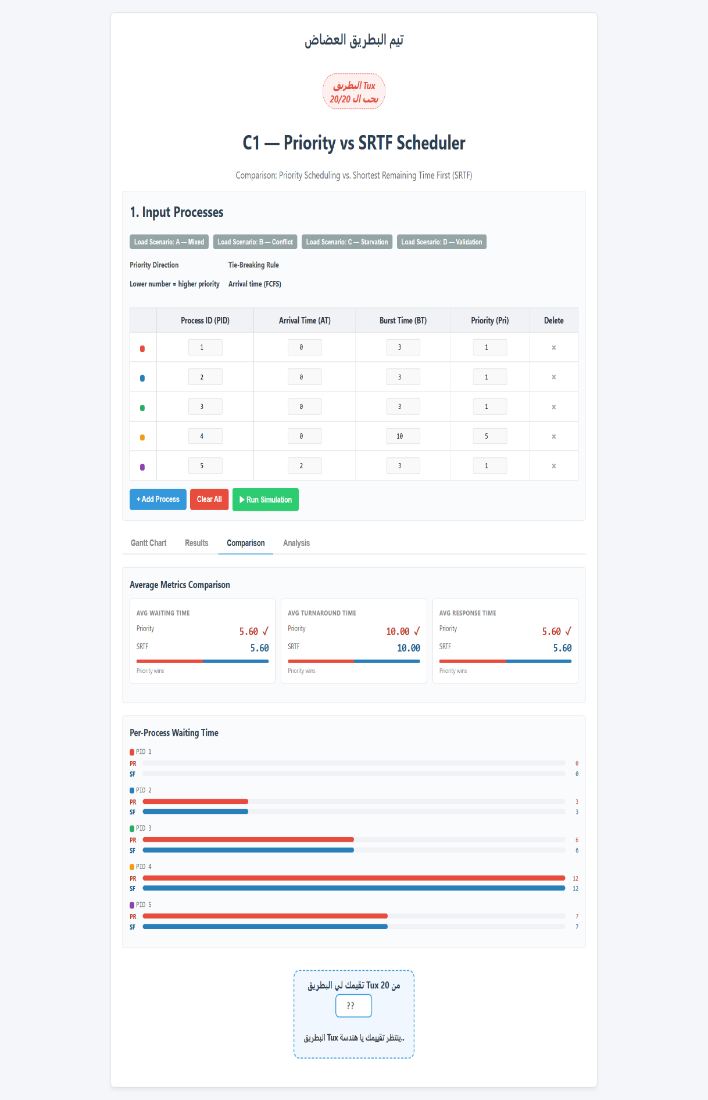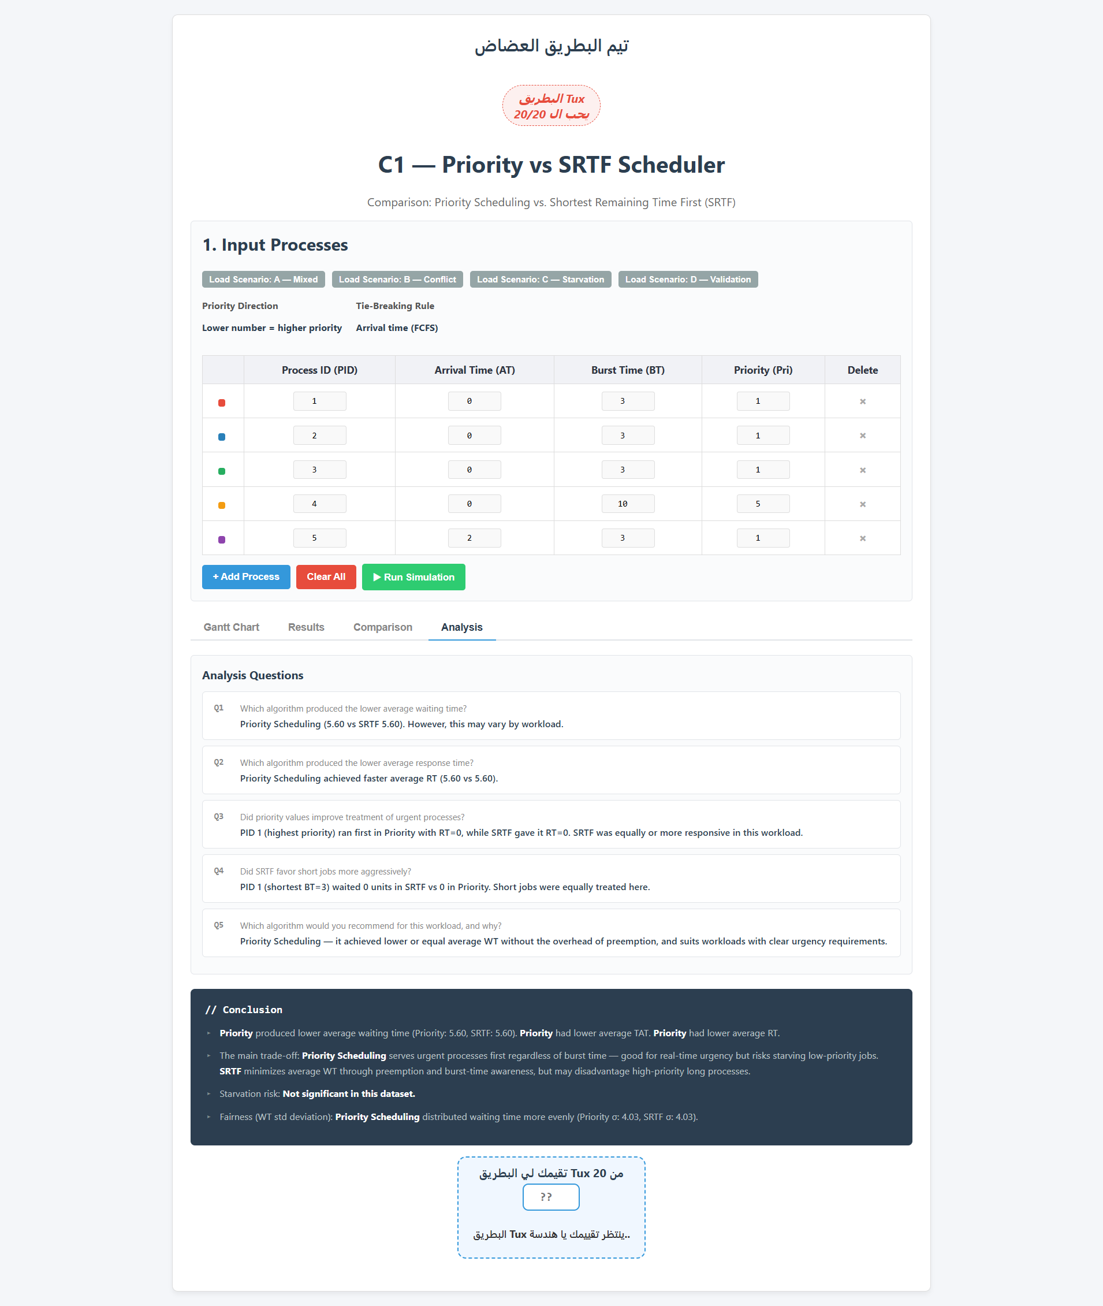

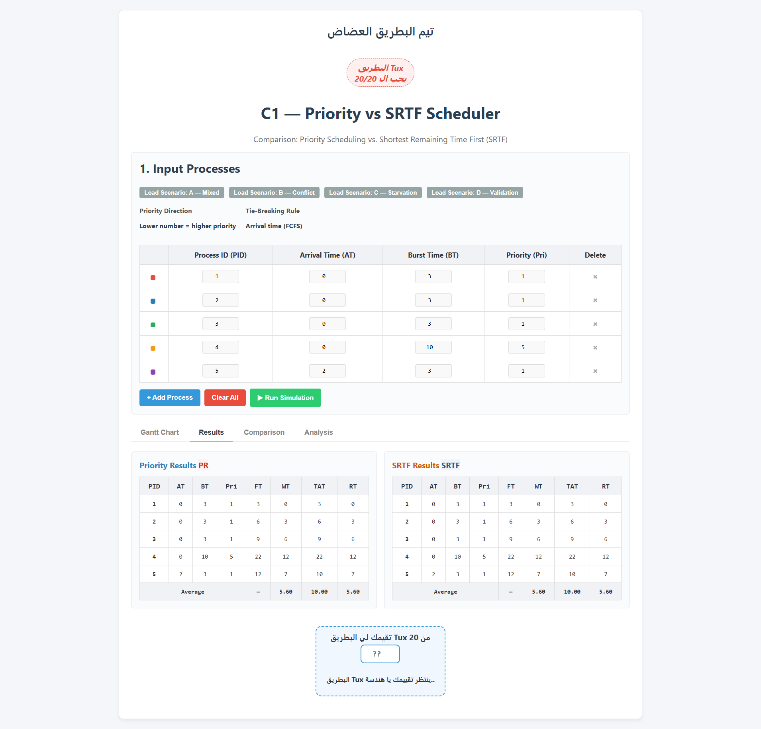

Scenario D: Input Validation Case
This scenario demonstrates how the simulator handles invalid input. The following data was entered deliberately to test rejection behavior.

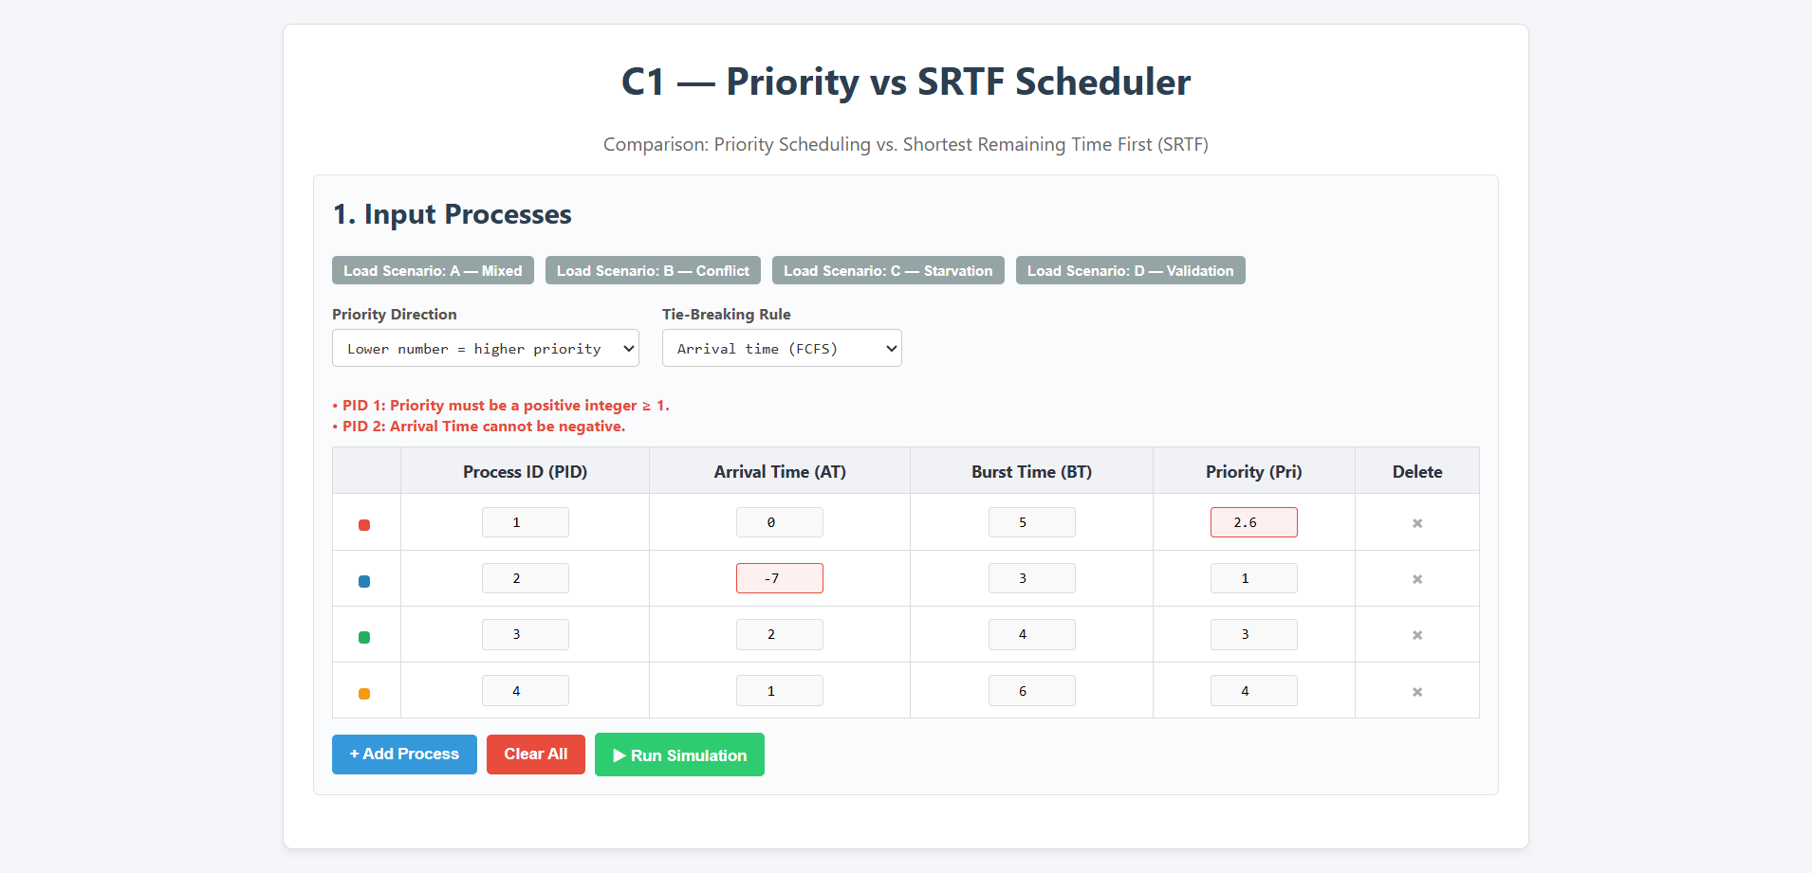

5.2 Answers to Required Analysis Questions

Which algorithm produced the lower average waiting time?
SRTF produced a lower average waiting time in all three scenarios. This is expected, as SRTF is theoretically optimal for minimizing average waiting time by always selecting the process closest to completion.

Which algorithm produced the lower average response time?
SRTF also produced lower average response times across all scenarios. Because it always picks the shortest job, short processes gain CPU access very quickly, resulting in low response times. Priority Scheduling may delay short processes if a longer high-priority process is running.

Did priority values improve treatment of urgent processes?
Yes, but with a cost. In Scenario B, the high-priority process P1 was guaranteed CPU access throughout its full 10-unit burst without interruption. This is beneficial for real-time or critical tasks where priority assignment carries semantic meaning. However, low-priority short processes were forced to wait significantly longer than under SRTF.

Did SRTF favor short jobs more aggressively?
Yes. SRTF is extremely aggressive in favoring short jobs. In Scenario B, the low-priority process P2 (burst = 2) immediately preempted the high-priority process P1 (burst = 10) the moment it arrived. This demonstrates that SRTF is entirely indifferent to priority values — it only cares about burst time. While this is efficient on average, it ignores the semantic importance of priority labels.

Which algorithm would you recommend for the tested workload, and why?
The answer depends on the use case:
- SRTF is recommended when the goal is to minimize average waiting and turnaround time across all processes, especially in general-purpose or batch environments.
- Priority Scheduling is recommended when processes carry real-world urgency values that must be respected (e.g., real-time systems, OS kernel tasks, critical system daemons), even at the cost of longer average waiting times.

5.3 Overall Algorithm Comparison

Criterion | Priority Scheduling | SRTF
Average WT | Higher (policy-driven delays) | Lower (burst-optimal)
Average TAT | Higher | Lower
Average RT | Higher (long high-priority jobs block short ones) | Lower (short jobs proceed quickly)
Respects Urgency | Yes — priority values enforced | No — burst time only
Fairness | Unfair to low-priority processes | Unfair to long processes
Starvation Risk | Low-priority processes may starve | Long processes may starve
Preemption Trigger | Higher priority arrival | Shorter remaining time arrival
Predictability | High — priority-based | Lower — depends on job stream
Best Use Case | Real-time / critical systems | Batch / throughput-optimized systems

6. Conclusion

6.1 Summary of Findings
This project implemented and compared two preemptive CPU scheduling algorithms — Priority Scheduling and SRTF — across four test scenarios covering typical workloads, edge cases, and conflict situations.

The key findings from the three simulation scenarios are:
- SRTF consistently achieved lower average Waiting Time and Turnaround Time.
- SRTF also achieved lower average Response Time, as short processes gained CPU access faster.
- Priority Scheduling guaranteed service to high-priority processes regardless of burst time, which is valuable for urgent or time-critical tasks.
- SRTF is entirely blind to priority: a low-priority short process will always preempt a high-priority long process.
- Both algorithms are susceptible to starvation — low-priority processes under Priority Scheduling, and long processes under SRTF.

6.2 Main Trade-Off Identified
Core Trade-Off
Priority Scheduling: Policy correctness vs Higher waiting times
SRTF: Optimal efficiency vs Ignoring process urgency

The fundamental tension is between respecting semantic importance (priority) and
maximizing CPU throughput efficiency (shortest job first).

6.3 Fairness Assessment
Neither algorithm is perfectly fair:
- Priority Scheduling is unfair to low-priority processes, which may wait arbitrarily long in the presence of continuous high-priority arrivals.
- SRTF is unfair to long processes, which may be repeatedly preempted by shorter jobs and never complete.
Between the two, SRTF distributes CPU time more evenly among processes of similar burst times. Priority Scheduling, by design, intentionally distributes CPU time unequally based on assigned urgency.

