📘 Midterm Exam Report
Statistical Analysis & Email Spam Classification
Student: I. Beroshvili
Course: Machine Learning / Data Analysis
Exam Type: Midterm
Programming Language: Python
Github Link: https://github.com/IA-art-commits/aimlmid2026_i_beroshvili25.git

PART I – Pearson Correlation Coefficient

1. Task Objective (5 points)
The objective of this task is to compute Pearson’s correlation coefficient (r) for a given set of observed data points obtained from a graphical visualization and to describe the full calculation process. A relevant graph is also provided to visually support the numerical result.

2. Given Data
The observed data points extracted from the graph are:
i | xi | yi
1 | -9.56 | 1.28
2 | -6.13 | 2.04
3 | -4.93 | -1.00
4 | -1.27 | 1.04
5 | 1.16 | -1.80
6 | 2.90 | 1.32
7 | 4.90 | -3.20
8 | 7.24 | -2.20
Number of observations:
n=8

3. Pearson Correlation Formula
r=∑i=1n​(xi​−xˉ)2⋅∑i=1n​(yi​−yˉ​)2​∑i=1n​(xi​−xˉ)(yi​−yˉ​)​
Where:
- xˉ = mean of x-values
- yˉ​ = mean of y-values

4. Step-by-Step Calculation

Step 1: Compute Means
xˉ=8−9.56−6.13−4.93−1.27+1.16+2.90+4.90+7.24​=−0.71125 yˉ​=81.28+2.04−1.00+1.04−1.80+1.32−3.20−2.20​=−0.315

Step 2: Compute Deviations and Products
- Sum of cross-products:
∑(xi​−xˉ)(yi​−yˉ​)≈−52.80
- Sum of squared deviations:
∑(xi​−xˉ)2≈237.02 ∑(yi​−yˉ​)2≈27.14

Step 3: Final Calculation
r=237.02⋅27.14​−52.80​≈−0.66​

5. Interpretation (5 points)
The Pearson correlation coefficient r ≈ −0.66 indicates a moderate negative linear correlation between x and y.
This means that as x increases, y generally decreases, although the relationship is not perfectly linear.

6. Visualization
A scatter plot was generated using Python (matplotlib) to visually confirm the numerical result.
The downward trend of the plotted points supports the negative correlation found analytically.

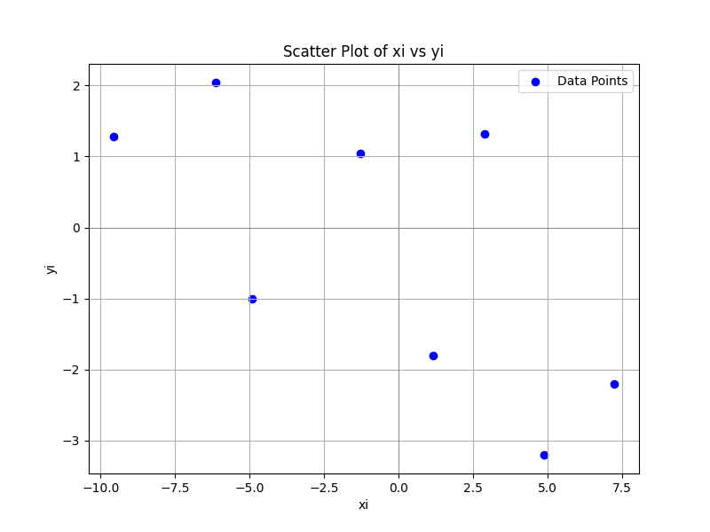

PART II – Email Spam Classification using Logistic Regression

1. Main Goal
The main goal of this task is to develop a Python console application that classifies emails into Spam and Legitimate classes using a Logistic Regression model, based on numerical email features.

2. Dataset Upload (1 point)
The provided dataset was uploaded to the repository:
data/i_beroshvili25_91478.csv

Dataset Features:
- words – total number of words
- links – number of URLs
- capital_words – number of uppercase words
- spam_word_count – number of spam-related keywords
- is_spam – class label (1 = spam, 0 = legitimate)

3. Data Loading and Processing (2 points)
The dataset is loaded using pandas in model_training.py:
df = pd.read_csv(csv_path)
X = df[FEATURE_COLUMNS]
y = df["is_spam"]
The data is split into:
- 70% training data
- 30% testing data
using stratified sampling to preserve class balance:
train_test_split(X, y, test_size=0.30, stratify=y)

4. Logistic Regression Model (3 points)

Model Choice (1 point)
Logistic Regression is chosen because:
- It is suitable for binary classification
- It outputs probabilities
- It is interpretable via coefficients

Model Training (2 points)
model = LogisticRegression(max_iter=2000, solver="lbfgs")
model.fit(X_train, y_train)

5. Model Coefficients (1 point)
Each coefficient represents how strongly a feature influences the probability of an email being spam.
- Positive coefficient → increases spam probability
- Negative coefficient → decreases spam probability
The coefficients are printed during execution for interpretability.

6. Model Validation (3 points)

Confusion Matrix & Accuracy (2 points)
The model is evaluated on unseen test data:
confusion_matrix(y_test, y_pred)
accuracy_score(y_test, y_pred)
- Accuracy measures overall correctness
- Confusion Matrix shows TP, TN, FP, FN

Validation Execution (1 point)
All metrics are computed automatically in main.py.

7. Email Text Classification (3 points)
The application can classify raw email text.

Feature Extraction (spam_features.py)
The email text is parsed to extract:
- Word count
- URL count
- Capitalized words
- Spam keyword count
extract_features(email_text)
The extracted features are passed to the trained model for prediction.

8. Manually Composed Emails

Spam Email (1 point)
URGENT!!! You have WON a FREE prize.
Click the link now to claim your reward!
Reason:
Contains spam keywords, capital letters, urgency, and links.

Legitimate Email (1 point)
Hello,
Please find attached the meeting notes from yesterday.
Best regards.
Reason:
Neutral tone, no spam keywords, professional structure.

9. Visualizations (4 points)

Visualization A – Class Distribution
A bar chart shows the ratio of Spam vs Legitimate emails.
This helps determine whether the dataset is balanced.

Visualization B – Confusion Matrix Heatmap
A heatmap visually represents prediction performance with clear labels:
- X-axis: Predicted class
- Y-axis: Actual class
Each visualization includes:
- Python code
- Title
- Axis labels
- Explanation

10. How to Run the Program
pip install -r requirements.txt
python main.py --mode train --data data/i_beroshvili25_91478.csv --show-plots

11. Conclusion
This project demonstrates:
- Statistical correlation analysis
- Logistic Regression modeling
- Feature extraction from raw text
- Model evaluation and visualization
- Practical spam detection
The solution satisfies all midterm requirements and provides both theoretical justification and practical implementation.

