Modeling Tool and Modeling Semantics
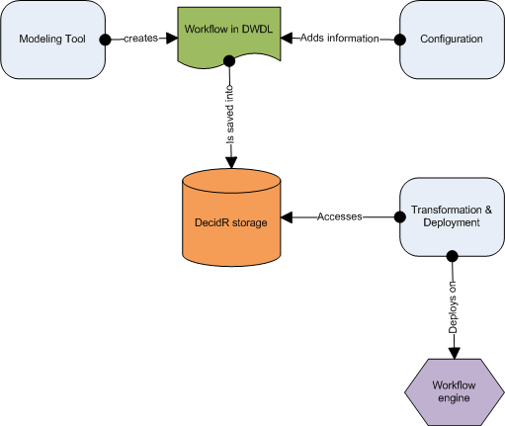
The purpose of this chapter is to describe the Modeling Tool of DecidR and the underlying semantics. The user can model workflows graphically with the Modeling Tool. The BPEL semantics of the graphical elements are described in this chapter.

Overview
The tenant admin models a workflow with the modeling tool. The workflow is saved in an XML file. The XML Format of the file is the DecidR Workflow Definition Language (DWDL). The XML file serves two purposes: It is the source document for the transformation into a BPEL workflow and is the storage format for the graphical representation of the workflow. Whenever the tenant admin wants to load a workflow, the XML file is read. A transformation and deployment component is responsible for the conversion from DWDL to BPEL and for the deployment on to a workflow engine. The workflow admin can and in some cases has to configure the workflow by adding additional information. Whenever the workflow admin wants to start a workflow, meaning creating an instance of the workflow, the transformation and deployment component is activated.

The Modeling Tool
The Modeling Tool allows the tenant admin to design a workflow. Workflows are basically designed as a graph with nodes and edges. A node represents an activity or a container. Edges represent the control flow. The Modeling tool interface consists of a canvas, a toolbar, a variables list, a role list and a property window. The graphical elements of the workflow are placed on the canvas. The toolbar allows the tenant admin to choose from activities and containers and place them on the canvas. In the variables list, the tenant admin can add, modify or delete variables which serve either as input or as output variables for the activities. With the role list the tenant admin can define roles. The property window displays the preferences of each activity, for example input and output variables.

Toolbar Elements
- Workflow related elements
  - Start activity
  - End activity
  - Email Web Service activity
  - Human Task Web Service activity
  - Flow container
  - If container
  - For Each container
- Editor related elements
  - Undo: The user can undo his last action
  - Redo: The user can redo a revoked action
  - Clear: Clear the workflow canvas to the default
  - Delete: Deletes a workflow element
  - Save: Saves the workflow

Variables List
The Variables List contains a list of variables. The tenant admin can add, modify or delete a variable from the list. Each entry of the list contains the unique variable name, the variable type and the variable value. Every variable is globally available, that means every variable on that list can be assigned to every activity as either an input variable or an output variable. The assignment is done in the property window of each activity. A variable can have one of the following types:
- Simple types
  - Integer
  - Float
  - String
  - Boolean
  - Date (consisting of year, month and day)
- Complex types
  - File reference
  - List of any simple type or reference

Role list
The role list contains a list of roles. The tenant admin can add, modify or delete an entry from the list. Each entry of the list contains the unique role name and the role. There can be two types, either a role (a set of persons) or an actor (exactly one person). Example: In a university lecture context, a role would be “student” (a set of persons); an actor would be “professor” (exactly one person). The “For Each container” can iterate over a role, but not over an actor. The “Human Task activity” accepts as input variable user an actor, but not a role.

Property Window
Whenever a tenant admin clicks on an activity or container, a property window is displayed. In this property window he can configure the activity or container. For every input and output variable of an activity, the tenant admin can assign a variable from the variables list through a pull down menu. Alternatively, instead of assigning a variable, he can choose the “define” entry of the pull down menu. A text field or area is the displayed, where he can enter the value of the input variables.

Activities
The following section describes the activities of which the workflows are composed of. Each activity has a short description of its functionality. The “Properties” section specifies the contents of the property window of an activity.

Start activity
Every workflow has to start with a start activity. It represents the beginning of the control flow. Within a start activity, a tenant admin can determine the configuration variables of the workflow. The configuration variables are normal variables which are created through the Variables List and are assigned as configuration variables in the property window of the start activity. All configuration variables together resemble the start configuration of the workflow. The start configuration has to be initialized by the workflow admin. The concept of configuration variables allows the tenant admin to model workflows independently of a workflow admin specific scenario. Having to initialize the start configuration, the workflow admin has the possibility to custom tailor each workflow instance to his wishes.

End activity
Every workflow has to end with an end activity. If the control flow a workflow instance reaches this activity, the workflow instance counts as successfully executed.
Properties:
- Fault Handler: The tenant admin has to define a role or an actor to which an email (with a customizable message) will be sent if the execution of a workflow instance has failed for any reason.
- Notify of Success: The tenant admin can check whether an email should to sent out to a role or actor if the control flow has successfully reached the end activity

Email Web Service activity
The Email Web Service sends emails to a given address with a specific subject and message.
Properties:
- Input variables
  - To (string or actor): Has to contain the recipient’s Email address
  - CC (string or actor): Can contain the recipient of a carbon copy
  - BCC (string or actor): Can contain the recipient of a blind carbon copy
  - Subject (string): Has to contain the subject of the email
  - Message (string): Can contain the message body of the email
  - Attachment (list of file references): Can contain a reference to the file that will be sent out as an attachment to the email
- Output variables
  - Sent (Boolean): Whether the email was sent successfully

Human Task Web Service activity
The Human Task Web Service creates work items for a specific participant of a workflow instance. The work item is displayed in the user’s work item list. A work item consist basically of a text part, an input form part and optionally a file upload and provide part. The text part describes what the user’s task is and what he has to do. The input form part contains one or more input fields, where the user can enter his result of the task he has been given.
Properties:
- Input variables
  - User (actor): Has to contain the username of the user who the task is designed for
  - Task description (list of strings): Has to contain the description of the task
  - File (list of file references): Can contain a file reference to a file
- Output variables
  - Input field (list of string, date, integer, Boolean or float): Can contain the values of the input fields form the input form part
  - File (list of file references): Can contain the file reference to a file the user has uploaded
- Options
  - Notify user per email: The tenant admin can decide whether an email should be sent out notifying the user that a new work item was assigned to him

Containers

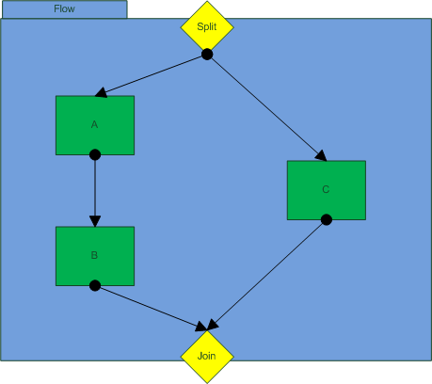
Flow container
If the tenant admin wants two or more activities or sequences of activities to be executed simultaneously, he has to place them in a flow container. A Flow container consists of a split point, a join point and the container area. The Split point is the target for an incoming edge outside the flow container. The split point is also the source of outgoing edges inside the container which point to activities that are executed simultaneously. The join point is the target for incoming edges from inside the flow container, that means every activity or sequence activity inside the flow container ends at the join point. The join point is the source of the outgoing edge outside the flow container. The join point is a gateway with an AND-condition. Every activity or sequence of activity has to end successfully to continue the control flow after the flow container.

If container
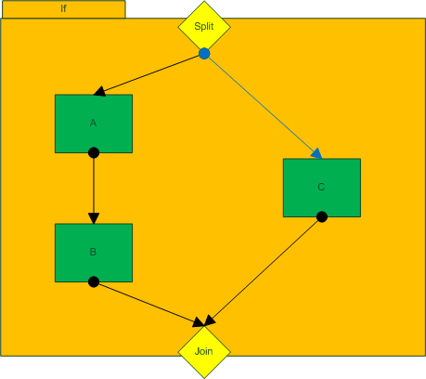
If the tenant admin has two or more activities or sequences of activities and he wants only one of them to be executed dependent on whether certain conditions are true, he has to place them in an If container. An If-container consists of a split point, a join point and the container area. The Split point is the target for an incoming edge outside the If container. The split point is also the source of outgoing edges inside the container which point to activities. In order to secure the execution of at least one sequence of activities even if no condition statement is true, there is one special outgoing edge from the split point: It is specifically colored and points to that sequence of activities which is executed if no condition is true. The join point is the target for incoming edges from inside the If container, that means every activity or sequence activity inside the If container ends at the join point. The join point is the source of the outgoing edge outside the If container. The join point is a gateway with an XOR-condition. Only one activity or sequence of activity has to end successfully to continue the control flow after the If container.
Properties:
For each outgoing edge, the tenant admin must define a transition condition. A condition statement is a Boolean expression where relational operators are applied to variables or roles. A condition statement looks like the following:
<Variable, List or Role> <Relational operator> <Value>
The variable, list or role can be selected by a pull down menu. According to the type of variable or list, the set of allowed relational operators are presented in an additional pull down menu. The value to which the variable is compared to has to be entered in a text field. The following relational operators are allowed for each type of variable:
- String
  - Equal to (“==”)
  - Contains (“?=”)
- Integer
  - Equal to (“==”)
  - Smaller than (“<”)
  - Smaller than or equal to (“<=”)
  - Greater than (“>”)
  - Greater than or equal to (“>=”)
- Float
  - Smaller than (“<”)
  - Greater than (“>”)
  - Equal to (“==”)
- Date
  - Equal to (“==”)
  - Before (“<”)
  - After (“>”)
- Boolean
  - Equal (“==”)
- Role/List
  - The same relational operators as listed under “integer” can be applied. But here, the comparison is in regard to the cardinality of the list or set respectively.

For each container
The For each container allows a tenant admin to iterate over a range of integer values, lists or roles. The activity or sequence of activity in the container is executed every iteration. Within a For each container, a loop variable is available. The type of the loop variable corresponds to the iteration object. The loop variable is a local variable, i.e. it can only be chosen by the activities in the container as an input or output variable.
Properties:
- Iteration object: The tenant can choose to iterate over a range of integer values, lists or roles
- Exit condition: The tenant admin can choose between an AND- or XOR-Exit. An AND-Exit means that every activity has to end successfully in order for the control flow to continue after the For each container. A XOR-Exit means that only one activity has to end successfully. If a sequence of activities has been defined in the container exactly one whole sequence has to complete successfully on order to meet the XOR-condition.

The DecidR Workflow Definition Language (DWDL)
The DecidR Workflow Definition Language (DWDL) is an XML-based language. It has two purposes: The first purpose is to serve as a data format to store the workflow models and configurations, i.e. it contains all semantic and graphical information that is necessary to load a model into the modeling tool. The second purpose is to server as source format for the transformation into a BPEL workflow. In order to minimize the complexity of a transformation to BPEL, the DWDL was designed with the goal to be BPEL-near, i.e. many elements of DWDL are merely a reduction of the according BPEL elements. In this section, the XML scheme of the previous activities and container will be discussed.
Note: The graphical information is not part of this specification because it is considered a design aspect of the modeling tool

Header
This is the basic header which characterizes every DWDL-Document.
<?xml version="1.0"?>

<xsd:schema targetNamespace="http://decidr.org/schema/workflow"
xmlns="http://decidr.org/schema/workflow"
xmlns:xsd="http://www.w3.org/2001/XMLSchema"
elementFormDefault="qualified">

Root element
This is the root element of every workflow. The basic elements of a workflow element in DWDL are nodes, arcs and variables. The nodes and arcs represent the vertices and edges of a workflow graph and model the control flow. The variables allow modeling the data flow through the workflow.
<xsd:element name="workflow" type="tWorkflow">
<xsd:annotation>
</xsd:annotation>
</xsd:element>

<xsd:complexType name="tWorkfow">
<xsd:sequence>
<xsd:element ref="documentation" minOccurs="0" />
<xsd:element ref="variables" minOccurs="0" />
<xsd:element ref="faultHandler" minOccurs="0" />
<xsd:element ref="nodes" minOccurs="0" />
<xsd:element ref="arcs" minOccurs="0" />
</xsd:sequence>
<xsd:attribute name="name" type="xsd:NCName" use="required" />
<xsd:attribute name="targetNamespace" type="xsd:anyURI" use="required" />
</xsd:complexType>

Inline documentation
The DWDL XML scheme allows inline documentation.
<xsd:element name="documentation" type="tDocumentation" />

<xsd:complexType name="tDocumentation" mixed="true">
<xsd:sequence>
<xsd:any processContents="lax" minOccurs="0" maxOccurs="unbounded" />
</xsd:sequence>
<xsd:attribute name="source" type="xsd:anyURI" />
<xsd:attribute ref="xml:lang" />
</xsd:complexType>

Variables list
<xsd:element name="variables" type="tVariables" />

<xsd:complexType name="tVariables">
<xsd:sequence>
<xsd:element ref="variable" minOccurs="1" maxOccurs="unbounded"/>
</xsd:sequence>
</xsd:complexType>

<xsd:element name="variable" type="tVariable" />

<xsd:complexType name="tVariable">
<xsd:attribute name="name" type="WorkflowVariableName" use="required" />
<xsd:attribute name="type" type="xsd:QName" use="optional" />
<xsd:attribute name="element" type="xsd:QName" use="optional" />
</xsd:complexType>

<xsd:simpleType name="WorkflowVariableName">
<xsd:restriction base="xsd:NCName">
<xsd:pattern value="[^\.]+" />
</xsd:restriction>
</xsd:simpleType>

Fault Handler
<xsd:element name="faultHandler" type="tFaultHandler"/>

<xsd:complexType name="tFaultHandler">
<xsd:sequence>
<xsd:element name="message" type="xsd:string" minOccurs="1" maxOccurs="1" />
<xsd:element ref="notify" minOccurs="1" />
</xsd:sequence>
</xsd:complexType>

<xsd:element name="notify" type="tNotify">

<xsd:complexType name="tNotify">
<xsd:sequence>
<xsd:element name="name" type="xsd:string" />
<xsd:element name="email" type="xsd:string" />
<xsd:sequence>
</xsd:complexType>

Nodes
Nodes are activities and containers. Although there is one node for every container, the activities are to be composed of Assign, Invoke, Receive and Reply nodes. Each of these nodes has a BPEL counterpart. Every node has an input and an output port which are the targets resp. sources of the links of the control flow.
<xsd:element name="nodes" type="tNodes" />

<xsd:complexType name="tNodes">
<xsd:sequence>
<xsd:group ref="nodeTypes" minOccurs="1" maxOccurs="unbounded"/>
</xsd:sequence>
</xsd:complexType>

<xsd:group name="nodeTypes">
<xsd:choice>
<xsd:element ref="assignNode"/>
<xsd:element ref="flowNode"/>
<xsd:element ref="forEachNode"/>
<xsd:element ref="ifNode"/>
<xsd:element ref="invokeNode"/>
<xsd:element ref="receiveNode"/>
<xsd:element ref="replyNode"/>
</xsd:choice>
</xsd:group>

<xsd:element name="simpleNode" type="tSimpleNode"/>

<xsd:complexType name="tSimpleNode">
<xsd:sequence>
<xsd:element ref="ports" minOccurs="0" />
</xsd:sequence>
<xsd:attribute name="id" type="xsd:ID" use="required" />
<xsd:attribute name="name" type="xsd:NCName" use="optional" />
</xsd:complexType>

<xsd:element name="ports" type="tPorts" />

<xsd:complexType name="tPorts">
<xsd:sequence>
<xsd:group ref="portTypes" maxOccurs="1"/>
</xsd:sequence>
</xsd:complexType>

<xsd:group name="portTypes">
<xsd:choice>
<xsd:element ref="inputPort" />
<xsd:element ref="outputPort" />
</xsd:choice>
</xsd:group>

<xsd:element name="simpePort" type="tsimplePort">

<xsd:complexType name="tsimplePort">
<xsd:sequence>
<xsd:element ref="arcs" maxOccurs="1" />
</xsd:sequence>
<xsd:attribute name="name" type="xsd:NCName" use="optional" />
</xsd:complexType>

Arcs
Arcs represent the links of the control flow (the representation of edges of a workflow graph). The BPEL counterparts are links. Each arc has exactly one node as a source and a different node as target.
<xsd:element name="arcs" type="tArcs" />

<xsd:complexType name="tArcs">
<xsd:sequence>
<xsd:element name="arc" type="tArc" />
</xsd:sequence>
</xsd:complexType>

<xsd:complexType name="tArc">
<xsd:attribute name="id" type="xsd:ID" use="required"/>
<xsd:attribute name="source" type="xsd:IDREF" use="required" />
<xsd:attribute name="target" type="xsd:IDREF" use="required" />
</xsd:complexType>

</xsd:schema>

