Modeling Tool and Modeling Semantics
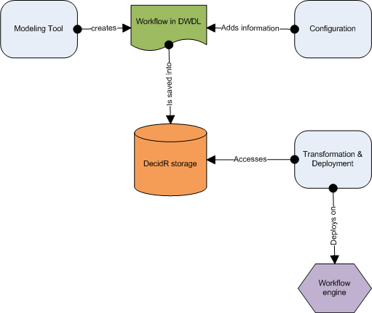
The purpose of this chapter is to describe the Modeling Tool of DecidR and the underlying semantics. The user can model workflows graphically with the Modeling Tool. The BPEL semantics of the graphical elements are described in this chapter.

Overview
The tenant admin models a workflow with the modeling tool. The workflow is saved in an XML file. The XML Format of the file is the DecidR Workflow Definition Language (DWDL). The XML file serves two purposes: It is the source document for the transformation into a BPEL workflow and is the storage format for the graphical representation of the workflow. Whenever the tenant admin wants to load a workflow, the XML file is read. A transformation and deployment component is responsible for the conversion from DWDL to BPEL and for the deployment on to a workflow engine. The workflow admin can and in some cases has to configure the workflow by adding additional information. Whenever the workflow admin wants to start a workflow, meaning creating an instance of the workflow, the transformation and deployment component is activated.

The Modeling Tool
The Modeling Tool allows the tenant admin to design a workflow. Workflows are basically designed as a graph with nodes and edges. A node represents an activity or a container. Edges represent the control flow. The Modeling tool interface consists of a canvas, a toolbar, a variables list, a role list and a property window. The graphical elements of the workflow are placed on the canvas. The toolbar allows the tenant admin to choose from activities and containers and place them on the canvas. In the variables list, the tenant admin can add, modify or delete variables which serve either as input or as output variables for the activities. With the role list the tenant admin can define roles. The property window displays the preferences of each activity, for example input and output variables.

Toolbar Elements
- Workflow related elements
  - Start activity
  - End activity
  - Email Web Service activity
  - Human Task Web Service activity
  - Flow container
  - If container
  - For Each container
- Editor related elements
  - Undo: The user can undo his last action
  - Redo: The user can redo a revoked action
  - Clear: Clear the workflow canvas to the default
  - Delete: Deletes a workflow element
  - Save: Saves the workflow

Variables List
The Variables List contains a list of variables. The tenant admin can add, modify or delete a variable from the list. Each entry of the list contains the unique variable name, the variable type and the variable value. Every variable is globally available, that means every variable on that list can be assigned to every activity as either an input variable or an output variable. The assignment is done in the property window of each activity. A variable can have one of the following types:
- Simple types
  - Integer
  - Float
  - String
  - Boolean
  - Date (consisting of year, month and day)
- Complex types
  - User reference
  - File reference
  - List of any simple type or reference

Role list
The role list contains a list of roles. There can be two types, either a role (a set of persons) or an actor (exactly one person). Example: A role would be “student” (a set of persons); an actor would be “professor” (exactly one person). The “For Each container” can iterate over a role, but not over an actor. The “Human Task activity” accepts as input variable user an actor, but not a role.

Property Window
Whenever a tenant admin clicks on an activity or container, a property window is displayed. In this property window he can configure the activity or container. For every input and output variable of an activity, the tenant admin can assign a variable from the variables list through a pull down menu. Alternatively, instead of assigning a variable, he can choose the “define” entry of the pull down menu. A text field or area is the displayed, where he can enter the value of the input variables.

Activities
The following section describes the activities of which the workflows are composed of. Each activity has a short description of its functionality. The “Properties” section specifies the contents of the property window of an activity.

Start activity
Every workflow has to start with a start activity. It represents the beginning of the control flow. Within a start activity, a tenant admin can determine the configuration variables of the workflow. The configuration variables are normal variables which are created through the Variables List and are assigned as input variables of the start activity. All configuration variables together resemble the start configuration of the workflow. The start configuration has to be initialized by the workflow admin. The concept of configuration variables allows the tenant admin to model workflows independently of a workflow admin specific scenario. Having to initialize the start configuration, the workflow admin has the possibility to custom tailor each workflow instance to his wishes.

End activity

Email Web Service activity
The Email Web Service sends emails to a given address with a specific subject and message.
Properties:
- Input variables
  - To (string): Has to contain the recipient’s Email address
  - Subject (string): Has to contain the subject of the email
  - Message (string): Can contain the message body of the email
- Output variables
  - Sent (Boolean): Whether the email was sent successfully

Human Task Web Service activity
The Human Task Web Service creates work items for a specific participant of a workflow instance. The work item is displayed in the user’s work item list. A work item consist basically of a text part, an input form part and optionally a file upload and provide part. The text part describes what the user’s task is and what he has to do. The input form part contains one or more input fields, where the user can enter his result of the task he has been given.
Properties:
- Input variables
  - User (user.username): Has to contain the username of the user who the task is designed for
  - Task description (string): Has to contain the description of the task
  - File (file reference): Can contain a file reference to a file
  - Due date (date): Has to contain a date which is the deadline for the user
- Output variables
  - Input field (string, integer or float): Can contain the values of the input fields form the input form part
  - File (file reference): Can contain the file reference to a file the user has uploaded

Containers

Flow container
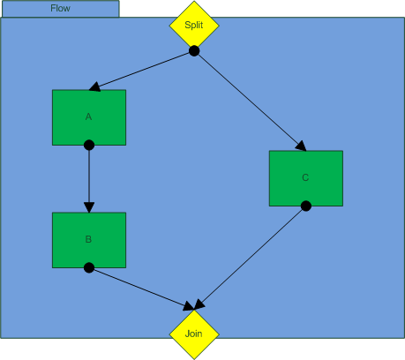
If the tenant admin wants two or more activities or sequences of activities to be executed simultaneously, he has to place them in a flow container. A Flow container consists of a split point, a join point and the container area. The Split point is the target for an incoming edge outside the flow container. The split point is also the source of outgoing edges inside the container which point to activities that are executed simultaneously. The join point is the target for incoming edges from inside the flow container, that means every activity or sequence activity inside the flow container ends at the join point. The join point is the source of the outgoing edge outside the flow container. The join point is a gateway with an AND-condition. Every activity or sequence of activity has to end successfully to continue the control flow after the flow container.

If container
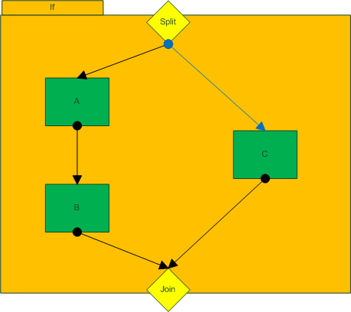
If the tenant admin has two or more activities or sequences of activities and he wants only one of them to be executed dependent on whether certain conditions are true, he has to place them in an If container. An If-container consists of a split point, a join point and the container area. The Split point is the target for an incoming edge outside the If container. The split point is also the source of outgoing edges inside the container which point to activities. In order to secure the execution of at least one sequence of activities even if no condition statement is true, there is one special outgoing edge from the split point: It is specifically colored and points to that sequence of activities which is executed if no condition is true. The join point is the target for incoming edges from inside the If container, that means every activity or sequence activity inside the If container ends at the join point. The join point is the source of the outgoing edge outside the If container. The join point is a gateway with an XOR-condition. Only one activity or sequence of activity has to end successfully to continue the control flow after the If container.
Properties:
For each outgoing edge, the tenant admin must define a transition condition. A condition statement is a Boolean expression where relational operators are applied to variables or roles. A condition statement looks like the following:
<Variable, List or Role> <Relational operator> <Value>
The variable, list or role can be selected by a pull down menu. According to the type of variable or list, the set of allowed relational operators are presented in an additional pull down menu. The value to which the variable is compared to has to be entered in a text field. The following relational operators are allowed for each type of variable:
- String
  - Equal to (“==”)
  - Contains (“?=”)
- Integer
  - Equal to (“==”)
  - Smaller than (“<”)
  - Smaller than or equal to (“<=”)
  - Greater than (“>”)
  - Greater than or equal to (“>=”)
- Float
  - Smaller than (“<”)
  - Greater than (“>”)
- Date
  - Equal to (“==”)
  - Before (“<”)
  - After (“>”)
- Boolean
  - Equal (“==”)
- Role/List
  - The same relational operators as listed under “integer” can be applied. But here, the comparison is in regard to the cardinality of the list or set respectively.

For each container
The For each container allows a tenant admin to iterate over a range of integer values, lists or roles. The activity or sequence of activity in the container is executed every iteration.
Properties:

The DecidR Workflow Definition Language (DWDL)

