1. Introduction
1.1 Purpose
This document is a requirements specification for a decision process modeling and execution system. Basic issues that it shall address are the following:
a) Functionality. What is the software supposed to do?
b) External interfaces. How does the software interact with people, the system’s hardware, other hardware, and other software?
c) Performance. What is the speed, availability, response time, recovery time of various software functions, etc.?
d) Attributes. What are the portability, correctness, maintainability, security, etc. considerations?
e) Design constraints imposed on an implementation. Are there any required standards in effect, implementation language, policies for database integrity, resource limits, operating environment(s) etc.?

The intended audience of this document is:
a) the developers: Modood Alvi, Johannes Engelhardt, Markus Fischer, Geoffrey Heinze, Daniel Huss, Thomas Karsten, Reinhold Rumberger, Jonas Schlaak and Aleksandar Tolev.
b) the customer: Ralph Mietzner
c) the project advisers: Dimka Karastoyanova, Oliver Kopp, Thorsten Scheibler,

1.2 Scope
The software system to be produced should offer decision processes „as a Service“ via a Web-Interface. It shall be used to model new decison processes, tie users into these processes and finally execute them. The goal is to offer a tool that solves problems by decision prosses and coordinates work. From now on this system is called Decidr.

1.3 Definitions, acronyms, and abbreviations
A company/a project will be called „tenant“.
ESB stands for „Enterprise service bus“.
BPEL stands for „Business process execution language“.
Eclipse is an IDE.
JAX-WS is the Java API for XML and Webservices.
Decision process and workflows are considered equivalent.
IAA stands for „Institute for architecture of application systems“
see Appencix (A)

1.4 References
IEEE Std 830-1998
Decidr Kick-Off presentation
see Appendix (B)

1.5 Overview
Chapter 2 gives an overall description of the software system to be specified. It describes requirements in an informal way and sets the context for a more technical and specific specification followed in Chapter 3, which should primarily guide the development team.

2. Overall description

2.1 Product perspective
2.1.1 User interfaces
User interfaces will only be Web-Interfaces which can be accessed via a webbrowser. User don’t have to install any software to use or interact with Decidr. The UI shoud support all popular browser (Firefox, Internet Explorer, Chrome, Safari). The modelling tool of Decidr can make constraints regarding supported browsers (if neccessary). Frameworks used in Decidr have to encapsulate browser specific behaivor. The webinterface consists of „pure“ HTML (no Flash, Silverlght). It is supposed that users will have enough maturity with internet browsing tools to deal with the user interfaces provided by Decidr.
2.1.2 System interfaces
Decidr will not have any system interfaces. There will be no larger system Decidr as a whole has to interact with. In this context Decidr will be a stand-alone application. Although, there is a plan to make webservices used by Decidr public.
2.1.3 Software interfaces
Decidr will use the following technologies: Web Services, BPEL, Application Server, SaaS, Cloud Computing, Ajax, JSP&Servlets. Decidr will consist of following components shown in Fig. 2.1.3.1.

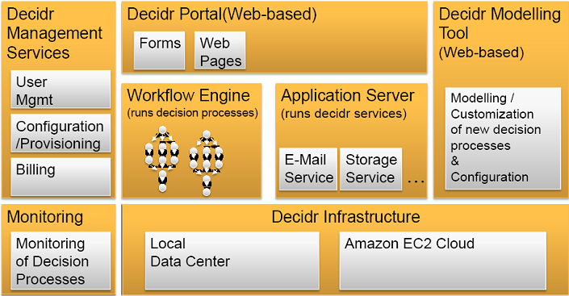

(Fig. 2.1.3.1)

Workflows are executed on the BPEL Engine Apache ODE.

2.2 Users
There are three types of users:

Tenant Administrator: A tenant administrator is someone who adjust Decidr for his project/ company. He can, but doesn’t have to be also the Workflow Administrator or the „normal“ user. There could be more than one tenant administrators for one tenant. There are no restrictions for users (visitors) to become a tenant administrator.

Workflow Administrator: A workflow administrator is someone who starts a certain process instance.

User: A user is a person who participates in a process of a tenant. A user can be associated to one or more tenants. He may also have no tenants.

Additionally, Decidr shall contain a Standard-Tenant who owns a predefined set of processes that every visitor of the Decidr-Site can use. No tenant administrator is needed for the standard tenant. Every user can start process instances from the standard tenants process pool without beeing a workflow administrator.

A person can be tenant admin, workflow admin and user at the same time.

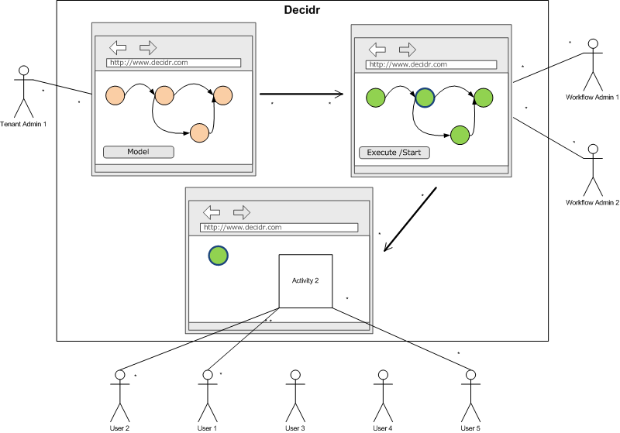

(Fig. 2.2.1)

Tenant administrators and workflow administraors are not expected to understand the whole funcionality of Decidr. There will be special workshops organised by the customer which will introduce the system to interesseted parties.

A tenant admin is familiar with the system (e.g. through adequate instructions). He understands how workflows work (but not necessarily how BPEL works). It is expected that tenants admins will probably need a „short“ training period.

A workflow admin understands workflows but he doesn’t know how to model and design them.

A user knows how to browse and „handle“ a website.

2.3 Product functions
There can be for each decision process different roles. ...

2.4 Constraints
Every library or open source middleware has to be compatible with the Apache License, Version 2.0.
Webservices should be implemented in Java using Eclipse. Eclipse BPEL Designer is the first choice for desiging BPEL processes.

All artefacts must be organised in an SVN repository that is accesible by all advisors and the customer. Developers must use an bugtracking tool, so advisors and customer can report bugs.

3. Specific requirements
3.1 Funtions
3.1.1 Tenant Administrator
3.1.1.1 Registration
Tenant Admins have to register themselves. The following information is needed for registration:
- Name of the company/ project
- Administrative contact person
- Last name
- First name
- Username
- Password
- Funktion
- E-mail
- Telephone
- Adress
- Street, NR
- ZIP Code
- Country
After registration the tenant admin will get his own project/tenant site. This site has an unique adress.
3.1.1.2 Login
There are two ways to log into Decidr. Either he calls the Decidr main site and logs in the main DecidR-Admin-Console or he prompts the tenant project site and logs in this way. After the login he should be able to change configurations and his profile. A help function explains how adjusting works.
3.2.1.3 GUI Adaption
He can adapt the look&feel of his project site. Following elements are interchangeable:
- Logo
- Background colour
3.2.1.4 Appointing workflow adminstrator
The tenant administrator can appoint a workflow administrator. He supervise the registration process of the workflow admin and accepts or rejects the registration.
3.2.1.5 Decision process modelling
He can model workflows. For this purpose there shall be a modelling tool that makes modelling on the fly possible. Processes should be modeled (if possible) with Drag ,n’ Drop. There has to be a „properties view“ for each activity. He can define different abstract roles for the users (e.g. pupil, teacher).
3.1.1.6 Process configurations
He can change process configurations like:
- workflow admins
3.1.1.7 Security
He can decide if only registered users should participate in a process.
3.2.1.8 Customizing der Services
3.1.2 Workflow Administrator
3.1.2.1 Registration
Following informtion should be passed for registration:
- Last name
- First name
- E-mail
- Username
- Password
3.1.2.2 Login
A workflow Admin logs in via the tenant specific DecidR-Console. He gets the link from the tenant administrator. After login he should be able to see the proccesses he can start and a help function that explain how to start the processes correctly.
3.1.2.3 Starting a process instance
He can assign users to roles.
3.1.2.4 Adjusting the process instance
A tenant Adminstrator can adjust some options of a process. He should be able to
- tie users to a process modell or to specific activities within the process modell
- change or create textual information of E-Mails that are sent
3.1.2.5 Monitoring
A workflow admin can use the funcions of the workflow engine to see the current process state. He can see the current state of the process he has started. Minimum requirements regarding this function:
- List of activity states and variable assignments.
A visual reprensentation of a the actual process state is optional.
3.1.3 „Normal“ User
3.1.3.1 Registration
There shall be three different possibilieties how a „normal“ user can register himself.
1. A workflow admin can tie a user to a process instance by entering the user’s e-mail adress into the process participants list. The user will then recieve a e-mail in which a special link and a random password is sent to him. He can use the link to indentify himself and enter user specific profile data to complete his registration.
2. A tenant administrator can invite a user by sending him an e-mail with a special link and a random password. The user can then indentify himselft and enter user specific profile data.
3. Visitor of the Decidr-Site may register themself independently.

In all cases the following information is needed for complete registration:
- Username
- E-mail
- Password
And optional:
- Last name
- First name
- Adress
- Mobilnumber
3.1.4 Activities
3.1.4.1 Send e-mail
- to all users
- to a specific user
- to all users of a role
3.1.4.2 Human Task
- Allows to integrate the user in a decision process (e.g. through web forms)
- Allows users to upload files
- Eskalation: Sends after 2 days an e-mail to an user or an workflow administrator
3.1.4.3 Storage
3.1.4.4 Datatransformation
- Simulation of the BPEL „Assign“ function (e.g. through XSLT)
3.1.4.5 ForEach Activity
- For Each User of a certain Role do the nested Activities
- Simulation of BPEL „ForEach“ activity
3.1.4.5 Optional Activities
3.1.4.5.1 Invocation
- Invocation of an extern webservice.
- Simulation of BPEL „Invoke“ activity
- User has to set WSDL
3.1.4.6 General
The architecture of the activity component has to be very flexible so that new activities could be added. Furthermore there has to be control flow with links and simplified transition conditions.
There should be also variables that can be linked to an human task (e.g. user has to prompt an adress…). Every Activities must be configurable (i.e. you can set whether an e-mail will be sent to all user or not, you can set the text of an e-mail. )
3.2 Performance requirements
Unlimited simultaneous users can use the system. Unlimited process instances can be started. Every Tenant can model unlimited many workflows in unlimited complexity. Restrictions are given are only due memory.
3.3 Design constraints
Code for Decidr should be „efficient“.
3.4 Software system attributes
3.4.1 Modularity
The system has to be modular. The GUI and the webservices are are decoupled. It shall be possible to deploy the GUI on one system and the webservices on another. Furthermore, webservices and workflow models can be deployed separately. There has to be an ESB as an intermediary between all webservices and the Apache Tomcat Servlet Container. Webservices should only be invoked through the ESB.
3.4.2 Reliability
The application shall be robust, that is to say errors in a webservice shouldn’t cause a whole sysem crash. The ESB can choose alternative webservices if a webservice is not available.
3.4.3 Availability
There are no requirements according availability so far.
3.4.4 Security
A control mechanism makes webservice not available from outside the Decidr system. The ESB has to provide WS-Security authentification for external WS-Interfaces. Several services are only invoiceable from outside the Decidr system if authentification is passed. Internal calls shall use ports that are not accessible from outside the Decidr system. Password are stored encrypted. Userdata are not accessible withour authentification. Data from every tenant has to be archived isolatedly, that is to say could be stored in the same database though, but Tenant A is never allowed to see Data form Tenant B.
3.4.5 Maintainability
There has to be logging for the following points:
- Which workflow admin has started which process instance of which tenant.
- Which webservice is invoked by which tenant (the ESB can logg this informtion)

Logging function can be disabled and enabled.
The IAA takes full reponsibilty for maintance of Decidr.
3.4.6 Portability
3.5 Other requirements
Appendixes
Index

