- 实验题目
##实验5：统计学生成绩

###要求：

- 从指定的文本文件读取成绩
- 获取最高成绩和最低成绩
- 计算所有学生的平均成绩
- 分别统计$60$～$69$，$70$～$79$，$80$～$89$，$90～100$分数段的学生人数
- 所有结果要输出到一个文本文件

###Data Sets:

- score.cvs

- 问题分析
需要解决的技术问题：文件输入输出
采用的技术方案：文件输入输出流、scanner类

- 实验的具体步骤
用eclipse完成代码

- 实现程序的完整代码
package pac;

public class Main {

public static void main(String[] args) {
StudentScore temp = new StudentScore("./score.csv");
temp.run();
}
}
-----------------------------------------------------
package pac;

import java.io.*;
import java.util.Scanner;

public class StudentScore {
private String fileName;
private int n = 0;
private int[] scores = new int[65535];
private int lowestS=101;
private int highestS=-1;
private double averageS=0;
private int S_60_69=0;
private int S_70_79=0;
private int S_80_89=0;
private int S_90_100=0;

public StudentScore(String fileName){
this.fileName = fileName;
getInput();
}
public void getInput(){
try {
FileInputStream in = new FileInputStream(new File(fileName));
Scanner s = new Scanner(in);
s.useDelimiter("\\n|\\r|;");
while(s.hasNextInt()){
s.nextInt();
scores[n++] = s.nextInt();
}
System.out.println("读取样本"+n+"个");
s.close();
}catch (Exception e) {
System.out.println("出现异常!");
e.printStackTrace();
}
}

public void calc(){
int totalS =0;
for(int i=0;i<n;i++){
totalS += scores[i];
if(scores[i] > highestS){
highestS = scores[i];
}
if(scores[i] < lowestS){
lowestS = scores[i];
}
if (scores[i]>=60 && scores[i]<=69){
S_60_69++;
}else if (scores[i]>=70 && scores[i]<=79){
S_70_79++;
}else if (scores[i]>=80 && scores[i]<=89){
S_80_89++;
}else if (scores[i]>=90 && scores[i]<=100){
S_90_100++;
}
}
averageS = (double)totalS / n;
System.out.println("计算已完成");
}

public void writeToFile(){
FileOutputStream fop;
try {
fop = new FileOutputStream(new File("output.txt"));
OutputStreamWriter writer = new OutputStreamWriter(fop, "UTF-8");
writer.append("最高成绩 : "+highestS +"\r\n");
writer.append("最低成绩 : "+lowestS +"\r\n");
writer.append("平均成绩 : "+averageS +"\r\n");
writer.append("成绩统计 : \r\n");
writer.append("60~69: "+S_60_69 +"\r\n");
writer.append("70~79: "+S_70_79 +"\r\n");
writer.append("80~89: "+S_80_89 +"\r\n");
writer.append("90~100: "+S_90_100 +"\r\n");
writer.close();
System.out.println("文件写入成功\r\n请查看output.txt");
} catch (FileNotFoundException e) {
e.printStackTrace();
} catch (UnsupportedEncodingException e) {
e.printStackTrace();
} catch (IOException e) {
e.printStackTrace();
}
}

public void run(){
calc();
writeToFile();
}
}

- 实验结果以及总结
实验结果：
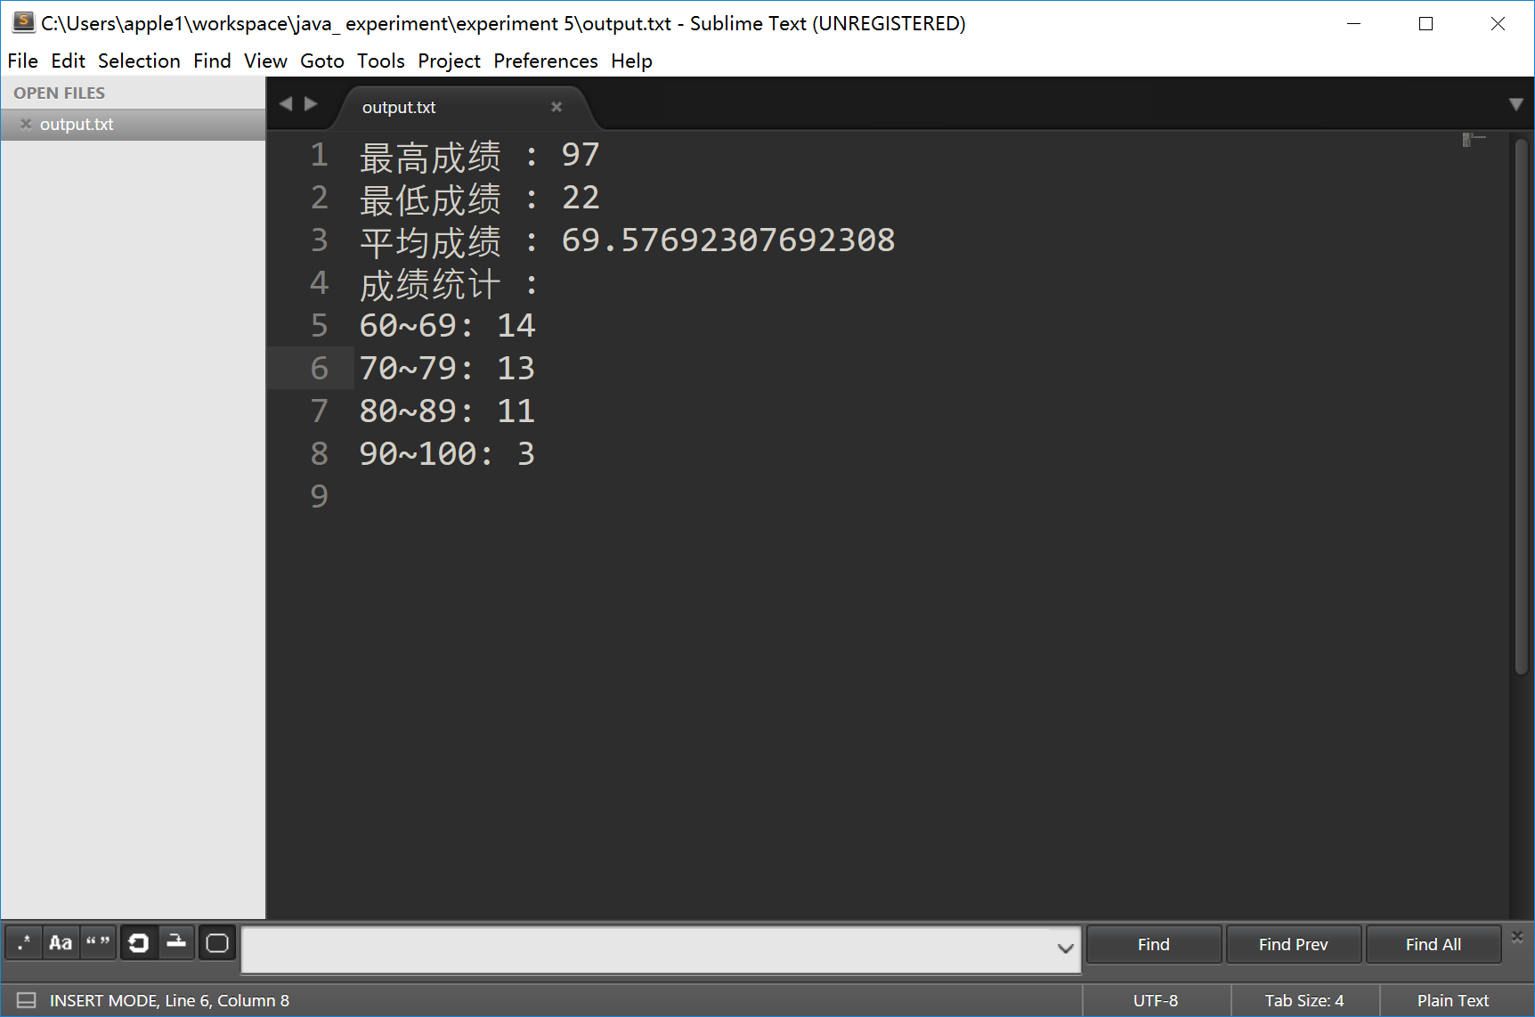
总结:
文件输入输出很重要

