实验3：K-Means算法实现对数据的聚类分析

- 实验题目
。##实验3：K-Means算法实现对数据的聚类分析

K-Means算法的基本思想是初始随机给定K个簇中心，按照最邻近原则把待分类样本点分到各个簇。
然后按平均法重新计算各个簇的质心，从而确定新的簇心。
一直迭代，直到簇心的移动距离小于某个给定的值。

###工作原理是：

~~~
选择K个点作为初始质心(随机选择)
Repeat
计算数据集中每个点到各个簇的质心的距离，将数据点分配到距离最近的簇
重新计算每个簇中所有点的均值并将该均值作为质心
Until 簇不发生变化或达到最大迭代次数
~~~

- 其中K是用户指定的参数，即所期望的簇的个数。
- 常用的距离度量方法为：欧几里得距离
- 簇的质心都是其均值，即向量各维取平均即可

###Data Sets:

- KMeans_Set.txt
- KMeans_Set2.txt

- 问题分析
用eclipse完成代码：
1建立Main类，作为程序总调度；
2建立Sushu 类

- 实验的具体步骤
用eclipse完成代码：
1建立Main类，作为程序总调度；
2建立K_Means类，包含子类 Point

- 实现程序的完整代码
package pac;
import java.util.Scanner;

public class Main {

public static void main(String[] args) {
System.out.println("请输入正整数K");
Scanner input = new Scanner(System.in);
int k = input.nextInt();
input.close();
System.out.println("第一组数据：");
K_Means temp1 = new K_Means(k,"./KMeans_Set.txt");
temp1.run();
System.out.println();
System.out.println("第二组数据：");
K_Means temp2 = new K_Means(k,"./KMeans_Set2.txt");
temp2.run();
}
}
-----------------------------------------------------
package pac;
import java.io.*;
import java.util.Scanner;

public class K_Means {
private String fileName ="";
private int k =0;
private int n = 0;
private point[] arr;
private int[] marks;
private point[] centers;

class point{
public double x;
public double y;

public point(double x,double y){
this.x = x;
this.y = y;
}

public point(point a){
this.x = a.x;
this.y = a.y;
}

public void show(){
System.out.println("["+x+","+y+"]");
}
}

public K_Means(int k,String fileName){
this.k = k;
this.fileName = fileName;
arr = new point[65535];
marks = new int [65535];
centers = new point [k];
getInput();
}

public void getInput(){
try {
FileInputStream in = new FileInputStream(new File(fileName));
Scanner s = new Scanner(in);
while(s.hasNextDouble()){
arr[n++] = new point(s.nextDouble(),s.nextDouble());
}
System.out.println("读取样本"+n);
s.close();
} catch (FileNotFoundException e) {
System.out.println("出现异常!");
e.printStackTrace();
}catch (Exception e) {
System.out.println("出现异常!");
e.printStackTrace();
System.out.println(e.toString());
}

}

public double distance(point a,point b){
return Math.sqrt( (a.x-b.x)*(a.x-b.x) + (a.y-b.y)*(a.y-b.y) );
}

public void run(){

for (int i=0;i<k;i++){
centers[i] = new point(Math.random()*10-5,Math.random()*10-5);
}
initCenters();

int count = 0;
do{
count++;
//第一步，重分配各个点
for (int i=0;i<n;i++){
marks[i] = 0;
for (int j=1;j<k;j++){
if (distance(arr[i],centers[marks[i]]) > distance(arr[i],centers[j])){
marks[i] = j;
}
}
}
//第二步,重算质心
point[] new_centers = new point[k];
for (int i=0;i<k;i++){
double totalX=0;
double totalY=0;
double num=0;
for (int j=0;j<n;j++){
if(marks[j] == i){
totalX += arr[j].x;
totalY += arr[j].y;
num++;
}

}
new_centers[i] = new point(totalX / num, totalY / num);
}
//第三步，退出循环条件:簇不发生变化或达到最大迭代次
boolean changed = false;
for (int i=0;i<k;i++){
if(new_centers[i].x != centers[i].x || new_centers[i].y != centers[i].y){
changed = true;
centers[i].x = new_centers[i].x;
centers[i].y = new_centers[i].y;
}
}
if (count >= 1000 || changed == false){
break;
}
}while(true);
System.out.println("运算结束，循环次数：" + count);
System.out.println(k + "个簇的质心如下：");
for(int i = 0;i<k;i++){
centers[i].show();
}
}
private void initCenters() {
int[] choose = new int [k];

for (int i=0;i<k;i++){
boolean ok;
int temp;
do{
temp = (int) Math.floor(Math.random()*n);
ok = true;

for (int j=0;j<i;j++){
if(choose[j] == temp){
ok = false;
break;
}
}
}while(!ok);
choose[i] = temp;
}
for (int i=0;i<k;i++){
centers[i] = new point(arr[ choose[i] ]);
}
}
}

- 实验结果以及总结

实验结果：
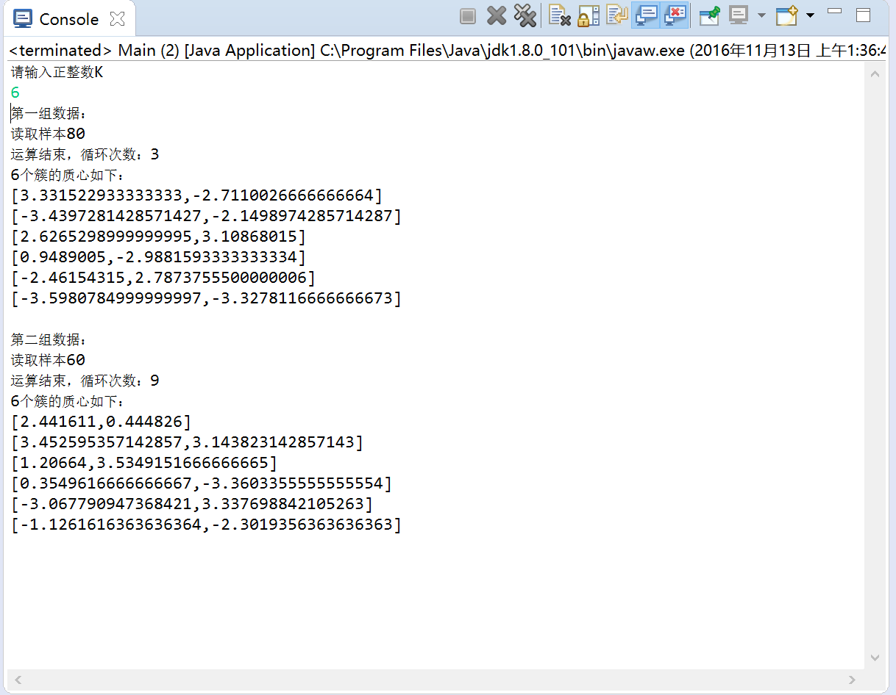

总结：
数据的归类与统计是很重要的算法

