实验4：线性回归(Linear Regression)找到最佳拟合直线

- 实验题目
##实验4：线性回归(Linear Regression)找到最佳拟合直线

在统计学中，线性回归(Linear Regression)是利用称为线性回归方程的最小平方函数对一个或多个自变量和因变量之间关系进行建模的一种回归分析。

设直线方程为
$$
f(x) = A x + B
$$

设数据集为$\{(x_k,y_k)\}_{k=1}^N $

误差均值为：

$$E_2(f)^2 = \frac{1}{N} \sum_{k=1}^N (Ax_k + B - y_k)^2$$

若
$$
\frac{\partial E (A, B)}{\partial A} = 0
$$
$$
\frac{\partial E (A, B)}{\partial B} = 0
$$
则
$$
0 = \sum_{k=1}^N (A x_k^2 + B x_k - x_k y_k) = A \sum_{k=1}^N x_k^2 + B \sum_{k=1}^N x_k - \sum_{k=1}^N x_k y_k
$$
$$
0 = \sum_{k=1}^N (A x_k + B - y_k) = A \sum_{k=1}^N x_k + NB - \sum_{k=1}^N y_k
$$
即：
$$
\left( \sum_{k=1}^N x_k^2 \right) A + \left( \sum_{k=1}^N x_k \right) B = \sum_{k=1}^N x_k y_k
$$
$$
\left( \sum_{k=1}^N x_k \right) A + N B = \sum_{k=1}^N y_k
$$

最后根据上述两式可以求出$A$和$B$

###Data Sets:

- LR_ex0.txt
- LR_ex1.txt

- 问题分析
需要解决的技术问题：求线性回归A、B
采用的技术方案：经过计算:
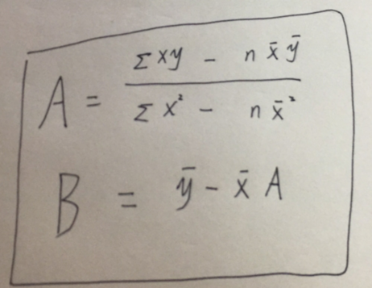

- 实验的具体步骤
用eclipse完成代码

- 实现程序的完整代码
package pac;

public class Main {
public static void main(String[] args){

System.out.println("第一组数据：");
LinearRegression temp1 = new LinearRegression("./LR_ex0.txt");
temp1.run();
System.out.println();
System.out.println("第二组数据：");
LinearRegression temp2 = new LinearRegression("./LR_ex1.txt");
temp2.run();
}
}
---------------------------------------------------
package pac;

import java.io.*;
import java.util.Scanner;

public class LinearRegression {
private String fileName;
private int n = 0;
private double[] x = new double [65535];
private double[] y = new double [65535];
private double averageX = 0;
private double averageY = 0;
private double A = 0;
private double B = 0;

public LinearRegression(String fileName) {
this.fileName = fileName;
getInput();
}
public void getInput(){
try {
FileInputStream in = new FileInputStream(new File(fileName));
Scanner s = new Scanner(in);

while(s.hasNextDouble()){
s.nextDouble();
x[n]=s.nextDouble();
y[n++]=s.nextDouble();
}
System.out.println("读取样本"+n+"个");
s.close();
}catch (Exception e) {
System.out.println("出现异常!");
e.printStackTrace();
}
}
public void calc(){
double totalX =0;
double totalY =0;
double totalXY =0;
double totalXX =0;
for(int i=0;i<n;i++){
totalX += x[i];
totalY += y[i];
totalXY += x[i]*y[i];
totalXX += x[i]*x[i];
}
averageX = totalX / n;
averageY = totalY / n;
A = (totalXY - n*averageX*averageY) / (totalXX - n*averageX*averageX);
B = averageY - averageX*A;
System.out.println("计算已完成");
}
public void show(){
System.out.println("f(x) = A * X + B 中 : ");
System.out.println("A = "+A);
System.out.println("B = "+B);
}
public void run() {
calc();
show();
}
}

- 实验结果以及总结
结果:
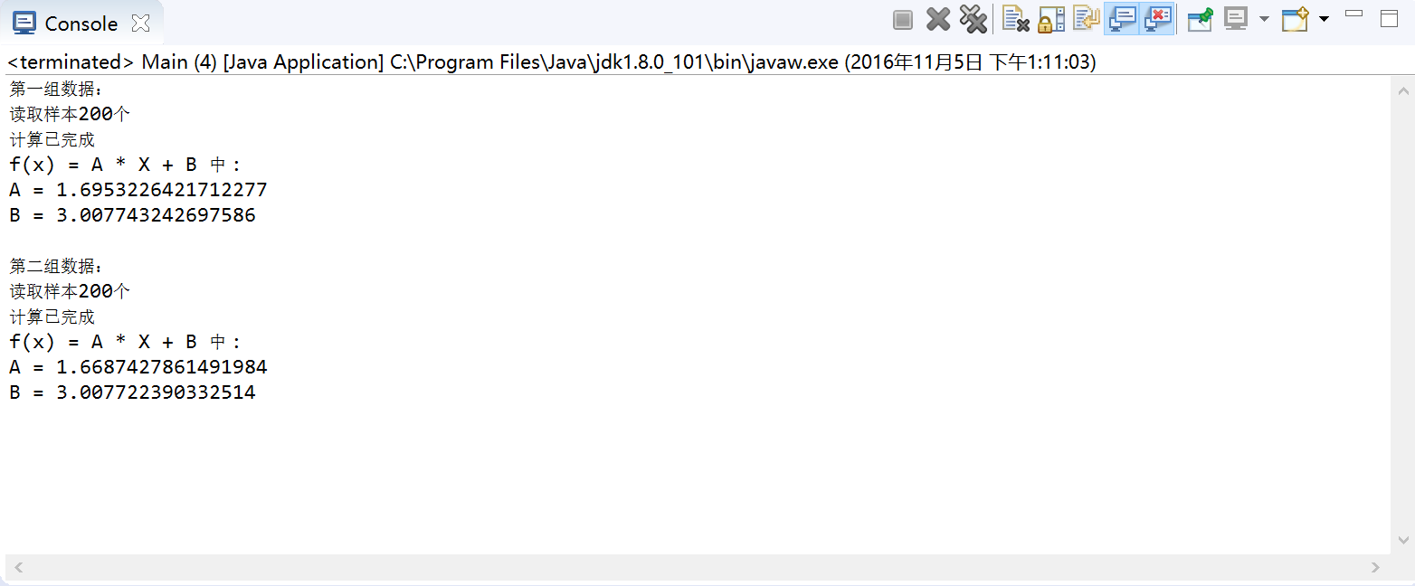
总结:
数学很重要

