- 实验题目
##实验8：网络编程基础

实现Java爬虫，抓去设定网站的信息

- 设定一家知名的信息网站，例如百度新闻，今日头条，新浪新闻，网易新闻等，
- 使用InetAddress类的方法获取设定网站的主机的IP地址；
- 获取本地机的名称和IP地址。
- 使用URL类下载首页信息，
- 分析首页信息，进行信息过滤，将新闻报道的正文进行分门别类的整理。
。

- 问题分析
需要解决的技术问题：InetAddress类、URL类、解析html文档
采用的技术方案：学习InetAddress类、URL类，使用JSoup解析html文档

- 实验的具体步骤
用eclipse完成代码、查阅JSoup的API

- 实现程序的完整代码
package pac;
public class Main {
public static void main(String[] args) {
XinlangNewsCrawler temp = new XinlangNewsCrawler();
temp.run();
}
}
package pac;

import java.io.*;
import java.net.*;

import org.jsoup.Jsoup;
import org.jsoup.nodes.Document;
import org.jsoup.nodes.Element;
public class XinlangNewsCrawler {
private void printInetAddressInfo(){
InetAddress inetAddress;
try {
System.out.println("目标InetAddress : ");
inetAddress = InetAddress.getByName("news.sina.com.cn");
System.out.println("HostName : "+inetAddress.getHostName());
System.out.println("Address : "+inetAddress.getHostAddress());

System.out.println();
System.out.println("本地InetAddress : ");
inetAddress = InetAddress.getLocalHost();
System.out.println("HostName : "+inetAddress.getHostName());
System.out.println("Address : "+inetAddress.getHostAddress());
} catch (UnknownHostException e) {
// TODO Auto-generated catch block
e.printStackTrace();
}
}

private String DownloadHtmlStr(){
StringBuffer html = new StringBuffer();
try {
URL xinlangnews = new URL("http://news.sina.com.cn/");
System.out.println();
System.out.println("正在爬取 http://news.sina.com.cn/ ");
//获取 资源的字节输入流
InputStream is = xinlangnews.openStream();
//将字节输入流 转换为 字符输入流
InputStreamReader isr =new InputStreamReader(is,"utf-8");
//为字符输入流添加缓冲
BufferedReader br = new BufferedReader(isr);
String data = br.readLine();
int n=1;
while (data!=null){
data = br.readLine();
html.append(data+"\n");
n++;
}
System.out.println("已读取"+n+"行HTML代码");
br.close();
isr.close();
is.close();
} catch (MalformedURLException e) {
e.printStackTrace();
} catch (IOException e) {
e.printStackTrace();
}
return html.toString();
}

private void soupParseAndPrint(String htmlStr) {
System.out.println();
System.out.println("解析中: ");
System.out.println("-------------------");
Document doc = Jsoup.parse(htmlStr);
Element title = doc.getElementsByTag("head").first().getElementsByTag("title").first();
System.out.println("标题 : "+title.html());

Element YaoWenBlock = doc.getElementById("blk_yw_01");
YaoWenBlock = YaoWenBlock.getElementById("syncad_1");
System.out.println("要闻 : ");
for (Element item : YaoWenBlock.getElementsByTag("h1")){
System.out.println(" - "+item.getElementsByTag("a").first().html());
}

Element JiaoDianTuBlock = doc.getElementById("Blk01_Focus_Cont");
System.out.println("焦点图 : ");
for (Element item : JiaoDianTuBlock.getElementsByTag("div")){
System.out.println(" - "+item.getElementsByTag("a").first().html());
}

System.out.println("国内新闻 : ");
Element GuoNeiNewsBlock = doc.getElementById("blk_new_gnxw");
for (Element item : GuoNeiNewsBlock.getElementsByTag("li")){
System.out.println(" - "+item.getElementsByTag("a").first().html());
}

System.out.println("国际新闻 : ");
Element GuoJiNewsBlock = doc.getElementById("blk_gjxw_01");
for (Element item : GuoJiNewsBlock.getElementsByTag("li")){
System.out.println(" - "+item.getElementsByTag("a").first().html());
}

}

public void run(){
printInetAddressInfo();
String htmlStr =DownloadHtmlStr();
soupParseAndPrint(htmlStr);
}
}

- 实验结果以及总结
实验结果:
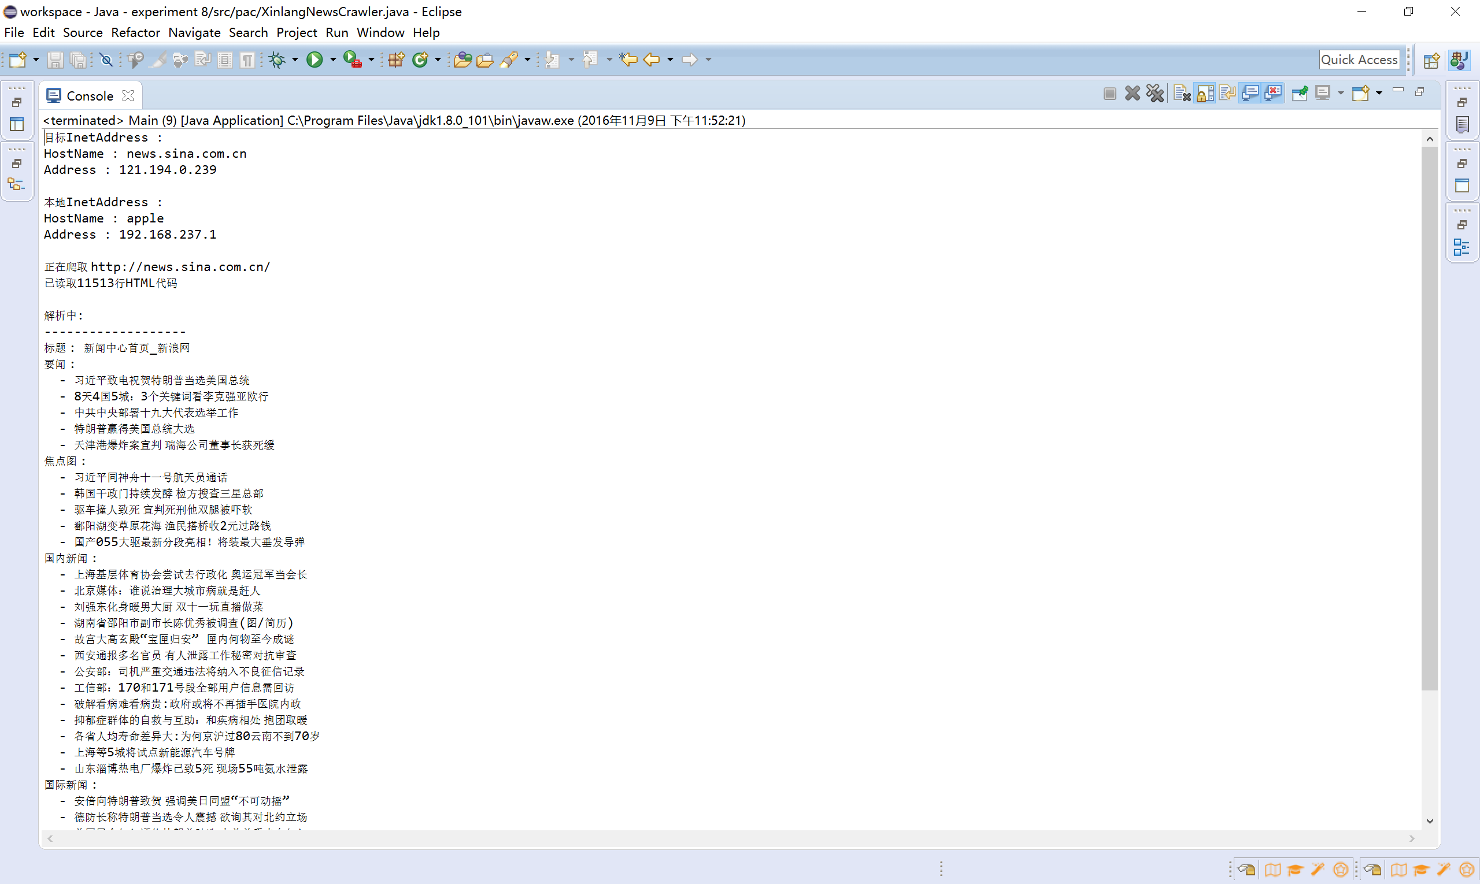
总结:
嗯，写过python爬虫，所以写个Java爬虫并不难~~

