Socket编程与客户/服务器应用开发

2. 进程1 向进程2发送3条消息M1、M2、M3.在下面两种情况下，这些消息可能以何种顺序到达进程？

1）采用无链接Socket发送消息

2）采用面向连接Socket发送每条消息

1)
M1,M2,M3
M1,M3,M2
M2,M1,M3
M2,M3,M1
M3,M1,M2
M3,M2,M1

2)
M1,M2,M3

编写一段可出现在某main方法中的Java程序片段，用于打开一个最多接收100字节数据的数据包Socket，设置超时周期为5秒。如果发生超时，需在屏幕上显示接收超时消息。
package homework_3_2_4;

import java.net.DatagramPacket;
import java.net.DatagramSocket;
import java.net.SocketTimeoutException;

public class ServerSock {

final static int MAX_LEN = 100;
final static String PORT = "8888";
private static final int TIME_OUT = 5000;

public static void main(String[] args) {

System.out.println("ServerSock begin:");

int port = Integer.parseInt(PORT);

try {
DatagramSocket mySocket = new DatagramSocket(port);
System.out.println("Waiting for receiving the data!");
// instantiates a datagram socket for receiving the data
byte[ ] buffer = new byte[MAX_LEN];
DatagramPacket datagram = new DatagramPacket(buffer, MAX_LEN);
mySocket.setSoTimeout(TIME_OUT);
mySocket.receive(datagram);
String message = new String(buffer);
System.out.println(message);
mySocket.close( );
}catch (SocketTimeoutException ex) {
System.out.println("接收超时！");
}catch (Exception ex) {
ex.printStackTrace( );
}
System.out.println("ServerSock end.");
}
}

6. 通过示范代码example2练习无连接数据包Socket
1）
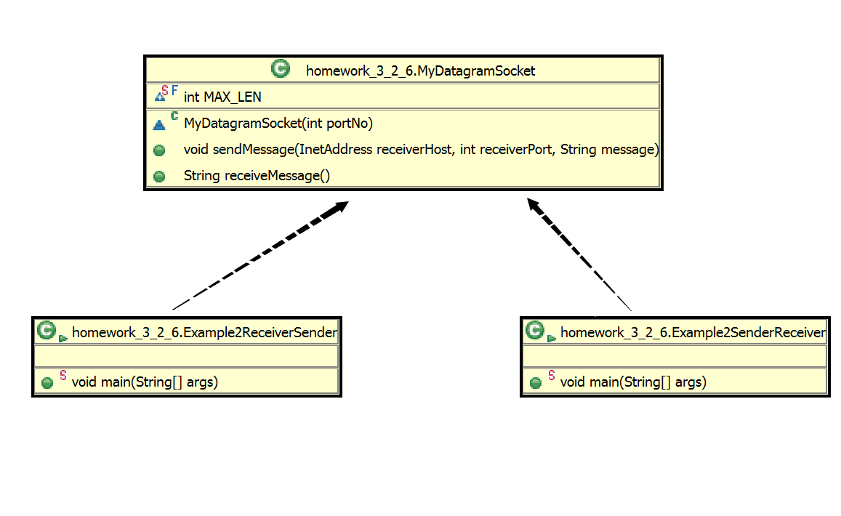

- Example2ReceiverSender(记为程序A)是先收再发，Example2SenderReceiver（记为程序B）是先发再收。如果先运行A，再运行B，则A先运行了A.receive，收到了B.send发来的消息，然后B运行了B.receive，收到了A.send的消息。
如果程序执行顺序反了的话（先运行B，再运行A）：则B.send发送的消息丢失，然后B.receive等待消息，同时A.receive等待消息，A和B都等着对方给自己发送消息，形成死锁。

3）
接着第2小问来理解，若每隔一段时间重复运行程序A和B,(尤其是当时间间隔不相等时)有可能出现第2小问提到的死锁的情况。即程序A的A.socket关闭后重新打开前，B.send发送的消息丢失，然后A和B一起进入了receive状态，A和B都等着对方给自己发送消息，形成死锁。
（避免死锁的方法：若不执行socket.close、不重新构造DatagramSocket，只是让A、B循环重复执行send和receive方法，则send方法不会丢失信息，因为端口一直被监听，信息会被存入缓冲区，在下一次receive时取出，不会产生死锁。避免死锁的程序如下所示）

package homework_3_2_6;
import java.net.InetAddress;

public class Example2ReceiverSender {
// An application which sends then receives a message using
public static void main(String[] args) {
if (args.length != 4)
System.out.println
("This program requires four command line arguments");
else {
try {
InetAddress receiverHost = InetAddress.getByName(args[0]);
int receiverPort = Integer.parseInt(args[1]);
int myPort = Integer.parseInt(args[2]);
String message = args[3];
MyDatagramSocket mySocket = new MyDatagramSocket(myPort);
// instantiates a datagram socket for both sending and receiving data
// First wait to receive a datagram from the socket

for (;;){

System.out.println("Message receiving.");
System.out.println(mySocket.receiveMessage());
// Now send a message to the other process.
mySocket.sendMessage( receiverHost, receiverPort, message);
System.out.println("Message Send.");
System.out.println("Sleeping.");
Thread.sleep(4000);
}

//mySocket.close( );
} // end try
catch (Exception ex) {
ex.printStackTrace( );
} //end catch
} //end else
} //end main
} //end class

package homework_3_2_6;
import java.net.InetAddress;

public class Example2SenderReceiver {

// An application which sends then receives a message using connectionless datagram socket.
public static void main(String[] args) {
if (args.length != 4)
System.out.println("This program requires four command line arguments");
else {
try {
InetAddress receiverHost = InetAddress.getByName(args[0]);
int receiverPort = Integer.parseInt(args[1]);
int myPort = Integer.parseInt(args[2]);
String message = args[3];
MyDatagramSocket mySocket = new MyDatagramSocket(myPort);
// instantiates a datagram socket for both sending and receiving data

for (;;){
mySocket.sendMessage( receiverHost, receiverPort, message);
System.out.println("Message Send.");
System.out.println("Message receiving.");
System.out.println(mySocket.receiveMessage());
System.out.println("Sleeping.");
Thread.sleep(100);
}
//mySocket.close( );
} // end try
catch (Exception ex) {
ex.printStackTrace( );
} //end catch
} //end else
} //end main

} //end class

