PIGE profiling – IAEA exercise
Proposal – version: 04/09/2023
- Al (0.98 μm) + Si (Bulk)
E₀ =1683.3 keV – 1723,3 keV; Energy step = 2 keV
Al “fake” cross-section: 1 mb/sr (constant)
2 options: Gaussian straggling and full straggling
2 options: ΔE₀ = 0 keV and 1 keV

- Al (0.98 μm) + Si (Bulk)
E₀ = 1682 keV -1688 keV; Energy step = 0.5 keV
Al “fake” cross-section: BW: E_{R} = 1683.3 keV; Γ_{R} = 0.1 keV; σ_{Máx} = 1 mb/sr
2 options: Gaussian straggling and full straggling
2 options: ΔE₀ = 0 keV and 1 keV

- Al (3.27 μm) + Si (Bulk)
E₀ = 2000 keV - 2120 keV; Energy step = 5 keV
Al cross-section: ²⁷Al(p,pγ₁₋₀)²⁷ Al (Eγ = 844 keV) - R. Mateus et al. (2022) – IBANDL
2 options: Gaussian straggling and full straggling
2 options: ΔE₀ = 0 keV and 1 keV

- Al (0.98 μm) + Si (Bulk)
E₀ =1683.3 keV – 1723,3 keV; Energy step = 2 keV
Al cross-section: ²⁷Al(p,pγ₁₋₀)²⁷ Al (Eγ = 844 keV) - R. Mateus et al. (2022) – IBANDL
2 options: Gaussian straggling and full straggling
2 options: ΔE₀ = 0 keV and 1 keV

- Si (11.41 μm) + Al (0.98 μm) + Si (Bulk)
E₀ = 2000 keV – 2040 keV; Energy step = 2 keV
Al “fake” cross-section: 1 mb/sr (constant)
2 options: Gaussian straggling and full straggling
- options: ΔE₀ = 0 keV and 1 keV

- Si (11.41 μm) + Al (0.98 μm) + Si (Bulk)
E₀ = 2000 keV – 2003 keV; Energy step = 0.5 keV
Al “fake” cross-section: BW: E_{R} = 1683.3 keV; Γ_{R} = 0.1 keV; σ_{Máx} = 1 mb/sr
2 options: Gaussian straggling and full straggling
2 options: ΔE₀ = 0 keV and 1 keV

- Si (11.41 μm) + Al (0.98 μm) + Si (Bulk)
E₀ = 2000 keV – 2040 keV; Energy step = 2 keV
Al cross-section: ²⁷Al(p,pγ₁₋₀)²⁷ Al (Eγ = 844 keV) - R. Mateus et al. (2022) – IBANDL
2 options: Gaussian straggling and full straggling
2 options: ΔE₀ = 0 keV and 1 keV

Additional information

All exercices at Room temperature, 300 K, for Doppler effect.
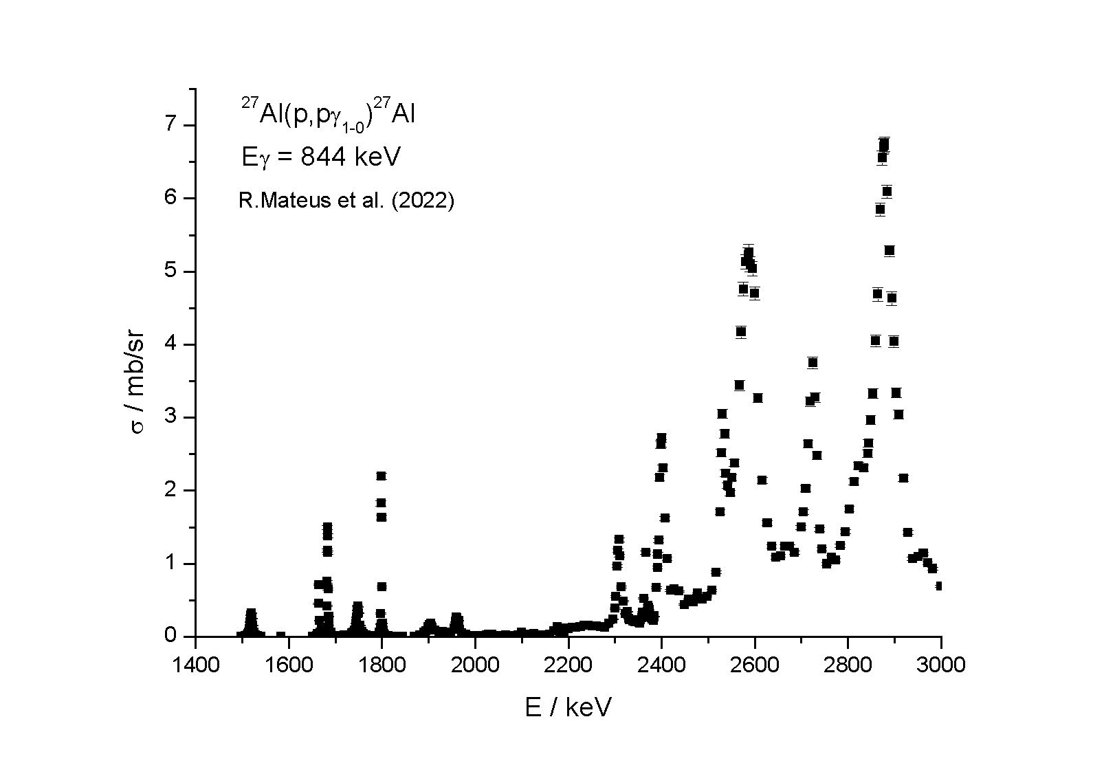
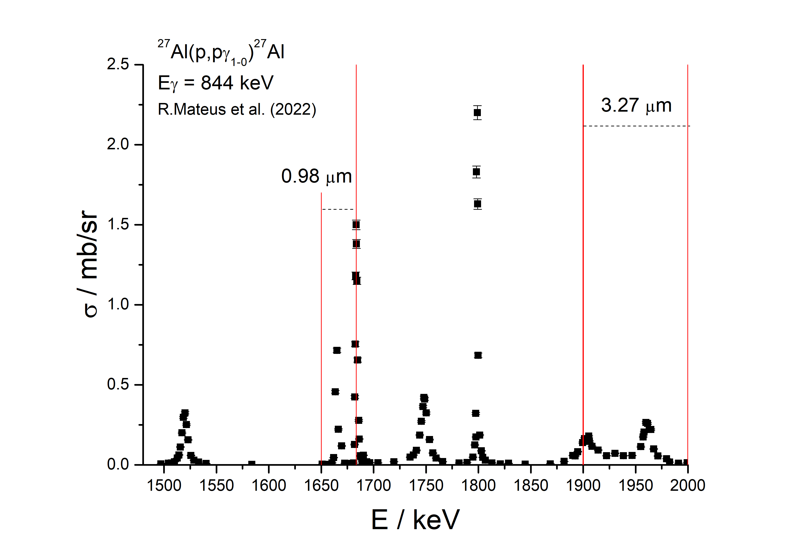

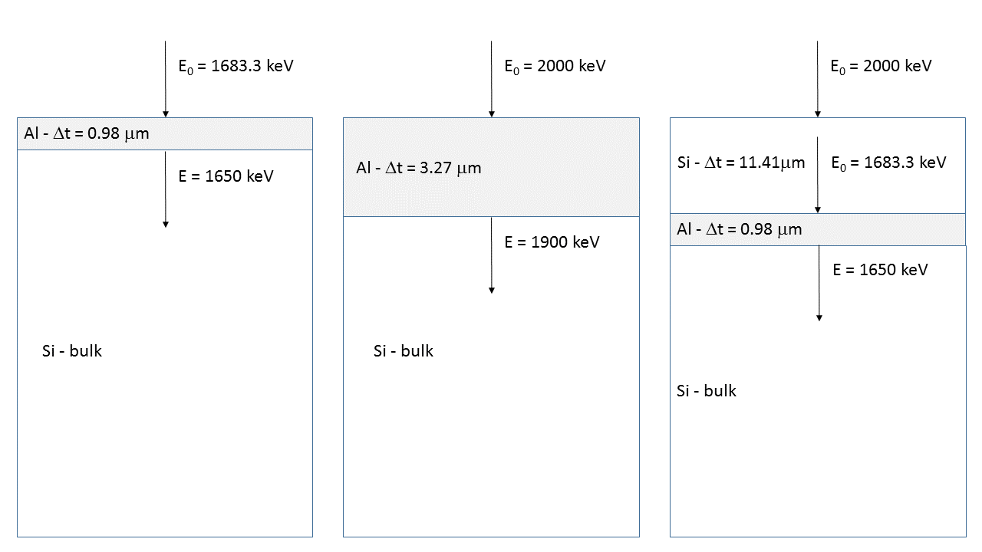

Material | Δt / μm | Δt / 10¹⁵ at/cm²
Al | 0.98 | 5.91×10³
Al | 3.27 | 19.7×10³
Si | 11.41 | 56.8×10³

ρ_{Al} = 2.70 g/cm³ = 6.03×10²² at/cm³
ρ_{Si} = 2.32 g/cm³ = 4.98×10²² at/cm³

