**How to deposit your tool on the NRDC GitHub website**

Naohiko Otsuka (2024-05-19)

Following recommendation from the NRDC 2024 meeting, I prepared a GitHub website for exchange of software tools developed by NRDC members. Note that the primary website for exchange of the software tools between the centres is NRDC software website (<https://nds.iaea.org/nrdc/nrdc_sft/>).

This is a short guide for the NRDC members who want to share an EXFOR related codes developed by a NRDC member to the NRDC GitHub website. In this guide, we consider upload of a tool “x4util” with a GitHub username “naohikootsuka”.

**1. Creation of your GitHub account (username, password, access token)**

1.1. Create a username and password with your email address at https://github.com/:



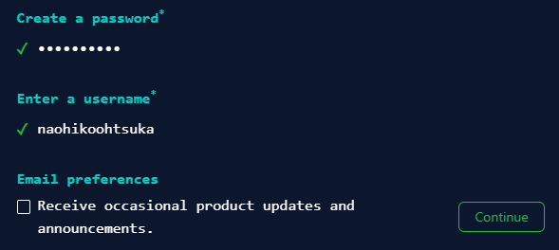

1.1. Sign in at <https://github.com/> with your account:

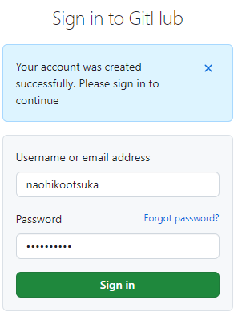

1.2. Generate an access token at <https://github.com/settings/tokens> :

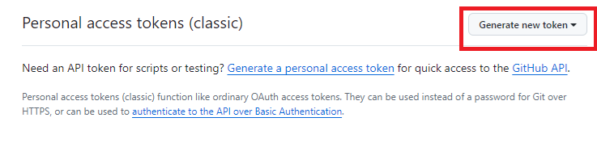

1.3. Provide note, expiration date and scope.

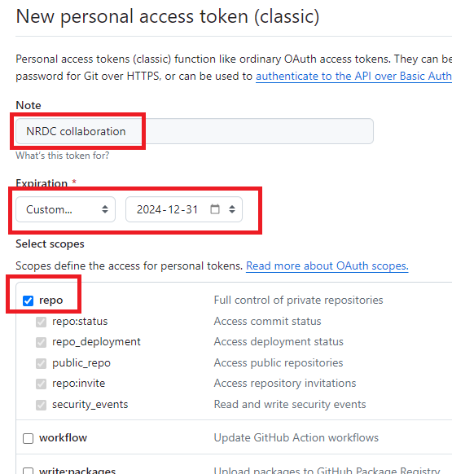

1.4. Click “Generate token”

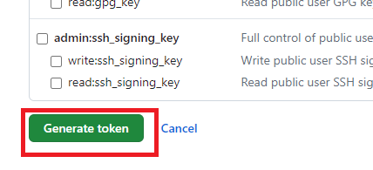

1.5. Print access token (This will be required when you deposit your tool.)

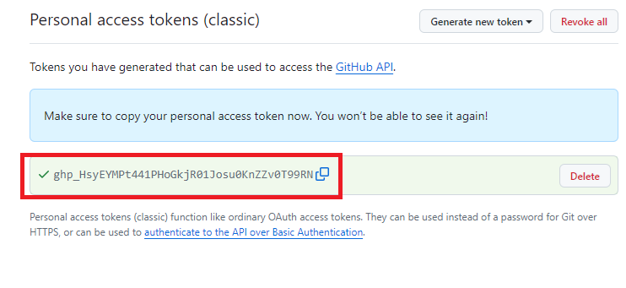

**2. Creation of a repository of your tool on the NRDC GitHub site**

2.1 Click “Repositories”:

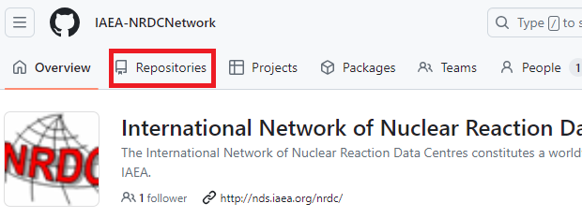

2.2. Click “New repository”:

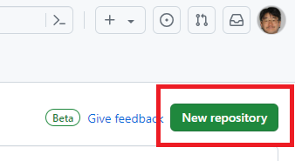

2.3. Provide the information of the tool to be deposited:

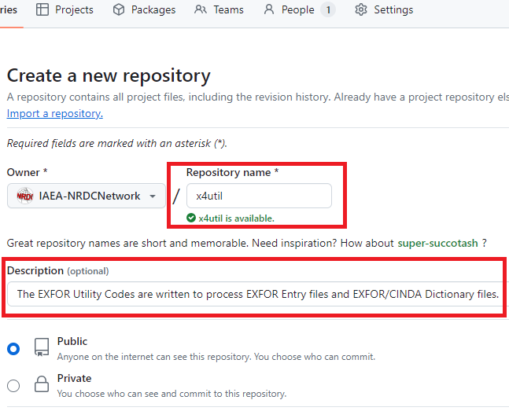

2.4. Click “Create repository”:

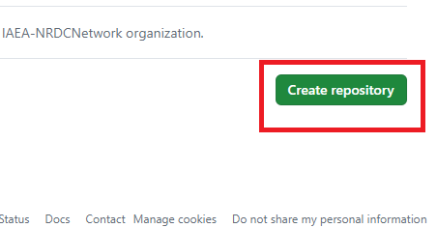

**3. Preparation of local repository on your computer (Linux)**

% cd /home/git/x4util

% ls

x4util-20240503/ iaea-nds-0244.pdf

% git init

Initialized empty Git repository in /home/git/x4util/.git/

% git add .

% git commit -m “initial commit”

[master (root-commit) ad2d3e2] initial commit

12 files changed, 6474 insertions(+)

create mode 100644 iaea-nds-0244.pdf

create mode 100644 x4util-20240503/x4_dic227.py

create mode 100644 x4util-20240503/x4_dica2j.py

create mode 100644 x4util-20240503/x4_dicdis.py

…

% git branch -M main

**3. Upload the files to NRDC GitHub from your computer**

% cd /home/git/x4util

% git remote add origin <https://github.com/IAEA-NRDCNetwork/x4util.git>

% git push origin main

Username for 'https://github.com': **naohikootsuka**

Password for 'https://naohikootsuka@github.com': ****

(Here you have to provide your access token, not password!)

Counting objects: 100% (15/15), done.

Delta compression using up to 8 threads

Compressing objects: 100% (15/15), done.

Writing objects: 100% (15/15), 266.08 KiB | 12.09 MiB/s, done.

Total 15 (delta 1), reused 0 (delta 0)

remote: Resolving deltas: 100% (1/1), done.

To https://github.com/IAEA-NRDCNetwork/x4util.git

* [new branch] main -> main

**4. Confirm presence of your files on NRDC GitHub**

Visit <https://github.com/IAEA-NRDCNetwork/x4util>:

