ialA Technical service

SS0001
Service Specification for VTS Traffic Clearance


Edition 1.6
September 2026

urn.mrn.iala:techsvc:ss0001:ed1.6

Date | Details | Approval
December 2024 | Edition 1.0.0  First version of Service Specification Annex to accompany Guideline G1128
April 2024 | Edition 1.5.1 Editorial changes applied to align the content with the official document format. | Secretariat
March 2026 | Editorial cleanup and clarifications based on inputs.
September 2026 | Intersessional and VTS60 changes to terminology

1 introduction 5
1.1 Purpose 5
1.2 Intended readership 5
1.3 Input from other sources 5
2 Service Identification 6
3 Operational context 7
3.1 Use cases for service 8
3.1.1 Use case 1 - Departing vessels from berth or anchorage. 8
3.1.2 Use Case 2 – Entering, leaving or passing through VTS area 9
3.1.3 Use Case 3 - Arriving vessels taking berth 9
3.1.4 Use Case 4 – Arriving vessel heading for anchorage 9
3.1.5 Use case 5 - Transiting within a VTS Area. 9
3.1.6 Use Case 6 - External influence to change Traffic Clearance 10
3.2 The business process of a traffic clearance request 10
3.3 Functional and non-functional requirements 11
3.3.1 Functional requirements 11
3.3.2 Non-functional requirements 15
3.4 Other constraints 16
3.4.1 Relevant Industrial Standards 17
3.4.2 Operational nodes 17
4 Service Overview 18
4.1 Logical operations 18
4.2 Logical parameters 18
5 Service Data Model 19
6 Service Dynamic Behaviour 21
6.1 The allowed use of different clearance statuses 21
6.2 Multiple clearance messages in a single request 21
6.3 Sequence diagrams 21
7 Definitions 28
8 Abbreviations 30
9 References 31

List of Tables
No table of figures entries found.
List of Figures
Figure 1 Traffic Clearance Service Use Cases 8
Figure 2 Traffic Clearance dataflow 10
Figure 3 Traffic Clearance Business Process 11
Figure 4 Traffic Clearance data model diagram 19
Figure 5 Use case 1 sequence diagram 22
Figure 6 Use Case 2 variation 1 sequence diagram 23
Figure 7 Use Case 2 variation 2 sequence diagram 23
Figure 8 Use Case 3 sequence diagram 24
Figure 9 Use Case 4 sequence diagram 25
Figure 10 Use Case 5 sequence diagram 26
Figure 11 Use Case 6 sequence diagrams 27

introduction

This document was produced as part of the work of IALA joint VTS-ENAV task group on development of technical service specifications for VTS. The document is structured according to the IALA Guideline G1128 The Specification of e-Navigation Technical Services [1]

Purpose

The purpose of this Service Specification is to provide a holistic overview of the digital service of VTS Traffic Clearance and its building blocks in a technology-independent way, according to the guidelines given in G1128. It describes a well-defined baseline of the service by clearly identifying the service version.
The aim is to document the key aspects of the VTS Traffic Clearance Service at the logical level, including:
- the operational and business context of the service:
- requirements for the service (e.g., information exchange requirements);
- involved nodes: which operational components provide/consume the service;
- operational activities supported by the service; and
- relation of the service to other services.
- the service description:
- service use cases;
- service operational sequence;
- logical operations;
- logical data model; and
- dynamic behaviour.

Intended readership

This Service Specification is intended to be read by service architects, system engineers and developers in charge of designing and developing an instance of the VTS Traffic Clearance Service.
Furthermore, this Service Specification is intended to be read by enterprise architects, service architects, information architects, system engineers and developers in pursuing architecting, designing and development activities of other related services.

Input from other sources

When developing this service inputs from IMO FAL.5/Circ.52 Guidelines for harmonized communication and electronic exchange of operational data for port calls [2] has been taken into consideration.

Service Identification

This section provides a unique identification of the service and describes where the service is in the engineering lifecycle.

Name | VTS Traffic Clearance Technical Service
ID | urn:mrn:iala:techsvc:ss0001:ed1.6
Version | 1.6
Description | The VTS Traffic Clearance Service specification describes a standardized service implementing the VTS traffic clearances communication between ship and shore.
Keywords | VTS, MS1, Traffic Clearance, Ship Traffic Management, S-212, S-421
Architect(s)
Status | Ready for testing

Operational context

One of the main tasks for VTS is to monitor and manage vessel traffic, including establishing a system for traffic clearances. Traffic clearances may be required in situations when a vessel is:
- entering or prior to entering a VTS area;
- departing from a berth or an anchorage within a VTS area;
- entering a fairway within a VTS area;
- deviations with (approved) planned intentions within a VTS area; or
- commencing a manoeuvre that may be detrimental to safe navigation.

Traffic clearance is a VTS authorization under conditions specified. The granting, or not granting, of permission to enter, depart or proceed refers to the process of ensuring that there is sufficient space and time for vessels to navigate safely through an area as well as consider other vessels, obstructions, regulatory and environmental factors. Based on the information available, the VTS assesses that it is safe and gives approval for the ship to proceed e.g. from or to a berth or anchorage, subject to the discretion of the Master.
The process of granting permissions includes the use of communication systems to inform mariners about the location and movements of other vessels and potential hazards.

To provide digital communication in globally harmonized way a common understanding of the operational procedures and standardised technical services are necessary.
A more digitally envisioned operational system for granting permissions will provide several valuable benefits to improve communication and with that safety, efficiency, and sustainability. Digital systems will enhance situational awareness for the vessel and provide real-time information and help to ensure that all parties timely have the necessary information to make informed decisions and take appropriate actions. Traffic Clearance Service paves the way for more automated services and decision support tools.
For effective Traffic Clearance Service, VTS requires the knowledge of vessels intentions. The primary means to share vessels ETA and ETD would be the sharing of vessels route plans, which always includes a schedule. If the vessel is not capable of sharing a route plan, the alternative mean would be sharing only ETA and ETD and destination of vessel. It should be ensured that the times in the different systems are aligned.
This service specification does not define the on-board systems used in for Traffic Clearance Service. When implementing the Traffic Clearance Service the on-board system which the service will be deployed on should also be planned.
It should be noted that if ECDIS will be used as an on-board system, it should be compatible with the performance standards for ECDIS. ECDIS PS does not support the dynamic exchange and modification of ETA/ETD timestamps, which limits the use of only timestamp-based systems to back bridge systems on-board.
This service should be used directly from ship board systems.
This service is based on standardized structured data format that will enable the exchange of information related to traffic clearances in the VTS area.

Use cases for service

Typical voyages through VTS areas can be defined by general use cases: (UC1) departing from a berth or anchorage within a VTS area, (UC2) entering or passing through a VTS area, entering VTS area to (UC3) take berth or (UC4) head for anchorage and (UC5) a vessel transiting within the VTS area. Next to that (UC6) an external influence could change the Traffic Clearance by VTS or vessel.
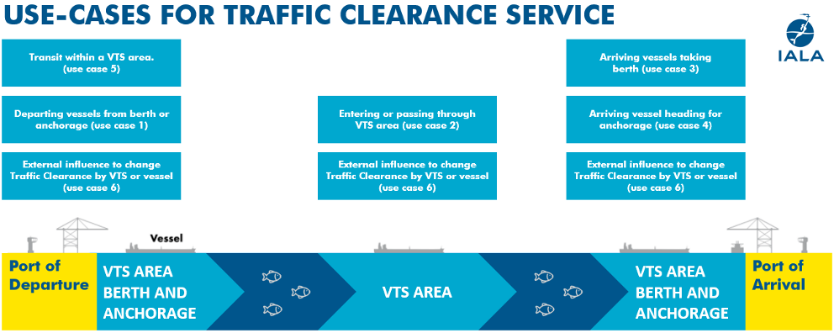
Figure 1 Traffic Clearance Service Use Cases
The following use cases provide examples for the digital information exchange between VTS and vessels using traffic clearance service. The reference in the following use case steps to operational use cases refers to the use cases listed in [11].

Use case 1 - Departing vessels from berth or anchorage.
- Vessel wants to leave berth/anchorage
- The vessel sends message with its estimated or planned time of departure through its system to the service and requests permission to leave berth/anchorage
- If vessel's schedule is suitable, then VTS gives traffic clearance to vessel [go to step 7] (operational use case 6.1.1)
- If vessel's estimated or planned time of departure is not suitable, VTS sends denial (operational use case 6.1.2) or a proposal with requested time of departure information (operational use case 6.1.3) on when vessel can leave the berth/anchorage.
- Service delivers response to the vessel
- The vessel approves planned time of departure and sends response to the VTS or creates new plan [go to step 2] (operational use case 6.1.3)

- The vessel leaves berth/anchorage

Use Case 2 – Entering, leaving or passing through VTS area
- Vessel is about to enter or pass through the VTS area
- The vessel sends message with estimated or planned time of arrival in VTS area through its system to the service and requests permission to proceed through the VTS area from the service
- If vessel's planned route and schedule is suitable, then VTS gives traffic clearance to vessel [go to step 7]
- If vessel's planned route or schedule is not suitable, VTS sends denial or a requested time of arrival to the vessel through the service
- Service delivers response to the vessel
- The vessel approves planned time of arrival and sends response to the VTS or creates new plan [go to step 2]

- The vessel enters the VTS area

Use Case 3 - Arriving vessels taking berth
- Vessel is about to enter the VTS area
- The vessel sends message (estimated or planned time of arrival at berth location) through its system to the service and requests permission to proceed to the predefined berth from the service
- If vessel's planned route and estimated or planned time of arrival is suitable, then VTS gives traffic clearance to vessel [go to 7]
- If vessel's planned route or estimated or planned time of arrival is not suitable, VTS sends denial or a requested time of arrival to the vessel through the service
- Service delivers response to the vessel
- The vessel approves planned time of arrival and sends response to the VTS or creates new plan [go to step 2]

- The vessel enters the VTS area

Use Case 4 – Arriving vessel heading for anchorage
- Vessel is about to enter the VTS area
- The vessel sends message (estimated or planned time of arrival at anchorage location) through its system to the service and requests permission to proceed to the predefined anchorage from the service
- If vessel's planned route and estimated or planned time of arrival is suitable, then VTS gives traffic clearance to vessel [go to 7]
- If vessel's planned route or estimated or planned time of arrival is not suitable, VTS sends denial or a recommended plan to the vessel through the service
- Service delivers response to the vessel
- The vessel approves recommended plan and sends response to the VTS or creates new plan [go to step 2]

- The vessel enters the VTS area

Use case 5 - Transiting within a VTS Area.
- Vessel wants to leave berth or anchorage.
- The vessel sends message with its planned time of departure and planned time of arrival through its system to the service and requests permission to leave berth/anchorage head for another berth or anchorage in the area.
- If vessel's schedule is suitable, then VTS gives traffic clearance to vessel [go to step 7]
- If vessel's schedule is not suitable VTS sends a denial or proposal which may include additional information on when vessel can leave the berth/anchorage
- Service delivers response to the vessel
- The vessel approves requested time of departure and/or arrival and sends response to the VTS or creates new plan [go to step 2]

- The vessel leaves berth/anchorage

Use Case 6 - External influence to change Traffic Clearance
- Approved plan needs changes due to external influences, e.g. weather conditions, delay or occurring hazardous situation
- VTS sends a withdrawal of existing traffic clearance to one or more vessels and either
  - Sends a new proposal for traffic clearance or
  - Sends a comment requesting vessels to wait for new clearance proposal coming later and sends new proposals later

- The vessel approves new clearance proposal and sends a response to the VTS or creates a new plan (see previous use cases).
This covers operational use cases 6.1.6 and 6.1.7.

Use Case 7 – Vessel cancels existing traffic clearance
- Vessel has previously sent a traffic clearance request that may still be waiting for response or has received a response from VTS
- Vessel decides to cancel the existing traffic clearance.
- VTS receives the cancellation and notifies vessel system that cancellation has been received.
This covers operational use cases 6.1.4 and 6.1.5.

Figure 2 gives an overview of the dataflows between vessels using the traffic clearance service and VTS.
Note that in the actual messages there is no concept of planned, estimated or requested time. The timestamp is passed in a more neutral effectiveTime field with the context of the time being conveyed by the subjectOfCommunication field and the type of request in the messageStatus field.
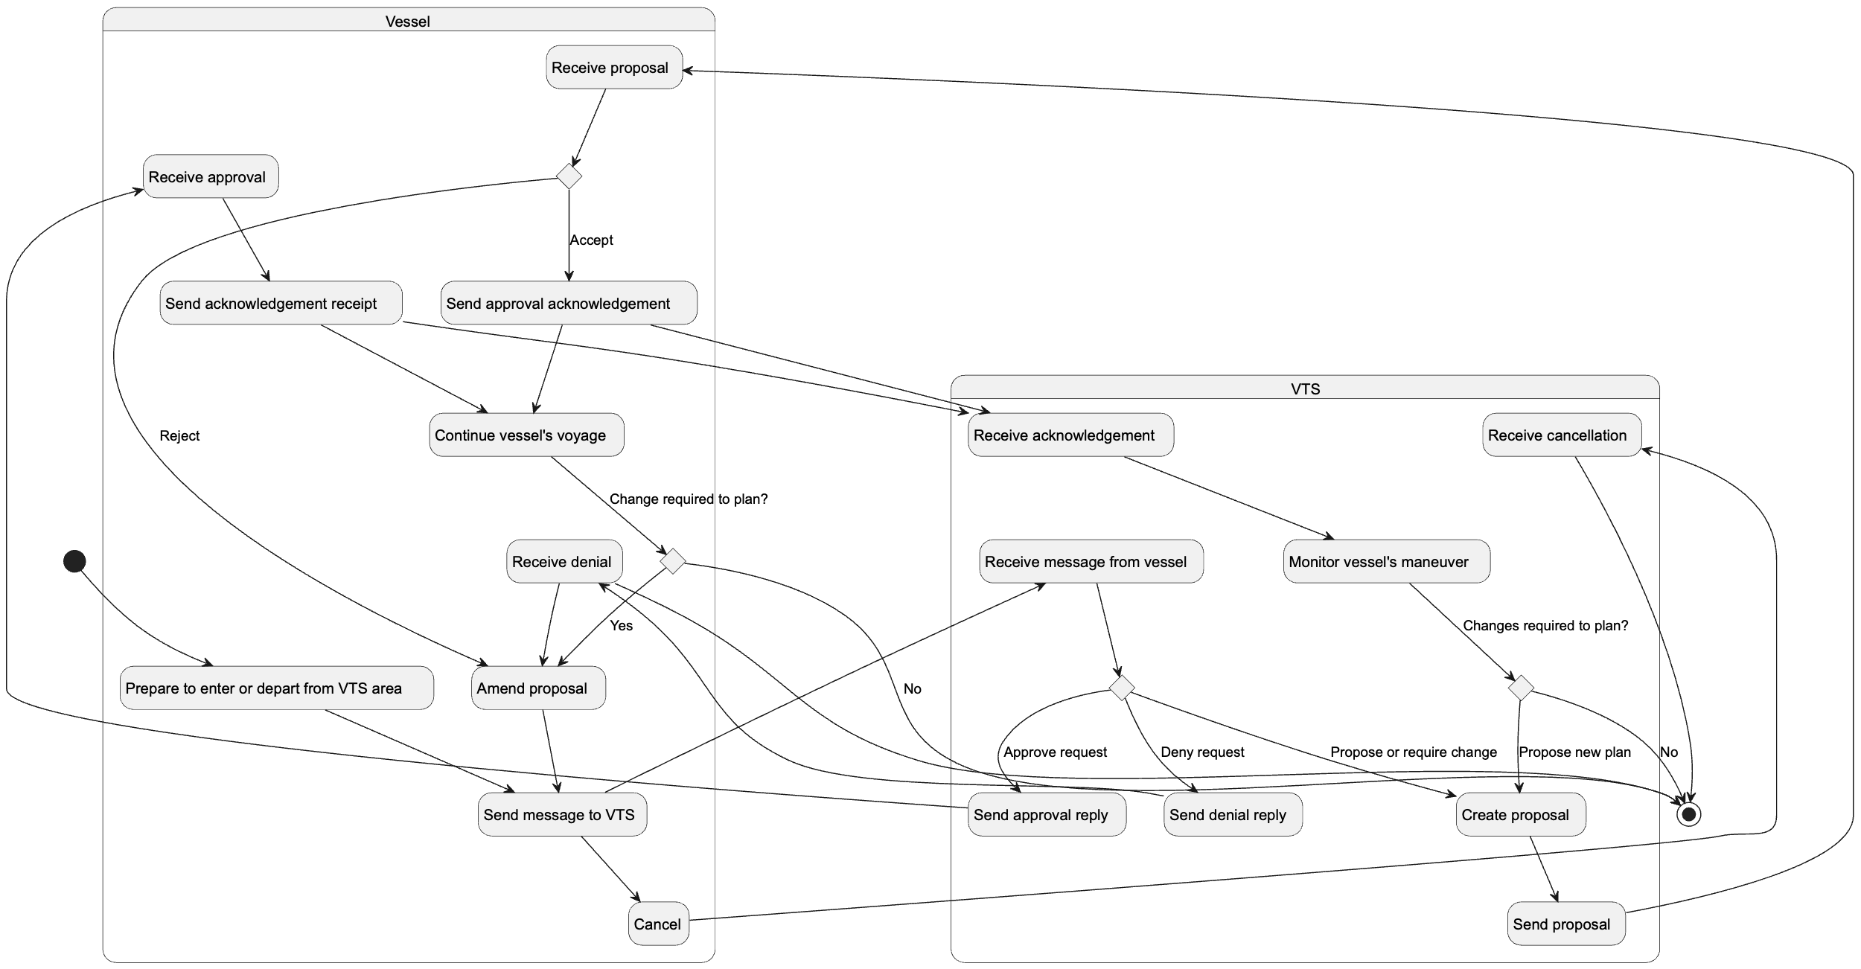
Figure 2 Traffic Clearance dataflow

The business process of a traffic clearance request

The following diagram illustrates the business process of a traffic clearance request and describes the allowed statuses of the request:
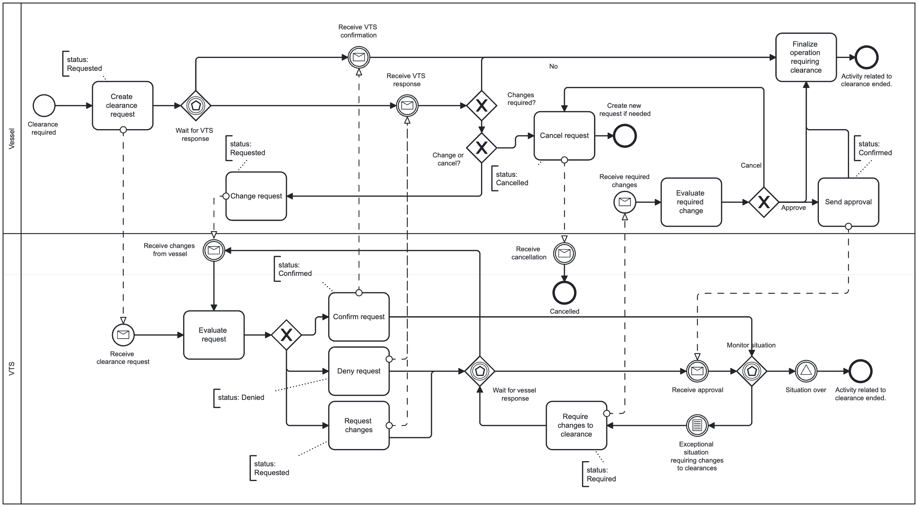
Figure 3 Traffic Clearance Business Process

Functional and non-functional requirements

For the sake of brevity, any reference in use cases to estimated time of arrival/departure (ETA/ETD) may either be estimated or planned time of arrival/departure (PTA/PTD). If the VTS send a request for a time it is always requested time of arrival/departure (RTA/RTD).

Functional requirements
Requirement ID | TCSF001
Requirement Name | Receive ETA from vessel
Requirement Text | A vessel must be able to send its estimated time of arrival (ETA) to the service. The service must have the ability to forward the received ETA to the VTS System.  The ETA may refer to arrival to VTS area, berth, anchoring or passing through a VTS area and may refer to a specified location, moving between specified locations or a geographical location referred to with a geometry.
Rationale | Sending the ETA of the vessel to the service is a core requirement of the service. In most cases the ETA sent will be the ETA to port, but it could be any ETA that is needed to communicate between the vessel and VTS.
Author

Requirement ID | TCSF002
Requirement Name | Receive ETD from vessel
Requirement Text | A vessel must be able to send its estimated time of departure (ETD) to the service. The service must have the ability to forward the received ETD to the VTS System.  The ETD may refer to leaving from VTS area, berth, anchoring or passing through a VTS area and may refer to a specified location, moving between specified locations or a geographical location referred to with a geometry.
Rationale | Sending the ETD of the vessel to the service is a core requirement of the service. In most cases the ETD sent will be the ETD from port, but it could be any ETD that is needed to communicate between the vessel and VTS.
Author

Requirement ID | TCSF003
Requirement Name | Send RTA proposal to vessel from VTS
Requirement Text | The service must facilitate the sending of an RTA proposal from VTSs to the vessel. The proposal may be a part of a rejection of an ETA request from a vessel or standalone. If the proposal is a part of a rejection, the rejection message must be identified.  The RTA may refer to arrival to VTS area, berth, anchoring or passing through a VTS area and may refer to a specified location, moving between specified locations or a geographical location referred to with a geometry.
Rationale | When VTS personnel are either reviewing a sent ETD from a vessel or trying to organize traffic and need to suggest an RTD to a vessel the service must be able to send an RTD proposal to the vessel.
Author

Requirement ID | TCSF004
Requirement Name | Send RTD proposal to vessel from VTS
Requirement Text | The service must facilitate the sending of an RTD proposal from VTS to the vessel. The proposal may be a part of a rejection of an ETD request from a vessel or standalone. If the proposal is a part of a rejection, the rejection message must be identified.  The RTD may refer to leaving from VTS area, berth, anchoring or passing through a VTS area and may refer to a specified location, moving between specified locations or a geographical location referred to with a geometry.
Rationale | When VTS personnel are either reviewing a sent ETD from a vessel or trying to organize traffic and need to suggest an RTD to a vessel the service must be able to send an RTD proposal to the vessel.
Author

Requirement ID | TCSF005
Requirement Name | Approve ETA/ETD from vessel
Requirement Text | The service must facilitate the sending of the acceptance of the ETA/ETD from the vessel without the need to negotiate the time. The approval may also include a new or changed location to which the ETA/ETD is defined.
Rationale
Author

Requirement ID | TCSF006
Requirement Name | Send RTA / RTD proposal from VTS to vessel
Requirement Text | It will be possible for VTS to send a requested time of arrival (RTA) and/or requested time of departure (RTD) to the vessel
Rationale | Even before the vessel communicates its ETA or ETD, there must be the ability to communicate a proposal RTA/RTD from VTS to a vessel.
Author

Requirement ID | TCSF007
Requirement Name | Send acknowledgement from vessel to VTS
Requirement Text | After receiving a suggested RTA/RTD from VTS to the vessel the mariner must be able to either accept the proposal and thus send an immediate acknowledgement to VTS or propose a new ETA/ETD to VTS.
Rationale | The negotiation process for a new proposed RTA/RTD may include several phases of proposed times and new counterproposals. However, a final acknowledgement must also be a part of the process so that VTS knows when vessel has approved the suggested RTA/RTD.
Author

Requirement ID | TCSF008
Requirement Name | Handle transits within a VTS area
Requirement Text | The system must allow the sending of a single message where a departure and arrival is combined to facilitate transits from one location to another within the VTS area.
Rationale | The normal situation in which this occurs is the transit of a ship from anchorage to berth or berth to berth as required by ship operations or any other source. The important fact to note is that the clearance must take place in a single interaction for both departure and approval.
Author

Requirement ID | TCSF009
Requirement Name | Handle exceptional situations
Requirement Text | When an exceptional situation occurs requiring either VTS or ship to require or request changes to an already approved plan, the system must allow the cancellation or denial of previously approved operation and proposal of new operation in a single message.
Rationale | Exceptional situations must be foreseen, and the service must be dynamic enough to allow changes to already approved plans. By allowing the cancellation/denial of an approved operation and the proposal/requirement of a new operation allows the service to react to unforeseen situations.
Author

Requirement ID | TCSF010
Requirement Name | Service integration with VTS System
Requirement Text | The service must integrate with the VTS System so that the information received from vessels can be utilized by the VTS System.
Rationale | The exact details of how this requirement are fulfilled are left to each implementer as they depend on the functionalities of the VTS System itself. In some cases, it may be better for the VTS System to poll the service, in other cases an event may be triggered, or a simple API call on the VTS System may be used. From the perspective of this specification the implementation details of how the service integrates with the VTS System can be left open.
Author

Requirement ID | TCSF011
Requirement Name | Requirements for identities
Requirement Text | The service must have a valid maritime identity. See Guideline G1183 [8]  A consumer must have a valid maritime identity.  The maritime identity certificate must include the vessel’s MMSI and IMO number and they must match with the IMO number specified in the MRN set to the vesselId attribute. If vessel does not have an IMO number then MMSI is allowed to be used. If the certificate information and the identifying information in the clearance message do not match an error must be returned and no further processing of the cleareance message is allowed.
Rationale | The consumer must be able to verify the identity of the service and its provider. The consumer must reject any connections from a service that does not have a valid maritime identity.  The service must require verification of the identity of the consumer and must decline service if a valid identity is not provided or if the identity provided does not match the metadata of the clearance message.
Author

Requirement ID | TCSF012
Requirement Name | Requirements for authenticity
Requirement Text | The consumer must be able to verify the authenticity of the clearance message from the originator of the message (VTS system or this service) to the actual consumer application (e.g. on-board system). This requires that if the communication between the service and the end-user application is not direct, the signature of the route is also delivered to the consumer application hand in hand with the clearance message.  The service must be able to verify the authenticity of the clearance message from the actual vessel it identifies. Thus, the clearance message must be signed with the signature of the same vessel it is from and the signature must be delivered to the service.
Rationale | ECDIS is mandated to verify the authenticity of all incoming external data. The same requirement generally applies to all devices in the protected ship network. Thus the signature of a received clearance message must be delivered to the on-board system hand in hand with the clearance message. See IACS UR E27 section 4.2.6 [7]  VTS systems and other end users of clearance messages must also be able to verify that the clearance message they receive actually originates from the ship identified so that spoofing or any other kinds of bad actions from third parties can be prevented.
Author

Requirement ID | TCSF012
Requirement Name | Requirements for retrying operations
Requirement Text | All sending of clearance messages and acknowledgments must be automatically retried if the initial transmission fails. The retries must be done frequently for the first minute after which a reduced frequency is allowed for the next five (5) minutes. If transmission is not successful during that time a user notification in the end user system is required and the user must be able to cancel the transmission.  This applies to both on-board system and VTS system.  The actual frequencies and methods of retries are left to be defined in the service design.
Rationale | As sending and receiving clearance messages is operationally important, the transmission of clearance messages and acknowledgments must be ensured.
Author

Requirement ID | TCSF013
Requirement Name | Requirements for encryption
Requirement Text | All communication between service and consumer must be encrypted during transport (transport layer encryption).  Additional payload encryption is not supported in the context of this service.
Rationale | IACS UR E27 [7] requires the use of encryption between on-board systems and shore-based systems.  Payload encryption is not required in the scope of traffic clearance messages.
Author

Requirement ID | TCSF014
Requirement Name | Service discovery
Requirement Text | The service must be listed in a maritime service registry so that it is discoverable by consumers. See [9] for use cases.
Rationale | The distributed nature of the maritime service domain requires that consumers have the ability to discover compatible maritime services to be able to discover new services that have been made available.
Author

Non-functional requirements

Requirement ID | TCSNF001
Requirement Name | Integrity
Requirement Text | It must be clear to both service provider and consumer whether changes have been made to the information after the dataset was created. All messages must be signed with the correct certificates so that the contents of a message can be validated. The technical designs must describe how this is managed.
Rationale
Author

Requirement ID | TCSNF002
Requirement Name | Availability
Requirement Text | The service must always be available with the ability defined by Owner of the service to deliver traffic clearance information to its consumers. The technical designs must describe how this is managed.
Rationale | The service must be available based on the VTS Service hours.
Author

Requirement ID | TCSNF003
Requirement Name | Performance – timeliness
Requirement Text | The service must provide a technical response to an incoming request instantly. This response is by necessity a technical delivery acknowledgement and not a business process response. This applies both to requests coming from vessels and VTS System. The technical designs must describe how this is managed.
Rationale | Especially from a vessel’s point of view it is important to get an acknowledgement that the service has received a request so that the vessel’s system does not need to try resending the request.
Author

Other constraints

Relevant Industrial Standards
- IALA Guideline G1128 ED 1.7 The Specification of E-navigation Technical Services
- IALA Guideline G1143 ED 3.1 June 2021 Unique identifiers for maritime resources (MRN)
- IHO Standard S-100 ED 5.2.0 May 2024 IHO Universal Hydrographic Data Model
- IALA S-212 0.7 (draft)

- IMO Compendium FAL.5/Circ.53 https://imocompendium.imo.org/public/IMO-Compendium/Current/index.htm

Operational nodes
Operational node | Remarks
Vessel | Participating ship that is required to participate with vessel traffic services and is sailing or expected to sail in a VTS area where there is coverage of technical service.
Mariner | In this document mariner means a person who is part of the bridge team that is responsible for the navigation of the vessel.
VTS | Vessel traffic services (VTS) means services implemented by a Government with the capability to interact with vessel traffic and respond to developing situations within a VTS area to improve safety and efficiency of navigation, contribute to the safety of life at sea and support the protection of the environment.
VTS centre | VTS centre responsible for a one or several VTS Areas for which the VTS provider is authorized to deliver vessel traffic services. A VTS centre is responsible for VTS route exchange service within its coverage area.
VTS personnel | The personnel of the VTS centre, means persons performing tasks associated with vessel traffic services, trained in vessel traffic services operations and appropriately qualified.
VTS system | The VTS system is the VTS software, hardware, communications and sensors. This excludes personnel and procedures.
Service | Implementation of the VTS Traffic Clearance Service. This is used to differentiate the service from a server as there may be multiple servers capable of accepting incoming requests / data.
Consumer | The vessel system interacting with the service. There may be a proxy server between the consumer and the service to facilitate data exchange, but the consumer can always be understood as the on-board system(s) used to interact with the service.

Service Overview

Logical operations

The following logical operations must be provided in the designs that follow this specification:
Operation | Description | Required
Operation | Description | Service | Consumer
Send message | An operation to send a message. Message may be an initial plan, proposal, or a disapproval. | X | X
Receive message | An operation that allows the receiving of messages. When message is received, and acknowledgement must be sent. | X | X
Send and Receive acknowledgement | An operation that allows the reception of an acknowledgement. | X | X
System status | For service registries and service consumers to be able to check if service is up an interface must be defined that allows the checking of service without sending a valid message. | x | x
Service registry updates | The service must be able to update its own metadata in the service registry according to the service registry definitions. This is required to maintain updated certificates in the service registry as well as to allow other automatic updates to service information. | x
Search service registry | The consumer must have a way to search a maritime service registry for traffic clearance services that it is compatible with its area of interest. |  | x

As an example, in a typical HTTP REST-based approach the send message is the HTTP request that sends the message to the recipients HTTP endpoint which serves as the receive operation. The receive acknowledgement can just as easily be the content of the HTTP response that the recipient sends in response to the request. This requires that both the vessel and ship has an HTTP server that has defined endpoints for all operations and can communicate the URLs of these endpoints to each other.

Send and receive acknowledgment
Both the service and consumer must have a method of sending and receiving acknowledgments of delivery to end systems. As many of the operations are asynchronous and may depend on multiple intermediate systems there is a need to be able to show to the end users of the systems the status of message delivery that exceeds the technical status of the initial message transfer. This interface must require the presence of the message identifier (see 4.2.2).

Logical parameters

As the logical operations are very abstract the logical parameters and response contents are part of the payload and will be described in 6. Actual parameter structures, response structures or error handling is not specified. These will be defined in more detail in the technical design documents.

Callback
For most operations initiated by the consumer a callback parameter must be present that defines how or where the service may respond to the consumer. The actual method of the callback depends on the service design.

Message identifier
In all operations where an acknowledgment is requested, a unique identifier of the message must be present that the acknowledgment can refer to. This is typically referred to as a transaction identifier, correlation id and so on.

Service Data Model

The service must consume a data model that is a direct subset of S-212.
For complete and updated documentation of the S-212 data model refer to the latest S-212 Product Specification which can be found at IALA S-200 Data modelling web site https://www.iala-aism.org/technical/data-modelling/iala-s-200-development-status/s-212/ [7]
The data transfer between service and consumers MUST always conform to the model displayed below. Fields that are optional are identified with MAY and SHOULD in the descriptions below.
This data model does not define the envelopes in which the data is sent between the ship and VTS system or the technical interface parameters. This data model does not consider response acknowledgement messages as they are technology dependent. This only defines the subset of S-212 that must be supported by the service.
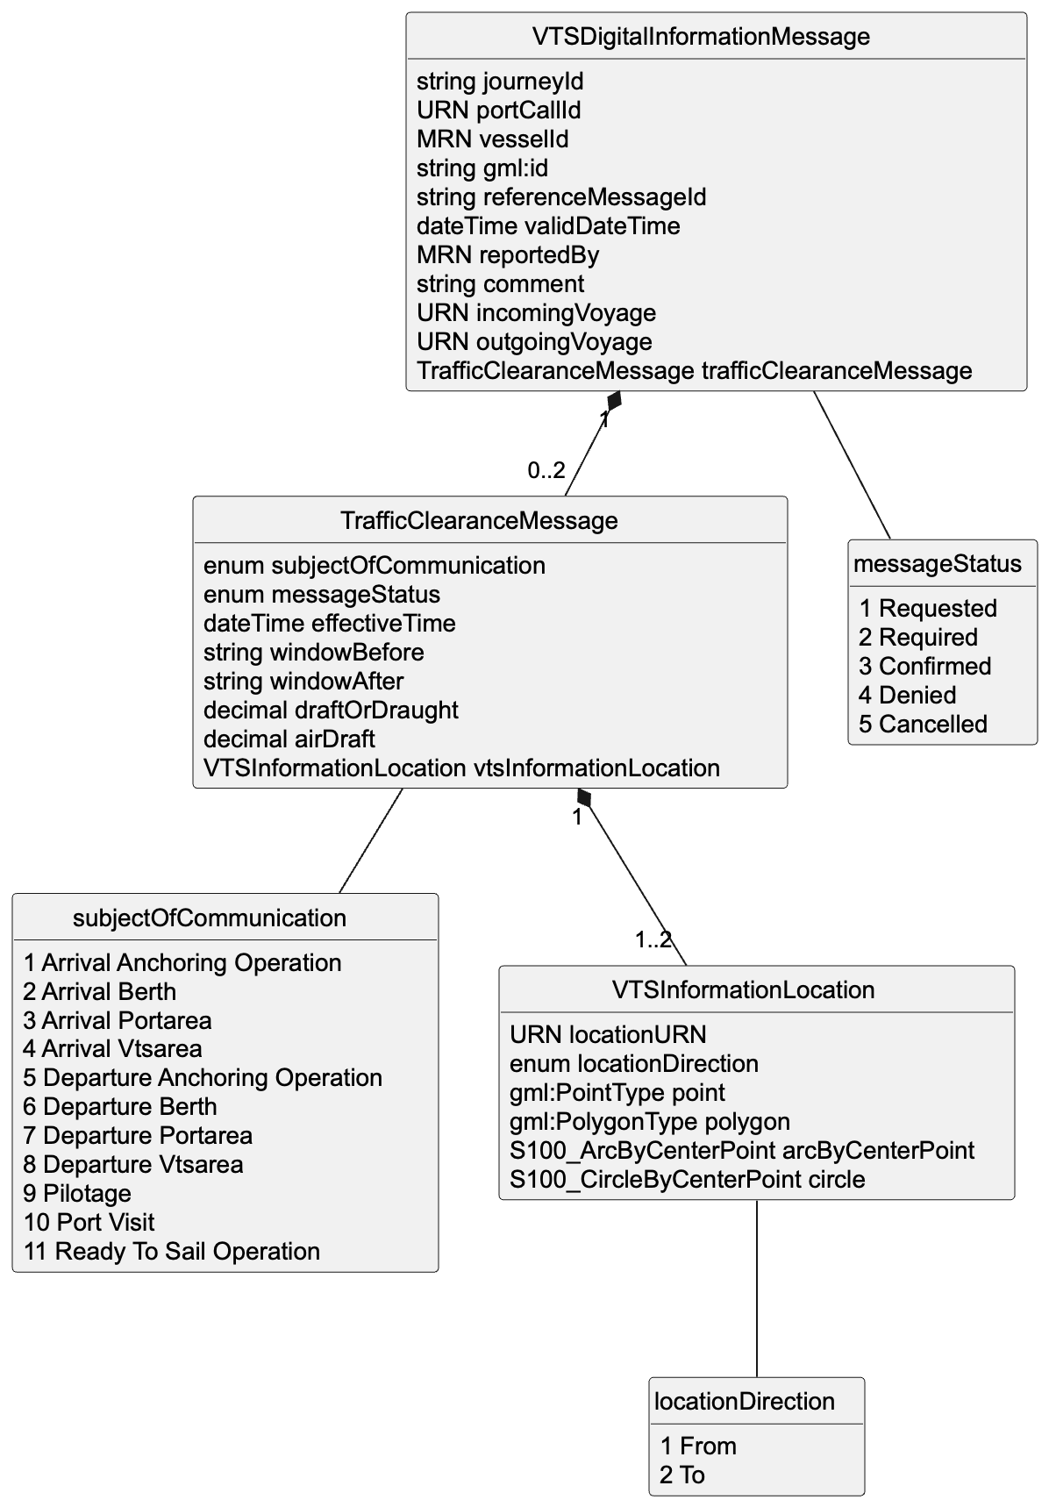
Figure 4 Traffic Clearance data model diagram
The description of the data model is as follows:
- Must be one of:
- portCallId – URN and preferred if known.
- journeyId – Only to be used if portCallId is not available. A uuid or similar unique identifier is preferred.
- vesselId – vessel MRN, IMO SHOULD is preferred, but MMSI or any other suitable identifying MRN MAY also be used.
- gml:id – UUIDv4 to uniquely identify the message across systems. Prefixed with id- to ensure xml:id requirements.
- referenceMessageId – UUIDv4, MUST be used in all messages following the first message and must refer to the message being replied to. Prefixed with id- to ensure xml:id requirements.
- validDateTime – SHOULD be used as timestamp of message creation. Implementations MAY decline any messages that do not contain this information.
- reportedBy – SHOULD be used to identify the MRN or other identity of the person sending the message, for audit trails etc. Implementations MAY decline any messages that do not contain this information.
- comment – MAY be used to pass additional information as part of the message for human consumption.
- incomingVoyage / outgoingVoyage – SHOULD be used to identify route that is shared or to ensure that all communication on a single arrival / departure is easily connected to a specific journey. When passing through a VTS area incomingVoyage is preferred. MRN is to be preferred, but validation will accept any valid URI.
- trafficClearanceMessage – must occur at least once or at most twice to allow for transitions. See 6.2 for when more than one clearance message is allowed.
- subject – Must be one of (case sensitive): Arrival Anchoring Operation, Arrival Berth, Arrival Portarea, Arrival Vtsarea, Departure Anchoring Operation, Departure Berth, Departure Portarea, Departure Vtsarea, Pilotage, Port Visit, Ready to Sail Operation
- effectiveTime – timestamp of the estimated, planned, requested time being communicated. Timestamp must have a timezone and should be given in UTC.
- windowBefore / windowAfter – MAY be used to give relative offset of the window requested / given. In hh:mm format.
- draftOrDraught – The vertical distance, at any section of a vessel from the surface of the water to the bottom of the keel. Especially useful for anchorage operations.
- airDraft – the vertical distance from the highest section of the vessel to the surface of the water.
- messageStatus – MUST be one of (case sensitive): Cancelled, Confirmed, Denied, Requested, or Required
- vtsInformationLocation – 1 to 2 instances of VTSLocation where:
    - one of:
      - gml:point
      - gml:polygon
      - S100_ArcByCentrePoint
      - S100_CircleByCentrePoint
      - locationURN – preferably a MRN but may be any valid URN
    - locationDirection – semantically correct option from enumeration. When passing through a location the entry and exit locations of the area should be defined.

Service Dynamic Behaviour

This section describes the interactive behaviour of the traffic clearances between ship and shore.
Before the exchange of information is initiated, the message recipient retrieves the identity of the service sender from the service infrastructure and performs an authentication procedure. If not authenticated, the service request is rejected. The specific authentication procedure is out of scope of the service specification and is described in the technical designs of this service. Thus, the following diagrams do not describe these steps.

The allowed use of different clearance statuses

The following requirements are placed on statuses:
- Requested – may be used by both vessel and VTS. Describes that this clearance is still under discussion.
- Cancelled – may only be sent from the vessel. This ends the clearance process and any new clearance must be requested as a new clearance message without a referenceMessageId field.
- Confirmed – may be sent by both vessel and VTS. After a confirmed is sent, the recipient does not need to answer with a confirmed message.
- Denied – may only be sent by VTS. If this is received as a single clearance message the vessel must either send a modified clearance request (status: requested) in the same conversation or cancel the clearance request entirely (status: cancelled).
- Required – may only be sent by VTS. In this case the message sent to by VTS should also have a denied clearance message that denies the previous clearance. This is reserved for use in exceptional situations (see use case 6).

Multiple clearance messages in a single request

A clearance request may have several clearance messages in only the following situations:
- An exceptional situation occurs and VTS denies previously granted clearance and requires a new action (described in use case 6).
- The clearance is dependent on another clearance and both clearances must be processed at the same time, e.g. departing anchorage and arriving in berth. In this case the status of the clearance messages must be identical throughout the clearance process. If statuses do not match, the recipient of the message must respond with an error.

Acknowledgement messages

The sequence diagrams below have multiple references to acknowledgments being sent of delivery to end systems (ship or VTS system) or opening of the message (clearance message). This is due to the asynchronous and multi-hop nature of the communication where the technical transmission of a message from one component to another does not always signify the successful transmission of the message from one end system to another.
Thus, the sequence diagrams show and prescribe when acknowledgments must be sent either on the successful delivery of the clearance message to the end system or of the opening of the clearance message by a user. If the received clearance message is automatically displayed on VTS or on-board systems, the opened acknowledgment can only be sent after the user has in some way interacted with the clearance message.

Sequence diagrams

The following diagrams contain variations of the use cases described above and do not cover every single option of looping through multiple steps of negotiation for the different operations that are supported. They are intended to capture and describe the required changes in the messages that support all of the functionalities that the use cases require.
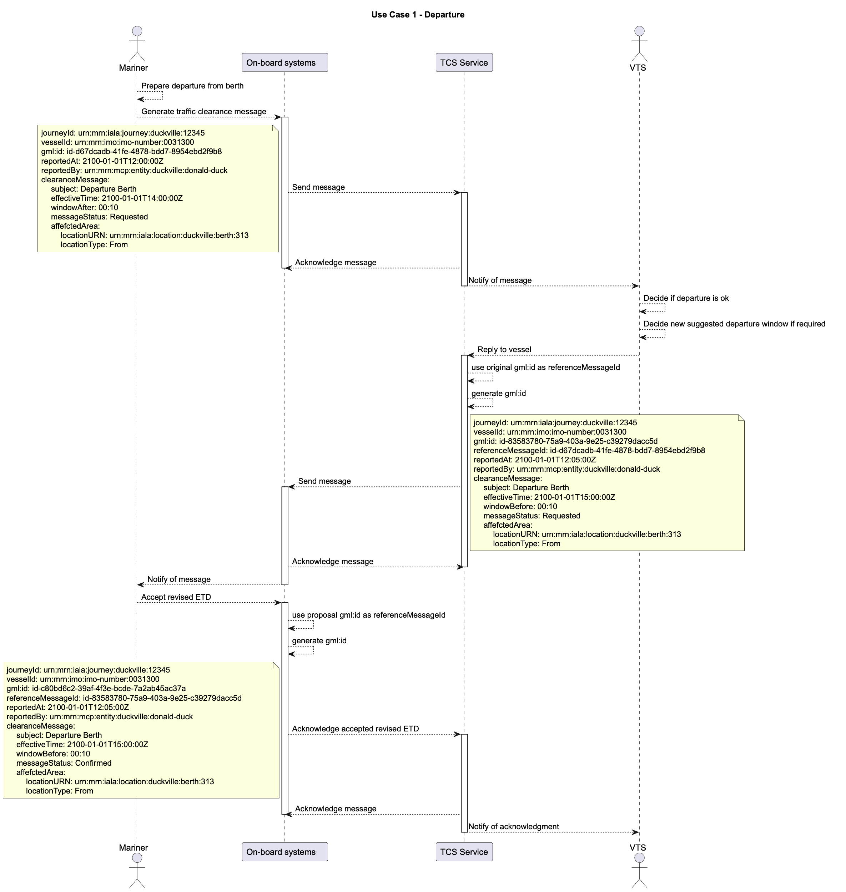
Figure 5 Use case 1 sequence diagram
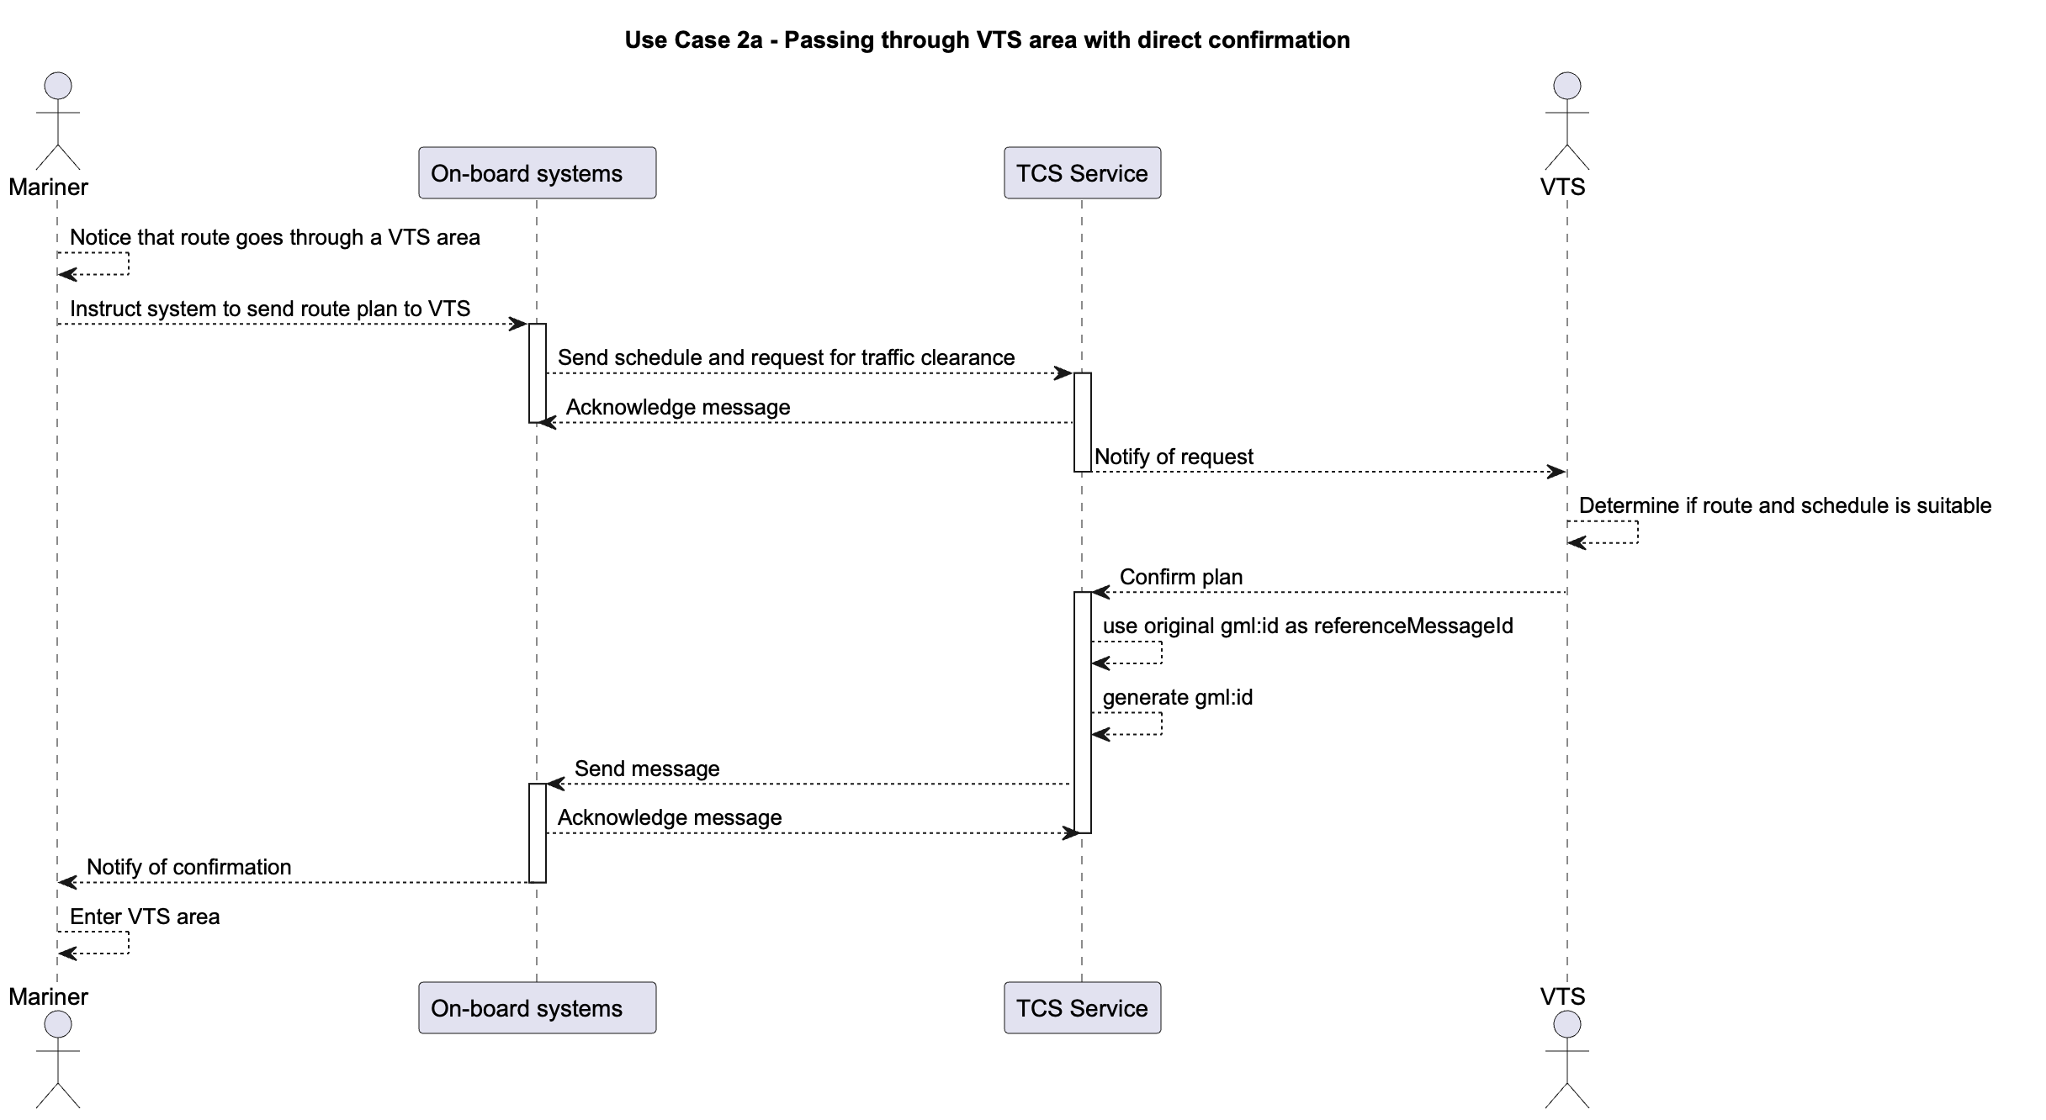
Figure 6 Use Case 2 variation 1 sequence diagram
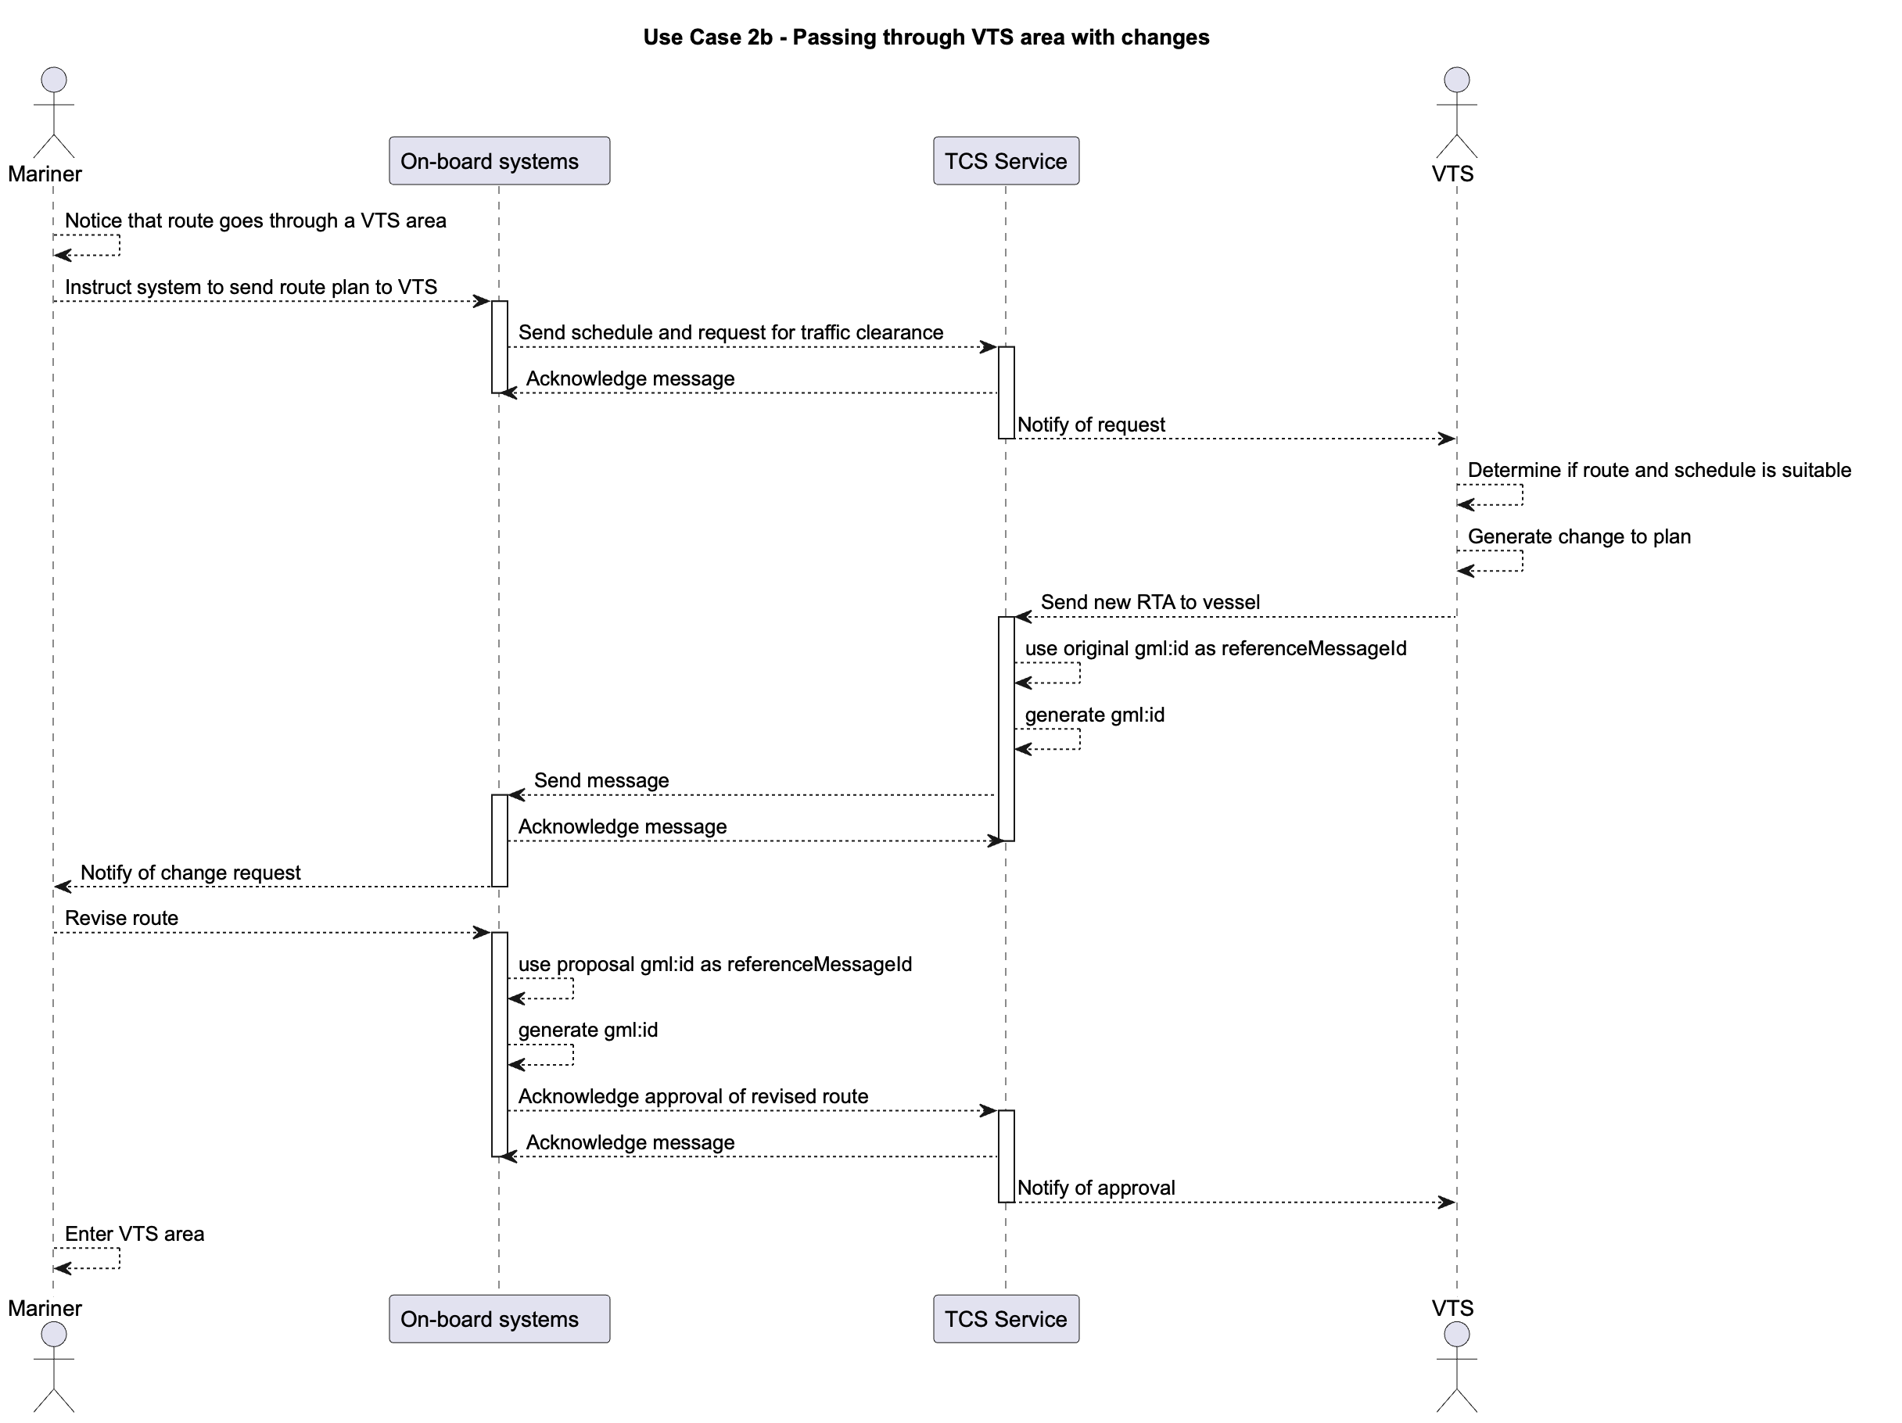
Figure 7 Use Case 2 variation 2 sequence diagram
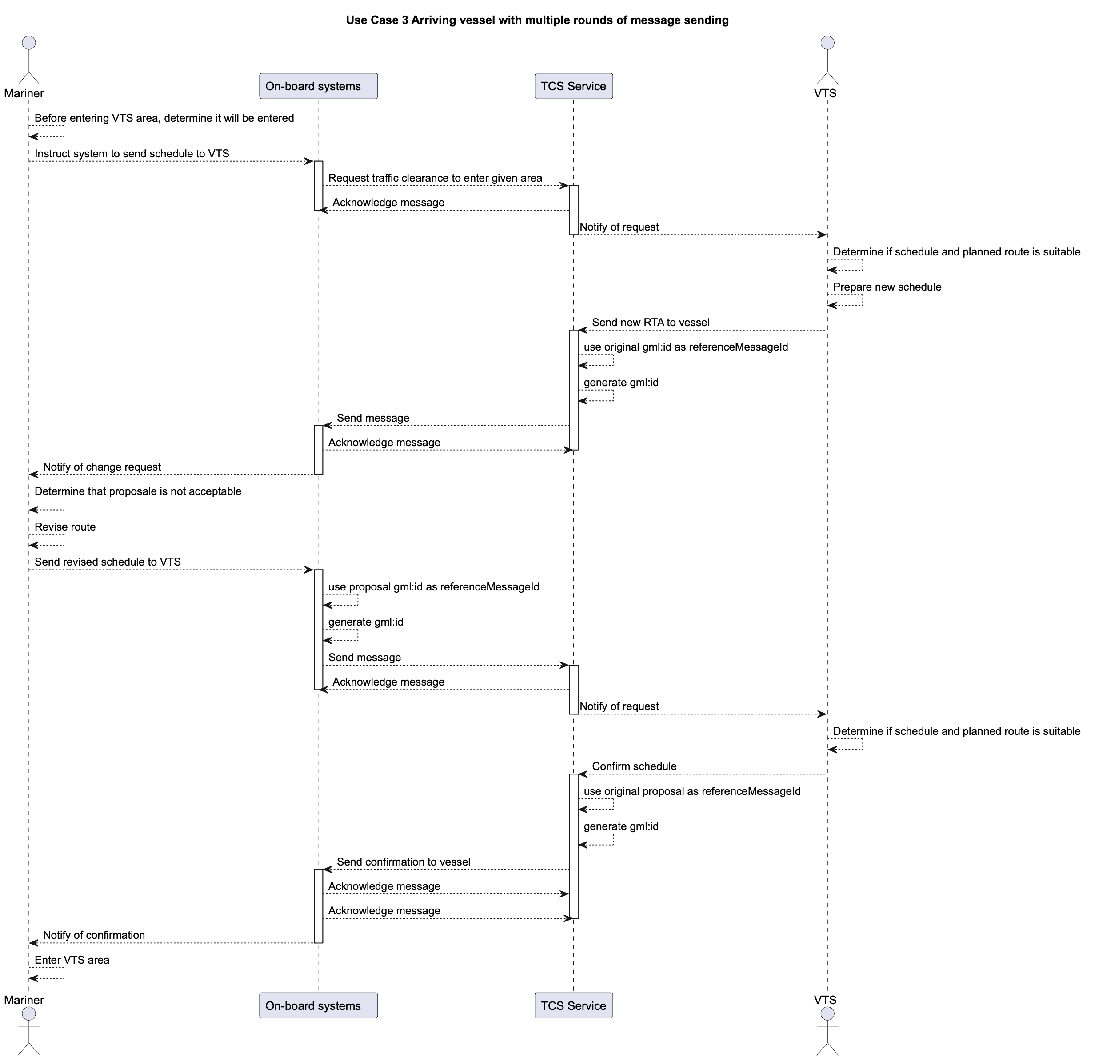
Figure 8 Use Case 3 sequence diagram
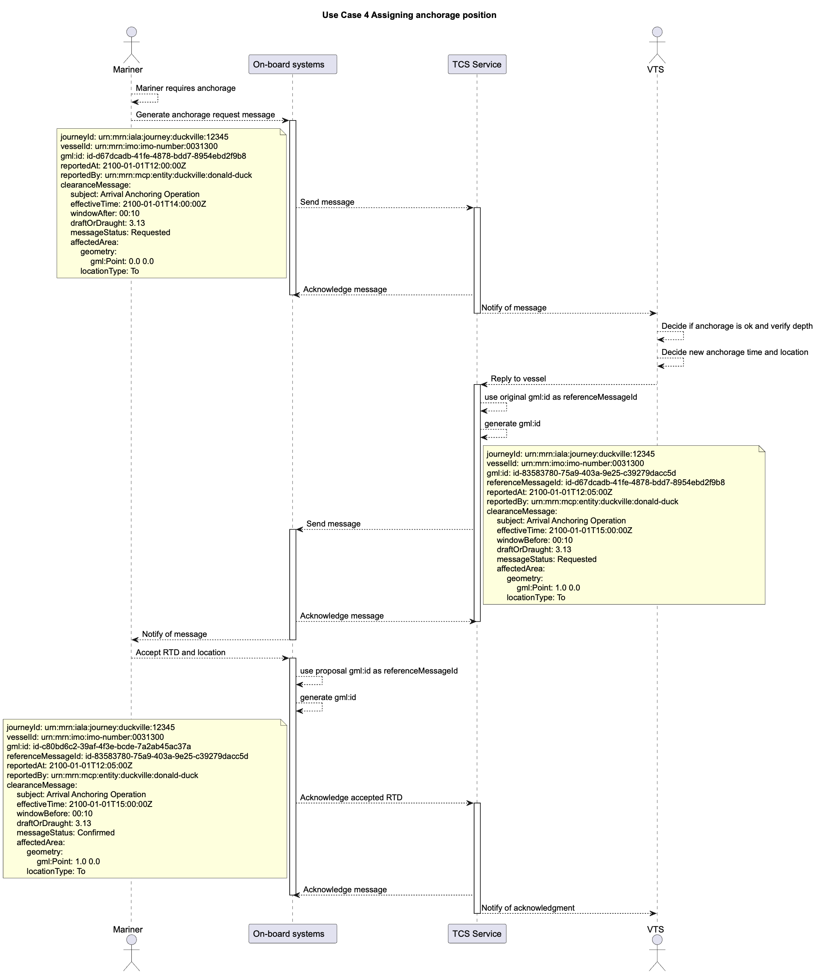
Figure 9 Use Case 4 sequence diagram
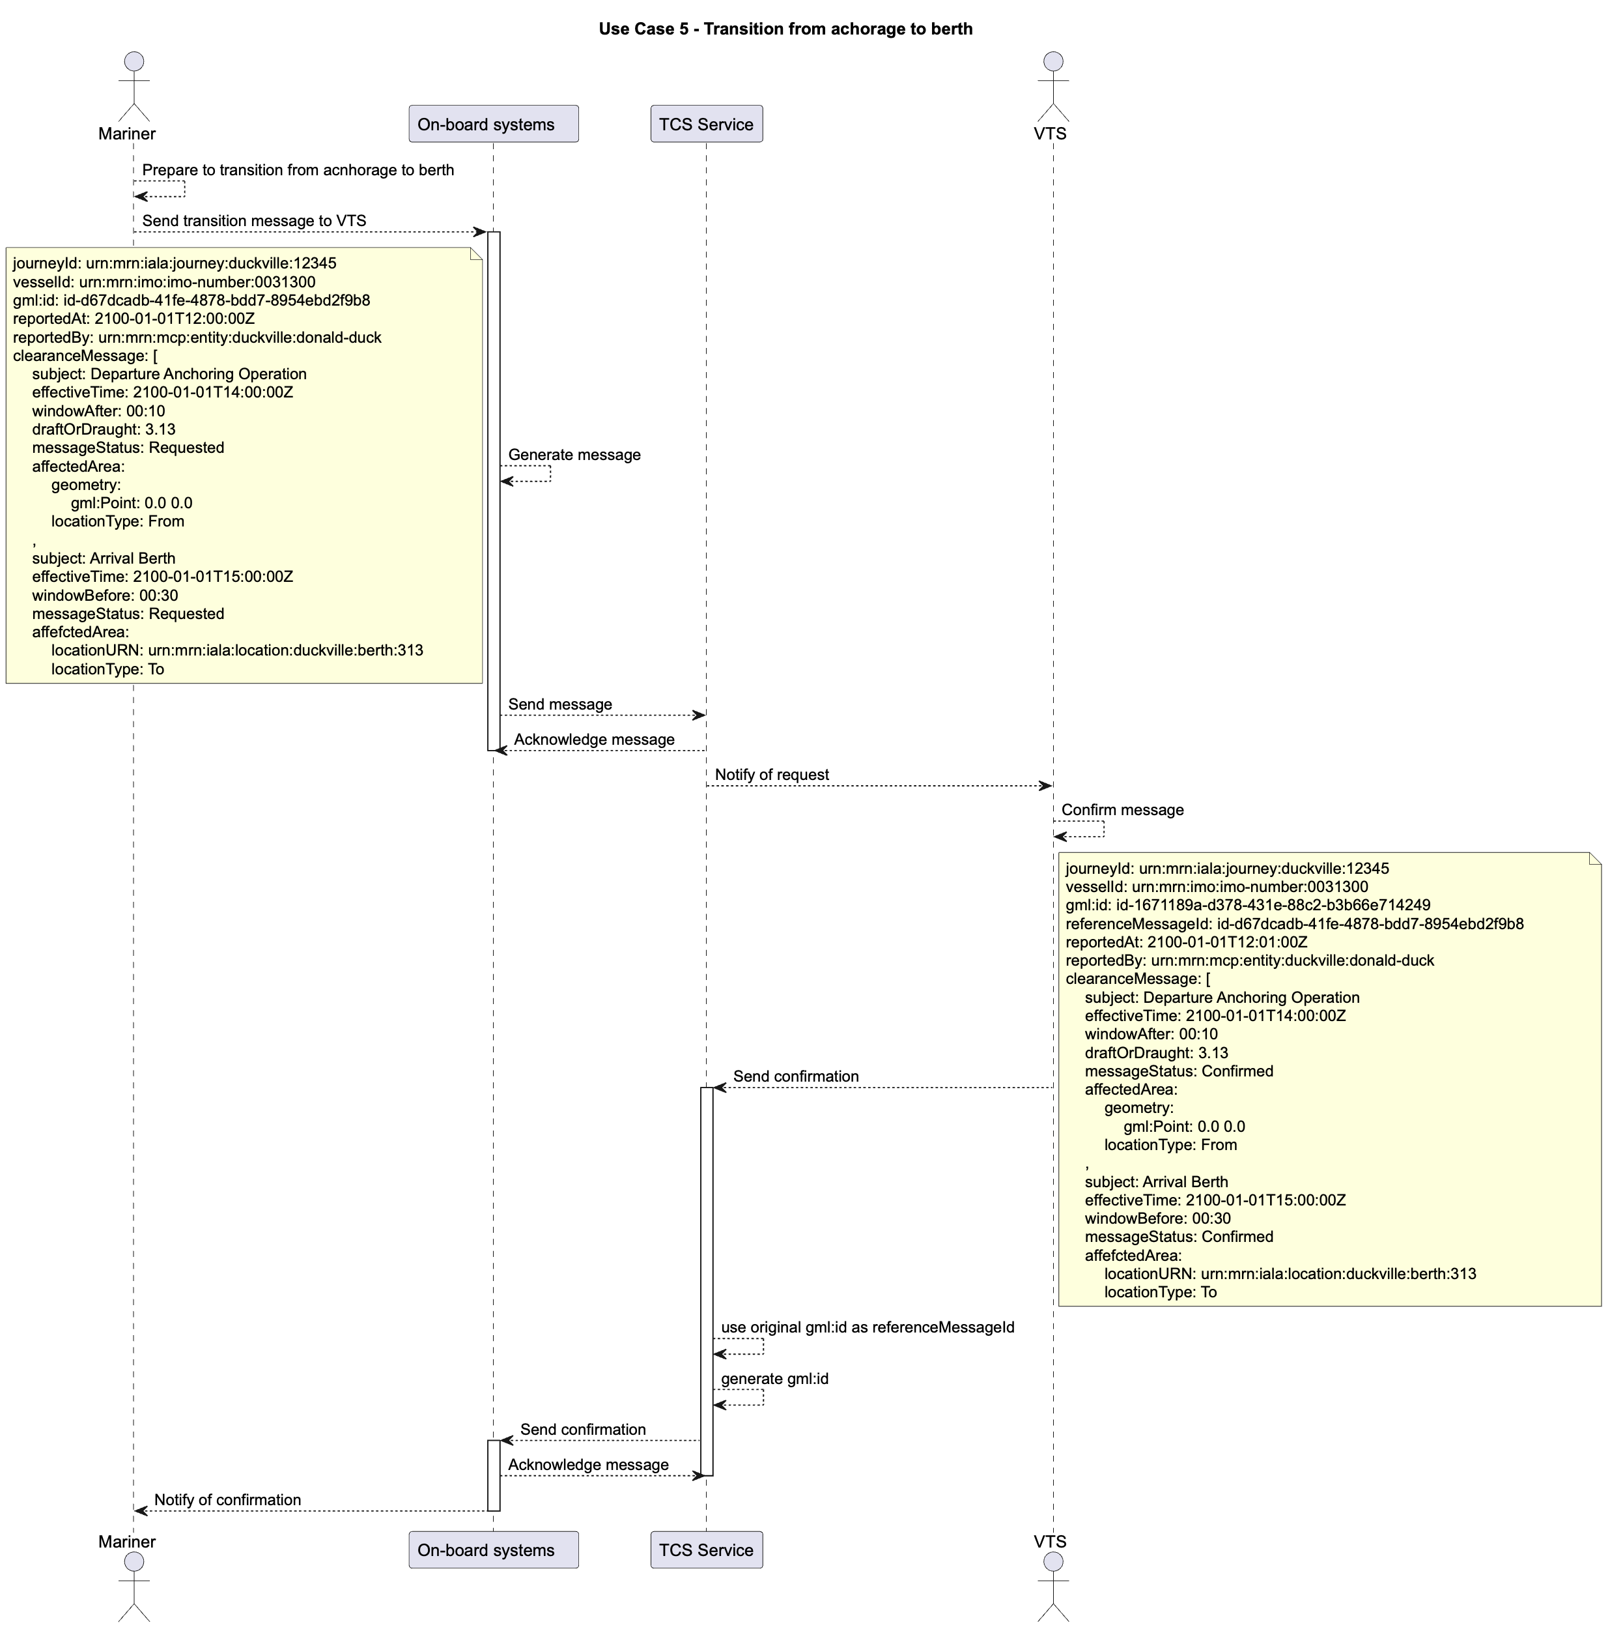
Figure 10 Use Case 5 sequence diagram

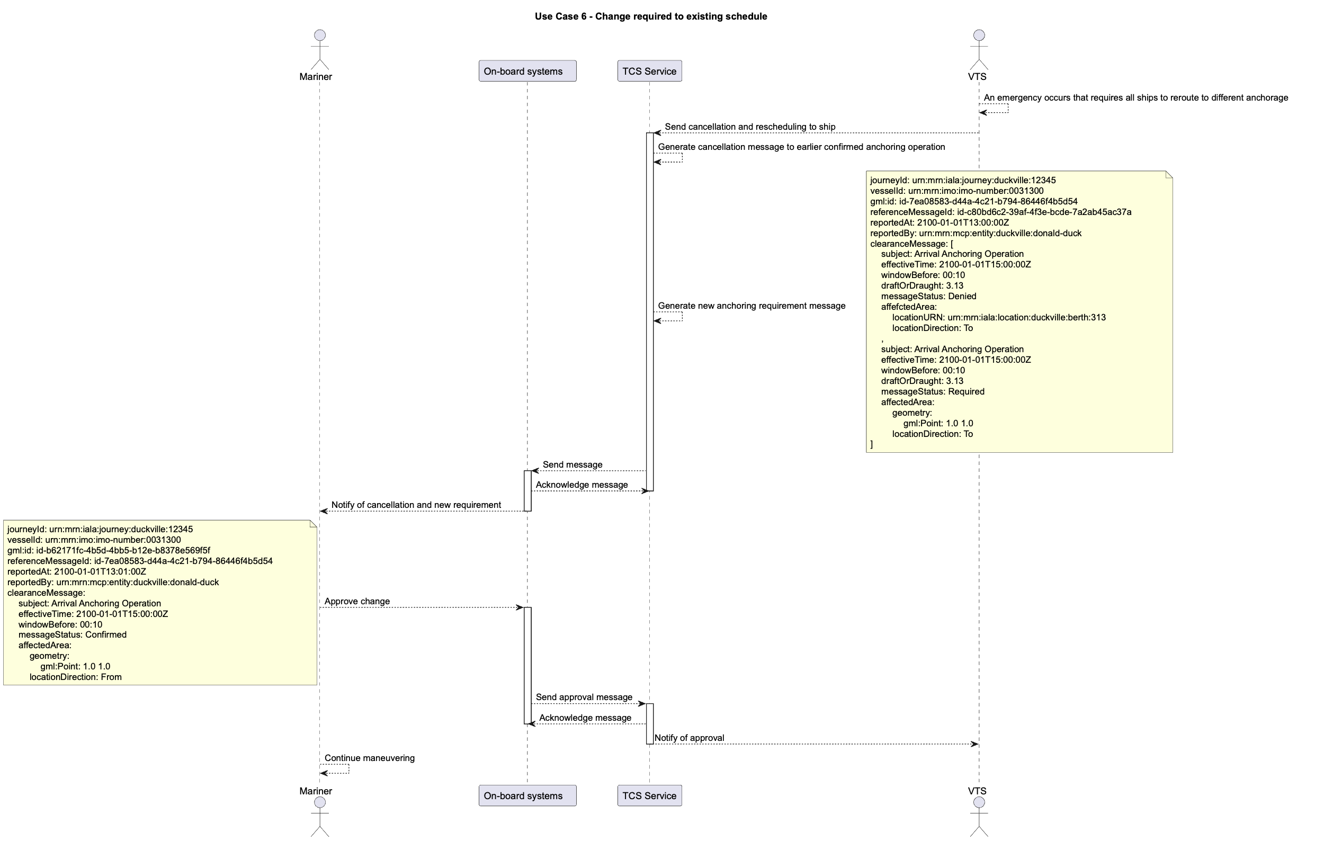
Figure 11 Use Case 6 sequence diagram

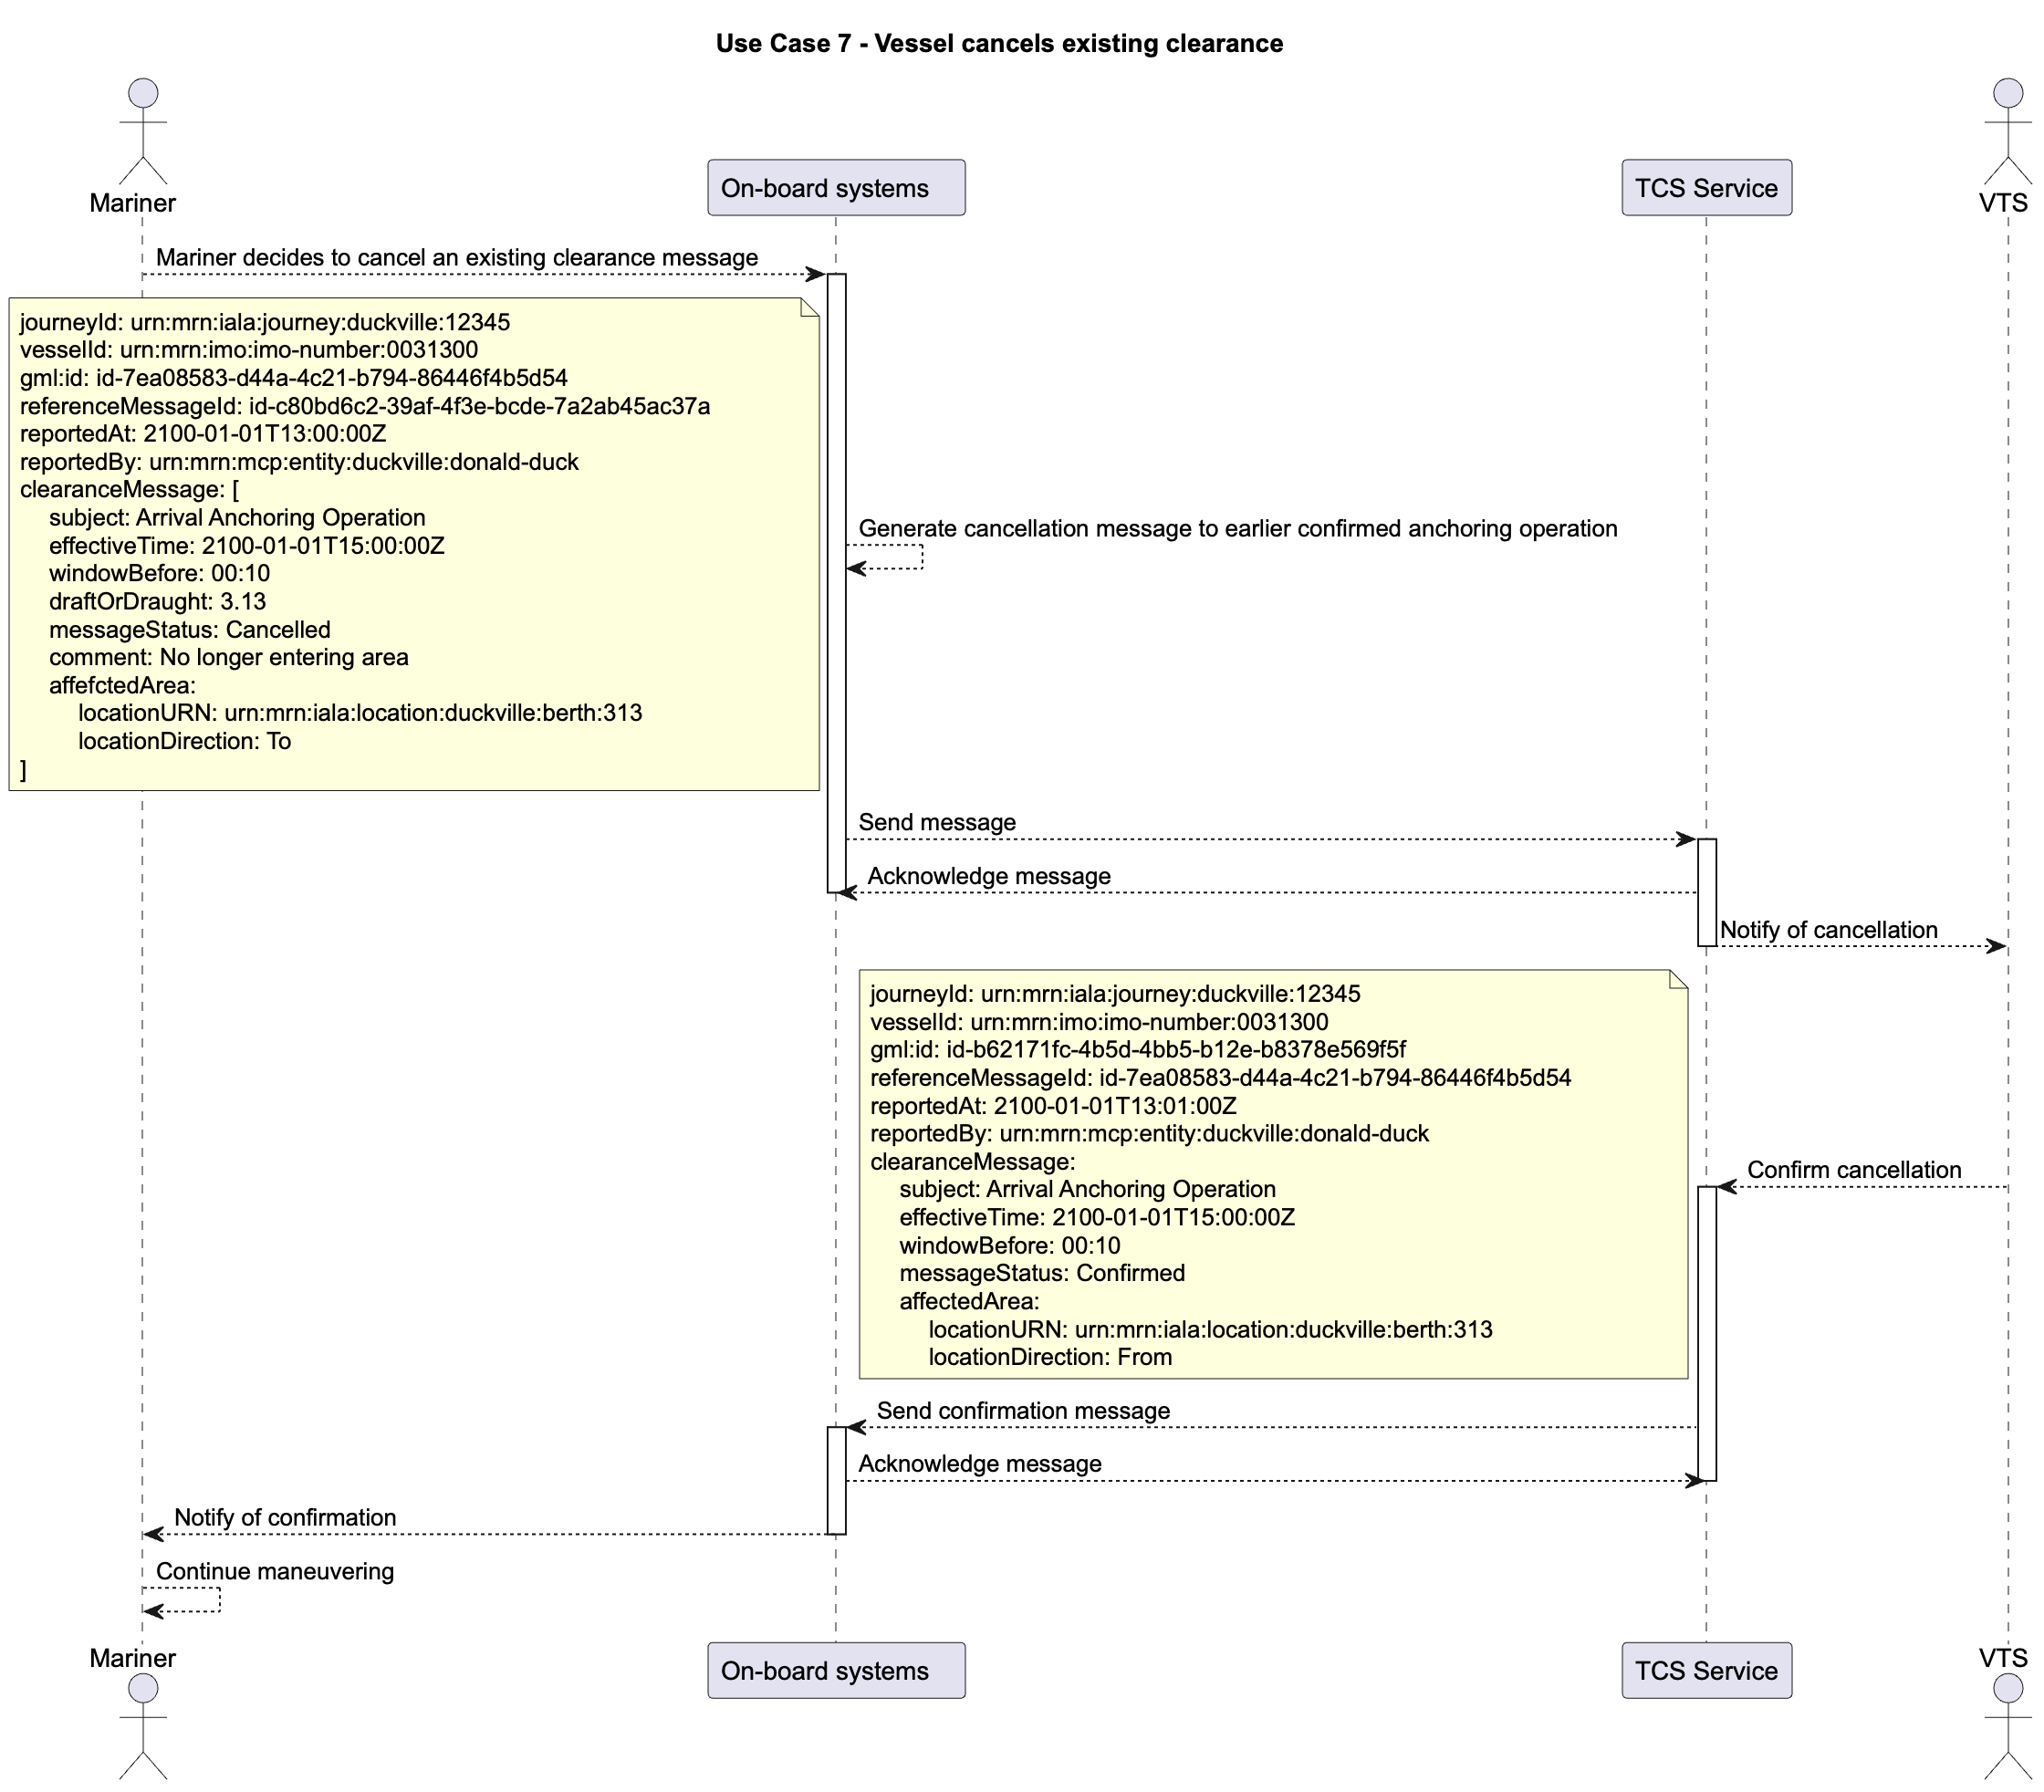
Figure 12 Use Case 7 sequence diagram

Definitions

Operational Node | A logical entity that performs activities. Note: nodes are specified independently of any physical realisation.  Examples of operational nodes in the maritime context are: Maritime Control Centre, Maritime Authority, Ship, Port, Weather Information Provider, etc.
Service | The provision of something (a non-physical object), by one, for the use of one or more others, regulated by formal definitions and mutual agreements. Services involve interactions between providers and consumers, which may be performed in a digital form (data exchanges) or through voice communication or written processes and procedures.
Service Consumer | A service consumer uses service instances provided by service providers. All users within the maritime domain can be service customers, e.g., ships and their crew, authorities, VTS centres, organizations (e.g., meteorological), commercial service providers, etc.
Service Data Model | Formal description of one dedicated service at logical level. The service data model is part of the Service Specification. Is typically defined in UML and/or XSD. If an external data model exists (e.g., a standard data model), then the service data model shall refer to it: each data item of the service data model shall be mapped to a data item defined in the external data model.
Service Interface | The communication mechanism of the service, i.e., interaction mechanism between service provider and service consumer. A service interface is characterised by a message exchange pattern and consists of service operations that are either allocated to the provider or the consumer of the service.
Service Operation | Functions or procedure which enables programmatic communication with a service via a service interface.
Service Physical Data Model | Describes the realisation of a dedicated service data model in a dedicated technology. This includes a detailed description of the data S-212 to be exchanged using the chosen technology. The actual format of the service physical data model depends on the chosen technology. Examples may be WSDL and XSD files (e.g., for SOAP services) or swagger (Open API) specifications (e.g., for REST services). If an external data model exists (e.g., a standard data model), then the service physical data model shall refer to it: each data item of the service physical data model shall be mapped to a data item defined in the external data model.  In order to prove correct implementation of the service specification, there shall exist a mapping between the service physical data model and the service data model. This means, each data item used in the service physical data model shall be mapped to a corresponding data item of the service data model. (In case of existing mappings to a common external (standard) data model from both the service data model and the service physical data model, such a mapping is implicitly given.)
Service Provider | A service provider provides instances of services according to a Service Specification and service instance description. All users within the maritime domain can be service providers, e.g., authorities, VTS centres, organizations (e.g., meteorological), commercial service providers, etc.

Abbreviations

API Application Programming Interface
MRN Maritime Resource Name
RTA/RTD Requested time of arrival/departure
URI Uniform Resource Identifier
UUID Universally Unique Identifier v4
XML Extendible Mark-up Language
XSD XML Schema Definition

References

- IALA. 2024. Guideline G1128 The Specification of e-Navigation Technical Services

- IALA. (draft) Data model S-212 IALA VTS Digital Information Service Product Specification https://www.iala-aism.org/technical/data-modelling/iala-s-200-development-status/s-212/
- IALA. 2022. Guideline G1183 Provision of MCP Identities

- IALA. 2026. Guideline G1191 Maritime Service Registry (MSR) Technical Specification
- IMO Just in Time Arrival Guide Unversioned https://wwwcdn.imo.org/localresources/en/OurWork/PartnershipsProjects/Documents/GIA-just-in-time-hires.pdf
- IALA. 2026. Use Cases on VTS Digital Communications https://www.iala.int/technical/vts-digital-communication/

Author to insert actual service name and version number

