ialA Technical service

SS0002
Service Specification for VTS - Vessel Route Exchange


Edition 1.2
March 2026

urn:mrn:iala:techsvc:ss0002:1.2

Date | Details | Approval
December 2024 | First version of Service Specification Annex to accompany Guideline G1128
April 2025 | Edition 1.0.1 Editorial changes applied to align the content with the official document format. | Secretariat
September 2025 | Changes based on proposed changes in upcoming versions of SECOM and S-421 in IEC. Clarifications based on global review.
March 2026 | Added section 5.6

1 introduction 6
1.1 Purpose 6
1.2 Intended readership 6
1.3 Input from other sources 6
2 Service Identification 7
3 Operational context 8
3.1 Use cases for VTS – Vessel Route Exchange 9
3.1.1 Use case 1 - Initial sharing of the route from Vessel to VTS 9
3.1.2 Use case 2 - VTS gives route recommendation to vessel within a geographically defined area 10
3.1.3 Use case 3 - VTS requests route updates from vessel 11
3.1.4 Use case 4 – Vessel’s route changes 11
3.1.5 Use case 5 – Vessel does not arrive to VTS area as planned 12
3.1.6 Use case 6 - VTS acknowledges the route with help from other services 12
3.1.7 Use case 7 - VTS personnel acknowledge the route without the use of other services 12
3.1.8 Use Case 8 - VTS sends route back with comments 13
3.1.9 Use Case 9 - Vessel gets multiple changes to their route 13
3.1.10 Use case 10 - VTS requests route from vessel 13
3.1.11 Use Case 11 – Route exchange with the use of automated services 14
3.1.12 Use Case 12 – Update route status from planning to monitoring 14
3.1.13 Use Case 13 – Route retrieval from VTS route library 15
3.1.14 Use case 14 – Vessel can discover compatible route services 15
3.1.15 Use Case 15 – VTS requests route after it has been shared 16
3.2 Data flows 16
3.3 Functional and non-functional requirements 18
3.3.1 Functional requirements 18
3.3.2 Non-functional requirements 26
3.4 Other constraints 27
3.4.1 Relevant Industrial Standards 27
3.4.2 Operational nodes 28
4 Service Overview 29
4.1 Logical operations 29
4.1.1 Search Service Registry 30
4.1.2 Service registry updates 31
4.1.3 System status 31
4.1.4 Send and receive acknowledgment 31
4.1.5 Send route 31
4.1.6 Receive route 31
4.1.7 Subscribe to changes 31
4.1.8 Route requests 32
4.1.9 Discovering service functionality 32
4.2 Logical parameters 32
4.2.1 Callback 32
4.2.2 Geometry 32
4.2.3 Route 32
4.2.4 Message identifier 33
4.2.5 Service discovery 33
5 Service Data Model 34
5.1 Container type 34
5.2 End-to-end verification of data 35
5.3 Changing the route edition number 35
5.4 Coordinate systems 35
5.5 Route status 35
5.6 Handling extensions 36
6 Service Dynamic Behaviour 37
6.1 Acknowledgement messages 37
6.2 Sharing of route 37
6.3 Route responses from VTS to vessel 43
6.4 Route request from VTS without a shared route 46
6.5 Route request from VTS after route has been shared 47
6.6 Using a route reference library 48
6.7 Service discovery 49
7 Definitions 51
8 Abbreviations 52
9 References 53

List of Tables
Table 1 Operational Nodes 26
Table 2 Logical interfaces 27

List of Figures
Figure 1 High-level view of route exchange use cases 8
Figure 2 Route Exchange Business Process 16
Figure 3 Abstract object model of the route plan data 33
Figure 4 Initial sharing of route 37
Figure 5 Requesting updates to route upon changes 38
Figure 6 Moving route to monitoring 39
Figure 7 Sharing route with multiple VTS 39
Figure 8 Changing route 40
Figure 9 Route cancellation 41
Figure 10 Route recommendation from VTS to vessel 43
Figure 11 Route acknowledgement by VTS 44
Figure 12 Route response from VTS to vessel with open issues 45
Figure 13 Requesting route from vessel 46
Figure 14 Requesting updated route from vessel 47
Figure 15 Route library usage flow 48
Figure 16 Service discovery flow 49

introduction

This document was produced as part of the work of IALA VTS task group on development of technical service specifications for VTS. The document is structured according to the IALA Guideline G1128 The Specification of e-Navigation Technical Services [1].

Purpose

The purpose of this Service Specification is to provide a holistic overview of the digital service of VTS – Vessel Route Exchange and its building blocks in a technology-independent way, according to the guidelines given in G1128. It describes a well-defined baseline of the service by clearly identifying the service version.
The aim is to document the key aspects of the VTS- Vessel Route Exchange at the logical level, including:
- the operational and business context of the service:
- requirements for the service (e.g., information exchange requirements);
- involved nodes: which operational components provide/consume the service;
- operational activities supported by the service; and
- relation of the service to other services.
- the service description:
- service use cases;
- service operational sequence;
- logical operations;
- logical data model; and
- dynamic behaviour.

Intended readership

This Service Specification is intended to be read by service architects, system engineers and developers in charge of designing and developing an instance of the VTS – Vessel Route Exchange.
Furthermore, this Service Specification is intended to be read by enterprise architects, service architects, information architects, system engineers and developers in pursuing architecting, designing and development activities of other related services.

Input from other sources

This service is based on the work and the use cases outlined in SECOM [6] and S-421 [5] and the outcome of the IEC TC 80 WG 17 October 2024 meeting.

When developing this service, the outcome from IEC TC 80 MT7 in their meeting in December 2024 and their work on IEC 61174-1 [9] has been taken into consideration.

Service Identification

This section provides a unique identification of the Service and describes where the Service is in the engineering lifecycle.

Name | VTS – Vessel Route Exchange Technical Service
ID | urn:mrn:iala:techsvc:ss:vts-res:1.1
Version | 1.1
Description | The VTS – Vessel Route Exchange Service specification describes a standardized service implementing the communication between ship and VTS in the exchange of routes.
Keywords | VTS, MS1, Route Exchange, Ship Traffic Management, S-421
Architect(s) | Ramin Miraftabi
Status | Ready for testing

Operational context

The route and schedule is a key element of the vessel's voyage and can be used to optimize safety and processes, as well as for the interaction of participants and stakeholders. The core element of the voyage plan is a route. The exchange of route plans between vessel and shore may improve situational awareness for the purpose to facilitate:
- reduced number of accidents and incidents by knowing the intentions of vessels by VTS;
- optimized fairway utilization by knowing the intentions of vessels;
- predictability of arrivals and departures by early information sharing enabling better planning for involved actors leading to reduced idle time for resources;
- Just-In-Time (JIT) operations by enabling stakeholders and service providers to be efficiently organized for handling vessel movements, port resources, and hinterland connections.
- VTS reporting of arrival/departure times and the specific route in the VTS area.
- One of the core means for future MASS and other highly automated vessels to communicate intentions and creating its voyage plan,
- Contributor of berth to berth navigation and JIT operations.
It its envisioned that a large number of proposed services within not only the VTS domain will need, use, compute, communicate route and schedule information such as Weather routing, Pilot Routes/passage plans, Ice navigation services, Fleet management, Remote operations, Reporting, Coastal surveillance and other use cases.
Route Exchange Service functions as a backbone facilitating the sharing of route between vessel and VTS in order to enable the following VTS services:
- Route Reference Service where VTS and other service providers offer predefined routes and waypoints, in electronic format. Route Reference Service is designed to assist mariners in their voyage planning to define the suitable route on commonly used passages, such as shipping lanes, approaches to ports, and coastal routes.
- Route Crosscheck Service which is used to validate a planned or monitored route from the vessel and compare the information with expertise of the VTS and its information regarding the specific VTS area (traffic separation, depth, speed restriction etc). When the VTS receives a route from a vessel the VTS should be able to execute a Route cross check. The cross-checking may be done before the vessel’s departure or before arrival at a certain geographical area (for example a VTS area). The cross-check may include Under Keel Clearance, air draft, no violation of no-go areas, Maritime Safety Information, compliance with mandatory routing et al.
- Route Monitoring Service which is used to monitor vessels that they stay within the planned schedule and corridor as defined in the route plan. Within this service the VTS will identify irregular vessel behaviour, such as vessels that may be deviating from their routes or schedules, allowing the VTS to intervene promptly in case of potential safety hazards and navigational issues.
In order to facilitate the route exchange from mariner or vessel, this service specification requires the use of ECDIS and the device used on board for planning (planning station) or other compatible ship systems. This service defines how the route plan exchange defined in IEC 63173-1 Annex A use cases are to be implemented in order to ensure interoperability between ship systems and VTS systems.
This service must be used directly from ship systems to communicate with VTS systems.
This service may be used to facilitate route exchange between other systems as well.

Use cases for VTS – Vessel Route Exchange

It is envisioned that many proposed services within not only the VTS domain will need, use, compute, communicate route and schedule information such as Weather routing, Pilot Routes/passage plans, Ice navigation services, Fleet management, Remote operations, Reporting, Coastal surveillance and other use cases.
To fulfil the use cases in this service, routes must conform to the requirements specified in 3.3.1
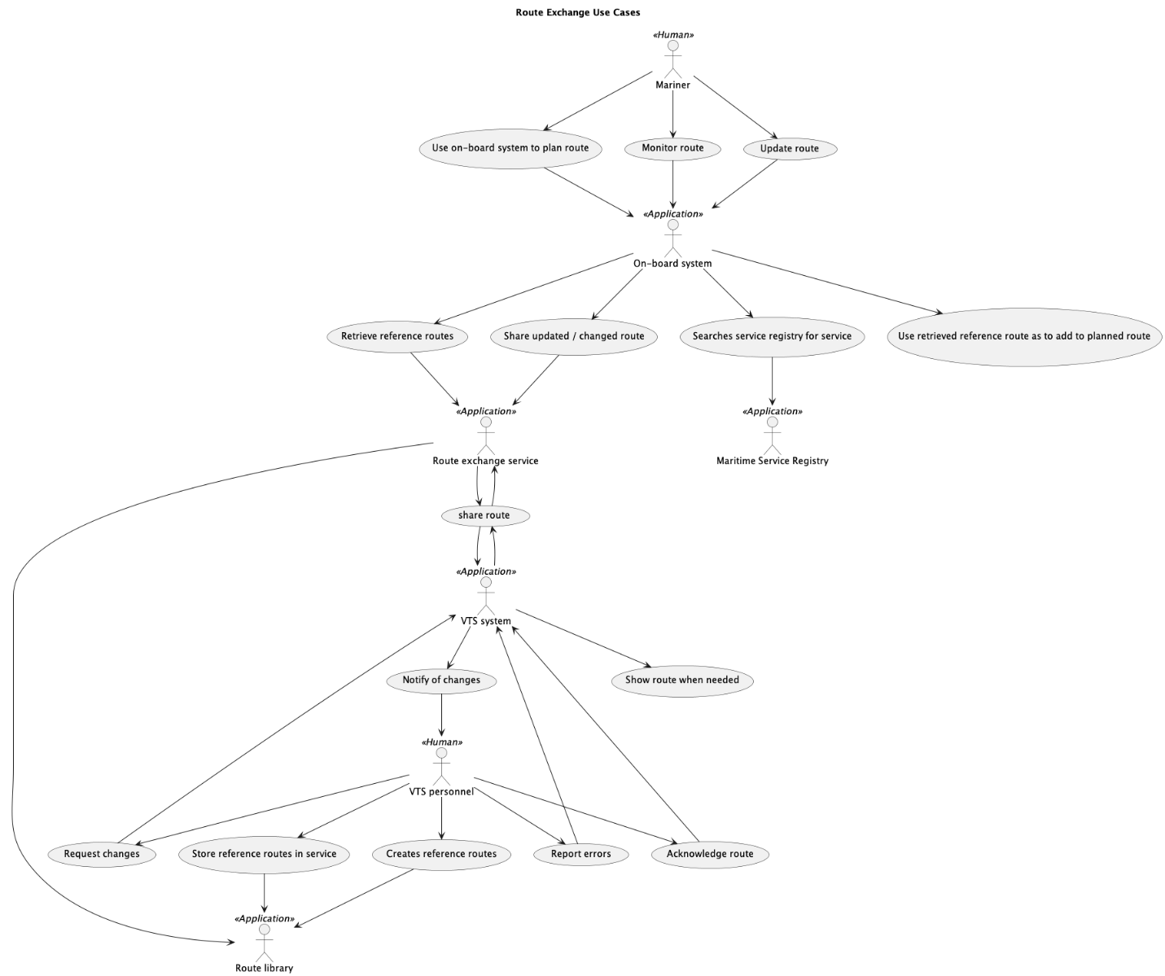
Figure 1 High-level view of route exchange use cases

Use case 1 - Initial sharing of the route from Vessel to VTS
Description - Vessel shares route with VTS before entering VTS area, leaving from berth/anchorage, departing from port/anchorage.
Typical sequence:
- The route is planned in the ship system by the mariner
- Ship system is used by mariner and master to validate and approve the route
- The on-board systems should send the route to the service before departure, but the route must be shared at latest according to local rules
- The service checks that the route is valid according to the schema and at least following information is included in the route
- Vessel Identification Information
- Waypoints (WP)
- Schedule / times of WPs
- Legs (including cross track distance limit (CL)
- The status of the route should be set to “planned”
- For the full list of requirements see RESF007
- The Route Exchange Service sends the route to the VTS System
- The Route Exchange Service sends “received” acknowledgement automatically to the vessel to notify the vessel of completed delivery
- VTS System can display the route as needed to the VTS personnel
- VTS requests to receive updates to the route (see 3.1.3)

Use case 2 - VTS gives route recommendation to vessel within a geographically defined area
Description - VTS gives route recommendation to vessel, for example due to:
- A certain part of the route is inaccessible, for example due to navigational danger, environmental conditions, or for monitoring and managing vessel traffic:
- Changing the geography of the route
- Changing the ETA to a specific waypoint
- Enhanced navigational assistance:
- Changing the turn radius
Typical sequence -:
- Vessel has already sent route to VTS
- VTS personnel creates the recommendation for vessel
- VTS system can assist VTS personnel to create the route recommendation
- VTS system sends back the recommended route to ship system
- Route can contain changes to waypoints and/or schedule
- RouteInfoDescription should be changed to include rationale and other assistance
- Route edition number must be increased
- Route status must be set to “recommended”
- Vessel sends route received acknowledgement automatically
- Mariner updates the route after receiving recommendations. The route edition must be changed and the status of the route must still be “planned.” The updated route is shared with VTS.
- The Route Exchange Service sends “received” acknowledgement automatically. VTS System can display the route as needed to the VTS personnel.

Use case 3 - VTS requests route updates from vessel
Description - VTS requests route updates from vessel for situational awareness and/or traffic management after receiving initial route from vessel (see use case 3.1.1).
Typical sequence -:
- After receiving a valid route from the vessel, the service will send a request for updates from the vessel
- Vessel sends route as requested when changes occur. For more details, see RESF012
The service receives the route and forwards it to VTS system.
- The service sends “received” acknowledgement automatically
- VTS System can display the route as needed to the VTS personnel with ability to highlight any changes. When route change is opened by VTS personnel, acknowledgment of opening is sent to vessel if requested.
- If changes to route require VTS to suggest and request changes from vessel see use case 2

Use case 4 – Vessel’s route changes
Description – Vessel wants to change its route
Typical sequence -:
- Vessel has already sent route to one or more VTS
- Mariner makes changes to its route
- Ship system sends updated route to one or more VTS
- If VTS has requested updates according to use case 3 that request must be honoured
- If the vessel is underway, only the waypoint preceding the current leg and all future route elements are to be shared.
- The service checks that the route is valid according to the schema and the requirements listed in RESF007
- If the route goes through a VTS area that is new for the route, the vessel should share the route to that VTS.
- VTS system sends “received” acknowledgement automatically
- VTS System can display the route as needed to the VTS personnel with ability to highlight the changes.
- If VTS needs to make changes to route, see 3.1.2

Use case 5 – Vessel does not arrive to VTS area as planned
Description - Vessel changes route and does not arrive to VTS area as part of its voyage (use case 1)
Typical sequence -:
- Vessel has already sent route to VTS
- Mariner makes changes the route where no waypoints are located inside geometry area
- Vessel sends cancellation to the service with status set to “terminated”. In this case only the RouteInfo element must be sent and the waypoints must not be sent.
- VTS system sends “received” acknowledgement automatically
- VTS system cancels any request for updates to the route.
VTS System can display the route as needed to the VTS personnel with ability to highlight the changes/cancellation

Use case 6 - VTS checks the route with help from other services
Description - VTS checks vessel’s route without changes. The checking process includes the use of other systems, e.g. cross-check, to assist VTS personnel in manual route checking.
Typical sequence -:
- Vessel has already sent route to VTS according to use case 1
- VTS system sends the route to Route Crosscheck Service (RCS) if available to checks the route
- Route Crosscheck Service checks the route and marks it as compliant
- If the route is not compliant go to use case 2 or 8
- VTS personnel takes in consideration the monitoring and managing vessel traffic and marks the route “ok” on the VTS system
- If the route is not suitable go to use case 2
- The VTS system sends a checked route back to the on-board systems.
- Only the RouteInfo-part of the route must be sent. No other parts of the route must be present.
- The status of the route must be set to “Checked”.
- Once the route has been delivered to the on-board systems it must acknowledge that it has received the route.
- On-board systems can display the VTS checked route to mariner

Use case 7 - VTS personnel acknowledge the route without the use of other services
Description - VTS personnel checks vessel’s route without changes. This use case does not include the use of external services to assist VTS personnel in the manual check of the route.
Typical sequence -:
- Vessel has already sent route to VTS
- VTS personnel checks the route and marks the route “ok” on the VTS system
- VTS personnel also takes in consideration the monitoring and managing vessel traffic
- If the route is not suitable go to use case 2 or 8
- Continue from step 5 in 3.1.6

Use Case 8 - VTS sends route back with comments
Description - VTS has issues with the vessel´s route and sends it back with comments without creating a recommendation.
Typical sequence -:
- Vessel has already sent route to VTS
- Route Crosscheck Service or/and VTS personnel checks the route and finds issues with the route
- VTS personnel decides not to make a recommendation
- VTS sends part of the route with issues back to the vessel with comments
- The route status must be set to one of “route issues” or “route incomplete”
- The routeInfoDescription must contain a description that describes the issues.
- Additional problems with specific legs should be described in the applicable leg’s routeWaypointLegIssue.
- The route edition number is not increased in this case.
- Vessel plans changes to its route [go to use case 4]

Use Case 9 - Vessel gets multiple changes to their route
Description - Vessel sends its route to many VTS areas and gets multiple change recommendations to their route.
Typical sequence -:
- Vessel has already sent route to multiple VTS areas
- VTS areas can give multiple recommendations to vessel´s route
- VTS can send recommended route or/and comments
- Vessel receives multiple change recommendations to their route and adjust it

Use case 10 - VTS requests route from vessel
Description - VTS requests route from vessel for situational awareness and/or traffic management. This is typically caused by the vessel neglecting to share the route with the VTS. Support for this use case is optional for the vessel.
Pre-condition – Consumer is registered in a maritime service registry
Typical sequence -:
- VTS request route from vessel. The request should contain a geometry of the area that the vessel is in or that route is expected to enter.
- Vessel decides if route is to be shared
- Vessel sends route as requested if request is approved.
- In this case the edition number of the route may be larger than 1
- The whole route must be shared.
- If request is not approved, the vessel must respond either with an appropriate error depending on service design or with a dummy route containing the following information (note this is an exception to RESF007):
- Only the routeInfo element
- Vessel identification as required
- Route status as ”Checked”
- The Route Exchange Service sends “received” acknowledgement automatically
- VTS System can display the route as needed to the VTS personnel with ability to highlight any changes

Use Case 11 – Route exchange with the use of automated services
Description - This service specification can also be used to create services that allow the sharing of the route to automated route services (e.g. cross-check, optimization). In this case, the requirements for the route shared from the vessel are exactly the same as when sharing the route with VTS personnel and must comply with the requirements of RESF007.
Typical sequence -:
- Vessel sends the route to the service
- Service forwards the route to the next service in the chain (e.g. cross-check, optimization)
  - The service checks that the route is valid according to the schema and the requirements listed in RESF007
- Next service processes route
- Next service returns the route
- If no changes are done to the route, the returned route may only consist of the routeInfo element with the appropriate status and an automatically filled routeInfoDescription
- If the route is changed, the full route must be returned.
- The returned route must comply with the requirement RESF008

Use Case 12 – Update route status from planning to monitoring
Description - When route is moved from planning to monitoring on-board the vessel the change of status must be shared with VTS.
Typical sequence -:
- Mariner decides to begin the journey and moves the route from planning to monitoring on ECDIS.
- ECDIS sends the route with status set to “used for monitoring” to the service. When route is moved to monitoring, it must be sent to all applicable VTS systems. The change of status affects the whole route and thus an update must be sent to all services that have requested updates.
- The route edition number must be increased.
- Service receives the route update
  - The service checks that the route is valid according to the schema and the requirements listed in RESF007
- Service delivers the route to VTS system and sends acknowledgment to ship systems that route has been delivered to VTS system.
- VTS system checks to see that route is identical to latest checked route.
- Either:
- If route is identical, notify personnel of status change in route.
- Otherwise reply with route with status set to “route errors” with the description “Route does not match” and notify VTS personnel of issue. Next steps should follow 3.1.4

Use Case 13 – Route retrieval from VTS route library
This use case is optional to implement for the service. The consumer must support the functionality needed to search and retrieve routes from the route library.
Description - VTS and other actors may provide route libraries that can be used as templates for whole routes or parts of routes. These routes differ from those that have been planned to include a schedule and thus have their own set of requirements for contents. See RESF011.
Typical sequence -:
- Vessel searches for routes from route library. Search parameters may include:
- Validity period
- Geometry of area of interest
- UN/Locode of the location. The UN/Locode parameter may also be the first two characters of the UN/Locode (e.g. FI) to search for all UN/Locodes in that country.
- A reference to the route requested if reference is known
- Route library searches for routes from the route library and returns the search result in a list of routes.
- Vessel receives route / routes and uses them in planning as appropriate.

Use case 14 – Vessel can discover compatible route services
Description – a vessel can discover the available compatible route exchange services within their area of interest from maritime service registries.
Typical sequence -:
- Service is registered in the Maritime Service Registry (MSR)
- Mariner plans a route
- During planning the ship system regularly checks that it has the service endpoints of all compatible route exchange services that cover the area of the route. If parts of the route are not covered by any route exchange service, the ship system must search for route exchange ser-vices from the MSR.
- MSR sends list of available services along route from its own area of responsibility. The MSR will also forward the search to all other participating MSRs and return the list of available services from other MSRs.

Use Case 15 – VTS requests route after it has been shared
Description - VTS requests route from vessel for situational awareness and/or traffic management after the route has already been shared by vessel to VTS. This is typically caused by vessel not sending the vessel changes and VTS requiring an updated route. Supporting this use case is optional for the vessel.
Typical sequence -:
- The sharing of route has already taken place according to previous use cases.
- VTS request route from vessel with a reference to the route via route exchange service.
- ECDIS sends the route if the mariner approves the sharing of current route
- The service forwards the route to VTS system
- The service technically acknowledges the delivery of route to VTS system to ECDIS
- VTS system notifies VTS operator of received route
- VTS system can display the differences between the previous route and the received route.

Data flows

Figure 2 gives an overview of the dataflows for the VTS – Vessel Route Exchange Service as described in the use cases.
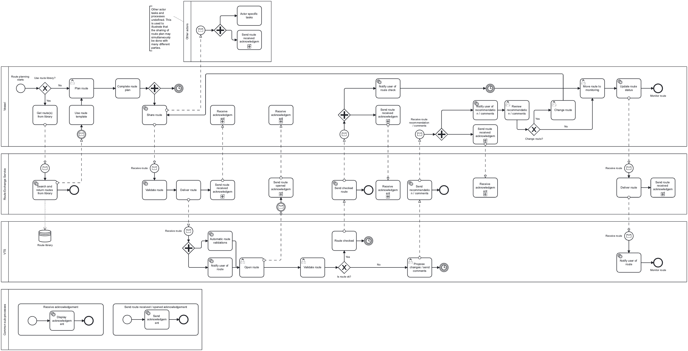
Figure 2 Route Exchange Business Process

Functional and non-functional requirements

Functional requirements
Requirement ID | RESF001
Requirement Name | Receive route from vessel
Requirement Text | A vessel must be able to send its route to the service. The service must have the ability to forward the received route to the VTS System.  The requirements for a valid route are outlined in RESF007
Rationale | Sending the route from the vessel to the service is a core requirement of the service.
Author

Requirement ID | RESF002
Requirement Name | Send route recommendation and/or comments to vessel from VTS
Requirement Text | The service must facilitate the sending of a route recommendation and/or comments from VTS to the vessel. The recommendation and/or comments may be a part of a rejection of a route received from a vessel or standalone.
Rationale | When VTS personnel are either reviewing a received route from a vessel or trying to organize traffic and need to suggest a route to a vessel the service must be able to send a route recommendation and/or comments to the vessel.
Author

Requirement ID | RESF003
Requirement Name | Send route recommendation and/or comments to vessel from VTS
Requirement Text | The service must facilitate the sending of an acknowledgment of a route from VTS to the vessel. The acknowledgment must not include the whole route but only the RouteInfo-section of the data model.
Rationale | There is no need to send the route received from the vessel back and thus use possibly limited transfer capacity.
Author

Requirement ID | RESF004
Requirement Name | Provide area of interest of VTS to vessel
Requirement Text | The service must provide its area of interest in the geometry used when registering to a service registry.
Rationale | The geometry is used to find the available route exchange services along the route of the vessel. The geometry can also be used by the vessel to filter the data sent from the vessel if so requested by the VTS.
Author

Requirement ID | RESF005
Requirement Name | Service must be able to request the route or updates to the route from vessel automatically.
Requirement Text | The service must be able to request the full route.  The service must be able to request updates to the route when it changes.  This means that the ship system can have the ability to send the route when requested.  The ship must have the ability to send updates to the service when the route changes.
Rationale | Due to complexity, this is optional to support on the vessel side but support in the service is required so that vessels that do support this functionality can receive better service.
Author

Requirement ID | RESF006
Requirement Name | Service integration with VTS System
Requirement Text | The service must integrate with the VTS System so that the information received from vessels can be utilized by the VTS System.
Rationale | The exact details of how this requirement are fulfilled are left to each implementer as they depend on the functionalities of the VTS System itself. In some cases, it may be better for the VTS System to poll the service, in other cases an event may be triggered, or a simple API call on the VTS System may be used. From the perspective of this specification the implementation details of how the service integrates with the VTS System can be left open.
Author

Requirement ID | RESF007
Requirement Name | Requirements for a valid route received from vessel
Requirement Text | The following information must be present in the route shared by the vessel:  - All elements required in the schema must be present  - Vessel must be identifiable, see RESF009  - Vessel voyage must be identified  - All waypoints must have at least one associated schedule element  - Waypoint schedule elements must not be of type “recommended”  - All waypoints except the first and last waypoint must have a non-zero turn radius or have both ETA and ETD defined and ETD must be later than ETA.  - All action points must have either a time to act or distance to act  - All legs must be defined. First waypoint must not have a leg.  - All legs must have both port and starboard CL defined  - All legs must have routeWaypointLegDraft defined  - All waypointIDs must be unique in the route.  - A route should not have more than 1000 waypoints or action points  - All dates and times must have an accompanying time zone. Time zone should be UTC.  - Character encoding of shared route must be UTF-8.  - routeInfoVesselHeight and RouteInfoVesselAirDraft must be set
Rationale | Additional business rules are required in addition to schema validation to validate a route shared by the vessel for checking purposes. These requirements fulfil the requirements from the VTS side on what is required to be able to check and verify the route shared from the vessel.  This requirement also takes into account the business rules defined in S-421 [5] and the minimum requirements placed on ECDIS devices
Author

Requirement ID | RESF008
Requirement Name | Requirements for sharing a route from VTS to vessel
Requirement Text | When VTS acknowledges a route only the routeInfo element may be present in the reply to vessel. No other child elements of route are permitted and the vessel must ignore acknowledgment if any other route elements are present.  If VTS has comments on a route it is recommended that VTS modifies the route so that a acceptable route is proposed instead. VTS is not required to send a proposal to the vessel and may send general information on problems in the route and request changes from vessel to fix them.  When VTS modifies a route the following differences to a valid route defined in RESF007 are allowed:  - Waypoints may have a turn radius of 0.0. Unless VTS requires a given turn radius, the radius in the route shared by VTS should always be set to 0.0 in waypoints created or edited by VTS.  - The following requirements are placed on routes modified in any way by VTS.  - The routeInfoAuthor must be populated and the content should include the VTS organization .  - The routeInfoDesciption must always be filled with a description and rationale of changes.  - If route recommendation contains temporal restrictions (e.g. under keel management, ice navigation) the validity period in routeInfo must be set.  - Any schedule element added or modified by VTS must be of type recommended even if it is calculated.  - Waypoints added or changed by VTS may leave out the schedule element.  - If routeActionPointExternalReference or routeWaypointExternalReference is included, it must be an MRN.
Rationale | The turn radius is dependent on many factors many of which may not be known to VTS. Thus it is important to clear the turn radius in all waypoints that have been created or changed by VTS to require a check and setting of the turn radius by the vessel. As S-421 does not allow a waypoint without a turn radius or empty turn radius, the value 0.0 is used to denote an unset turn radius.
Author

Requirement ID | RESF009
Requirement Name | Requirements for identities
Requirement Text | The service must have a valid maritime identity. See Guideline G1183 [3]  A consumer must have a valid maritime identity.  The maritime identity certificate must include the vessel’s MMSI and IMO number and they must match with the MMSI and IMO number in the route. If vessel does not have an IMO number then only MMSI is required. If the certificate information and the identifying information in the route do not match an error must be returned and no further processing of the route is allowed.
Rationale | The consumer must be able to verify the identity of the service and its provider. The consumer must reject any connections from a service that does not have a valid maritime identity.  The service must require verification of the identity of the consumer and must decline service if a valid identity is not provided or if the identity provided does not match the metadata of the route.
Author

Requirement ID | RESF010
Requirement Name | Requirements for authenticity
Requirement Text | The consumer must be able to verify the authenticity of the route from the originator of the route (VTS system or this service) to the actual consumer application (e.g. ECDIS). This requires that if the communication between the service and the end-user application is not direct, the signature of the route is also delivered to the consumer application hand in hand with the route.  The service must be able to verify the authenticity of the route from the actual vessel it identifies. Thus, the route must be signed with the signature of the same vessel it is from and the signature must be delivered to the service.
Rationale | ECDIS is mandated to verify the authenticity of all incoming external data. Thus the signature of a received route must be delivered to the ECDIS hand in hand with the route. See IACS UR E27 section 4.2.6 [7]  VTS systems and other end users of shared routes must also be able to verify that the route they receive actually originates from the ship identified so that spoofing or any other kinds of bad actions from third parties can be prevented.
Author

Requirement ID | RESF011
Requirement Name | Requirements for a valid route from route library
Requirement Text | The following requirements are placed on the contents of a shared reference route:  - routeID and routeEditionNo are set by publisher and must be changed by vessel if used directly  - Route status must be “initial”  - Route must have a name, editor and description  - Route must have a validity period  The route must be a valid S-421 document, but additional requirements defined in RESF007 are not required
Rationale | Depending on the type of reference route and local conditions other attributes and elements may be required. The list above serves as the baseline for all reference routes. A reference route by definition will not have a schedule or any other vessel dependent information.
Author

Requirement ID | RESF012
Requirement Name | Requirements for when route has changed
Requirement Text | If VTS has requested updates to the route due to changes, vessel must send an update if the route is unloaded from ECDIS for updating before it is taken into monitoring again.  If route is still under planning then the following changes constitute a change that must be sent to VTS:  - Any schedule item of type “manual” is changed  - The location of any waypoint or action point is changed  - The radius of any waypoint is changed  - The port or starboard CL of a leg is changed  - The routeWaypointLegDraft of a leg is changed  - Any required child of routeInfo is changed  These changes must be updated before route is moved to monitoring, i.e. normal procedure of planning must be followed and any previous status checked of the route from VTS is cleared by any of the above changes.  During the voyage and update must be sent if the any of the rules listed above apply or ETA to the geometry VTS is interested in or ETA to last waypoint changes by more than:  - 12 hours if ETA is over 168 hours away (t >= 168)  - 6 hours if ETA is between 72 and 168 hours away (72 <= t < 168)  - 2 hours if ETA is between 24 and 72 hours away (24 <= t < 72)  - 1 hour if ETA is between 12 and 24 hours away (12 <= t < 24)  - 30 minutes if ETA is between 6 and 12 hours away (6 <= t < 12)  - The combined total minutes of the window (if defined) or a maximum of 15 minutes in any other case (e.g. if window is a total of 10 minutes, a change of over 10 minutes in ETA is a change; if window is a total of 20 minutes, a change of over 15 minutes is a change)  When the vessel is underway, the route shared must include the waypoint preceding the current leg and all remaining waypoints and action points.
Rationale | Defining what constitutes a change to the schedule of a route is challenging and very dependent on how timely the change is. This definition attempts to solve that problem.  Changes to significant other required parts of the route are more clear cut and should not be a source for conflict.
Author

Requirement ID | RESF013
Requirement Name | Requirements for retrying operations
Requirement Text | All sending of routes and acknowledgments must be automatically retried if the initial transmission fails. The retries must be done frequently for the first minute after which a reduced frequency is allowed for the next five (5) minutes. If transmission is not successful during that time a user notification in the end user system is required and the user must be able to cancel the transmission.  This applies to both ship system and VTS system.  The actual frequencies and methods of retries are left to be defined in the service design.
Rationale | As route exchange is operationally important, the transmission of routes and acknowledgments must be ensured.
Author

Requirement ID | RESF014
Requirement Name | Requirements for encryption
Requirement Text | All communication between service and consumer must be encrypted during transport (transport layer encryption).  The service must support encryption of route payload so that only the recipient can open the route when intermediates are used during transport.  The vessel may support encryption of the route payload.
Rationale | IACS UR E27 [7] requires the use of encryption between ECDIS and shore-based systems.  Some consumers may want the additional layer of security to the confidentiality of the route by encrypting it so that only the intended VTS or consumer may open the route.
Author

Non-functional requirements
Requirement ID | TCSNF001
Requirement Name | Integrity
Requirement Text | It must be clear to both service provider and consumer whether changes have been made to the information after the dataset was created. All messages must be signed with the correct certificates so that the contents of a message can be validated. The technical designs must describe how this is managed.
Rationale
Author

Requirement ID | TCSNF002
Requirement Name | Availability
Requirement Text | The actual SLA of the service must be defined by instance owner. The service should be highly available and be considered a critical component of the VTS system.
Rationale | In IALA G1111 Section 3.1 [8] the availability requirements for VTS systems are defined. As the service is required for successful digital exchange of route plans and such exchange may occur at any time of the day the service should be available whenever VTS system is available.
Author

Requirement ID | TCSNF003
Requirement Name | Performance – timeliness
Requirement Text | The service must provide a technical response to an incoming request instantly. This response is by necessity a technical delivery acknowledgement and not a business process response. This applies both to requests coming from vessels and VTS System. The technical designs must describe how this is managed.
Rationale | Especially from a vessel’s point of view it is important to get an acknowledgement that the service has received a request so that the vessel’s system does not need to try resending the request.
Author

Requirement ID | TCSNF004
Requirement Name | Uniqueness
Requirement Text | All requirements for uniqueness during route exchange are guaranteed to exist only during the transmit of a route.
Rationale | On either side of the exchange changes to non-technical identifiers or names in the route are possible and may conflict with each other. Relying on user editable names or identifiers in communication must be done carefully by ensuring that the same element is being discussed.
Author

Other constraints

Relevant Industrial Standards
- IALA Guideline G1128 1.6 The Specification of E-navigation Technical Services
- IALA Guideline G1143 3.1 Unique identifiers for maritime resources (MRN)
- IHO Standard S-100 5.2.0 IHO Universal Hydrographic Data Model https://iho.int/uploads/user/pubs/standards/s-100/S-100_5.2.0_Final_Clean.pdf
- IALA Guideline G1183 1.1 Provision of MCP Identities
- IEC 63173-2 Committee Draft 80/1149/CD Secure communication between ship and shore (SECOM)
- IEC 63173-1 Committee Draft 80/1148/CD S-421 Route Plan based on S-100
- IACS UR E26/27 Rev1 International Association of Classification Societies https://iacs.org.uk/resolutions/unified-requirements/ur-e
- IALA Guideline G1111 2.0 Establishing Functional Performance Requirements

Operational nodes
Table 1 Operational Nodes
Operational node | Remarks
Route plan or route | Route plan is the common definition of what is being shared. For brevity, route is used as a synonym for route plan throughout this specification.
Vessel | Participating ship that is required to participate with vessel traffic services and is sailing or expected to sail in a VTS area where there is coverage of technical service.
Mariner | In this document mariner means a person who is part of the bridge team that is responsible for the navigation of the vessel.
VTS | Vessel traffic services (VTS) means services implemented by a Government with the capability to interact with vessel traffic and respond to developing situations within a VTS area to improve safety and efficiency of navigation, contribute to the safety of life at sea and support the protection of the environment.
VTS centre | VTS centre responsible for a one or several VTS Areas for which the VTS provider is authorized to deliver vessel traffic services. A VTS centre is responsible for VTS route exchange service within its coverage area.
VTS operator | The personnel of the VTS centre, means persons performing tasks associated with vessel traffic services, trained in vessel traffic services operations and appropriately qualified.
VTS system | The VTS system is the VTS software, hardware, communications and sensors. This excludes personnel and procedures.
Service | Implementation of the Route Exchange Service. This is used to differentiate the service from a server as there may be multiple servers capable of accepting incoming requests / data.
Consumer | The vessel system interacting with the service. There may be a proxy server between the consumer and the service to facilitate data exchange but the consumer can always be understood as the on-board system(s) used to interact with the service.

Service Overview

Logical operations

The following logical operations must be provided in the designs that follow this specification ((x = required, o = optional):
Table 2 Logical interfaces
Operation | Description | Required
 |  | [Node X] | [Node Y]
Send route | An operation to send a message. Message may be an initial plan, proposal, or a disapproval. | x | x
Receive route | An operation that allows the receiving of messages. When message is received and delivered to the end system (on-board or VTS) an acknowledgement must be sent. | x | x
Send acknowledgement | An operation that allows sending of an acknowledgement that route has been delivered to end system or opened by end user. | x | x
Receive acknowledgement | An operation that allows the reception of an acknowledgement. | x | x
Subscribe to changes | VTS system must have a way to inform the vessel of what kinds of changes to the route they want to receive automatically.  The consumer must have a way to subscribe to the results of long running processes or processes that require human interaction and thus an asynchronous response. | x | x
Request route | The consumer can support the service requesting a route (see 3.1.10).  The service may support the consumer requesting a specific route or searching for routes (see 3.1.12) | o | o
Discover service capabilities | The consumer must have way to discover if the service supports requesting a specific route or searching for routes.  The service must have a way to discover if the consumer supports payload encryption or requesting the route. | x | x
System status | For service registries and service consumers to be able to check if service is up an interface must be defined that allows the checking of service without sending a valid message. | x | x
Service registry updates | The service must be able to update its own metadata in the service registry according to the service registry definitions. This is required to maintain updated certificates in the service registry as well as to allow other automatic updates to service information. | x | x
Search service registry | The consumer must have a way to search a maritime service registry for route exchange services that it is compatible with its area of interest.  The service must have a way to search a maritime service registry for the consumer endpoint if it is registered. | x | x

In this table the requirement that a vessel has an interface means that the vessel must have access to an interface that ensures that the incoming data is transported to the vessel’s on-board systems. It does not mean that the vessel must have connectivity all the time or that the vessel must accept random incoming connections. However, the vessel systems must have a way to send data to the service and get the technical sign-off of a successful transmit in a synchronous call.
What this means is that the end-to-end acknowledgment that is described in use cases and sequence diagrams differs from the technical acknowledgment that signals a successful end of transmission. This service and others that work between shore and vessel are often components of a more complex system. As such, the technical ok of a single transmission being complete does not indicate that a message has been delivered end to end. Thus, a separate mechanism for acknowledging delivery of end-to-end transmission is required. This is done by adding a method for acknowledging when the route has been delivered to the end system and opened by a recipient and visualizing this acknowledgement in the sending systems to facilitate e.g. operational acknowledgment.

Search Service Registry
Service discovery is a required functionality of both the service and its consumers.
The consumers must be able to search for valid route exchange services that the consumer supports and cover its area of interest. For this functionality to work, the following parameters are expected:
- The technical service design MRN and version number that the service implements that the consumer supports.
- Geometry of the area of interest. See 4.2.1
If the service has not received a callback parameter, the service must be able to search the service registry for the consumer to discover valid endpoints for the consumer. The following parameters are expected in this case:
- The technical service design MRN and version number that the service implements.
- The MRN of the consumer.
The actual method and logic of service discovery is outlined in IEC 63173-2.

Service registry updates
The service should be able to update the supported versions of the technical service design, its certificates and endpoint automatically to the service registry. The service must also define the geometry of the area that the service covers to allow for service discovery.
If registered in a service registry, the consumer should also be able to update the supported versions of the technical design, its certificates and endpoint automatically to the service registry.
The actual method and logic of service discovery is outlined in IEC 63173-2.

System status
Both the service and consumer endpoints must support a way of checking that the endpoint is available via e.g. a ping interface without sending a valid message.

Send and receive acknowledgment
Both the service and consumer must have a method of sending and receiving acknowledgments of delivery to end systems. As many of the operations are asynchronous and may depend on multiple intermediate systems there is a need to be able to show to the end users of the systems the status of message delivery that exceeds the technical status of the initial message transfer. This interface must require the presence of the message identifier (see 4.2.4).

Send route
Both the service and consumer must have a method of sending the route. When sending the route from the vessel it must conform to the requirement RESF007. When sending the route from VTS to the vessel it must conform to the requirement RESF008.

Receive route
Both the service and consumer must have a method of receiving the route.
The vessel may require that any routes it receives are related to an earlier shared route unless the route is returned as a result of a search to a VTS route library. In this case the message identifier of the message in which the route was initially shared by the vessel is passed as a parameter. The vessel must reject all incoming routes that do not come from a service with a valid maritime identity.
The service must be able to accept any route sent by a vessel with a valid maritime identity.
When receiving a route all parties must validate the route according to the S-421 XML Schema and according to the requirements RESF007 and RESF008 as applicable.
A longer route may be larger than what the transfer mechanism allows depending on the service design. If so, the service design must define interfaces that allow the sharing of arbitrarily large messages to ensure that sharing of routes is not limited by transfer protocol limitations and routes of at least 1000 waypoints, 999 legs, and 1000 action points with all associated additional attributes can be shared.

Subscribe to changes
Many of the use cases described above require human interaction in both the VTS and vessel. Thus, many interactions are asynchronous by nature and require an interface to allow subscriptions (e.g. 3.1.3) to updates to the route.

Route requests
When requesting a route it can either be done as a search with search parameters or target a single known route based on some reference to the route. The search parameters may include a validity period, route reference, geometry or UN/Locode.
The consumer must be able to either search for full routes or search for a list of route references and retrieve routes one at a time based on the references. The service is not required to support incoming route requests from the consumer.
The consumer may support requests for a route without any search parameters or with a geometry parameter. When a request is received without any parameters the route under monitoring should be returned without an increase to the edition number. If the geometry parameter is present, the monitored route should be returned only if the search geometry and the route geometry intersect.

Discovering service functionality
The service and consumer must have the ability to discover all of the interfaces provided by the service. The service and consumer must provide an interface that supports the discovery of available functionality.

Logical parameters

Here we will cover the abstract logical parameters that are common for multiple interfaces. Actual parameter structures, response structures or error handling is not specified. These will be defined in more detail in the technical design documents.

Callback
For most operations initiated by the consumer a callback parameter is expected that defines how or where the service may respond to the consumer. This parameter is not required, but if it is not present, the consumer must be available in a service registry for discovery (see 4.1.1). The actual method of the callback depends on the service design.

Geometry
When sharing geometries as a search parameter the geometry may either be an actual representation of the route with all waypoints and legs represented or a simplified representation of the geometry that can be any of the following (non-inclusive)
- List of waypoint coordinates
- A simplified polygon of the route
- A simplified version of the route

Any padding that is needed for the geometry when creating the geometry (e.g. for searches of services along a route) must be added by the creator of the query. Recipients can use the incoming geometry as is.

Route
When shared by any actor, a route must always be a valid S-421 document.
Additionally, the route must also include the data required by RESF007, RESF008 or RESF011 as applicable.

Message identifier
In all operations where an acknowledgment is requested, a unique identifier of the message must be present that the acknowledgment can refer to. This is typically referred to as a transaction identifier, correlation id and so on.

Service discovery
The typical parameters used in service discovery are defined in 4.1.1. It is important to note that searching for multiple versions of a service design that can be used is possible to ensure that the search returns all compatible versions and not just a single version.
It is also important to note that from a service discovery point of view the version of the actual implementation should not have any significance.

Service Data Model

The basis of the data model used in this service is S-421 as defined in IEC 63173-1. In addition to the validations in the schema and the business rules defined in S-421 the following requirements are placed on conforming services.
Conforming S-421 products may use all the possible elements in S-421 without any additional requirements. The requirements for valid routes from the perspective of this service are outlined in requirements RESF007, RESF008 and RESF011.
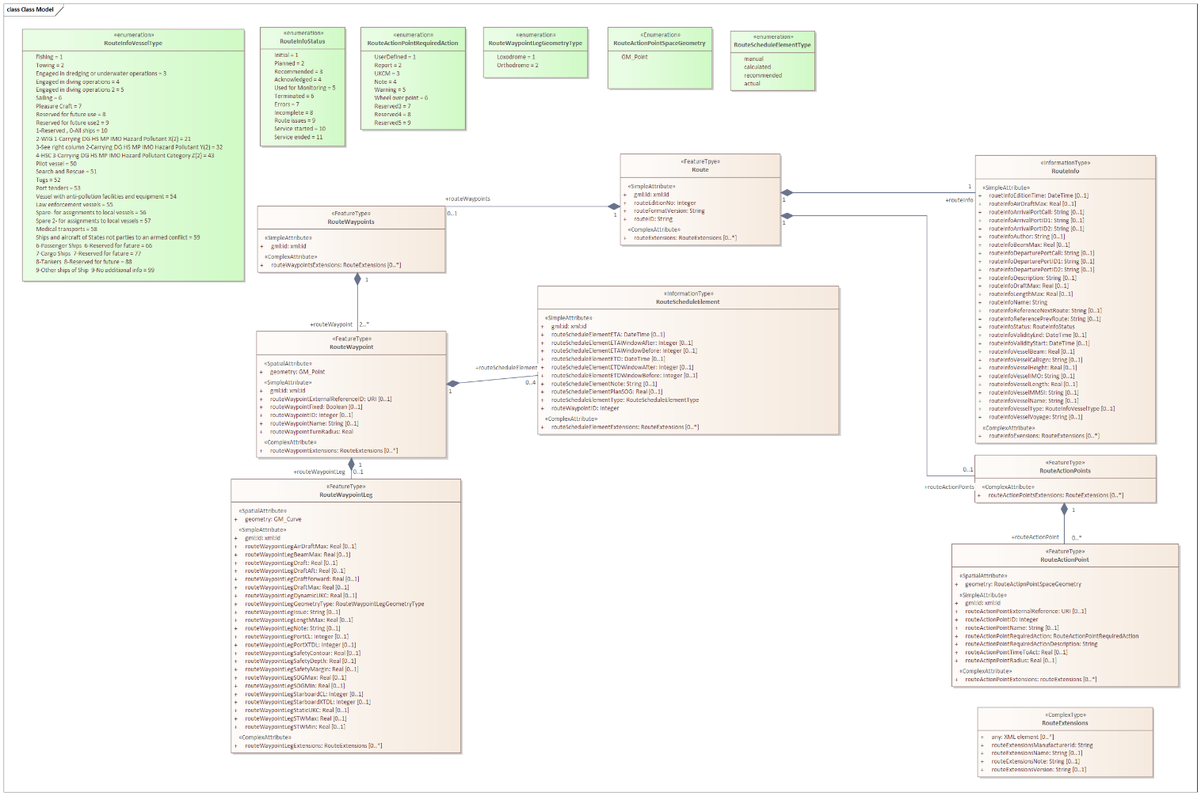
Figure 3 Abstract object model of the route plan data
Thus, while S-421 allows for routes without a schedule for use in different scenarios, from the perspective of this service all routes being exchanged must have a schedule with the exception described in the first paragraph of RESF008 and RESF011 in its entirety.

Container type

While S-100 and S-421 supports transmitting a route in an S-100 exchange set or dataset; or a plain S-421 message without any additional metadata, for the use of this service only the use of plain S-421 messages is supported.
The rationale for this is that there is no need to create a globally unique filename and/or path combination for the message that is required in both the S-100 exchange set and dataset metadata. The route being shared in this service can be considered ephemeral and the S-421 format of the route does not need to be kept in storage for either the consumer or service. However, in all conforming systems the generation of a S-421 from an imported unmodified route must create an identical S-421 document object model even if the generated message has cosmetic differences.
If the route is sent as an exchange set it must be rejected as invalid if it contains any Lua scripting.

End-to-end verification of data

Because the routes shared in conforming applications do not have the full set of metadata and external structures of an S-100 exchange set, the signature of the route required in RESF010 must accompany the route in other means. In normal direct communication between consumer and service this is normally handled by communication headers and may be provided by the protocol. The service design must specify how the signature is transmitted.

Changing the route edition number

The routeEditionNo of a non-reference route must be updated whenever:
- Planned route is sent from vessel
- Planned route is moved to status monitoring
- VTS (or other shore operator) creates a new route recommendation
For reference routes, the route producer may update the edition number whenever a new version of the reference route is published.

Coordinate systems

The coordinate system used must be defined. It should be EPSG:4326 according to S-100 and the coordinate order when using EPSG:4326 must always be latitude longitude. Service and consumer are not required to ensure correct handling of other coordinate systems or coordinate orders.
It is adequate to define the used coordinate system for the bounding box of the route. All subsequent geometries must default to the coordinate system defined for the root bounding box unless another coordinate system is explicitly defined for that geometry.

Route status

The sequence diagrams in S-421 standard (see section 7.3.6 [5]) give a high-level view of how the different statuses are used. However, there is some leeway in the use of the different statuses that shore may send to ship. From the perspective of this specification, the following understanding is required:
- Checked: VTS does not have any comments / issues / errors in route and has manually (or only automatically in the case of use case 11) checked the route. This does not imply that the route is error free or approved, just that VTS does not have any comments on the route.
- Recommended: Route has modifications by VTS that are recommended and solve all of the issues in the route. RouteInfoDescription-element may contain comments on changes etc but not require any additional changes to route. RouteWaypointLegIssues-elements must not be present.
- Route issues: Route may have recommendations (see above) but it also has issues that VTS does not have a recommendation on how to solve. RouteInfoDescription-element must have comment on issues and RouteWaypointLegIssue-elements may be used to further identify issues.
- Route incomplete: Route has too many issues for VTS to comment upon in detail. RouteInfoDescription must have some description on what is needed, but this status does not require detailed instructions on how to improve the route.
- Route errors: Route has errors identified by technical means. Specifically schema validation is passed but business rule validations have errors. RouteInfoDescription must have a human readable list of errors found. RouteWaypointLegIssue may also be used to pinpoint errors.
- Initial: When route is sent from the VTS route library. See RESF011 for detailed requirements on route contents.

Fixed route waypoints

Setting a waypoint as fixed is used by both ship and shore to signify that the waypoint should not be moved. This can be used to denote a position that is required for some reason, e.g. ice navigation or pilot boarding point. Setting the waypoint as fixed applies to the position of the waypoint and not any of the other attributes of the waypoint. Changing the location of a fixed waypoint should require a manual step from the user.

Action Points

While the data model at a schema level allows the positioning of action points in all possible coordinates, to ensure the relevance of action points they should be placed on the route centerline. Action points that are outside of the route crosscheck area may be ignored by recipients of the route.

Handling extensions

S-421 supports extensions to the data model in nearly all the main datatypes. Unless otherwise specified in this specification, consumer and service must not maintain the contents of extensions after changes. Any unsupported extensions must be removed from the response. This service defines route exchange using S-421 and support for any kind of data in extensions is purely optional.

Service Dynamic Behaviour

In all of the following diagrams ship systems include the ECDIS and any other systems on-board that mariners can use to plan and change routes. It is a requirement that at least the ECDIS [11] supports all of the functionality described in this specification, other on-board systems may communicate with route exchange service directly or via ECDIS.
Every time the service receives a route it must check that the route is valid according to schema. If route does not pass schema validation, then the appropriate error message must be returned depending on the service design.
The use cases described earlier in this document are looked at from a more technical perspective and the actual data and flow of information from one component to another is described here.
While service discovery may be needed, it is left last in the description of dynamic behaviour as it is already described in more detail in G1128 and may not be a required part of each use case.
In each case we will assume that a route is a valid route according to the XML schema. The handling of routes that are valid according to schema but do not fulfil the business rules of the use case will be described here.
While the service may often be integrated into a VTS system, from the perspective of this specification there is a boundary between the VTS system and the service as the service may also deliver and interact with other backend systems.
Due to the nature of vessel connectivity, we do not assume that all connections between the service and on-board consumers are direct. There may be shore based intermediate components involved as well depending on the actual service design. These components are not of interest from the perspective of this specification but the addition of multiple components in a single message transmission (multi-hop) is taken into account and adds complexity to the specification and implementations.

Acknowledgement messages

The sequence diagrams shown have multiple references to acknowledgments being sent of delivery to end systems (ship or VTS system) or opening of the message (route). This is due to the asynchronous and multi-hop nature of the communication where the technical transmission of a message from one component to another does not always signify the successful transmission of the message from one end system to another.
Thus, the sequence diagrams show and prescribe when acknowledgments must be sent either on the successful delivery of the route to the end system or of the opening of the route by a user. If the received route is automatically displayed on VTS or ship systems, the opened acknowledgment can only be sent after the user has in some way interacted with the route.

Sharing of route

The default use of the service is initiated by the vessel sharing a route that is being planned with all relevant VTSs that the route will require being in contact with. The route may be shared with other parties as well, but from the perspective of this specification we will only consider the interaction between the vessel and VTS.
Use case 1 describes the interaction between the vessel and a single VTS while use case 9 expands upon this and considers how the behaviour changes when interaction with multiple VTS’ is required. We will consider both use cases in this part of the dynamic behaviour description.
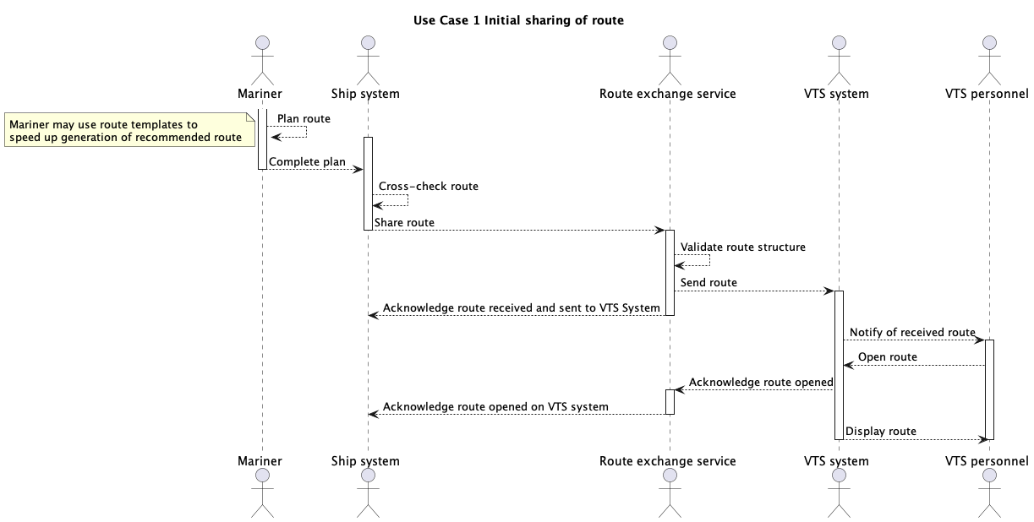
Figure 4 Initial sharing of route
As described in the use cases, the route initially shared by the vessel should have the edition number 1 to denote that it:
- is the first version of the route to be shared; and
- has not been moved to monitoring.
If the route VTS initially receives from a vessel has an edition number that is larger than 1, it is not an error (see use case 4 and 10). Any subsequent routes that are shared must have an edition number that is greater than 1.
Whenever the route edition number changes the route edition time must also be changed.
The consumer must request acknowledgments from the service both when the route is delivered to the VTS system and when the route has been opened by a user.
For each subsequent time that the route is shared from the vessel to VTS the following steps must take place:
- Mariner plans route and moves it from status “initial” to “planned” or route is moved to monitoring and status changes to “used for monitoring”
- Ship system (i.e. consumer) sends route to the service
- The service performs a schema validation to the route and validates that all rules of RESF007 are respected
- If valid, the route is forwarded to VTS system
- The service subscribes to changes of route. Service settings define if the request is for all changes to the route or only changes that affect the route in the area of interest of the service.
- Acknowledgment of route delivery to end system sent back to source of route
- VTS system performs additional validation to route contents based on business rules
- VTS operator is notified of route
- Once VTS operator opens route, acknowledgment of route opening is sent to source of route
The service must subscribe to changes to the route whenever it receives a new valid route that has not previously been shared. The changed route may be shared by any compatible ship system. The sharing of the route in this case follows process listed above with the exception of step 1 which in this case reads as follows:
- Mariner changes the route and when it is completed the route is shared with the status set to “planned”; route is moved to monitoring and status is set to “used for monitoring”; or a change fulfilling the requirements in RESF012 has taken place and route is automatically shared from ECDIS.
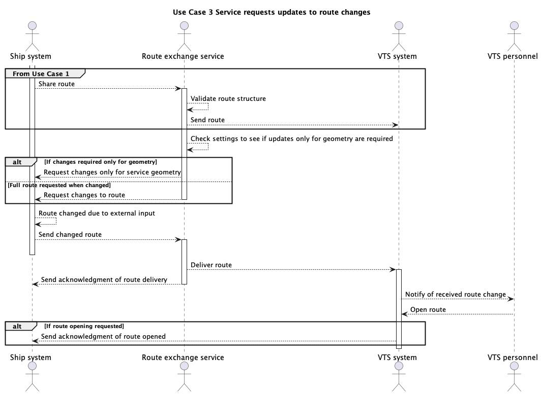
Figure 5 Requesting updates to route upon changes
When route is moved to monitoring it should be automatically shared to all VTS’ that it has previously been shared with. The shared route must be the complete route.
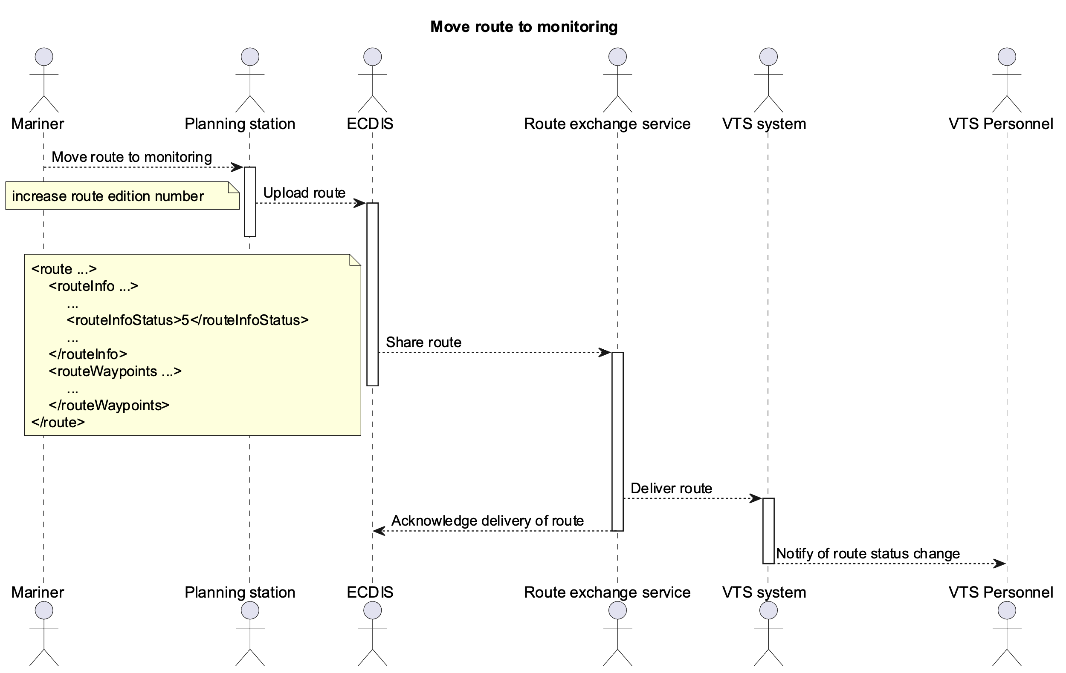
Figure 6 Moving route to monitoring
The complexity of interaction in use case 9 (see diagram) means that the process outlined above is repeated multiple times and sharing of route to VTS’ that have already checked the route may happen multiple times if requested. However, different parties may end up having different versions of the route (as denoted by the route edition number) if changes to one part of the route have not had an impact on other parts of the route.
Thus, the service and VTS system it is connected to must not assume that the route edition number increase by 1 or any other constant increment when received from the vessel.
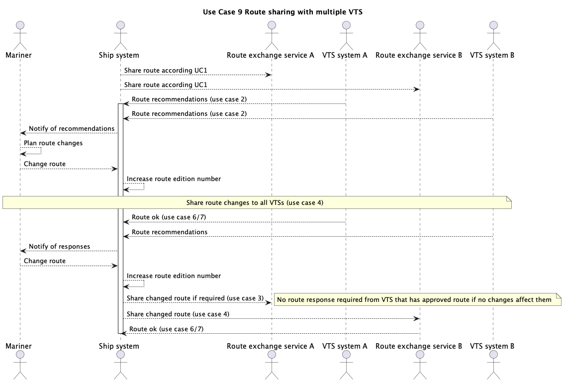
Figure 7 Sharing route with multiple VTS
When the route is changed, it is shared according to the process described below.
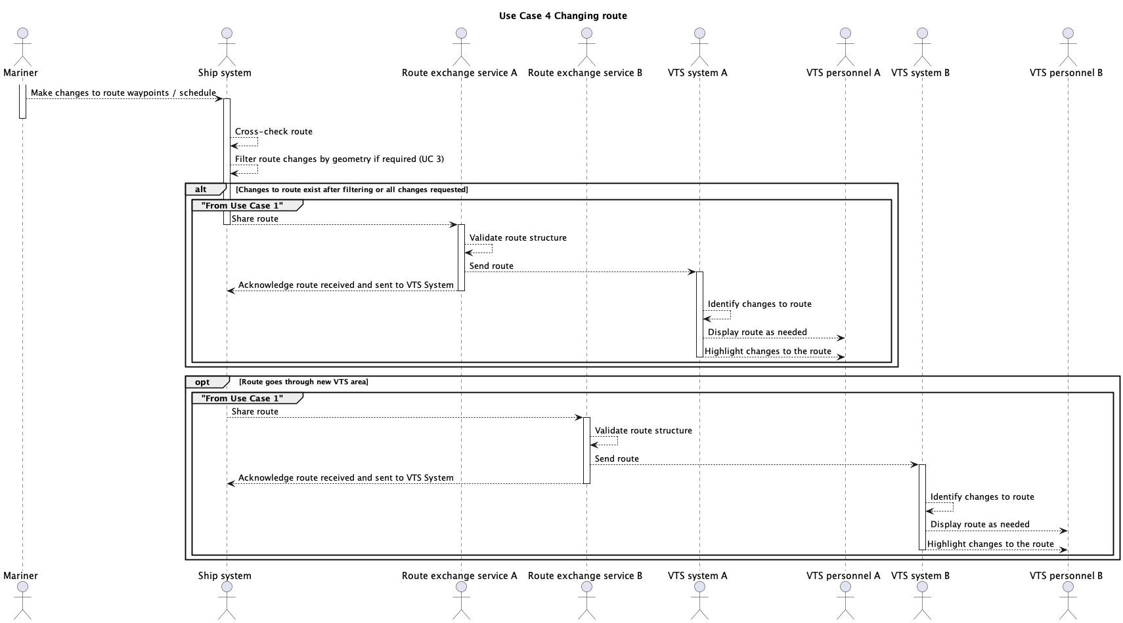
Figure 8 Changing route
If the changed route enters a new VTS area, the route must also be shared with this new VTS. In this case the route edition number should be greater than 1 even though the new VTS is receiving the route for the first time.
If the changed route no longer enters a VTS area the ship system must send a cancellation of the route to the VTS in question. The route cancellation must include the entire route as defined when sharing the route from vessel to VTS.
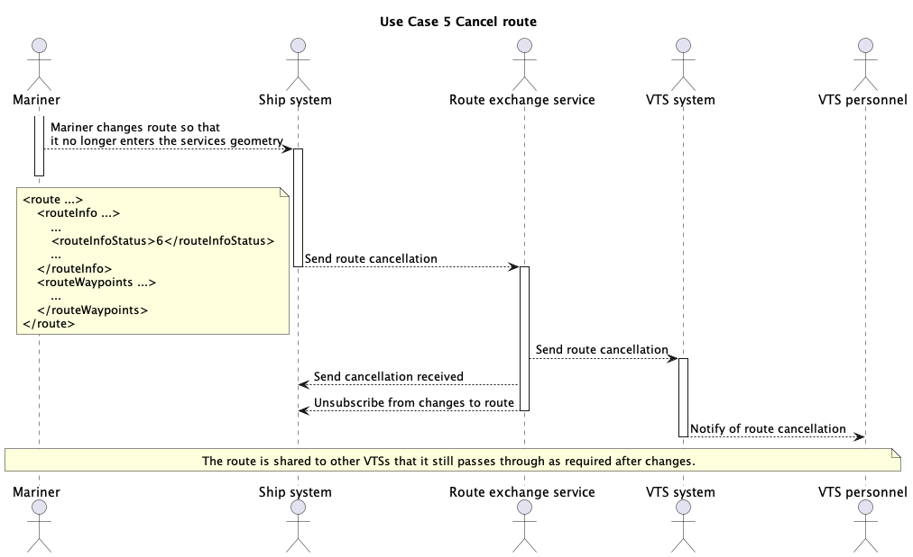
Figure 9 Route cancellation
When multiple VTS make a recommendation to change the route at the same time and send them to the vessel, the vessel will receive multiple versions of the route with the same edition number. This is to be expected and the systems onboard must be able to identify the changes to the route to assist the mariner in collating the multiple recommendations.
It is also possible that the mariner has already made changes to the route and shared a new edition of the route with some recipients and receives a recommendation with an earlier, older route edition number. This is not an error situation, and on-board systems must not assume that recommendations received are always accompanied by a route edition number that is larger than the one on-board. For example:
- Vessel shares initial route with VTSs A, B and C (route edition number 1)
- VTS A checks route (route edition number 1), VTS B sends recommendations (route edition number 2)
- VTS A and VTS B subscribe to all changes to route, VTS C only to those in the geometry of its area of interest
- Vessel makes changes to route and shares it with VTS A and B (route edition number 3) as no changes to route in VTS C area of interest
- VTS C makes recommendation to initial route (route edition number 2)
- Vessel makes another round of changes to route and shares it with VTS A, B and C (route edition number 4)
If the route is being shared as a reaction to VTS requesting the route (use case 10) all requirements above are true with the exception that route edition number should be greater than 1 as route should have already been sent to at least some VTS and moved to monitoring. Both of these actions should already have affected the edition number at least once if not more.

Route responses from VTS to vessel
Use cases 2, 6, and 7 all cover variants of VTS responding to the vessel about the shared route.
The requirements for a valid route shared by VTS are described in RESF008.
The only allowed status values when sharing a route from VTS to vessel are:
- Recommended
- Checked
- Route issues
- Route incomplete
- Route errors
- Initial (when shared from route library)
VTS systems are allowed to increase the route edition number only when sending back a route recommendation.
When sending back a route recommendation the route must be a complete route and include all of the unchanged elements from the original route received from the vessel. Deleted waypoints or action points must not be included.
As described in RESF008 when the route is edited by VTS, it may have waypoints with a turn radius of “0.0” which indicates to the vessel that it must set a turn radius. If VTS does not have a recommendation for the speed or timing across an edited portion of the route, schedule element may be unset to indicate to the vessel that speed and timing is up to them.
The sequence of actions whenever VTS sends a route back to the vessel is:
- VTS checks / edits / comments route with required annotations.
- VTS system sends route to the service
- Service validates the route against the schema and business rules
- Service sends the route to the vessel
- Once on-board systems have received the route an acknowledgment is sent to the service and forwarded to VTS system
- Once the mariner opens the route an acknowledgment is sent to the service and forwarded to VTS system
- If the mariner sends an updated route the dynamic behavior is as defined in 6.2
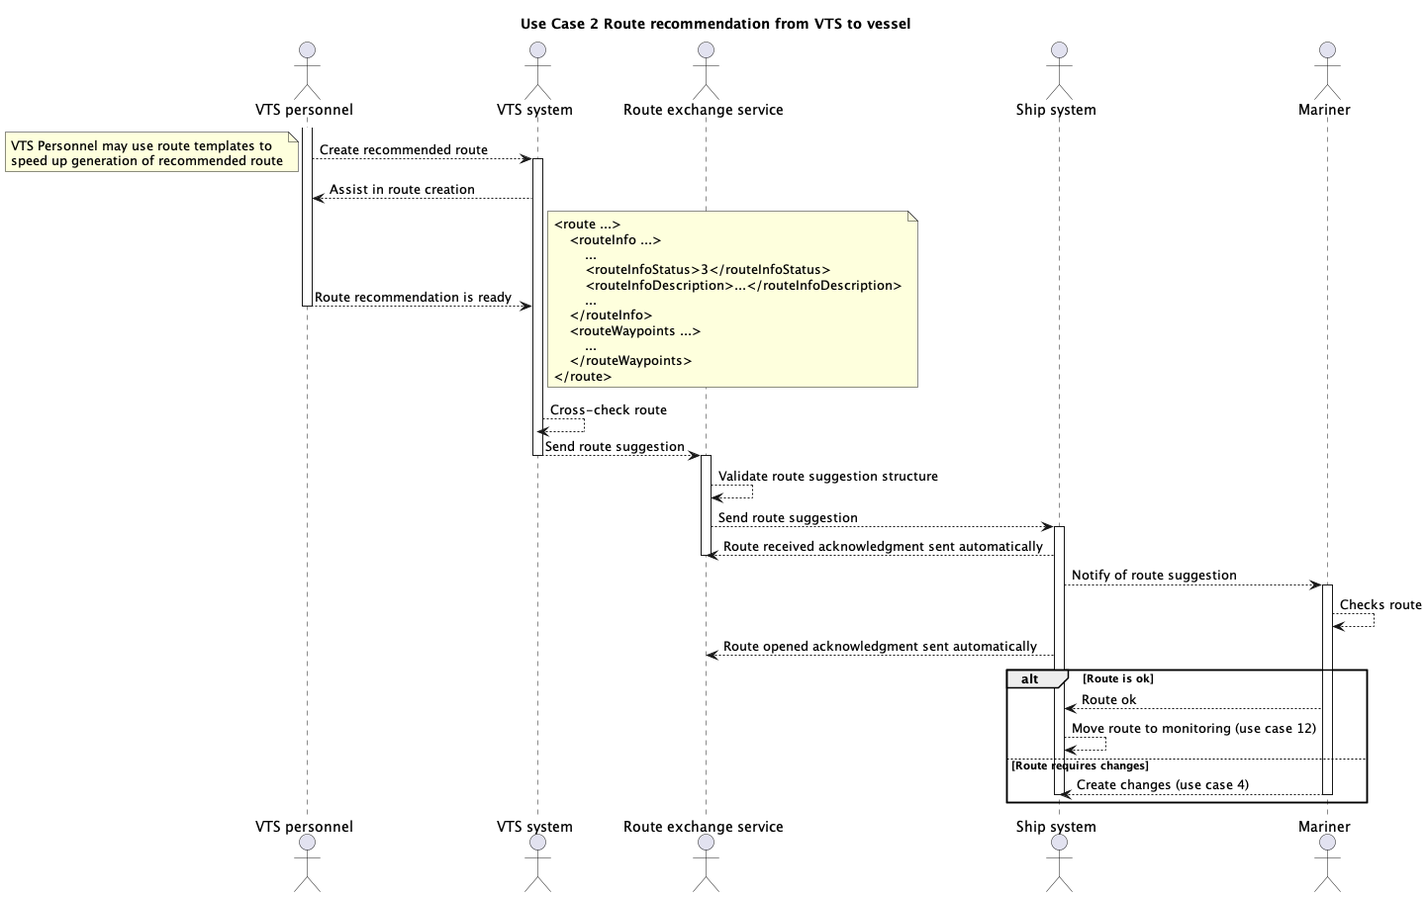
Figure 10 Route recommendation from VTS to vessel
If VTS checks the route without a recommendation, the route used in the reply must only include the routeInfo-element and its required contents with the status set to “Checked”. It is not allowed to send any of the other route elements (waypoints or action points) as they are unnecessary in this case. The edition number must not be changed, but the routeEditionTime must be updated to reflect time that route was checked and the routeInfoAuthor must be changed.
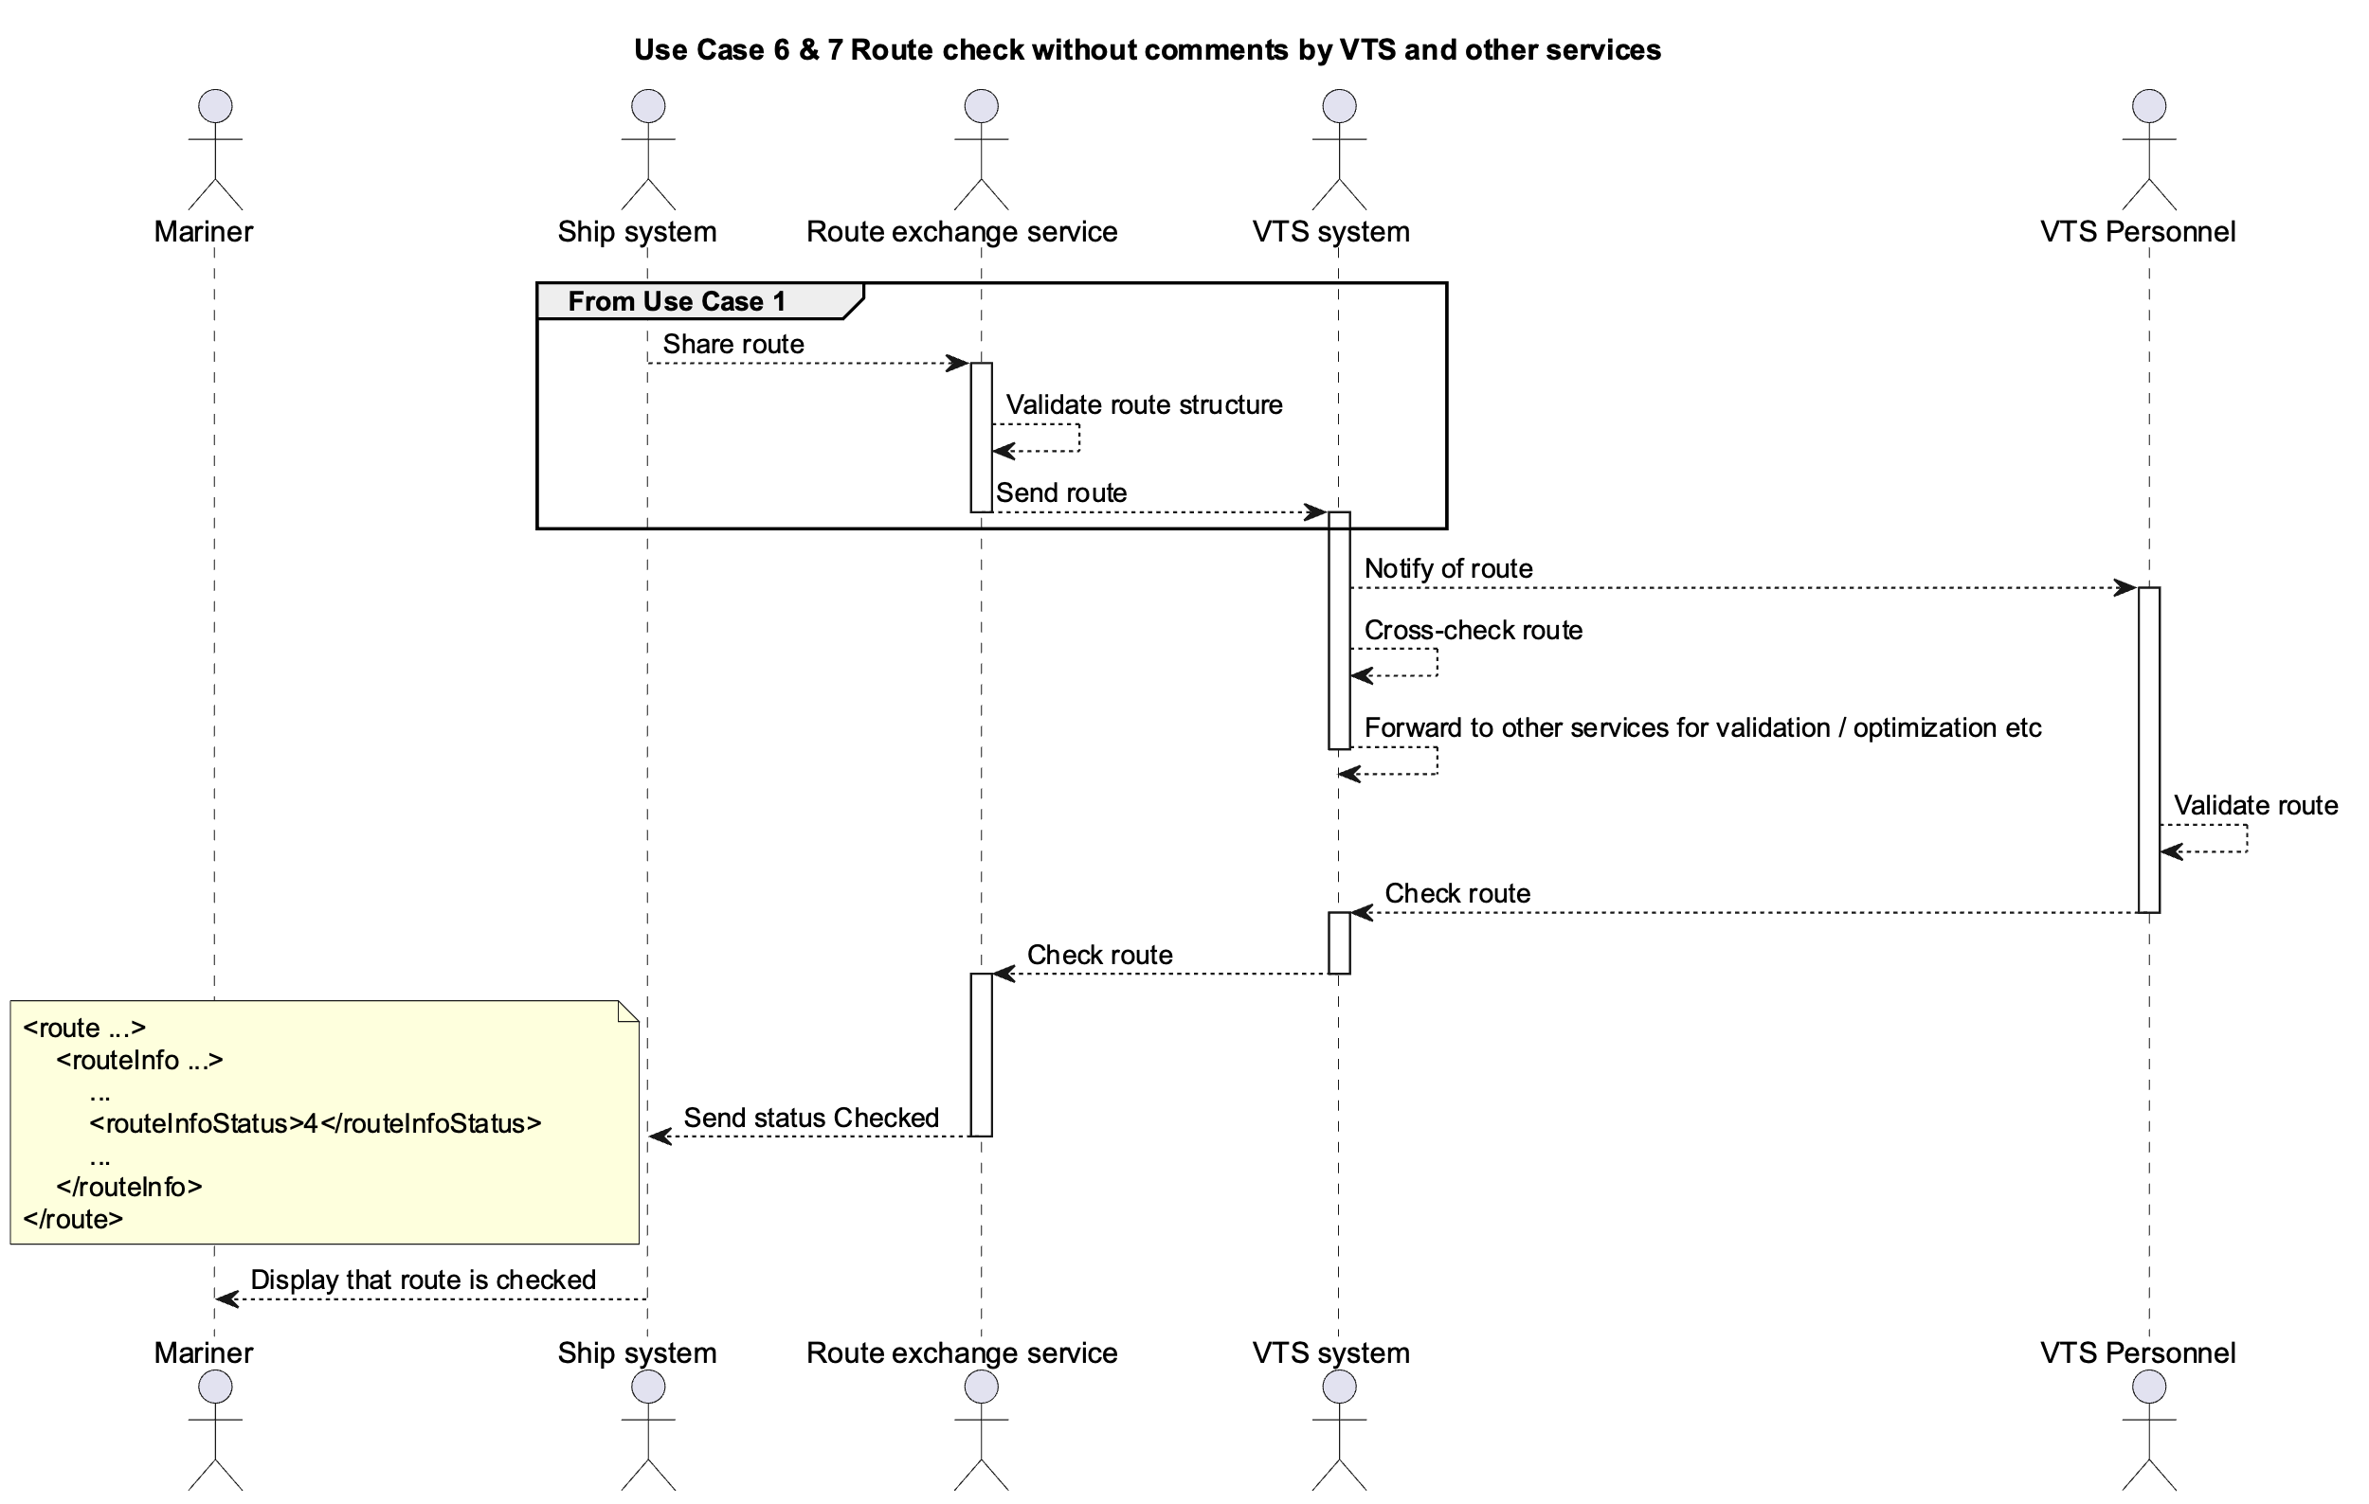
Figure 11 Route acknowledgement by VTS
If the reply to the route from VTS is not a checked route or does not contain a recommendation edited by VTS it must be a reply with adequate comments provided to describe what problems the route has so that the mariner is able to improve it for the next time it is shared. In this case the status of the route may be one of:
- Route issues
- Route incomplete
- Route errors
The description of the route must have a description of the issues found in the route preventing acknowledgment or giving a recommendation.
Additionally the routeWaypointLegIssue-element may and should be used to pinpoint any problems as accurately as possible.
The contents of both the description and leg issue must be human readable even if they are automatically generated.
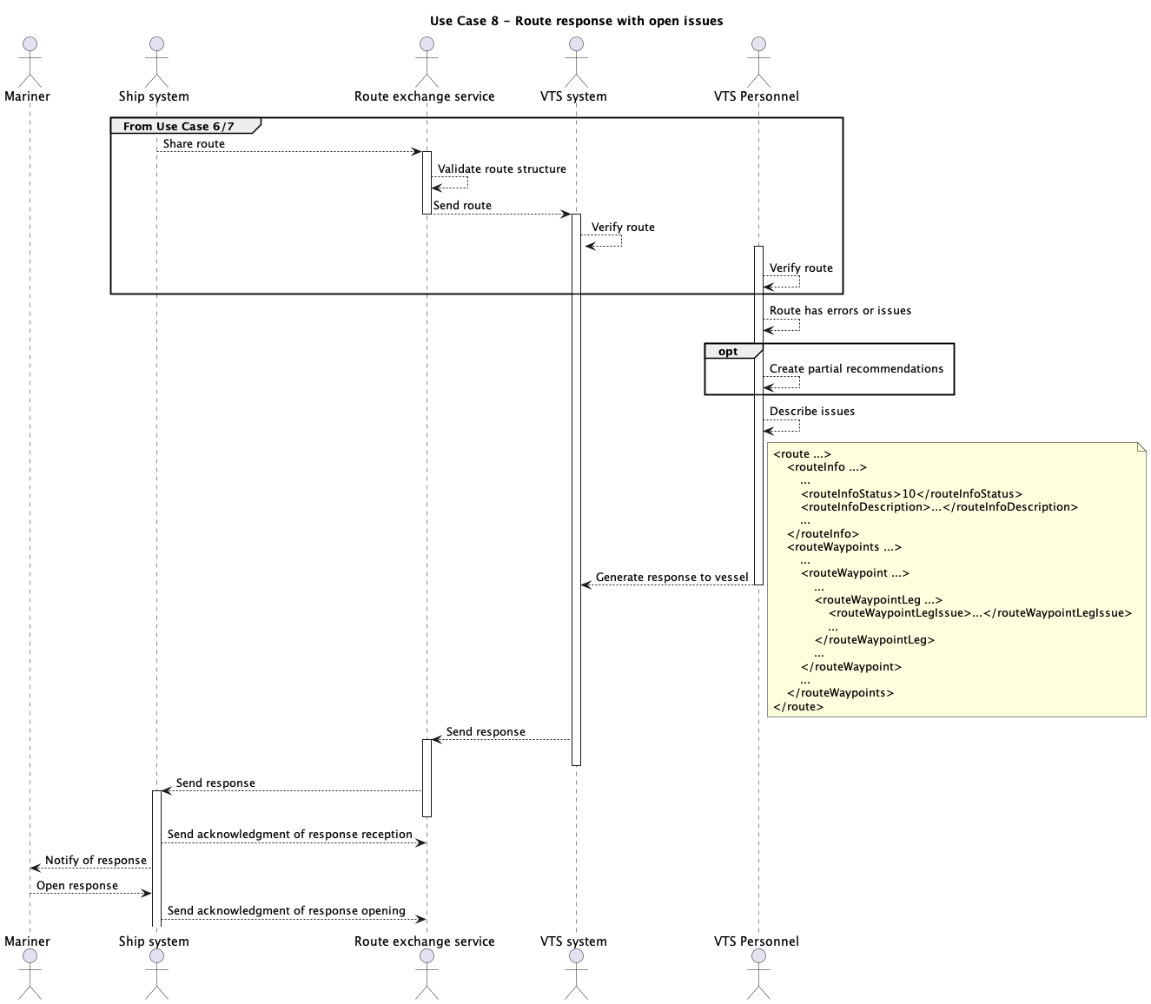
Figure 12 Route response from VTS to vessel with open issues

Route request from VTS without a shared route
Consumer support for this use case is optional.
In case the vessel has not shared its route with VTS and VTS has the need to get the route from the vessel there must be a mechanism in place for VTS to request the active route from the vessel.
Consumers compliant with this specification can support this functionality but it may be disabled by a setting and by not registering the consumer in any maritime service registry.
If the consumer supports automated requests for the active route, the consumer must be registered in a maritime service registry to facilitate endpoint discovery. In this case, it is up to the consumer to ensure adequate protection is in place to prevent unauthorised use of the interface and avoid showing route requests from malicious parties. If request is automatically denied, an adequate error response depending on service design must be returned.
Ship systems must require an approval for sharing the route from the mariner. If approval is granted, follow the sequence from 6.2.
If request is denied either an appropriate error message must be returned based on service design or a dummy route with only the following elements must be returned:
- The route and routeInfo element and their required attributes
- The routeInfo element contains
- Vessel identification as required
- All elements required by schema
- routeInfoStatus as checked
- No waypoints or actionPoints are allowed.
The response must also signify that it is in response to a previous request from VTS to receive the active route of the vessel.
If the vessel does not support automated requests for route, the VTS system must have the ability to prompt the VTS operator to request the route via radio or other communication method. In this case the mariner must be able to share the route from the ECDIS with the current status (used for monitoring) set correctly.
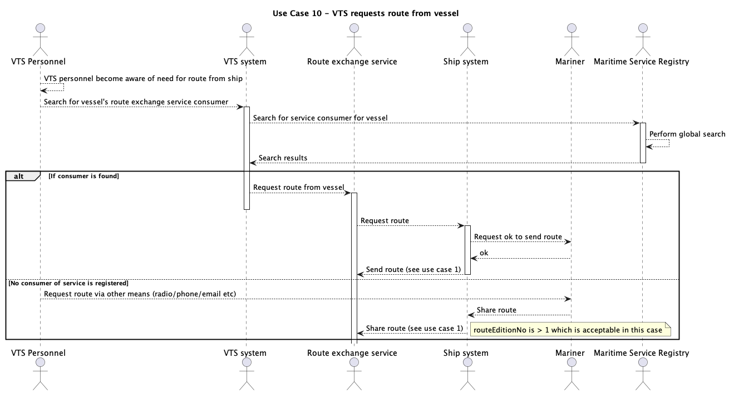
Figure 13 Requesting route from vessel

Route request from VTS after route has been shared
Consumer support for this use case is optional.
ECDIS can support an interface through which the currently monitored route can be requested by the service to get an updated version of the monitored route to display in VTS systems. This request can be automatically processed by ECDIS and the updated route can be shared without mariner interaction.
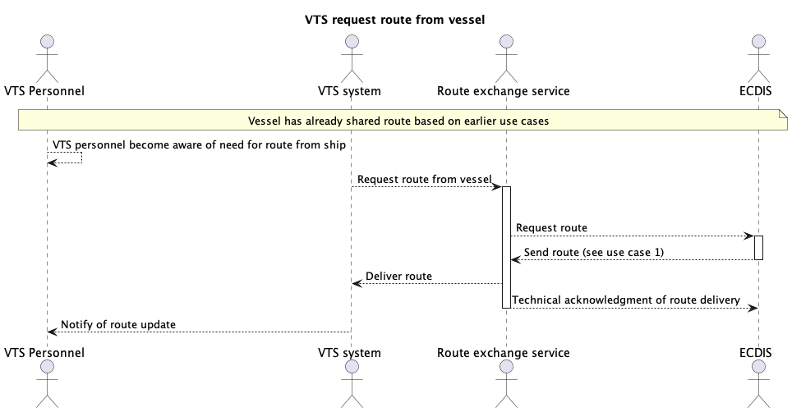
Figure 14 Requesting updated route from vessel

Using a route reference library
VTS may provide a library of reference routes to aid mariners in planning routes. The routes in the reference library may be incomplete but must comply with the requirements in RESF011.
The consumer must support the functionality to retrieve routes from a reference library. This includes the ability to determine whether the service supports the reference library feature or not. The actual mechanism of this is described in the service design.
If a route library is provided, the service must support searching for routes from the library with any combination of the following logical parameters:
- Validity period with any combination of validFrom and validTo set. These must be DateTimes in the format [YYYYMMDD]T[HHMMSS]Z. The timezone must always be UTC as shown in the format string.
- Geometry of the area where routes are searched. The results must include all routes that intersect with the given geometry.
- UN/Locode of the location
- A reference to the route if known. This is used when vessel is checking for updates to the route in the library.
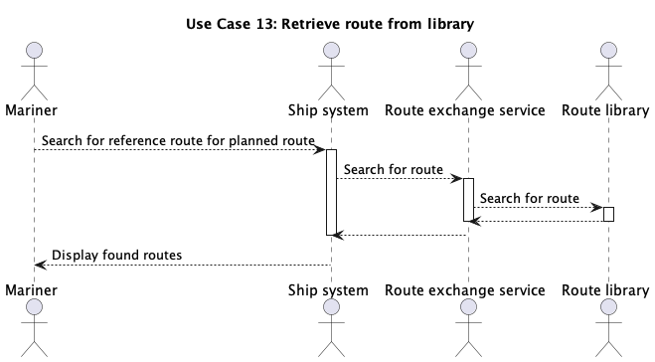
Figure 15 Route library usage flow

Service discovery

The method for service discovery using maritime service registries (MSRs) is described in more detail in G1128.
To allow service discovery in the maritime domain, the service must be registered in a maritime service registry that participates in the global search.
If the consumer allows automated requesting of route, it must be discoverable in a MSR that participates in global search.
The consumer must support searching for compatible instances of the service in MSRs by using the geometry of the route and an applicable version of a service design based on this specification. The geometry of the route may be simplified if required.
The service must support searching for consumers based on the vessel’s MRN; or IMO or MMSI number.
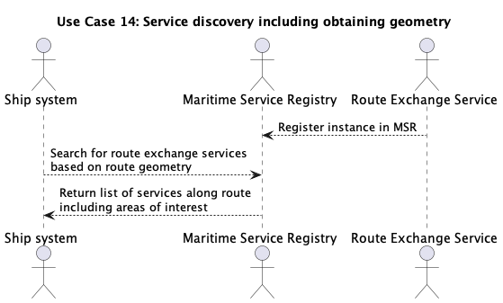
Figure 16 Service discovery flow

Definitions

Operational Node | A logical entity that performs activities. Note: nodes are specified independently of any physical realisation.  Examples of operational nodes in the maritime context are: Maritime Control Centre, Maritime Authority, Ship, Port, Weather Information Provider, etc.
Service | The provision of something (a non-physical object), by one, for the use of one or more others, regulated by formal definitions and mutual agreements. Services involve interactions between providers and consumers, which may be performed in a digital form (data exchanges) or through voice communication or written processes and procedures.
Service Consumer | A service consumer uses service instances provided by service providers. All users within the maritime domain can be service customers, e.g., ships and their crew, authorities, VTS centres, organizations (e.g., meteorological), commercial service providers, etc.
Service Data Model | Formal description of one dedicated service at logical level. The service data model is part of the Service Specification. Is typically defined in UML and/or XSD. If an external data model exists (e.g., a standard data model), then the service data model shall refer to it: each data item of the service data model shall be mapped to a data item defined in the external data model.
Service Interface | The communication mechanism of the service, i.e., interaction mechanism between service provider and service consumer. A service interface is characterised by a message exchange pattern and consists of service operations that are either allocated to the provider or the consumer of the service.
Service Operation | Functions or procedure which enables programmatic communication with a service via a service interface.
Service Provider | A service provider provides instances of services according to a Service Specification and service instance description. All users within the maritime domain can be service providers, e.g., authorities, VTS centres, organizations (e.g., meteorological), commercial service providers, etc.

Abbreviations

API Application Programming Interface
MRN Maritime Resource Name
MSR Maritime Service Registry
VTSO VTS Operator
XML Extendible Mark-up Language
XSD XML Schema Definition

References

- IALA. 2024. Guideline G1128 The Specification of e-Navigation Technical Services
- IALA. 2022. Guideline G1143 Unique Identifiers for Maritime Resources (MRN)
- IALA. 2022. Guideline G1183 Provision of MCP Identities
- IHO. 2024. Universal Hydrographic Data Model Standard S-100 5.2.0
- IEC. 2021. 63173-1 S-421 Route Plan based on S-100 Committee Draft 80/2542/PCC
- IEC. 2021. 63173-2 Secure communication between ship and shore (SECOM) Committee Draft 80/2532/PCC
- IACS. 2024. UR E26 & E27 Rev1 International Association of Classification Societies https://iacs.org.uk/resolutions/unified-requirements/ur-e
- IALA. 2022. Guideline G1111 Establishing Functional Performance Requirements
- IEC. 2024. 61174-1 Electronic chart display and information system (ECDIS) – Operational and performance requirements, methods of testing and required test results IEC TC80 MT7 December 2024 meeting outcome
- IMO. 2024. MSC.530(106)/Rev.1 Performance Standards For Electronic Chart Display And Information Systems (ECDIS) https://docs.imo.org/Shared/Download.aspx?did=151274
- IMO 2024. MSC.1/Circ.1610/Rev.1 INITIAL DESCRIPTIONS OF MARITIME SERVICES IN THE CONTEXT OF E-NAVIGATION https://docs.imo.org/Shared/Download.aspx?did=150086

Author to insert actual service name and version number

