Title of IALSA Analysis Project: Study Name
Authors

Word count (for the main text):

Address correspondence regarding this manuscript to:

Abstract

Objectives.
Method.
Results.
Discussion.
Keywords: (up to 5 keywords)

Introduction

Method
Data
Data for this study

Measures
Physical functioning
Pulmonary function (e.g., PEF, FEV).
Muscle strength (e.g., Grip strength, Leg extension).
Walking speed time.
Chair rise time.
Flamingo stand time.
Summary measures of physical functioning.
Cognitive functioning
Knowledge.
Reasoning.
Speed.
Visuospatial ability.
Executive functioning.
Mental status.
Basic Covariates
Age (at baseline) and age-squared.
Age at death.
Sex.
Education.
Socioeconomic status / socioeconomic position.
Marital status.
Height.
Weight.
BMI (calculated).
Additional Covariates
Smoking history (current, former, never; pack-years).
Alcohol intake.
Computer experience.
Physical activity (current, time-varying; all available scales and indices).
Muscle strength (e.g., grip).
Blood pressure.
Depressive symptoms.
Medical conditions (including cardiovascular disease / heart attack, diabetes, and conditions associated with a chronic physical illness index (comprised of angina, heart attack, congestive heart failure, diabetes or high blood sugar, a stroke, chronic lung disease, arthritis or rheumatism, or cancer; see Gale et al. 2014)
Exclusion criteria. (diagnosis of dementia, Parkinsons, or other neurodegenerative disorder; serious memory impairment)

Results
Descriptive Statistics

Multivariate Analyses of Change

Discussion

Funding. This work was supported in part by the National Institute on Aging of the National Institutes of Health under award number P01AG043362 for the Integrative Analysis of Longitudinal Studies of Aging and Dementia (IALSA) research network. The content is solely the responsibility of the authors and does not necessarily represent the official views of the National Institutes of Health.
Acknowledgements.
Conflict of Interest. The authors report no conflict of interest.

References

Table 1 (template from Emery et al., 2012)
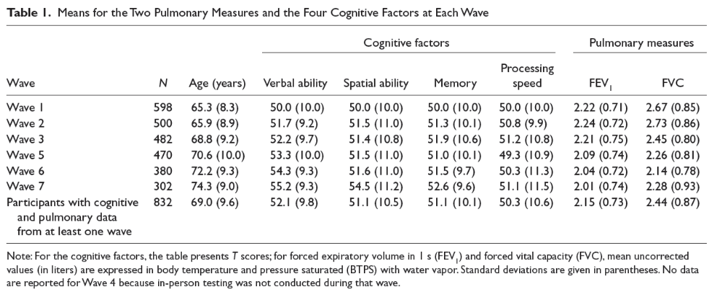

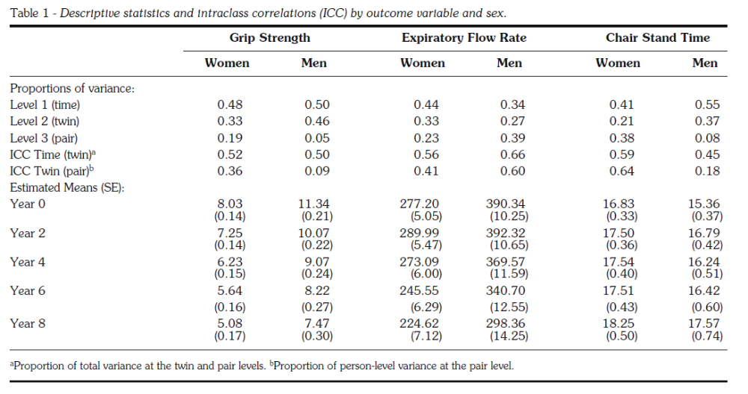
Table 2. Parameter Estimates and Fit Statistics from the Linear Latent Growth Model (age conditional only; see Supplementary materials for full Empty/Linear/Quadratic LGM estimates for fully conditional models)
Modify table format below for LGM model parameters
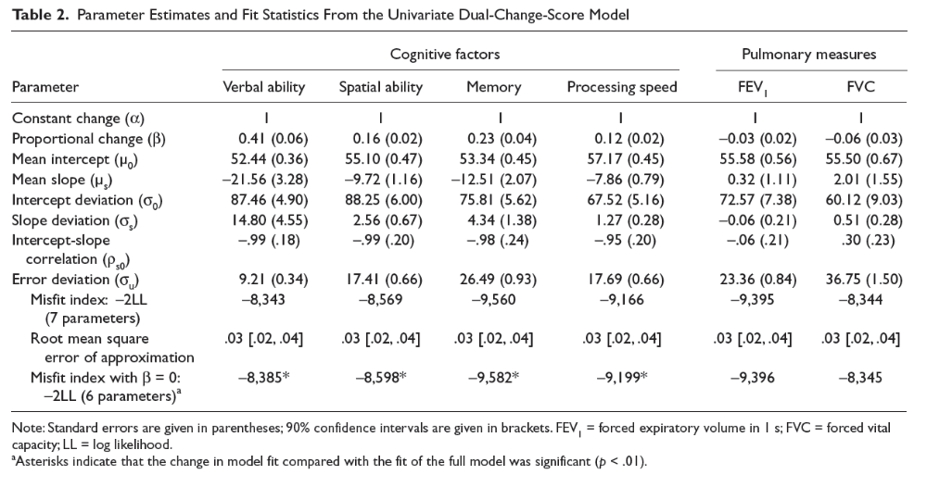

Table 3. Random Effects Correlation Estimates
Scales | Level |  | Slope |  | Occasion-Specific Residual
 | Age Only | Fully Cond | Age Only | Fully Cond | Age Only | Fully Cond
A with…
CD | 0.50 | 0.49 | 0.53 | 0.52 | 0.39 | 0.39
D | 0.50 | 0.48 | 0.47 | 0.44 | 0.42 | 0.42
SA | 0.37 | 0.47 | 0.46 | 0.43 | 0.38 | 0.38
SR | 0.46 | 0.50 | 0.39 | 0.44 | 0.31 | 0.31
CD with…
D | 0.60 | 0.57 | 0.80 | 0.81 | 0.50 | 0.50
SA | 0.46 | 0.64 | 0.85 | 0.83 | 0.52 | 0.52
SR | 0.42 | 0.52 | 0.56 | 0.57 | 0.40 | 0.40
D with…
SA | 0.42 | 0.62 | 0.87 | 0.88 | 0.61 | 0.61
SR | 0.34 | 0.43 | 0.57 | 0.62 | 0.39 | 0.39
SA with…
SR | 0.67 | 0.66 | 0.56 | 0.57 | 0.45 | 0.46

Note. All associations are statistically significant at the p < .01 level.
Figure Caption
Figure 1.

Supplementary Material
Table 1. Descriptive Statistics for Covariates at Baseline Assessment (From Gale et al., 2014)
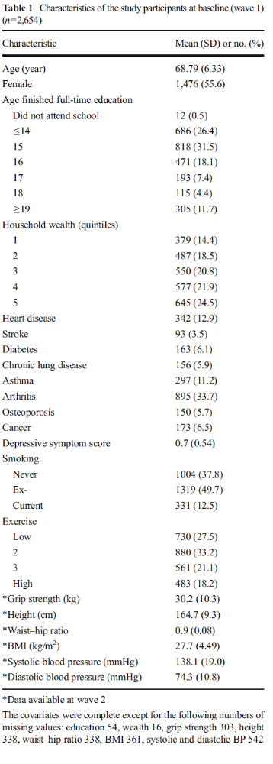

Table 2. Table 2. Fixed and Random Effects Estimates for the Linear Time-Based Model conditional on covariates
Table 3. Table 2. Fixed and Random Effects Estimates for the Quadratic Time-Based Model conditional on covariates

