Methods

Coordinated Analysis with Replication (CAR or CAWR)

[Briefly, what CAR is]

The coordinated analysis with replication (Hofer & Piccinin, 2009) is an alternative method to data-pooling and meta-analysis, which relies on conducting parallel analyses of independent longitudinal studies without sharing any person-level data. Instead of focusing on harmonizing the measures from different studies so that they can be combined into a single data frame for analysis, CAR coordinates statistical modeling on idiosyncratic data sets and compares the model estimates across studies and condition.

[Benefits of coordinated replication]

This section describes the coordinated analysis with replication (CAR) approach: a vehicle for organizing and implementing a large-scale replication of longitudinal analyses across multiple studies.  The CAR method aims to gather corroborating evidence for a broad hypothesis from multiple data sources. For example, the hypothesis "decline in pulmonary function is associated with decline in perceptual speed" may be tested by observing a statistical relationship between the trajectories of peak expiratory flow (**pef**) and performance on the symbol substitution task (**symbol**) in the data from Einstein Aging Study (**EAS**). The conclusion, however, even though supported by statistical significance, would be limited to specific operationalizations and samples. However, if statistical significance holds across other operationalizations of the pulmonary function (e.g. forced expiratory flow) and perceptual speed (e.g. number comparison), and shows consistency across various samples (e.g. LASA, SATSA, ELSA, etc.) this would constitute a strong evidence of effect and solid defense against replication bias.

Procedures

[What happened: overview]

In February of 2015 IALSA conducted a collaborative workshop in Portland, OR, bringing together the data from nine longitudinal studies[*1]. Each of the study asked its data the same question: *is decline in physical abilities related to the decline in cognitive abilities as people age in later life*? The identical statistical operationalization of this question tested the data from each study: the bivariate growth curve model. While sharing no person-level data, each study submitted the results of model estimation (namely, Mplus output files) to the collective. The model pool, hosted in a public cloud location for transparency and accountability, counted over 1000 outputs, pairing 3 physical measures (pulmonary function, gait speed, and grip strength) with more than 50 different cognitive tests (e.g. mmse, block design, line orientation, etc.). The current paper uses the models that involved bivariate models pairing a pulmonary measure (forced expiratory volume and peak expiratory flow) with a measure of cognitive performance.

[ Three days of the workshop ]

The workshop took place over the course of 3 days. The first day consisted of a series of brief lectures on methodology of bivariate growth fitting, software demonstrations, and discussion of data idiosyncrasies in each study. While the general blueprint was laid out months before the event, many of the technical decisions had to be made on site, taking the advantage of the speedy feedback loop among the participants and organizers. The second day was dedicated almost entirely to model estimation. The participants manually adjusted the prototypical Mplus automation script to various modeling conditions, supervised the estimation, checked the output for errors, addressed the discovered issues, and pushed the text files with model solutions to the cloud storage location in the dedicated github repository. The third day involved evaluating the workshop, identifying the remaining issues, sketching the manuscripts, and planning for the follow up meetings.

[Statistical model ]

A multilevel bivariate growth curve model was used to operationalize the relationship between two processes. The general specification of the model is given in Figure X. The parameters of the particular interest are indices that quantify the variances of random intercept ( ), random slope (), and the residual () components. The statistical significance of indicates that the within-person changes of these two processes are related, supporting the hypothesis of concomitance. In order to compare the effects across different studies that varied in sample size and the metric of the measures, we have converted covariances into correlations during the estimation step.

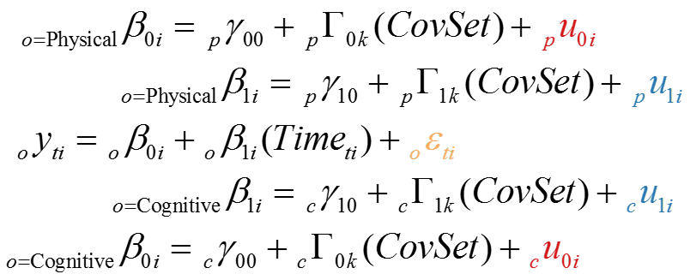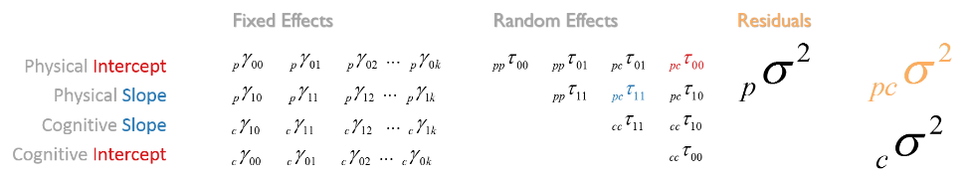

[Figure X : General specification of a bivariate growth curve model used in replication]

[Subgroups and covariates]

Based on the existing literature on cognitive decline and the availability of measures in all 9 participating longitudinal studies, we have identified seven covariates which can be applied consistently across all samples: sex, age, education, height, smoking, cardio, and diabetes. Given substantial differences between the sexes on some physical measures we have decided to enter this covariate as a subgroup membership: parameters were estimated separately for men and women. [Andrea, Graciela, please double-check my reconstruction of this decision, I’m not entirely sure in its accuracy]. The metrics and centering points of each covariate is given in table Y.

[Table Y : metrics and center points of covariates used in models ]

|  |  |  |  |
| --- | --- | --- | --- |
| *Covariate* | *Metric* | *Center* | *Notes* |
| Age | Years of life | 70 |  |
| Education | Years of education | 7 |  |
| Height | Centimeters | Men = 172, Women = 160 |  |
| Smoking | Yes/No | n/a | Ever smoked at the time of study’s entry? |
| Cardio | Yes/No | n/a | Ever diagnosed with cardiovascular disease at the time of study’s entry? |
| Diabetes | Yes/No | n/a | Ever diagnosed with diabetes mellitus at the time of study’s entry? |