Tables & Graphs

This report displays the results for two Growth Curve Mixture models with two latent classes from OCTO-Twin and Newcastle 85+ studies,

# Table of Results

|  |  |  |  |  |  |
| --- | --- | --- | --- | --- | --- |
| effect | label | dense | dense | dense | dense |
|  |  | Newcastle 85+ | Newcastle 85+ | OCTO-Twin | OCTO-Twin |
|  |  | Fast decliners | Slow decliners | Fast decliners | Slow decliners |
|  |  | (N= 317, 80%) | (N= 81, 20%) | (N= 177, 31%) | (N= 393, 69%) |
| Fixed effects | Intercept | 27.79( .80), <.001 | 23.49(2.48), <.001 | 22.31(4.64), <.001 | 26.57(1.08), <.001 |
| Fixed effects | Female | .23( .38), .54 | -2.01(1.35), .14 | -.79(1.54), .61 | .36( .32), .27 |
| Fixed effects | Dementia | -5.20( .71), <.001 | -4.45(1.72), .01 | -5.51(1.67), .00 | -3.73( .62), <.001 |
| Fixed effects | Education | .45( .14), .00 | .81( .54), .13 | -.47(1.76), .79 | .17( .07), .01 |
| Fixed effects | Years to death from study entry | .51( .18), .01 | 2.57( .56), <.001 | .68( .36), .06 | .21( .08), .01 |
| Fixed effects | Higher Social Class | -.51( .42), .22 | -1.70(2.29), .46 | -.90(2.11), .67 | .09( .32), .79 |
| Fixed effects | Age at study entry | -.44( .55), .42 | -1.00(1.37), .47 | -.47( .29), .10 | -.24( .06), <.001 |
| Fixed effects | Linear slope | -1.16( .51), .02 | -10.98(1.25), <.001 | -2.08(1.86), .26 | -.75( .34), .02 |
| Fixed effects | Linear slope *Female | -.23( .21), .28 | .14( .79), .86 | -.08( .46), .86 | .11( .19), .57 |
| Fixed effects | Linear slope *Dementia | -.78( .41), .06 | -.56( .71), .43 | -.90( .50), .07 | -1.58( .40), <.001 |
| Fixed effects | Linear slope *Education | .10( .08), .20 | .17( .23), .44 | -.31( .43), .48 | .03( .04), .41 |
| Fixed effects | Linear slope *Years to death from study entry | -.07( .08), .33 | -1.22( .22), <.001 | -.19( .20), .36 | .03( .02), .15 |
| Fixed effects | Linear slope *Social class | -.45( .23), .05 | -2.35( .95), .01 | -.32( .78), .68 | .05( .11), .68 |
| Fixed effects | Linear slope* age at study entry | .06( .28), .83 | .11( .72), .88 | -.03( .12), .78 | -.04( .06), .52 |
| Fixed effects | Quadratic slope |  |  | -.15( .19), .42 | -.10( .03), <.001 |
| Fixed effects | Quadratic slope *Female |  |  | -.01( .04), .69 | .01( .03), .65 |
| Fixed effects | Quadratic slope *Dementia |  |  | -.05( .06), .44 | -.14( .04), .00 |
| Fixed effects | Quadratic slope *Education |  |  | -.02( .02), .29 | .00( .00), .61 |
| Fixed effects | Quadratic slope *Years to death from study entry |  |  | -.03( .01), .02 | -.00( .00), .44 |
| Fixed effects | Quadratic slope *Social class |  |  | -.04( .07), .60 | .01( .01), .62 |
| Fixed effects | Quadratic slope* age at study entry |  |  | -.00( .01), .91 | -.00( .01), .74 |
| Residual variances | Intercept | 5.77( .90), <.001 | 5.77( .90), <.001 | 5.42(1.59), .00 | 5.42(1.59), .00 |
| Residual variances | Linear slope | .15( .15), .31 | .15( .15), .31 | .42( .13), .00 | .42( .13), .00 |
| Residual variances | Quadratic slope |  |  | .00( .00), .16 | .00( .00), .16 |
| Residual variances | Error | 2.91( .42), <.001 | 14.09(2.87), <.001 | 25.94(3.87), <.001 | 1.40( .43), .00 |

# Figure 1

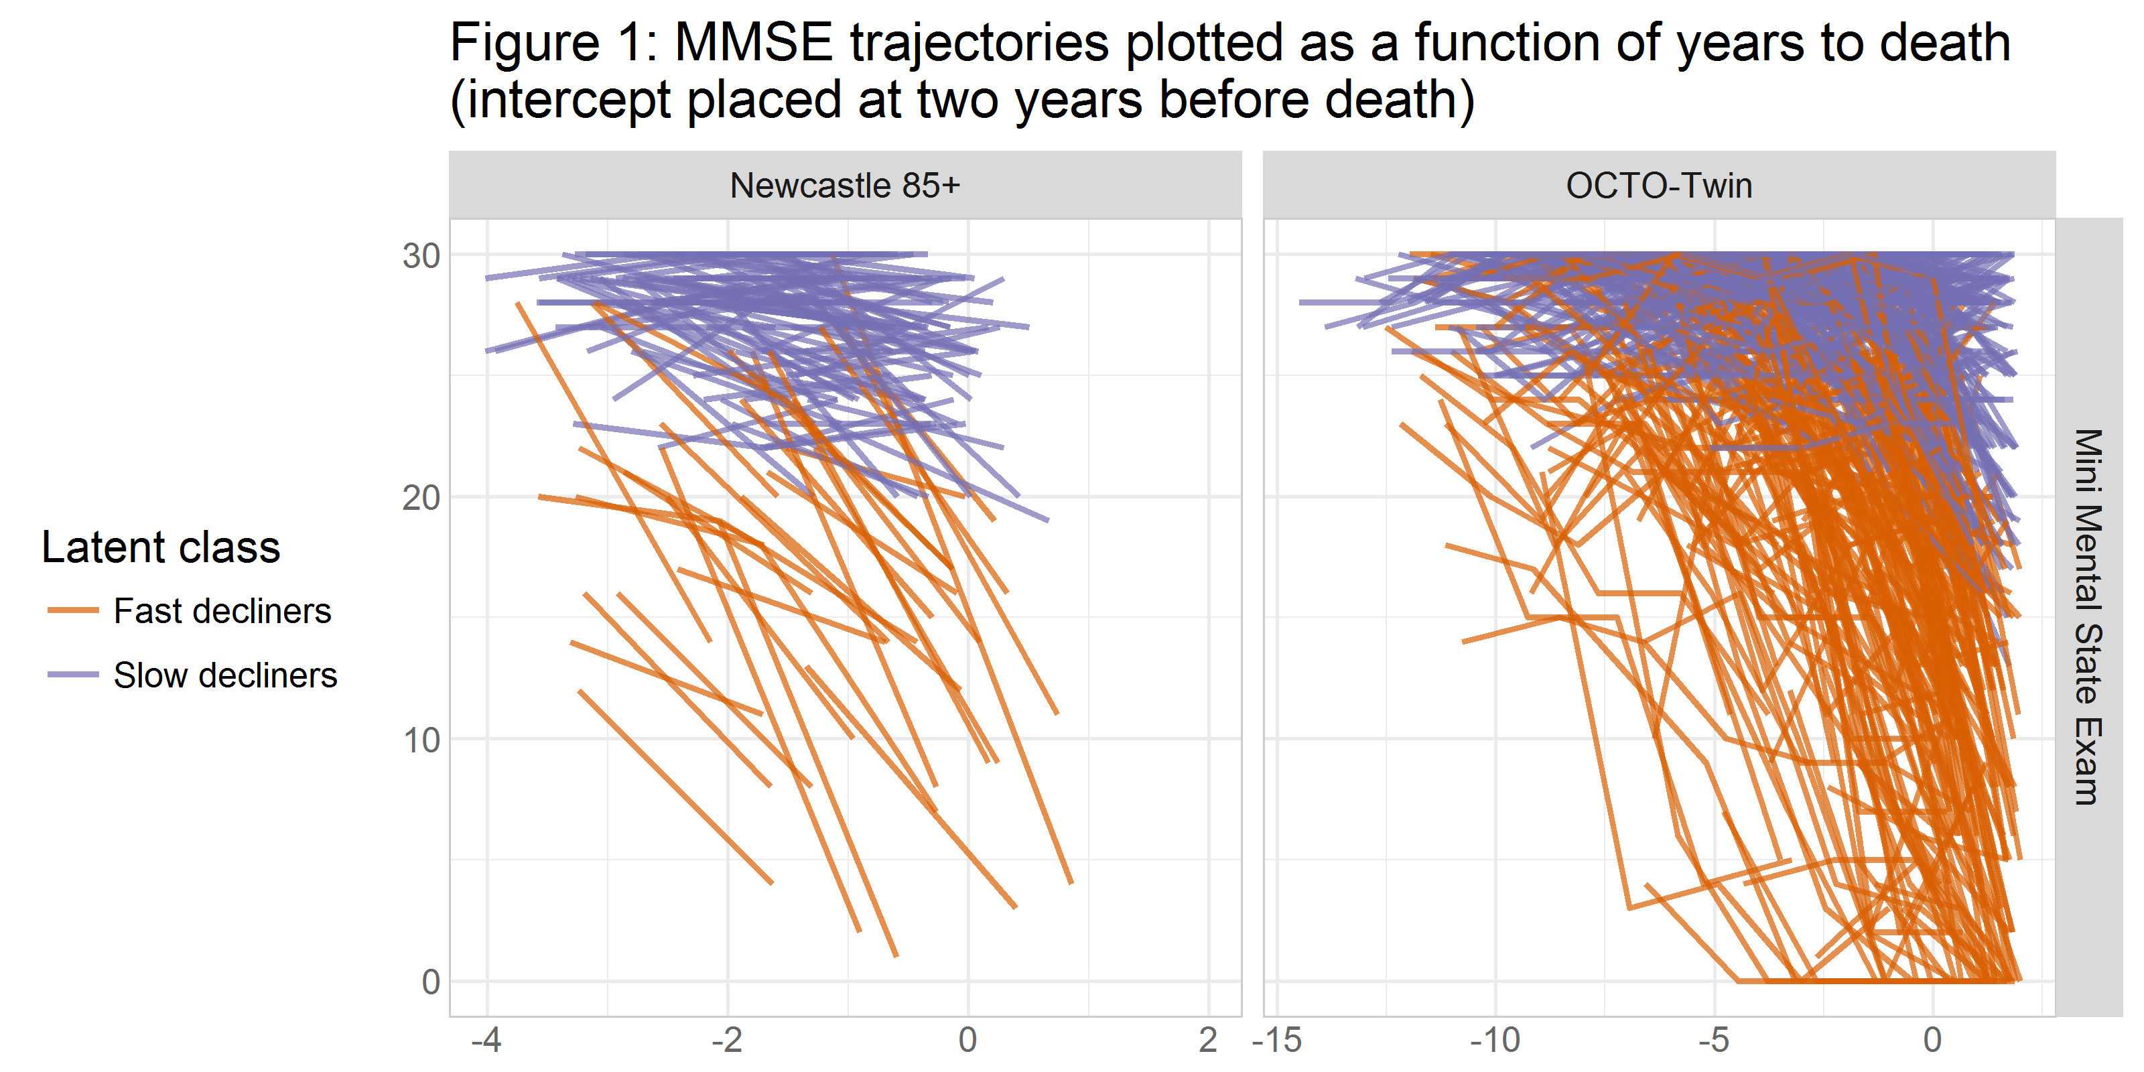

## By Gender

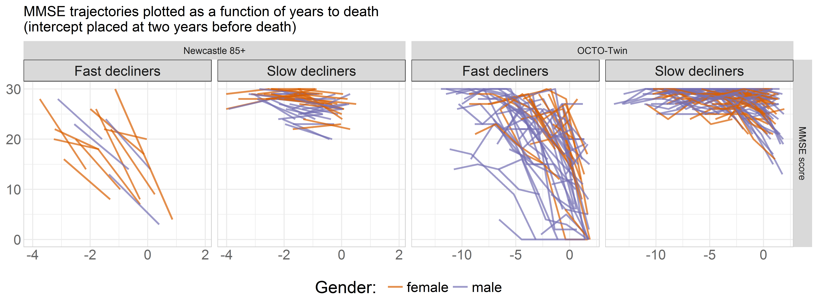

## By SES

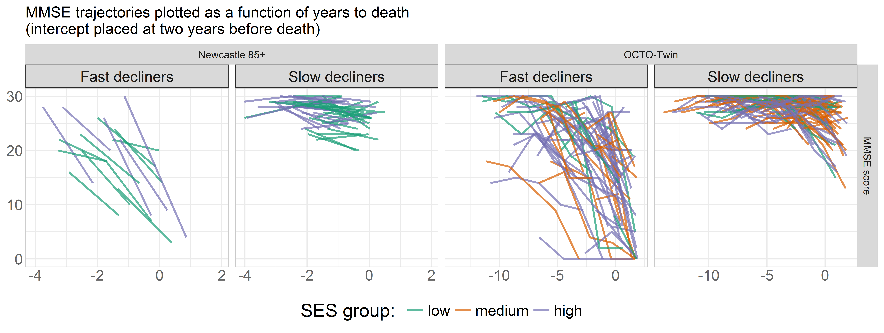

## By Education

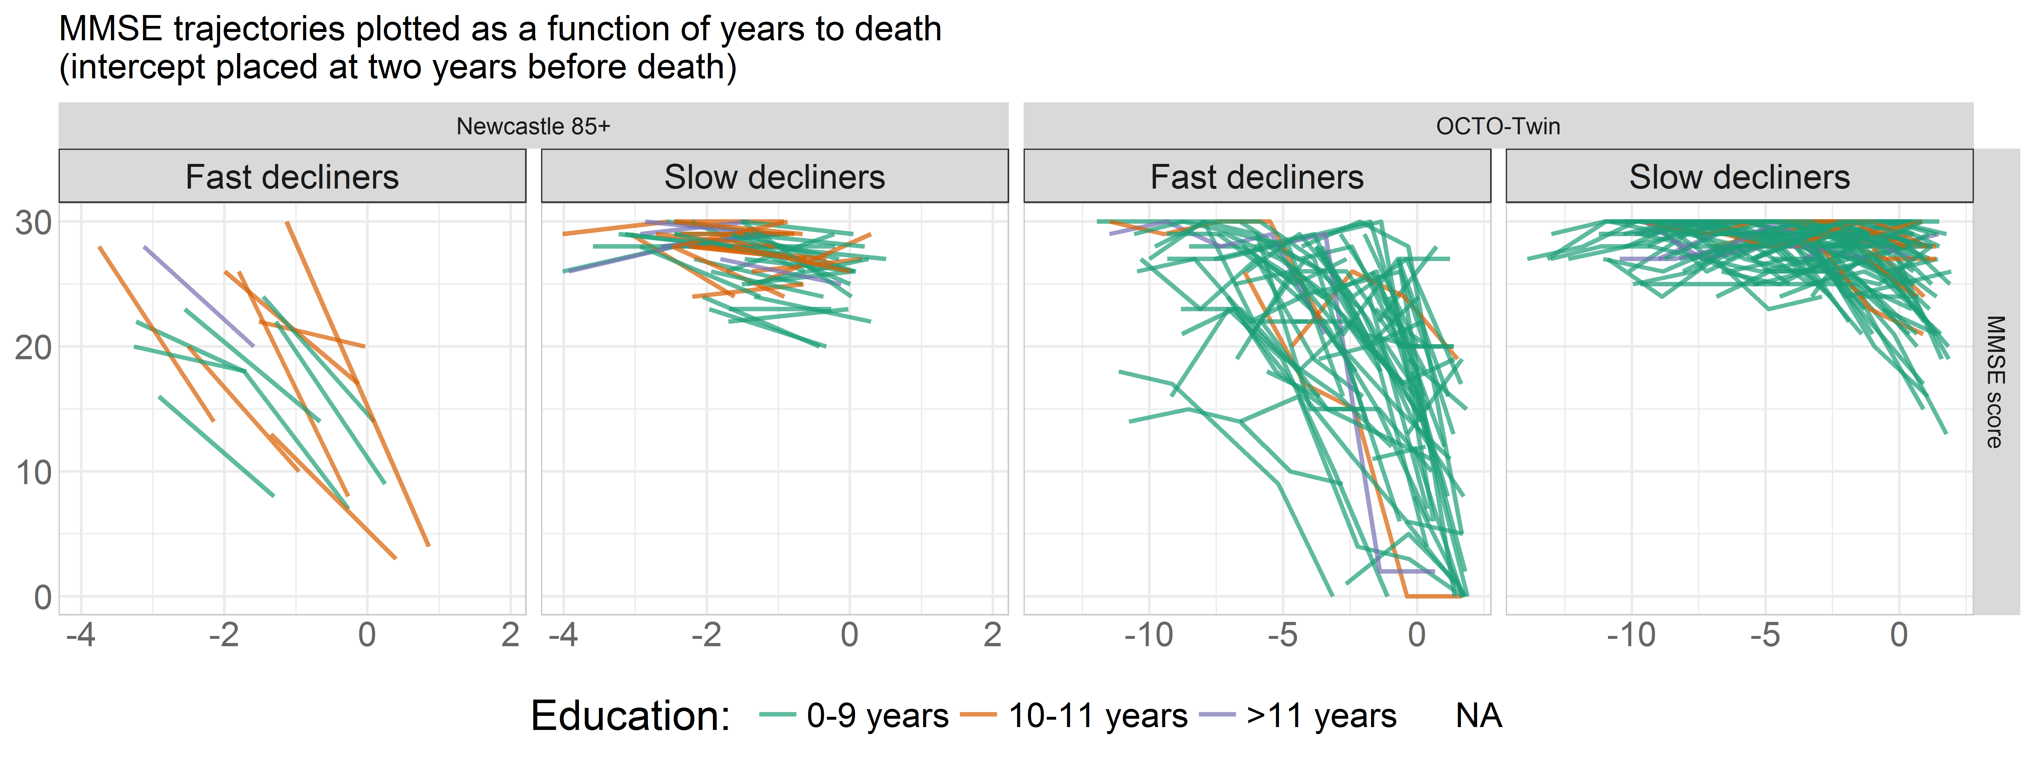

## By Dementia

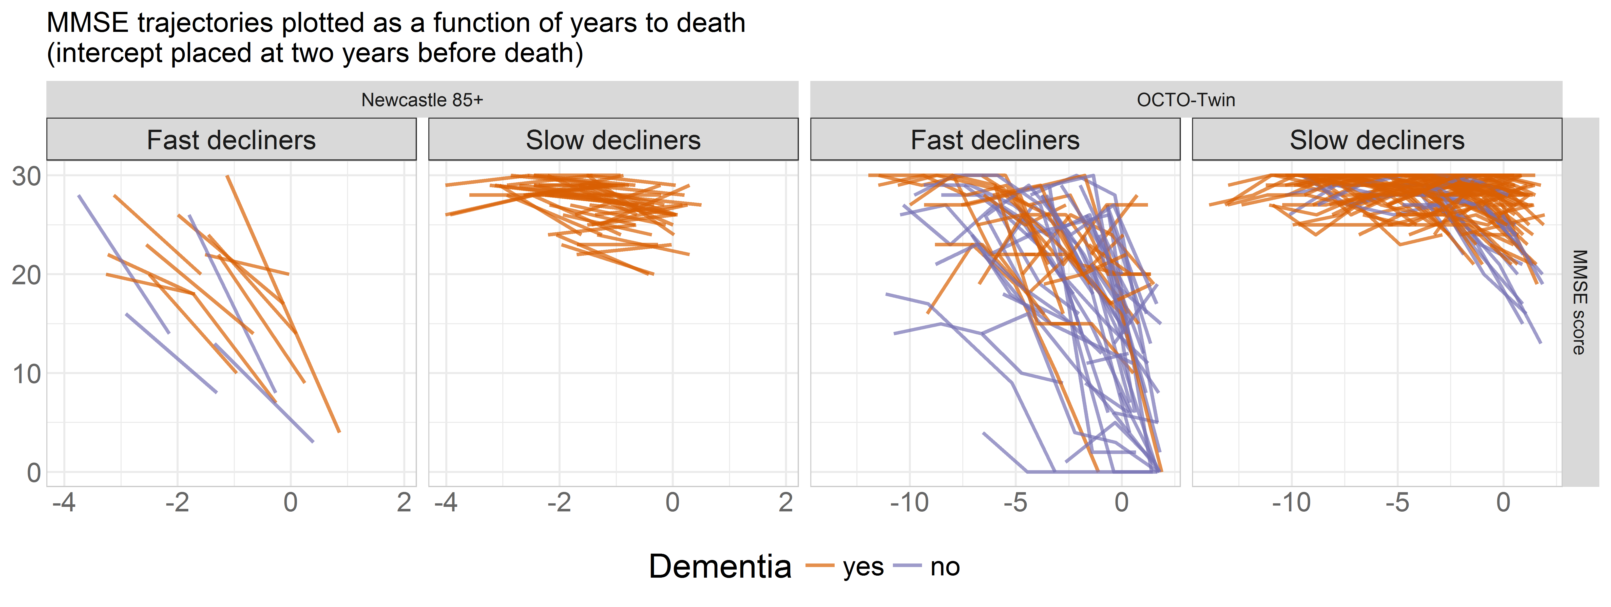

# Figure 2

