Tables & Graphs

This report displays the results for two Growth Curve Mixture models with two latent classes from OCTO-Twin and Newcastle 85+ studies,

# Table of Results

|  |  |  |  |  |  |
| --- | --- | --- | --- | --- | --- |
| effect | label | dense | dense | dense | dense |
|  |  | Newcastle 85+ | Newcastle 85+ | OCTO-Twin | OCTO-Twin |
|  |  | Fast decliners | Slow decliners | Fast decliners | Slow decliners |
|  |  | (N= 291, 73%) | (N= 107, 27%) | (N= 386, 68%) | (N= 184, 32%) |
| Fixed effects | Intercept | 25.31( .66), <.001 | 10.44(2.96), <.001 | 26.33(1.51), <.001 | 21.10(10.64), .05 |
| Fixed effects | Female | -.01( .35), .98 | -2.53(1.37), .06 | .32( .77), .68 | -.73(2.67), .78 |
| Fixed effects | Dementia | -3.64( .80), <.001 | -6.37(1.80), <.001 | -3.81(1.01), <.001 | -5.96(1.82), .00 |
| Fixed effects | Education | .27( .13), .04 | -.08( .61), .89 | .17( .29), .54 | -.11(4.33), .98 |
| Fixed effects | Years to death from study entry | .42( .14), .00 | 2.51( .66), <.001 | .19( .06), .00 | .66( .26), .01 |
| Fixed effects | Higher Social Class | -.33( .39), .39 | 1.77(1.38), .20 | .04( .26), .87 | -.61(5.79), .92 |
| Fixed effects | Age at study entry | -.28( .45), .53 | -.39(1.50), .79 | -.25( .06), <.001 | -.48( .36), .18 |
| Fixed effects | Linear slope | -.54( .35), .12 | -2.66(1.76), .13 | -.77( .84), .36 | -2.17(4.98), .66 |
| Fixed effects | Linear slope *Female | -.21( .21), .30 | -.09(1.04), .93 | .08( .63), .89 | -.02(2.03), .99 |
| Fixed effects | Linear slope *Dementia | -.18( .44), .68 | -1.62( .98), .10 | -1.63( .54), .00 | -1.03( .45), .02 |
| Fixed effects | Linear slope *Education | .07( .07), .37 | -.22( .32), .49 | .04( .15), .82 | -.20(1.11), .85 |
| Fixed effects | Linear slope *Years to death from study entry | -.07( .08), .35 | -.53( .32), .09 | .03( .03), .38 | -.17( .16), .29 |
| Fixed effects | Linear slope *Social class | -.31( .23), .18 | -.44( .83), .59 | .04( .10), .68 | -.24(1.11), .82 |
| Fixed effects | Linear slope* age at study entry | .09( .24), .71 | .66( .95), .49 | -.04( .06), .54 | -.03( .17), .86 |
| Fixed effects | Quadratic slope |  |  | -.10( .05), .03 | -.16( .48), .74 |
| Fixed effects | Quadratic slope *Female |  |  | .01( .08), .90 | -.01( .40), .98 |
| Fixed effects | Quadratic slope *Dementia |  |  | -.15( .05), .00 | -.06( .06), .37 |
| Fixed effects | Quadratic slope *Education |  |  | .00( .02), .85 | -.02( .06), .76 |
| Fixed effects | Quadratic slope *Years to death from study entry |  |  | -.00( .00), .44 | -.03( .02), .21 |
| Fixed effects | Quadratic slope *Social class |  |  | .01( .01), .51 | -.04( .04), .32 |
| Fixed effects | Quadratic slope* age at study entry |  |  | -.00( .01), .76 | -.00( .01), .95 |
| Residual variances | Intercept | 3.70( .80), <.001 | 3.70( .80), <.001 | 4.86(1.48), .00 | 4.86(1.48), .00 |
| Residual variances | Linear slope | .32( .23), .16 | .32( .23), .16 | .39( .54), .47 | .39( .54), .47 |
| Residual variances | Quadratic slope |  |  | .00( .01), .66 | .00( .01), .66 |
| Residual variances | Error | 1.47( .38), <.001 | 22.24(4.01), <.001 | 1.30( .57), .02 | 25.83(5.96), <.001 |

# Figure 1

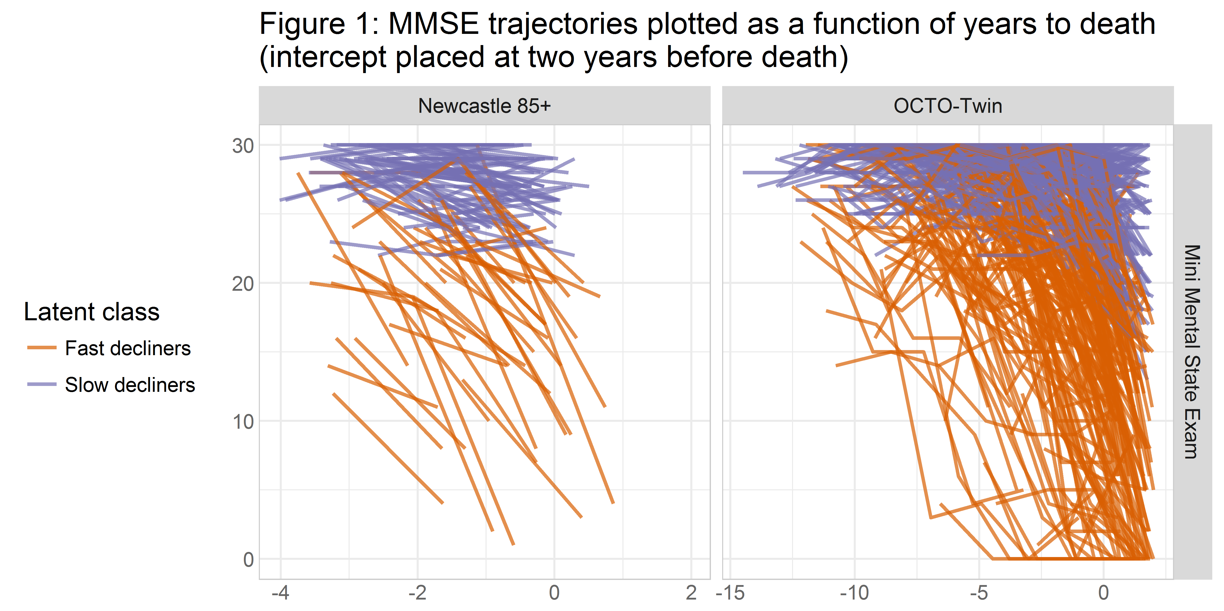

## By Gender

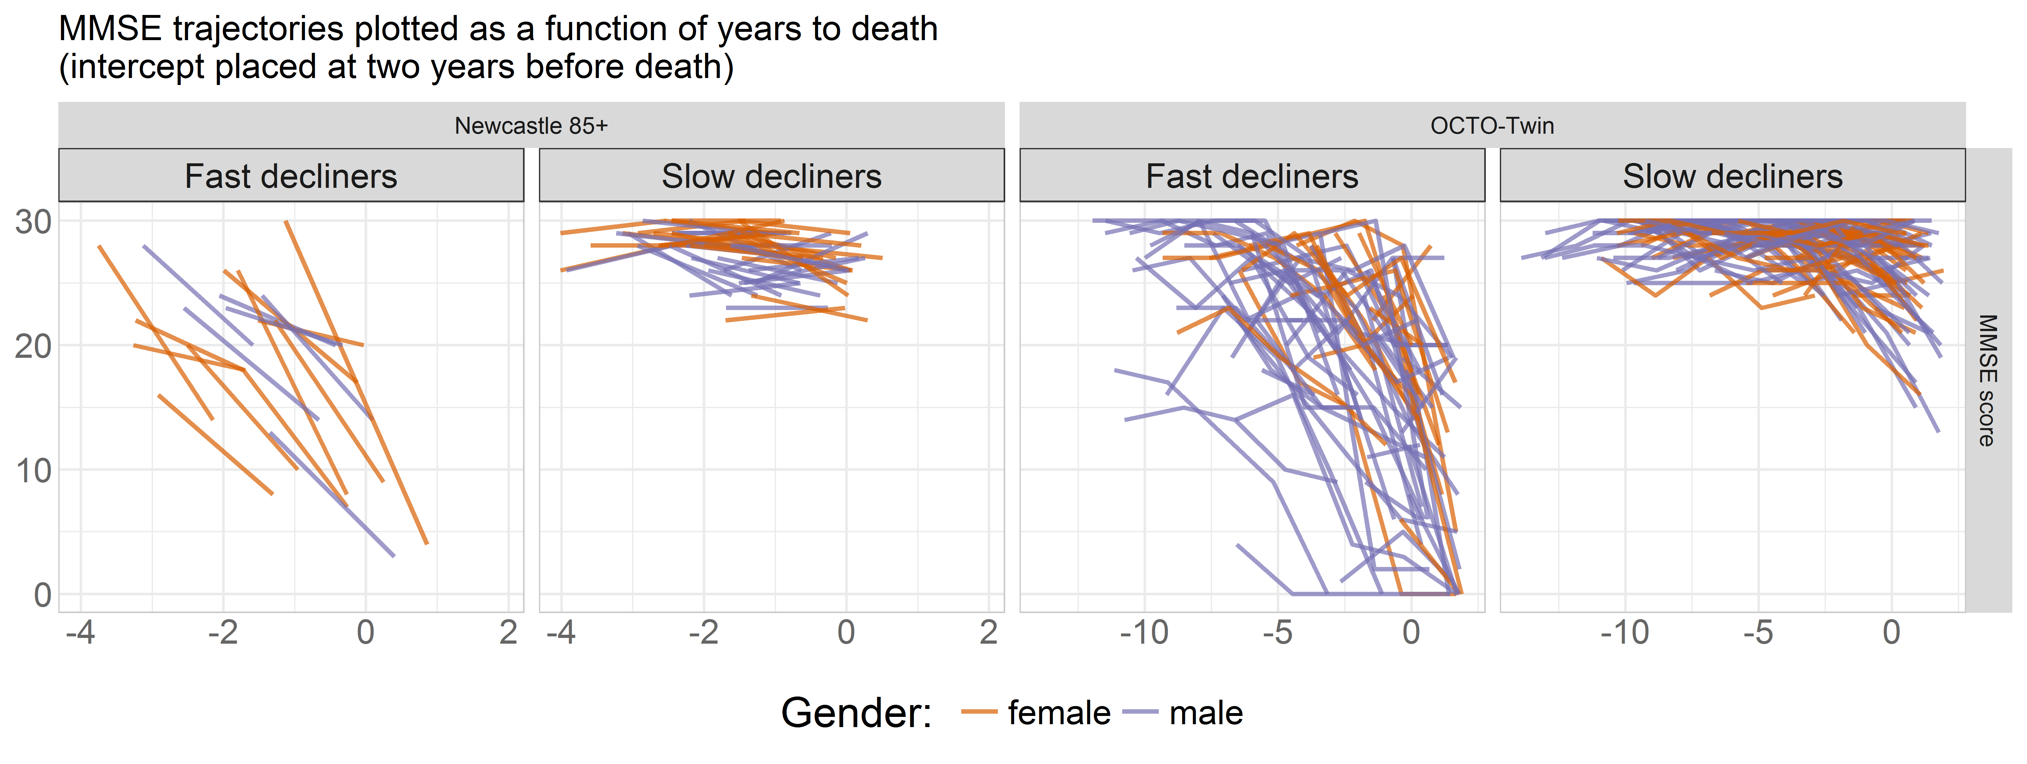

## By SES

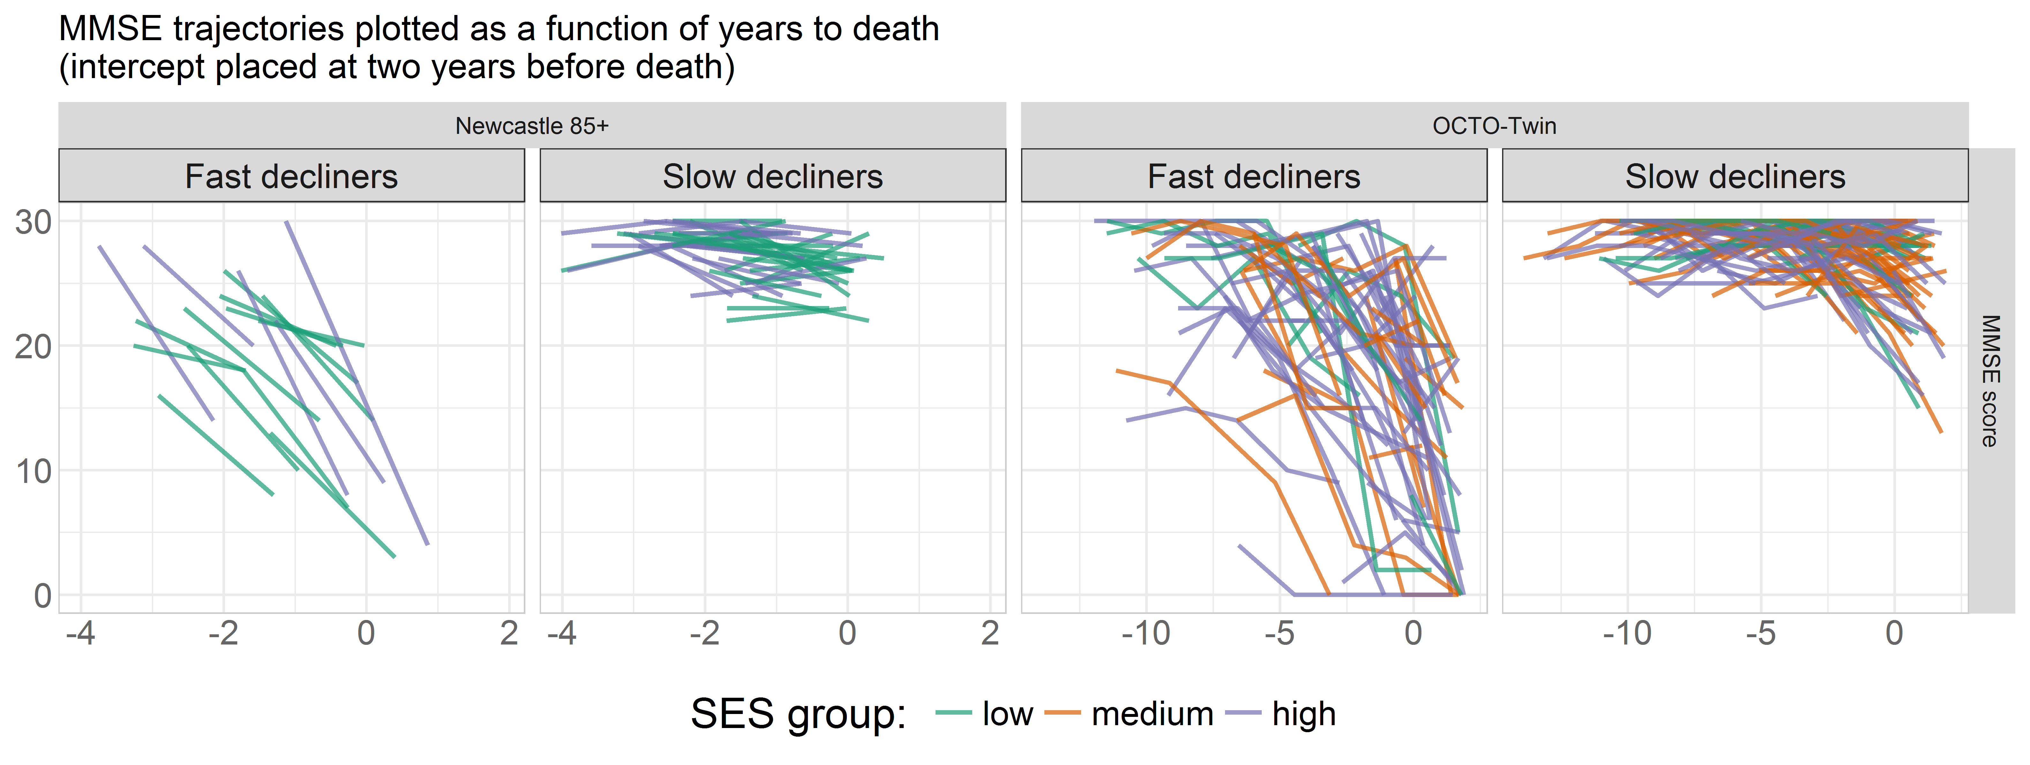

## By Education

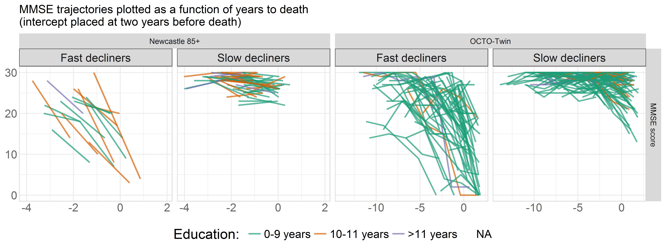

## By Dementia

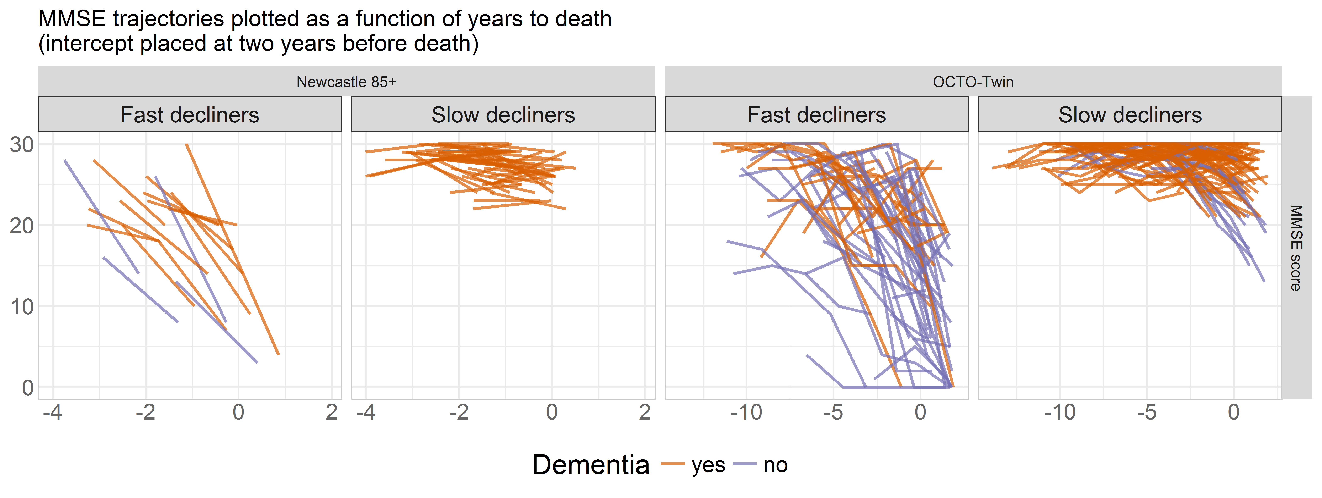

# Figure 2

