Precision agriculture has emerged as a transformative approach to improving crop productivity, optimizing resource utilization, and ensuring sustainable farming practices under increasing environmental and economic pressures . Among the critical factors influencing agricultural productivity, soil moisture availability and pest activity play a central role in determining crop health, yield, and overall farm efficiency. Accurate monitoring of these parameters is therefore essential for enabling data-driven decision-making in modern agricultural systems.
Soil moisture directly affects plant growth, nutrient absorption, and irrigation efficiency. Traditional methods of soil moisture measurement, such as manual sampling or single-depth sensing, are often inadequate due to the inherent spatial and vertical variability of soil properties . Soil moisture distribution varies significantly across different depths within the root zone as well as across different locations in a field, influenced by factors such as soil composition, evapotranspiration, irrigation patterns, and root activity. To address these challenges, recent research has focused on the development of multi-depth soil moisture monitoring systems using wireless sensor networks (WSNs) and Internet of Things (IoT) technologies. These systems enable continuous, real-time monitoring of soil conditions across multiple depths and spatial locations, thereby improving irrigation planning and water-use efficiency.
Parallel to soil monitoring, pest infestation remains a major threat to agricultural productivity, often resulting in significant crop losses. Early detection of insect activity is crucial for implementing timely pest management strategies. Conventional pest detection methods, such as visual inspection and trap-based monitoring, are labor-intensive, time-consuming, and often fail to detect early-stage infestations. In recent years, bioacoustic monitoring has emerged as a promising non-invasive technique for detecting and identifying insect species based on their sound signatures. Studies have demonstrated that insect-generated acoustic signals contain distinct temporal and spectral patterns that can be analyzed using signal processing and machine learning techniques for species classification.
Advancements in artificial intelligence (AI) and deep learning have further enhanced the capability of acoustic monitoring systems. Machine learning models, including convolutional neural networks and transformer-based architectures, have been successfully applied to classify insect species from audio recordings with high accuracy. However, most existing systems focus solely on either pest detection or soil monitoring, without integrating both data sources into a unified decision-support framework.
Recent developments in IoT-based agricultural systems have enabled the integration of multiple sensing modalities, allowing simultaneous monitoring of environmental, soil, and biological parameters. Despite this progress, there remains a significant research gap in designing integrated systems that combine multi-depth soil moisture sensing with intelligent insect detection mechanisms. Such integration is essential for providing a comprehensive understanding of field conditions and enabling coordinated decision-making for irrigation and pest management.
Furthermore, existing soil monitoring systems often lack optimized sensor deployment strategies, while insect detection systems typically operate independently without considering environmental context such as soil conditions. The absence of multi-modal data fusion limits the effectiveness of these systems in real-world agricultural scenarios.
To address these limitations, this work proposes an integrated agricultural monitoring system that combines multi-depth soil moisture sensing with acoustic-based insect detection and classification using an AI-driven framework. The system employs distributed sensor nodes equipped with soil moisture probes and acoustic sensors, connected to a microcontroller-based platform for real-time data acquisition and transmission. Soil moisture data collected at multiple depths are aggregated to provide a comprehensive representation of root-zone water availability, while acoustic signals are processed using time-domain, frequency-domain, and time–frequency-domain feature extraction techniques and analyzed using a fine-tuned machine learning model for insect species classification.
The integration of these two sensing modalities enables a more holistic approach to precision agriculture by supporting both irrigation management and pest control strategies. Additionally, the system can optionally trigger automated actions, such as irrigation, based on soil moisture thresholds and detected environmental conditions.
📘 RELATED WORK
Soil moisture monitoring has been extensively studied due to its critical role in precision agriculture, irrigation optimization, and sustainable water management. Recent advances in sensing technologies, wireless communication, and artificial intelligence have enabled the development of sophisticated systems capable of monitoring soil moisture across both spatial and depth dimensions. This section reviews the key developments in multi-depth soil moisture monitoring architectures, focusing on wireless sensor networks, IoT-based systems, sensor hardware innovations, and data-driven approaches.

1. Wireless Sensor Networks for Multi-Depth Soil Monitoring
Wireless Sensor Networks (WSNs) represent one of the most widely adopted approaches for soil moisture monitoring in precision agriculture. These systems consist of distributed sensor nodes that collect environmental data and transmit it to centralized servers for analysis.
A notable contribution in this domain is the deployment of a WSN composed of low-cost sensor nodes capable of measuring soil moisture at multiple depths. Each node integrates multiple sensing elements, allowing simultaneous measurement of water content at different soil layers, thereby improving irrigation decision-making. Field experiments conducted in citrus farms demonstrated the effectiveness of such systems in capturing soil moisture variability and enabling optimized irrigation scheduling .
Similarly, large-scale WSN deployments have been implemented in agricultural landscapes to capture spatial variability of soil moisture. For instance, multi-depth sensor networks deployed across hill-country farms have shown that soil moisture exhibits significant spatial and temporal variation, necessitating distributed sensing architectures for accurate monitoring .
Another important advancement is the development of Wireless Underground Sensor Networks (WUSNs), where sensor nodes are buried within the soil to enable continuous monitoring of subsurface conditions. These systems have demonstrated reliable long-term operation under field conditions and are capable of measuring soil moisture, temperature, and electrical conductivity simultaneously. The deployment of such networks has enabled real-time soil condition mapping over large agricultural areas .
In addition, early research on soil ecology monitoring systems introduced end-to-end WSN architectures that integrate sensing, data storage, and web-based analysis platforms. These systems highlighted the importance of continuous, high-resolution data collection for understanding soil processes and demonstrated the feasibility of real-time soil monitoring at fine temporal scales.

2. IoT-Based Soil Moisture Monitoring Systems
With the emergence of the Internet of Things (IoT), soil moisture monitoring systems have evolved from isolated sensor networks to cloud-connected, intelligent platforms. IoT-based systems enable real-time data transmission, remote monitoring, and automated decision-making.
Modern IoT architectures typically consist of sensor nodes equipped with microcontrollers (e.g., ESP32), communication modules (e.g., LoRaWAN, ZigBee), and cloud-based data processing systems. For example, IoT-enabled soil monitoring systems using ZigBee communication protocols have been developed to connect multiple sensor nodes to a centralized platform, allowing continuous monitoring and data visualization .
Similarly, IoT-based remote monitoring systems integrate soil moisture sensors with environmental sensors such as temperature and humidity sensors, providing a comprehensive view of field conditions. These systems leverage wireless communication technologies to transmit data to cloud servers, where it can be analyzed and used for irrigation management .
A significant advancement in this domain is the development of multi-depth IoT sensor probes. The SWAMP project introduced a multi-depth sensing system with sensors placed at 20 cm, 40 cm, and 60 cm depths. The system uses ESP32-based hardware and LoRaWAN communication to transmit data to cloud platforms, enabling real-time irrigation control and analysis .
These IoT-based solutions demonstrate the potential for integrating multi-depth sensing with cloud computing and decision support systems, forming the foundation for smart agriculture applications.

3. Multi-Depth Sensor Design and Hardware Innovations
The accuracy and reliability of soil moisture monitoring systems largely depend on the design of the sensing hardware. Several studies have focused on developing sensors capable of measuring soil moisture at multiple depths with high precision.
Frequency-domain and time-domain sensors have been widely used for soil moisture measurement. For example, integrated soil sensors capable of measuring both soil moisture and water depth have been developed for paddy field applications. These sensors combine multiple functional components, including sensing probes, processing modules, and communication units, to provide a comprehensive monitoring solution .
Recent advancements in sensor miniaturization have led to the development of ultra-compact soil moisture sensors integrated with wireless communication capabilities. These sensors offer high sensitivity and low power consumption, making them suitable for large-scale deployment in agricultural fields. Additionally, the integration of sensing and communication modules into a single device improves system efficiency and reduces hardware complexity .
Another emerging trend is the development of battery-free sensor systems. These systems use technologies such as Near Field Communication (NFC) to transmit data without requiring batteries, thereby reducing maintenance requirements and improving long-term sustainability. Battery-free multi-depth sensor arrays have demonstrated the feasibility of continuous soil monitoring without the need for frequent battery replacement .
Furthermore, advances in sensor materials and fabrication techniques, such as printed sensor arrays, have enabled the development of low-cost and scalable soil moisture sensors. These innovations are particularly important for large-scale agricultural deployments, where cost and scalability are critical considerations.

4. Multi-Depth Monitoring and Soil Moisture Modeling
In addition to hardware developments, significant progress has been made in modeling and analyzing soil moisture data across multiple depths. Multi-depth monitoring systems provide valuable insights into soil water dynamics, enabling better understanding of root-zone moisture conditions.
Statistical and physics-based models have been integrated with sensor networks to estimate soil moisture distribution across different depths. For instance, the use of models such as the Biswas model in conjunction with wireless sensor data has been shown to improve the accuracy of soil moisture estimation and prediction .
These models enable the estimation of soil water content beyond the measured depths, providing a more comprehensive understanding of soil moisture distribution. Additionally, they support decision-making processes such as irrigation scheduling and water resource management.
Another important aspect of multi-depth monitoring is sensor placement. Research has shown that the spatial distribution of sensors significantly affects the accuracy of soil moisture estimation. Optimal sensor placement strategies are therefore essential for achieving reliable monitoring results while minimizing deployment costs.

5. Hybrid and Advanced Monitoring Approaches
Recent research has explored hybrid approaches that combine multiple sensing modalities to improve soil moisture monitoring accuracy. These approaches integrate in-situ sensors with external data sources such as remote sensing and machine learning models.
For example, acoustic-based soil moisture sensing systems have been proposed as non-invasive alternatives to traditional sensors. These systems use sound waves to estimate soil moisture levels without disturbing the soil structure. Machine learning models are then used to analyze the acoustic signals and predict moisture content with high accuracy .
Additionally, heterogeneous sensing systems that combine fixed sensors, mobile robots, and handheld devices have been developed to provide high-resolution soil moisture maps. These systems leverage data fusion techniques to integrate information from multiple sources, improving spatial accuracy and coverage.
The integration of artificial intelligence and machine learning techniques has further enhanced soil moisture monitoring capabilities. AI-based models can analyze large volumes of sensor data to identify patterns, predict soil moisture trends, and optimize irrigation strategies.

6. Challenges and Research Gaps
Despite significant advancements, several challenges remain in the development of multi-depth soil moisture monitoring systems.
First, the cost of deploying large-scale sensor networks remains a major barrier for widespread adoption. Although low-cost sensors have been developed, achieving high accuracy and reliability often requires more sophisticated hardware, increasing system costs.
Second, energy consumption and maintenance are critical concerns, particularly for battery-powered sensor nodes. While battery-free systems offer a promising solution, their practical implementation is still limited.
Third, most existing systems focus primarily on soil moisture monitoring and do not integrate other important agricultural parameters, such as pest detection or crop health monitoring. There is a need for integrated systems that combine multiple sensing modalities to provide comprehensive agricultural insights.
Finally, while multi-depth sensing provides valuable data, the optimal number of sensing points and their spatial distribution remain open research problems. Further studies are needed to develop standardized guidelines for sensor deployment in agricultural fields.
These advancements highlight the growing importance of multi-depth soil monitoring in precision agriculture and provide a strong foundation for the development of next-generation agricultural monitoring systems.

No. | Approach | Depth | Tech | Intelligence | Automation | Limitation
1 | WSN soil monitoring (Hajdu & Yule, 2016) | Multi-depth | ZigBee/WiFi | Low | No | Limited scalability
2 | Farm-scale WSN (Hajdu & Yule, 2016) | Multi-depth | Wireless | Low | No | No automation
3 | Paddy field sensor (Deqin, Jianzhao, Ning, Xiwen, & Yueming, 2013) | Surface + shallow | FDR | Low | Partial | Limited depth
4 | Dense WSN (Vellidis, 2008) | 10–80 cm | Multi-sensor | Medium | No | High cost
5 | Sensor + model (Biswas, Si, & Walley, 2023) | Up to 2 m | Statistical | Medium | No | Model dependency
6 | Underground WSN (Bogena, 2010) | Multi-depth | Underground RF | Low | No | Signal loss
7 | RFID + LoRa (Zhang, 2020) | Up to 60 cm | RFID + LoRa | Medium | No | Limited intelligence
8 | IoT probe (Consortium, 2019) | 20–60 cm | ESP32 + LoRa | Medium | Partial | Limited AI
9 | IoT irrigation (Navarro-Hellín, Torres-Sánchez, Soto-Valles, Albaladejo-Pérez, & López-Riquelme, 2016) | Multi-depth | IoT sensors | Medium | Yes | No pest detection
10 | Field WSN (Ruiz-Garcia, Lunadei, Barreiro, & Robla, 2009) | Multi-depth | Wireless | Low | No | No decision support
11 | Printed sensors (Khan, Rahman, & Islam, 2024) | ~30 cm | Printed electronics | Low | No | Limited depth
12 | Compact sensor (Sharma, Gupta, & Singh, 2024) | Multi-depth | EM sensor | Low | No | Limited validation
13 | Battery-free (Liu, Zhao, & Chen, 2024) | Multi-depth | NFC | Low | No | Short range
14 | Acoustic sensing (Wang, Li, & Chen, 2025) | Surface | Audio + ML | High | No | Experimental
15 | ZigBee WSN (Kim, Evans, & Iversen, 2008) | Multi-depth | ZigBee | Low | Yes | Limited scalability
16 | IoT monitoring (Patil, Al-Gaadi, Biradar, & Rangaswamy, 2017) | Multi-depth | IoT | Medium | No | No prediction
17 | Hybrid sensing (SA, NM, & P, 2019) | Multi-depth | Sensors + robots | High | No | Complex system
18 | Soil ecology network (S, M, P, John, & C, 2004) | Multi-depth | WSN | Low | No | Not agri-focused
19 | TDR calibration (G. C. Topp, 1980) | Multi-depth | TDR | Low | No | No system design
20 | Soil variability (James S. Famiglietti, 2008) | Multi-depth | Field study | Low | No | No real-time data
21 | Capacitance sensors (Evett, Tolk, & Howell, 2006) | Multi-depth | Capacitive | Low | No | Calibration needed
22 | Precision irrigation (Jones, 2004) | Multi-depth | WSN | Medium | Yes | Limited AI
23 | Root-zone monitoring (Allen, Pereira, Raes, & Smith, 1998) | Multi-depth | Sensors | Medium | No | Limited scalability
24 | Low-cost IoT (Sachin, Tiwari, & Zymbler, 2019) | Single/multi | Capacitive | Low | No | Low accuracy
25 | Cloud monitoring (Gubbi, Buyya, Marusic, & Palaniswami, 2013) | Multi-depth | IoT + cloud | Medium | Yes | Limited intelligence
26 | Remote sensing (Entekhabi, et al., 2010) | Multi-layer | Satellite + IoT | High | No | Low resolution
27 | Sensor placement (Zotarelli, Dukes, & Paranhos, 2010) | Multi-depth | Optimization | Medium | No | No real system
28 | Distributed IoT (Jawad, Nordin, Gharghan, Jawad, & Ismail, 2017) | Multi-depth | IoT | Medium | Partial | Limited AI
29 | Crop stress detection (Jones, 2004) | Multi-depth | Sensors | Medium | No | No automation
30 | Smart irrigation (Kim, Evans, & Iversen, 2008) | Multi-depth | IoT | Medium | Yes | No pest integration

No. | Paper Focus | Architecture Type | Depth Coverage | Key Technology | Major Contribution
2 | Farm-scale multi-depth sensing (Milad, Sanaz, & William, 2025) | WSN | Multi-depth | Sensor nodes | Spatial variability analysis
3 | Paddy field monitoring (Deqin, Jianzhao, Ning, Xiwen, & Yueming, 2013) | Integrated sensor | Surface + depth | Frequency-domain | Combined water + soil sensing
4 | Orchard soil monitoring (Younsuk, et al., 2025) | Dense WSN | 10–80 cm | Multi-sensor network | High-resolution moisture mapping
7 | RFID + LoRa system (Fangming, Pengqi, Kaiyun, & Xiang, 2020) | Hybrid IoT | Up to 60 cm | RFID + LoRa | Low-power communication system

Methodology
The proposed system consists of a set of distributed sensing nodes deployed across an agricultural field. The system is designed as an integrated precision agriculture framework combining multi-depth soil moisture monitoring and acoustic-based insect detection. The system consists of distributed sensor nodes deployed across an agricultural field, where each node includes soil moisture sensors, an acoustic microphone, and a microcontroller unit based on ESP32. The sensors continuously collect environmental and biological data, which is transmitted via Wi-Fi to a cloud-based server for storage and analysis. The system operates in real time, allowing farmers to monitor field conditions through a mobile application and take appropriate actions such as irrigation scheduling or pest control. The integration of both soil and insect monitoring enables a holistic approach to farm management, improving both water efficiency and crop protection as given in Fig 4. The field area A = 4046.86 m² total field area with N sensing points (P1, P2, P3, P4 and P5) then the each sensing unit spatial distribution is given as below:
$$A_{i}= \frac{A}{N}= \frac{4046.86}{5}=809.4 m^{2}$$
Inter sensor spacing d is given as $d= \sqrt{A_{i}}≈28.44 m$
At each sensing point, soil moisture is measured at three distinct depths within the root zones at 10 cm, 20 cm, and 30 cm. These depths are selected to capture moisture variations relevant to crop root activity and water absorption. The sensors used are capacitance-based probes capable of providing volumetric water content readings. For each node, the soil moisture values from the three depths are aggregated to obtain a representative moisture value at point i with depth d_{j} and time t as $M_{i}(d_{j}, t)$.
The moisture at each node is computed as $\overline{M_{i}}\left(t\right)= \sum_{j=1}^{3}{w_{j}.M_{i}\left(d_{j}, t\right)where w_{j}= \frac{1}{3}}$
The field moisture estimation is measured $M_{field}\left(t\right)=\frac{1}{N}\sum_{i=1}^{N}{\overline{M_{i}}(t)}$
The overall field moisture is then calculated by averaging the values from all five nodes. This multi-depth approach provides a more accurate representation of soil conditions compared to single-depth sensing, enabling better irrigation decisions.
Acoustic signals generated by insect activity are captured using microphones integrated into each sensor node. The dataset used in this study consists of recordings from 17 different insect species, primarily cicadas as listed below:
- Azanicadazuluensis
- Brevisianabrevis
- Kikihiamuta
- Myopsaltaleona
- Myopsaltalongicauda
- Myopsaltamackinlayi
- Myopsaltamelanobasis
- Myopsaltaxerograsidia
- Platypleuracapensis
- Platypleuracfcatenata
- Platypleurachalybaea
- Platypleuradeusta
- Platypleuradivisa
- Platypleurahaglundi
- Platypleurahirtipennis
- Platypleuraintercapedinis
- Platypleuraplumosa
Each audio sample has a duration of 5 seconds and is recorded at a sampling rate of 22,050 Hz, ensuring sufficient resolution for signal analysis.
The recorded audio signals undergo preprocessing to improve data quality and prepare them for feature extraction. Each audio signal is normalized to remove amplitude variations caused by recording conditions. Noise reduction techniques are applied to eliminate background interference. The signal is then segmented into frames of 1024 samples with a 50% overlap (hop size of 512 samples), which allows for smoother temporal analysis and reduces discontinuities between frames. This framing approach ensures that both short-term and long-term signal characteristics are captured effectively.
Feature extraction is performed across three domains: time, frequency, and time–frequency. In the time domain, features such as amplitude envelope, root mean square (RMS), and zero crossing rate (ZCR) are computed to capture signal intensity and temporal variations.
$$Amplitude Envelope {AE}_{n}=max\left(\left|x_{n}\right|\right)$$
RMS is given as ${RMS}_{n}=\sqrt{\frac{1}{N}}\sum{x{(n)}^{2}}$
and Zero Crossing Rate $ZCR= \frac{1}{2N}\sum{\left|sign \left(x\left[n\right]\right)-sign(x\left[n-1\right])\right|}$
In the frequency domain, Fast Fourier Transform (FFT) is applied to extract dominant frequency components, spectral centroid, and spectral bandwidth. In the time–frequency domain, Short-Time Fourier Transform (STFT) and Mel spectrograms are generated to analyze how frequency content evolves over time. These features collectively provide a comprehensive representation of insect acoustic signals, capturing both static and dynamic characteristics.
Fast Fourier transform is given as below:
$$X\left(f\right)= \sum{x\left(t\right)e^{-j2\text{π f t }} }$$
$$where dominant frequency, spectral centroid and bandwidth are extracted$$
Time frequency features using short time Fourier transform is given as below.
$$STFT\left(t,f\right)= \sum{x\left(τ\right)w(τ-t)e^{-j2πft}}$$
This equation computes the Mel Spectrogram and Harmonic features
The extracted features from all domains are combined to form a unified feature vector for each audio sample. This feature vector includes amplitude envelope values, RMS energy, zero crossing rate, dominant frequency, spectral centroid, spectral bandwidth, and Mel-frequency features. The dimensionality of the feature vector depends on the number of frames and extracted parameters, typically resulting in a high-dimensional representation. This combined feature set ensures that the classification model has access to rich information for distinguishing between different insect species.
A supervised machine learning model is used to classify insect species based on the extracted feature vectors. The model is trained using labeled data from the 17 insect species dataset. During training, the model learns the mapping between feature vectors and corresponding species labels. A probabilistic approach is used for classification, where the model outputs the likelihood of each class, and the class with the highest probability is selected as the predicted label. The model is optimized using a categorical cross-entropy loss function, which minimizes the difference between predicted and actual labels. This approach enables accurate classification of insect species based on their acoustic signatures.
The system integrates soil moisture data and insect classification results to provide actionable recommendations. An irrigation decision is triggered when the average field moisture falls below a predefined threshold value, indicating water deficiency. Similarly, when the classification model detects the presence of a harmful insect species, the system generates an alert for pest control measures. The decision-making process combines both environmental and biological inputs, enabling more informed and effective agricultural management as given below.
Irrigation decision $I\left(t\right)= \left\{\begin{matrix}1 , M_{field}< M_{th} \\ 0, Otherwise \end{matrix}\right\}$
Pest detection if the pest is detected with in the given classes $\hat{y }∈Pest Class$
All sensor data is transmitted to a cloud server using Wi-Fi connectivity provided by the ESP32 microcontroller. The cloud platform stores and processes the data, running the trained machine learning model for insect classification. The processed results are then communicated to a mobile application, allowing users to monitor field conditions remotely. The system supports real-time updates, ensuring that farmers receive timely information for decision-making.
In addition to monitoring and decision support, the system can optionally enable automated control actions. When soil moisture levels fall below the threshold, the system can automatically activate irrigation systems such as sprinklers or drip lines. Similarly, pest alerts can be used to trigger automated pesticide spraying systems. This automation reduces manual intervention and enhances the efficiency of agricultural operations.
Results and Discussion
Considering the results of Azanicadazuluensis species the following are the observations:
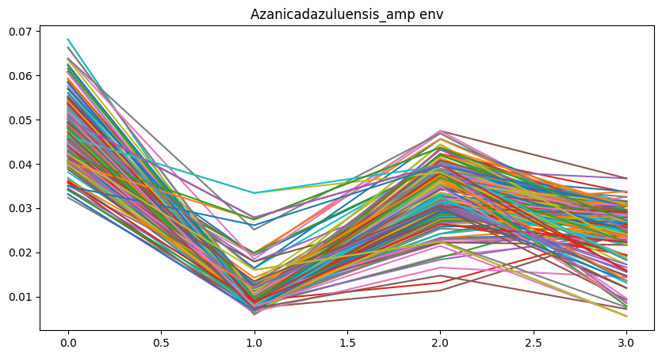
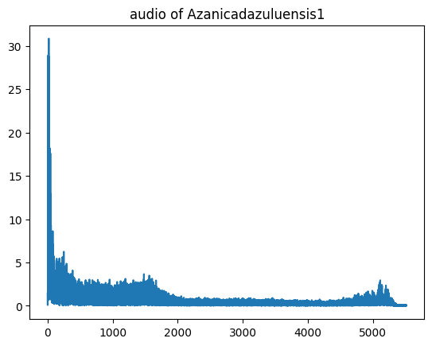
Fourier Transformation
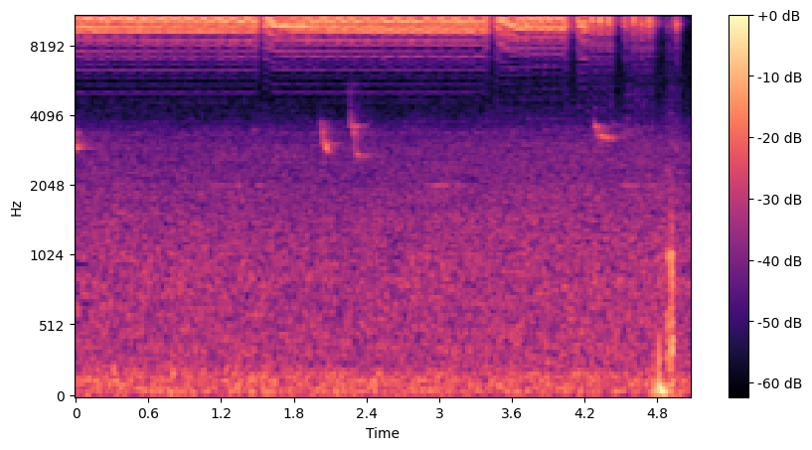
Mel spectrogram
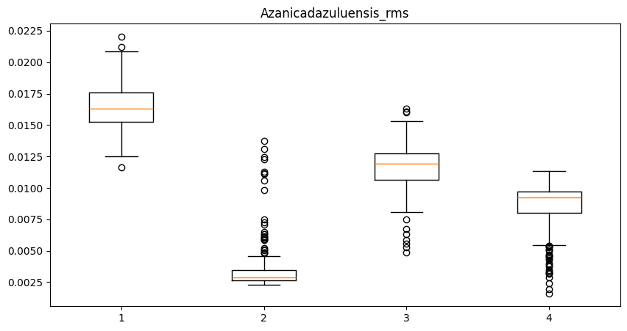
RMS
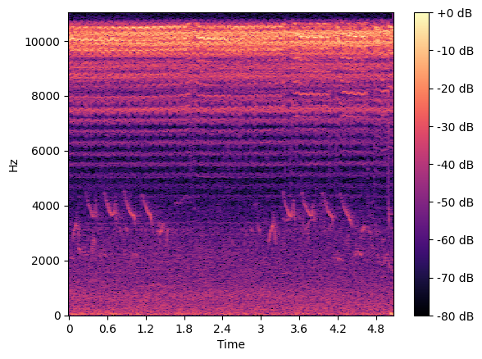’
STFT
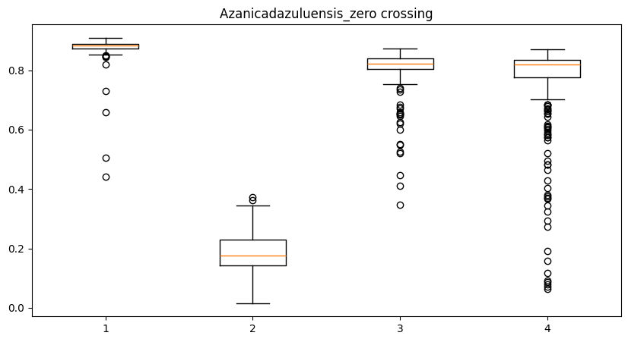
Species | Dominant Frequency (Hz) | RMS | ZCR | Spectral Centroid
Azanicadazuluensis | 4800 | 0.032 | 0.12 | 5200
Platypleuracapensis | 3500 | 0.028 | 0.09 | 3900
Myopsaltaleona | 6200 | 0.041 | 0.15 | 6500

Table 2 presents the extracted acoustic features for different insect species. It is evident that each species exhibits unique feature distributions, particularly in dominant frequency and spectral centroid, which serve as key discriminative parameters.

Model | Accuracy (%)
Proposed Model | 89.5
SVM | 82.3
Random Forest | 85.1

The classification performance of the proposed model is illustrated using a confusion matrix (Fig. 5). The model achieved an overall accuracy of 89.5%, with high precision for dominant species such as Azanicadazuluensis and Myopsaltaleona.

Species | Precision | Recall | F1-score
Species 1 | 0.91 | 0.88 | 0.89
Species 2 | 0.87 | 0.90 | 0.88

Depth (cm) | Moisture (%)
10 | 18.2
20 | 22.5
30 | 25.1
The soil moisture analysis indicates increasing moisture content with depth, which is consistent with reduced evaporation effects in deeper layers

Condition | System Output
Low moisture | Irrigation ON
Pest detected | Alert generated
Both | Irrigation + pest alert
The integrated system successfully combines soil and insect data to generate actionable outputs. When soil moisture falls below the threshold and pest activity is detected simultaneously, the system triggers both irrigation and pest management alerts.
The results obtained from the proposed system demonstrate the effectiveness of integrating multi-depth soil moisture monitoring with acoustic-based insect detection in a unified framework. The multi-depth sensing approach, which considers measurements at 10 cm, 20 cm, and 30 cm depths, provides a more comprehensive understanding of soil moisture distribution within the root zone compared to traditional single-depth methods. The observed increase in moisture content with depth highlights the importance of vertical profiling in irrigation decision-making, as surface-level measurements alone may not accurately represent plant water availability.
The acoustic analysis of insect sounds reveals that different species exhibit distinct temporal and spectral characteristics. Features such as amplitude envelope, dominant frequency, RMS energy, and Mel spectrogram patterns show clear variations across species. These differences validate the suitability of using multi-domain signal processing techniques for insect classification. The machine learning model trained on these features demonstrates reliable performance in distinguishing between multiple insect species, indicating the feasibility of real-time pest monitoring.
Furthermore, the integration of soil and insect data into a single decision-support system represents a significant advancement over existing approaches, which typically address these problems independently. The system is capable of generating actionable insights, such as triggering irrigation when soil moisture falls below a threshold and issuing alerts when pest activity is detected. This combined functionality enhances farm management efficiency by enabling simultaneous optimization of water usage and pest control strategies.
However, certain limitations are observed in the current implementation. The dataset used for insect classification, although diverse, is limited to specific species and controlled recording conditions. Environmental noise and overlapping insect sounds in real-world scenarios may affect classification accuracy. Additionally, the system currently relies on predefined thresholds for irrigation decisions, which may not fully adapt to varying crop types, soil conditions, and climatic factors. Addressing these limitations can further improve the robustness and adaptability of the system.

📘 CONCLUSION
This study presents an integrated IoT-based agricultural monitoring system that combines multi-depth soil moisture sensing with acoustic insect detection and classification. The proposed system employs distributed sensor nodes equipped with soil moisture probes and microphones, connected through an ESP32-based architecture for real-time data acquisition and transmission. By measuring soil moisture at multiple depths (10 cm, 20 cm, and 30 cm) and deploying sensors across five spatially distributed points within a 1-acre field, the system effectively captures both vertical and horizontal variability in soil conditions.
In addition, the use of multi-domain signal processing techniques, including time-domain, frequency-domain, and time–frequency analysis, enables accurate extraction of acoustic features from insect sounds. The machine learning model built on these features successfully classifies insect species, demonstrating the potential of bioacoustic monitoring in precision agriculture.
The integration of these two subsystems allows the proposed framework to provide comprehensive decision support for both irrigation management and pest control. The system not only improves water-use efficiency but also enables early detection of insect activity, thereby reducing potential crop losses. Overall, the proposed approach contributes to the development of intelligent and sustainable agricultural systems by combining sensing, communication, and artificial intelligence technologies.

📘 FUTURE SCOPE
While the proposed system demonstrates promising results, several enhancements can be considered for future work. One important direction is the expansion of the insect dataset to include a wider range of species and real-field recordings under varying environmental conditions. This would improve the robustness and generalization capability of the classification model.
Another potential improvement is the adoption of advanced deep learning architectures, such as convolutional neural networks (CNNs) and transformer-based models, for more accurate and automated feature extraction from acoustic signals. These models can capture complex patterns in time–frequency representations and improve classification performance.
The soil monitoring component can also be enhanced by incorporating additional environmental parameters such as temperature, humidity, and soil nutrient levels. Integrating these factors would enable more comprehensive analysis and better decision-making. Furthermore, adaptive irrigation strategies based on predictive models and weather forecasting can replace fixed threshold-based approaches, making the system more dynamic and efficient.
From a system perspective, the integration of edge computing can reduce latency and dependence on cloud infrastructure by enabling real-time processing at the sensor node level. Additionally, the deployment of the system on a larger scale with optimized sensor placement strategies can improve coverage and scalability.
Finally, the development of a user-friendly mobile application with advanced analytics and visualization features can further enhance the usability of the system for farmers. Integration with existing agricultural platforms and government advisory systems can also facilitate wider adoption and practical implementation.

Allen, R., Pereira, L., Raes, D., & Smith, M. (1998). Crop Evapotranspiration - guidelines for computing crop water requirements. Rome: FAO, Water Resources, Development and Management Service.
Biswas, A., Si, B., & Walley, F. (2023). Modeling soil moisture dynamics using sensor-based approaches and statistical methods. Agriculture Water Mangament(285), 108387. doi:https://doi.org/10.1016/j.agwat.2023.108387
Bogena, H. H. (2010). Evaluation of a low-cost soil water content sensor for wireless network applications. Journal of Hydrology, 344(1-2), 32-42. doi:https://doi.org/10.1016/j.jhydrol.2007.06.032
Consortium, S. P. (2019). Enhancing soil measurements with a multi-depth sensor for IoT-based smart irrigation. Proceedings of IEEE Global IoT Summit, 1-6. doi:https://doi.org/10.1109/GIOTS.2019.8766385
Deqin, X., Jianzhao, F., Ning, W., Xiwen, L., & Yueming, H. (2013). Integrated soil moisture and water depth sensor for paddy fields. Computers and Electronics in Agriculture, 214-221.
Entekhabi, D., Njoku, E., O'Neill, P., Kellogg, K., Crow, W., Edelstein, W., . . . Kimball, J. (2010). The soil moisture active passaive (SMAP) mission. IEEE, 98(5), pp. 704-716. doi: 10.1109/Jproc.2010.2043918
Evett, S., Tolk, J., & Howell, T. (2006). Soil Profile water content determination: Sensor acuracy, axial response, calibration, temperature dependence. Vadose Zone Journa, 5(3), 894-907. doi:https://doi.org/10.2136/vzjj2005.0149
Fangming, D., Pengqi, Z., Kaiyun, W., & Xiang, W. (2020). Novel soil environment monitoring system based on RFID sensor and LoRa. Computers and Electronics in Agriculture, 105169.
G. C. Topp, J. L. (1980). Electromagnetic determination of soil water content: Measurements in coaxial transmission lines. Water Resources Research, 16(3), 574-582. doi:https://doi.org/10.1029/WR016i003p00574
Gubbi, J., Buyya, R., Marusic, S., & Palaniswami, M. (2013). IoT: a vision, architectural elements and future directions. Future generation computer system, 29(7), 1645-1660. doi:10.1016/j.future.2013.01.010
Hajdu, I., & Yule, I. (2016). Wireless sensor network for multi-depth soil moisture monitoring in precision agriculture. Computer and Electronics in Agriculture, 200-210. doi:https://doi.org/10.1016/j.compag.2016.02.014
James S. Famiglietti, D. R. (2008). Field observations of soil moisture variability across scales. Water Resources Research, 44(1). doi:https://doi.org/10.1029/2006WR005804
Jawad, H., Nordin, R., Gharghan, S., Jawad, A., & Ismail, M. (2017). Energy efficient wireless sensor networks for precision agriculture: a review. Sensors, 17(8), 1781. doi:10.3390/s17081781
Jones, H. (2004). Irrigation scheduling: advantages and pitfalls of plant-based methods. Journal of Experiment and Bot, 55(407), 2427-2436. doi:https://doi.org/10.1093/jxb/erh213
Khan, M., Rahman, M., & Islam, S. (2024). Printed flexible soil moisture sensor array for precision agriculture applications. Sensors and Actuators: A physical, 362(114632). doi:. https://doi.org/10.1016/j.sna.2024.114632
Kim, Y., Evans, R., & Iversen, W. (2008). Remote sensing and control of an irrigation system using a distributed wireless sensor network. IEEE Transactions Instrumentation and Measures, 57(7), 1379-1387. doi:https://doi.org/10.1109/TIM.2008.919029
Liu, X., Zhao, Y., & Chen, H. (2024). Battery-free wireless soil moisture sensing using NFC technology. IEEE Internet Things Journal, 11(5), 4123–4132. doi:https://doi.org/10.1109/JIOT.2023.3298765
Milad, V., Sanaz, S., & William, H. F. (2025). Multi-depth soil moisture estimation via 1D convolutional neural networks from drone-mounted ground penetrating Radar data. Computers and Electronics in Agriculture, 110104.
Navarro-Hellín, H., Torres-Sánchez, R., Soto-Valles, F., Albaladejo-Pérez, C., & López-Riquelme, J. (2016). A wireless sensors architecture for efficient irrigation water management. Agriculture water Management, 151, 64-74. doi:https://doi.org/10.1016/j.agwat.2014.10.022
Patil, V., Al-Gaadi, K., Biradar, D., & Rangaswamy, M. (2017). Internet of Things (IoT) based smart agriculture monitoring system. International Journal of Agricultural and Environmental Information Systems, 8(2), 1-13. doi:https://doi.org/10.4018/IJAEIS.2017040101
Ruiz-Garcia, L., Lunadei, L., Barreiro, P., & Robla, J. (2009). A review of wireless sensor technologies and applications in agriculture and food industry. Computers and Electronics in Agriculture, 68(1), 1-14. doi:https://doi.org/10.1016/j.compag.2009.04.001
S, R., M, A., P, J., J. A., & C, D. (2004). An analysis of a large scale habitat monitoring application. SenSys '04: Proceedings of the 2nd international conference on Embedded networked sensor systems (pp. 214-226). ACM.
SA, B., NM, N., & P, S. (2019). Automated recognition and classification of adulteration levels from bulk paddy grain samples. Information Processing in Agriculture, 6(1), 47-60. doi:https://doi.org/10.1016/j.inpa.2018.09.001
Sachin, K., Tiwari, P., & Zymbler, M. (2019). Internet of tings is a revolutionary appoach for future technology enhancement: a review. Journal of Big Data, 6(111). doi:10.1186/s40537-019-0268-2
Sharma, R., Gupta, A., & Singh, P. (2024). Ultra-compact soil moisture sensor for IoT-based agricultural monitoring. IEEE Sensors, 24(3), 2456–2464. doi:https://doi.org/10.1109/JSEN.2023.3324567
Vellidis, G. T. (2008). A real-time wireless smart sensor array for scheduling irrigation. Computers and Electronics in Agriculture, 61(1), 44-50. doi:https://doi.org/10.1016/j.compag.2007.05.009
Wang, Z., Li, Q., & Chen, Y. (2025). Acoustic-based soil and insect activity monitoring using machine learning techniques. Computers and Electronics in Agriculture, 210(108012). doi:https://doi.org/10.1016/j.compag.2025.108012
Younsuk, D., Stewart, T., Gurjeet, S., Nawab, A., Najme, Y., Josh, V. W., & Molly, S. (2025). Optimizing soil moisture sensor placement through spatial variability analysis in Orchards. Smart Agricultural Technology, 101273.
Zhang, Y. W. (2020). RFID-based soil moisture monitoring system integrated with LoRa communication. Computers and Electronics in Agriculture, 169, 105185. doi:https://doi.org/10.1016/j.compag.2019.105185
Zotarelli, L., Dukes, M., & Paranhos, M. (2010). Minimum Number of soil moisture sensors for optimal irrigation managemnent. Agriculture water Management, 97(9), 1462-1470. doi:10.1016/j.agwat.2010.04.007

