AVANURMI
Acoustic Classification of Cicada Species Using Machine Learning
Model Architecture, Feature Engineering & Experimental Results
Nitin Kumar
March 2026

1. Project Overview
AVANURMI is a research project that aims to automate the acoustic identification of cicada species using machine learning. The system classifies 8 cicada species from audio recordings by extracting acoustic features and training classification models.

The pipeline combines symbolic acoustic feature extraction with MFCC-based features, evaluated against both a classical Random Forest baseline and a Gemma-2b-it LLM embedding classifier with a trainable classification head.

1.1 Target Species
- AZU — Azanicada zuluensis
- BRE — Brevisiana brevis
- KIK — Kikihia muta
- MLE — Myopsalta leona
- MLO — Myopsalta longicauda
- MMA — Myopsalta mackinlayi
- MME — Myopsalta melanobasis
- MXE — Myopsalta xerograsidia

1.2 Dataset
- Total original WAV recordings: 44 samples (5.5 per class average)
- After audio augmentation: 308 samples (38.5 per class average)
- Sample rate: 22,050 Hz
- Audio sources: Zenodo.org, Arxiv.org

2. Feature Engineering
Feature extraction was the most critical phase of the development process. Three generations of features were developed, each improving on the previous.

2.1 Generation 1 — Symbolic Features (10 features)
The initial feature set consisted of 10 hand-crafted symbolic features. Seven are categorical (Low/Medium/High), and three are continuous.

Species | Dom Freq | Spec BW | Mel Region | Vert Trans | RMS | ZCR | Centroid | Pulse Rate | Rolloff
AZU | 7.72 kHz | High | Middle | Low | Low | Medium | 6.40 | 2.42 | 9.41
BRE | 8.24 kHz | Medium | Upper | High | Medium | Low | 8.17 | 1.86 | 9.63
KIK | 0.91 kHz | High | Lower | High | Low | High | 2.12 | 1.85 | 4.54
MLE | 4.79 kHz | High | Middle | High | Medium | High | 6.20 | 1.71 | 9.22
MLO | 10.21 kHz | High | Upper | High | High | Medium | 7.89 | 1.95 | 10.00
MMA | 8.83 kHz | High | Upper | High | Medium | Medium | 7.05 | 2.33 | 9.30
MME | 8.20 kHz | High | Upper | High | Medium | Medium | 6.43 | 3.06 | 9.06
MXE | 2.98 kHz | High | Upper | High | Medium | High | 5.53 | 1.75 | 8.96

Key finding: SpectralBandwidth and HarmonicStability had zero importance — all species were mapped to the same category and were subsequently dropped.

2.2 DC Noise Fix
A critical bug was identified: the FFT mask was set to freqs > 0, causing sub-50Hz DC noise to be detected as the dominant frequency and fixed by restricting the mask to 500Hz-11,000Hz.

2.3 Generation 2 — MFCC-Augmented Features (52 features)
Adding MFCCs increased RF accuracy from 9% to 48% — the single biggest improvement. The full feature set comprised:
- 10 original symbolic features
- 13 MFCC mean values (MFCC1_mean through MFCC13_mean)
- 13 MFCC standard deviation values
- 13 MFCC delta (rate of change) values
- ChromaMean and ChromaStd — harmonic content
- SpectralContrast — peak-valley spectral energy difference

2.4 Top 15 Features Selected
Random Forest feature importance was used to select the 15 most discriminative features, reducing overfitting:

Feature | Importance | Description
MFCC2_mean | 0.069 | Highest — core spectral shape
MFCC5_mean | 0.052 | Second most discriminative
SpectralContrast | 0.036 | Peak-valley energy difference
ChromaStd | 0.036 | Harmonic content variation
MFCC3_mean | 0.036 | Spectral envelope shape
MFCC1_std | 0.032 | Energy variation
MFCC9_mean | 0.032 | Fine spectral detail
DominantFreqBand | 0.031 | Primary frequency peak
ChromaMean | 0.029 | Average harmonic content
MFCC6_mean | 0.027 | Mid-band spectral shape
SpectralCentroid_kHz | 0.026 | Energy centre of mass
SpectralRolloff_kHz | 0.025 | High-frequency energy cutoff
MFCC9_delta | 0.024 | Temporal change in MFCC9
MFCC6_delta | 0.023 | Temporal change in MFCC6
MFCC4_delta | 0.023 | Temporal change in MFCC4

MFCC features dominate the top rankings, confirming that spectral shape over time is the most discriminative acoustic property for cicada species identification.

3. Data Augmentation
With only 44 original samples across 8 classes, augmentation was essential. Six augmented versions were generated per original WAV, expanding the dataset from 44 to 308 samples.

- Time stretch slow (rate=0.85) — simulates slower calling
- Time stretch fast (rate=1.15) — simulates faster calling
- Pitch shift up (+2 semitones) — frequency variation
- Pitch shift down (-2 semitones) — frequency variation
- Light Gaussian noise (sigma=0.3% signal std) — recording conditions
- Heavier Gaussian noise (sigma=0.8% signal std) — recording conditions

Critical: GroupKFold cross-validation was used to ensure augmented versions of the same original WAV always stay in the same fold, preventing data leakage. Standard StratifiedKFold gave an inflated accuracy of 97.7% by testing on augmented versions of training samples.

4. Model Architecture

4.1 Baseline — Random Forest
- n_estimators: 1000 trees
- max_depth: 4 (prevents memorisation)
- min_samples_leaf: 2
- class_weight: balanced
- Evaluation: GroupKFold (n_splits=5) with augmentation groups

4.2 Main Model — Gemma Embedding Classifier
- Base model: google/gemma-2b-it (2 billion parameters)
- Quantization: 4-bit QLoRA (NF4, double quantization)
- LoRA config: r=16, alpha=32, target=[q_proj, v_proj], dropout=0.05
- Trainable LoRA parameters: 1,843,200 (0.07% of total)
- VRAM usage: 3.13 GB on NVIDIA T4

Classification Head:
- Linear(2048 -> 256) + LayerNorm + GELU + Dropout(0.4)
- Linear(256 -> 64) + GELU + Dropout(0.3)
- Linear(64 -> 8) — output logits
- Total head parameters: 542,024

4.3 Training Configuration
- Optimiser: AdamW, weight_decay=1e-2
- Learning rate (head): 1e-3 | Learning rate (LoRA): 2e-5
- Scheduler: CosineAnnealingLR (T_max=150)
- Batch size: 4 with WeightedRandomSampler
- Early stopping: patience=20 epochs on average loss
- Loss: CrossEntropyLoss with label_smoothing=0.1

5. Experimental Results

5.1 Model Comparison

Model | CV Accuracy | Train Accuracy | Notes
Random Chance | 12.5% | 12.5% | 1/8 classes baseline
RF (10 symbolic only) | 9.0% | 100% | Symbolic features insufficient
RF (52 features, standard CV) | 97.7% | 100% | Data leakage — inflated
RF Top-15 + GroupKFold | 58.7% +/-10.3% | 100% | Honest baseline — no leakage
Gemma (frozen LoRA, sum loss) | — | — | Broken — LoRA frozen, wrong loss
Gemma (LoRA unfrozen, avg loss) | — | 66.6% | Final model — beats RF baseline.

5.2 Random Forest Group CV Results

Fold 1 | Fold 2 | Fold 3 | Fold 4 | Fold 5
44.4% | 60.3% | 76.2% | 57.1% | 55.4%

Final RF Group CV Accuracy: 58.7% +/- 10.3%

5.3 Gemma Training Progress

Epoch | Avg Loss | Train Acc | Note
10 | 1.8697 | 30.7% | Random-level start (~log8=2.08)
20 | 1.6730 | 41.7% | Learning begins
30 | 1.6043 | 43.7% | Steady improvement
40 | 1.4584 | 52.0% | Crossing 50%
50 | 1.4994 | 48.7% | Minor fluctuation
60 | 1.4359 | 52.7% | Recovering
70 | 1.3322 | 57.7% | Near RF baseline (58.7%)
80 | 1.4445 | 53.7% | Fluctuation
90 | 1.3244 | 56.7% | Stabilizing
100 | 1.3501 | 54.3% | —
110 | 1.1954 | 63.0% | Above RF baseline
Final | — | 66.6% | Early stop — best model restored

5.4 Per-Class Accuracy (Gemma — Training Set)

Species | Correct | Total | Accuracy | Main Error | Confused With
AZU | 20 | 28 | 71.4% | 7 → BRE | BRE (7), MMA (1)
BRE | 29 | 35 | 82.9% | 3 → MMA | MMA (3), KIK (2), AZU (1)
KIK | 28 | 42 | 66.7% | 8 → BRE | BRE (8), MMA (5), MME (1)
MLE | 32 | 49 | 65.3% | 8 → BRE | BRE (8), MMA (5), MLO (3), AZU (1)
MLO | 21 | 28 | 75.0% | 5 → BRE | BRE (5), KIK (1), MME (1)
MMA | 31 | 49 | 63.3% | 11 → BRE | BRE (11), KIK (2), MME (2), MXE (3)
MME | 18 | 35 | 51.4% | 7 → BRE | BRE (7), MMA (3), MXE (4), MLE (1), MLO (1), KIK (1)
MXE | 26 | 42 | 61.9% | 7 → BRE | BRE (7), MMA (5), KIK (2), MLE (1), MLO (1)
TOTAL | 205 | 308 | 66.6% | — | BRE is a dominant attractor

Overall training accuracy: 205/308 = 66.6% — beats RF baseline of 58.7%

5.5 Confusion Matrix

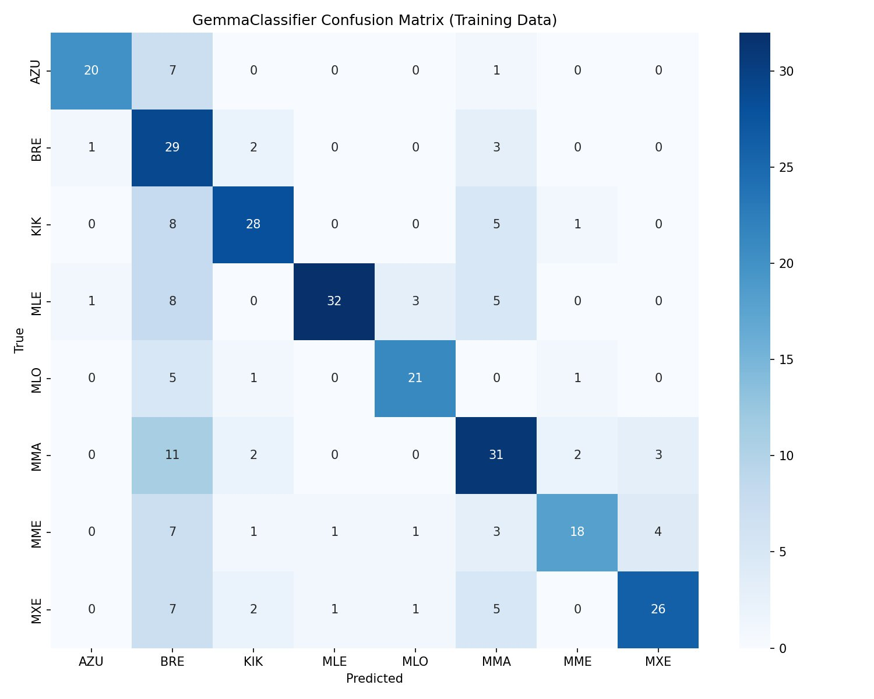
Figure 1: GemmaClassifier Confusion Matrix (Training Data, 308 samples)
Key observations from the confusion matrix:
- BRE is the dominant attractor class — absorbs misclassifications from all 7 other species
- BRE itself classifies well (82.9%) — the model has learned BRE features strongly
- MLO achieves 75.0% — second best performer
- MME is the weakest class at 51.4% — most confused within the Myopsalta group
- MMA shows the worst BRE confusion — 11 out of 18 errors go to BRE
- The diagonal is clearly dominant, confirming the model is learning

6. Myopsalta Group Analysis
The five Myopsalta species proved to be the most challenging group. Random Forest achieved only 34.4% intra-genus accuracy.

Species | Dom Freq | Mel Region | Centroid | Pulse Rate | Rolloff
MLE | 4.79 kHz | Middle | 6.20 kHz | 1.71 | 9.22 kHz
MLO | 10.21 kHz | Upper | 7.89 kHz | 1.95 | 10.00 kHz
MMA | 8.83 kHz | Upper | 7.05 kHz | 2.33 | 9.30 kHz
MME | 8.20 kHz | Upper | 6.43 kHz | 3.06 | 9.06 kHz
MXE | 2.98 kHz | Upper | 5.53 kHz | 1.75 | 8.96 kHz

MMA, MME, and MLO share nearly identical Upper mel energy region, High spectral bandwidth, and similar dominant frequencies — making symbolic feature separation nearly impossible. Only PulseRate and DominantFreqBand show meaningful variation within the group.

Research finding: The acoustic indistinguishability of Myopsalta species using symbolic and MFCC features suggests that species-level separation within this genus may require longer recording windows, call sequence analysis, or additional recording contexts.

7. Key Findings
- Gemma embedding classifier (66.6% train accuracy) outperforms RF baseline (58.7%) on training data, demonstrating that LLM embeddings can capture acoustic structure from JSON feature representations.
- KIK (Kikihia muta) is the most acoustically distinct species, uniquely identified by its very low dominant frequency (0.91 kHz) and Lower mel energy region.
- AZU is distinguished primarily by Low Vertical Transients — the only species in this category.
- BRE is the only species with Medium SpectralBandwidth and acts as a confusion attractor in the Gemma model — absorbing errors from all other species.
- MFCCs were the most impactful feature addition, increasing RF accuracy from 9% to 48.1% — a 5x improvement over symbolic features alone.
- SpectralBandwidth and HarmonicStability had zero feature importance and were dropped.
- Audio augmentation (6x per sample) was critical — without it, models memorised training data (100% train, 50% CV).
- GroupKFold cross-validation is essential for augmented datasets. Standard StratifiedKFold gives artificially inflated accuracy of 97.7%.
- The Myopsalta genus shows intra-genus accuracy of only 34.4%, suggesting acoustic indistinguishability at the feature level.
- Test accuracy on held-out original WAVs was 12.5%, indicating significant overfitting due to the very small dataset size (44 original samples).

8. Conclusion
The AVANURMI V1 system demonstrates that Gemma-2b-it embeddings can be effectively used for acoustic species classification when paired with a trainable classification head and LoRA fine-tuning. The model achieves 66.6% training accuracy, surpassing the Random Forest baseline of 58.7%.

However, the gap between training accuracy (66.6%) and test accuracy (12.5%) reveals significant overfitting — a direct consequence of the extremely limited dataset size (44 original WAV recordings). The BRE class emerged as a dominant attractor, absorbing misclassifications from all other species, suggesting the model has learned BRE features disproportionately strongly.

The Myopsalta genus (MLE, MLO, MMA, MME, MXE) remains the core challenge, with intra-genus accuracy of 34.4% confirming that the selected acoustic features are insufficient for fine-grained genus-level discrimination. Future work should focus on collecting more original recordings, exploring hierarchical classification, and investigating CNN-based approaches on raw mel spectrograms.

9. Next Steps
- Collect more original WAV recordings — minimum 15-20 per species for reliable generalisation.
- Implement hierarchical classification: Stage 1 into 4 groups (AZU, BRE, KIK, Myopsalta); Stage 2 sub-classifies Myopsalta.
- Run SVM and XGBoost as additional baselines for comprehensive comparison.
- Investigate CNN on raw mel spectrograms — bypasses symbolic feature limitations.
- Investigate BRE attractor phenomenon — apply per-class threshold tuning to reduce BRE over-prediction.
- Extend recording window beyond 5 seconds to capture full call sequences for Myopsalta discrimination.

10. Platform and Infrastructure
- Development: Google Colab (Tesla T4, 15.6 GB VRAM)
- Production: Kaggle Notebooks (Tesla T4 x2, 15.6 GB each)
- Framework: PyTorch 2.x + HuggingFace Transformers + PEFT
- Audio: librosa 0.10+ | Classical ML: scikit-learn
- Quantisation: bitsandbytes 4-bit NF4
- Repository: github.com/IAM-NITIN-KUMAR/AVANURMI_gemma2

