The Legacy Server Breach
Incident Response & Remediation — Tech Solutions Inc. SOC
CAP 195 Capstone
Parker Collins
Ron Richardson
Faith Telva
Hossain Azim
Michael Williams

Contents
1. Executive Summary
2. Investigation Timeline
3. Phase 1 — Prepare
4. Phase 2 — Detect & Analyze
5. Phase 3 — Contain
6. Phase 4 — Eradicate & Recover
7. Phase 5 — Report & Present: Lessons Learned
Appendix: Individual Evidence (A–E)

1. Executive Summary
On [date], the Network Operations Center detected anomalous outbound traffic from a legacy company server. A Security Operations response team investigated and confirmed the server had been compromised through multiple critical, unpatched vulnerabilities, including a backdoor that granted attackers complete administrative (root) control of the system.
The team contained the threat without disrupting legitimate services, permanently removed the backdoor and the most severe vulnerabilities — including a second confirmed remote-code-execution flaw (distccd) — and hardened the server to reduce future risk. The system is now stable and every confirmed attacker access path is closed.
Business impact: the exposed vulnerabilities gave an unauthenticated attacker the same level of control as a system administrator, with no password required. Left unaddressed, this represented direct risk of data loss or theft, disruption to a business-critical internal application, reputational damage if the compromise became public, and potential compliance/audit failure. Every entry point was closed at its source, independently re-verified, and is now checked automatically by a standing health-check script so any regression is caught immediately.
DRAFT — Parker/team: review and adjust this business-impact paragraph to match the team's own wording before final submission.
Recommendation: this hardening is an effective interim control, but legacyserver remains an unpatchable legacy system by design. The team's top recommendation is to segment it further from the rest of the network and begin planning its decommission, migrating the business-critical application it hosts to a supported, patchable platform.
[date] and the two paragraphs above are marked DRAFT/placeholder — team to confirm the incident date and sign off on the wording before this goes to the instructor.

2. Investigation Timeline
Chronological record of the incident response, beginning with the initial alert.
Time / Date | Event
Day 1, 08:00 | NOC alert: anomalous outbound traffic from legacyserver (192.168.2.3)
Day 1 | Phase 1 — Prepare: isolated NAT Network lab built; connectivity and initial recon completed
Day 2 | Phase 2 — Detect & Analyze: deep vulnerability scan, AI threat profiling, NVD verification; spoofed FTP banner exposed via ftp-vsftpd-backdoor script (id returned uid=0 root)
Day 3 | Phase 3 — Contain: volatile evidence preserved to /tmp/evidence; surgical firewall containment; verified from Analyst VM
Day 4 | Phase 4 — Eradicate & Recover: permanent removal of vsftpd backdoor, Ingreslock entry, and distccd; hardened four additional services; reboot-persistence verified; automated health check run (SECURE)
[date] | [ Team: confirm your actual session dates/times for the final submission ]

3. Phase 1 — Prepare
Each team member independently built an isolated VirtualBox lab (NAT Network "CapstoneNAT") per the Individual Lab Mandate, confirmed connectivity to the target (legacyserver, 192.168.2.3) from their own Analyst VM (Kali, 192.168.2.4), and ran an initial full-port service/version scan (nmap -sV -p-).
This initial recon is what first surfaced the scale of the exposure: legacyserver returned roughly 30 open ports with identifiable service versions, and nmap itself flagged port 1524/tcp as an active, unauthenticated root backdoor (bindshell) before any deliberate vulnerability testing had even begun — the clearest possible signal that deeper investigation (Phase 2) was warranted immediately.
Each member's own connectivity test and initial scan screenshots are in their Appendix (Fig 1–2).

4. Phase 2 — Detect & Analyze
This section documents the vulnerabilities identified and verified following the initial recon. Each CVE was confirmed against the National Vulnerability Database (NVD); the vsftpd finding was confirmed by active exploitation.

4.1 Confirmed Vulnerability Matrix
Service | Port | CVE | CVSS | Status | Remediation
vsftpd 2.3.4 (banner spoofed 2.0.8) | 21 | CVE-2011-2523 | 10.0 / 9.8 | Confirmed (exploited) | Uninstall/replace vsftpd; backdoored binary, cannot patch
UnrealIRCd | 6667 | CVE-2010-2075 | 7.5 / 9.8 | Confirmed | Reinstall from checksum-verified source
Samba smbd | 139, 445 | CVE-2007-2447 | 6.0 / 8.8 | Confirmed | Disable username map script; upgrade past 3.0.25rc3
distccd | 3632 | CVE-2004-2687 | 9.3 | Confirmed | Disable/remove distccd; not needed
Java RMI | 1099 | CVE-2011-3556 | 7.5 *(confirm NVD citation)* | Confirmed by NSE script | Disable RMI or restrict to trusted hosts
Apache httpd | 80 | CVE-2007-6750 (Slowloris) | — | Confirmed | Apply request-timeout/connection-limit mitigations or upgrade
Bind shell (Ingreslock) | 1524 | No CVE (backdoor) | 10.0 (informal) | Confirmed | Indicator of compromise: remove inetd entry, block port
Corrected: Apache httpd's CVE is CVE-2007-6750 (Slowloris), not the earlier CVE-2011-3192 guess — this correction already went out to the team during Phase 2 but the shared matrix hadn't picked it up. Java RMI's CVSS (7.5) still needs one NVD click-through confirmed by whoever owns that finding before final submission.

4.2 Verification Note: Spoofed Service Banner (Port 21)
The service-version scan reported port 21 as "vsftpd 2.0.8 or later," which would rule out the vsftpd 2.3.4 backdoor (CVE-2011-2523). The team did not trust the banner. Running Nmap's ftp-vsftpd-backdoor script triggered the backdoor and executed the id command on the target, returning uid=0(root). This proved the banner was spoofed and the service is the backdoored vsftpd 2.3.4 — direct demonstration of why the Manual Verification Mandate exists: automated version detection alone would have produced a false negative on the most critical finding on the host.

4.3 Attack Path Hypothesis (MITRE ATT&CK Aligned)
Initial Access (T1190, Exploit Public-Facing Application): the attacker most likely gained entry through the confirmed vsftpd 2.3.4 backdoor (CVE-2011-2523), which yields a root shell directly; UnrealIRCd (CVE-2010-2075), distccd (CVE-2004-2687), and Samba (CVE-2007-2447) are additional viable unauthenticated entry points. Execution (T1059): command execution as a privileged user. Persistence (T1505): the attacker planted a root bind shell on port 1524 for password-free re-entry, which the team detected as a live indicator of prior compromise.

5. Phase 3 — Contain
Volatile system state (active connections, processes, logged-in users) and relevant logs were captured to /tmp/evidence before any change, preserving the crime scene. Surgical host-firewall rules then blocked the confirmed attack paths, neutralizing them while leaving SSH, web, and other legitimate services online. The block was verified from the Analyst VM.
Reviewer note for Parker: confirm the exact port list blocked at this stage against the team's containment evidence. Ron's individually verified Phase 3 log shows ufw deny rules on 21/tcp and 1524/tcp only (the two confirmed root backdoors) — if other members' labs also blocked 3632/6667 at containment, that's fine, just make sure this section matches whatever screenshots back it up.

6. Phase 4 — Eradicate & Recover

6.1 Eradication (Task 8)
The vsftpd 2.3.4 backdoor, the port 1524 ingreslock root bind shell, and the distccd remote-code-execution service were all removed permanently at their actual source — not just firewalled. Standard commands (service stop, apt-get purge) failed outright for two of the three, because neither was managed the way a textbook Ubuntu service is.
Vector | Root Cause Found | Permanent Fix Applied | Reboot-Safe?
vsftpd (port 21) — CVE-2011-2523 | Managed by xinetd (/etc/xinetd.d/vsftpd), not a normal service/package | disable = yes set in the xinetd config; live process killed; xinetd restarted | Yes
Ingreslock (port 1524) | Legacy /etc/inetd.conf entry, honored via xinetd -inetd_compat; spawned a root shell on connect; no trace in /etc/xinetd.d/ | Line commented out in inetd.conf; live process killed; xinetd restarted | Yes
distccd (port 3632) — CVE-2004-2687 | Properly installed service; STARTDISTCC="true" in /etc/default/distcc | Set to "false"; all 4 live distccd processes killed (service/init.d stop commands were start-only, so kill -9 was used) | Yes

Finding the invisible backdoor
The Ingreslock backdoor had no entry anywhere in /etc/xinetd.d/ — the config directory every guide says to check. It was found by working backward from the live network state: identifying the PID holding the port open, tracing that process's real launch command, discovering an undocumented -inetd_compat flag, and finally locating the actual entry in the legacy /etc/inetd.conf file. This is the kind of finding a checklist scan misses entirely.

6.2 System Hardening (Task 9)
Beyond eradicating the confirmed attack vectors, the team audited the Phase 1 scan for services running but not required for the server's core function, and disabled them to reduce the attack surface. Four non-critical services were found auto-starting from /etc/rc.local:
Port | Service | Why it was disabled
1099 | Java RMI (rmiregistry) | Remote method invocation; not needed for core function and a known RCE surface
5900 | VNC (Xtightvnc) | Remote desktop; redundant with SSH and an unnecessary remote-access exposure
6667 | UnrealIRCd | IRC service; unnecessary and from a previously trojaned release
8787 | Ruby DRb (druby_timeserver) | Distributed Ruby remote object access; not required

Because these services were launched from /etc/rc.local rather than managed as init services, disabling them required two actions per service: commenting out the startup line and stopping the currently running process. Verification after a full firewall-disable-and-reboot cycle confirmed all four ports are genuinely closed, not merely firewalled.

6.3 Automated Health Check (Task 10)
A pure-Bash health-check script (adapted from a version written by teammate Parker Collins) checks the 7 remediated ports above plus SSH as a reachability gate, using Bash's /dev/tcp pseudo-device with no external dependencies. It reports three states per port (OPEN / CLOSED / FILTERED), not just pass/fail, so it can tell a genuinely-removed service apart from one merely hidden behind the firewall — the exact distinction the Phase 3 verification lesson was about. Result is SECURE only if all 7 monitored ports are non-open and SSH responds.

Before / After — team-standard 7-port list
Port / Service | Before | After
21 — vsftpd | open | closed
1524 — Ingreslock | open | closed
1099 — Java RMI | open | closed
3632 — distccd | open | closed
6667 — UnrealIRCd | open | closed
5900 — VNC | open | closed
8787 — Ruby DRb | open | closed

The script caught a real regression during testing: a later run found port 5900 (VNC) unexpectedly open again after a respawned Xtightvnc process, which was identified via ss -tulpn and killed, then re-verified SECURE. This is the health check doing exactly its job — catching drift before it shipped as "verified."

7. Phase 5 — Report & Present: Lessons Learned
Each team member contributes: one major challenge, one key technical takeaway, and an honest note on how AI helped or hindered the work.

Parker Collins
Challenge: The port 21 service banner reported vsftpd 2.0.8, and the well-known FTP backdoor, CVE-2011-2523, only affects version 2.3.4. On paper that ruled the vulnerability out, and both the AI and the assignment's own example pointed us toward a version that didn't match what we were seeing. The challenge was deciding whether to trust the banner and move on, or to keep digging on a finding that "shouldn't" have been there.
Takeaway: We ran Nmap's ftp-vsftpd-backdoor script instead of trusting the version string, and it triggered the backdoor and returned uid=0(root). The banner was spoofed. The service was actually the backdoored 2.3.4, and it was the most critical vulnerability on the host, the one we almost dismissed. The lesson is that a service banner is a claim, not proof, and automated version detection can be defeated by an attacker or a deliberately deceptive build. Confirming a finding with an active check rather than a passive read is the difference between catching the most dangerous hole on the box and writing it off as a false positive.

Ron Richardson
Challenge: The Ingreslock backdoor on port 1524 had no entry anywhere in the expected /etc/xinetd.d/ configuration directory — the place every guide says to check. On paper that looked like a dead end, the same trap the vsftpd banner nearly set for the team. The challenge was deciding whether to accept that and move on, or keep digging on a live, open port that had to be coming from somewhere.
Takeaway: Working backward from the live network state — the process actually holding the port open, then its real startup command — turned up an undocumented -inetd_compat flag pointing to a second, legacy configuration file with zero trace in the modern xinetd tooling. I also made a real methodology mistake along the way: my first "is this port truly closed" test only removed one firewall rule and missed that the firewall's default policy was still blocking everything regardless of that rule, so a passing result was right for the wrong reason. Catching it changed how I verified every fix afterward: fully disable the firewall for a clean test, then restore it immediately.
AI Note: Claude was useful for narrowing down where to look next and drafting the health-check script, and it directly suggested tracing the live process instead of guessing at more config locations — the approach that actually found the hidden backdoor. It also fell short in a way worth naming: its suggested firewall verification test looked complete and I trusted it at first, but it wasn't checked against how the firewall actually behaves as a whole system — a gap I had to catch myself rather than one the AI flagged. A direct prompt correction — telling it plainly to be specific about evidence-tracking instead of accepting a vague first draft — also fixed a real problem immediately, which was its own lesson in how much prompt precision matters.

Faith Telva
[ Faith: challenge, takeaway, AI note ]

Hossain Azim
[ Hossain: challenge, takeaway, AI note ]

Michael Williams
[ Mike: challenge, takeaway, AI note ]

Appendix: Individual Evidence
Each member has their own labeled section with their own screenshots — this is a critical pass/fail requirement. If any member's evidence is missing, the section scores zero for the whole team. Confirm all five are complete before export.

Appendix A: Parker Collins's Evidence
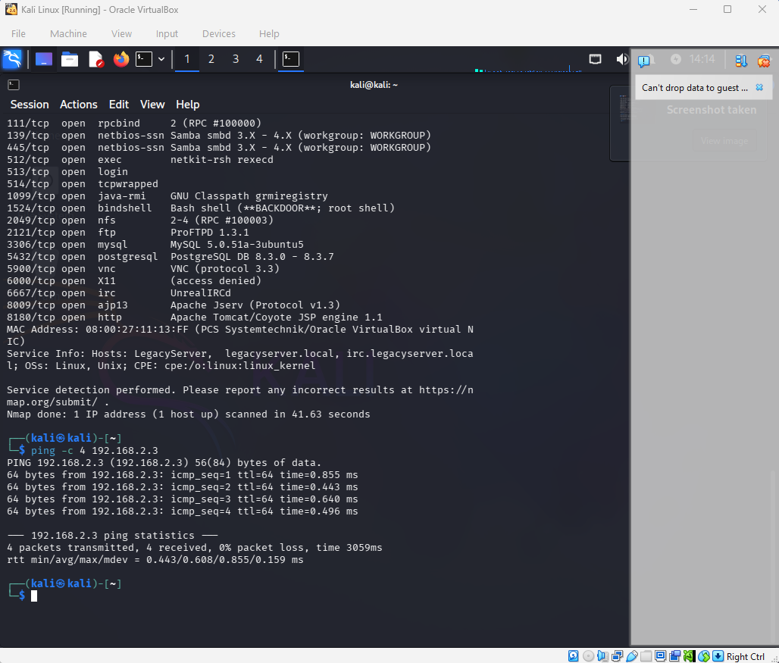
Fig 1: Connectivity Test (ping to 192.168.2.3)
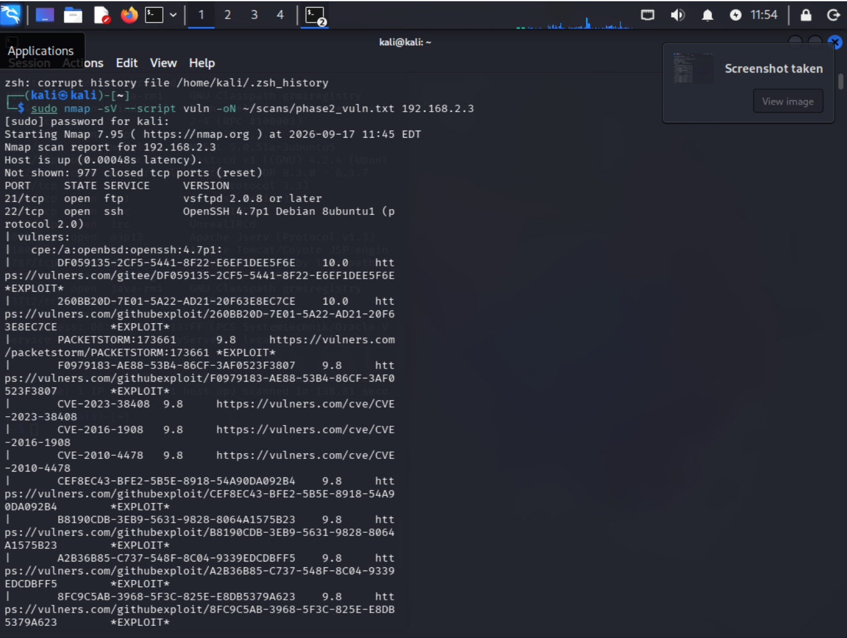
Fig 2: Scan Results (nmap -sV)
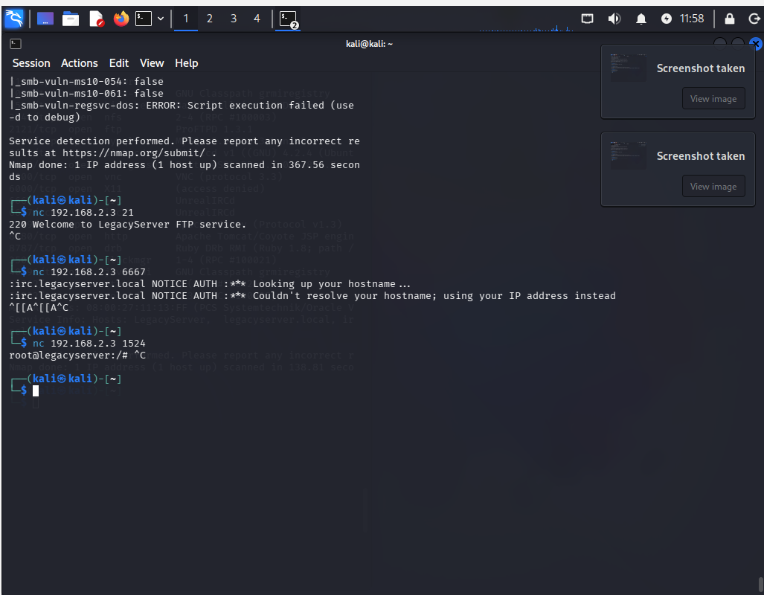
Fig 3: Vulnerability Scan (nmap --script vuln)
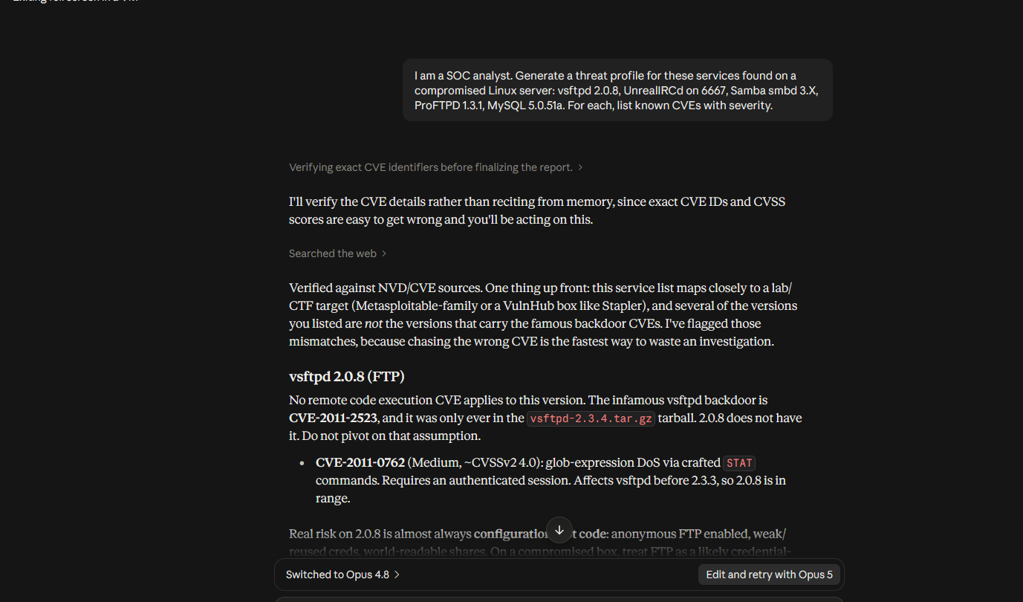
Fig 4: AI Threat Profile + prompt iterations
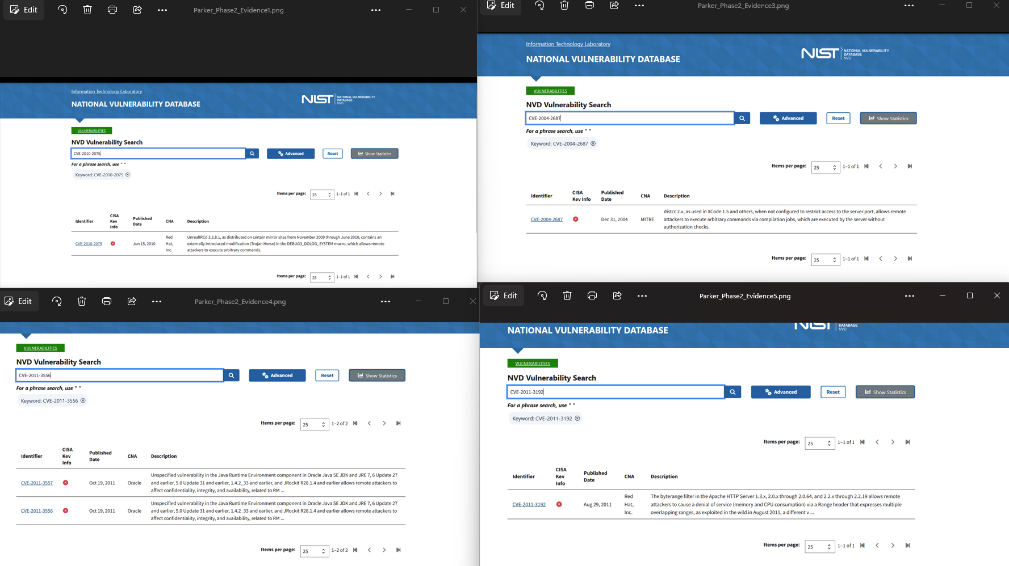
Fig 5: NVD verification (CVE-2010-2075, 2007-2447, 2004-2687,
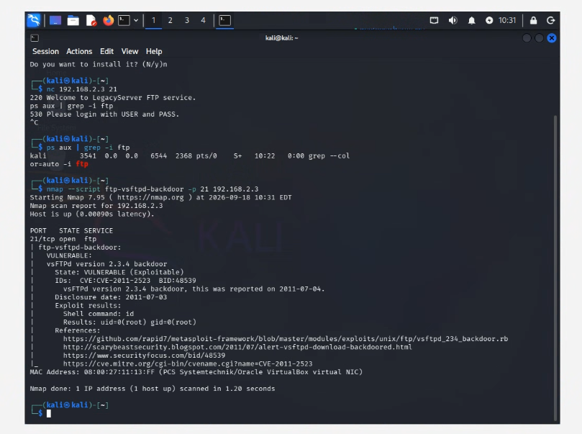
Fig 6: FTP backdoor confirmed (ftp-vsftpd-backdoor, uid=0 root)
[ Screenshot not yet provided ]
Fig 7: Evidence Locker (ls -l /tmp/evidence)
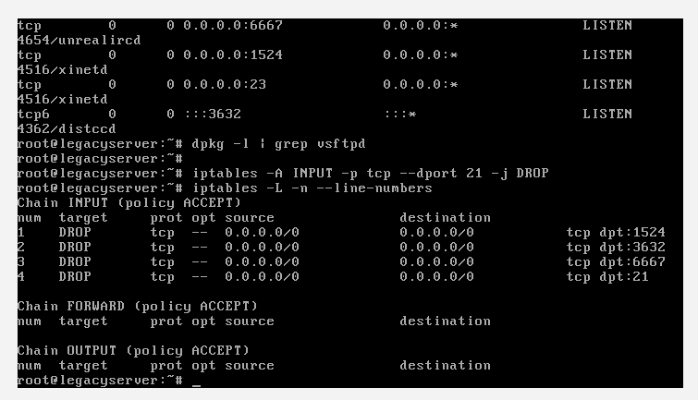
Fig 8: Containment Command (iptables, all four DROP rules)
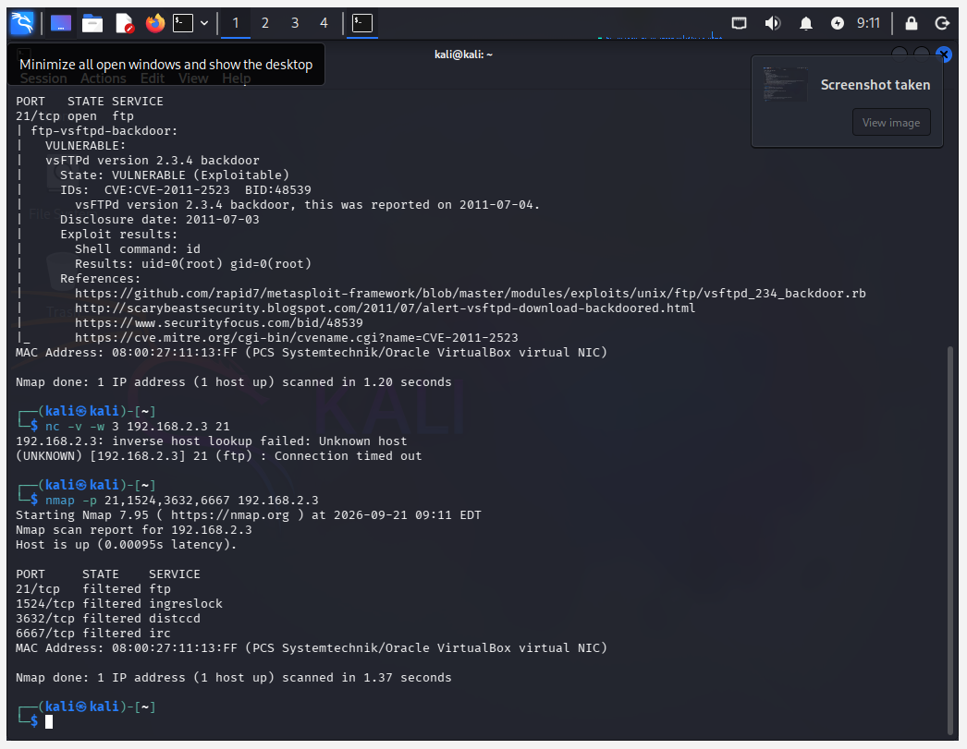
Fig 9: Mitigation Verification (ports filtered from Kali)
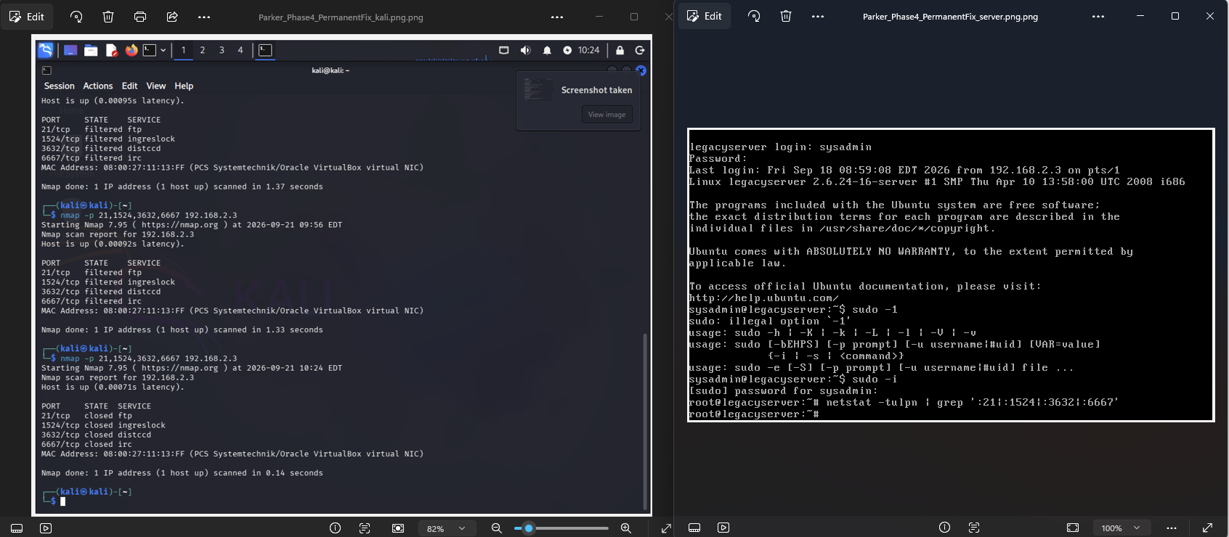
Fig 10: Permanent Fix (backdoor removed, port closed after reboot)
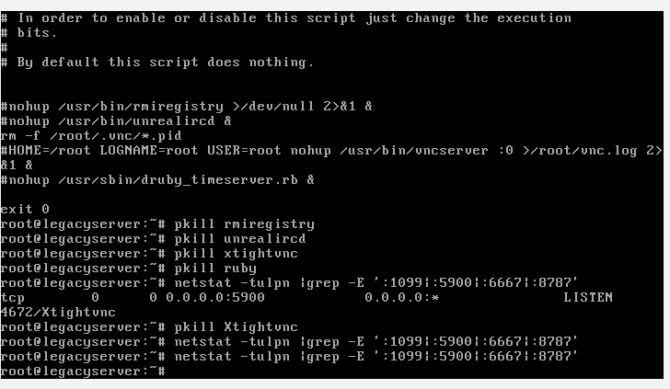
Fig 11: Attack Surface Reduction (extra service disabled)
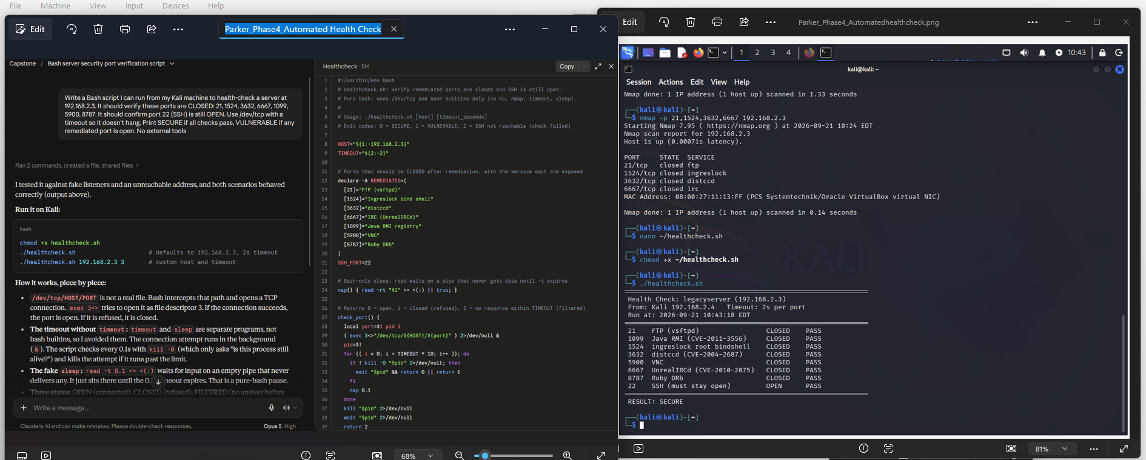
Fig 12: Automated Health Check (script + SECURE output)

Appendix B: Ron Richardson's Evidence
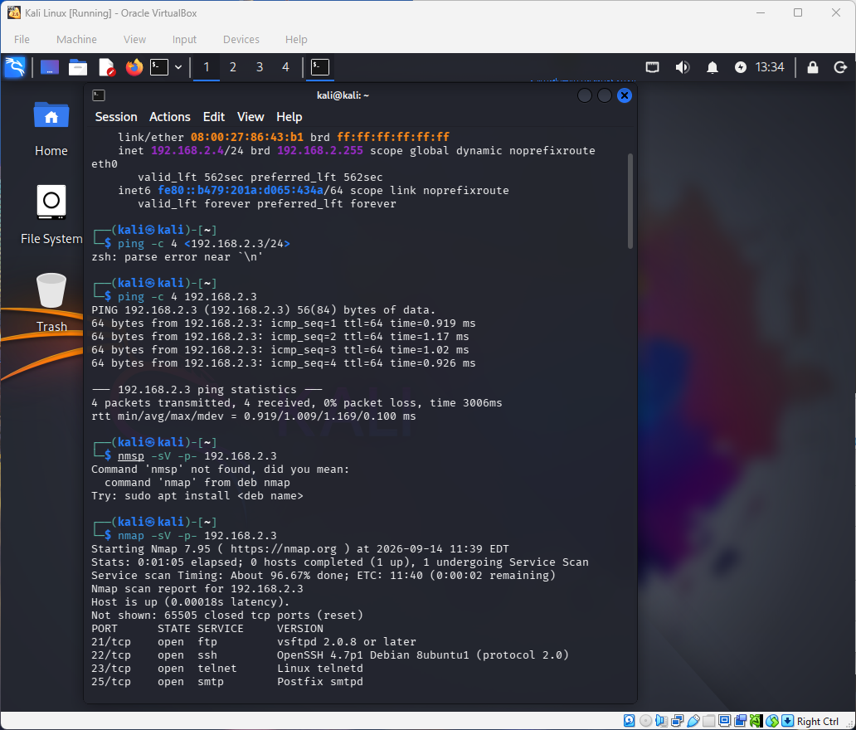
Fig 1: Connectivity Test
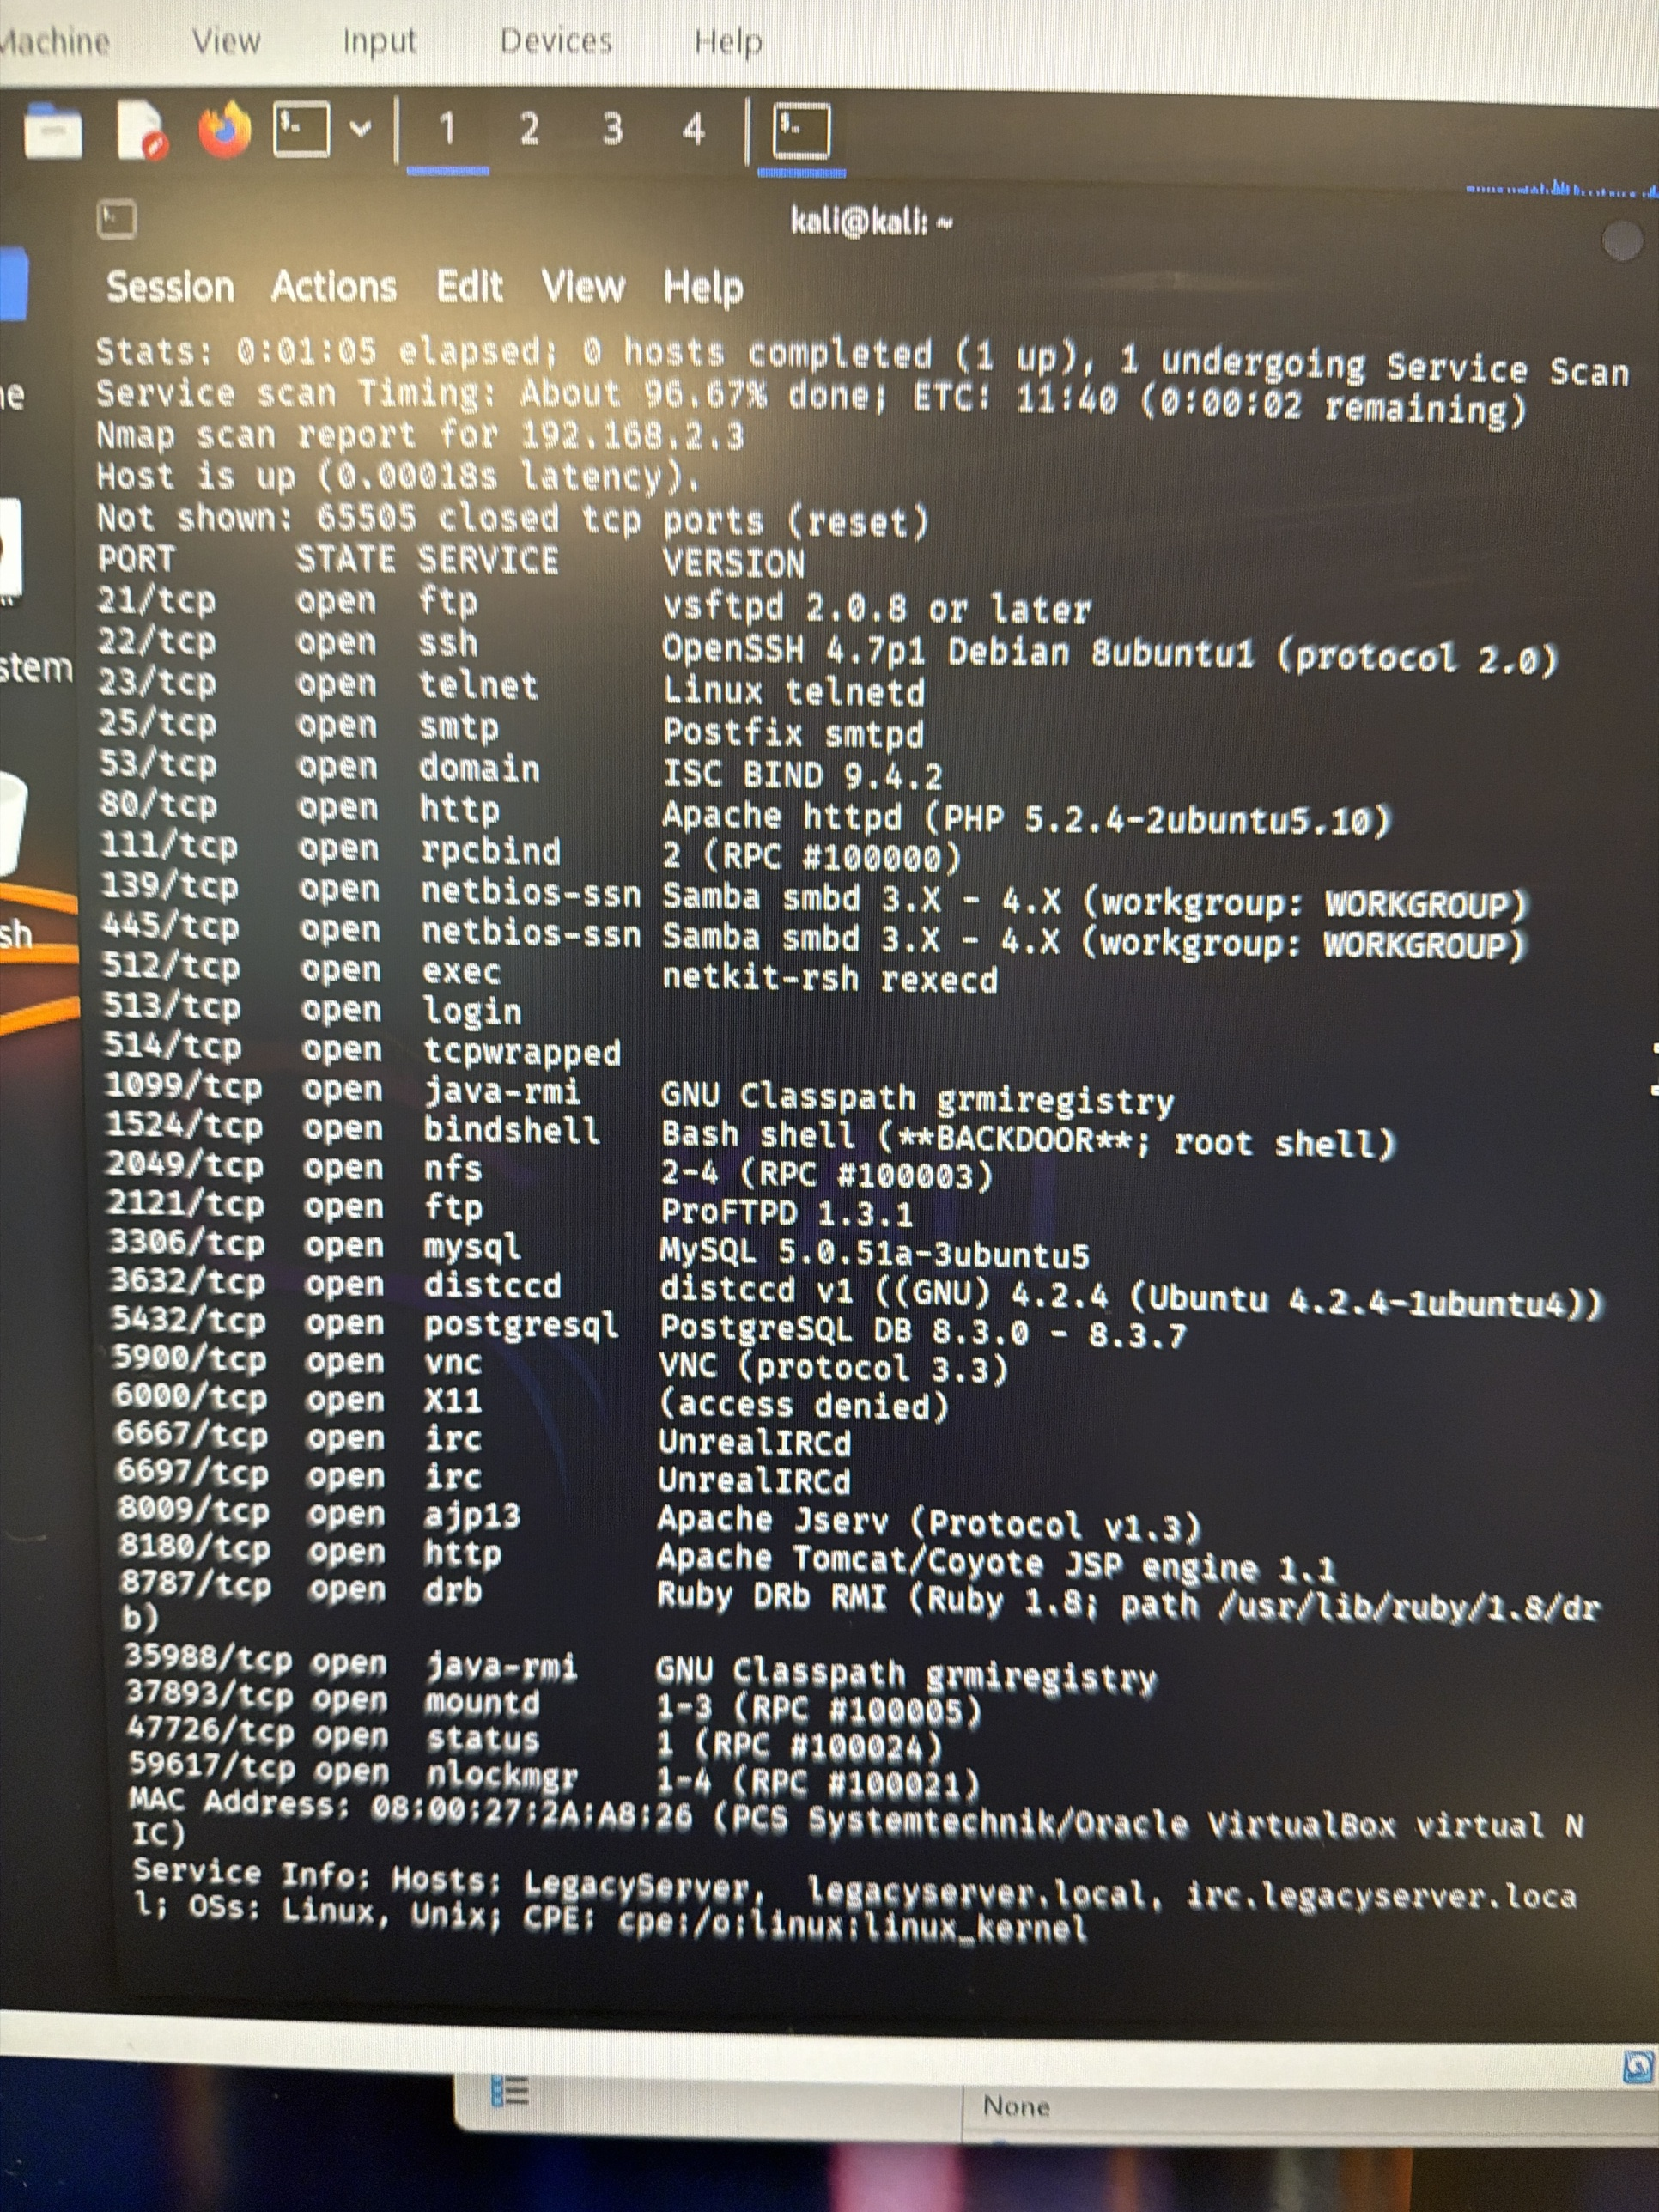
Fig 2: Scan Results
[ Screenshot not yet provided ]
Fig 3: Vulnerability Scan
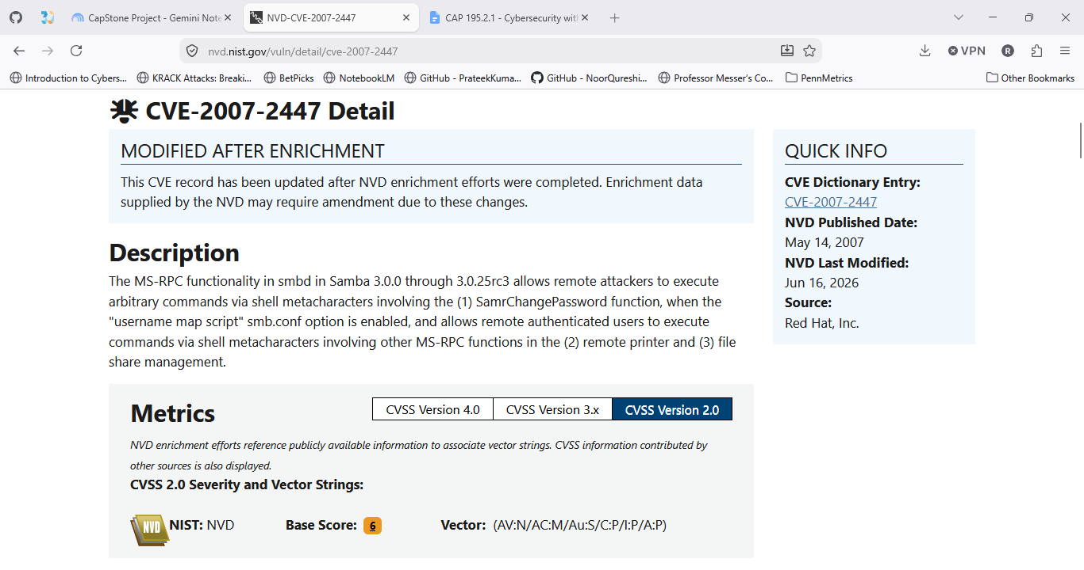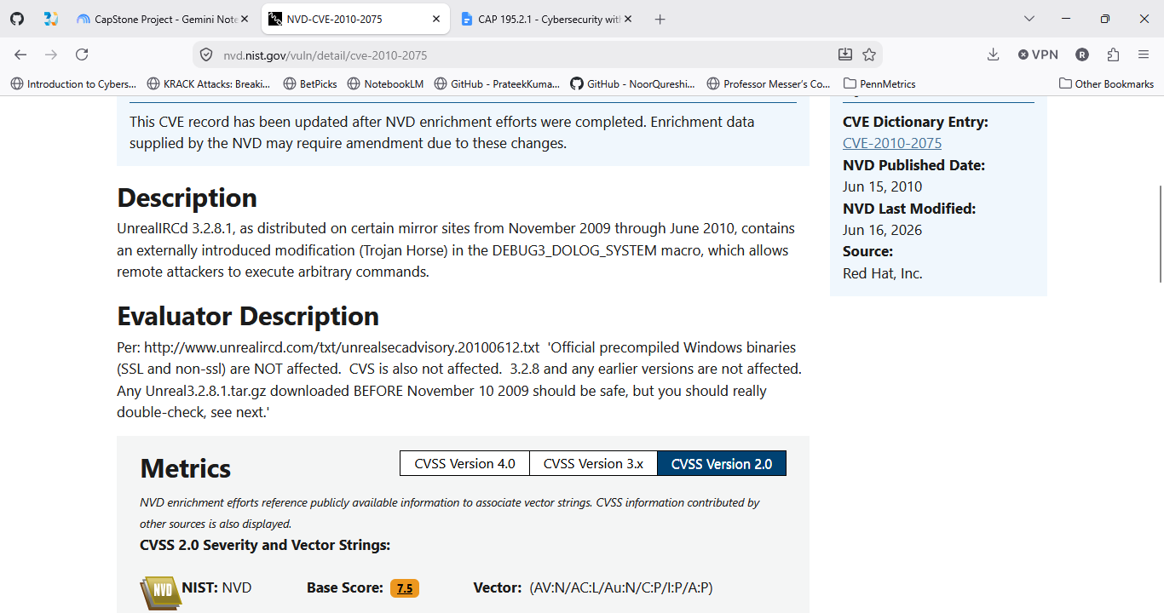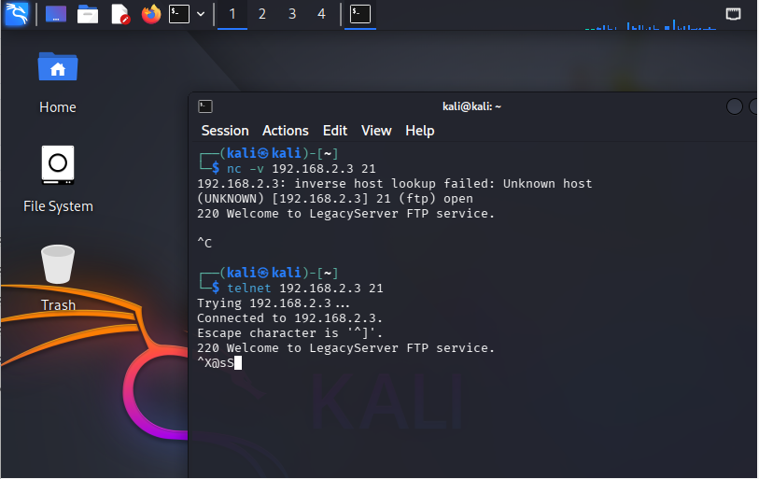
Fig 4: AI Threat Intel + NVD verification
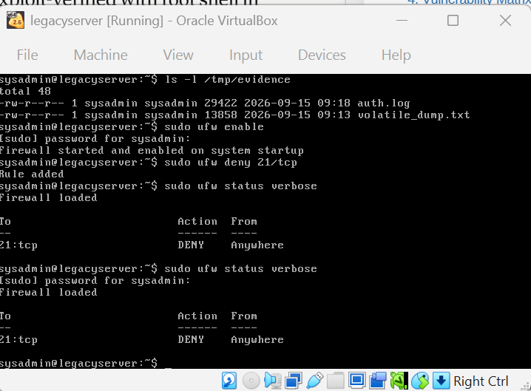
Fig 5: Evidence Locker
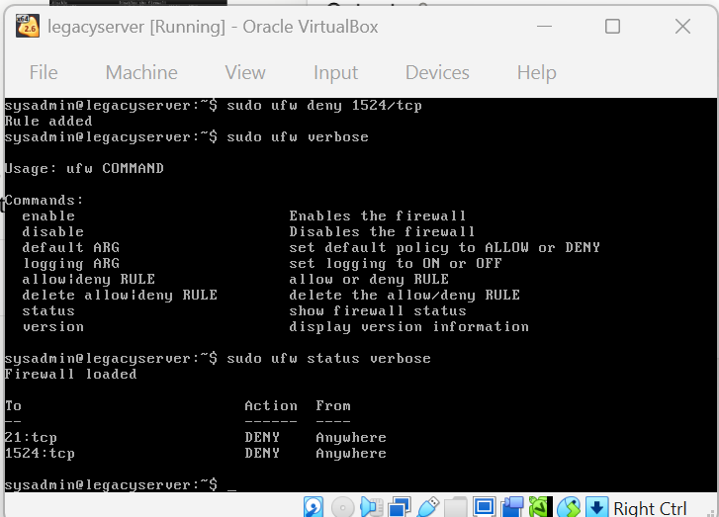
Fig 6: Containment Command
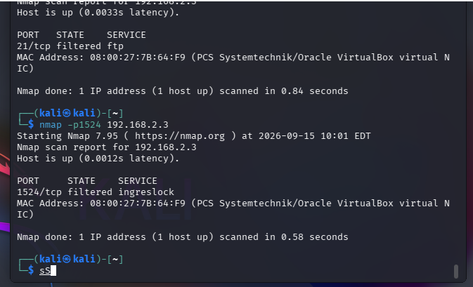
Fig 7: Mitigation Verification
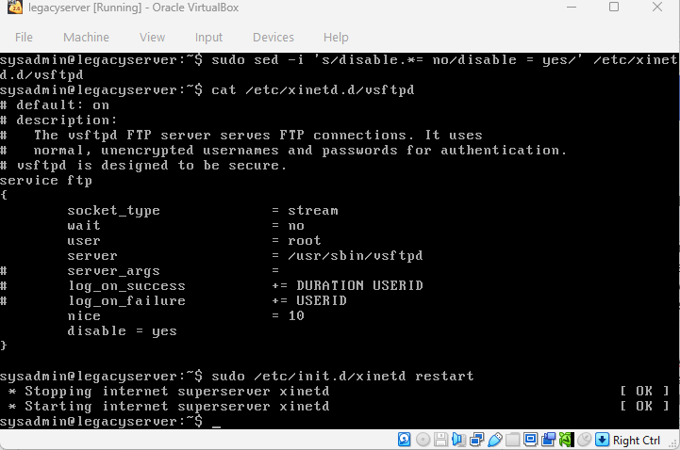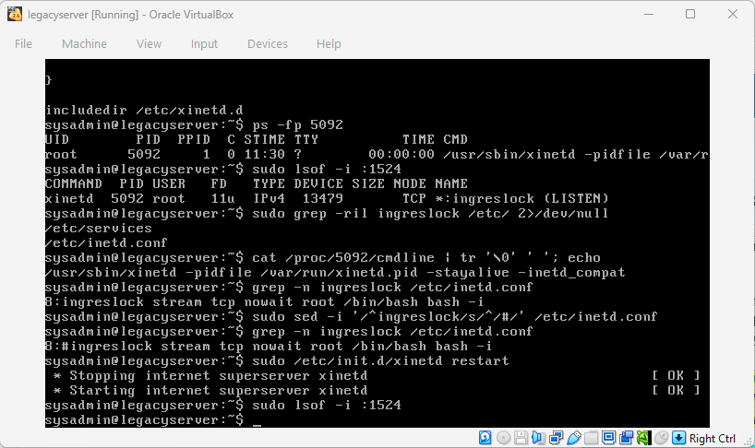
Fig 8: Permanent Fix
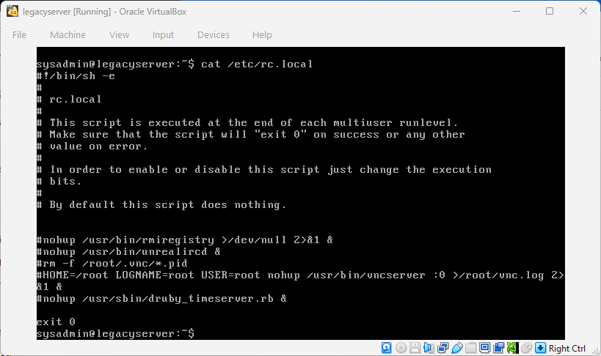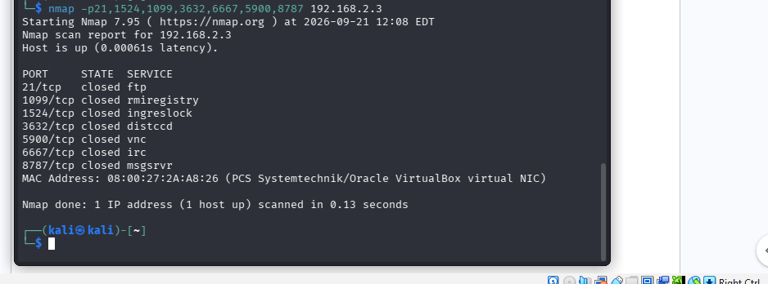
Fig 9: Attack Surface Reduction
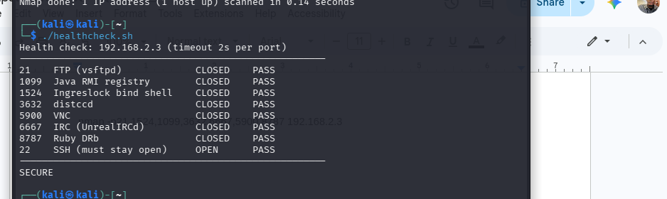
Fig 10: Automated Health Check

Appendix C: Faith Telva's Evidence
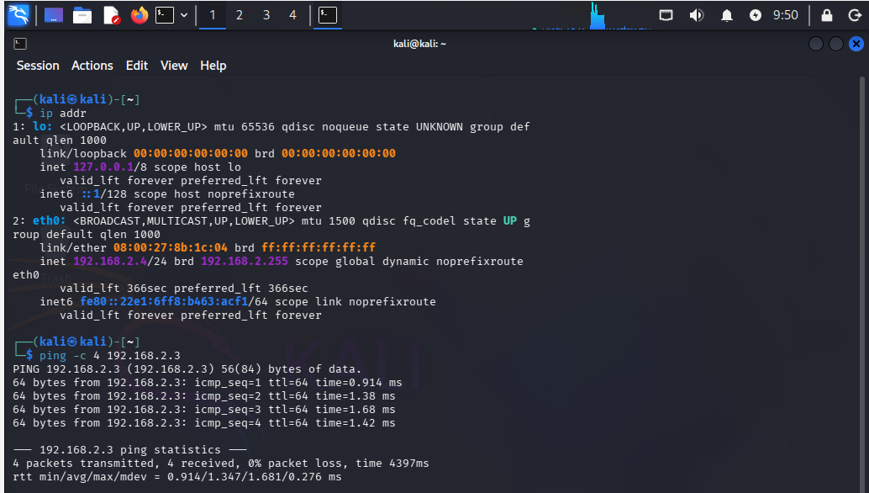
Fig 1: Connectivity Test
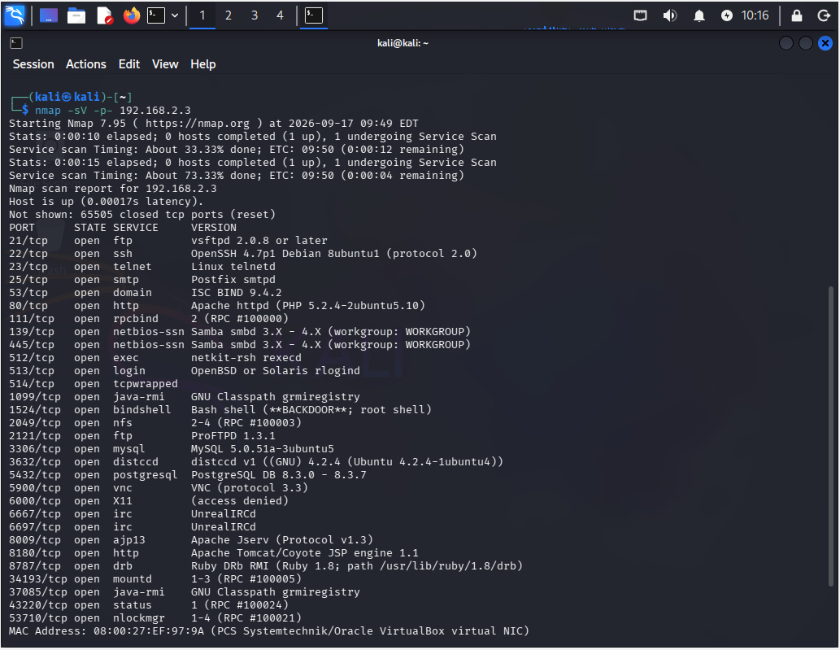
Fig 2: Scan Results
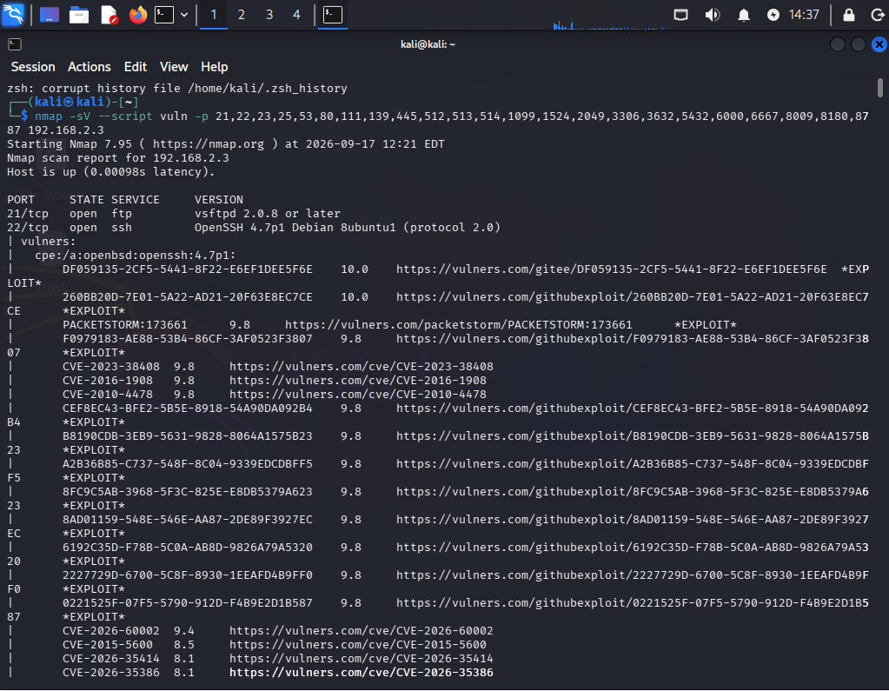
Fig 3: Vulnerability Scan
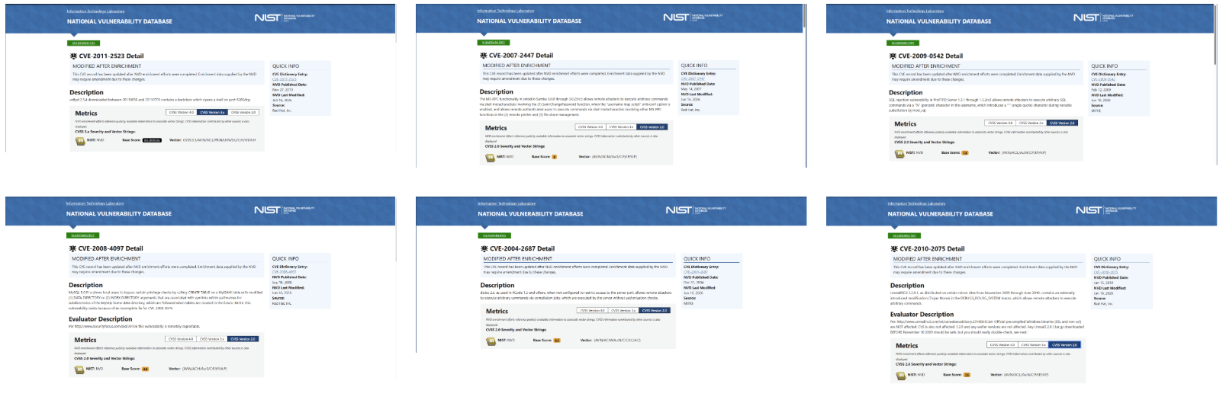
Fig 4: AI Threat Intel + NVD verification
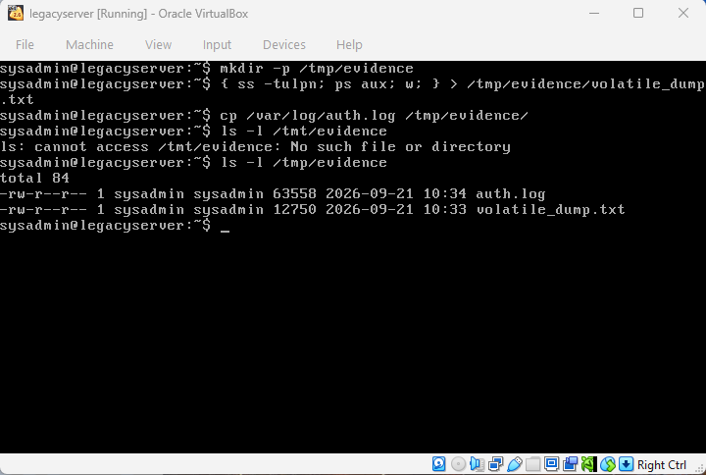
Fig 5: Evidence Locker
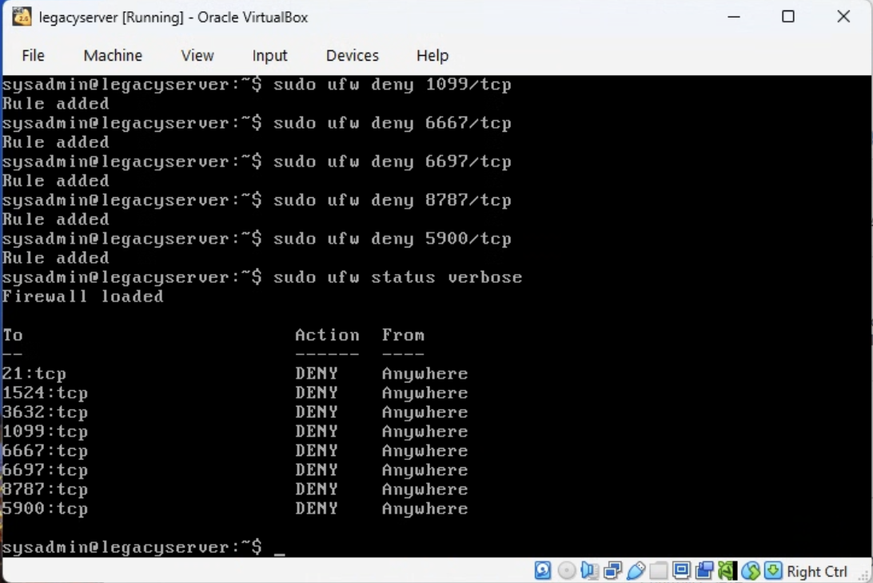
Fig 6: Containment Command
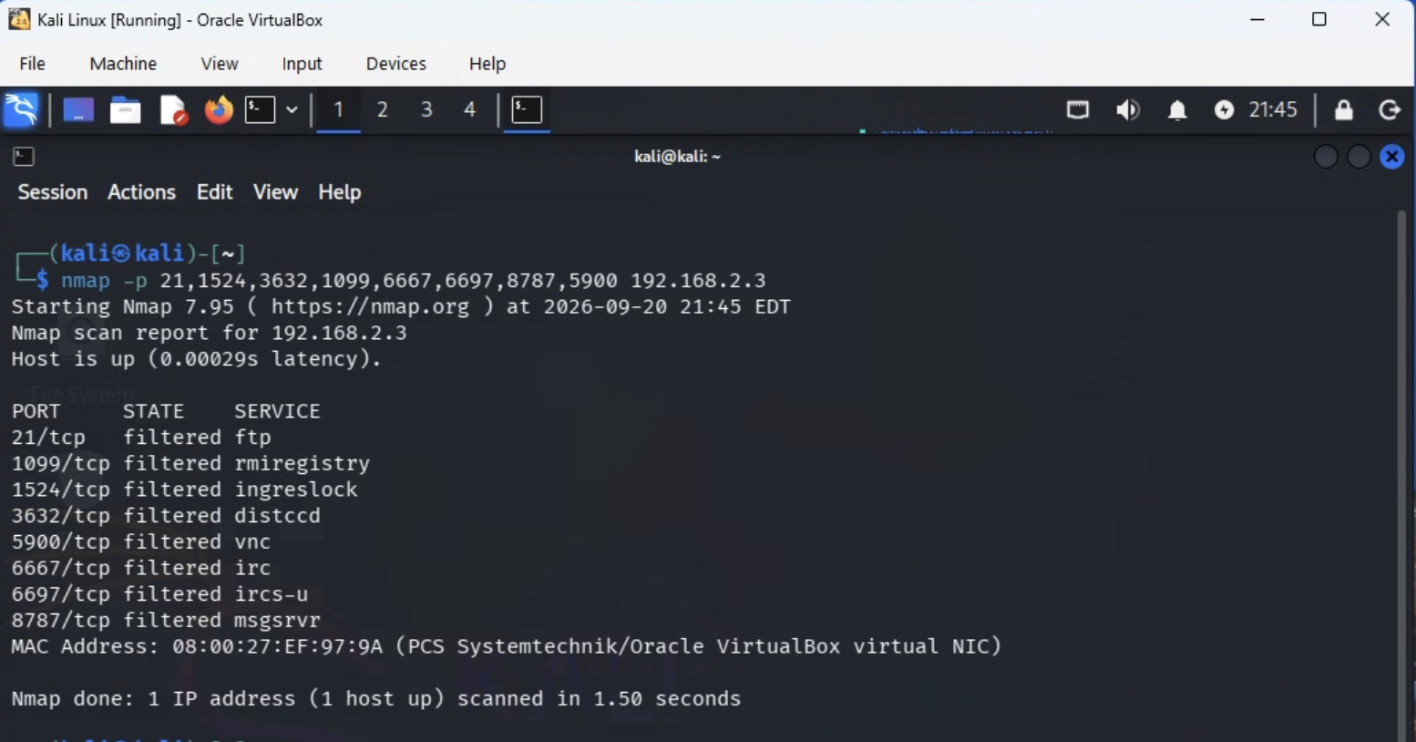
Fig 7: Mitigation Verification
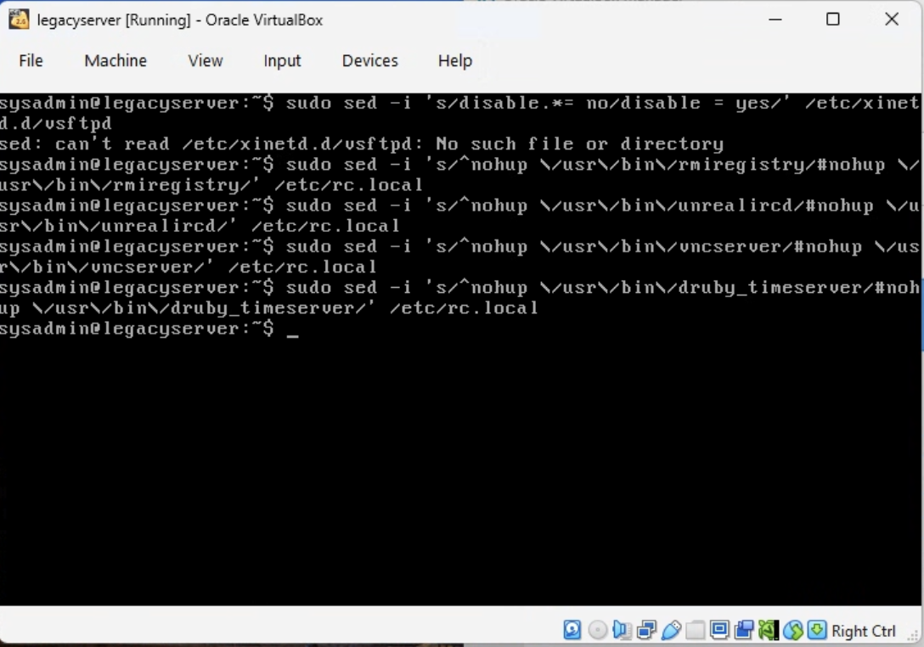
Fig 8: Permanent Fix
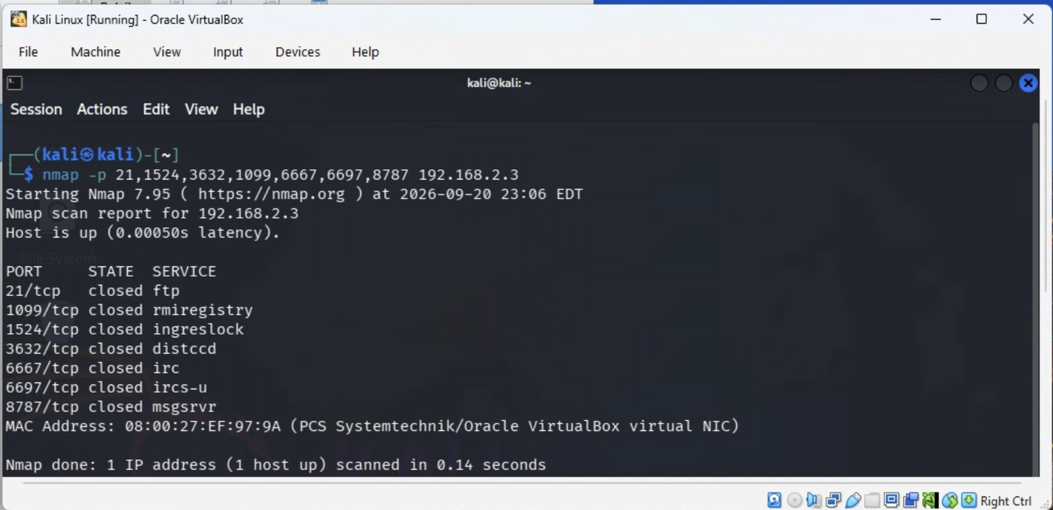
Fig 9: Attack Surface Reduction
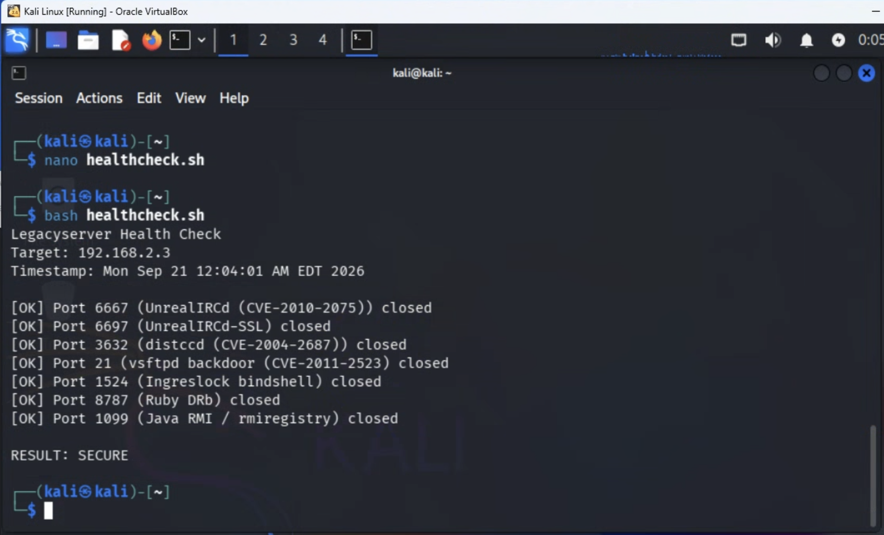
Fig 10: Automated Health Check

Appendix D: Hossain Azim's Evidence
Empty — Hossain still needs to paste in his own screenshots for all 10 figures below.
[ Screenshot not yet provided ]
Fig 1: Connectivity Test
[ Screenshot not yet provided ]
Fig 2: Scan Results
[ Screenshot not yet provided ]
Fig 3: Vulnerability Scan
[ Screenshot not yet provided ]
Fig 4: AI Threat Intel + NVD verification
[ Screenshot not yet provided ]
Fig 5: Evidence Locker
[ Screenshot not yet provided ]
Fig 6: Containment Command
[ Screenshot not yet provided ]
Fig 7: Mitigation Verification
[ Screenshot not yet provided ]
Fig 8: Permanent Fix
[ Screenshot not yet provided ]
Fig 9: Attack Surface Reduction
[ Screenshot not yet provided ]
Fig 10: Automated Health Check

Appendix E: Michael Williams's Evidence
Empty — Mike still needs to paste in his own screenshots for all 10 figures below.
[ Screenshot not yet provided ]
Fig 1: Connectivity Test
[ Screenshot not yet provided ]
Fig 2: Scan Results
[ Screenshot not yet provided ]
Fig 3: Vulnerability Scan
[ Screenshot not yet provided ]
Fig 4: AI Threat Intel + NVD verification
[ Screenshot not yet provided ]
Fig 5: Evidence Locker
[ Screenshot not yet provided ]
Fig 6: Containment Command
[ Screenshot not yet provided ]
Fig 7: Mitigation Verification
[ Screenshot not yet provided ]
Fig 8: Permanent Fix
[ Screenshot not yet provided ]
Fig 9: Attack Surface Reduction
[ Screenshot not yet provided ]
Fig 10: Automated Health Check

