MRS Lab 1: Effect of Parameters on the Swarm
Mohammad Haadi Akhter
I tested 10 parameter sets in Stage. I recorded each 90-second run with ros2 bag and plotted it from the bag. Robots are 7.5 cm squares, so they touch at about 0.075 m.

Parameter sets
Set | Separation | Alignment | Cohesion | Radius (m) | FOV | Robots | Map | Max acc. (m/s²) | Start circle (m)
A Base | 0.06 | 1.0 | 0.5 | 1.0 | 270° | 10 | Empty 10×10 | 0.5 | Radius 1
B Corrected | 0.12 | 1.0 | 0.5 | 1.0 | 270° | 10 | Empty 10×10 | 1.0 | Radius 1
C No alignment | 0.06 | 0 | 0.5 | 1.0 | 270° | 10 | Empty 10×10 | 0.5 | Radius 1
D High cohesion | 0.06 | 1.0 | 2.0 | 1.0 | 270° | 10 | Empty 10×10 | 0.5 | Radius 1
E Low separation | 0.005 | 1.0 | 0.5 | 1.0 | 270° | 10 | Empty 10×10 | 0.5 | Radius 1
F Small radius | 0.06 | 1.0 | 0.5 | 0.4 | 270° | 10 | Empty 10×10 | 0.5 | Radius 1
G Narrow view | 0.06 | 1.0 | 0.5 | 1.0 | 90° | 10 | Empty 10×10 | 0.5 | Radius 1
H Many robots | 0.06 | 1.0 | 0.5 | 1.0 | 270° | 30 | Empty 10×10 | 0.5 | Radius 1
I Small map | 0.06 | 1.0 | 0.5 | 1.0 | 270° | 10 | Empty 3×3 | 0.5 | Radius 1
J Hard maze | 0.06 | 1.0 | 0.5 | 1.0 | 270° | 10 | Hard maze 10×10 | 0.5 | Radius 0.6, at (−1.5, 0)
Bold values differ from Set A. In all sets, speed stays between 0.15 and 0.3 m/s.

Results and fixes
Set | Align. | Spacing (m) | Closest (m) | Collisions | What happened and why | Fix and result
A | 0.99 | 0.31 | 0.075 | 1 robot (0.5 s) | One flock forms and turns smoothly at walls. Two robots touch at 9 s as the circle closes. Cohesion pulls everyone in, and the minimum speed stops them slowing down. | Use Set B: separation 0.12, max acc. 1.0.
B | 0.99 | 0.41 | 0.226 | None | Best set. One flock. Stronger separation keeps robots apart as the circle closes. The actual velocity follows the command (Figure 1). | None needed.
C | 0.63 | 0.44 | 0.078 | 2 robot (0.5 s) | No proper flock, 2 to 3 groups. Nothing makes robots agree on a direction, so they cross paths. | Alignment 0.5 with Set B: alignment 0.98, no collisions.
D | 0.97 | 0.18 | 0.083 | 1 robot (0.3 s) | Too tight. The pull to the centre is much stronger than separation. | Separation 0.24, alignment 2.0, max acc. 1.0: alignment 0.95, no collisions.
E | 0.99 | 0.12 | 0.076 | 4 robot (5.9 s) | Almost touching. Separation is too weak against cohesion. The actual velocity drops to zero while blocked (Figure 2). | Use Set B.
F | 0.13 | 1.32 | 0.076 | 2 robot (1.0 s) | About 10 single robots. The 0.62 m start gap is larger than the radius, so no robot sees another. | Radius 1.0 m with Set B.
G | 0.06 | 0.81 | 0.076 | 4 robot (228 s) | About 6 groups. Pairs crash side-on and neither robot can see the other, so no rule pushes them apart. One pair is stuck for 86 s (Figure 3). | Use Set B, which has FOV 270°.
H | 0.98 | 0.18 | 0.075 | 19 robot (7.9 s) | One flock, but crowded. Separation is divided by the number of neighbours, so each of 29 neighbours pushes about a third as hard as each of 9. | Separation 0.4, radius 2.0 m, max acc. 1.0, start radius 2 m: alignment 0.95, no collisions.
I | 0.97 | 0.27 | 0.100 | 1 robot, 1 wall (0.7 s) | The flock circles the small room. Walls are always near, so it has little room to turn. | Set B on this map: alignment 0.95, no collisions.
J | 0.95 | 0.26 | 0.084 | 2 robot (2.1 s) | One flock, but tight corridors squeeze it. | Set B with radius 2.0 m: alignment 0.94, no collisions.
Align. means how much the robots move the same way (1 is all the same, 0 is random). Spacing is the average distance to the nearest robot. Closest is the smallest distance between two robots. Collision time is the total for that run. Each fix was tested in a separate run.

What the parameters do
Separation and cohesion work against each other, and their balance sets the spacing. Alignment sets how well robots agree on a direction. Radius and FOV set how much each robot knows, so too little breaks the flock. More robots need more separation and a larger radius.

Commanded and actual velocity, and accelerations
These plots come from plot_flocking.py, using the ros2 bag of each run. Commanded velocity comes from cmd_vel. Actual velocity comes from the change in odom position, because Stage repeats the command in the odom velocity even when a robot is blocked. Each acceleration plot shows the x part, the y part and the size.
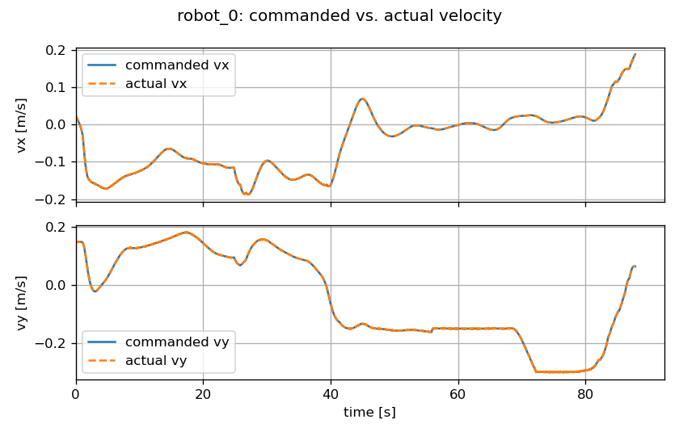 | 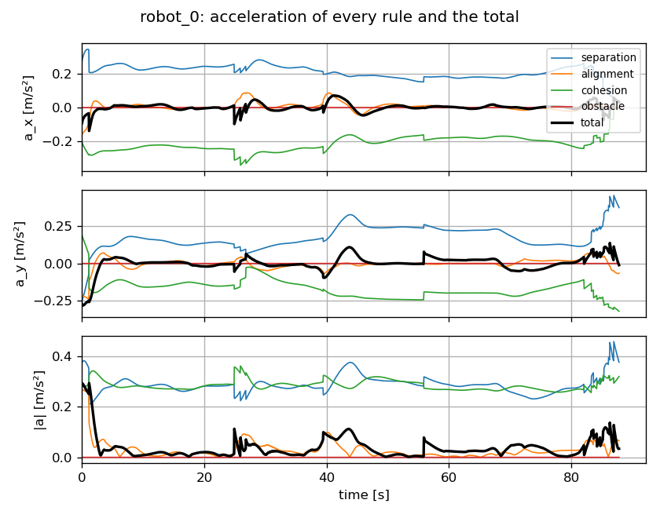
Figure 1. Set B, robot 0. The actual velocity matches the command for the whole run. The total stays small, because separation and cohesion balance.
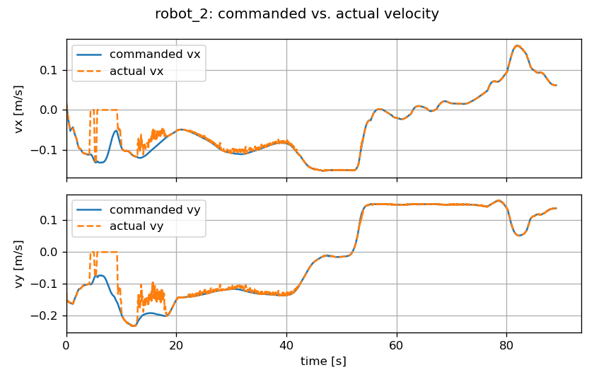 | 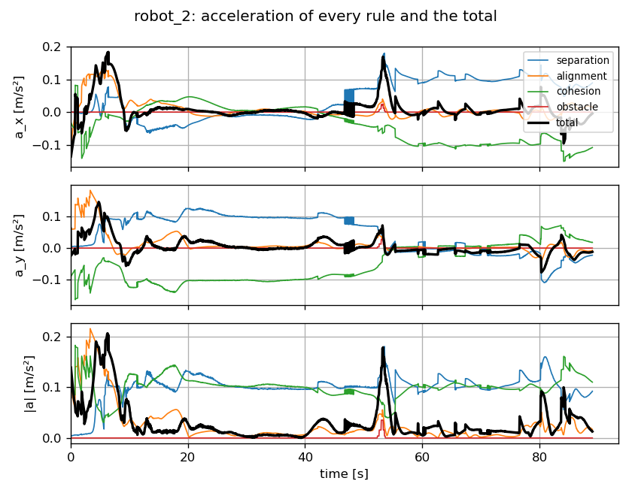
Figure 2. Set E, robot 2. The actual velocity drops to zero at about 5 to 9 s while the command continues, because the robot is touching others.
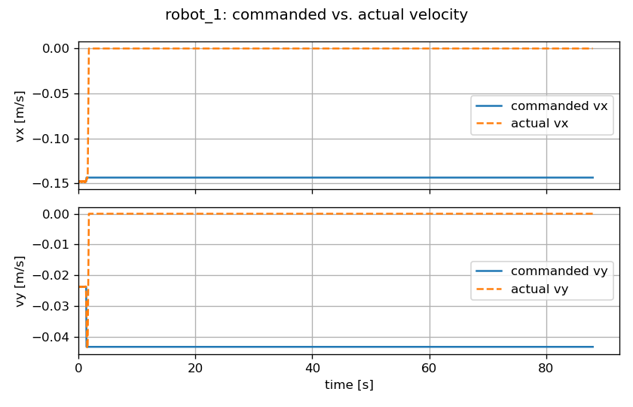 | 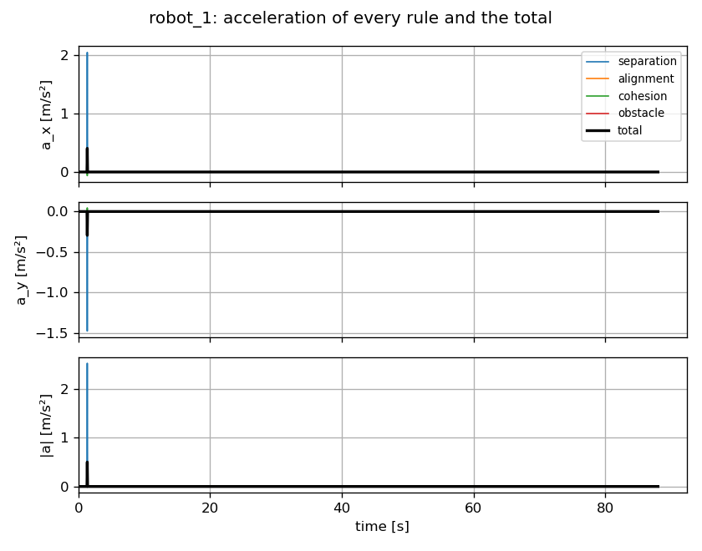
Figure 3. Set G, robot 1. The robot is commanded to move but stays still from 1.7 s. After one spike, every acceleration is zero, because it sees no neighbours.

