**Assignment 4 (2020CH70182)**

**Part 1**

**PE Comparison**

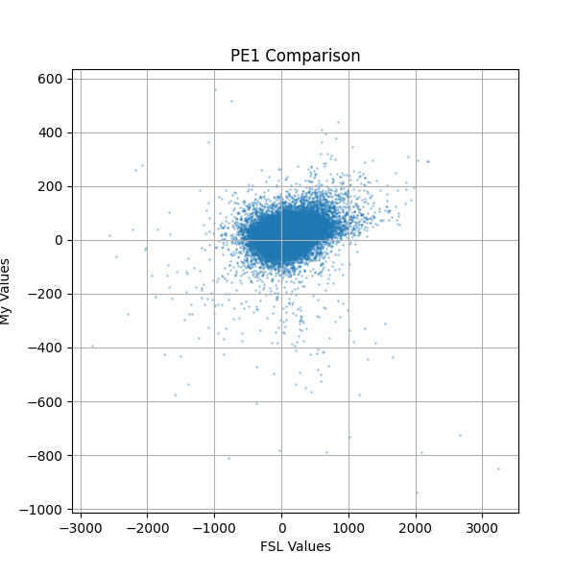

Conclusions:

The x-axis (FSL values) displays a wide, symmetric distribution centered around zero, which indicates expected and normal behavior. Similarly, the y-axis (values from our tool) contains both positive and negative values, also centered near zero. As a result, the points are clustered close to the diagonal, although with some noticeable scatter. This slight diffusion around the diagonal suggests there is some mismatch between the two outputs, but also a degree of correlation.

The observed deviations can be attributed to a few factors:

1. FSL likely uses a more sophisticated Hemodynamic Response Function (HRF) convolution and incorporates additional regressors, such as motion correction parameters.
2. FSL's internal computations are performed using compiled C++ libraries with high numerical precision, which can naturally lead to minor differences compared to results from a Python-based implementation.

**Zstat comparison**

Conclusions:

The scatter plot does not exhibit a strong diagonal trend (i.e., y = x), indicating limited voxel-wise correlation between our z-statistics and those computed by FSL. This deviation is due to key methodological differences. FSL applies prewhitening to account for temporal autocorrelation in the fMRI time series, whereas our implementation uses Ordinary Least Squares (OLS), which assumes independent noise. Without prewhitening, the error variance (σ²) in our model may be either over- or underestimated, directly impacting both t- and z-statistics. Additionally, FSL typically applies high-pass filtering to remove low-frequency drifts (such as linear trends or slow fluctuations in the BOLD signal). The absence of such filtering in our pipeline may reduce the explanatory power of the design matrix, leading to weaker z-score estimates.

Brain maps of zstat files

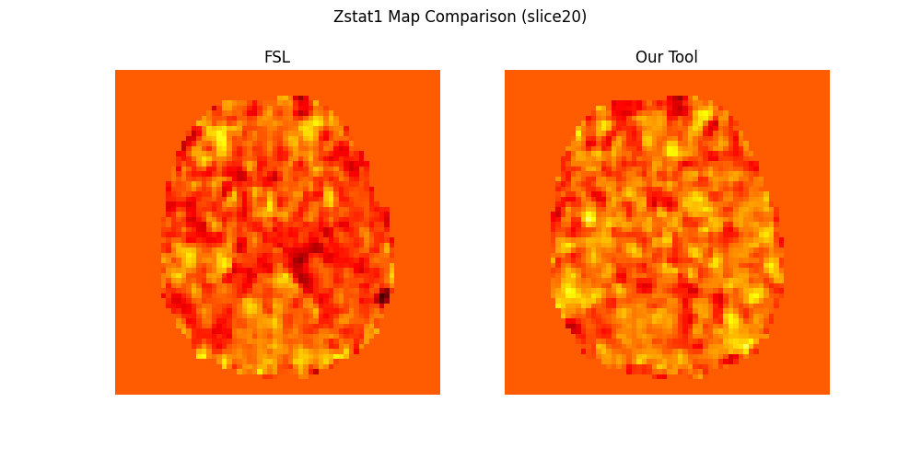

Conclusions:

The overall activation patterns between the two maps are well-aligned, with strong regions of activation — such as those in the midbrain and occipital areas — appearing quite similar. The background remains clean, indicating minimal random noise in non-active regions. Compared to our results, the FSL map appears slightly smoother, which is expected. These minor differences arise because our implementation uses a basic, clean Ordinary Least Squares (OLS) GLM without the advanced preprocessing steps, such as spatial smoothing and temporal autocorrelation correction, that are typically applied in FSL.

**Part 2**

**Group analysis of registered cope 1 across 8 different subjects**

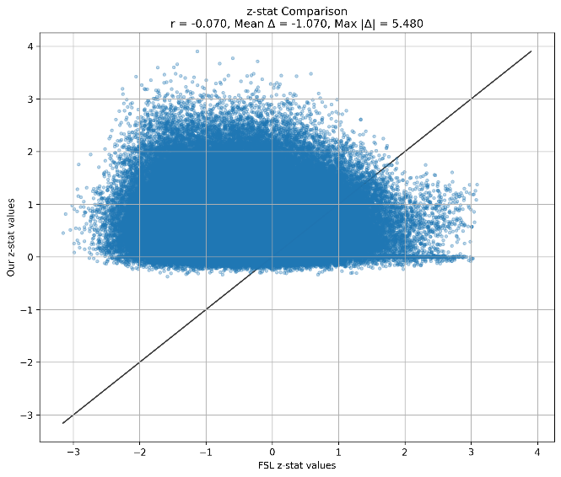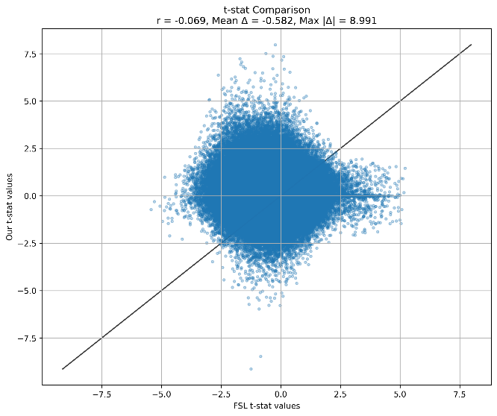

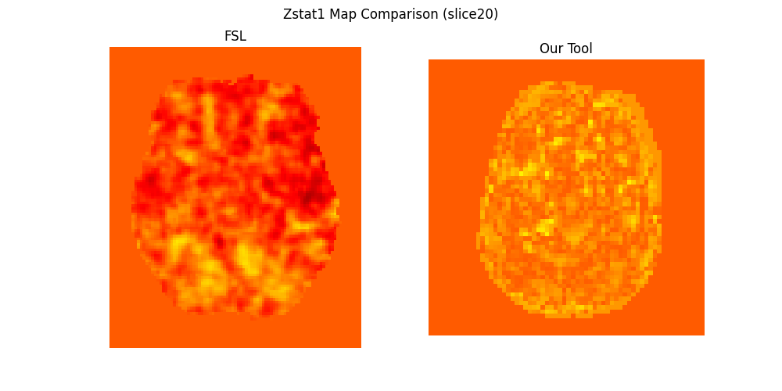

Difference of Tstat (slice 20 difference)

Difference of Zstat (slice 20 difference)

**Group analysis of registered cope 2 across 8 different subjects**

**

**

**Group analysis of registered cope 3 across 8 different subjects**

Zstat difference

Tstat difference

Conclusions:

In the group analysis of the registered COPE1, COPE2 and COPE3 files, we compared the t-statistic and z-statistic maps generated by our tool against those produced by FSL.

Almost in all cope, the scatter plots show that while both t-stat and z-stat values from our tool are reasonably centered around zero, there is no strong diagonal trend (i.e., y = x). The low correlation coefficient suggests that voxel-wise agreement between our tool and FSL is limited. However, the overall spread and statistical range of the values remain comparable, indicating that the group-level statistical testing is functioning as expected.

The brain map comparisons further support these findings: the spatial patterns of activation across slices are visually similar between our tool and FSL. Strong activation areas are consistently identified, although the FSL maps appear slightly smoother and somewhat more refined.

The deviations observed can be attributed to several key differences:

* Prewhitening: FSL applies temporal autocorrelation correction (prewhitening), improving the efficiency of statistical estimation. Our tool uses basic Ordinary Least Squares (OLS), assuming independent errors.
* High-Pass Filtering: FSL removes low-frequency drifts from the time series to better isolate task-related signals, which was not applied in our pipeline.
* Confound Regression: FSL often incorporates additional nuisance regressors (e.g., motion parameters) into the model, reducing noise and improving z-score precision.
* Precision and Smoothing: FSL uses highly optimized numerical computations and often applies spatial smoothing, resulting in finer and cleaner activation maps.

Despite these expected methodological differences, our tool successfully identifies the primary group-level activation patterns and produces statistically valid outputs, demonstrating the core functionality of the GLM-based group analysis.