Create 2 VMs
- if config / ip a
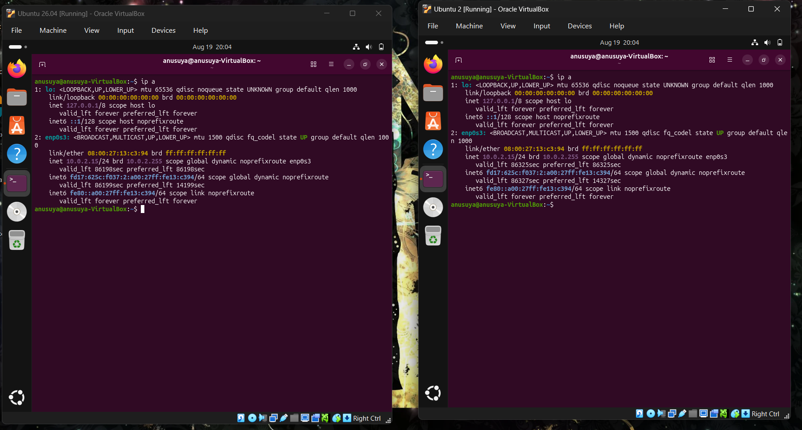
Files -> Tools -> Network
Create customized NAT Network in Virtual Box
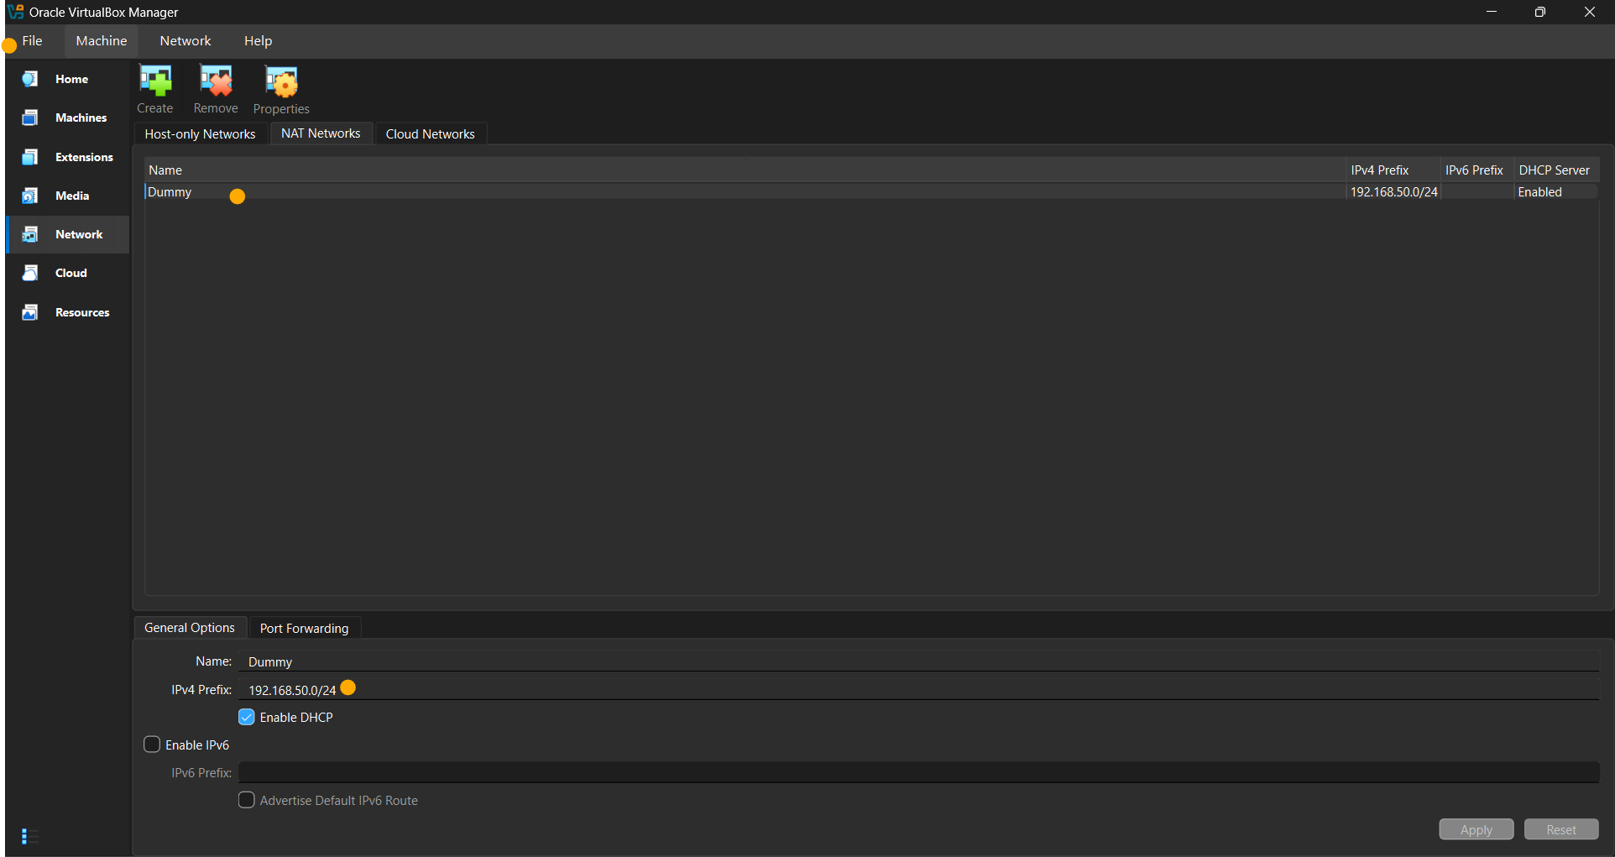

Use your NAT Network (‘Dummy’ here)
In both of your Virtual Machines
Machine -> Settings->Expert->Network->Attached to “NAT Network”->Your Network
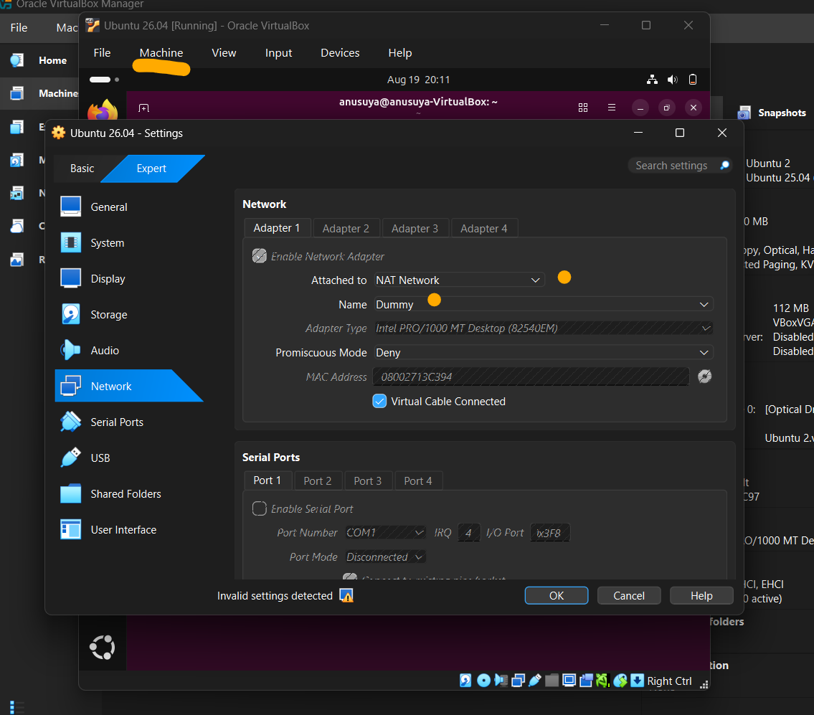
Do same for the other VM too.
Shut both of them and then Power on again.

Ping Your VM’s to each other, if the are receiving packets or not.
Ping <inet IP address of your VM>
Ex: Ping 192.168.50.3
