**Report**

**Introduction:**

Company:

This report is on National Masonry™. The National Masonry™ story began with the acquisition of Boral Masonry’s Mackay operation in April 2012 and continues to grow with the acquisition of Boral Masonry’s South Queensland and Victorian operation in January 2013. National Masonry™ retains the heritage of expertise and industry credentials and combine these with the flexibility and innovative foresight of an independent privately owned company. Our valued customers will benefit from dealing with the same great people, same great products and services, and a new vision for the future.

National Masonry™ is one of the leading manufacturer and reseller of Concrete Blocks, Bricks, Pavers & Retaining Wall Servicing Brisbane, Gold Coast and etc. The Vision of the company is

“*Customers for Life.*”

In Australia the brick industry is worth $2.8 billion to the economy and creates employment for 30,000 people nationwide in the manufacturing and installation of its product. The brick industry plays very important role in country economy the net worth 2.8 billion Dollar is more than 70% of Pakistan’s budget as Pakistan budget was 4.5tn rupee which is 51573108 to Australian Dollar. Every industry can contribute its part in country economy if does it job according to the Country Standard (CS). As well as International Standard (IS) as International Standards are very important for export and export is the major factor in country’s economy.

Products:

We manufacturer an extensive range of Masonry blocks, bricks, pavers and retaining wall products. The mighty Grey Block is an iconic building material with thousands of applications. Our range of Grey Blocks utilize the latest technology producing a lightweight high strength block for all your building needs. These are available in a full range of sizes from 100 through to 300 series blocks. National Masonry’s Designer Block range is the architect’s choice, available in range of colors and finishes which provide an aesthetic and functional walling solution. Our range of landscape products caters to your every need be it paving or building a retaining wall. From DIY projects, residential property, to commercial scale projects we have the variety of products to meet your needs. We also stock a full range of accessories to complement our range.

The Concrete Grey Block is one of our top products, an iconic building material that has numerous uses. Fire Rated Concrete Grey Block products also available.

Architectural Designer Block products, which is the favorite of architects throughout Australia, are available in a wide range of vibrant colors and textures. Aesthetically-pleasing and highly functional.

Landscaping products that ensure that your, patio, courtyard, gardens, driveway and backyards always look impressive. From easy to lay retaining wall blocks, to concrete pavers in a range of sizes, you will find the perfect National Masonry™ products to achieve your project.

* Concrete Blocks.
* Bricks.
* Pavers.
* Retaining Wall Products direct from the manufacturer.
* Landscaping Products
* Pallet returns from your property.

**Planning:**

*“Defining goals, establishing strategies to achieve goals, developing plans to integrate and coordinate activities.”*

In National Masonry™ the Goals aredefined by the top management instead of deciding the goals with employee’s cooperation. There are two Main types of goals Financial (expected internal financial performance of the organization) and Strategic (Strategically related to the environment e.g. competitors). Sometime everyone participates in defining goals. However, goals are transferred through to lower staff through top managers. Decision making at unit or department is centralized. Everyone in the organization has heterogeneous image (with different picture of goal that is to be achieved) of goal because the goal is decided by top management.

**Heterogeneous Image:**

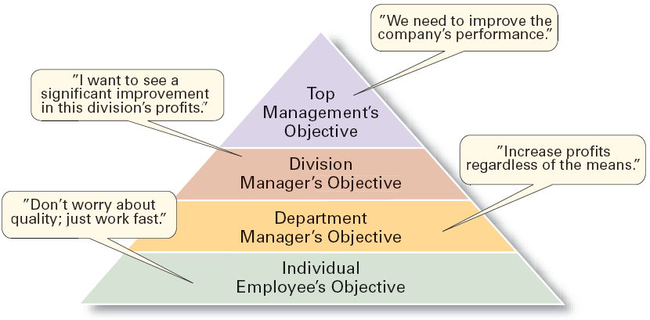

It means that they are still following the traditional goal setting instead of completely Following Management by Object (MBO) in which every employee of the organization has homogeneous image. In Management by Objective (MBO)

* Goals are jointly determined by employees and managers.
* Progress toward accomplishing goal is periodically reviewed.
* Rewards are allocated on the basis of progress towards the goals.
* Employees have Homogeneous picture of goal.
* Key elements of MBO:
* Goal Specificity.
* Participative decision making.
* An explicit performance / evaluation period.
* Feedback.

**Homogeneous Image:**

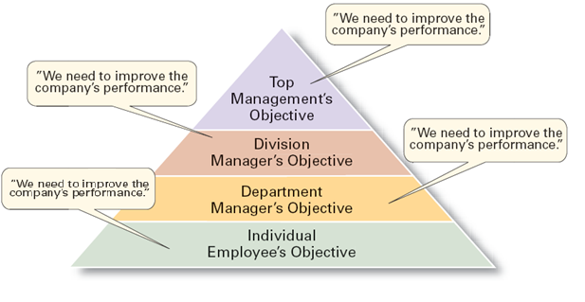

Strategic Plans (Long Term plans) are followed mostly but because the environment is dynamic means it’s changing day by day therefore, Operational Plans (that are dynamic and can be applied in dynamic environment these plans are for the short period of time) are also used. Single used plans are also used in order to meet any unique situation. Most of the plans of the organization are flexible and can be changed with requirements. The Degree of risk in the planning is moderate. Degree of risk very important factor in planning. There must be the degree in planning.

The vision and mission is one of the basic building block of unit. It plays important role in building plans. Organization summarize their goals and objectives in mission and vision statements. Vision and Mission are the major goal. To achieve those goals.

**Organizing:**

*“Arranging and structuring work to accomplish organizational goals.”*

In National Masonry™ tasks are mostly completed in group every member has clear view on what to do but the way work is done by employee at individual level depends on how employee want to do it.

National Masonry™ train people in organization. In organization mostly people are train by working in group. The new members of organization are trained through special training program. There are certain rules about how the things will be organized in the Organization. While organizing things these rules are followed in Organization. These rules are made by special researches.

Organization Structure is functional. The units in the organization are clustered by targeted groups. There are very few levels of hierarchy. Organization is Flat and the Span of control is

Wide. Some ways of organizing the work in the company includes

* Planned Job Rotation Results.
* Delegation Of Responsibility.  
  The knowledge of employees about the job ( work to be done) is above average. Organization is Multitasking (The manager with more than one job). Often the employees are not easily shift in practice from one role to another. Attitude of employees is resistive towards change. The mindset of employees. Employees are given chance to demonstrate superior performance through Diversity of Work. Employees shows willingness to share their knowledge and information. Company promotes knowledge sharing culture by providing infrastructure. The knowledge management is benefiting the company by increasing customer satisfaction. Employees face the competitive business environment through constantly updating knowledge.

Company’s performance criteria include:

* Quality of Work.
* Timeliness in completing the work.
* Quantity of Work.
* Knowledge of Job.
* Ability to make decisions.
* Ability to Solve Problems.

**Hierarchy of Organization:**



**Leading:**

*“Working with and through people to accomplish goals.”*

Everyone in group has equal rights. Rank is not considered in group decisions. Everyone can give its opinion. Implications will be made on group decision.

Leading is the most important factor. Leader is someone who knows the shows the way and goes the way. Leader should be better than other group members. Leader should be experienced. Inexperience leads to wrong decision. Leaders can lead the organization to the top and can be the great cause of organization loss in the form of financial or poor performance.

Departmental Head or Manager appraises the employees. The employees are appraised yearly. The most significant reason for performance appraisal is identifying the gaps in actual and desired outcomes. Employees are guided by the leadership while achieving their objectives. The style of leadership is combination of more than below.

* Declarative.
* Consultative.
* (Participative) making decisions together with the employee, and supporting him/her in the task performance.
* (Sedation-oriented) mainly collaborating.
* (Instructive) indicating step by step what employees should do, and keep close supervision of the performance.
* (task-oriented) mainly directing.

**Controlling:**

*“Monitoring, comparing, and correcting work.”*

In 1916, Henry Fayol formulated one of the definition of control as it pertains Management:

“*Control of an undertaking consists of seeing that everything is being carried out in accordance with the plan which has been adopted, the orders which have been given, and the principles which have been laid down. Its object is to point out mistakes in order that they may be rectified and prevented from recurring.*”  
Controlling can affect the employees performance which can have its impact on company financial record. Company tends to achieve higher productivity through:

* Creating performance driven culture.
* Focusing on the development of its work force.

The employees communicate their objectives and job expectations by One to One communication. Boss communicates the employee’s objectives and expectations. Ability of meeting desired standards is the ability of criteria while evaluating the performance of any employee in the company. The employees are motivated to perform the best of the by Monetary Benefits. Company provides counseling & coaching to increase employee’s performance.

**Conclusion:**

Management Practices are exceptional in Australian Organization and the one which is leading in the field has to be best in implication.

* Both theories MBO and Traditional are followed and there are multiple plans to achieve the desired outputs.
* Organization is multitasking having flat hierarchy. Organization reward its employees.
* Departmental Head or Manager appraises the employees. The employees are appraised yearly. Multiple leadership styles.
* The employees communicate their objectives and job expectations by One to One communication. Boss communicates the employee’s objectives and expectations.  
  As per expectations Management practice are Excellent in the Australian Organization.

xxxx----xxxx------xxxx----xxxx----xxxx