**SM MANAGEMENT SYSTEM**

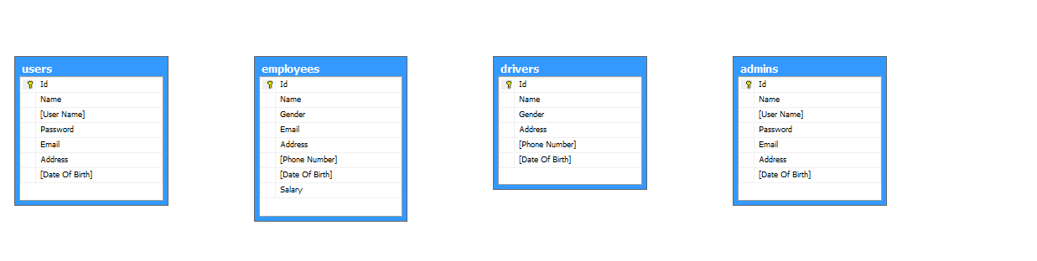

create table employees

(

Id int primary key identity,

Name varchar(50) NOT NULL,

Gender varchar(10) Not Null,

Email varchar(50) NOT NULL unique,

Address varchar(250) NOT NULL,

[Phone Number] varchar(20) NOT NULL unique,

[Date Of Birth] datetime Not NULL,

Salary int not null

);

create table admins

(

Id int NOT NULL Identity,

Name varchar(50) NOT NULL,

primary key(Id),

[User Name] varchar(50) NOT NULL unique,

Password varchar(50) NOT NULL,

Email varchar(50) NOT NULL unique,

Address varchar(250) NOT NULL,

[Date Of Birth] Datetime Not NULL,

);

create table users

(

Id int NOT NULL Identity,

Name varchar(50) NOT NULL,

primary key(Id),

[User Name] varchar(50) NOT NULL unique,

Password varchar(50) NOT NULL,

Email varchar(50) NOT NULL unique,

Address varchar(250) Not Null,

[Date Of Birth] Datetime Not NULL,

);

create table suppliers

(

Id int primary key identity,

Name varchar(50) NOT NULL unique,

Email varchar(50) Not null unique,

Address varchar(250) NOT NULL,

Number varchar(20) Not Null unique,

Created Datetime Not Null,

);

create table vehicles

(

Id int primary key identity,

Name varchar(50) NOT NULL,

Number varchar(20) Not null unique,

Company varchar(50) not null,

[Max Load] int not null,

[Date Of Purchase] Datetime not null,

);

create table orders

(

Id int primary key identity,

[Customer Name] varchar(50),

Booked Datetime not null,

[Total Weight] int not null,

[Total Price] int not null,

);

create table products

(

Id int identity,

Name varchar(50) NOT NULL unique

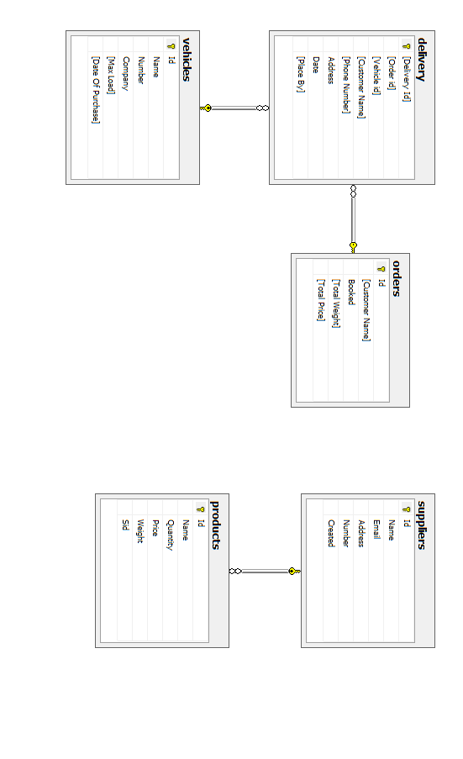

Quantity int Not null,

Price int NOT NULL,

Weight int not null,

Sid int NOT NULL,

Primary Key (Id),

Foreign Key (Sid) References suppliers(Id)

);

create table drivers

(

Id int primary key identity,

Name varchar(50) NOT NULL,

Gender varchar(10) not null,

Address varchar(250) NOT NULL,

[Phone Number] varchar(20) NOT NULL unique,

[Date Of Birth] Datetime Not NULL,

);

create table delivery

(

[Delivery Id] int primary key identity,---------------------------------------

[Order id] int not null,

[Vehicle id] int not null,-----------------------------------------------------

[Customer Name] varchar(50) not null,

[Phone Number] varchar(20) not null,--------------------------------------------

Address varchar(250) not null,------------------------------------------------------

Date Datetime not null,

[Place By] varchar(50),

Foreign key ([Order Id]) References orders(Id),

Foreign key ([Vehicle Id]) References vehicles(Id),

);