SM Management System



Bahria University Karachi Campus

Group Member

Your name here

Submitted to:

Teacher Name

Contents

SM Management System 1

SM MANAGEMENT SYSTEM 3

**Introduction:** 3

**Working:** 3

**Functionality:** 3

**Forms:** 4

Log_In: 4

Register: 5

forgot_password: 6

7

Admin_Options: 7

Add_User: 8

Add_Items: 8

Add_Employees: 10

# 

# SM MANAGEMENT SYSTEM

### **Introduction:**

SM is Store Management System. Its Simple efficient and easy to use. To use this software, you must be login as user or admin. Admin can use all the feature while users have limited access. SM Management System will keep the financial record of the market.

××××-------- ××××--------××××--------××××

### **Working:**

To enjoy the whole functionality of S.M Management System you must be login as an admin. You can also login as an admin to have limited access to this software. Admin can manage employees. Add user accounts. Admin Can manage Items. User have limited access.

××××-------- ××××--------××××--------××××

### **Functionality:**

* Two user login Admin and multiple users (employees).
* Admin can item in list of goods with price and quantity.
* Admin can manage employees add employee and delete employee.
* Admin can check records.
* Employee can add record for good sold.
* Employee can Generate Slip.
* Employee will receive payment via Cash or Credit Card.
* Employee can book home delivery.

××××-------- ××××--------××××--------××××

### **Forms:**

### Log_In:

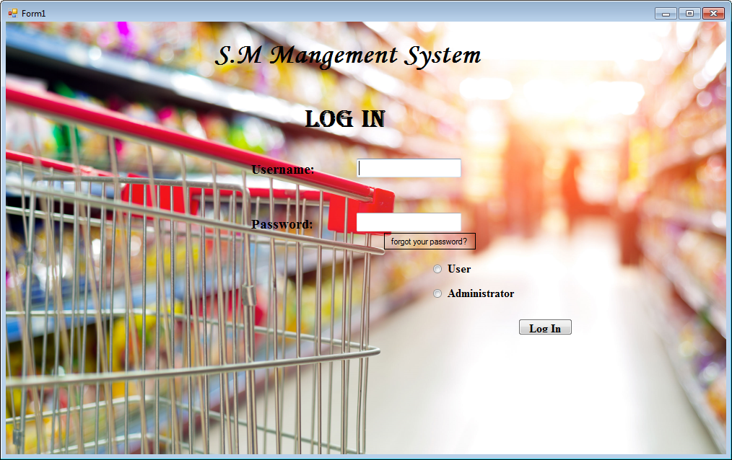

××××-------- ××××--------××××--------××××

### Register:

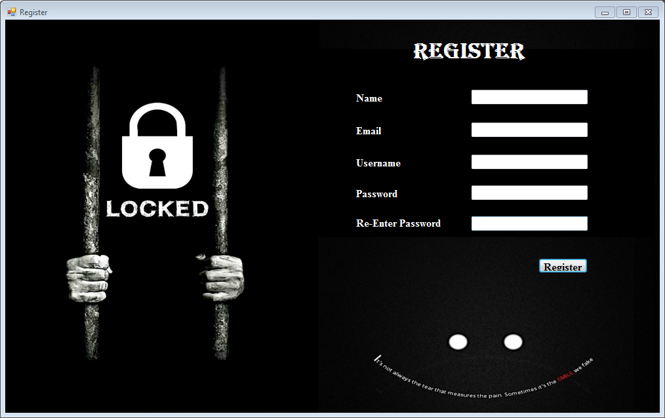

××××-------- ××××--------××××--------××××

### forgot_password:

### 

××××-------- ××××--------××××--------××××

]

### Admin_Options:

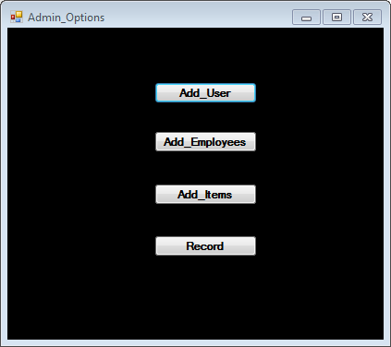

××××-------- ××××--------××××--------××××

### Add_User:

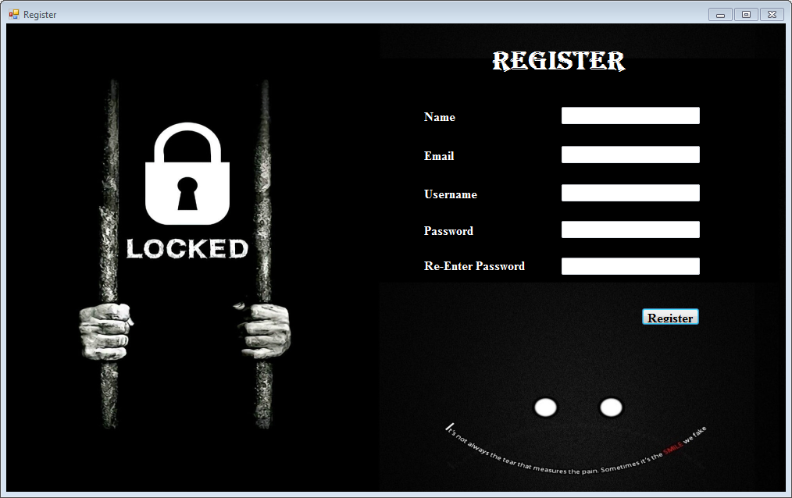

××××-------- ××××--------××××--------××××

### Add_Items:

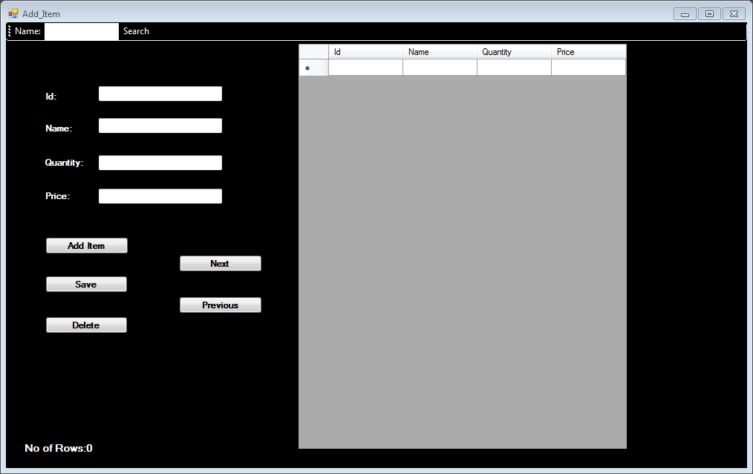

××××-------- ××××--------××××--------××××

### Add_Employees:



 