UNIT Converter



University Name Here

Group Member Enrollment no

# here

* Name

Submitted To:

**\*Teacher Name Here\***

Contents

UNIT Converter 1

1

Unit Converter 3

**Quantities:** 3

**Objects:** 3

**Conversions:** 3

Distance: 3

*Acceleration* 3

Area: 3

Temperature: 3

Weight: 4

Pressure: 4

Speed: 4

Time: 4

**Output:** 4

Menu Options: 4

From Meter: 4

From Kilo-Meter: 5

From Meter Per Second Square: 5

From Kilo-Meter Per Second Square: 5

From Meter Square: 5

From Kilo-Meter Square: 5

From Kelvin: 5

From Celsius: 5

From Kilo-Gram: 6

From Gram: 6

From Pascal: 6

From Atmospheric Pressure: 6

From Meter Per Second: 6

From Kilo-Meter Per Hour: 6

From Seconds: 7

From Minutes: 7

From Hour: 7

# Unit Converter

Unit Converter can convert the units of distance, speed, acceleration and etc. Unit converter is made on MIPS Architecture. Mips is Assembly language is closer to the Machine Language as compare to high level language such as C# ,C++ and c. It can work Faster Load program faster as compare to other languages.

### **Quantities:**

1. Distance.
2. Acceleration.
3. Area.
4. Temperature.
5. Weight
6. Pressure.
7. Speed.
8. Time.

### **Objects:**

Objects are the instance of class. Object is a particular instance.

### **Conversions:**

### Distance:

* Meter to Kilo-Meter.
* Kilo-Meter to Meter.
* Meter to Centi-Meter.
* Kilo-Meter to Centi-Meter.
* Meter to Inch.
* Kilometer to Inch.

#### Acceleration:

* Meter Per Second Square to Kilo-Meter Per Second Square.
* Kilo-Meter Per Second Square to Meter Per Second Square.

### Area:

* Meter Square to Kilo-Meter Square.
* Kilo-Meter Square to Meter Square.

### Temperature:

* Kelvin to Celsius.
* Celsius to Kelvin.

### Weight:

* Gram to Kilo-Gram.
* Kilo-Gram to Gram.
* Kilo-Gram to Pound.
* Gram to Pound.
* Kilo-Gram to Ounce.
* Gram to Ounce.

### Pressure:

* Atmospheric Pressure to Pascal.
* Pascal to Atmospheric Pressure.
* Millimeter-of-Mercury to Atmospheric Pressure.
* Pascal to Millimeter-of-Mercury.

### Speed:

* Meter Per Second to Kilo-Meter Per Second.
* Kilo-Meter Per Second to Meter Per Second.

### Time:

* Minutes to Second.
* Minutes to Hour.
* Seconds to Minutes.
* Seconds to Hours.
* Hour to Minute.
* Hour to Second.

### **Output:**

### Menu Options:

#### 

### From Meter:

#### 

××××-------- ××××--------××××--------××××

### From Kilo-Meter:

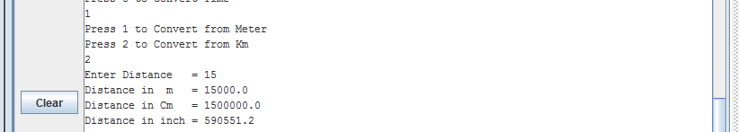

### From Meter Per Second Square:

#### 

### From Kilo-Meter Per Second Square:

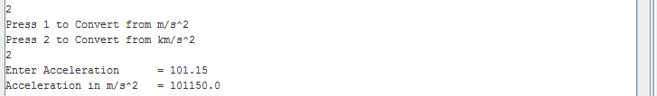

### From Meter Square:

#### 

### From Kilo-Meter Square:

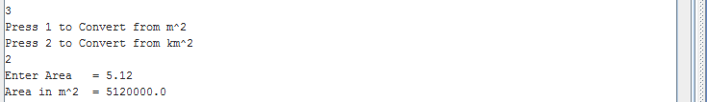

### From Kelvin:

#### 

### From Celsius:

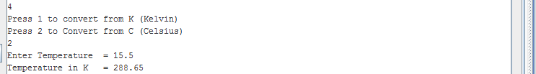

××××-------- ××××--------××××--------××××

### From Kilo-Gram:

#### 

### From Gram:

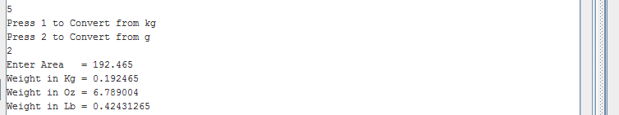

### From Pascal:

#### 

### From Atmospheric Pressure:

#### 

### From Meter Per Second:

#### 

### From Kilo-Meter Per Hour:

#### 

××××-------- ××××--------××××--------××××

### From Seconds:

#### 

### From Minutes:

#### 

### From Hour:



 