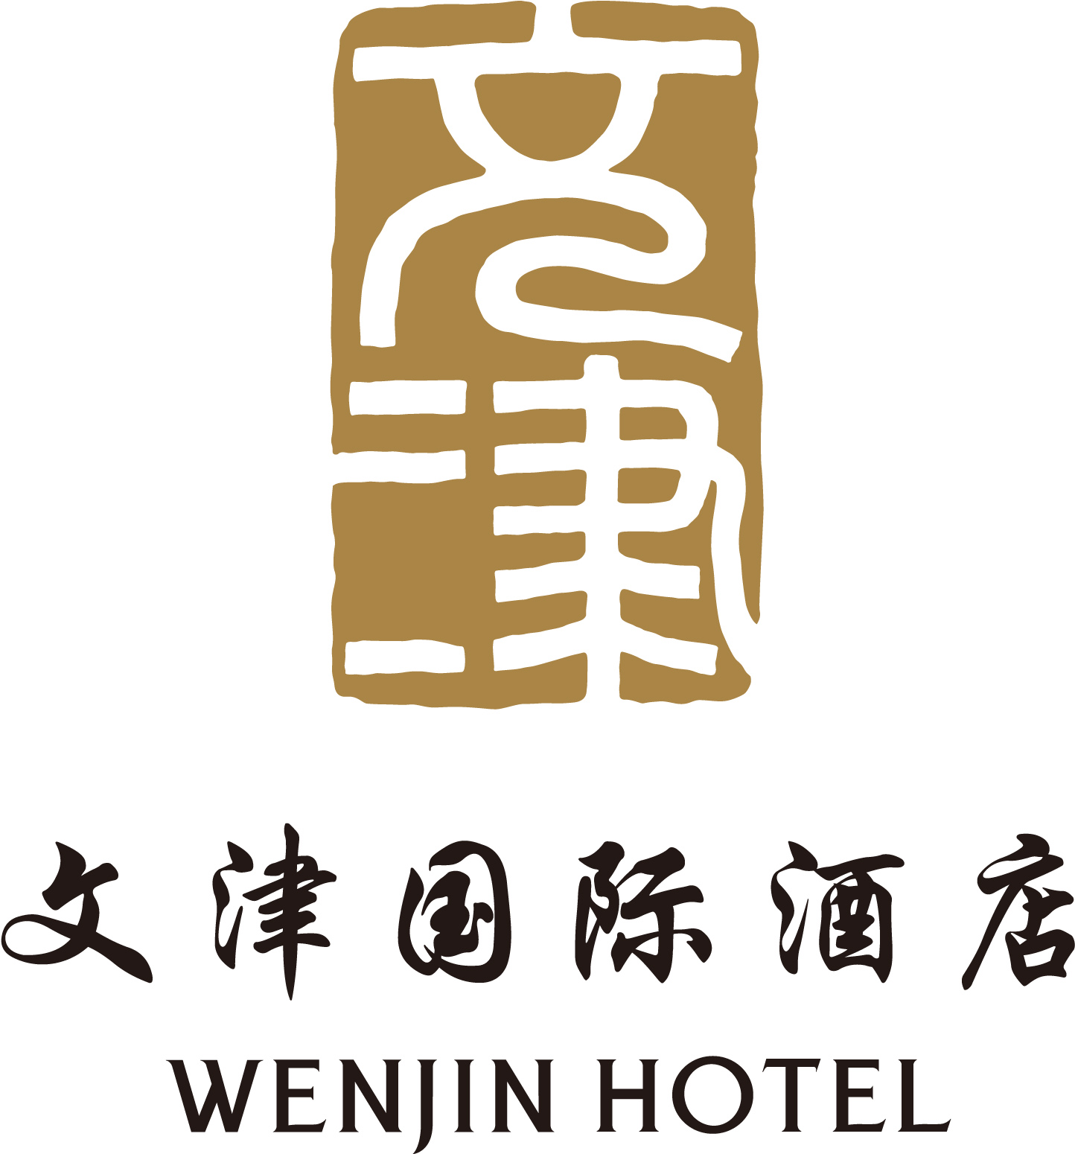
WENJIN HOTEL ROOM RESERVATION FORM
Conference Name: Quantum Information Processing 2013 (QIP2013)
Guest Name： Tel：

Arrival Date： Departure Date：
Room Type and Quantity of Rooms (please select)
Room Types | Room Fee | Quantity of Room
Superior Room | 728 RMB net/night
Business Room | 828 RMB net/night
Executive Room | 928 RMB net/night

Note: The room fee includes 1 breakfast, internet and gym.
Please pay the room charge by credit card and complete the form.
Credit card No:
__ __ __ __ /__ __ __ __ /__ __ __ __ /__ __ __ __
Expiry Date: __ __ /__ __
Cardholder Name _________________________
Cardholder Address___________________________________________________
Cardholder Signature__________________________
Please fax the form to Wenjin Hotel 86-10-62543230.
Or send the E-mail to emmayang@wenjin.com.cn
Chinese note to show to the taxi driver:
师傅，您好！请送我到文津国际酒店。地址：北京市海淀区清华科技园清华大学南门

