Exam
Automation Technologies
Summer 2025
First Name: | Last Name:
Matriculation number: | Study program:

Instructions:
- You can only take part in the exam if you are registered in the campus management system.
- Prepare your student ID and a photo ID card on your desk.
- Label each exam sheet with your name. Start a new exam sheet for each task.
- Answers must be given with a complete, comprehensible solution. Answers without any context will not be considered. Answers are accepted in German and English.
- Permitted tools are (exclusively): black/blue pens (indelible ink), a triangle/scale, a non-programmable calculator without a graphic display and 1 DIN A4 cheat sheets.
- The exam time is 120 minutes

Evaluation:
Question | 1 | 2 | 3 | 4 | 5 | 6 | 7 | 8 | Total
Maximum score | 14 | 16 | 4 | 4 | 4 | 4 | 4 | 10 | 60
Score secured

Question 1: Fundamentals of the magnetic field
14 marks
The iron core consists of thin single metal sheets with a cross-sectional area of A = 900 mm² and with an air gap of δ = 3 mm. A simplified sketch is shown in Fig. 1.1 The material behaviour of the selected iron is visualised in Fig. 1.2. The coil with N turns contains a direct current, which results in a homogeneous magnetic flux density of B_{δ} = 1.8 T in the air gap.
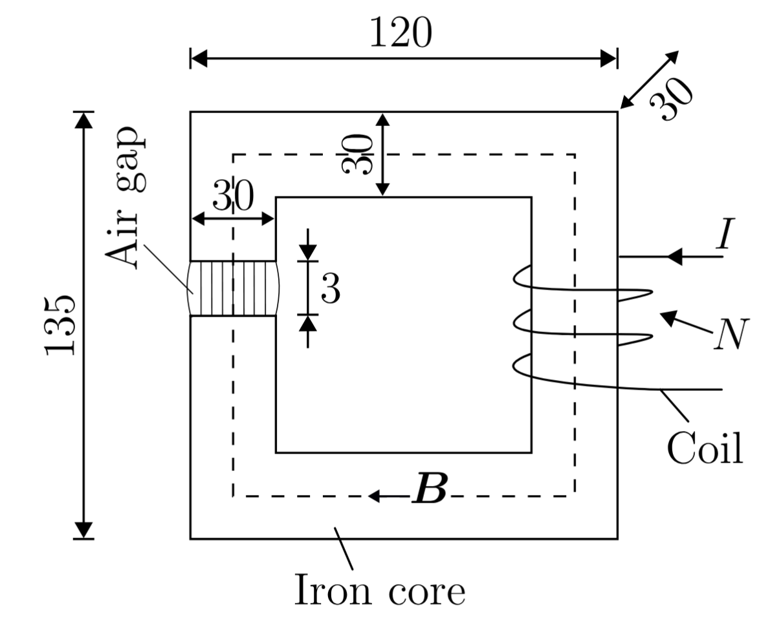
Fig. 1.1: Simplified sketch of a magnetic iron core. All dimensions of the core are given in mm.
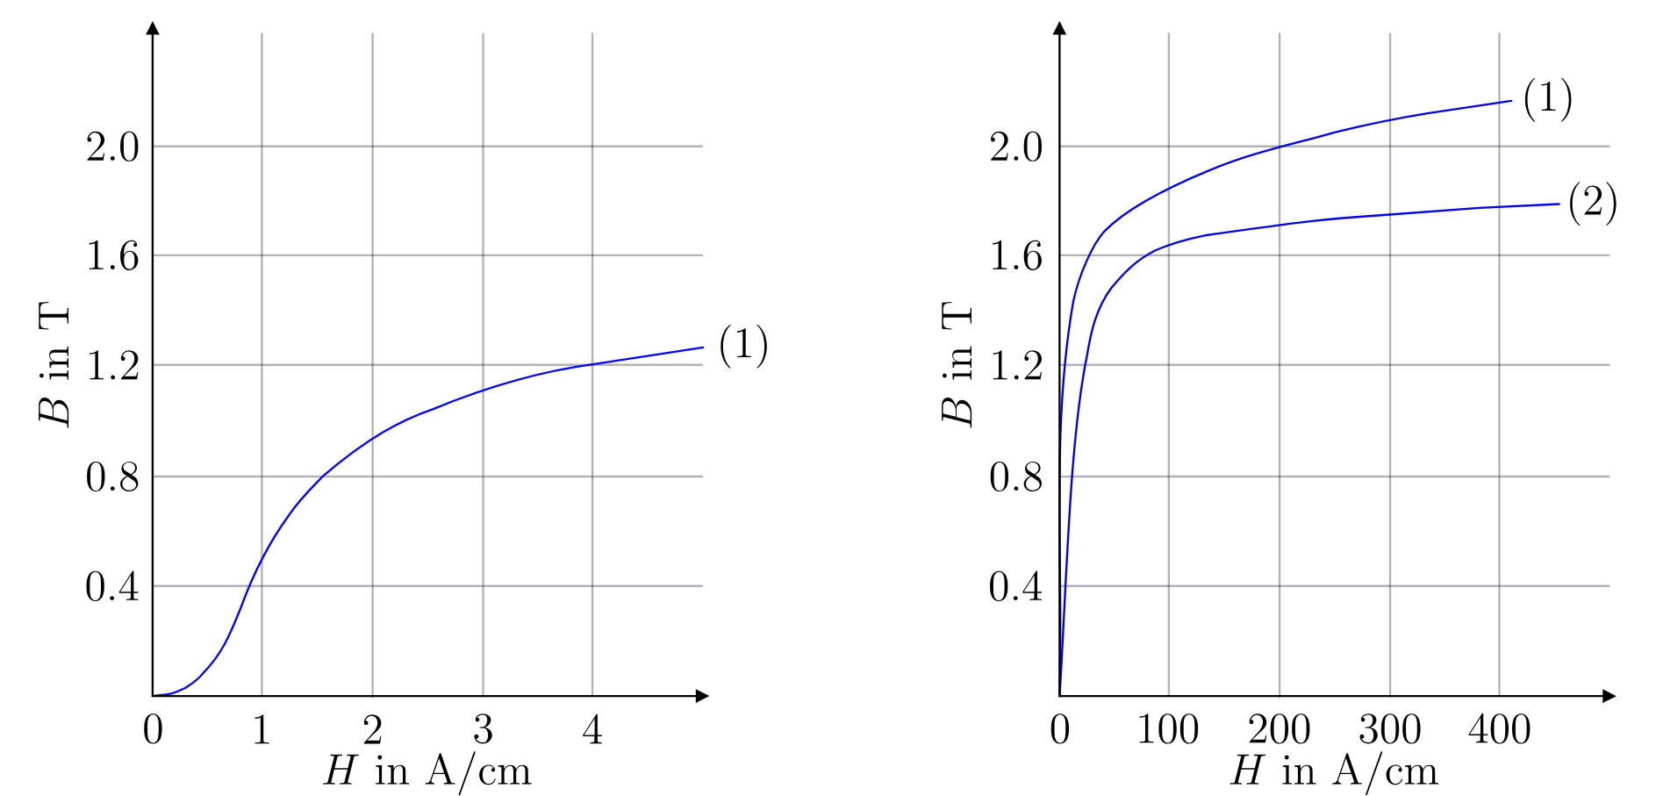
(1) | (2)
Figure 1.2: Direct current magnetisation curves of electrical steel for (1) hot rolled processing with a thickness of 0.5 mm and (2) cold rolled processing with a thickness of 0.35 mm. The magnetisation curve in the figure on the left side is a zoomed version of material (1) for lower field strengths.

  - Calculate the magnetic flux ϕ_{δ} in the air gap.
Final solution:_____________ (____/ 2 )


  - How big is the magnetic flux density B_{Fe} in the iron core at the dotted line in Fig. 1.1? Neglect the leakage flux.
Final solution:_____________ (____/ 2 )

  - What is the value of the permeability μ and the magnetic field strengths H_{δ} and H_{Fe} in the air gap and in the iron for the given operating point?

Final solution:_____________ (____/ 4 )

  - What is the required magnetomotive force θ = N · I in the excitation coil to excite the flux density B_{δ} = 1.8 T?




Final solution:_____________ (____/ 5 )


  - What is the required current I if the coil has N = 500 turns?
Final solution:_____________ (____/ 1 )

Question 2: Three-phase transformer
16 marks

A three-phase step-down transformer is connected to 6600 V mains and takes a current of 24 A. The ratio of turns per phase is 12. Assume ideal conditions, no losses. Calculate the (i) secondary line voltage, (ii) line current and (iii) output power, for the following connections:
Final solutions: _____________ (______/4)
  - $Δ$-$Δ$ (Delta-Delta)

  - Star-star

Final solutions: _____________ (______/4)

  - $Δ$-star

Final solutions: _____________ (______/4)

  - Star-$Δ$

Final solutions: _____________ (______/4)

Question 3: Four quadrants of machine operation
4 marks
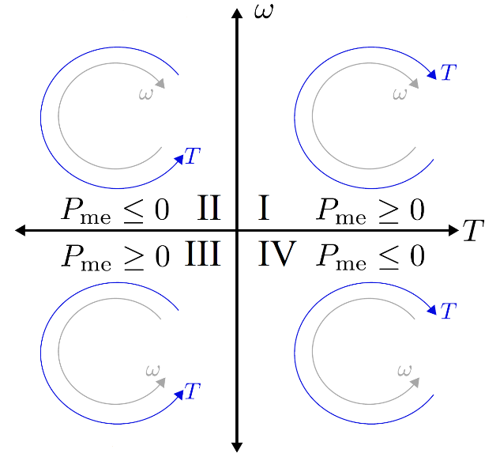
Fig. 3: Diagram for Question 3
Fig. 3 shows the operating modes of an electrical machine in four quadrants. Define the operating modes of each quadrant:
3.1. First quadrant
3.2. Second quadrant
3.3. Third quadrant
3.4. Fourth quadrant

Question 4: Power Semiconductor devices
4 marks
The following plots show the ideal characteristics of either of the following devices:
- Diode
- Thyristor
- Insulated Gate Bipolar Transistor
- Power Metal Oxide Semiconductor Field Effect Transistor (MOSFET)
The current flowing through the component is i_{a} and the voltage drop across the component is is u_{a}. Enter the name of the associated part under each diagram:
(______/4)
______________________________ | ______________________________
______________________________ | ______________________________

Question 5: Buck/boost converter for both voltage polarities
4 marks
A full bridge converter topology, which is used to realise a buck/boost converter topology with both voltage polarity is shown in Fig. 5. Fill in the switching states table with relevant values in terms of input (u₁) and output (u₂) voltages and input (i₁) and output (i₂) currents.
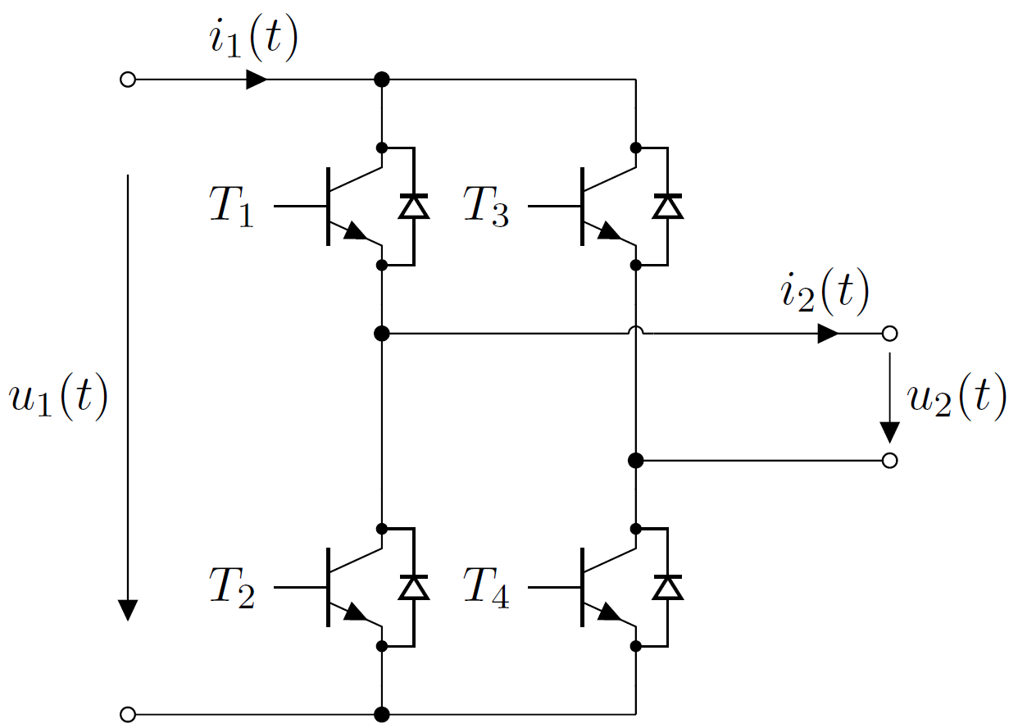
Fig. 5: Full bridge converter topology
T₁ | T₂ | T₃ | T₄ | u₂ | i₁
On | Off | Off | On | _______ | ______
Off | On | On | Off | ______ | ______
On | Off | On | Off | ______ | ______
Off | On | Off | On | ______ | ______

Question 6: Non-isolated power converter analysis
4 marks
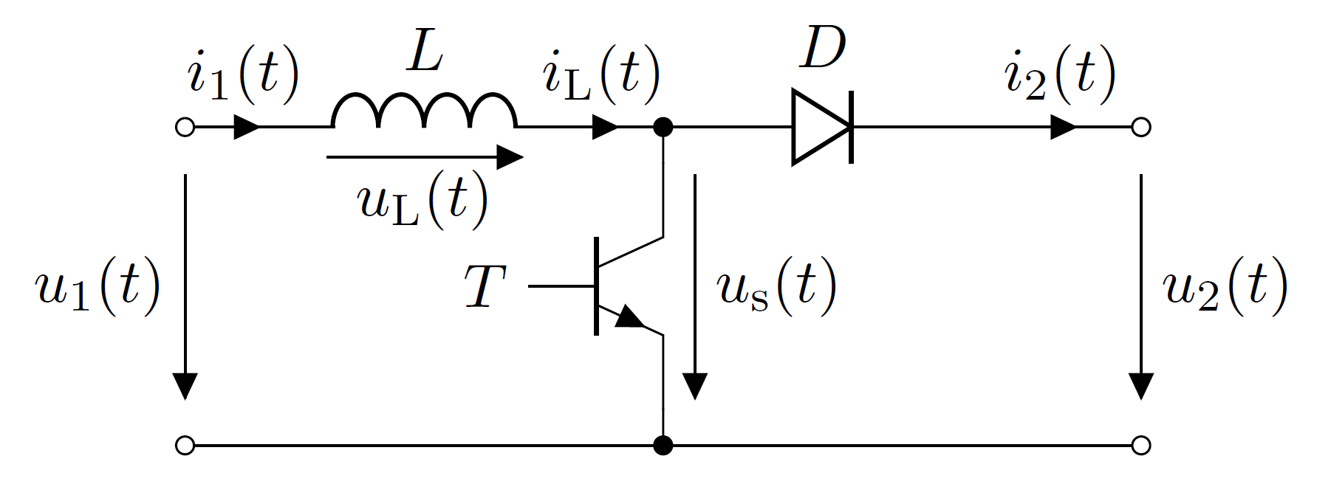
Fig. 6: Schematic of a power converter
For the converter topology given in Fig. 6, draw the waveforms considering the control pulses defined in the plot below for T. Assume operation in continuous conduction mode. The amplitude of each parameter is already mentioned in the schematic. There is no need to compute values; just waveforms are expected.
T_{ON}
T_{OFF}
T_{ON}

i_{L} (t)

v_{L} (t)

i₂ (t)

I_{D} (t)

Question 7: Isolated power converter analysis
4 marks
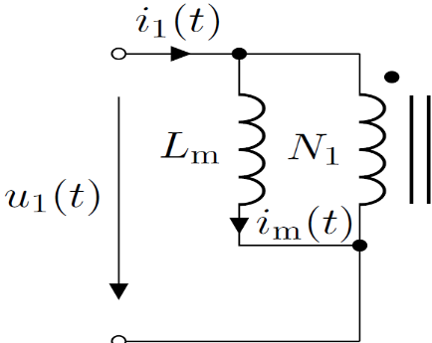
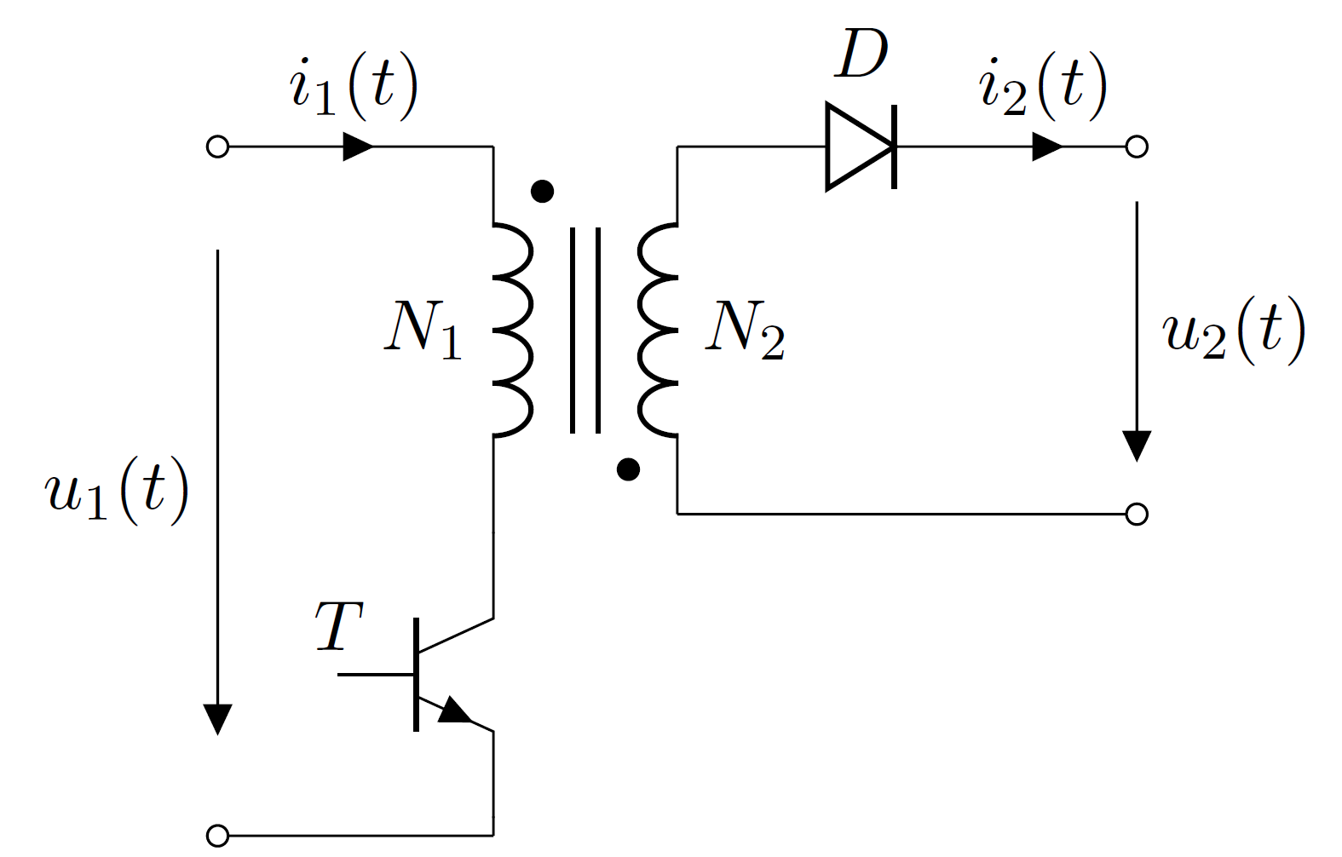
Fig. 6: Schematic of a buck/boost converter
For the converter topology given in Fig. 7, draw the waveforms considering the control pulses defined in the plot below for T. Assume operation in continuous conduction mode. The amplitude of each parameter is already mentioned in the schematic. There is no need to compute values; just waveforms are expected.
T_{ON}
T_{OFF}
T_{ON}

i_{m} (t)

u_{Lm} (t)

i_{D} (t)

u_{T} (t)

Question 8: Isolated converter numerical
10 marks
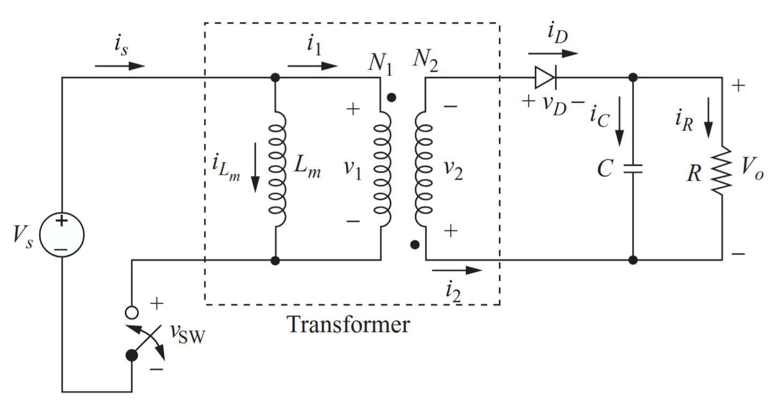
Fig. 7. Schematic of the converter under investigation
The above circuit has the following parameters:
V_{s}=24 V, turns taio- N₁/N₂= 3, L_{m}=500 $μ$H, load R=5 Ω, filter C=200 $μ$F, switching frequency of switch in primary (with voltage v_{sw}) = 40 kHz and output voltage (V_{o})=5V. Assume ideal components and calculate:
7.1. The required duty ratio- D

Final solution:_____________ (____/ 2 )


7.2. The average, maximum, and minimum values for the current in L_{m}
Final solution: _____________ (______/6)

7.3. The output voltage ripple

Final solution:_____________ (____/ 2 )

