README

The package includes followings sample projects:

1. IATADev: Sample API in .NET
2. IATACmd: Sample Client to consume the API

Setting up environment

This document supposes that the IATADev will be run/deployed as a web application inside a website. Below are steps required:

1. In your development machine, put WISeKey Demo Root (cert/wisekey_root.crt) in the Trusted Root Store:

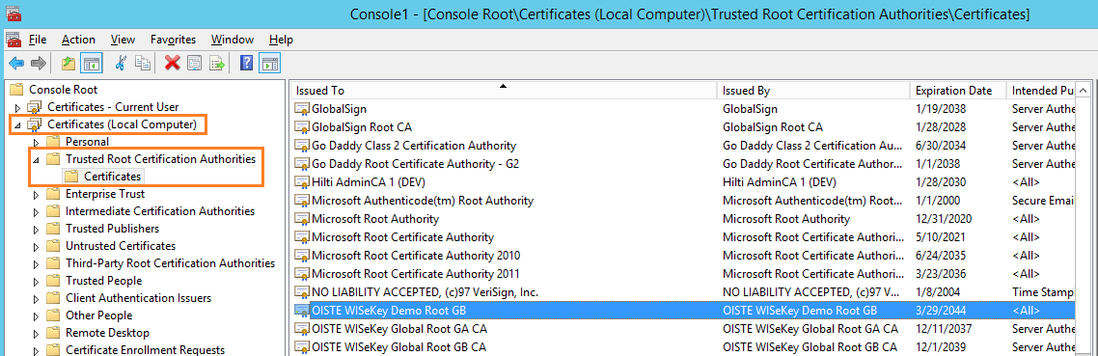

1. Put WISeKey CA (cert/wisekey_ca.crt) in the CA Store:

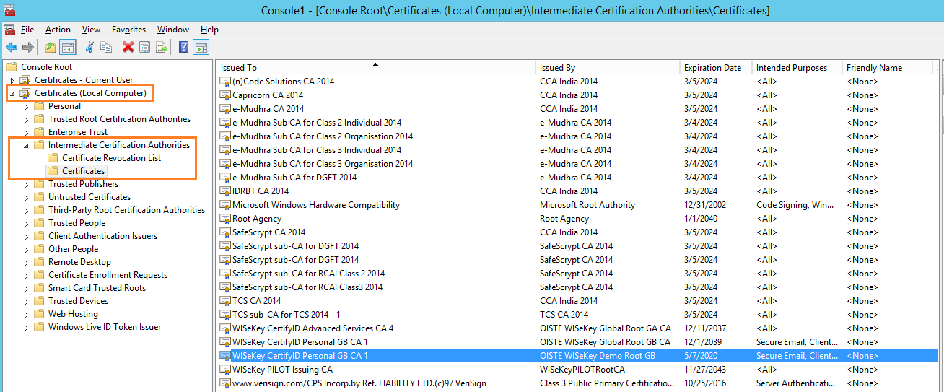

1. Install IIS, and then enable SSL for the website that contains the application.

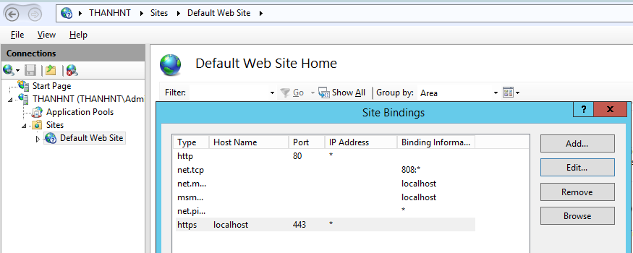

1. Enable SSL like below for the IATADev application

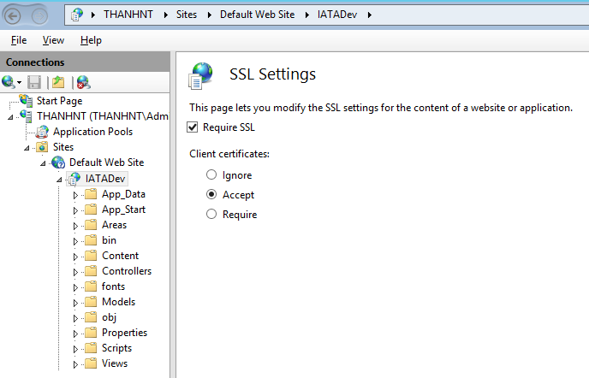

1. Using Using IE or Chrome to open the IATA at <https://localhost/IATADev>, then view the SSL Certificate, choose Details tab, and then Copy the SHA1 thumbprint of the SSL Certificate.
2. Open App.config of the IATACmd and then paste the thumprint into the value field of the SSLCertThumbprint, remove spaces. See the image below:

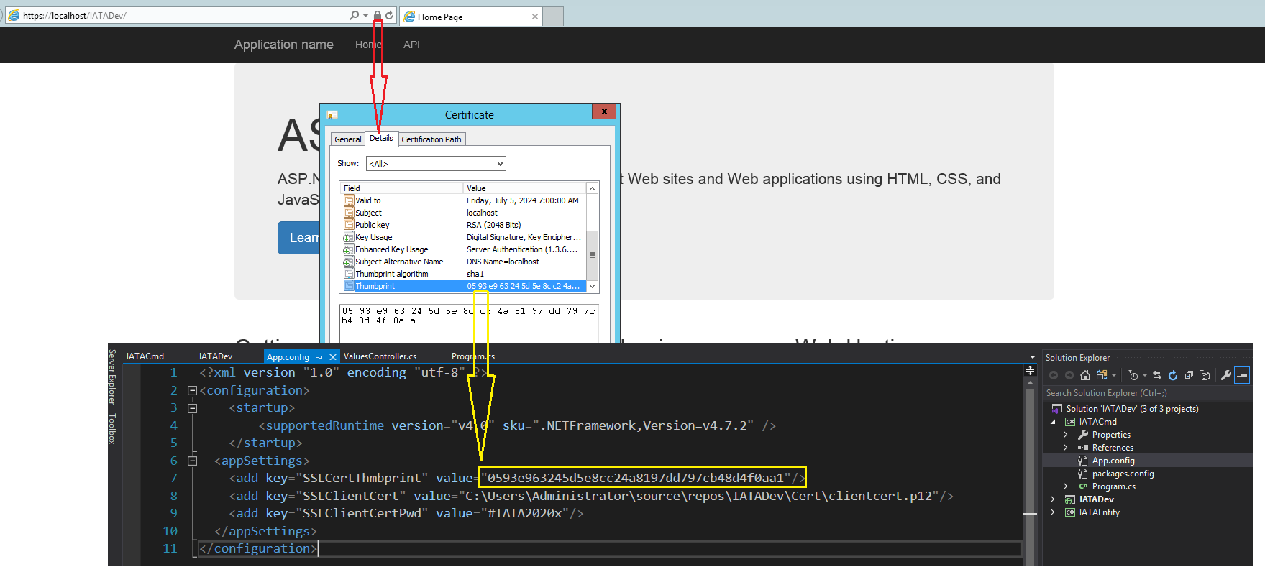

1. Edit the path to the SSL Client Certificate in the SSLClientCert setting.

For NETCore Development

1. The setting of the project is as follows:

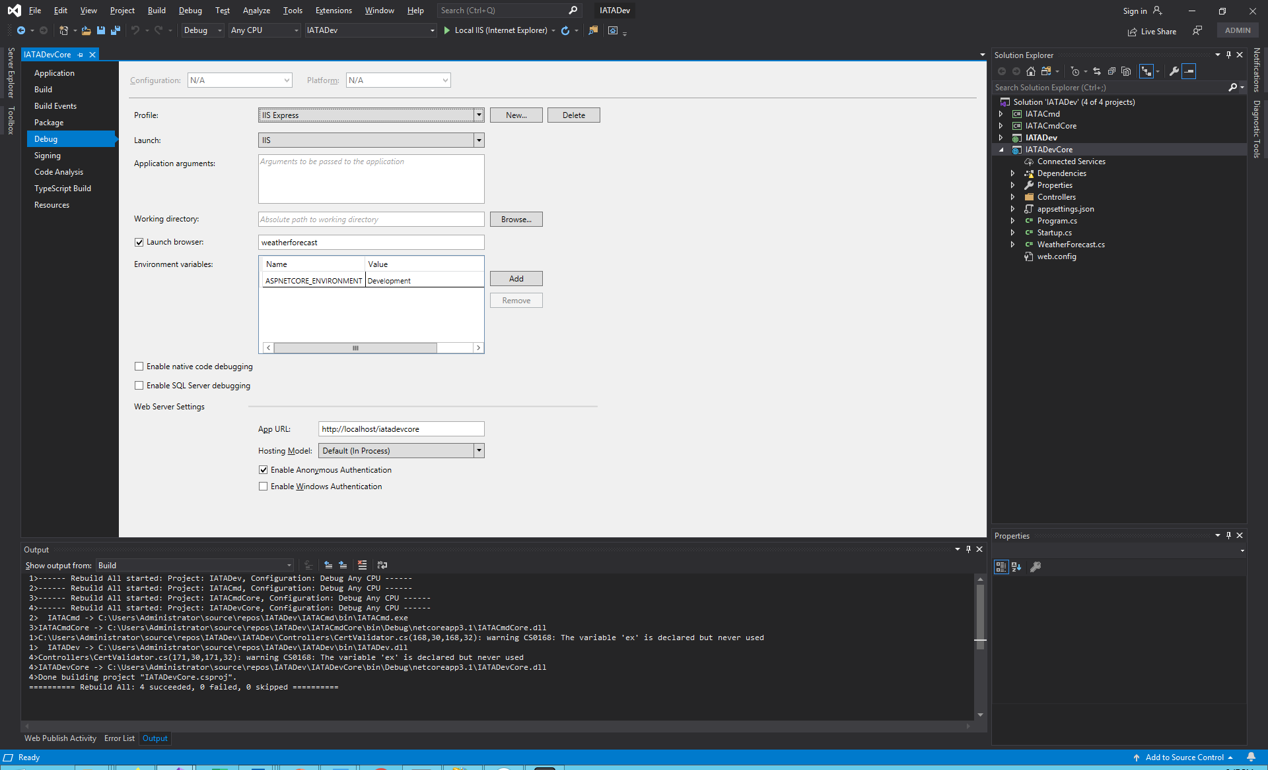

1. And in IIS

