Nature of second order system response

Undamped: roots

Underdamped: roots

Critically damped: roots $= -x_{1}=-x_{2}$

Overdamped: roots

where final (usually 1)

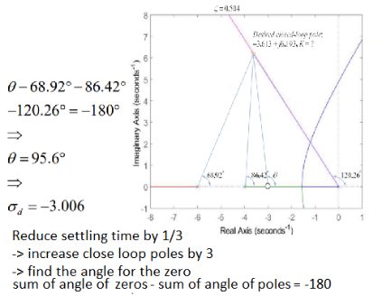

1/(Ts/T)

Lead-lag:

Choose ωmax­ as 2/3ωBW

find phase margin

Φmax =

Desired – PM + 10

Find B and shit

build Glag(s) and Glead(s)

Lead:

find phase margin

Φmax =

Desired – PM + 10

Find B

Find ωmax in dB by B

Find frequency by check -ωmax from 0

Find 1/T

build Gc(s)

Steady/Lag:

Adjust K

find phase margin

PM+10

find frequency(ω0dB)

find change in dB

build Gc(s)

PI controller

Lag compensator

%OS:

find phase margin

find frequency

find gain in dB

PID

1. PD
2. PI
3. PID

Lead compensator(Modified PD)

Use when K = inf / locus become **+**

Pole = (s+42.96)

Zero = (s+5)

PD controller

Im/(-Re+σ) = tan(180-θ)